© Edunet Foundation

www.edunetfoundation.org

2022

Core Module 1

Fundamentals of Computer Hardware & Networking

Table of Contents

Introduction to Tools 4

Assembling and Disassembling PC 33

Computer Disassembly 48

Software Installation 53

File System 65

Introduction to Linux operating system 132

What is Linux Operating System? 139

Familiarization with GUI environment 157

Syntax of shell commands 168

Shell scripting 175

Familiarization of open office tools for creating documents 193

Open Office tools for creating spreadsheet 210

Open Office tools for creating presentation 268

Familiarization with Disk management 312

Even Viewer 348

Device manager 352

Shared folders 355

Services and Applications 358

Virus and its type and Antivirus 358

Using different types of firewalls 364

Hardware Maintenance 370

Preventive Maintenance 386

Maintenance Scheduling 393

Basic Troubleshooting of PC 417

Introduction to networks 426

Internet and Intranet etc. 454

Network Interface Card 470

Transmission Media and Topologies Media Type 474

Crimping tools and Color standards for Straight crimping and Cross crimping 478

Concept of Server, client. 2

Analog Transmission 10

Digital Transmission 11

Base band and Broadband transmission 14

STP cable, UTP cable, Coaxial cable, Fiber cable and Connectors 14

Physical and logical topologies 21

Asynchronous & Synchronous Transmission 28

Web Protocols 32

Transmission Control Protocol 33

Internet Protocol 37

User Datagram Protocol (UDP) 43

POP Protocol 45

Hyper Text Transfer Protocol 50

Hyper Text Transfer Protocol Secure 51

File Transfer Protocol 53

Simple Mail Transfer Protocol 54

Open System Interconnection Model (OSI) Introduction 56

Media Access Methods 60

Domain Name Services 62

Dynamic Host Configuration Protocol 65

Windows Internet Name Service 67

Web Services 71

Proxy Services 77

Network Devices 80

Switches 84

Routers 88

Bridges 95

Internet Service Provider 98

Introduction to Network Security 105

LAN security considerations 118

Types of Network Security Devices 120

Firewalls 121

Antivirus 122

Content Filtering 122

Intrusion Detection Systems 122

Overview of Remote Access 124

VPN Types 134

VPN Tunneling 137

VPN Security 140

Remote Access Authentication Protocol 143

Remote Authentication Dial-In User Service (RADIUS) 150

TCP/IP Routing 155

# Introduction to Tools

## What is Tools?

An item or implement used for a specific purpose. A tool can be a physical object such as mechanical tools including saws and hammers or a technical object such as a web authoring tool or software program. Furthermore, a concept can also be considered a tool.

"Creativity is the tool which allows a child's mind to grow."

## Functions

One can classify tools according to their basic functions:

1. Cutting and edge tools, such as the knife, sickle, scythe, hatchet, and axe are wedge-shaped implements that produce a shearing force along a narrow face. Ideally, the edge of the tool needs to be harder than the material being cut or else the blade will become dulled with repeated use. But even resilient tools will require periodic sharpening, which is the process of removing deformation wear from the edge. Other examples of cutting tools include gouges and drill bits.
2. Moving tools move large and tiny items. Many are levers which give the user a mechanical advantage. Examples of force-concentrating tools include the hammer which moves a nail or the maul which moves a stake. These operate by applying physical compression to a surface. In the case of the screwdriver, the force is rotational and called torque. By contrast, an anvil concentrates force on an object being hammered by preventing it from moving away when struck. Writing implements deliver a fluid to a surface via compression to activate the ink cartridge. Grabbing and twisting nuts and bolts with pliers, a glove, a wrench, etc. likewise move items by applying torque (rotational force).
3. Tools that enact chemical changes, including temperature and ignition, such as lighters and blowtorches.
4. Guiding, measuring and perception tools include the ruler, glasses, set square, sensors, straightedge, theodolite, microscope, monitor, clock, phone, printer
5. Shaping tools, such as molds, jigs, trowels.
6. Fastening tools, such as welders, rivet guns, nail guns, or glue guns.
7. Information and data manipulation tools, such as computers, IDE, spreadsheets.

Some tools may be combinations of other tools. An alarm-clock is for example a combination of a measuring tool (the clock) and a perception tool (the alarm). This enables the alarm-clock to be a tool that falls outside of all the categories mentioned above.

There is some debate on whether to consider protective gear items as tools, because they do not directly help perform work, just protect the worker like ordinary clothing. They do meet the general definition of tools and in many cases are necessary for the completion of the work. Personal protective equipment includes such items as gloves, safety glasses, ear defenders and biohazard suits.

## Types of Tools

## Mechanical Tools

Mechanical Tools help in carrying out a number of tasks and these include:

**Cutting Tools:** These tools are compact and light weight and like the name indicates they are used to cut parts like wood, metal, plastic etc. Cutting tools include:

* Scissors
* Knives
* Saw
* Blades etc.

**Fig: cutting tool**

**Reference:** <https://sites.google.com/view/master-training>

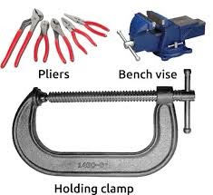**Grabbing and Clamping Tools**

Grabbing and Clamping tools are hand held tools which are used to hold materials in place while they are being worked upon.

These tools also help in shaping and bending a wide variety of materials. Grabbing and Clamping Tools include:

* C-Clamps
* Pliers
* Bench Vise
* Tweezers (for small objects) etc.

**Hammers and Mallets**

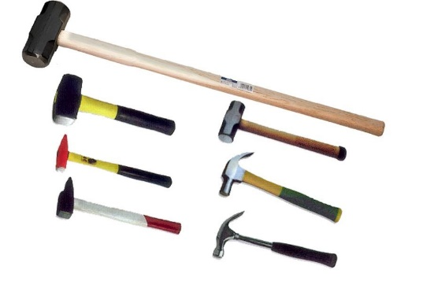Hammers and Mallets are also known as finishing tools. Different hammers have different purposes.

* Ball Point Hammer - Used for rounding off edges
* Nail Hammer - Used to Nail an object and remove nails
* Tack Hammer - The flat side of the tack hammer is magnetized and it helps in holding small nails in place
* Mallet - Used to remove dents



**Screw Drivers and Fasteners**

Hand held tools used to fasten objects using screws. There are different types of screw drivers like Phillips Screw Driver etc. Allen Key Set is a set of tools that can fasten / unfasten special set of screws.

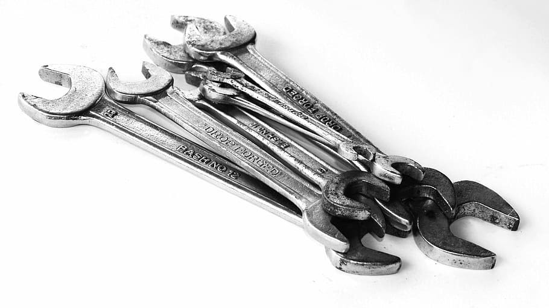**Spanners**

Spanners are tools that provides grip and mechanical advantage in applying torque/force to turn objects.

An adjustable wrench has a movable jaw. It allows us to use different sizes of fastener heads.

## Measurement Tools

**Vernier Calliper**

A Vernier scale (Vernier Caliper) is a visual aid to take an accurate measurement reading between two graduation markings on a linear scale by using mechanical interpolation thereby increasing resolution and reducing measurement uncertainty by using Vernier acuity to reduce human estimation error.

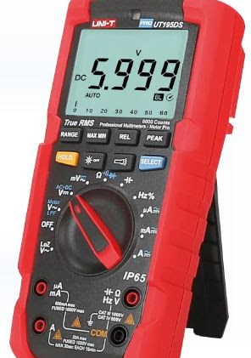**Multimeter**

A multimeter or a multi tester, also known as a VOM (volt ohm milli-ammeter), is an electronic measuring instrument that combines several measurement functions in one unit. A typical multimeter can measure voltage, current, and resistance

**Digital Oscilloscope**

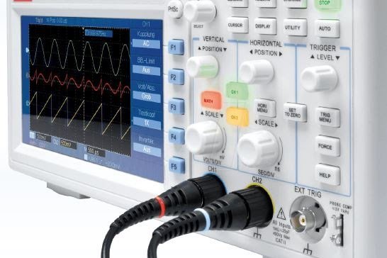A digital storage oscilloscope (often abbreviated DSO) is an oscilloscope which stores and analyses the signal digitally rather than using analog techniques It is now the most common type of oscilloscope in use because of the advanced trigger, storage, display and measurement features which it typically provides

## Power Tools

**Power Drill**

A power drill is an electrical motor that rotates a replaceable drill bit to make a hole in wood, plastic, or metal. Alternately, a screwdriver tip can be installed to turn screws. Corded or cordless drills can handle a wide variety of tasks, including drilling holes and driving screws in and out.

Corded or cordless drills can be used in mobility, but the stationary drill or drill station has to be used on the surface bed of the stationary drill.



**Hot Glue Gun**

Hot glue guns use continuous heating elements to melt the adhesive The gun would heat the glue, and you could use the hot glue to adhere pieces of fabric together (or to make other craft projects).

Hot melt also has the advantage of not losing any thickness when drying.

**Hot Air Gun**

A hot air gun is a device used to emit a stream of hot air It comprises a source of heat usually an electrically heated element and a mechanism to move the hot air.

Different types of heat gun operate at different temperatures and with different airflow, they can be used to strip paint, shrink tubing, shrink film, and shrink wrap packaging, dry out damp wood, bend and weld plastic, soften adhesives, and thaw frozen pipes.

## Specification of Hand tools

**Screw drives**A screwdriver is a [tool](https://en.wikipedia.org/wiki/Tool), manual or powered, used for driving [screws](https://en.wikipedia.org/wiki/Screw). A typical simple screwdriver has a handle and a shaft, ending in a tip the user puts into the screw head before turning the handle. This form of the screwdriver has been replaced in many workplaces and homes with a more modern and versatile tool, a [power drill](https://en.wikipedia.org/wiki/Power_drill), as they are quicker, easier, and also can drill holes.

Proper use requires that the screwdriver's tip engage the head of a screw of the same size and type designation as the screwdriver tip. Screwdriver tips are available in a wide variety of types and sizes ([List of screw drives](https://en.wikipedia.org/wiki/List_of_screw_drives)). The two most common are the simple 'blade'-type for slotted screws, and Phillips, generically called "cross-recess", "cross-head", or "cross-point".

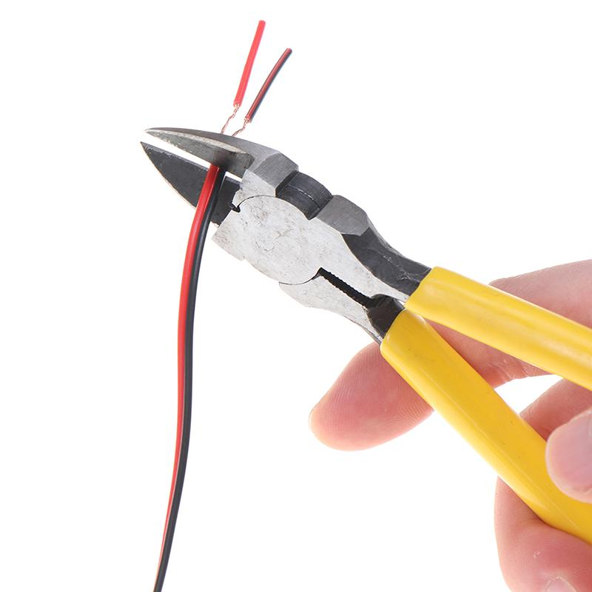**Cutting pliers**

Pliers are made in various shapes and sizes and for many uses. Some are used for gripping something round like a pipe or rod, some are used for twisting wires, and others are designed to be used for a combination of tasks including cutting wire. There are also tools that are used just for cutting wires (as opposed to wire cable and rope). Use the correct pliers or wire cutters for the job.

**Proper use of side cutting (lineman's) pliers:**

* Many applications including electrical, communications and construction work
* Use to grip, splice or cut wires, and strip insulation.

**Proper use of long nose pliers:**

* Use to grip small objects, reach awkward places, holding wires, bend loops, and attach wires
* Work involving smaller gauge wire.

**Proper use of diagonal cutting pliers:**

* For work involving cutting and skinning wires, cutting and removing pins, nails and other fasteners.

**Tweezers**

Tweezers are small tools used for picking up objects too small to be easily handled with the human [fingers](https://en.wikipedia.org/wiki/Finger).

People commonly use tweezers mainly for tasks such as [plucking hair](https://en.wikipedia.org/wiki/Plucking_(hair_removal)) from the face or eyebrows, often using the term eyebrow tweezers. Other common uses for tweezers are as a tool to manipulate small objects, including for example small, particularly [surface-mount](https://en.wikipedia.org/wiki/Surface-mount), [electronic parts](https://en.wikipedia.org/wiki/Electronics), and small mechanical parts for [models](https://en.wikipedia.org/wiki/Scale_model) and precision mechanisms.

**Pointed tip tweezer.**

Point tweezers are also known as precision tweezers. They have an ultra-sharp tip that grabs every hair individually, which explains their namesake.

Because they’re so sharp, they’re a little scary looking, and it’s important to keep them away from children. However, they’re indispensable in a wide range of situations, both for beauty and first aid.

### **When to Use**

Point tweezers are best for any kind of precision work, or for when you need to extract something that’s buried deep in the skin. They only pull a single hair at a time, so they’re great for refined eyebrow tweezing work.

**What Is crimping tools?**

Crimp tools are a varied collection of devices used to join materials or components by pressing them together and creating a seal or crimp. One of the most common uses of crimping tools is the attachment of connectors to the end of electrical cables.

Many crimping tools are multi-functional, with compression available alongside bending, cutting, stripping and similar actions. They are designed to work with particular cable, wire or pipe sizes - or gauges – and some models work with several.

#### **How does it work?**

To use this crimping tool, each wire is first placed into the connector. Once all wires are in the jack, the connector with wires are placed into the crimping tool, and the handles are squeezed together. Crimping punctures the plastic [connector](https://www.computerhope.com/jargon/c/connect.htm) and holds each of the wires, allowing for data to be transmitted through the connector.

## Types of Crimp Tool

Crimp tools can be used for many different applications across a range of industries and environments. Here are some additional types of crimp tool:

### **1212045Bootlace Crimp Tools**

As the name suggests, [bootlace crimp tools](https://uk.rs-online.com/web/c/hand-tools/cable-connector-crimping-tools/crimp-tools/?applied-dimensions=4292052487) are specifically designed to work with [bootlace ferrules](https://uk.rs-online.com/web/c/connectors/wire-terminals-splices/bootlace-ferrules/), which require a different form of crimping to standard cabling. Precision must be combined with force to ensure a strong indent crimp.

### **RJ45 Crimping Tool**

The [RJ45 crimping tool](https://uk.rs-online.com/web/c/hand-tools/cable-connector-crimping-tools/crimp-tools/?applied-dimensions=4292052105,4292052496,4292052072) is a flexible and powerful handheld crimper, compatible with [CAT5e](https://uk.rs-online.com/web/c/connectors/network-telecom-connectors/ethernet-connectors/?applied-dimensions=4294518919,4291877699,4291847198,4293277729,4294431788), [CAT6](https://uk.rs-online.com/web/c/connectors/network-telecom-connectors/ethernet-connectors/?applied-dimensions=4294518919,4291877699,4291847198,4293277729,4294431995), [CAT6A](https://uk.rs-online.com/web/c/connectors/network-telecom-connectors/ethernet-connectors/?applied-dimensions=4294518919,4291877699,4291847198,4293277729,4294430614) and CAT7 terminals.

### RJ9 crimping tool for RJ12 RJ11 RJ45 (4P 6P 8P) - Cablematic**RJ9 Crimp Tool**

### The RJ9 is a widely used handheld crimp tool fitted with three dies (crimping heads) compatible with the standard connector types [RJ45](https://uk.rs-online.com/web/c/connectors/network-telecom-connectors/ethernet-connectors/?applied-dimensions=4294518919), [RJ11](https://uk.rs-online.com/web/c/connectors/network-telecom-connectors/ethernet-connectors/?applied-dimensions=4294430322) and [RJ12](https://uk.rs-online.com/web/c/connectors/network-telecom-connectors/ethernet-connectors/?applied-dimensions=4294388123). This adaptability means engineers require fewer items in their crimp toolsets when conducting repairs or installations.

## Hand Tools Safety – Hazards & Precautions

**Hand Tools :** A tool held in the hand and operated without electricity or other energy. The tools like hammer, chisel, screw driver, shovel, [Pickaxe](https://en.wikipedia.org/wiki/Pickaxe) is comes under hand tools.

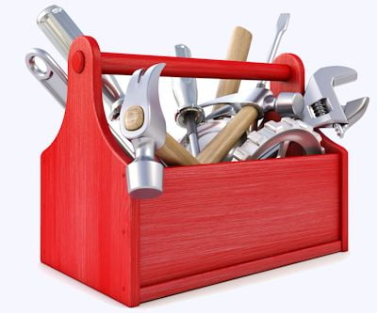**Hand Tools Hazards**

* Eye injuries due to the flying particles
* Hammer may cause Impact Injuries
* Damage handles of hand tools
* Slipping while using.
* Falling from height.
* While climbing ladder carrying tools in hand.

Reference : <https://safetynotes.net/wp-content/uploads/2016/03/hand-tools.jpg>

[**Safety**](http://safetynotes.net/)**Precaution of Hand Tools:**

* Inspection should be done before use.
* Always keep clean.
* Always keep tools in box.
* Use proper tool for the job doing.
* Use bucket and leather bad to shift the tools at height.
* Follow color coding.
* Awareness among the workers for the safe using.

**Carrying or transporting tools**

* Use a tool box, tool-holder, belt or pouch, this will protect the person and the tool
* Carry pointed or sharp tools with the point or cutting edge away from the body
* Do not carry tools by hand up ladders
* Do not lay tools down where people can trip on them or they can fall on someone

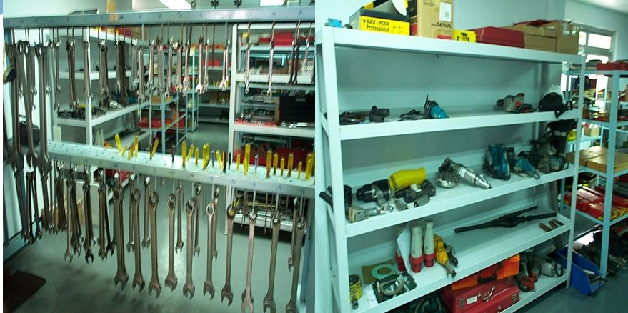

## Soldering

Soldering is a joining process used to join different types of metals together by melting solder. Solder is a metal alloy usually made of tin and lead which is melted using a hot iron. The iron is heated to temperatures above 600 degrees Fahrenheit which then cools to create a strong electrical bond.

### **Overview: What is soldering and when should you use it?**

* Soldering is a process in which two or more metal items are joined together by melting and then flowing a filler metal into the joint—the filler metal having a relatively low melting point.
* Soldering is used to form a permanent connection between electronic components.
* The metal to be soldered is heated with a soldering iron and then solder is melted into the connection.
  + Only the solder melts, not the parts that are being soldered.
  + Solder is a metallic "glue" that holds the parts together and forms a connection that allows electrical current to flow.
* You can use a solderless breadboard to make test circuits, but if you want your circuit to last for more than a few days, you will want to solder the components together.

## Materials

### Materials and Equipment

* A soldering iron
  + A soldering iron is used to heat the connections to be soldered.
  + For electronic circuits, you should use a 25- to 40-watt (W) soldering iron.
  + Higher wattage soldering irons are not necessarily hotter; they are just able to heat larger components. A 40-W soldering iron makes joints faster than a 25-W soldering iron does.
  + A soldering iron can be purchased at hardware stores and at most large department stores.
* Rosin core solder
  + Solder has a lower melting point than the metals that are being connected do. The solder melts when it is heated by the soldering iron, but the metals being joined will not melt.
  + The rosin core acts as a *flux.* It prevents oxidation of the metals that are being connected, and enhances the ability of the solder to "wet" the surfaces that are being joined.
  + Solder that is used to join copper pipes has an acid core, which is appropriate for pipes, but will corrode electronic connections. Use solder that has a rosin core.
  + For most electronics work, a solder with a diameter of 0.75 millimeters (mm) to 1.0 mm is best. Thicker solder might make soldering small joints difficult and also increases the chances of creating *solder bridges* between copper pads that are not meant to be connected.
  + An alloy of 60/40 (60% tin, 40% lead) is used for most electronics work, but lead-free solders are available as well.
* Stand on which to hold the hot soldering iron
  + There are a variety of stands available. It is important to always keep the hot iron in its stand when not in use.
* Sponge
  + The damp sponge is used to clean the tip of the iron.

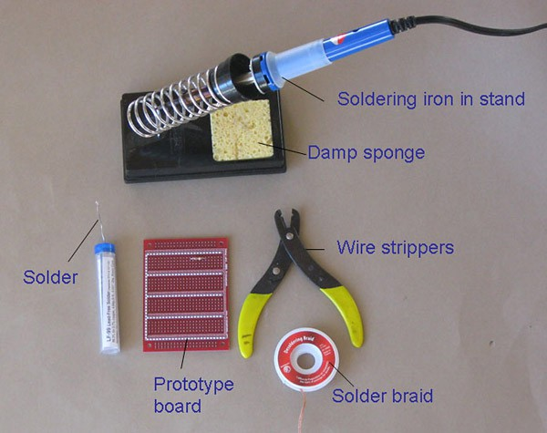  
**Figure 1.** Soldering equipment and materials. The *solder* in this picture is coiled inside a plastic tube; it is pulled through the top as needed. The spring on the stand holds the hot soldering iron. The *damp sponge* is used to clean the tip of the iron. *Solder braid* is used to remove solder; solder is "soaked up" into the braid when it is heated by the soldering iron. The *wire strippers* can be adjusted to strip the plastic covering off of various thicknesses of wire. The *prototype board* is used to connect electronic components in a circuit.

Reference: <https://www.sciencebuddies.org/science-fair-projects/references/how-to-solder>

* Solder braid
  + This is used to remove solder.
  + To use the braid, place it over the solder to be removed and heat it from above with the iron. The solder will flow into the braid.
  + Solder braid is used to extract an electronic component that is soldered onto a board.
  + It is also used to reduce the amount of solder on a connection.
* Prototype board
  + A prototype board is used to assemble the circuit. The board shown is from [www.protostack.com](http://www.protostack.com/index.php?main_page=product_info&anolcPath=1_2&products_id=3), but [Jameco Electronics](http://www.avantlink.com/click.php?tt=cl&mi=10609&pw=182414&ctc=how-to-solder&url=http%3a%2f%2fwww.jameco.com%2fwebapp%2fwcs%2fstores%2fservlet%2fStoreCatalogDrillDownView%3flangId%3d-1%26storeId%3d10001%26catalogId%3d10001%26freeText%3dPROTOBOARD%26search_type%3djamecoall) also supplies prototype boards.
  + Prototype boards have copper tracks or pads for connecting components.
* Steel wool or fine sandpaper
  + This is used to clean connections prior to soldering.
  + Solder will *not* flow over a dirty connection.
* Crocodile clips
  + These can be used as heat sinks, if needed.

## Safety & Tips

### Safety Precautions

1. **Caution:** A soldering iron can heat to around 400°C, which can burn you or start a fire, so use it carefully.
2. Unplug the iron when it is not in use.
3. Keep the power cord away from spots where it can be tripped over.
4. Take great care to avoid touching the tip of the soldering iron on a power line. If a power cord is touched by a hot iron, there is a serious risk of burns and electric shock.
5. Always return the soldering iron to its stand when it is not in use.
6. Never put the soldering iron down on your work bench, even for a moment!
7. Work in a well-ventilated area.
8. The smoke that will form as you melt solder is mostly from the flux and can be quite irritating. Avoid breathing it by keeping your head to the side of, not above, your work.
9. Solder contains lead, which is a poisonous metal. Wash your hands after using solder.

### Tips

Reliable operation of a circuit with soldered connections depends on good soldering practices. Here are some tips for successful soldering.

1. Plan before you start to solder. Identify all the parts that you will be using.
2. It is helpful to attach each part to a piece of paper and write what it is and its value (for example, resistor #1: 100 ohms).
3. Some components, such as LED's, must be placed the correct way around in order to function.
4. The following is a suggested order for the installation of various components:
   * Integrated circuit (IC) holders (note the orientation). The IC will be added later.
   * Resistors
   * Capacitors, less than 1 micro farad
   * Large capacitors, 1 micro farad or greater, note the orientation.
   * Diodes, note the orientation.
   * LED's, note the orientation.
   * Transistors, note the orientation.
   * Solid wire connections between components on the board
     + Solid wire is fairly rigid, so it will stay in place once attached.
   * Stranded wire to parts that are connected by wire to the circuit
     + Stranded wire is more flexible than solid wire.
   * Integrated circuits
     + Connect them the correct way around.
     + Many IC's are static sensitive.
     + Leave IC's in their antistatic packaging until you need them, then ground your hands by touching a metal water pipe or window frame before touching the IC's.
     + Carefully insert IC's in their holders. Make sure all the pins are lined up with the socket, then push down firmly with your thumb.

### Preparing

### Preparing the Soldering Iron: Tinning the Tip

1. Place the soldering iron in its stand and plug it in.
2. Wait for the soldering iron to heat up.
3. Moisten the sponge.
4. Wipe the tip of the iron on the damp sponge. This will clean the tip.
5. Melt a little solder on the tip of the iron.
   * This is called *tinning* and it will help the heat flow from the iron's tip to the joint.
   * The solder should flow onto the tip, producing a bright shiny surface.
   * If the solder will not flow onto the tip, clean it by wiping it on the wet sponge.
   * When tinned, wipe excess solder off on the wet sponge.
   * You do not need to tin the tip before every joint, but you should re-tin it if it has gone dull when the soldering iron has not been used for a few minutes.
   * Check the manufacturer's instructions related to tinning the tip.
6. The tip of the soldering iron should be a shiny silver color. If it is black and pitted, replace it with a new one.

### Soldering

### Soldering

1. Solder needs a clean surface on which to adhere.
   * Buff the copper foil of a PC board with steel wool before soldering.
   * Remove any oil, paint, wax, etc. with a solvent, steel wool, or fine sandpaper.
2. To solder, heat the connection with the tip of the soldering iron for a few seconds, then apply the solder.
   * Heat the connection, *not* the solder.
   * Hold the soldering iron like a pen, near the base of the handle.
   * Both parts that are being soldered have to be hot to form a good connection.

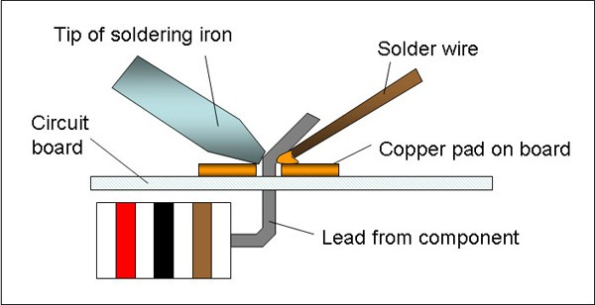  
**Figure 2.** The tip of the soldering iron heats both the copper pad and the lead from the electronic component. Solder melts when placed in contact with the hot metals to be joined.

Reference: <https://www.sciencebuddies.org/science-fair-projects/references/how-to-solder>

1. Keep the soldering tip on the connection as the solder is applied.
   * Solder will flow into and around well-heated connections.
   * Use just enough solder to form a strong connection.
2. Remove the tip from the connection as soon as the solder has flowed where you want it to be. Remove the solder, then the iron.
3. Don't move the connection while the solder is cooling.
4. Don't overheat the connection, as this might damage the electrical component you are soldering.
   * Transistors and some other components can be damaged by heat when soldering. A crocodile clip can be used as a heat sink to protect these components.

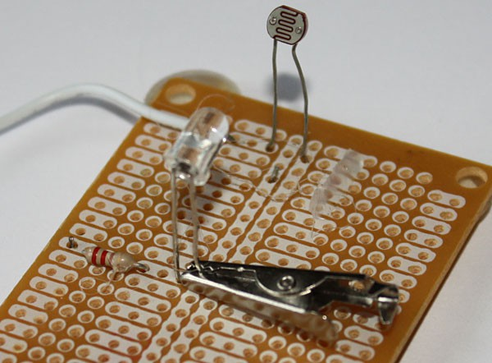  
**Figure 3.** By absorbing heat, the crocodile clip will reduce the heat that flows to the component, helping to prevent damage.

Reference: <https://www.sciencebuddies.org/science-fair-projects/references/how-to-solder>

1. Soldering a connection should take just a few seconds.
   * If it is taking longer, see the troubleshooting section below.
2. Inspect the joint closely. It should look shiny (note: lead-free solder may appear dull, this is OK).
   * If you are soldering a wire (called the *lead*) onto a PC board (on the *track*), it should have a volcano shape. See Figure 3.
   * If the connection looks bad, reheat it and try again.

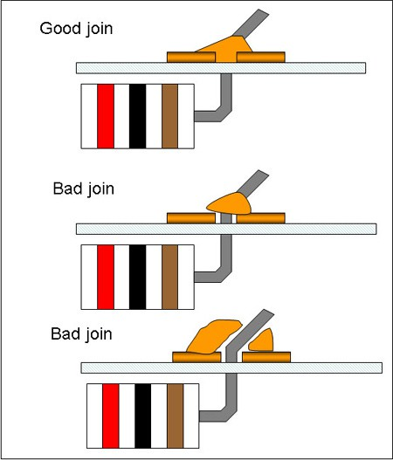  
**Figure 4.** The solder in a good join will be shaped like a cone, with solid contact between the solder and all surfaces to be joined. Bad joins (also called *dry joins*) should be melted and remade.

Reference: <https://www.sciencebuddies.org/science-fair-projects/references/how-to-solder>

1. Wipe the tip of the iron on a damp sponge to clean it. The tip should now be shiny.
2. Unplug the soldering iron when it is not in use.

## Troubleshooting

### Common Problems and Troubleshooting

1. Solder will not flow.
   * The parts to be joined may be dirty. Remove the solder and clean the parts.
2. The connection looks grainy or crystalline.
   * Parts were moved before the solder was allowed to cool.
   * Reheat to form a good joint. You may need a larger soldering iron to heat connections adequately.
3. The tip is oxidized.
   * Soldering is much easier with a shiny, clean tip.
   * Clean the tip with a damp synthetic sponge while the iron is hot.
   * To avoid oxidizing the tip, do not leave the iron plugged in when not in use.
   * Do not use the iron at a higher temperature than is necessary to melt solder.
   * Clean the tip of the iron on a damp synthetic sponge as soon as it starts to change from a silver color.
4. There is too much or too little solder.
   * Using too much solder can cause a solder bridge, which means that two adjacent joints are accidentally connected.
   * Using too little solder might result in poor electrical continuity between the board and component. The connection should be smooth, shiny, and rigid.

## What is cable?

Cable is the medium through which information usually moves from one network device to another. There are several types of cable which are commonly used with LANs. In some cases, a network will utilize only one type of cable, other networks will use a variety of cable types. The type of cable chosen for a network is related to the network's topology, protocol, and size. Understanding the characteristics of different types of cable and how they relate to other aspects of a network is necessary for the development of a successful network.

The following sections discuss the types of cables used in networks and other related topics.

* Unshielded Twisted Pair (UTP) Cable
* Shielded Twisted Pair (STP) Cable
* Coaxial Cable
* Fiber Optic Cable
* Cable Installation Guides
* Wireless LANs
* Unshielded Twisted Pair (UTP) Cable

Twisted pair cabling comes in two varieties: shielded and unshielded. Unshielded twisted pair (UTP) is the most popular and is generally the best option for school networks



*Fig.1. Unshielded twisted pair*

The quality of UTP may vary from telephone-grade wire to extremely high-speed cable. The cable has four pairs of wires inside the jacket. Each pair is twisted with a different number of twists per inch to help eliminate interference from adjacent pairs and other electrical devices. The tighter the twisting, the higher the supported transmission rate and the greater the cost per foot. The EIA/TIA (Electronic Industry Association/Telecommunication Industry Association) has established standards of UTP and rated six categories of wire (additional categories are emerging).

#### Categories of Unshielded Twisted Pair

|  |  |  |
| --- | --- | --- |
| **Category** | **Speed** | **Use** |
| 1 | 1 Mbps | Voice Only (Telephone Wire) |
| 2 | 4 Mbps | LocalTalk & Telephone (Rarely used) |
| 3 | 16 Mbps | 10BaseT Ethernet |
| 4 | 20 Mbps | Token Ring (Rarely used) |
| 5 | 100 Mbps (2 pair) | 100BaseT Ethernet |
| 1000 Mbps (4 pair) | Gigabit Ethernet |
| 5e | 1,000 Mbps | Gigabit Ethernet |
| 6 | 10,000 Mbps | Gigabit Ethernet |

### **Unshielded Twisted Pair Connector**

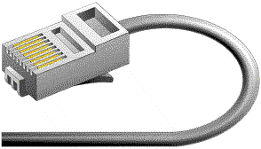The standard connector for unshielded twisted pair cabling is an RJ-45 connector. This is a plastic connector that looks like a large telephone-style connector (See fig. 2). A slot allows the RJ-45 to be inserted only one way. RJ stands for Registered Jack, implying that the connector follows a standard borrowed from the telephone industry. This standard designates which wire goes with each pin inside the connector.

## Shielded Twisted Pair (STP) Cable

Although UTP cable is the least expensive cable, it may be susceptible to radio and electrical frequency interference (it should not be too close to electric motors, fluorescent lights, etc.). If you must place cable in environments with lots of potential interference, or if you must place cable in extremely sensitive environments that may be susceptible to the electrical current in the UTP, shielded twisted pair may be the solution. Shielded cables can also help to extend the maximum distance of the cables.

Shielded twisted pair cable is available in three different configurations:

1. Each pair of wires is individually shielded with foil.
2. There is a foil or braid shield inside the jacket covering all wires (as a group).
3. There is a shield around each individual pair, as well as around the entire group of wires (referred to as double shield twisted pair).

## Coaxial Cable

Coaxial cabling has a single copper conductor at its center. A plastic layer provides insulation between the center conductor and a braided metal shield (See fig. 3). The metal shield helps to block any outside interference from fluorescent lights, motors, and other computers.

**

*Coaxial cable*

Although coaxial cabling is difficult to install, it is highly resistant to signal interference. In addition, it can support greater cable lengths between network devices than twisted pair cable. The two types of coaxial cabling are thick coaxial and thin coaxial.

Thin coaxial cable is also referred to as thinnet. 10Base2 refers to the specifications for thin coaxial cable carrying Ethernet signals. The 2 refers to the approximate maximum segment length being 200 meters. In actual fact the maximum segment length is 185 meters. Thin coaxial cable has been popular in school networks, especially linear bus networks.

Thick coaxial cable is also referred to as thicknet. 10Base5 refers to the specifications for thick coaxial cable carrying Ethernet signals. The 5 refers to the maximum segment length being 500 meters. Thick coaxial cable has an extra protective plastic cover that helps keep moisture away from the center conductor. This makes thick coaxial a great choice when running longer lengths in a linear bus network. One disadvantage of thick coaxial is that it does not bend easily and is difficult to install.

### Coaxial Cable Connectors

The most common type of connector used with coaxial cables is the Bayone-Neill-Concelman (BNC) connector (See fig. 4). Different types of adapters are available for BNC connectors, including a T-connector, barrel connector, and terminator. Connectors on the cable are the weakest points in any network. To help avoid problems with your network, always use the BNC connectors that crimp, rather screw, onto the cable.

**

*BNC connector*

## Fiber Optic Cable

Fiber optic cabling consists of a center glass core surrounded by several layers of protective materials (See fig. 5). It transmits light rather than electronic signals eliminating the problem of electrical interference. This makes it ideal for certain environments that contain a large amount of electrical interference. It has also made it the standard for connecting networks between buildings, due to its immunity to the effects of moisture and lighting.

Fiber optic cable has the ability to transmit signals over much longer distances than coaxial and twisted pair. It also has the capability to carry information at vastly greater speeds. This capacity broadens communication possibilities to include services such as video conferencing and interactive services. The cost of fiber optic cabling is comparable to copper cabling; however, it is more difficult to install and modify. 10BaseF refers to the specifications for fiber optic cable carrying Ethernet signals.

The center core of fiber cables is made from glass or plastic fibers (see fig 5). A plastic coating then cushions the fiber center, and kevlar fibers help to strengthen the cables and prevent breakage. The outer insulating jacket made of teflon or PVC.

**

*Fiber optic cable*

### Overview of the Internet

The Internet is defined as an electronic communications network that connects computer networks and organizational computer facilities around the world. - Merriam-webster

We can say that the internet is a global network of interconnected computer networks and other electronic devices world-wide, which uses standard Internet Protocol (TCP/IP). It is possible to access almost any information, communicate with anyone else in the world using the internet. Networking functionality of internet can be described as below:

* Every computer on the internet is identified by a unique IP address.
* IP Address is a unique set of numbers (such as 110.22.33.114) which identifies a computer location.
* A special computer DNS (Domain Name Server) is used to give a name to the IP Address so that users can locate a computer by a name.

**Integrated Drive Electronics (IDE) :**  
IDE is an interface standard introduced in the year 1986. It is for connection of storages devices such as [Hard Disk Drives (HDD), Solid State Drives (SSD)](https://www.geeksforgeeks.org/difference-between-hard-disk-drive-hdd-and-solid-state-drive-ssd/) and CD/DVD drives to the computer. In IDE data transfer speed ranges from 100 MB/s to 133 MB/s. It is a parallel connector. It gives a slower performance and does not support of hot plugging. It is an older concept.

[**Serial Advanced Technology Attachment (SATA)**](https://www.geeksforgeeks.org/sata-full-form/)**:**SATA is a computer bus interface or standard hardware interface introduced in the year 2003. It connects hard drives, Solid State Drives (SSD) and CD/DVD drives to the computer. In SATA data transfer speed ranges from 150 MB/s for SATA I and 300 MB/s for SATA II. It is a serial connector. It gives a faster performance with support of hot plugging. It is a newer concept. SATA cables are better than IDE.

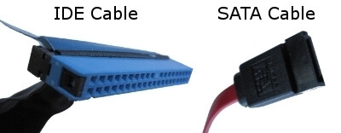

**CAT 6 Cables**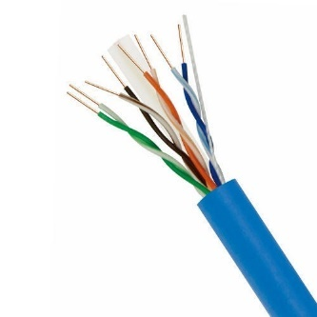

Category 6 cable (Cat 6) is a standardized [twisted pair](https://en.wikipedia.org/wiki/Twisted_pair) cable for [Ethernet](https://en.wikipedia.org/wiki/Ethernet) and other network [physical layers](https://en.wikipedia.org/wiki/Physical_layer) that is [backward compatible](https://en.wikipedia.org/wiki/Backward_compatible) with the [Category 5/5e](https://en.wikipedia.org/wiki/Category_5_cable) and [Category 3 cable](https://en.wikipedia.org/wiki/Category_3_cable) standards.

Cat 6 must meet more stringent specifications for [crosstalk](https://en.wikipedia.org/wiki/Crosstalk) and system noise than Cat 5 and Cat 5e. The cable standard specifies performance of up to 250 MHz, compared to 100 MHz for Cat 5 and Cat 5e.

## HDMI cables

### **What is HDMI?**

HDMI stands for High-Definition Multimedia Interface, a standard for simultaneously transmitting digital video and audio from a source, such as a computer or TV cable box, to a computer monitor, TV or projector. Originally developed by a consortium of electronics manufacturers, it has been widely adopted with almost all televisions and computer monitors supporting the interface.

### **HDMI Cables**

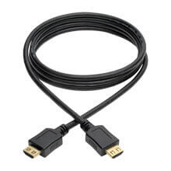The HDMI interface allows a port to send high-resolution digital video, theatre-quality sound and device commands through an HDMI connector and down a single HDMI cord, each designed to support a video resolution and features in the HDMI specification.

HDMI cable

HDMI connectors are available in three sizes: standard, mini and micro.

There are also different types of HDMI cable (see the chart below). Not all cables use the logo but the cable specifications should indicate whether it is Standard, High Speed, Premium High Speed or Ultra High Speed. If the type is not indicated, assume Standard.

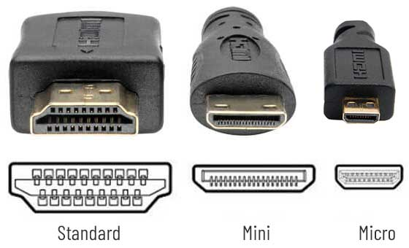

HDMI connectors

## What is a USB Cable?

The term USB stands for **"Universal Serial Bus"**.  USB cable assemblies are some of the most popular cable types available, **used mostly to connect computers to peripheral devices** such as cameras, camcorders, printers, scanners, and more.

**Detail of USB Cable Construction**

The USB cable standard allows for these advantages over serial cable types:

* USB cables are **"Hot Pluggable"**, in other words you can connect and disconnect the cables while the computer is running without fear of freezing the computer
* USB cables are **fast**, transferring up to 480Mbps.  Compare that to serial communication which transfers data at about 20Kbps
* USB cables **carry power** as well as signals.  This allows for "USB powered" gadgets as well as recharging batteries in cameras and other USB peripherals
* USB cables are designed with **several distinct connector types**, making it easy to identify which plug goes into the computer and which plug goes into the peripheral device
* USB cables are a **universal standard** and are fairly easy to find and to afford

**Types of USB cables**

**USB-A** is most commonly used with computers or power outlets. When charging, you will connect the USB-A side into the USB-plug or into a laptop or computer.

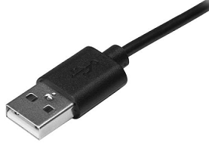USB-A cables will only go into the port one way. You can usually tell which way up they should be by the USB symbol printed on the top. Make sure that the cable is inserted the correct way so as not to damage the cable or device.

**TYPE B**

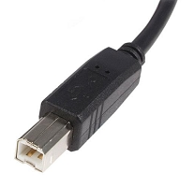

USB-B ports are mostly used to connect printers or external hard drives with computers. They are not as common as the other types of USB cables.

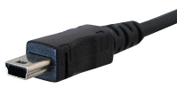**The USB-Mini** was used for connecting mobile devices including MP3 players and cameras, and is a much smaller connection, thus allowing smaller devices to connect.

**Micro-USB** used to be the most common USB port and is still found on many older models. This type of connection allows data to be read without needing a computer. For example, you can connect Flash Drives, or Memory Sticks, directly to your mobile device.

Like USB-A cables, Micro-USB will only go into a portif it's the correct way round. Be careful to match the shape of the port with the Micro-USB cable to avoid causing any damage.

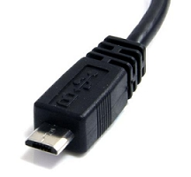

**USB-C** is the most recent USB development and all new Samsung devices come with USB-C ports. USB-C cables allow high speed data transfers and a higher power flow, allowing your phone to charge more quickly. USB-C cables are also reversible and can be plugged in either way round.

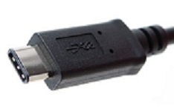

**USB 3** was designed to be able to be backwards compatible with earlier versions of USB cables and ports. The USB 3 has different shaped connector pins so it can withstand more frequent use. The USB 3-A and USB 3-B cables are identical to the USB-A and USB-B cables at the top of this article, except they are coloured blue inside to distinguish them. The USB 3 micro cable has extra pins to enable the transference of more data.

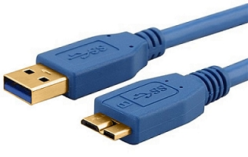

**Connectors**

A connector is the unique end of a plug, jack, or the edge of a card that connects to a port. For example, all desktop computer [expansion cards](https://www.computerhope.com/jargon/e/expacard.htm) have a connector that allows them to connect in a slot on the [motherboard](https://www.computerhope.com/jargon/m/mothboar.htm). When referring to cables, the connector is the end of the cable that connects into a port. For example, the end of a [USB](https://www.computerhope.com/jargon/u/usb.htm) cable has a connector that allows it to connect to a USB port.

**AV ports**

The input/output paths on audio and video devices. Following are the major plugs and sockets.

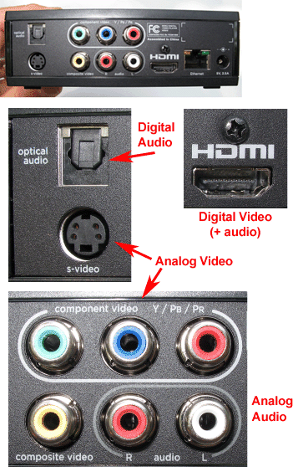

Ref: <https://www.pcmag.com/encyclopedia/term/av-ports>

## RF Connectors

**A coaxial RF connector** (radio frequency connector) is an [electrical connector](https://en.wikipedia.org/wiki/Electrical_connector) designed to work at [radio frequencies](https://en.wikipedia.org/wiki/Radio_frequency) in the multi-megahertz range. RF connectors are typically used with [coaxial cables](https://en.wikipedia.org/wiki/Coaxial_cable) and are designed to maintain the shielding that the coaxial design offers. Better models also minimize the change in transmission line [impedance](https://en.wikipedia.org/wiki/Characteristic_impedance) at the connection in order to reduce [signal reflection](https://en.wikipedia.org/wiki/Signal_reflection) and power loss.

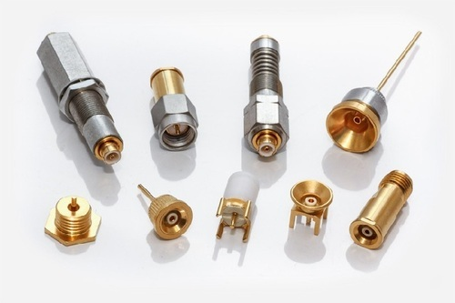

Ref: <https://5.imimg.com/data5/RO/XO/MY-3767981/rf-connectors-500x500.jpg>

# Assembling and Disassembling PC

## Introduction

Computer assembly is an essential job of a computer installation technician. The technician has to work in a logical, methodical manner while handling various computer components and peripherals. The technician can improve the computer assembly skills with practice. Computer assembly is a process in which all the internal components required for the computer system are fitted so as to make the computer functional. There is a proper sequence of attachment of each and every component into the computer system. To establish proper connectivity, one has to use the tools. Proper handling of tools is also required by the technician. It is required that students learn the steps of installation of each component. The main component involves installing CPU, motherboard, drives, video, graphics card, sound card, modem and adapter, and connectors, and system panel connector. In this Chapter, we will understand the step by step process of assembling a computer. It also covers the need for adequate system resources to efficiently run the customer’s hardware and software.

## Computer Assembly

As we know, computer assembly is a systematic process. First, arrange the computer parts. The sequence for assembly and working of the computer listed below is as:

1. Open the case.
2. Install the power supply.
3. Attach the components to the motherboard.
4. Install the motherboard.
5. Install internal drives.
6. Connect all internal cables.
7. Install motherboard power connections
8. Connect external cables to the computer.
9. Boot the computer for the first time.

Prepare the workspace before starting installation of the computer. There should be adequate lighting, good ventilation, and a comfortable room temperature. The workbench or table should be accessible from all sides. Avoid cluttering the surface of the workbench or table with tools and computer components. An anti‑static mat on the table will help to prevent physical and electrostatic discharge (ESD) damage to equipment. Small containers can be used to hold small screws and other parts as they are being removed.

**Material Required**

* Computer case, with power supply installed
* Motherboard
* CPU
* Heat sink/fan assembly
* Thermal compound
* RAM module(s)
* Motherboard standoffs and screws
* Anti‑static wrist strap and anti-static mat
* Tool kit

## Procedure

**Step 1: Open the case**

1. The first step in assembling a computer is to open the computer case (see Figure 1.1). There are different methods for opening cases.
2. The computer comes with various types of cabinets. The method for opening the case is different based on the manufacturer.
3. To open the case, first remove the screws of the left side cover and slide the side cover (see Figure 1.2).

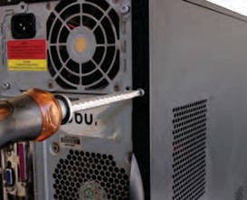





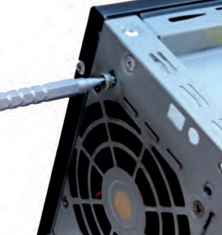

**Fig 1.1 unscrew cabinet Fig 1.2 unscrew bolts** **Ref:** [**https://ncert.nic.in/vocational/pdf/keit104.pdf**](https://ncert.nic.in/vocational/pdf/keit104.pdf)

**Step 2: Install the power supply**

1. 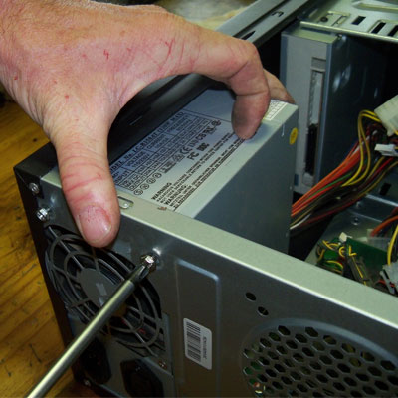Install the power supply The next step is to install a power supply (see Figure 1.3). There are usually four screws that attach the power supply to the case. Power supplies have fans that can vibrate and loosen screws that are not secured. When installing a power supply, make sure that all of the screws are used and that they are properly tightened.

* Insert the power supply into the case.
* Align the holes in the power supply with the holes in the case.
  + 1. Secure the power supply to the case using the proper screws.  **Fig.1.3 insert power supply**

**Ref:** [**http://craftycorner.co.za/diy/computer_care/replacing-pc-psu/pc-psu-power-supply.jpg**](http://craftycorner.co.za/diy/computer_care/replacing-pc-psu/pc-psu-power-supply.jpg)

1. **Step 3: Attach the components to motherboard**

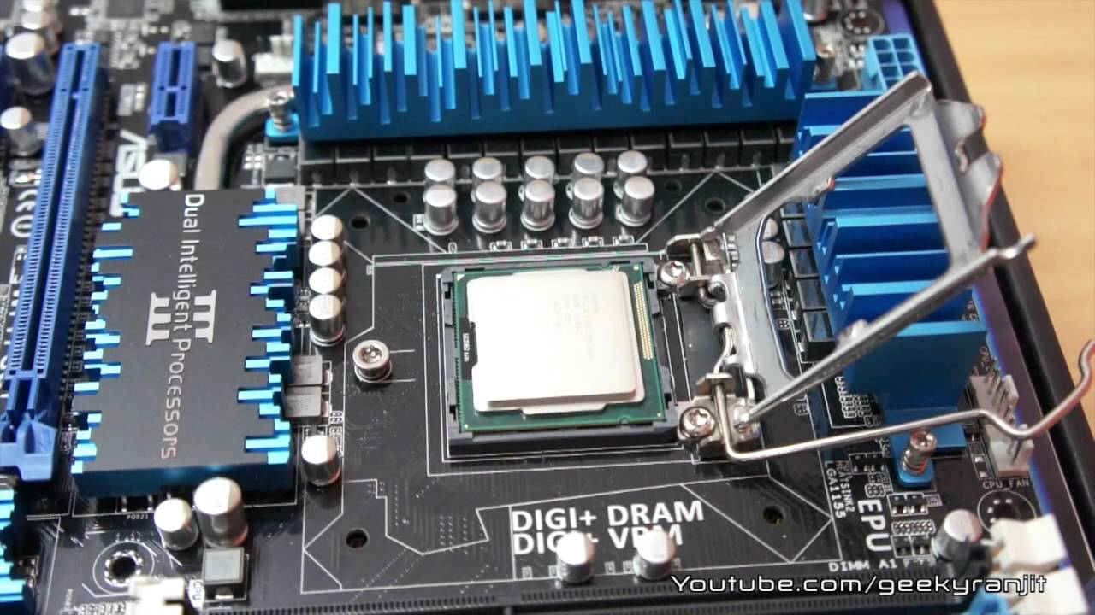The motherboard has to be prepared before its installation. To prepare the motherboard, you first need to install the CPU, then the heat sink on the CPU and CPU fan.

**Fig 1.5 installing CPU on motherboard Reference:** [**https://i.ytimg.com/vi/H3yTF6wqTbg/maxresdefault.jpg**](https://i.ytimg.com/vi/H3yTF6wqTbg/maxresdefault.jpg)

## CPU

The CPU and motherboard are sensitive to electrostatic discharge. So place them on a grounded anti-static mat and wear an anti-static wrist strap while handling the CPU. When handling a CPU, do not touch the CPU contacts at any point. The CPU is secured to the socket on the motherboard with a locking assembly.

Thermal compound which is used to conduct heat away from the CPU is applied on the top of CPU. In case of an old CPU, first clean the top of the CPU, and then apply the thermal compound. Clean the top of the CPU and the base of the heat sink with isopropyl alcohol and a lint‑free cloth. This removes the old thermal compound. Then apply a new layer of thermal compound (see Figure 1.6).

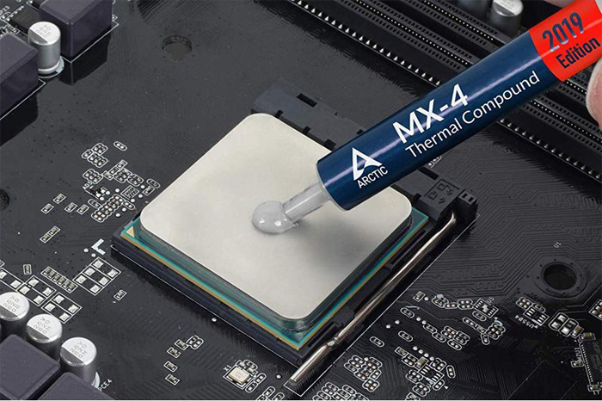Fig 1.6 : Applying thermal compound on CPU.

Ref: <https://b5c9g2d3.rocketcdn.me/wp-content/uploads/2021/06/how-to-apply-thermal-paste-processor-1.jpg>

**Heat sink and fan assembly**

Heat sink and fan assembly is a two-part cooling device. The heat sink draws heat away from the CPU. The fan moves the heat away from the heat sink. The assembly has a 3-pin power connector.

To install a CPU and heat sink and fan assembly, follow these steps:

* First, open the CPU load plate. Align the CPU orientation so that the notches on the CPU are aligned with the orientation keys on CPU socket.
* Place the CPU gently into the socket.
* Close the CPU load plate.
* Close the load lever.
* Apply a small amount of thermal compound to top of the CPU (see Figure 1.6).
* Screw the CPU fan on the heat sink.
* Align the heat sink and fan assembly with the holes on the motherboard.
* Place the assembly onto the CPU socket carefully.
* Screw the assembly on the motherboard (see Figure 1.7).
* Connect the assembly power cable to the CPU fan connector on the motherboard.

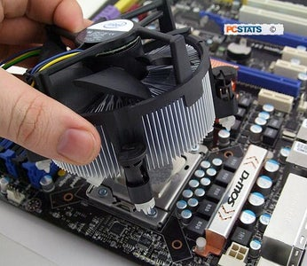

**Fig 1.7 Heat sink assembly**

**Ref:**[**https://content.instructables.com/ORIG/F97/Y4PB/KKCKYS94/F97Y4PBKKCKYS94.jpg?auto=webp&fit=bounds&frame=1&auto=webp&frame=1&height=300**](https://content.instructables.com/ORIG/F97/Y4PB/KKCKYS94/F97Y4PBKKCKYS94.jpg?auto=webp&fit=bounds&frame=1&auto=webp&frame=1&height=300)

**Installation of RAM**

It is better to install the RAM first on the motherboard and then fix the motherboard in the case. To install RAM, first ensure its compatibility with the motherboard. If DDR3 is mentioned on the motherboard, then DDR3 RAM may be fixed in the memory slot. To install RAM, follow these steps.

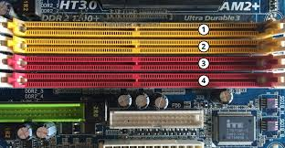

Fig 1.8 Memory Slot

Ref: <https://encrypted-tbn0.gstatic.com/images?q=tbn:ANd9GcREsFBYn_au89zChyMMDNg4OMhdNcJs4GXYtg&usqp=CAU>

* Press down the side locks of the memory slot (see Figure 1.8). Align the notches on the RAM module to the keys in the slot and press down on both ends of RAM module until the side lock gets locked.
* Make sure that the side tabs have locked the RAM module.
* Repeat the above steps to install additional RAM modules.

1. **Step 4: Install motherboard**

After preparing the motherboard, you can install the computer case, as shown in Figure 1.9. Plastic and metal standoffs are used to mount the motherboard and to prevent it from touching the metal portions of the case. To install the motherboard, follow these steps:

* Lay the motherboard over the standoffs to mount it on the holes.
* Align the screw holes of the motherboard with the standoffs.
* Then screw the board using a standard screwdriver.
* Tighten all the motherboard screws.
* Connect the 4-pin ATX power connector from the power supply to the motherboard.

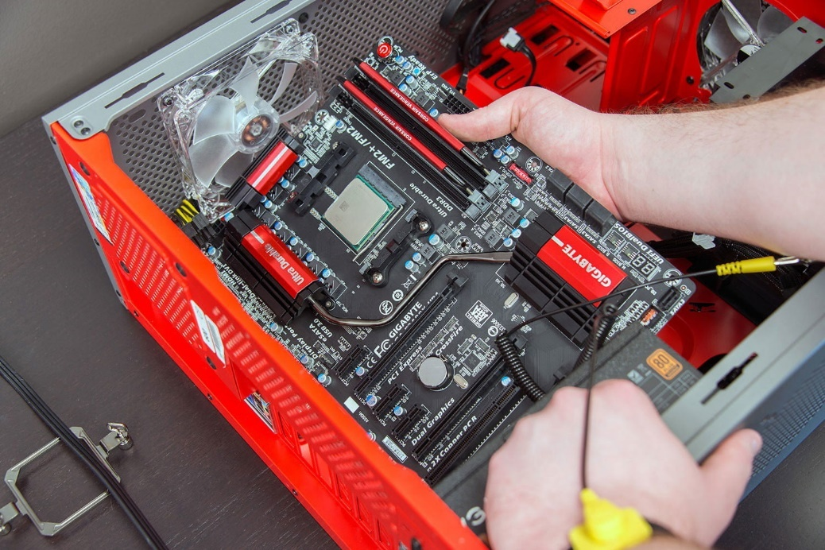

Fig 1.9 Lay the motherboard over the standoffs

Ref: <https://icdn.digitaltrends.com/image/digitaltrends/installmotherboard01.jpg>

**Step 5: Install internal drives**

## Hard drive

The hard drive is the device which stores all the data. It is 3.5 inch wide and needs to be mounted so that access to the cable connections on the back is gained. Drives that are installed in internal bays are called internal drives. A hard disk drive (HDD) is an example of an internal drive. To install HDD, follow these steps:

* Position the HDD so that it aligns with the 3.5-inch drive bay.
* Insert the HDD into the drive bay so that the screw holes in the drive line up with the screw holes in the case (see Figure 1.10)
* Secure the HDD to the case using proper screws.

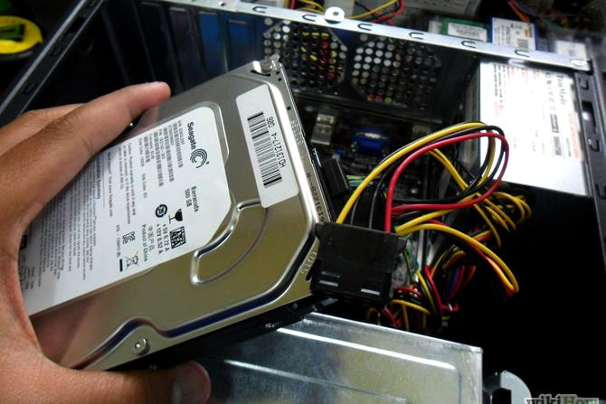Fig :1.10 insert hard disk

Ref: <https://www.deskdecode.com/wp-content/uploads/2020/05/installing-hard-drive-min.jpg>

**Optical drive**

* Position the optical drive so that it aligns with the 5.25 inch drive bay.
* Insert the optical drive into the drive bay so that the optical drive screw holes align with the screw holes in the case (see Figure 1.11).
* Secure the optical drive to the case using the proper screws.
* Connect the power cable coming from the SMPS to the power socket of optical drive.
* Connect SATA data cable from optical drive socket to the motherboard socket.

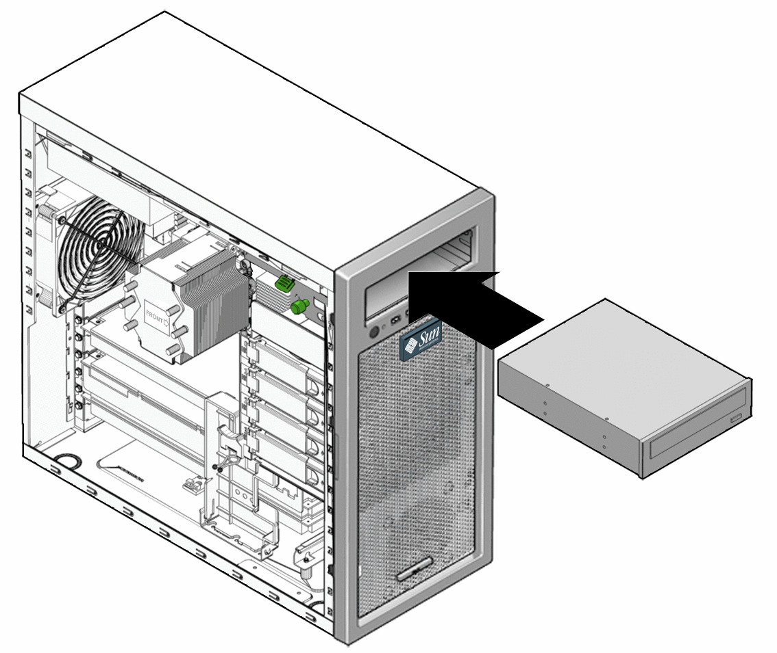

**Fig 1.11 Insert optical drive Ref:** [**https://docs.oracle.com/cd/E19127-01/ultra27.ws/820-6776/images/126223new.gif**](https://docs.oracle.com/cd/E19127-01/ultra27.ws/820-6776/images/126223new.gif)

**Step 6: Connect all internal cables**

Power cables are used to distribute electricity from the power supply to the motherboard and other components. Data cables transmit data between the motherboard and storage devices, such as hard drives.

**Step 7: Install motherboard power connections**

Just like other components, motherboards require power to operate. The Advanced Technology eXtended (ATX) main power connector will have either 20 or 24 pins. The power supply may also have a 4-pin or 6-pin auxiliary (AUX) power connector that connects to the motherboard. A 20-pin connector will work in a motherboard with a 24-pin socket. Follow these steps for motherboard power cable installation:

* Align the 20-pin ATX power connector with the socket on the motherboard.
* Gently press down on the connector until the clip clicks into place (see Figure 1.12).
* Align the 4-pin AUX power connector with the socket on the motherboard.
* Gently press down on the connector until the clip clicks into place (see Figure 1.13).

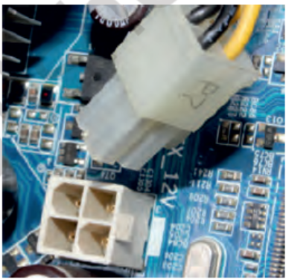

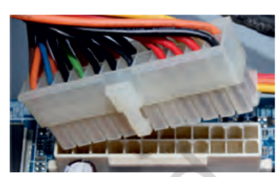

Fig 1.12Plug-in 20-pin ATX power connector to motherboard Fig 1.13 Plug-in 4-pin AUX power connector to motherboard

Ref: <https://ncert.nic.in/vocational/pdf/keit104.pdf>

**Step 8: Connect external cables to the computer**

Setting up the computer system involves the complete process of establishing the proper connectivity of various parts of the computer system — input and output devices, connectivity of computer with the surge power supply. Reattach the side panels to the case. The process of connecting the external cables given below:

**Locate the monitor cable**

Locate the two power cable and one VGA cable or monitor cable (see Figure 1.14). The VGA cable is used to connect to monitor and another point on to the back side of the cabinet. If you are having trouble finding these, refer to the instruction manual of or the computer. You can skip 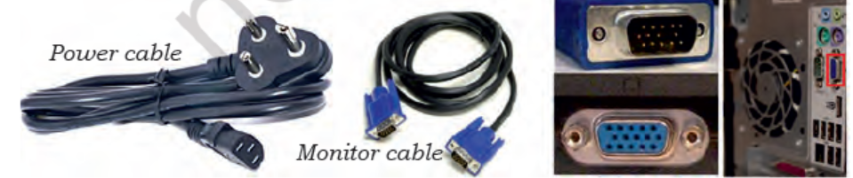to ‘Step 3’, in case of all-in-one computer that is built into the monitor.

Fig 1.14 Display cables and ports Ref: <https://ncert.nic.in/vocational/pdf/keit104.pdf>

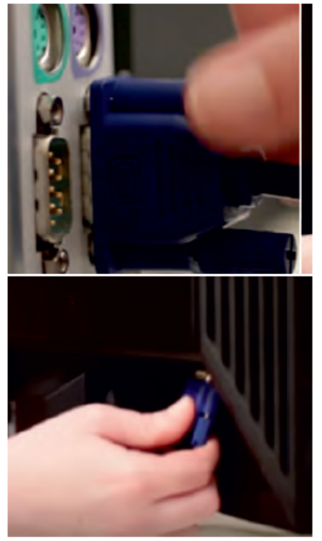**Connecting monitor**

Connect one end of the cable to the monitor port on the back of the computer case and the other end to the monitor. In case of VGA cable as shown in Figure 12.22 tighten the screws on the monitor cable to secure it.

The cables will only fit in a specific way. If the cable does not fit, do not force it, otherwise the connectors might get damaged. Make sure the plug aligns with the port, then connect it. So, first identify all the cables, ports, and connectors.

**Fig 1.15** *Connecting VGA or monitor cable to the port on back panel of computer*

Ref: <https://ncert.nic.in/vocational/pdf/keit104.pdf>

**Connecting keyboard** 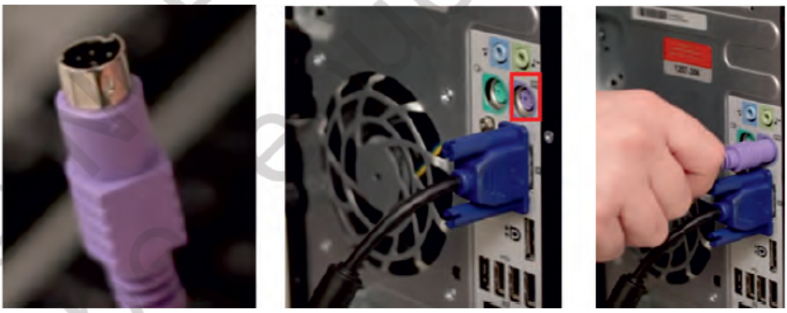Unpack the keyboard and determine whether it uses a USB (rectangular) connector or a PS/2 (round) connector. If they have colour coded plugs that are light green and lavender, plug them into the corresponding colour-coded ports, it is more likely if they use round PS/2 connectors. If it uses a USB connector, plug it into any of the USB ports on the back of the computer. The following Figures 1.16 and 1.17 shows connecting keyboard in PS/2 connector and USB connector.

**Fig 1.16** *Connecting keyboard in PS/2 port*

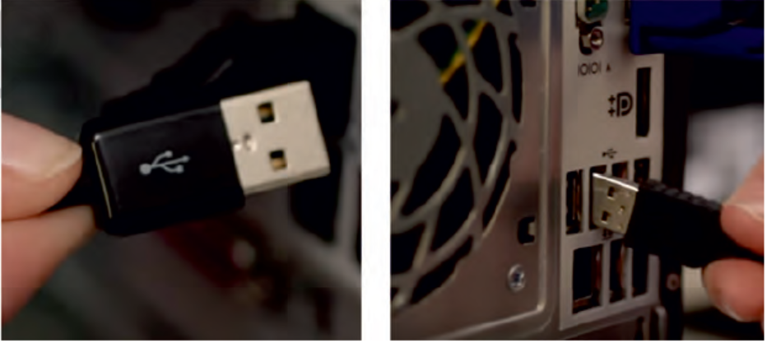

**Fig 1.17** *Connecting keyboard in PS/2 port*

Ref: <https://ncert.nic.in/vocational/pdf/keit104.pdf>

**Connecting mouse** Unpack the mouse and determine whether it uses a USB or PS/2 connector. If it uses a USB connector, plug it into any of the USB ports on the back of the computer. If it uses a PS/2 connector, plug it into the green mouse port on the back of the computer. In case of wireless mouse or keyboard, connect a Bluetooth dongle (USB adapter) in one of the USB ports of the computer. However, it is not necessary to connect an adapter for the modern computers which have built-in Bluetooth.

## Connecting headphones or speakers, and microphone

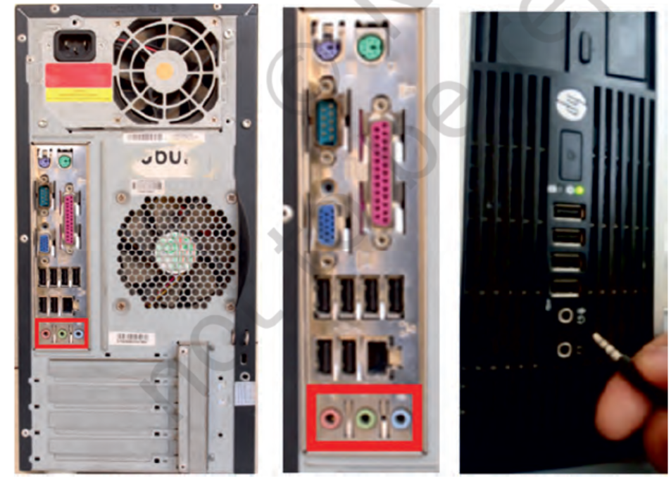Connect the external speakers or headphones, to computer’s audio port (either on the front or back of the computer case). The modern computers have colour-coded ports. Speakers or headphones connect to the green port, and microphones connect to the pink port. The blue port is the line-in, which can be used with other types of devices. They can be also connected to the USB port. Some speakers, headphones, and microphones have USB connectors instead of the usual audio plug. Connect them to any USB port. Some computers have speakers or microphones built into the monitor.

**Fig 1.18** *Connecting speakers or headphones, and microphone*

Ref: <https://ncert.nic.in/vocational/pdf/keit104.pdf>

**Connect the computer to a power supply** Locate the two power supply cables that came with the computer. Plug the first power supply cable into the back of the computer case and then into a surge protector. Then, using the other cable, connect the monitor to the surge protector. It is better to use an uninterruptable power supply (UPS), which acts as a surge protector.

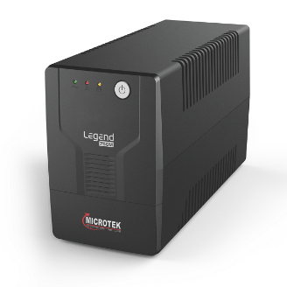**Ups (uninterruptible power supply)** While working on computer, its power supply should not be interrupted. UPS is like a power bank which gives power to the computer system. So make sure to plug power cable of monitor and cabinet into the UPS power output socket. Ensure the connection is proper.

**Plug the surge protector** Plug the surge protector into a wall outlet after finishing the connectivity of all the parts and peripherals, plug the surge protector into the main power supply. You may also need to turn on the surge protector if it has a power switch.

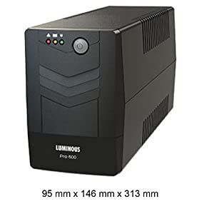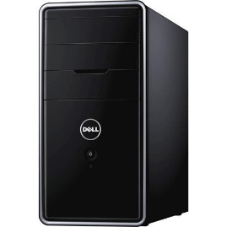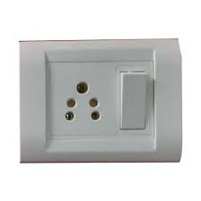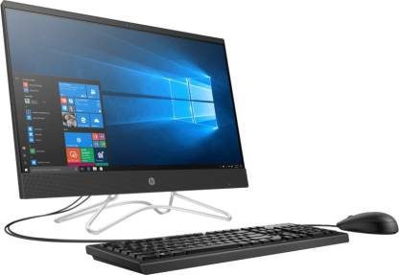

**Connecting printer, scanner, webcam**

To connect the peripherals such as printer, scanner, webcam, identify the respective connectors of the cable and port on the cabinet. Plug in the connectors of these peripherals in respective ports. Correctly plugging in will recognise the peripherals as they are plug and play devices.

It may be required to install their software drivers for them to function properly. Use the instructions included with the device to install them if necessary. Installation of peripherals is optional, and it be can added at any time; it may not be required during the initial setup of your computer.

**Checklist the following before starting the computer :**

* 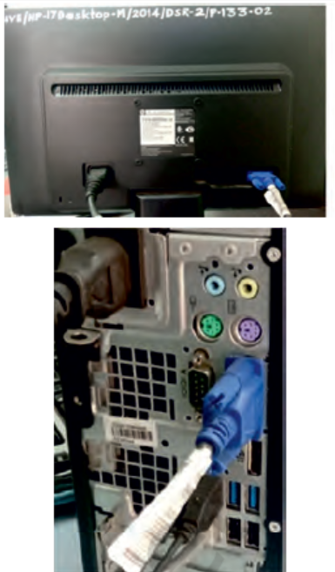VGA cable of monitor is connected to the cabinet or not.
* Power cable of monitor and cabinet has been plugged into the UPS power output socket. Make sure monitor is connected to the power supply or not.
* Keyboard and mouse both are connected to their proper ports.

**Fig 1.21** Proper connectivity of parts of computer system

Ref: <https://ncert.nic.in/vocational/pdf/keit104.pdf>

**Step 9: Starting the computer**

To start the computer, it is necessary to follow the correct sequence to start up. Now push the power button on the CPU to start the computer. Practically when we start our vehicle, we always check that the light or air conditioner (AC) is off. Otherwise, it will consume more power compared to normal start up.

Always remember that the first step is to push power button of the CPU than the monitor’s. Because the monitor consumes more electricity when powered. An operating system or system software like Window or Linux will start loading as shown in Figure 1.22, 1.23, and 1.24 and the home window will appear as shown in Figure 1.25, 1.26, and 1.27. Now your computer is ready to use.

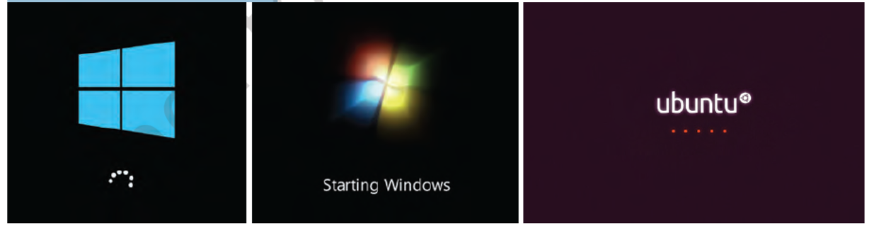

**Fig 1.22** Starting window of Windows 10**Fig 1.23** Starting window of Windows 7 **Fig 1.22** Starting of ubuntu

Ref: <https://ncert.nic.in/vocational/pdf/keit104.pdf>

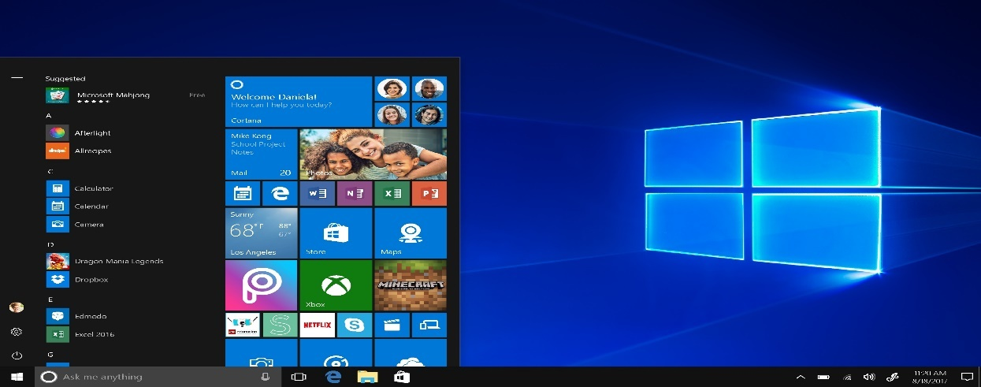

**Fig 1.25** windows 10

Ref: <https://blogs.windows.com/wp-content/uploads/2017/06/8c2133bc59b7dea5a6fb40725fe9e4dc.jpg>

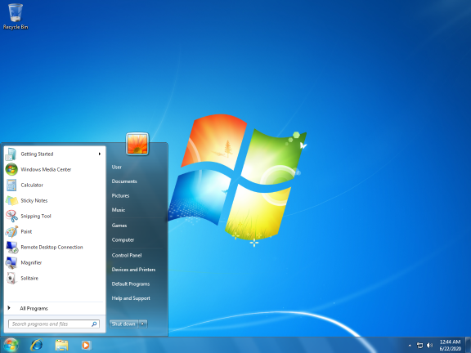

**Fig 1.26** windows 7

Ref: <https://upload.wikimedia.org/wikipedia/en/5/50/Windows_7_SP1_screenshot.png>

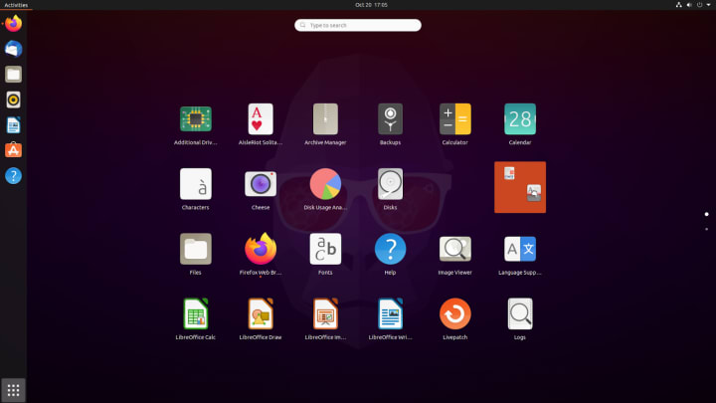

**Fig 1.27** ubuntu

Ref: <https://res.cloudinary.com/canonical/image/fetch/f_auto,q_auto,fl_sanitize,c_fill,w_720/https://lh3.googleusercontent.com/I7lFmpIndiuad64rxfL10k8Y36762hDUZiUn51lBLOw2iGCViFEz7oYhhVvO_xD8_NSlAkvBD8ZNfB5NbJYreLSjIq2LBxHgqcbfD9gwCQn1mZJd7jM1TMJa4YWKVBzZgSemQFX5>

# Computer Disassembly

Disassembly is the process of breaking down a device into separate parts. Disassembly of any device is required to determine a problem, to replace a part, or take the parts and use them in another device. A computer is also an electronic device which requires disassembly for such issues. For example, if a RAM gets dysfunctional in a computer, then it requires disassembling the computer to take out the dysfunctional RAM and replace it with new RAM chips. As we know, computers have standard internal components, but the way of placement may vary as per the PC tower case and different brands of computer. The best way is to refer to the manufacturer instructions manual. But in general there is a standard process of computer disassembly, which is demonstrated in this session. Just like computer assembly, the disassembly is a standard process. The process involves unplugging of all the cords and cables connecting a component to other components, then removing the part from the case or frame. Components can be attached to the case with special clips, screws, or by insertion into a holder. A small amount of force is required to remove each part of the computer system.

**Material Required**

* One working PC
* An anti‑static wrist strap
* An anti‑static mat
* Anti-static bags of various sizes
* Technician’s toolkit
* A plastic cup or box to organise screws, nuts, and bolts

**Procedure**

The disassembly procedure of computer is demonstrated as below.

**Step 1: Unplugging**

* Unplug the power cord from the PC and from the wall socket to prevent any injuries and damage of the PC from electrostatic discharge (ESD).
* Unplug all the peripherals attached to the computer, such as the keyboard, mouse, monitor, headphones, and any external drives.
* Wear a grounding strap to discharge any static electricity.

**Step 2: Open the case**

The computer comes with various types of cabinets. The methods of opening the case are different based on the manufacturer.

1. To open the case, first remove the screws of the left side cover and slide the side cover.
2. Pull the latch to release the side panel. Then lift the side cover out from the chassis.

To remember connectivity of internal cables, take the photographs of internal circuitry. It will help to assemble back the system.

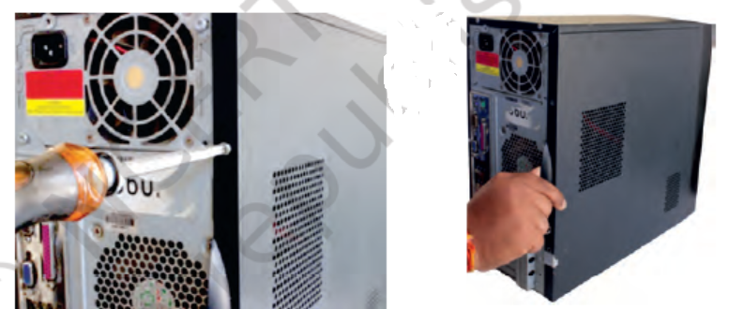

**Fig 1.28** unscrew PC cabinet Ref <https://ncert.nic.in/vocational/pdf/keit104.pdf>

**Step 3: Disconnect all the connectors**

Disconnect all the connectors connected to the motherboard. These include SATA power cable and data cable of HDD as well as SATA cable of optical drive.

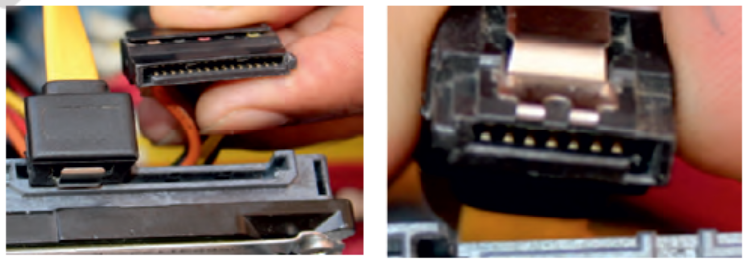

**Fig 1.29 unplug connector from HDD** Ref <https://ncert.nic.in/vocational/pdf/keit104.pdf>

**Step 4: Remove the fan**

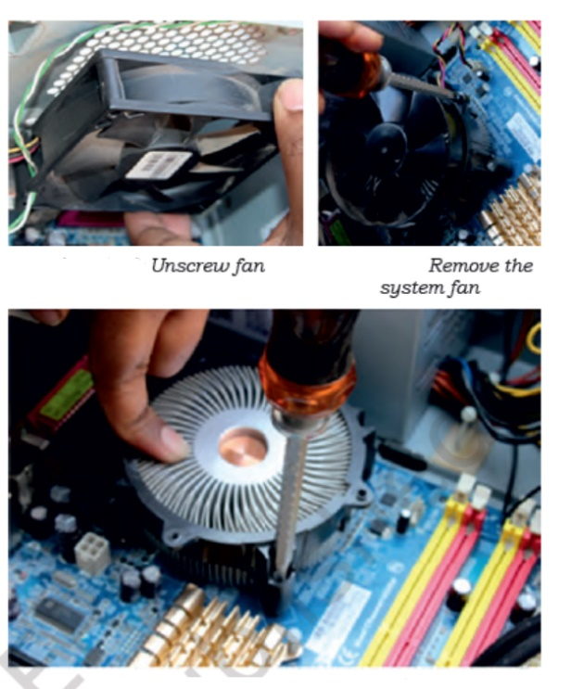Remove the fan now. Most computers have two fans — the system fan and CPU fan. The system fan is located at the back side of the computer to blow air into the computer. The CPU fan is located on top of the CPU heat sink. The fans and its connectors are labelled with their names.

To remove the system fan, first, disconnect its connector from the motherboard. Then, unscrew it from the outside of the back of the case and lift the fan out of the system.

To remove the CPU fan from the heat sink, first, disconnect its connector from the motherboard. Then remove the four screws securing it (see Figure 1.30).

**Fig 1.30 Remove FAN**  Ref <https://ncert.nic.in/vocational/pdf/keit104.pdf>

#### **Step 5: Remove the power supply**

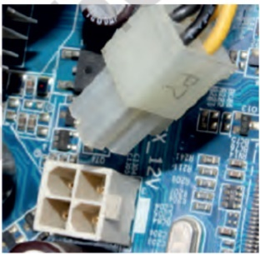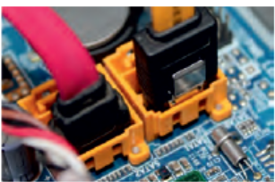The power supply is connected to the motherboard by a 20-pin connector and 4-pin connector. It is also connected to hard disk drive and the optical drive. Firstly, disconnect hard disk drive and the optical drive connectors from the motherboard (see Figure 1.31).

**Fig 1.31 Unplug SATA cables from motherboard**  Ref <https://ncert.nic.in/vocational/pdf/keit104.pdf>

* Disconnect the power cable of the hard disk and optical drive which connects to the SMPS (see Figure 1.32).
* Remove the screws that secure the power supply unit to the chassis (see Figure 1.33).
* Carefully lift the power supply out of the chassis (see Figure 1.34).

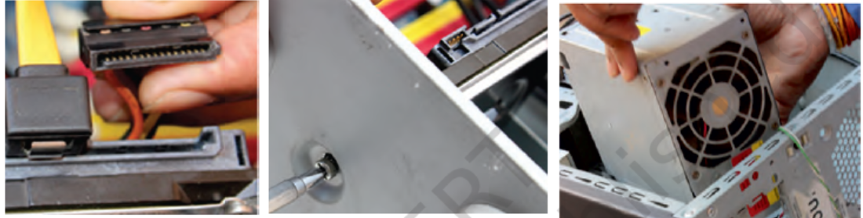

**Fig 1.32 Unplug power from HDD Fig 1.33 Remove the screw Fig 1.34 Unplug the SMPS**    Ref <https://ncert.nic.in/vocational/pdf/keit104.pdf>

**Step 6: Removing HDD and optical drive**

1. Remove the SATA cable connecting to the HDD and motherboard.
2. Then unscrew the four screws securing it in place and pull out the HDD.
3. **Step 7: Remove RAM (random access memory) modules**
4. RAM allows for the transfer of information to and from the CPU. Computer runs fast with more RAM. Most computers have four RAM slots, and two RAM chips. To remove the RAM, push down on both tabs holding the RAM in place, which are located at both ends of the RAM. It will cause the module to pop up for easy removal.

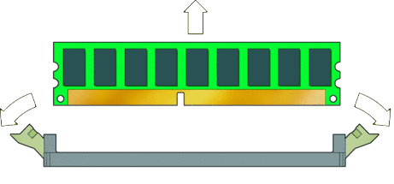

**Fig 1.35 Unplug the RAM from slot**  Ref <https://docs.oracle.com/cd/E19127-01/ultra27.ws/820-6776/images/23967.gif>

**Step 8: Remove expansion cards**

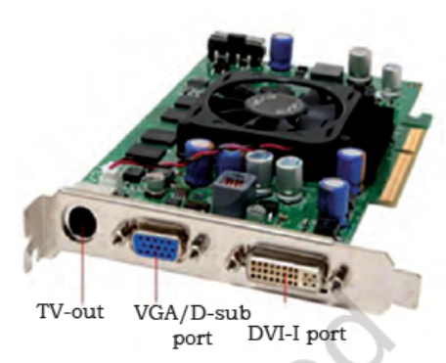The modern motherboards are integrated with the audio, video and network cards. However, if your computer has the expansion card as shown in Figure 1.31, insert into the expansions slot to increase the functionality. The expansion card is screwed with a single screw on top of expansion card slot.

* To remove the expansion cards, disconnect the cables attached to it.
* Remove the screws securing the card in the slot.
* Carefully take out the card from the slot

**Fig 1.31 Expansion card**  Ref <https://ncert.nic.in/vocational/pdf/keit104.pdf>

**Step 9: Remove motherboard**

Every part of the computer is attached to the motherboard. The CPU, RAM, and expansion cards are directly attached to the motherboard.

To remove the motherboard, disconnect all the cables from the motherboard. It has seven screws holding it to the frame. Remove these screws and then lift the motherboard out of the frame.

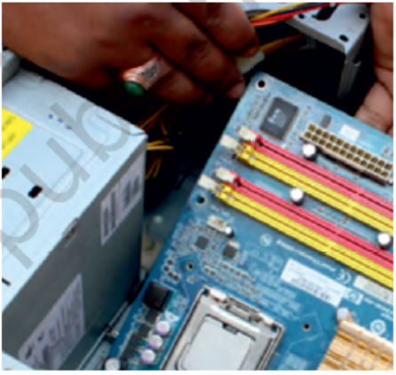

**Fig 1.31 Removing Motherboard** Ref <https://ncert.nic.in/vocational/pdf/keit104.pdf>

**Step 10: Reassemble the components**

* Identify every component and take its photograph.
* After identification of each component, put all the components back in their place and ensure that all cables and wires are connected at the right place to avoid further troubleshooting.
* Close the case and put the screws back in their place.
* Lastly, connect every external device such as the keyboard, mouse, monitor, etc., and turn on the computer to see everything is working fine after assembled.

# Software Installation

**What is software?**

Software is the collection of data, programs, procedures, routines and instructions that tell a computer or electronic device how to run, work and execute specific tasks. This is in contrast to hardware, which is the physical system and components that perform the work.

**Types of Software**

In a computer system, the software is basically a set of instructions or commands that tells a computer what to do. Or in other words, the software is a computer program that provides a set of instructions to execute a user’s commands and tell the computer what to do. For example like MS-Word, MS-Excel, PowerPoint, etc. The chart below describes the types of software:

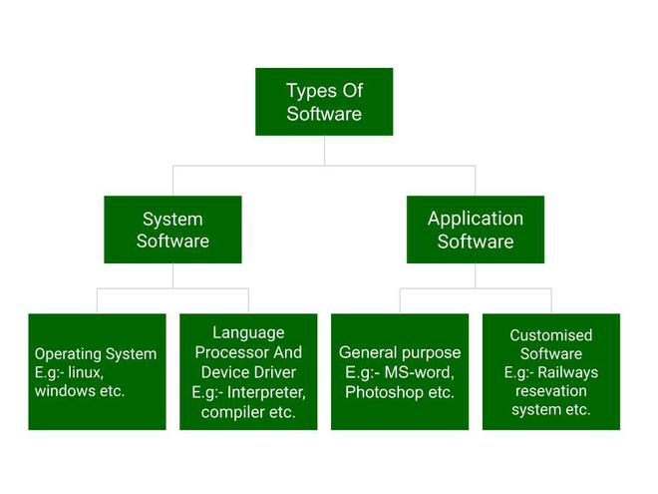Fig 1.32 Classification of software Ref: <https://www.geeksforgeeks.org/software-and-its-types/>

Above is the diagram of types of software. Now we will briefly describe each type and its subtypes:

## ****System Software****

System software is software that directly operates the computer hardware and provides the basic functionality to the users as well as to the other software to operate smoothly. Or in other words, system software basically controls a computer’s internal functioning and also controls hardware devices such as monitors, printers, and storage devices, etc. It is like an interface between hardware and user applications, it helps them to communicate with each other because hardware understands machine language(i.e. 1 or 0) whereas user applications are work in human-readable languages like English, Hindi, German, etc. so system software converts the human-readable language into machine language and vice versa.

### **Features of system software:**

Let us discuss some of the features of System Software:

* 1. System Software is closer to the computer system.
  2. System Software is written in a low-level language in general.
  3. System software is difficult to design and understand.
  4. System software is fast in speed(working speed).
  5. System software is less interactive for the users in comparison to application software.

## Types of system software:

It has two subtypes which are:

1. **Operating System:** It is the main program of a computer system. When the computer system ON it is the first software that loads into the computer’s memory. Basically, it manages all the resources such as memory, CPU, printer, hard disk, etc., and provides an interface to the user, which helps the user to interact with the computer system. It also provides various services to other computer software. Examples of operating systems are Linux, Apple macOS, Microsoft Windows, etc.
2. **Language Processor:**As we know that system software converts the human-readable language into a machine language and vice versa. So, the conversion is done by the language processor. It converts programs written in high-level programming languages like Java, C, C++, Python, etc(known as source code), into sets of instructions that are easily readable by machines(known as object code or machine code).
3. **Device Driver:**A device driver is a program or software that controls a device and helps that device to perform its functions. Every device like a printer, mouse, modem, etc. needs a driver to connect with the computer system eternally. So, when you connect a new device with your computer system, first you need to install the driver of that device so that your operating system knows how to control or manage that device.

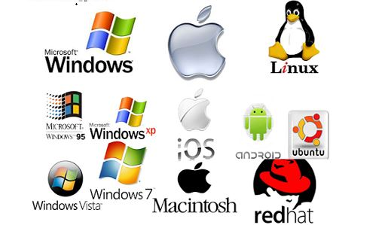

Fig 1.33 system software Ref:[**https://1.bp.blogspot.com/-03nJ5rqWOTs/X0eSgdkWvMI/AAAAAAAADe0/F_Q-TWLf6kYjnRjOdW_O8_I2AGeHvutNACLcBGAsYHQ/s0/system%2Bsoftware.jpg**](https://1.bp.blogspot.com/-03nJ5rqWOTs/X0eSgdkWvMI/AAAAAAAADe0/F_Q-TWLf6kYjnRjOdW_O8_I2AGeHvutNACLcBGAsYHQ/s0/system%2Bsoftware.jpg)

## ****Application Software****

Software that performs special functions or provides functions that are much more than the basic operation of the computer is known as application software. Or in other words, application software is designed to perform a specific task for end-users. It is a product or a program that is designed only to fulfill end-users’ requirements. It includes word processors, spreadsheets, database management, inventory, payroll programs, etc.

**Features of application software:**

Let us discuss some of the features of Application Software:

1. An important feature of application software is it performs more specialized tasks like word processing, spreadsheets, email, etc.
2. Mostly, the size of the software is big, so it requires more storage space.
3. Application software is more interactive for the users, so it is easy to use and design.
4. The application software is easy to design and understand.
5. Application software is written in a high-level language in general.

**Types of application software:**

There are different types of application software and those are:

1. **General Purpose Software:**This type of application software is used for a variety of tasks and it is not limited to performing a specific task only. For example, MS-Word, MS-Excel, PowerPoint, etc.
2. **Customized Software:**This type of application software is used or designed to perform specific tasks or functions or designed for specific organizations. For example, railway reservation system, airline reservation system, invoice management system, etc.
3. **Utility Software:**This type of application software is used to support the computer infrastructure. It is designed to analyze, configure, optimize and maintains the system, and take care of its requirements as well. For example, antivirus, disk fragmenter, memory tester, disk repair, disk cleaners, registry cleaners, disk space analyzer, etc.

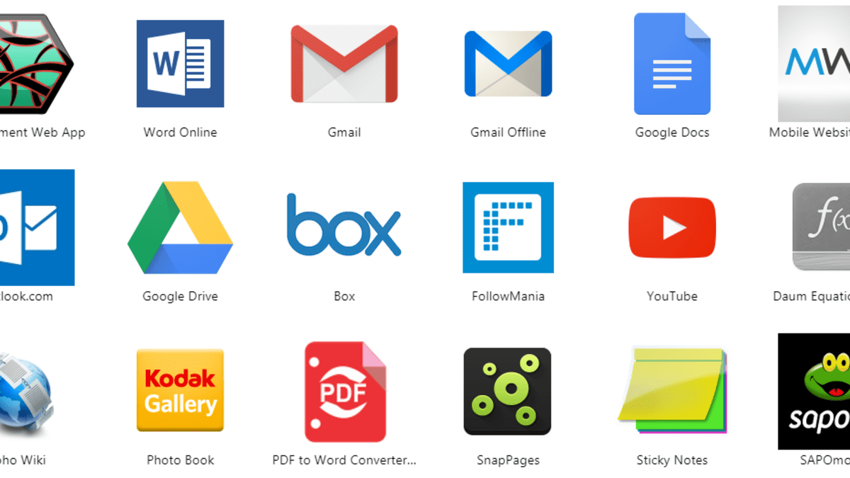

Fig 1.34 Application Software

Ref: <https://images.saymedia-content.com/.image/ar_16:9%2Cc_fill%2Ccs_srgb%2Cq_auto:eco%2Cw_1200/MTc2NDU0MjY4MDgwNDMzMTE0/three-categories-of-application-software.png>

## ****Difference between system software and application software****

Now, let us discuss some difference between system software and application software:

|  |  |
| --- | --- |
| System Software | Application Software |
| It is designed to manage the resources of the computer system, like memory and process management, etc | It is designed to fulfill the requirements of the user for performing specific tasks. |
| Written in a low-level language | Written in a high-level language |
| Less interactive for the users | More interactive for the users |
| System software plays vital role for the effective functioning of a system | Application software is not so important for the functioning of the system, as it is task specific. |

|  |  |
| --- | --- |

## Introduction to Operating system

An operating system acts as an intermediary between the user of a computer and computer hardware. The purpose of an operating system is to provide an environment in which a user can execute programs conveniently and efficiently.

An operating system is a software that manages computer hardware. The hardware must provide appropriate mechanisms to ensure the correct operation of the computer system and to prevent user programs from interfering with the proper operation of the system.

**Operating System – Definition**: 

* An operating system is a program that controls the execution of application programs and acts as an interface between the user of a computer and the computer hardware.
* A more common definition is that the operating system is the one program running at all times on the computer (usually called the kernel), with all else being application programs.
* An operating system is concerned with the allocation of resources and services, such as memory, processors, devices, and information. The operating system correspondingly includes programs to manage these resources, such as a traffic controller, a scheduler, a memory management module, I/O programs, and a file system.

**Functions of Operating system –** Operating system performs three functions: 

1. **Convenience:** An OS makes a computer more convenient to use.
2. **Efficiency:** An OS allows the computer system resources to be used efficiently.
3. **Ability to Evolve:** An OS should be constructed in such a way as to permit the effective development, testing, and introduction of new system functions at the same time without interfering with service.
4. **Throughput:** An OS should be constructed so that It can give maximum **throughput**(Number of tasks per unit time).

## Types of Operating Systems

An Operating System performs all the basic tasks like managing files, processes, and memory. Thus operating system acts as the manager of all the resources, i.e. **resource manager**. Thus, the operating system becomes an interface between user and machine.

**Types of Operating Systems:** Some widely used operating systems are as follows-

**1. Batch Operating System –**   
This type of operating system does not interact with the computer directly. There is an operator which takes similar jobs having the same requirement and group them into batches. It is the responsibility of the operator to sort jobs with similar needs.

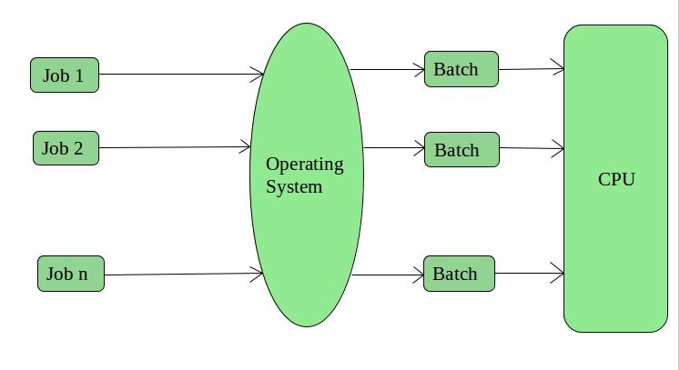

Fig 1.35 Batch OS

Reference: <https://www.geeksforgeeks.org/types-of-operating-systems/?ref=lbp>

**Advantages of Batch Operating System:**

* It is very difficult to guess or know the time required for any job to complete. Processors of the batch systems know how long the job would be when it is in queue
* Multiple users can share the batch systems
* The idle time for the batch system is very less
* It is easy to manage large work repeatedly in batch systems

**Disadvantages of Batch Operating System:**

* The computer operators should be well known with batch systems
* Batch systems are hard to debug
* It is sometimes costly
* The other jobs will have to wait for an unknown time if any job fails

**Examples of Batch based Operating System:** Payroll System, Bank Statements, etc.

**2. Time-Sharing Operating Systems –**   
Each task is given some time to execute so that all the tasks work smoothly. Each user gets the time of CPU as they use a single system. These systems are also known as Multitasking Systems. The task can be from a single user or different users also. The time that each task gets to execute is called quantum. After this time interval is over OS switches over to the next task.

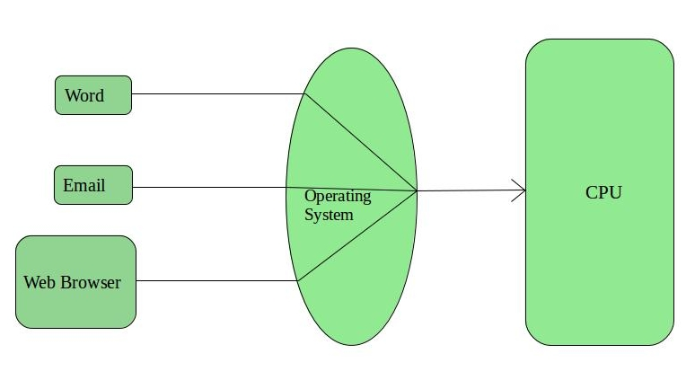

Fig 1.35 Time sharing OS

Reference: <https://www.geeksforgeeks.org/types-of-operating-systems/?ref=lbp>

**Advantages of Time-Sharing OS:**

* Each task gets an equal opportunity
* Fewer chances of duplication of software
* CPU idle time can be reduced

**Disadvantages of Time-Sharing OS:**

* Reliability problem
* One must have to take care of the security and integrity of user programs and data
* Data communication problem

**Examples of Time-Sharing OSs are:** Multics, Unix, etc.

## Lightbox****Network Operating System****

These systems run on a server and provide the capability to manage data, users, groups, security, applications, and other networking functions. These types of operating systems allow shared access of files, printers, security, applications, and other networking functions over a small private network. One more important aspect of Network Operating Systems is that all the users are well aware of the underlying configuration, of all other users within the network, their individual connections, etc. and that’s why these computers are popularly known as **tightly coupled systems**.

1.36 Network OS

Reference: <https://www.geeksforgeeks.org/types-of-operating-systems/?ref=lbp>

**Advantages of Network Operating System:**

* Highly stable centralized servers
* Security concerns are handled through servers
* New technologies and hardware up-gradation are easily integrated into the system
* Server access is possible remotely from different locations and types of systems

**Disadvantages of Network Operating System:**

* Servers are costly
* User has to depend on a central location for most operations
* Maintenance and updates are required regularly

**Examples of Network Operating System are:** Microsoft Windows Server 2003, Microsoft Windows Server 2008, UNIX, Linux, Mac OS X, Novell NetWare, and BSD, etc.

**Real-Time Operating System –**   
These types of OSs serve real-time systems. The time interval required to process and respond to inputs is very small. This time interval is called **response time**.

**Real-time systems** are used when there are time requirements that are very strict like missile systems, air traffic control systems, robots, etc.

**Two types of Real-Time Operating System which are as follows:**

* **Hard Real-Time Systems:**   
  These OSs are meant for applications where time constraints are very strict and even the shortest possible delay is not acceptable. These systems are built for saving life like automatic parachutes or airbags which are required to be readily available in case of any accident. Virtual memory is rarely found in these systems.
* **Soft Real-Time Systems:**   
  These OSs are for applications where for time-constraint is less strict.

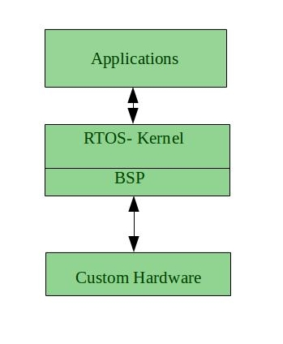

1.36 RTOS

Reference: <https://www.geeksforgeeks.org/types-of-operating-systems/?ref=lbp>

**Advantages of RTOS:**

* **Maximum Consumption:** Maximum utilization of devices and system, thus more output from all the resources
* **Task Shifting:** The time assigned for shifting tasks in these systems are very less. For example, in older systems, it takes about 10 microseconds in shifting one task to another, and in the latest systems, it takes 3 microseconds.
* **Focus on Application:** Focus on running applications and less importance to applications which are in the queue.
* Real-time**operating system in**the **embedded system:** Since the size of programs are small, RTOS can also be used in embedded systems like in transport and others.
* **Error Free:** These types of systems are error-free.
* **Memory Allocation:** Memory allocation is best managed in these types of systems.

**Disadvantages of RTOS:**

* **Limited Tasks:** Very few tasks run at the same time and their concentration is very less on few applications to avoid errors.
* **Use heavy system resources:** Sometimes the system resources are not so good and they are expensive as well.
* **Complex Algorithms:** The algorithms are very complex and difficult for the designer to write on.
* **Device driver and interrupt signals:** It needs specific device drivers and interrupts signals to respond earliest to interrupts.
* **Thread Priority:** It is not good to set thread priority as these systems are very less prone to switching tasks.

**Examples of Real-Time Operating Systems are:** Scientific experiments, medical imaging systems, industrial control systems, weapon systems, robots, air traffic control systems, etc.

## Difference between Linux and Windows

**Linux** could be a free and open supply OS supported operating system standards. It provides programming interface still as programme compatible with operating system primarily based systems and provides giant selection applications. A UNIX operating system system additionally contains several severally developed parts, leading to UNIX operating system that is totally compatible and free from proprietary code.

**Windows** may be a commissioned OS within which ASCII text file is inaccessible. it’s designed for the people with the angle of getting no programming information and for business and alternative industrial users. it’s terribly straightforward and simple to use.

The distinction between Linux and Windows package is that Linux is completely freed from price whereas windows is marketable package and is expensive. Associate operating system could be a program meant to regulate the pc or computer hardware Associate behave as an treater between user and hardware.

Linux is a open supply package wherever users will access the ASCII text file and might improve the code victimisation the system. On the opposite hand, in windows, users can’t access ASCII text file, and it’s a authorized OS.

|  |  |
| --- | --- |
| **Linux OS** | **Windows OS** |
| Linux is a open source operating system | While windows are the not the open-source operating system. |
| Linux is free of cost. | While it is costly. |
| While it is costly. | While it’s file name is case-insensitive. |
| In linux, monolithic kernel is used. | While in this, micro kernel is used. |
| Linux is more efficient in comparison of windows | While windows are less efficient. |
| Linux provides more security than windows. | While it provides less security than linux. |

## Difference between 32-bit and 64-bit operating systems

In computing, there are two types of processors existing, i.e., 32-bit and 64-bit processors. These types of processors tell us how much memory a processor can access from a CPU register. For instance,

Most computers made in the 1990s and early 2000s were 32-bit machines. The CPU register stores memory addresses, which is how the processor accesses data from RAM. One bit in the register can reference an individual byte in memory, so a **32-bit** system can address a maximum of 4 GB (4,294,967,296 bytes) of RAM. *The actual limit is often less than* *around****3.5 GB****since part of the register is used to store other temporary values besides memory addresses*. Most computers released over the past two decades were built on a 32-bit architecture, hence most operating systems were designed to run on a 32-bit processor.

A **64-bit** register can theoretically reference 18,446,744,073,709,551,616 bytes, or 17,179,869,184 GB (16 exabytes) of memory. This is several million times more than an average workstation would need to access. What’s important is that a 64-bit computer (which means it has a 64-bit processor) can access more than 4 GB of RAM. If a computer has 8 GB of RAM, it better has a 64-bit processor. Otherwise, at least 4 GB of the memory will be inaccessible by the CPU.

A major difference between **32-bit processors and 64-bit processors** is the number of calculations per second they can perform, which affects the speed at which they can complete tasks. 64-bit processors can come in dual-core**,**quad-core**,**six-core**, and**eight-core**versions** for home computing. Multiple cores allow for an increased number of calculations per second that can be performed, which can increase the processing power and help make a computer run faster. Software programs that require many calculations to function smoothly can operate faster and more efficiently on the multi-core 64-bit processors, for the most part.

**Advantages of 64-bit over 32-bit**

* Using 64-bit one can do a lot in multi-tasking, user can easily switch between various applications without any windows hanging problems.
* Gamers can easily play High graphical games like Modern Warfare, GTA V, or use high-end software like Photoshop or CAD which takes a lot of memory since it makes multi-tasking with big software, easy and efficient for users. However, upgrading the [video card](https://en.wikipedia.org/wiki/Video_card) instead of getting a 64-bit processor would be more beneficial.

# ****File System****

## ****Difference between FAT32 and NTFS****

A file system provides the way of organizing a drive. Its primary operation is to specify the way the data is stored on the drive and the types of information attached to files such as filenames, permissions, and other attributes. Windows supports three different file systems namely [FAT32, exFAT, and NTFS](https://www.geeksforgeeks.org/difference-fat32-exfat-ntfs-file-system/). The transition of these file systems was as follows:

* 8-bit FAT (Original 8-bit FAT)
* FAT12 (8-bit File Allocation Table)
* FAT16 (Initial 16-bit File Allocation Table(with 16-bit sector entries))
* FAT16B (Final 16-bit File Allocation Table(with 32-bit sector entries))
* FAT32 (File Allocation Table-32)
* exFAT (Extensible File Allocation Table)
* NTFS (New Technology File System)

FAT32 and NTFS are the types of file systems used in an operating system.

**1. FAT32 :**  
FAT32 stands for File Allocation Table. FAT32 is an extension of previous file systems in which the data is stored in chunks of 32 bits. FAT32 is an upgraded version of FAT16 designed to overcome the limitations of FAT16 and add support for larger media. FAT32 was used in older versions of operating systems like Windows 95 up until Windows XP.

**Advantages of FAT32 –**

* FAT32 efficiently work under partitions of 200 MB.
* FAT32 provides compatibility with different operating systems.
* FAT32 is frequently used as a primary partition on multiboot systems.

**Disadvantages of FAT32 –**

* The partitions in FAT32 of size over 200 MB can degrade the performance.
* FAT32 is insecure because of lack of encryption.
* FAT32 is susceptible to fragmentation.

**2. NTFS :**  
NTFS stands for New Technology File System. First introduced in 1993, it is used in newer versions of operating systems such as Windows NT and 2000 and later versions of Windows. NTFS is a more robust, high-performance logging file system with multi-user access control, ACLs, and many other things that make it appropriate to work with an Operating System that has protection. NTFS includes characteristics such as data recovery, multi-streaming, fault tolerance, security, extended file size, and file systems, UNICODE names. exFAT is used where NTFS is not feasible, due to its data-structure overhead, but a greater file-size limit than the standard FAT32 file system is needed.

**Advantages of NTFS –**

* NTFS is highly secure because it prevents unauthorized access to file contents by enforcing Encryption File System(EFS).
* NTFS performs well even in the partitions of size over 400 MB.
* NTFS is less susceptible to fragmentation.

**Disadvantages of NTFS –**

* NTFS is not extensively supported.
* Performance in NTFS file system degrades under partitions of 400 MB.

**Windows System Commands -**

1. **FDISK**

The **fdisk** command is used to create and delete [partitions](https://www.computerhope.com/jargon/p/partition.htm) on the [hard drive](https://www.computerhope.com/jargon/h/harddriv.htm) in earlier versions of MS-DOS and Windows.

## Availability

Fdisk is an [external command](https://www.computerhope.com/jargon/e/extecomm.htm) that is available for the following Microsoft operating systems. With MS-DOS 3.3x and below, fdisk.com was used as the external file. MS-DOS 4.x and later including versions of Windows that support the command, use fdisk.exe as the external file.

## Fdisk syntax

Configures a hard disk for use with MS-DOS.

FDISK [/STATUS] /X

## Fdisk examples

fdisk

1. **FORMAT**

The **format** command is used to erase information from a computer [diskette](https://www.computerhope.com/jargon/d/disk.htm) or fixed drive.

### Windows 10 and Windows 11 syntax

FORMAT volume [/FS:file-system] [/V:label] [/Q] [/L[:state]] [/A:size] [/C] [/I:state] [/X] [/P:passes] [/S:state]

FORMAT volume [/V:label] [/Q] [/F:size] [/P:passes]

FORMAT volume [/V:label] [/Q] [/T:tracks /N:sectors] [/P:passes]

FORMAT volume [/V:label] [/Q] [/P:passes]

FORMAT volume [/Q]

## Format examples

format a:

Would erase all the contents off a [floppy disk](https://www.computerhope.com/jargon/f/floppydi.htm). Commonly used on an unformatted diskette or one you want to erase.

format a: /q

Quickly erases all the contents of a floppy diskette. Commonly used to erase all information on the diskette quickly.

format c:

Erase the contents of your C: [hard drive](https://www.computerhope.com/jargon/h/harddriv.htm). In other words, unless you want to erase all your computer's information, this command should not be executed unless you're planning on starting over.

1. **SCANDISK**

Microsoft ScanDisk was first introduced with MS-DOS 6.2. It is a [software](https://www.computerhope.com/jargon/s/software.htm) utility capable of checking the [hard drive](https://www.computerhope.com/jargon/h/harddriv.htm) and [floppy diskette](https://www.computerhope.com/jargon/f/floppydi.htm) for any disk errors.

ScanDisk is an [external command](https://www.computerhope.com/jargon/e/extecomm.htm) that is available for the following Microsoft operating systems.

* MS-DOS 6.2 and above

## ScanDisk examples

scandisk c: /autofix

Runs ScanDisk on the primary hard drive for any errors and if found automatically fix those errors.

## Tree directory displayed by the MS-DOS tree command.What is directories in operating system?

A **directory** is a location for storing files on your computer. Directories are found in a [hierarchical file system](https://www.computerhope.com/jargon/h/hierfile.htm), such as [Linux](https://www.computerhope.com/jargon/l/linux.htm), [MS-DOS](https://www.computerhope.com/msdos.htm), [OS/2](https://www.computerhope.com/jargon/o/os2.htm), and [Unix](https://www.computerhope.com/unix.htm).

Pictured is an example of output from the Windows/DOS [tree command](https://www.computerhope.com/jargon/t/treestru.htm). It shows all the local and [subdirectories](https://www.computerhope.com/jargon/s/subdirec.htm) (e.g., the "big" directory in the "cdn" directory). When looking at this overview, the [current directory](https://www.computerhope.com/jargon/c/currentd.htm) is the [root directory](https://www.computerhope.com/jargon/r/root.htm) of the C: drive. It's called the "root" directory because there is nothing beneath it, and the other directories "branch" from it. If you are using an operating system with multiple user accounts, the directory may also be referred to as a [home directory](https://www.computerhope.com/jargon/h/homedir.htm).

1.36 Directories in DOS

Reference: <https://www.computerhope.com/jargon/d/director.htm>

## Overview of a directory and path

Below is an example of what a directory [path](https://www.computerhope.com/jargon/p/path.htm) would look like in MS-DOS.

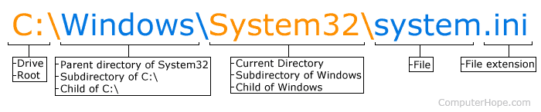

In the picture, C: is the [drive](https://www.computerhope.com/jargon/d/drive.htm) letter and the current directory is System32, which is a [subdirectory](https://www.computerhope.com/jargon/s/subdirec.htm) of the Windows directory.

## How do I list or view directories?

To see directories and files in the current MS-DOS directory, use the dir command. In Linux to view directories and files in the current directory, you'd use the ls command.

* See the [dir command](https://www.computerhope.com/dirhlp.htm) page for further information and examples on this command.
* See the [ls command](https://www.computerhope.com/unix/uls.htm) page for information and examples on this command.

**What is fragmentation and Defragmentation is Computer OS?**

**Fragmentation**

Fragmentation commonly occurs when old files are opened, modified and subsequently saved.

One example of this, would be where a previously saved file, let's say, a document, is opened and added to. This will cause the file to be larger in physical space than when it was first saved. The operating system will then break the file into 2 or more pieces, and store those pieces (fragments) in different parts of the storage area.

The file system, such as File Allocation Table (FAT) or NTFS, would then keep a record of where the different fragments of the file are stored.

When the operating system requires the file again, it will query the file system to find out where the different fragments of the file are located on the partition (drive).

**Defragmentation**

As noted above, the process of defragmentation rejoins the fragmented parts of a file. It loads the file fragments and then saves them in consecutive parts of the storage.

The process of defragmenting can be time consuming, but it is one of the easiest ways to increase the performance of your computer. The frequency at which a PC should be defragmented will directly depend on the amount of usage area.

**Disk Defragmentation :** In this process, all scattered fragments (data) rearrange in such that they come in sequence form with further utility program available in Windows. In this process program first, check percentage of the fragment available in disk then Defragment all disk as can as possible.

**Defragmentation of Disk :**

1. Right-click on any drive available on your computer which we want to Defragment then click on the tools section and after optimize.

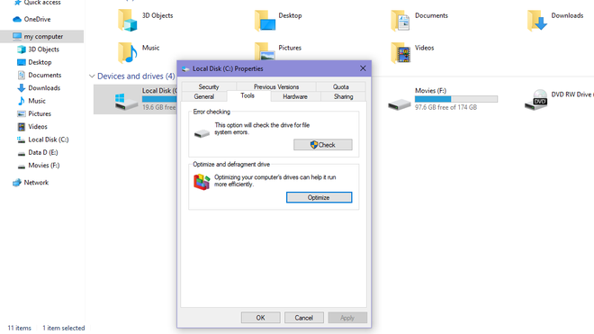

1.37 Defragmentation

Reference: <https://www.geeksforgeeks.org/disk-defragmentation-in-operating-system/>

1. After Optimize it will check the total fragmented available in the selected disk and click on Optimize.

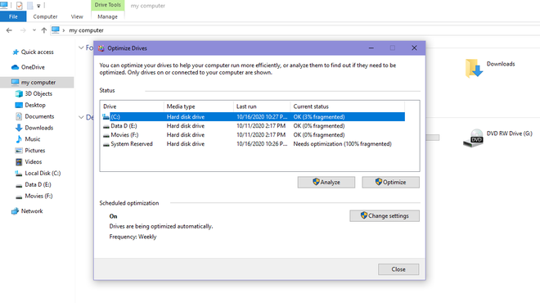

1.38 Defragmentation

Reference: <https://www.geeksforgeeks.org/disk-defragmentation-in-operating-system/>

1. It will take some time and after this process 0% Fragment will be present in the disc.

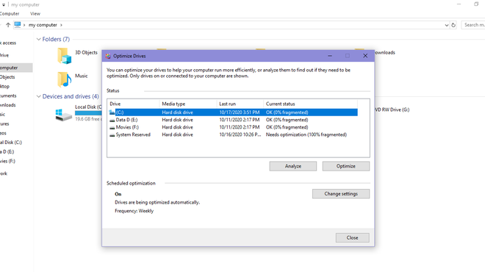

1.37 Defragmentation

Reference: <https://www.geeksforgeeks.org/disk-defragmentation-in-operating-system/>

## Functions of Keyboard and Mouse

## What is a Computer Keyboard?

A keyboard is a peripheral device that enables a user to input text into a computer or any other electronic machinery. It is a peripheral device that is the most basic way for the user to communicate with a computer. It consists of multiple buttons, which create numbers, symbols, and letters, and special keys like the Windows and Alt key, including performing other functions. The design of the keyboard comes from the typewriter keyboards, and numbers and letters are arranged on the keyboard in that way, which helps to type quickly.

 A keyboard is connected to a computer system using a cable or a wireless connection.

**Who Invented Keyboard?**

Christopher Latham Sholes is known as the inventor of the first QWERTY keyboard and the first modern practical typewriter. A keyboard consists of different letters and numbers that enable users to input information to the computer to give commands and perform operations.

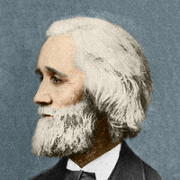

Image 1: Founder of Keyboard

Reference: <https://www.javatpoint.com/keyboard>

### Categories of Keys on a Keyboard

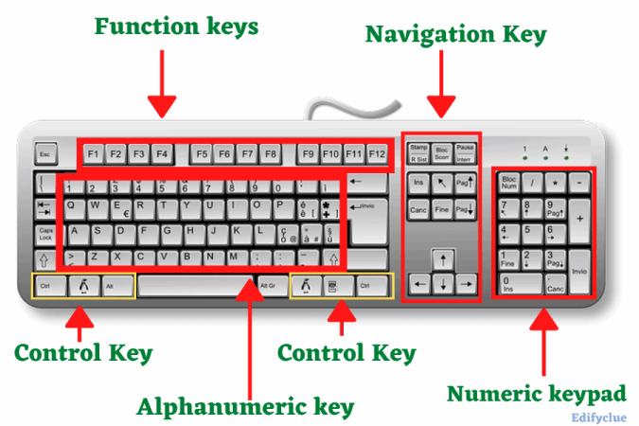

Image 2: Categories of Keys

Reference: <https://www.javatpoint.com/keyboard>

The buttons on the keyboard of the computer are called keys. Generally, a keyboard has 104 or more keys. A keyboard has different groups of keys such as Alphabet keys Numeric keys and Function keys.

**Alphabet Keys**

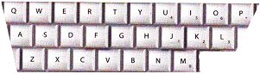

Image 3: Alphabetic Key

Reference: <https://www.studyadda.com/notes/2nd-class/computers-science/mouse-and-keyboard-usage/>

The alphabet keys are, A, B, C... Z. These keys help us to write words and sentences on the computer. In English there are 26 alphabets from A to Z that’s why there are 26 alphabet keys on the keyboard.

**Numeric Keys**

The number keys contain the numbers from 0 - 9. You can write numbers using them. Computer keyboard contains two groups of number keys from 0 to 9. First group is located above the QWERTYUIOP keys row and second group is located below the indicators. The first group of number keys can be used if numlock keys is activated or not. Whereas, second group of keys are only used when numlock is activated.

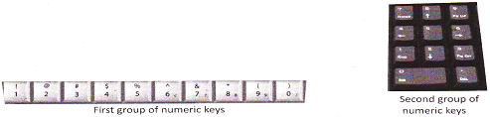

Image 4: Numeric Key

Reference: <https://www.studyadda.com/notes/2nd-class/computers-science/mouse-and-keyboard-usage/>

**Function Keys**

A keyboard usually has 12 function keys from F1 to F12. The function of each key is unique and their function are depended on the operating system installed in the computer.



Image 5: Function Keys

Reference: <https://www.studyadda.com/notes/2nd-class/computers-science/mouse-and-keyboard-usage/>

**Other Important Keys**

In addition to the keys discussed above there are some other important keys which have special purpose.

**Space Bar**

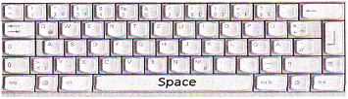

Image 6: Spacebar

Reference: <https://www.studyadda.com/notes/2nd-class/computers-science/mouse-and-keyboard-usage/>

Space Bar helps us to give space between the words. It is the longest key on the keyboard.

**Shift Key**

This key helps you to type the signs marked on top of the numeric keys and also used to type, <, >,?,:,"", {, }. To type the capital letter, the keys combination shift and key of that letter are used.

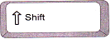

Image 7: Shift Key

Reference: <https://www.studyadda.com/notes/2nd-class/computers-science/mouse-and-keyboard-usage/>

**Enter Key**

This key helps us to move the cursor to the next line. While typing, you just press the Enter key to start writing from a new line. Another function of Enter Key is pressed to execute the given command.

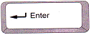

Image 8: Enter Key

Reference: <https://www.studyadda.com/notes/2nd-class/computers-science/mouse-and-keyboard-usage/>

**Backspace Key**

If you have written something wrong on the computer, you can erase it by using the backspace key. This key helps to erase the letters to the left side of the cursor. The cursor is the blinking line that you see on the screen of the computer. It looks like\.

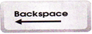

Image 9: Backspace Key

Reference: <https://www.studyadda.com/notes/2nd-class/computers-science/mouse-and-keyboard-usage/>

**Delete Key**

This key helps to erase the letters to the right side of the cursor. Sometime, the delete key with other keys is pressed for performing an operation, such as, the keys combination, Ctrl + Alt + Delete are used for booting the computer again.



Image 10: Delete Key

Reference: <https://www.studyadda.com/notes/2nd-class/computers-science/mouse-and-keyboard-usage/>

**Arrow Keys**

The arrow keys help in moving the cursor in all the directions (left, right, up or down). Hence they are also called cursor control keys. There are four arrow keys on the keyboard.

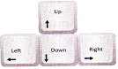

Image 11: Arrow Keys

Reference: <https://www.studyadda.com/notes/2nd-class/computers-science/mouse-and-keyboard-usage/>

**The Right Way to Use Keyboard**

We should know the right way to use the keyboard. If we use it improperly then we might enter wrong command and damage can also be caused to it.

**The following- are the ways to use the keyboard properly:**

* Always remember to press the keys gently.
* Use both hands to use the keyboard for writing.
* Do not put any weight on the keyboard.
* Press the required key once and release. Do not press it repeatedly.

## What are the Uses of Keyboard in Computer?

There are five uses of a keyboard in a computer, which are given below.

1. Input Date
2. Type Numbers
3. Text Chatting
4. Type Special Character
5. Types computer short cut Keys

**1. Uses of Keyboard for Input Data**

The keyboard is used to input data in a computer because the keyboard is an input device. With the use of a keyboard, we can enter any type of data or information on the computer.

**2. Uses of Keyboard for Typing Numbers**

Using the keyboard, you can enter any type of numerical data into the computer. The numeric block of the keyboard contains all the number buttons so that you can press any number according to your work.

Like - 1, 2, 589, 999, 558 and 1000 etc. You can press any type of number like these using the keyboard.

**Note** - You can use the keyboard's numbers button only after pressing the Num lock button.

**3. Uses of Keyboard for Text Chatting**

You can also chat with someone else using the keyboard. Chatting means talking to any person in writing.

You cannot chat with any other person from your computer without a keyboard.

**4. Uses of Keyboard for Pressing Special Character**

Using the keyboard, you can also use the button of a special character. Examples of some special characters are given below.

!, @, #, $, %, ^ , &, *, ( ), < > etc.

**5. Uses of Keyboard for Typing computer short cut Keys**

Using the keyboard, you can also use the computer short cut keys button in the computer.

Shortcut Keys Buttons are used to do any work in the computer quickly. For example, by pressing Alt + F4 button, your computer system shuts down.

Shortcut Keys button is in every keyboard

### Types of Keyboards

1. Gaming Keyboard
2. Mechanical Keyboard
3. Ergonomic Keyboard
4. Multimedia Keyboard
5. Hand Keyboard
6. Flexible Keyboards
7. Wireless Keyboard
8. Laptop Keyboard
9. Laser Virtual Keyboards

**Gaming Keyboard**

If you are dedicated to playing games on your PC, you may invest in a common keyboard and use it for a few days. But if you really want to take your favorite games to the next level, a gaming keyboard can come in handy.

Gaming keyboards are specifically designed to enhance your gaming experience and increase your wins. These types of keyboards are geared toward users who spend hours while playing computer games.

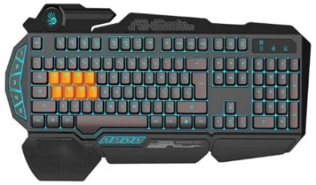

Image 12: Gaming Keyboard

Reference: <https://digitalworld839.com/types-of-keyboards-computer/>

**Mechanical Keyboard**

Mechanical keyboards are one of the types of important keyboards. They are expensive and require a little learning to understand how they work.

Two of the main benefits of mechanical keyboards are, first is their responsiveness, and second is durability in comparison to a membrane keyboard.

The working mechanism of a mechanical keyboard comes down to one thing: a key switch. A key switch refers to the mechanism by which the keys physically move and activate a switch below each key that sends a signal to record the keystroke.

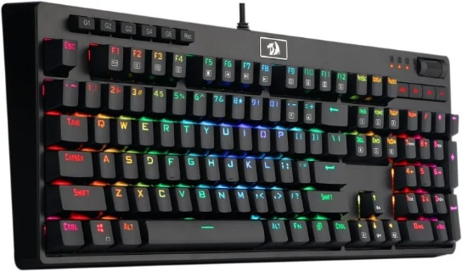

Image 13: Mechanical Keyboard

Reference: <https://digitalworld839.com/types-of-keyboards-computer/>

With a membrane keyboard, there is a rubber dome membrane that supports all keys. This membrane is designed to resist depression, which is what makes the keys return to their original position after you take your finger off the key.

These types of keyboards work in a fairly similar way. It resists keystrokes, which means that the keys return to their initial positions once you remove your finger instantly. But instead of using a rubber membrane, mechanical keyboards prefer to use springs.

The springs result in smoother, more linear pulsations to the mechanical keyboard.

These keyboards also provide a faster return to the original key positions. You can also press the keys halfway to register the value of the key. This particular feature makes mechanical keyboards more superior and results in a faster typing speed.

**Ergonomic Keyboard**

Ergonomic keyboards are not really a normal type of computer keyboard on their own, but rather refer to any keyboard that is designed to minimize stress and pain on your body and enhance comfort.

This keyboard has the difference that their design in an enhanced way, so that the user can adopt a more comfortable and relaxed typing position.

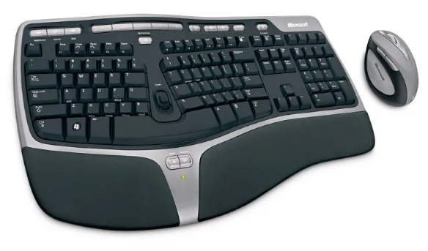

Image 14: Ergonomic Keyboard

Reference: <https://digitalworld839.com/types-of-keyboards-computer/>

These keyboards are designed for long working hours people, where the user can avoid or help to reduce cramps or muscle pain, due to bad posture for working hours on the keyboard.

**Multimedia Keyboard**

Multimedia keyboards are very similar to common keyboards but with the addition of a series of keys that allow you to control directly the most common functions of multimedia content players, such as Play, Stop, Resume, Rewind, Mute, Volume, etc.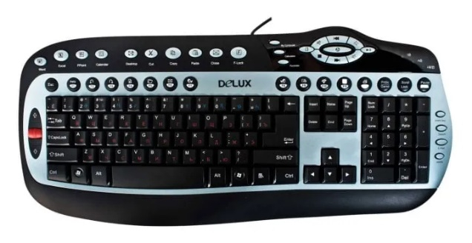

Image 15: Multimedia Keyboard

Reference: <https://digitalworld839.com/types-of-keyboards-computer/>

These keyboards have the advantage of the actions that are carried out much faster than those functions directly on the keyboard with a dedicated button since in general, the user’s hands are on it.

Therefore, these types of keyboards are much more productive to have the most common functions on a physical keyboard than on the screen.

Clearly, the multimedia keyboard for pc is intended for a certain audience that may possibly welcome these additions, but at the same time, there are other users who will see it as a barrier.

**Most Common Keys of Multimedia Keyboard:**

1. Play ▶
2. Stop ⏹
3. Next ⏭
4. Previous ⏮
5. Pause ⏸
6. Volume ➕
7. Volume ➖
8. Mute????

**Hand Keyboard**

Some keyboards look so unconventional cause they create a whole new category. Such as the AlphaGrip handheld keyboard, which combines the design of a game controller with the functions of a basic keyboard and ergonomic keyboard too.

This keyboard is a small unit, full of buttons. This is not surprising as it has to accommodate all the standard functions of both the keyboard and trackball. So why would anyone want to invest in AlphaGrip? Well, it provides versatility. You can type while walking on a treadmill.



Image 16: Hand Keyboard

Reference: <https://digitalworld839.com/types-of-keyboards-computer/>

There is a demonstration of how you can work and exercise at the same time on the manufacturer’s alpha grip website. You can sync it with your TV to play with the familiarity of a gaming keyboard.

AlphaGrip also says that you can learn to type easily with this handheld keyboard, just as fast or faster than you learn to type on a traditional keyboard.

**Flexible Keyboards**

These keyboards are very eye-catching for those who see them for the first time, stand out for their appearance and the material with which they are built by rubber, silicon and plastic.

With the increasing popularity of small-sized portable devices like tablets, it’s no surprise that you again also need a truly compact and portable keyboard.

As its name says, they can be rolled, or folded with the aim of being transported without taking up much space and in tiny places.

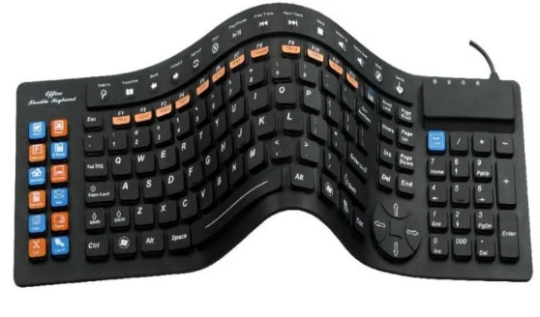

Image 17: Flexible Keyboard

Reference: <https://digitalworld839.com/types-of-keyboards-computer/>

Furthermore, thanks to their inbuilt components, they are more resistant to shocks than a common keyboard. Its compact structure makes it perfect to take on your professional, business, or vacation trips.

In terms of functionality, folding keyboards are similar to basic keyboards. However, different manufacturers use different power sources for their flexible keyboards. You can find such types of keyboards in both formats wireless and others that work with USB.

**Unique Features**

The first fact is that they are waterproof in general. These keyboards are designed to resist splashing and total immersion in water.

Secondly, a roll-up keyboard offers silent operation due to the inbuilt silicone and membrane structure. This keyboard produces so tiny noise that it can hardly be detected. Such features of flexible keyboards enable us to use them in extreme areas like factories and laboratories as well.

**Wireless Keyboard**

The second one is wireless keyboards, which connect to the terminal with wireless signals like Wi-Fi or via Bluetooth, without any need for wire cables.

There is a wide variety of wireless keyboards that are marketed today and basically depending on the user’s need, it is advisable to carefully analyze the offers and features to acquire the most suitable wireless keyboard.

These wireless keyboard models are optimized for portability, we found different designs in which the number of keys varies. These keyboards are an excellent complement to extend the functionalities of portable devices, such as smartphones and tablets, where typing is required.

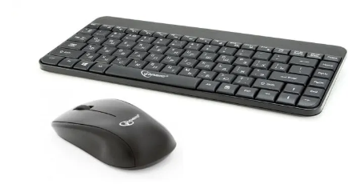

Image 18: Wireless Keyboard

Reference: <https://digitalworld839.com/types-of-keyboards-computer/>

These types of keyboards are currently gaining popularity as they offer far superior features in terms of portability and comfort. It offers the particularity of being able to be used without having to be physically connected to the PC or Mac through a cable.

**Main Technologies of Wireless Keyboards**

**Bluetooth:** This is the most popular method to sync your wireless keyboard with your computer or tablet. It works with a broad range of Bluetooth-compatible devices, from tablets, some smartphones, and Smart TVs as well.

**Radio Frequency:** RF keyboards use a transmission technique similar to Wi-Fi standards (Wi-Fi Signal) to create a wireless connection to your PC or Mac. Most keyboards come with an adapter plug into the USB port to pair your wireless keyboard with 2.4 GHz RF technology.

**Laptop Keyboard**

The keyboard used in a laptop is called a laptop keyboard or QWERTY keyboard. The layout of the laptop keyboards is designed according to the size of the laptop slightly different from normal keyboards.

The numeric keypad on the right has been removed on the keyboard to make most laptops appear smaller. If you use a laptop keyboard after using a desktop keyboard more, then you may face confusion between the buttons while typing.



Image 19: Laptop Keyboard

Reference: <https://digitalworld839.com/types-of-keyboards-computer/>

Because its keys are very close to each other. In addition, some additional keys are also provided in the laptop which performs different types of functions as compared to the PC keyboard.

The main keys of laptop keyboards are like reducing the brightness of the screen, the volume, muting, controlling multimedia, putting the laptop into sleep mode, or turning on the airplane mode. Laptop keyboards do not deteriorate soon compared to desktop keyboards.

These types of keyboards are much more expensive than desktop ones. Therefore, one should protect their laptop from falling on the ground and should clean the keyboards periodically to avoid dust on it.

**Laser Virtual Keyboards**

Imagine being able to use any flat surface for writing. For devices that don’t have a built-in physical keyboard, like your phone or tablet, this could be a boon. We are talking about an optical virtual keyboard appear on the screen, or as it is popularly known, a virtual keyboard.

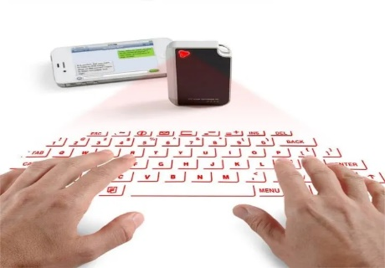

Image 20: Laser virtual Keyboard

Reference: <https://digitalworld839.com/types-of-keyboards-computer/>

Virtual keyboards appear on screens, either of computers or smartphones, and therefore are used either by a mouse or by touch screens. In recent years keyboards for Android or iPhone have become very popular and can be downloaded from virtual stores.

These laser virtual keyboards are a very good alternative for those systems that do not have a conventional physical keyboard.

Invented by IBM engineers, this is one of the latest innovations in the field of keyboard technology. In general, the projection keyboard uses lasers to display a virtual keyboard visible on a surface.

When you select keys on the virtual keyboard, the optical sensors or the camera capture the finger movements, which are then translated or used into actions by computer software.

## Five Functions of Keyboard

**Built-in functions**

Two common built-in functions are the Home and End keys. Pressing "Home" in any type of edit window will cause the cursor to jump to the beginning of the line you are editing, and pressing "End" will move the cursor to the end of the line. These functions are built into most every PC keyboard.

**Boot sequence functions**

When your PC is first booted up, the keyboard has a few important functions built into the BIOS, the interface between you and your computer. Commonly, the boot functions are F1 to continue, ESC to exit the current command, and F2 to enter the system setup. Keep in mind that the BIOS setup deals exclusively with the computer hardware and changes made to the BIOS could make the computer inoperable without major repairs.

**Operation keystrokes.**

A large number of computer programs use the F1 key as a universal help key. Likewise, pressing the ESC key will usually take you back to the previous step. Other function keys--F1 through F12--have typical functions, such as F8 saving a document. It is important to note that these functions are set by individual programs, and will vary from one application to the next.

**Shortcut commands**

Almost all programs allow basic keyboard commands. These commands include Ctrl+A to select and highlight all content, Ctrl+C to copy highlighted text, and Ctrl+V to paste text you have copied. You may be surprised to find out that more than half of your keys have functions associated with the CTRL key combination, and the help files of your software program will offer a complete list.

**Specialty keys**

Some keyboards now have specialty keys that give the user the ability to launch Internet functions or common computer programs. Your keyboard may have specialty keys that will launch your web browser, an email program or a chat program. You also may have keys that will launch your computer's calculator or shutdown your computer.

## Other Functions of Keyboard

There are various other functions of keyboard, which are given below.

1. Print Screen
2. Scroll Lock
3. Pause
4. Brightness UP & Down
5. Volume UP & Down

**1. Print Screen**

The Print Screen button is on every computer keyboard that is used to take a screenshot of the [monitor screen](https://quicklearncomputer.com/what-is-the-full-form-of-monitor/).  
  
Screenshot means taking a photo of whatever is on the screen or whatever is going on the screen.  
  
**2. Scroll Lock**

The Scroll Lock button is also on the keyboard of every computer, which is used to temporarily turn off the scrolling features.  
  
You cannot scroll the monitor screen with your keyboard by pressing the Scroll Lock button.  
  
**3. Pause Button**

The Pause button is also on the keyboard of every computer, which is used to pause something.  
  
Basically, this button is used to pause the video or audio file.  
  
**4. Brightness UP & Down**

The Brightness Up & Down button is also on the keyboard of every computer, which is used to decrease or increases the light of the screen.  
  
Brightness UP & Down These are also functions of a computer keyboard.

**5. Volume UP & Down**

Volume UP & Down button is also on the keyboard of every computer, which is used to increase or decrease the volume of the computer.  
  
Volume UP & Down These are also functions of a computer keyboard.

### How does Keyboard Works in Computer?

A keyboard contains many mechanical switches or push-buttons called "keys". When one of these are pushed, an electrical circuit is closed, and the keyboard sends a signal to the computer that tells it what letter, number or symbol it would like to be shown on the screen.

Computer keyboard is an device used to convert the keystrokes in to the electrical signals that a computer can understand. There are special types of switches and circuits to do this. When we press a key, it completes its corresponding circuit and an electrical signal goes to keyboard’s internal processor which detects the key which is pressed.

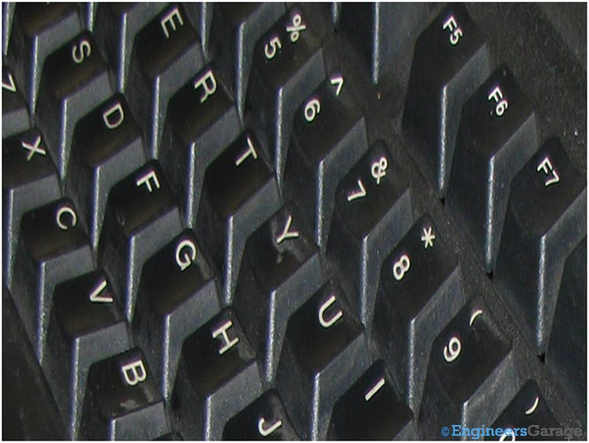

Image 21: Image of Computer Keypad

Reference: <https://www.engineersgarage.com/insight-how-computer-keyboard-works/>

Keyboard contains its own internal processor that takes electrical signals through key strokes.

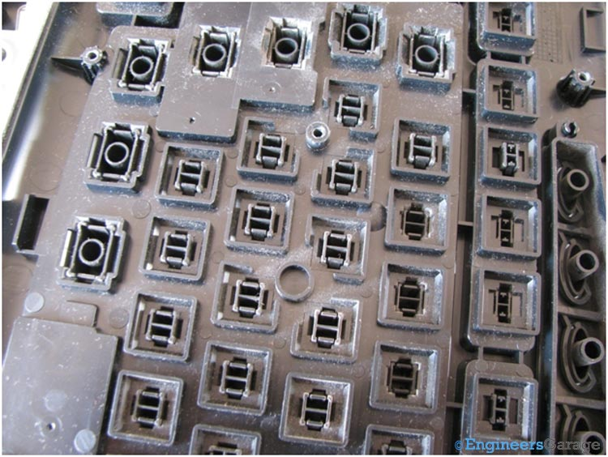

Image 22: Internal Processor of Keypad and Plungers

Reference: <https://www.engineersgarage.com/insight-how-computer-keyboard-works/>

Each key has a special shaped arrangement at the bottom known as plunger.

**Plunger & Circuitry**

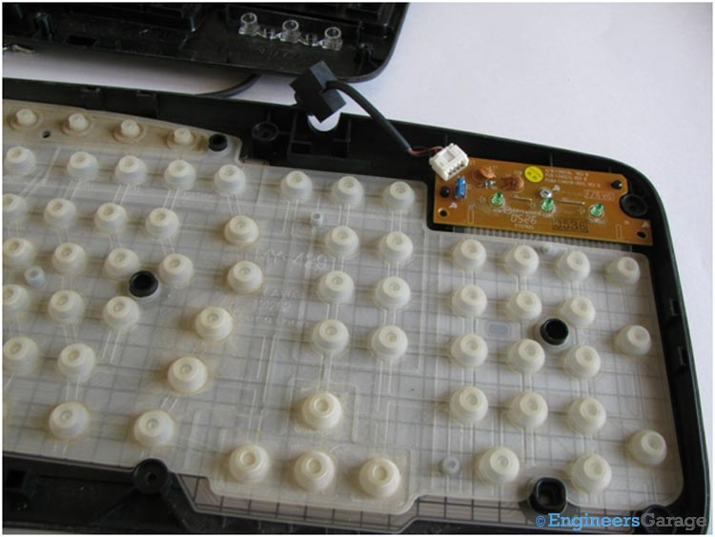

Image 23: Dome-Shaped Rubber Buttons Inside Rear Cover of Keypad

Reference: <https://www.engineersgarage.com/insight-how-computer-keyboard-works/>

Opening the screws removes the rear cover of the keyboard. We can have a look to the dome shaped rubber buttons that are pressed with the plunger at the bottom of the key.

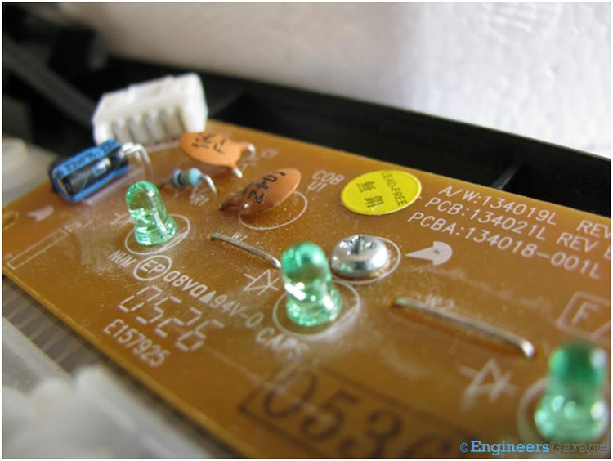

Image 24: Image Showing Internal Processor of Keypad

Reference: <https://www.engineersgarage.com/insight-how-computer-keyboard-works/>

The circuit shown in the image above works as its internal processor.

**Processor & Buttons**

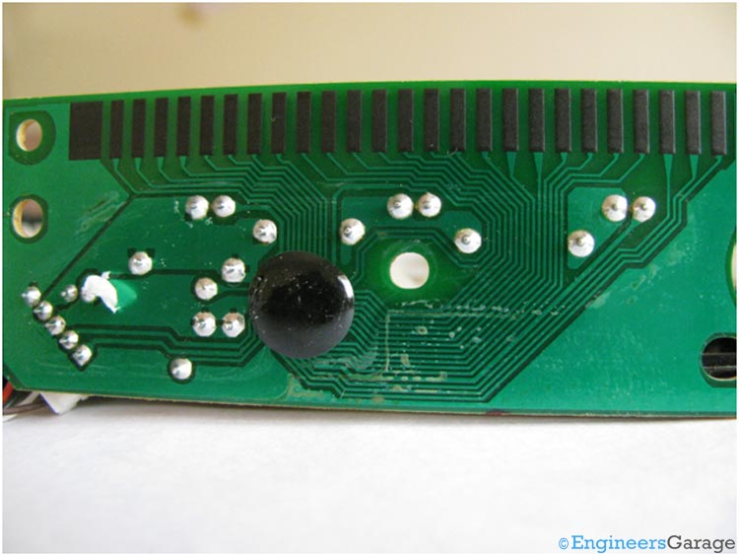

Image 25: COB IC of Keypad to Process Signals

Reference: <https://www.engineersgarage.com/insight-how-computer-keyboard-works/>

A COB IC is used to process signals. This IC gets the electrical signals from the key strokes and sends the information about the key pressed to the computer.

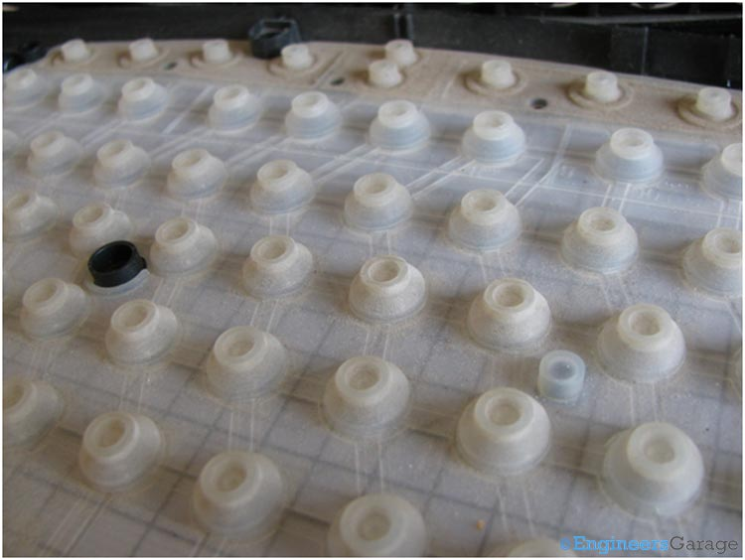

Image 26: Closer View of Dome-Shaped Rubber Buttons Underneath Keys of Keypad

Reference: <https://www.engineersgarage.com/insight-how-computer-keyboard-works/>

<https://www.engineersgarage.com/insight-how-computer-keyboard-works/>

The above image shows the dome shaped rubber buttons which are pressed when keys are pressed.

There are two layers of plastic sheets with embedded circuitry. The two layers behave as miniature size switches which connects/disconnects two electrical points. Both the layers are separated by third a third thin plastic layer.

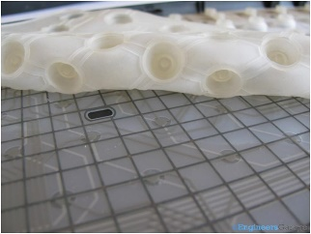

Image 27: Plastic Sheets and their Embedded Circuitry

Reference: <https://www.engineersgarage.com/insight-how-computer-keyboard-works/>

**Plastic Sheets & Working**

We can see how the rubber button when pressed, it presses the round point which connects the top and the bottom layer.

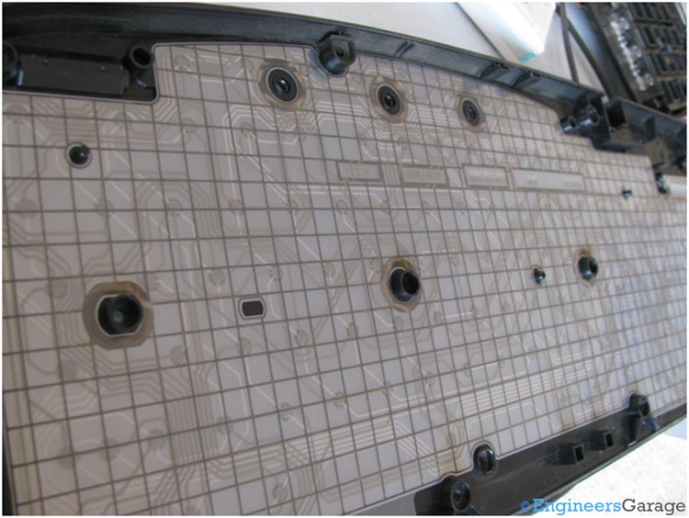

Image 28: Connection Points Under Plastic Sheets

Reference: <https://www.engineersgarage.com/insight-how-computer-keyboard-works/>

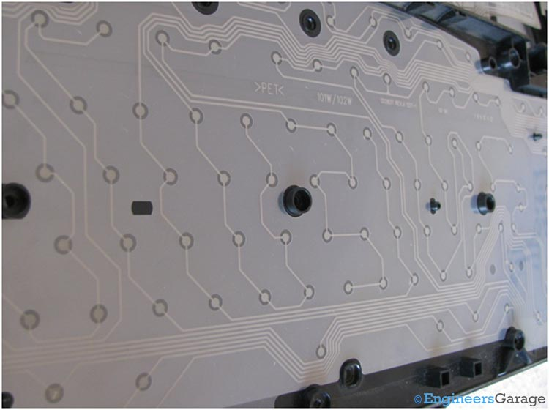

Image 29: Keyboard Circuit Layout Under Plastic Sheets

Reference: <https://www.engineersgarage.com/insight-how-computer-keyboard-works/>

Removing the top layer of plastic sheet shows the above view.

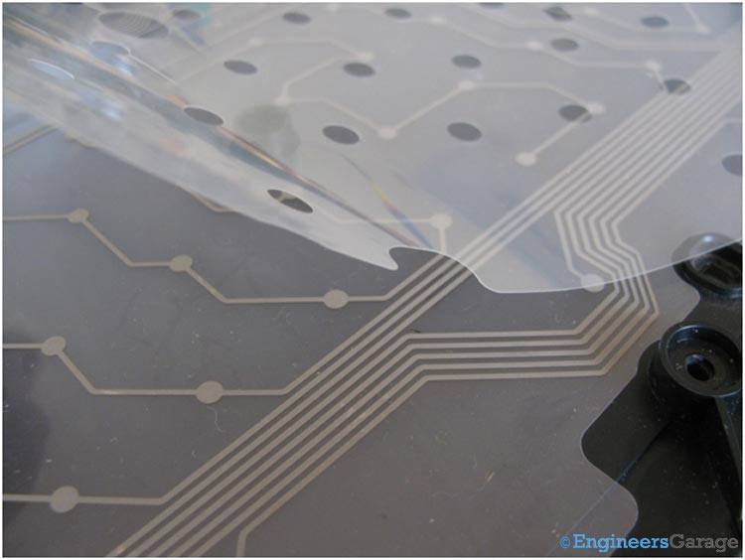

Image 30: Thin Plastic Strip that Keeps Two Layers of Circuits Separated

Reference: <https://www.engineersgarage.com/insight-how-computer-keyboard-works/>

We can have a look at the middle thin plastic layer sheet which is settled amid the two layers with a round cut beneath each key. This plastic strip helps to keep the two circuits separated and when a key is pressed, two points of both the layer connects with each other.

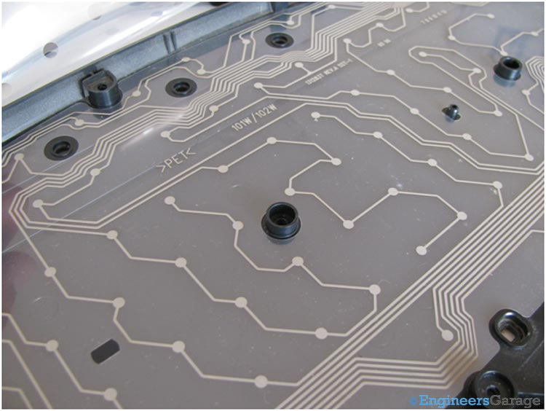

Image 31: Bottom Circuit Layer of Computer Keyboard

Reference: <https://www.engineersgarage.com/insight-how-computer-keyboard-works/>

The image shows the bottom layer.

Working: A keyboard works on a 5V power which it takes from the computer through the Serial cable or USB. When we press a key on the keyboard, it pushes down the dome shaped rubber button which in turn electrically connects the top & bottom layer at that point and the signal is sent to the COB IC. The IC processes the signal and sends it to the computer through a PS2 port or USB.

## Keyboard Advantages and Disadvantages

### Advantages of Keyboard

**1. User Friendly**

A concept keyboard typically takes less time to learn compared to a standard keyboard. The user is not going to physically type here. Therefore, there is no learning involved in the key usage. Detailed instructions and functions of each key is displayed to the user which makes them familiar with this technology.

**2. Security**

In terms of security too a concept keyboard provides many benefits. A concept keyboard makes sure that it is free of tampering. Whatever the information that is offered cannot be corrupted easily. Thus, customers information which are meant to be kept private are secured to a very high extent.

**3. Visual Representation**

Visual representations used in a concept keyboard is able to bring instant responses more than a traditional keyboard. By using a concept keyboard, organizations can display actual images instead of standard characters. This is especially convenient for restaurants and super markets where they display various products to the customers.

**4. Water Proof**

A concept keyboard on default is designed to withstand any environmental constraints. This includes water proof technology as well. Environments where there are water splashes and surrounding dirts will not damage a concept keyboard.

**5. Typing Errors**

Concept keyboards are also less vulnerable to typing errors. Typos can negatively impact the overall image of a company; both in terms of sales and reputations. Hence, at the very best concept keyboard makes sure that there is no typing errors. Even if the user does mistakes in pressing a button, they could simply undo them with the back key.

### Disadvantages of Keyboard

**1. Cost**

The initial cost involved in a concept keyboard is much higher than a regular keyboard. This is because concept keyboards are meant to be accessed by multiple users. As a result, different sets of command lines need to be programmed individually. Hence, concept keyboards are mostly recommended for repetitive tasks.

**2. Maintenance**

A concept keyboard uses pre-programmed icons to depict products of an organization. Therefore, whenever a new product is added or existing product is upgraded, the programming needs to be done accordingly. As a result, it could increase the long-term maintenance costs of an organization.

**3. Cleanliness**

It is difficult to maintain cleanliness when using a concept keyboard. A concept keyboard is used similar to a touchscreen. Hence the oil and other dirt from the finger can be easily left on the screen. Since more people tends to use this screen, overtime it could mess up the keyboard.

**4. Text/Numeric Input**

A concept used according to a command line basis. Thus, a numeric or textual input keyboard is absent in a concept keyboard. Even though some concept keyboards come with a numeric keypad, in most models however this feature is excluded. This leads to problems when there is extreme necessity to enter amounts such as while processing payments.

**5. Health Risks**

Using a concept keyboard for a long time poses increased number of health risks. Users who use this technology often perform repetitive tasks which results in strain injury. And also, posture related problems such as shoulder pain, back pain and neck pain are commonly experienced. However, by following proper posture practices and using both hands you can reduce this risk to some extent.

## What is Computer Mouse?

A mouse is a pointing input device that controls the movement of the cursor or pointer on a display screen.

A mouse is a small hardware input device used by hand. It controls the movement of the cursor on the computer screen and allows users to move and select folders, text, files, and icons on a computer.



Image 33: Mouse

**Who Invented the Mouse?**

Douglas Engelbart invented the mouse while working for Stanford Research Institute (SRI) in 1964. Douglas built and designed a mouse with the help of engineer Bill English at the SRI research lab.



Image 34: Founder of Mouse

Reference: <https://www.javatpoint.com/mouse>

### What are the uses of a Mouse?

A mouse is capable of performing various functions on a computer, which are as follows:

**Move the mouse pointer:** The main function of a mouse is to move the mouse cursor on the screen in the desired direction.

**Select:** A mouse provides users the option to select the text, file, or folder and many files at once. For example, if you want to send multifile to anyone, you can select many files at once and can send them.

**Open or execute a program:** You can open a folder, icon, or other objects by a mouse. You are required to move the cursor to a file, folder, or an icon, then double click on the object that you want to open or execute.

**Drag-and-drop:** When you select something, it can also be moved from one location to another by using the drag-and-drop method. In this method, first, you need to highlight the file or an object that you want to move. Then, move this file while pressing the mouse button and drop it on the desired location.

**Hovering:** When you move the mouse pointer on any object, hover changes the color of links, and by clicking on that link, you can go on the destination page.

**Scroll Up & Down:** If you are viewing a long web page or working with a large document, you need to scroll up or down a page. The mouse's scroll button helps to up and down your document page; otherwise, you can also click and drag the scroll bar.

**Perform other functions:** Most of the desktop mouse contains buttons, which can perform any function by programming them according to the requirement. For instance, on the thumb portion, many mouses have two side buttons that can be programmed to go back on web pages.

**Playing Game:** A mouse provides users the option to play various games like chase games, in which a mouse is used to select any particular objects.

**Combination Activities:** A mouse can be used in many combination activities like, Ctrl + Mouse click can be used for the hyperlink in new windows.

### Computer Mouse Parts with their Functions

**Buttons:** Now these days, every mouse has two buttons, one is left and other right. With the help of these buttons, users can be manipulating any objects and text as well.

**Ball/laser/LED:** In mechanical mouse have rubber ball that roll on the surface things such as table. In the optical mouse have laser or LED, these parts allow to mouse for movement on x-axis and y-axis directions, and its parallel move the mouse cursor on the computer screen.

**Mouse Wheel:** Main objective of wheel in mouse for scroll your document page up and down direction.

**Printed Circuit Board:** This board is placed inside of mouse chasses, in that board all electronics components embedded such as capacitor, diode, and register etc. This board takes input in the form of electronics signals when user given instructions by mouse such as clicking, scrolling, and more.

**Cable/Wireless Receiver:** Corded mouse have cable for plugging with computer. If your mouse is wireless then require the USB receiver for getting the broadcasted signals such as (Infrared, Bluetooth, Radio signals), and then give input to computer.

**Battery:** This component is used in the wireless mouse for running stages. if its battery get down then mouse will not working properly.

**Microprocessor:** This is a processor that is embedded on the circuit board of mouse. Microprocessor is the brain of mouse, because without microprocessor all components of mouse are workless.

**Other Internal Electronic components are:**

**Register** – Store data in temporary nature with the help of Microprocessor.

**Capacitor –** Help to store electronic information in electric field.

**Diode** – For flowing the current in one direction.

**Transistor** – For amplify or switch electronic signals.

**IC** – This is small wafer, and made of silicon

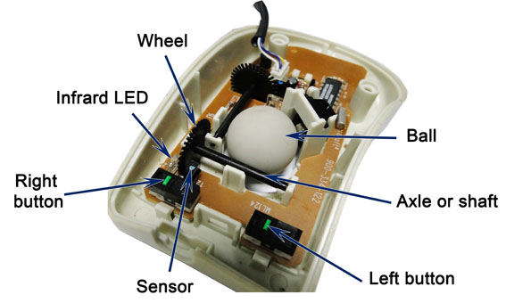

Image 35: Mouse Parts

Reference: <https://www.nidirect.gov.uk/articles/keyboard-and-mouse-basics>

## Types of Mouse

1. Optical Mouse

2. Gaming Mouse

3. Wireless Mouse

4. Laser Mouse

5. Trackball Mouse

6. Ergonomic Mouse

7. 3D Mouse

8. Mechanical Mouse

9. Roller Bar Mouse

10. Finger Mouse

11. Pen Mouse (Stylus)

**1. Optical Mouse**



Image 36: Optical Mouse

Reference: <https://digitalworld839.com/types-of-mouse-computer/>

The first is an Optical Mouse. These mice feature a small optical sensor mounted on the bottom of the unit that takes repeated images of the surface directly below the mouse, illuminated by an LED light. This light can detect mouse movement and translate it into cursor movement.

When the user moves the mouse, the optical mouse works with an optical sensor that recognizes the flat surface where it makes its movements. This is possible, thanks to the photosensor system that was developed.

These mice are less prone to dust buildup as it made with no moving parts on the bottom, but the buildup of debris in the optical sensor aperture can block its motion detection ability. Of course, you need to clean the lower mouse surface frequently where you move.

These types of mouse use sensors, allowing the user to use the computer with greater accuracy, not only in a cleaner way but also with less noise than the mechanical mouse. As can be seen, this is an advantage for the user since it does not run the risk of the course getting stuck, as opposite the case with the ball.

**2. Gaming Mouse**

Gaming mice can either be wired or wireless, but created explicitly for gaming will give you that gaming edge to win. These types of mice have the speed, accuracy, and set of features need that need for a better gaming experience overall.



Image 37: Gaming Mouse

Reference: <https://digitalworld839.com/types-of-mouse-computer/>

The gaming mouse can make a massive difference in your gaming experience and immersion, as well as help you get the most out of that brand new, any latest PC.

More than that, the best gaming mouse is not only built to last but also offers excellent ergonomics to save you from unnecessary chronic pain like in arms, shoulders, or hands. There are also many top-notch mice at every price point available in the market.

Thus, you can find something that delivers, performance, and speed, RBG, design, as well as durability without blowing your budget in your gaming experience.

**3. Wireless Mouse**

Wireless Mouse allows the user to move the mouse without the need to connect any wire to the computer. They usually use batteries or other charging devices for the operation.

To carry out information with this input device, you must have a USB port as the receiver with the computer and then connect it with the mouse in charge of transmitting the different movements or actions through a signal.

These types of mice are comfortable for daily work and achieve greater accuracy in the work area. Because it has a significant advantage is that when it does not have a cable, it will not give us problems like “hitting or colliding” with the things that we have on the desk.



Image 38: Wireless Mouse

Reference: [h](https://www.engineersgarage.com/insight-how-computer-keyboard-works/)<https://digitalworld839.com/types-of-mouse-computer/>

Types of Wireless Mouse

1. Radio Frequency Mouse

This variant of wireless mice uses a signal in GHz to interconnect with the computer at a distance between 5 and 10 meters, at a reasonable speed and price.

2. Infrared Mouse

This is the type of wireless transmission between the mouse and the PC using an infrared signal to send information and requires that the equipment be close to each other. Their inferior performance made them almost dead.

3. Bluetooth mouse

Mouse with wireless Bluetooth connection is widely used currently, with a range greater than 10 meters. Enables fast data entry as well.

The only downside to some wireless models is their slightly slower response speed, relative to a wired mouse. Another drawback is that the battery usually lasts a little with some models, and is necessary to charge periodically. However, this point is increasingly is resolved.

**4. Laser Mouse**

A laser mouse replaces the large LED light of an optical mouse with a laser-tip illuminator, sometimes infrared and visible to the naked eye. This type of computer mouse works with a high-power laser led, concentrated in one point, which allows the mouse to detect even the most subtle movements on various surfaces.



Image 39: Laser Mouse

Reference: <https://digitalworld839.com/types-of-mouse-computer/>

On the move, it has a laser with high-resolution optical technology (much than an optical mouse), which allows it better sensitivity, precision, and more efficiency in handling the computer.

The key point of the laser mouse is the best quality and accuracy of the sensors used in the mouse. That’s why some professionals use it for precision as they need.

Other types of laser mice include laser pairs for even greater accuracy, and these models can even work on glass or reflective surfaces that would leave a regular optical mouse useless.

**5. Trackball Mouse**

The design of the optical mouse is similar to that of some optical mice. It has a fixed ball on the mouse for control to generate Input Motion. The trackball is stable and does not require much space. It can work on most of the surfaces like laser mouses as compared to other mouses.



Image 40: Trackball Mouse

Reference: <https://digitalworld839.com/types-of-mouse-computer/>

Since exact control is more evident in the case of a trackball, therefore these types of mouse are popular in the gaming industry. It is static, and the movements are generated only by moving the ball with the thumb, fingers, or palm.

When you turn it, the movement will be transmitted to the pointer, so they are useful for gamers to perform all kinds of tricks, as well as for designers and photographers for designing the graphics. Its comfort to work in small spaces and makes it innovative.

**6. Ergonomic Mouse**

The ergonomic mouse model is ideal for people who feel pain in their posture while using the mouse in front of the computer. It is known as a vertical mouse due to its ergonomic posture.

Who does not like comfort? These types of mouse adjust to the user’s posture and make comfortable and maintain the natural position of the arm so that you do not get tired or pain.



Image 41: Ergonomic Mouse

Reference: <https://digitalworld839.com/types-of-mouse-computer/>

The ergonomic mouse is an excellent solution for those people who spend several hours in front of the computer screen and manifest pain in their arms, shoulders, or hands.

They allow them to acquire a relaxed posture, without overloads and simplifying movements in front of the computer screen, avoiding pain when adopting a correct position.

The trackball mouse is an example of ergonomic mice. They are composed of a plastic sphere on the top, which allows you to move the cursor on the screen without having to move the mouse over the desk. These types of a mouse are flexible ones and make the hand, remaining relaxed for a long time.

They usually are vertical, like the classic joystick, where the buttons are located on top to ‘click’.

**7. 3D Mouse**

A 3D mouse is a type of tricky pointing input mouse, used primarily in a virtual (3D) environment. It includes different sensors that allow it use in 3D and 2D movements, especially for virtual entertainment.



Image 42: 3D Mouse

Reference: <https://digitalworld839.com/types-of-mouse-computer/>

This types of mouse have greater acceptance in video game consoles (especially in high graphics) since it has a long learning curve of its functions. However, it gives considerable gains in productivity in gaming.

3D mouse used explicitly by individual professionals such as architects, designers, and engineers, thus giving the image a contribution of realism and professionalism in such fields.

**8. Mechanical Mouse**

The mechanical mouse is also known as a ball mouse because it contains a plastic sphere in its lower part. This computer mouse works through a ball located at the bottom, and when it turns, it activates small rollers in charge of transmitting the movement to the computer.

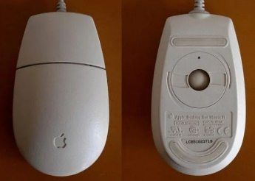

Image 43: Mechanical Mouse

Reference: <https://digitalworld839.com/types-of-mouse-computer/>

As the user moves the mouse, this ball causes two roller bars to thrust, converting the movement of the mouse into the direction of the cursor on the computer screen. Ball mice are cheap, but opening the mechanism tends to attract dust and debris, causing buildup on moving parts that can inhibit freedom of operation.

The mechanical mouse has the internal function where the pulses made by said sphere are counted in each movement, between two perpendicular rotating axes, generating electrical impulses interpreted by the computer.

**9. Roller Bar Mouse**

The roller bar is the horizontal bar-shaped mouse that is used by placing it in the front end of your keyboard. From this bar you can move sideways, forward, and backward to control your cursor, it ends up feeling a lot like using a trackpad on a laptop.

To use the buttons, you can tap on them to click. It is also usually an ergonomic model for strain and palm rest. Obviously, since it is very not quite the same as the usual standard mouse, it takes some getting used to.



Image 44: Roller Bar Mouse

Reference: <https://digitalworld839.com/types-of-mouse-computer/>

A decent option for individuals with joint and thumb pain and other people who think that it’s hard to grip an ordinary mouse. It very well is used by both hands to build comfort and minimize fatigue. This type of bar mouse is not suitable for gaming however might be useful for editing and designing.

**10. Finger Mouse**

The Finger mouse is very small in size with an optical LED light for functioning. One can use finger mice by wearing its band for any finger size since it is adjustable. They can wireless or wired USB and needs a AAA battery.

Similarly, as with our ordinary mouse, it also has three buttons (for right and left click) and a scroll. The idea behind this kind of mouse is to effortlessly switch between typing, clicking, pointing, and scrolling.



Image 45: Finger Mouse

Reference: [h<https://digitalworld839.com/types-of-mouse-computer/>](https://www.engineersgarage.com/insight-how-computer-keyboard-works/)

It is required to wear on the middle finger utilizing a customizable band, although few people have likewise worn on the index finger in order to their comfort.

The biggest advantage of finger mice is that can be utilized on any surfaces even on non-glossy surfaces since it doesn’t need a surface to operate. This makes it ideal for use while standing, for example, during presentations. This can be a very good option for individuals with joint pain.

Despite the fact that the types of finger mice function admirably for normal applications, they perform poorly with regards to gaming, designing, and editing tasks.

**11. Pen Mouse (Stylus)**

A stylus is a small pen-like shaped device. These types of mice are also known as stylus pens or GStick mice. Because Gordon Stewart invented the Stylus Mouse. Hence ‘g’ in GStick means Gordan.

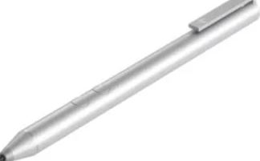

Image 46: Pen Mouse

Reference: <https://digitalworld839.com/types-of-mouse-computer/>

These types of a mouse (pen mice) are used to design or make selections by tapping, on devices with touchscreens such as computers, smartphones, game consoles, and graphics tablets. A stylus pen mouse provides more precision and controllable input. Its use is also called pen computing.

## How does Mouse Works in Computer?

**Optical mouse**

The LED installed at the bottom of the mouse emits a bright light in the downward direction. Since a mouse is usually used on plain surfaces, the light bounces back from the surface and enters a photocell that’s also mounted on the bottom, almost next to the LED.

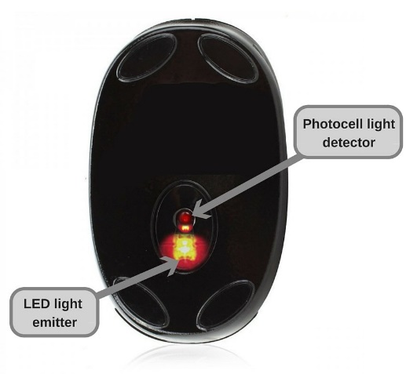

Image 47: An optical mouse kept upside down

This photocell has a frontal lens that magnifies any light reaching it. As you move the mouse around, the pattern of the reflected beam changes; this is then used by the light-detector chip to figure out how and in which direction you’re moving the mouse.

Optical mice are much lighter and faster than mechanical ones, and have therefore gained enormous popularity all over the world. With improvements in technology, newer and even more advanced mice – that address issues like ergonomics and the health of the user – are taking center stage. The choice of the right variant rests with the user, but one thing remains universally true – computers and mice shall always remain inseparable.

### Mouse Advantages and Disadvantages

**Advantages of Mouse:**

* Mostly use with desktop computer systems.
* When buy new brand computer then get mouse with computer.
* No need more training for using it.
* Solve many problems when use mouse while keyboard’s keys.
* Freedom for movement flexibility.
* Freedom for selection of mouse according user’s comfortable because mouse have huge varieties are available in the market.
* Portability- Easy to carry one place to another place.
* Most preferred device for graphic applications areas.
* Some multi-function mouse provides to users more flexibilities for cursor movement.
* Having faster to traditional mouse.
* No need more space for using it.
* Low cost.
* Easy to operate indoor and outdoor areas

**Disadvantages of Mouse:**

* Need flat surface.
* Need services regular basis.
* More dust sensitive.
* Some time, dragging operations is difficult by user.
* Mouse can be damaged easily.
* May be, can be eye sight problems due to more use of mouse rotation.
* Need little space for using.
* Palm can be getting pain due to use mouse long time.
* Not easy task for giving text input to computer.
* Getting very low performance due to virus infection.

## Applications MS Paint/Notepad

## What is MS Paint?

Paint is a drawing tool. It is a part of Windows. You can use to create simple or elaborate drawings. These drawings can be either black-and-white or color, and can be saved as bitmap files. You can print your drawing. You can also use itf or creating your desktop background, or paste it into another document. You can even use paint to view and edit scanned photos. You can also use Paint to work with pictures, such as .jpg, .gif, or .bmp files. You can paste a Paint picture into another document you've created. The extension file name of Paint is .bmp.



Image 48: paint

Microsoft Paint or 'MS Paint' is a basic graphics/painting utility that is included in all the Microsoft Windows versions.

MS Paint can be used to draw, colour and edit pictures, including imported pictures from a digital camera for example.

MS Paint is found in the Windows Start menu within the Accessories Folder.

It can save creations in standard formats such as .jpg and .bmp

Paint can enable ‘painting’ by dragging the mouse and using different types of artistic brushes or pens that can give for example a watercolor or oil effect. The paint also ‘runs out’ on certain brushes after a period of time so that the brush needs to be put back into the colour again, as if it was a real painting brush.

More recent versions of Paint allow up to three colors to be picked at a time using the primary colour with left mouse click, the secondary colour with right mouse click and the tertiary colour with the control key on the keyboard and any mouse click

Features included in paint are pencil, brush and airbrush tool. The ability to add text, lines and shapes. Also included are an eraser, magnifier, and fill colour tools.

Many complex graphics software applications have concepts that are included in Microsoft Paint and the same principals can be applied in these from learning within Microsoft Paint.

### Tools of MS Paint



Image 49: Paint Tools

Reference: <https://www.kofastudy.com/courses/jss2-computer-studies-2nd-term/lessons/computer-graphic-packages-ii-week-7/topic/ms-paint-tools-and-their-functions/>

## What is Notepad?

Notepad is a generic text editor included with all versions of Microsoft Windows that allows you to create, open, and read plaintext files. If the file contains special formatting or is not a plaintext file, it cannot be read in Notepad.

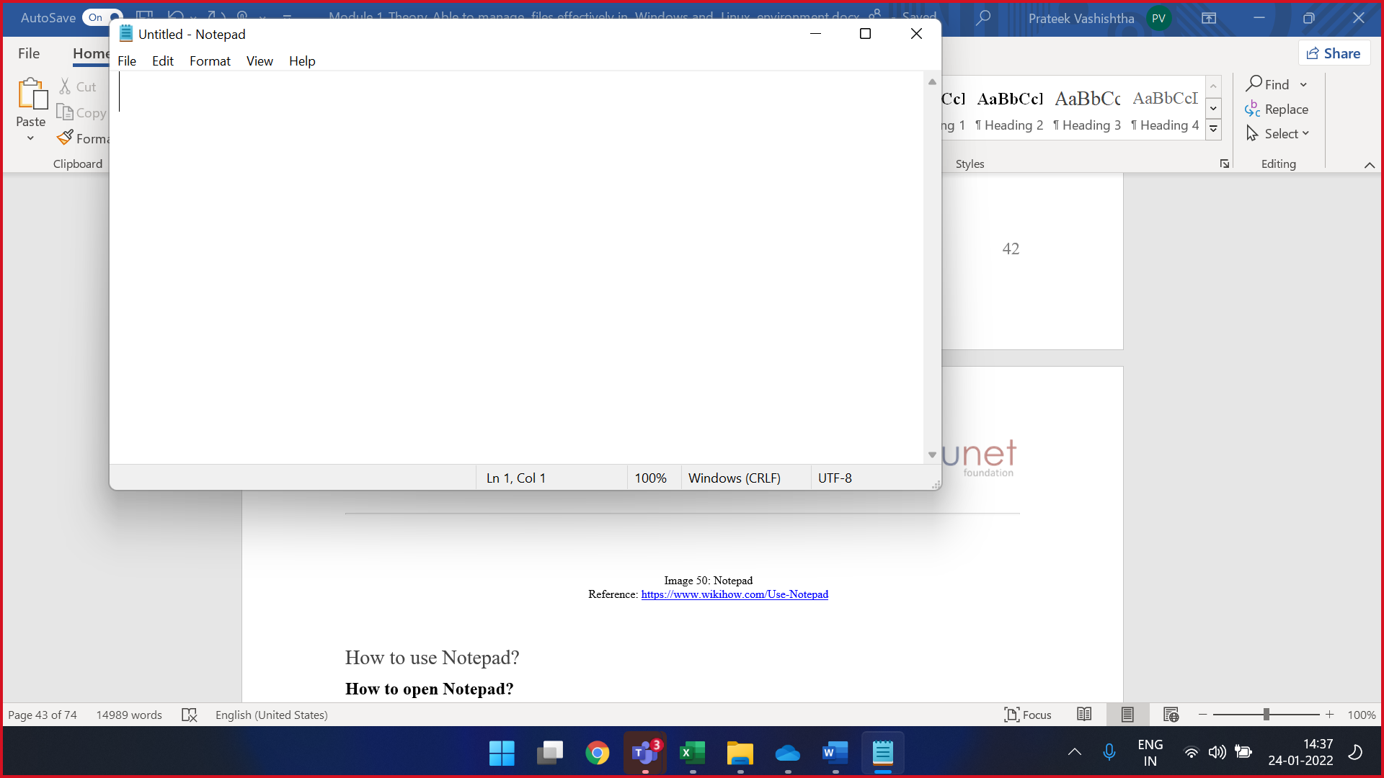

Image 50: Notepad

### How to use Notepad?

**How to open Notepad?**

Users who are using Microsoft Windows can run Notepad (notepad.exe) by following the steps below.

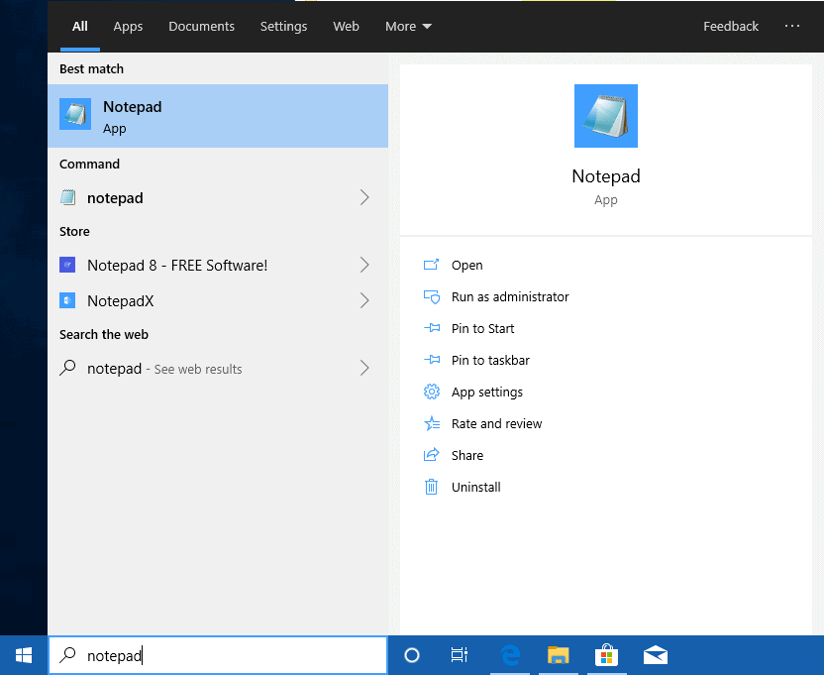

Image 51: Open Notepad

**Windows 10**

On the Windows desktop, find the Windows Search Box.

In the search box, type notepad.

Click the Notepad option in the search results.

**How to create a text file using Notepad?**

Open Notepad and type the text you want in the file. Once done, save the file by clicking File and selecting Save. When saving the file, make sure the file is saved with a ".txt" extension.

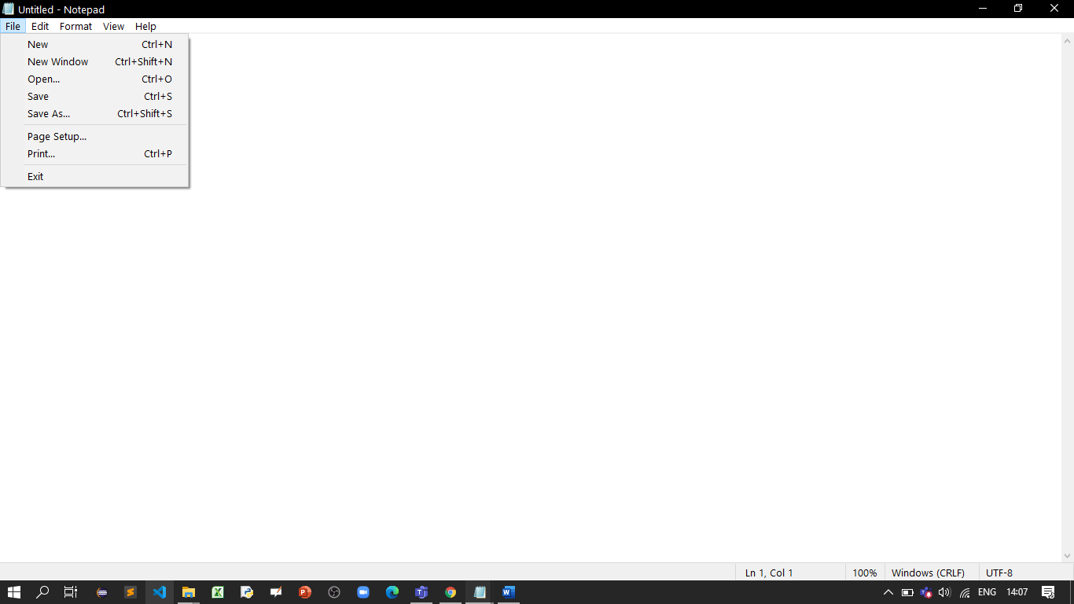

Image 52: Notepad File Create

**Can you insert a picture in Notepad?**

No. Notepad is a plaintext editor and does not support pictures. If you want to insert pictures, consider using WordPad instead of Notepad. Keep in mind that if a WordPad document contains pictures, it must be saved as an .RTF (rich text file), and not a .TXT (plain text file).

## Different text formats

### What is the text-based formats?

UTF-8, which can represent texts of all languages in real use, is becoming more common and may be the best choice for long term storage of text.

### File format extensions for text files

Creating text files and using a word processor is one of the most common tasks on a computer. Below is the most common file extensions used with text files and documents.

* .doc and .docx - Microsoft Word file
* .odt - OpenOffice Writer document file
* .pdf - PDF file
* .rtf - Rich Text Format
* .tex - A LaTeX document file
* .txt - Plain text file
* .wpd - WordPerfect document

## Different image formats

### What is the image-based formats?

Image Format describes how data related to the image will be stored. Data can be stored in compressed, Uncompressed or vector format. Each format of the image has a different advantage and disadvantage. Image types such a TIFF is good for printing while JPG or PNG, are best for web.

**TIFF(.tif, .tiff)**

Tagged Image File Format this format store image data without losing any data. It do not perform any compression on images have a high-quality image is obtained but size of image is also large, which is good for printing, professional printing.

**JPEG (.jpg, .jpeg)**

Joint Photographic Experts Group is a loss-prone (lossy) format in which data is lost to reduce size of image. Due to compression, some data is lost but that loss is very less. It is a very common format and are good for digital cameras, nonprofessional prints, E-Mail, PowerPoint etc., making it ideal for web use.

**GIF (.gif)**

GIF or Graphics Interchange Format files are used for web graphics. They can be animated and are limited to only 256 colors, can allow for transparency. GIF files are typically small is size and are portable.

**PNG (.png)**

PNG or Portable Network Graphics files are a lossless image format. It was designed to replace gif format as gif supported 256 colors unlike PNG which support 16 million colors.

Bitmap (.bmp)

Bit Map Image file is developed by Microsoft for windows. It is same as TIFF due lossless, no compression property. Due to BMP being a proprietary format, it is generally recommended to use TIFF files.

**EPS (.eps)**

Encapsulated PostScript file is a common vector file type. EPS files can be opened in applications such as Adobe Illustrator or CorelDRAW.

RAW Image Files (. raw, .cr2, .nef, .orf, .sr2)

These Files are unprocessed created by a camera or scanner. Many digital SLR cameras can shoot in RAW, whether it be a .raw, .cr2, or .nef. These images are the equivalent of a digital negative, meaning that they hold a lot of image information. These images need to be processed in an editor such as Adobe Photoshop or Lightroom. It saves metadata and is used for photography.

### File format extensions for image files

There are many different image types and image file extensions that can be used when creating and saving images on the computer. Below is a list of the most common image file extensions.

* .ai - Adobe Illustrator file
* .bmp - Bitmap image
* .gif - GIF image
* .ico - Icon file
* .jpeg or .jpg - JPEG image
* .png - PNG image
* .ps - PostScript file
* .psd - PSD image
* .svg - Scalable Vector Graphics file
* .tif or .tiff - TIFF image

## Advantages of compressing files

### What Is a Compressed File?

A compressed file is any file which is smaller than its original size and could contain one or more files, or even a directory. A compressed file has the compressed attribute switched on. Compressed files have the advantage of being faster to transmit and download, and can allow more data to be stored in physical or removable media.

Examples of compressed file extensions are .RAR, .ZIP and .TAR. A compressed file is created with the help of different file compression techniques which perform mathematical analysis of the data contained in the file and remove redundancies involved. Compressed files are ideal for text, word processor documents, .WAV audio files and spreadsheets. However, compressed files are poorer in quality in the case of graphic files or certain audio and video formats. It is often recommended to check the data contained in the files before creating compressed files.

### Why Compress Files?

Compressing is mainly used for the following purposes:

1. A compressed file takes up less storage space. A smaller file can be transferred faster between locations e.g., on the Internet.
2. Several files and folders are combined into one package that is easy to manage; it is usually easier to handle one file than a set of, say, 10,000 files.



Image 53: Compress Files

The file icon or the .zip extension will tell you that a file is compressed.

How much use is compression to you? The following image shows a real-life example with the uncompressed (docx) file and compressed (zip) file of a student’s pro-seminar project. Note the considerable difference in file size!

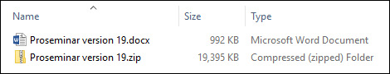

Image 54: Compressing Files

Note that compressed files have to be extracted before they can be opened in their respective applications.

#### When To Compress Files

The following are some situations where it makes sense to compress files:

* A file takes up a great deal of space on the hard drive, USB flash drive or other storage medium.
* You want to archive a file in compact form because you will not be needing it for a long time.

You are going to send several small files to a friend by e-mail. Attaching a compressed folder to an e-mail is easy, while attaching an uncompressed folder is usually impossible. The image below shows an uncompressed and a compressed folder.

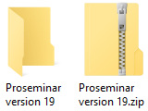

Image 55: Compressed & Uncompressed folder

Note that certain types of files are already compressed. For example, JPEG and PDF files may not be compressed at all, whereas a photograph in TIFF or BMP format may be compressed to a fraction of its original file size.

### How Does Compression Work?

Data compression is a means of altering or encoding structured data to take up less disk space when stored on a computer-based system. In other words, any instance in which data or fragments of data undergo a reduction of their original storage-size or bit-rate, is data compression.

**Types of Compression**

Compressed files usually end with.zip, sit and .tar. These are called extensions, and they indicate different compression formats--different types of software used to compress files. For PCs, .zip is most common, sit is used often with Macs and .tar used with Linux. When you see a file with one of these extensions, it may be either a single large file or a group of files bundled together.

**Lossless Compression**

Lossless compression is a way to compress files without losing any data. This method shoves the data closer together by replacing it with a type of shorthand. It can reduce file sizes by around half. The .zip format uses lossless compression. With this form, the file decompresses to provide an exact duplicate of the compressed file, with the same quality. However, it cannot compress files to a really small size, making it less useful for very large files.

**Lossy Compression**

To make files up to 80 percent smaller, lossy compression is used. Lossy compression software removes some redundant data from a file. Because data is removed, the quality of the decompressed file is less than the original. This method compresses graphic, audio and video files, and the slight damage to quality may not very noticeable. JPEG uses lossy compression, which is why files converted to JPEG lose some quality. MP3 also uses lossy compression to fit a great deal of music files in a small space, although the sound quality is lower than with WAV, which uses lossless compression.

**Decompression**

In order to use a compressed file, you must first decompress it. The software used to decompress depends on how the file was compressed in the first place. To decompress a .zip file you need software, such as WinZip. To decompress a .sit file, you need the Stuffit Expander program. WinZip does not decompress .sit files, but one version of Stuffit Expander can decompress both .zip and .sit files. Files ending in .sea or .exe are called self-extracting files. These are compressed files that do not require any special software to decompress. Just click on the file and it will automatically decompress and open.

## Common Compression and Extraction Methods

One of the most commonly used compression methods is ZIP compression. Most operating systems have a pre-installed program for ZIP compression or “zipping”. If you have an older operating system, you may have to install a separate ZIP program.

Popular compression methods include:

**Compression method**  **Operating-system support for this compression method**

**zip** Both Windows and Linux as well as Mac OS can handle zip files, usually without having to install a separate zip program.

**rar** Usually requires installing a separate compression/extraction program (e.g., WinRAR).

**gz** Gz packages are common in Linux and Unix, which usually have their own default applications for handling them, such as gzip. For Windows and Mac OS, there are separate programs with which you can open gz files.

**7z** The file extension of the 7-Zip packing application.

Note that many programs for compression and extraction know how to handle different compression types. When you have installed a compression program, you can pack and unpack files or packages consisting of several files. All compression/extraction programs usually work alike. When you know how to use one program, you probably know how to use them all.

**Compressing Files as Zip packages**

Windows 10 has a pre-installed program for compressing and extracting files. To compress files with it, follow these steps:

go to the folder which contains the file or subfolder you want to compress. Note that the file you are about to compress must not be open in any program.

Right-click the file or folder. Select Send to, and then in the next submenu, select Compressed (zipped) folder. Here is the pop-up menu:

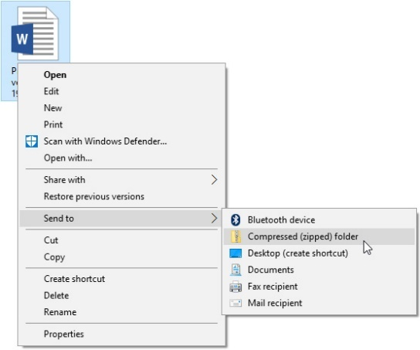

Image 56: Select Compressed Folder

The compression program will pack the selected file or subfolder into the same folder where the original file is located.

Extracting a Zip package

When you extract a zip package, the extracted file is usually stored in a separate folder. After extraction, you can delete the zip file if you wish. Zipping programs do not usually delete the original package after extraction.

When you wish to extract a zip file, save it to a folder. Then, right-click the package and select Extract All. Next, select the folder where you want to extract the package. The program will suggest a folder to you. If you want to extract to that folder, click Extract. If you want to change the folder, click Browse and then select the folder you want. Then proceed by clicking Extract.

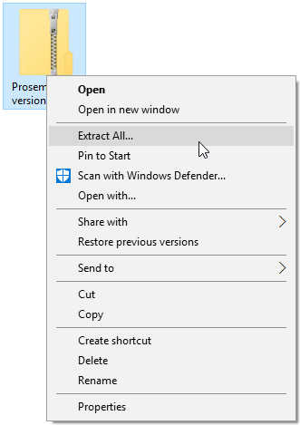

Image 57: Extract Zip Package

The extraction program will extract the file into the directory you have selected.

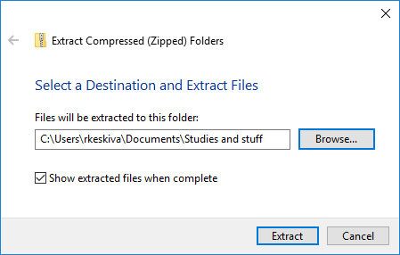

Image 58: Extraction

## Advantages & Disadvantages of Using File Compression

**Advantages of File Compression**

**Increased computing efficiency**

Compressed data permits users to back-up and store data faster, especially when dealing with larger files. Note: The advantage of compressing digital video is becoming more useful as video sales letters (VSLs) and personalized videos become more prevalent.

**Quicker transfers**

Not only does file compression enable you to move files around on a local device more efficiently, it also enables you to send large documents and data faster over the internet.

**Improved file integrity**

Uncompressed files can often become corrupt when sent over the web. Zipped files serve to preserve the integrity of your files and make sure your data goes uncorrupted.

**Email/webpage accessibility**

It’s easier to compress larger files when uploading them to a webpage or sending them via email. Also, as previously mentioned, the most common email systems restrict the size of attachments. So, compression offers a way to send multiple files collectively, instead of one by one.

**Disadvantage of File Compression**

Compressing files on your computer saves disk space on both removable and non-removable drives. The compression process reduces the overall size of a computer file by physically removing data from the file that is repeated or empty. The process then places a flag indicating the removal. The flag takes up less space, but there are disadvantages to compressing files.

**Memory Issue**

When uncompressing a file for reading, your computer uses more memory to complete the task. During the uncompressing process, your computer will pause and allocate any free memory to complete the task. You may encounter one or more "Low Resources" or "Out of Memory" errors if your computer doesn't have enough memory. The errors also occur if you have multiple applications running at the same time while your computer is processing the compressed file.

**Speed**

The uncompressing process not only uses memory but also processor time. The process is slow and is a disadvantage when you are trying to access a file quickly. The processing time varies due to file size and the method used to compress the file. Also, running multiple applications on your system during the uncompressing process makes the task run longer.

**File Size**

An increase in file size is another disadvantage of compressing files. In some situations including compressing video and audio files, the file you are compressing cannot be made smaller, resulting in a compressed file that is larger in size than the original file.

**Viruses and Malware**

Your computer's anti-virus program may not be able to scan a compressed file for viruses and other malware, resulting in your computer being exposed to files that may contain viruses, Trojans, spyware and other harmful programs. These types of programs can destroy your computer. Compressed files from unknown sources should be uncompressed only after a complete scan with an anti-virus program that is capable of scanning the compact files.

**File Transfer**

If you send a compressed file to someone else via the Internet, email or on a computer network, that person may not be able to open the file if they don't have a program to uncompress it. This disadvantage is easily resolved by including a link to download a free or shareware program to uncompressed the file.

## Difference between the Zip and Rar format.

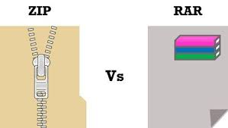

Image 59: Zip vs Rar

Reference: <https://blogs.helsinki.fi/students-digital-skills/1-introduction-to-the-use-of-computers/1-2-files-and-directories/compression-and-extraction/>

**1. ZIP:**

It is a file format that supports lossless data compression and archiving. Phil Katz was the developer of this file format in 1989. Today, ZIP is a widely used format and is supported by several software utilities including the built-in ZIP support provided by Microsoft Windows and Mac OS X. The best part, ZIP files can be opened with any program that creates ZIP files.

ZIP files are data containers that contain one or more files together in a compressed or zipped format using Zip compression. Well, ZIP archives are capable of more than just compressing files; they can encrypt files (password protected) and split archives with just a few clicks. Multiple files can be compressed or zipped using several methods such as LZMA, WavPack, PPMd, BZIP2, DEFLATE, etc.

**2. RAR:**

RAR stands for Roshal Archive Compressed file is a proprietary archive file format. It contains one or more files or folders together.

However, unlike a normal folder on your hard drive, RAR files require third-party software to open and extract the contents of the archive. It’s a native file format of WinRAR archiver which stores multiple files in the compressed form – all you need to do is unpack its contents to access the files. RAR is generally better at data compression than the default support for ZIP files.

| **SR.NO** | **ZIP** | **RAR** |
| --- | --- | --- |
| 1 | ZIP is an archive file format created by Phil Katz as a standard format for lossless data compression. | RAR is a proprietary archive file format for lossless data compression developed by Eugene Roshal. |
| 2 | It is free and open standard with many implementations and is supported almost everywhere. | It is not free and requires a third-party tool called WinRAR archiver to compress/decompress files. |
| 3 | The rate of compression of ZIP is lower than that of the RAR format. | The rate of compression of RAR is better than that of the ZIP format. |
| 4 | ZIP offers a password-based protection. | RAR doesn’t offers a password-based protection. |
| 5 | ZIP files can be created with several programs such as WinRAR, WinZIP, Freebyte Zip etc. | RAR files are limited to only one program that is WinRAR. |
| 6 | ZIP uses the ZIP 2.0 encryption algorithm which is relatively weak. | RAR uses the much efficient AES-128 encryption. |
| 7 | Filename extension are .zip and .zipx. | Filename extension are .rar, .rev, .r00, .r01. |
| 8 | ZIP uses DEFLATE compression algorithm to compress data which is less efficient than the newer compression method. | RAR uses a compression algorithm which is substantially better and efficient than the DEFLATE compression method. |

## Distinguish between backup and cloning

### What is Backup?

A backup is a copy of important data that is stored on an alternative location, so it can be recovered if deleted or it becomes corrupted. Depending on how often the data changes, how valuable it is, and how long it takes to back up determines how often to backup.

For example, a company with customer records that change frequently may back up their data every few hours. Even more sensitive data such as bank records may be stored on RAID drives that help protect the data even if a drive fails.

Today, there are several ways to back up your information and mediums to keep your data. For example, CD-R, DVD-R, USB thumb drives, external drives, and in the cloud are some of the most popular places to back up your data.

### Why should I back up my data?

A computer could stop working at any time, and data on a hard drive could become corrupted or lost if the hard drive fails. When hardware or the computer stops working, data on the computer could be lost. Any important files should be backed up to prevent loss of data and ensure you can recover those files if needed.

### Types of Backups

**How many types of Backups?**

There are mainly three types of backup are there: Full backup, differential backup, and incremental backup. Let’s take a look at each type of backup and its respective pros and cons.

**Full backup**

I am quite sure everybody who’s reading this blog has heard of full backups. They are the simplest form of backup and the easiest to understand. Full backup essentially makes a backup of everything you wish to protect every time. So, all files, objects, bytes however you wish to measure your data – every one of them is copied over to a secondary storage target each time. If you perform a full backup once a day – then everything is copied over once a day.

Let’s take an example – say you have 4 files A, B, C, and D. And let’s say each of them is about 1GB each and each of them takes 10 mins to backup.

* On Day 1 – you’ll backup 4GB and it’ll take you 40 mins
* On Day 2, let’s say File B changes to B1, and a new File called E is added. A-C & D remain the same.
* hence you run the backup on Day 2, it’ll backup all 5 files and it’ll take you 50mins
* One Day 3, let’s say File B changes again and becomes B2. File C also changes to C1, and File D gets deleted.
* When you run the backup on Day 3, it’ll backup 4 files again (D is removed – remember?) and it’ll take you 40 mins.

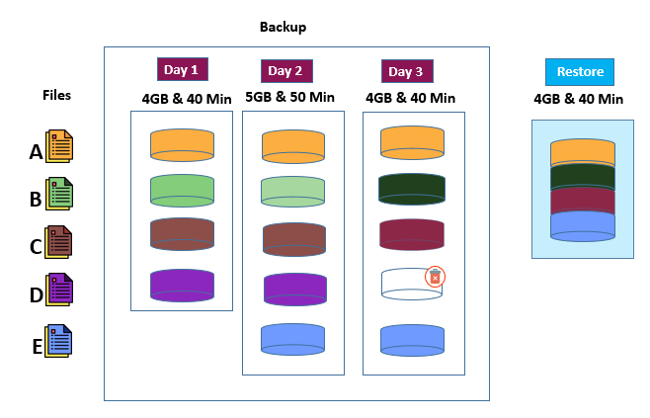

Image 60: Full Backup

Reference: <https://parablu.com/demystifying-data-backups-types-of-backups/>

When you restore, you will most likely get data from the latest backup and it’ll take you 40 mins to restore.

**Differential backup**

Full backups, as you can see take time. 40 minutes – 50 minutes each day as in our example. The next optimization the industry made was a differential backup. Differential backup makes a copy of files that have changed since the full backup.

Let’s take the same example – say you have 4 files A, B, C, and D. And let’s say each of them is about 1GB each and each of them takes 10 mins to backup

* On Day 1 – you’ll backup 4GB and it’ll take you 40 mins
* On Day 2, let’s say File B changes to B1, and a new File called E is added. Files A, C & D stay the same.
* When you run the backup on Day 2, it’ll backup just the 2 changed files and the backup will take you 20mins
* One Day 3, let’s say File B changes again and becomes B2. File C also changes to C1 and File D gets deleted.
* When you run the backup on Day 3, it’ll backup 3 files (B2, C1, and E) and it’ll take you 30 mins. Why did we backup E? Remember a differential backup picks up everything that changed since the full backup.

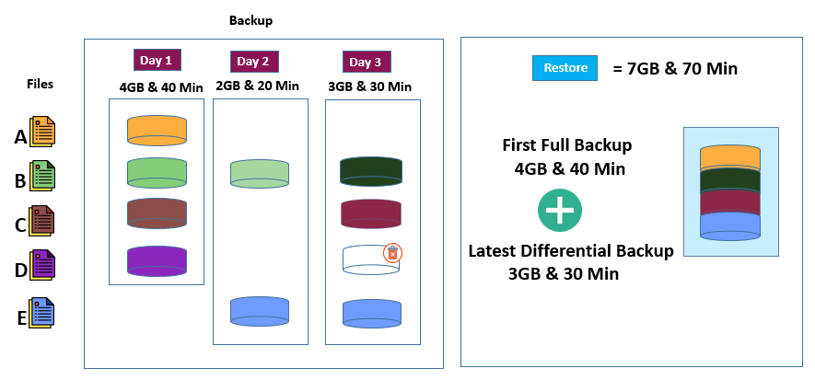

Image 61: Differential Backup

Reference: <https://parablu.com/demystifying-data-backups-types-of-backups/>

Let’s see what happens when you restore. When you restore data, just like in the previous case – you’ll need to restore the Full backup first – and then layer in each incremental backup on top of that – in order.

If you wish to get back the latest copy of data, it’ll take us 80 mins to restore – that 40 + 20 + 20. So, not great from a restore standpoint.

So, while we have been able to improve backup speeds progressively, we have traded off restore times in each of the above cases.

It is for this reason that traditional types of backup strategies recommend doing a full backup at frequent points in time – weekly, monthly, quarterly, yearly, etc. The idea is to ensure that you’re able to keep restore times in check. If you’re able to start the restore from a recent full backup, then the number of subsequent backups to restore and overlay on top of it are limited – thus saving time.

But modern, enterprise-class backup technology has progressed further than this – and will allow you to have the best of both worlds. Fast incremental backups and fast restores. The secret is something called cataloging.

**Incremental backup**

But if you think about it, differential backup has the potential to keep getting bigger and take longer and longer each day. After all, they’re backing up all changes since the full backup. So, there could come a point where a daily differential backup is taking as much time as a full backup (or perhaps more).

Enter the next innovation – incremental backup. Incremental backup only backup what was changed since the last backup. Sounds efficient right?

Let’s look at this with the same example:

So, you have 4 files A, B, C, and D. And let’s say each of them is about 1GB each and each of them takes 10 mins to backup

* On Day 1 – you’ll backup 4GB and it’ll take you 40 mins
* On Day 2, let’s say File B changes to B1, and a new File called E is added.
* When you run the backup on Day 2, it’ll backup just the 2 changed files – and it’ll take you 20 mins
* One Day 3, let’s say File B changes again to B2. File C also changes to C1 and File D gets deleted.
* When you run the backup on Day 3, it’ll backup just the 2 files again (B2 and C1) (D is removed – remember?) and it’ll take you 20 mins

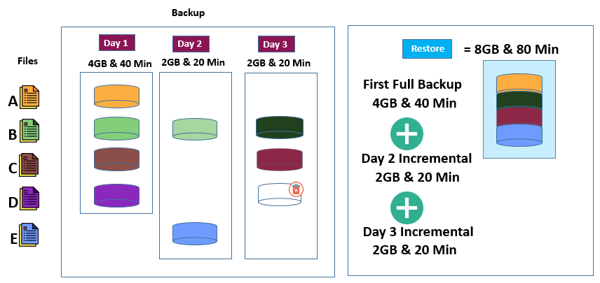

Image 62: Incremental Backup

Reference: <https://parablu.com/demystifying-data-backups-types-of-backups/>

Let’s see what happens when you restore. When you restore data, just like in the previous case – you’ll need to restore the Full backup first – and then layer in each incremental backup on top of that – in order.

If you wish to get back the latest copy of data, it’ll take us 80 mins to restore – that 40 + 20 + 20. So, not great from a restore standpoint.

So, while we have been able to improve backup speeds progressively, we have traded off restore times in each of the above cases.

It is for this reason that traditional types of backup strategies recommend doing a full backup at frequent points in time – weekly, monthly, quarterly, yearly, etc. The idea is to ensure that you’re able to keep restore times in check. If you’re able to start the restore from a recent full backup, then the number of subsequent backups to restore and overlay on top of it are limited – thus saving time.

But modern, enterprise-class backup technology has progressed further than this – and will allow you to have the best of both worlds. Fast incremental backups and fast restores. The secret is something called cataloging.

Modern enterprise class backup technology has progressed further and now offers best of both the worlds – Fast incremental backups and fast restores. The secret is something called Cataloging.

**The Magic of Cataloging**

Cataloging is a meta-data – i.e. data about your data. In each of the above cases, our backups were self-describing. There is no additional information required to restore from any of those backups.

But meta-data describes data – it can contain interesting information about file versions, about locations on media files, are kept, etc. – which can dramatically improve restore performance.

Let’s try the same example – this time with cataloging.

So, you have 4 files A, B, C, and D. And let’s say each of them is about 1GB each and each of them takes 10 mins to backup

* On Day 1 – you’ll backup 4GB and it’ll take you 40 mins
* On Day 2, let’s say File B changes to B1 and a new File called E is added.
* When you run the backup on Day 2, it’ll backup just the 2 changed files – and it’ll take you 20 mins
* One Day 3, let’s say File B changes again to B2. File C also changes to C1, and File D gets deleted.
* When you run the backup on Day 3, it’ll backup just the 2 files again (B2 and C1) (D is removed – remember?) and it’ll take you 20 mins

Now, when you restore, the catalog will supply you the latest version of each file automatically – So A, B2, C1 and E. In 40 minutes. And you’ll not even bother bringing back D because the catalog knows it was deleted.

The secret? Cataloging. Modern backup software keeps a meta-data catalog which remembers which version of which file is present in which backup – and allows a smart way of bringing back just the data that you need on a restore. This way – one doesn’t have to start with a full backup and layer each incremental on top. You can get the latest versions of all files in a single go.

When you have the strength of data cataloging working for you – you don’t need to run full backup over and over again. You can run incremental backup forever.

.

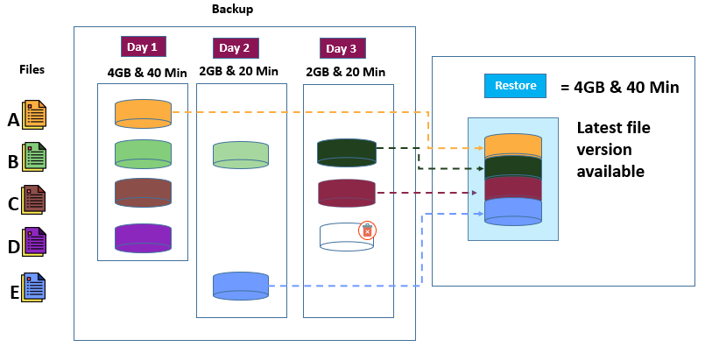

Image 63: Cataloging

Reference: <https://parablu.com/demystifying-data-backups-types-of-backups/>

**Synthetic Full backup**

A number of backup solutions now also offer a synthesized full backup. This is usually meant to satisfy archaic backup policies (that are still extant) which dictate that one should have a full backup available each week/month/year etc.

Rather than take the hit of running a full backup each week, month, or year – which is technically unnecessary – modern backup software offers to “synthesize a full” backup for you. It is the equivalent of running a restore of all your latest file versions – but rather than actually restore the data, it re-records the meta-data as if to show that these files got backed up again. It is a neat trick that doesn’t require any data movement – but simply adds/updates meta-data records

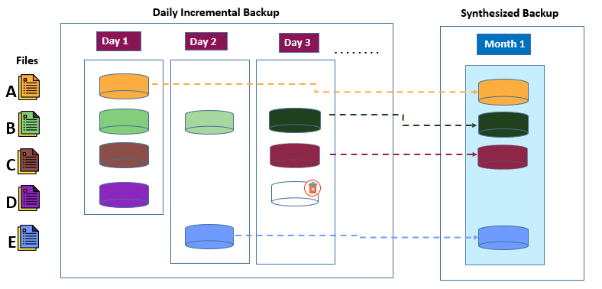.

Image 64: Synthetic Full Backup

Reference: <https://parablu.com/demystifying-data-backups-types-of-backups/>

### Advantages and disadvantages of backup

| **Method** | **Advantages** | **Disadvantages** |
| --- | --- | --- |
| Full | Files are easy to find – Since full backups include all data contained on a device, you don’t have to search through several media to find a file that you need to restore.  There is always a current backup of your entire system on one media or media set – If you should need to restore your entire system, all of the most current information is located on the last full backup. | Redundant backups – since most of the files on your file server rarely change, each full backup following the first is merely a copy of what has already been backed up. This requires more media.  Full backups take longer to perform – Full backups can be time consuming, especially when you have other devices on the network that need to be backed up (e.g., agent workstations, remote servers). |
| Differential | Files are easy to find – Restoring a system backed up with a differential strategy requires a maximum of two backups – the latest full backup and the latest differential backup. This is less time consuming than backup strategies that require the latest full backup and all incremental backups created since the full backup.  Less time required for backup and restore – Differential backups take less time to restore than full backups. Faster recovery is possible in disaster situations because you only need the latest full and differential backup media to fully restore a device. | Redundant backups – All of the files created or modified since the last incremental backup are included; thus creating redundant backups. |
| Incremental | Better use of media – Only files that have changed since the last backup are included, so there is much less data storage space required.  Less time required for backup – Incremental backups take much less time than full and differential backups to complete. | Backups are spread across multiple media – Since multiple media is required in a disaster situation, this can cause recovery of a device to take longer. In addition, the media must be restored in the correct order to effectively bring the system up to date. |
| Working Set | Restoring a system backed up with a working set strategy requires only the media containing the latest working set backup media and the media containing the most recent full backup.  You can perform a working set backup, restore the data to a new system, and be up and running faster than if you had to restore a full backup followed by all of the incremental or differential backups.  Working set backups take less time to run than full backups. | The Last accessed in (x) days method is available only on platforms that support the last accessed date (Windows, NetWare, and UNIX). Working set backups will work as differential backups when selected for other platform |

## What is Cloning?

Cloning is also used to describe the act of making the exact copy of a directory file or disk inclusive of any subdirectories or files within the disk or directory.

Cloned applications and programs are often customized applications. In many cases, they are technically superior to the original, as in the case of Linux. Cloning in programming, in all cases copies the values from the concerned object to the other object. Cloning allows programmers to copy the values of an object or source code of an application program to another without the need for writing the explicit code.

Cloning a hard drive comes with several benefits that make it an easy way to get the most out of your storage solutions. Cloning allows you to create a 1-to-1 copy of your hard drive, which is useful when you need to backup or transfer data. Even better, it also allows you to copy over your Windows 10 installation with your preferences and settings completely intact.

**Why you should clone your hard drive?**

There are several reasons why you may want to clone your hard drive. You may want to upgrade your hard drive to one with more storage, such as upgrading from 500GB to 2TB. Or you may be interested in increasing your PC’s performance by swapping out your traditional hard-disk drive (HDD) to a solid-state drive (SSD)

**1. When upgrading your hard drive**

One of the biggest reasons to upgrade your hard drive is a lack of space. If that sounds like you, cloning your hard drive to a new one is a smart move that will allow you to increase your PC's storage capacity without losing any of your old files.

If your device has room to install 2 hard drives – most desktops and some laptops allow for this – you could use your initial hard drive as a backup drive. Then, you can use your new drive as your primary option. This allows you to keep certain cloned files on your initial hard drive, such as your Windows operating system as a backup. This is ideal just in case you encounter any issues when you install your new hard drive.

Pro tip: If you’re looking for a new hard drive, be sure to check out our buying guide to choosing the best hard drive.

**2. Increase PC performance**

PC performance is important to every user, but it’s especially vital for those who push their machines to the max, like gamers, video editors, engineers, and other creative pros. If you prioritize speed and efficiency, chances are you want to use an SSD. Or you may want to swap out your SSD for one with more storage capacity. In either case, cloning your initial hard drive over to the new one is a great way to keep all your data.

PCs also tend to slow down once they get a low disk space warning in their main hard drive. Cloning that drive to one with a higher capacity means you won’t reach your storage capacity. If you’re a gamer, this means you can avoid lag in the middle of a heated online match. And for video editors, this helps prevent crashes or slowdowns when you’re rendering 4K video or other high-quality media.

**What to do before cloning your hard drive?**

There are several important steps to take before you create your clone drive.

**1. Back up any important data to an external drive**

If you have any especially important data on your drive that you plan to clone, back it up to an external drive first. This is crucial because you will overwrite all of the data on your initial hard drive during the cloning process. You don’t want to lose any of it in the case something goes wrong.

**2. Check the hard drive’s storage**

Make sure the hard drive you’re cloning to has enough space to store all your data. It’s easy to run into space problems, particularly when upgrading from an HDD to an SSD. If the original is an HDD with 1TB of space, make sure your new SSD can handle that amount. If you try to clone too much data, the hard drive cloning process will fail and it will overwrite all of your data. (Luckily you backed everything up first like we suggested in Step 1.)

**3. Be prepared to open your device**

Keep a screwdriver nearby so you can open up your desktop to swap out the hard drive once the cloning completes. When performing a hard drive cloning, you need to double-check that your new hard drive is properly connected to your desktop PC.

**4. Have the right cable handy for your laptop**

And if you own a laptop with only one hard drive slot available, make sure you own a SATA to USB cable to connect your new hard drive to your device during the cloning process.

**How to clone a hard drive?**

It may sound intimidatingly technical, but cloning a hard drive is actually a straightforward process. However, it does have several steps to follow to make sure you do it properly, otherwise you could lose your data. (Doublecheck that backup!) Here’s how it works.

**1. Boot up third-party software or the System Image tool**

Windows 10 comes with a built-in tool called System Image to help transfer your hard drive. System Image only works if you are cloning your hard drive to a larger hard drive, so you can’t use it to clone hard drive partitions. It also uses a process called imaging, which differs from hard drive cloning in several ways. Primarily, it creates a backup drive instead of a 1-to-1 copy.

Because of these limitations, you may want to use third-party disk cloning software. This simplifies the process, making it a better option for less advanced PC users. AOMEI Backupper Standard and Macrium Reflect Free are two well-rated third-party drive cloning software options.

**2. Start the cloning process**

Using either AOMEI Backupper Standard or Macrium Reflect, you can now start the cloning process. For laptop owners, make sure your device is plugged into an electrical outlet and receiving power.

Select your original hard drive, which is also known as the “Source disk”

Then, select the new hard drive that you will clone to, also known as the “Destination disk”

Click “Start Clone” in AOMEI Backupper Standard or “OK" in Macrium Reflect

The process may take several hours, depending on the size of the drives. To prevent any potential hiccups, your PC needs sufficient power during the cloning process. Make sure you do not turn off your device until the cloning process is complete.

**3. Finish the cloning process**

Once the process completes, click “Finish” to wrap things up. Before it ends, however, you will have the option to resize the partitions on the new hard drive.

**4. Connect new hard drive**

After you clone your data to your new hard drive, you need to manually replace your new hard drive. You can do this by opening up your laptop or desktop and then placing the new drive into the hard drive slot in the device.

Pro tip: If this sounds complicated, here’s a tip to make it much easier: Take a photo of what your current hard drive looks like inside your computer before you remove it. This will help you know where the wires go when connecting your new drive.

If your PC has more than one hard drive slot, you may want to leave your initial hard drive connected. This is helpful in case anything goes wrong and you need to restore a backup. You can do this with an external USB drive, which we recommended using prior to beginning the cloning process.

**5. Make your new hard drive bootable**

The final step in successfully cloning a hard drive is changing the boot priority of the hard drive. This allows your newly cloned hard drive to be the primary drive and that Windows and other programs load directly from your newly cloned hard drive.

To change the boot priority on your system:

* Restart your PC
* Press the F2 key upon startup to enter BIOS
* Once the BIOS loads, navigate to the boot option and select the new hard drive as the first boot device
* Press the F10 key to save changes
* Exit

### Simple steps with cloning software

* Install all desired programs and files to a master computer
* Use software create an image of the master computer's hard disk.
* Clone the image to the other computers.

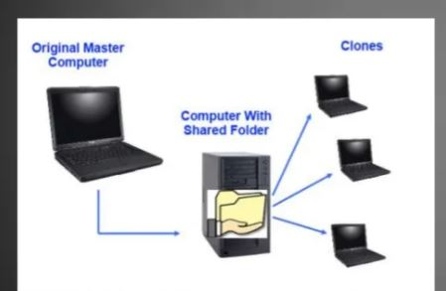

Image 65: Cloning a Computer

Reference: <https://www.slideshare.net/olgunsadik/cloning-a-computer>

### Advantages and disadvantages of Cloning

**Advantages of Clone**

* A faulty computer can be wiped clean of data and restored from the untouched master image
* Don't have to waste the installing individual applications to new computers.
* A comprehensive backup of operating systems and installed softwares

**Disadvantages of Clone**

* Need to have a high number of the same hardware for the same image
* Must have dedicated IT staff when dealing with more than just a few computers
* Care must be given to ensure the master image i reliable and uncorrupted
* Isn’t appropriate for daily backups.

### Backup Vs Clone

**What is a hard drive backup?**

You can create a backup of any disk or partition (this is a section of your hard drive that's separate from the other ones). The backup will contain all data, like technical information from your operating system and any files you create.

When you back up data, all the information on your disk is saved, as a single file. This file is called an image. If your computer crashes or gets corrupted, you may lose some or all of your data. You can use this file to restore your device exactly back to how it was before.

**What is cloning a hard drive?**

This process might be what you traditionally think of when we talk about backing up your data. Cloning your hard drive will essentially copy the data from one hard drive to another. That way, your new and old hard drives will contain the same data.

It's a simple one-time operation and will help you transfer your data between hard drives. You can update to a new hard drive to help your computer run faster and store more data.

## Backup VS. Clone

After reading our explanations, you should understand what a backup and disk clone is. Now it's time to compare the two to see which one you should use.

**They have different uses**

Cloning and backup are two different processes. Disk cloning transfers data from one hard drive to another. This process is useful if you want to change the type or size of the hard drive you use. It will also allow you to access your files right away if your system crashes. On the other hand, a backup helps you restore the files on your computer. This tool comes in handy if your computer crashes.

**You can update a backup**

Cloning is a one-time operation. It only allows you to store one lot of data at a time. Whereas, a backup will have automatic updates for your files. That saves time! It also will create different backups so you can restore your computer to a specific time. That's great if any unwanted changes have occurred!

**They take up different amounts of space**

A backup saves as one file, which we call an image. This option means it takes up less space allowing you to have multiple backups saved. A clone will take up more space because partitions are created on the new device right away. Therefore, the data isn't compressed down and saves separately.

So, there you have it! Backup and disk clone are both useful tools with different functions. Pick cloning if you need a handy copy of your files to access quickly when your computer crashes. Use a backup to restore any lost data.

# Introduction to Linux operating system

## What is an Operating System?

An Operating System (OS) is a software that acts as an interface between computer hardware components and the user. Every computer system must have at least one operating system to run other programs. Applications like Browsers, MS Office, Notepad Games, etc., need some environment to run and perform its tasks.

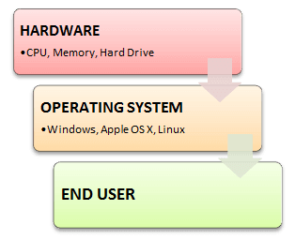

Image 1: Operating System

Reference: <https://www.guru99.com/introduction-linux.html>

## Types of Operating System (OS)

* Batch Operating System
* Multitasking/Time Sharing OS
* Multiprocessing OS
* Real Time OS
* Distributed OS
* Network OS
* Mobile OS

**Batch Operating System**

Some computer processes are very lengthy and time-consuming. To speed the same process, a job with a similar type of needs are batched together and run as a group.

The user of a batch operating system never directly interacts with the computer. In this type of OS, every user prepares his or her job on an offline device like a punch card and submit it to the computer operator.

**Multi-Tasking/Time-sharing Operating systems**

Time-sharing operating system enables people located at a different terminal(shell) to use a single computer system at the same time. The processor time (CPU) which is shared among multiple users is termed as time sharing.

**Real time OS**

A real time operating system time interval to process and respond to inputs is very small. Examples: Military Software Systems, Space Software Systems are the Real time OS example.

**Distributed Operating System**

Distributed systems use many processors located in different machines to provide very fast computation to its users.

**Network Operating System**

Network Operating System runs on a server. It provides the capability to serve to manage data, user, groups, security, application, and other networking functions.

**Mobile OS**

Mobile operating systems are those OS which is especially that are designed to power smartphones, tablets, and wearables devices.

Some most famous mobile operating systems are Android and iOS, but others include BlackBerry, Web, and watchOS.

## Functions of Operating System

Some typical operating system functions may include managing memory, files, processes, I/O system & devices, security, etc.

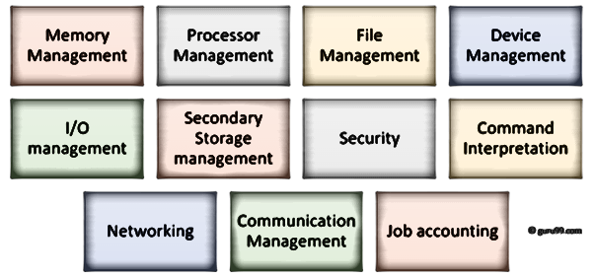

Image 2: Function of OS

Reference: <https://www.guru99.com/introduction-linux.html>

**Process management**: Process management helps OS to create and delete processes. It also provides mechanisms for synchronization and communication among processes.

**Memory management**: Memory management module performs the task of allocation and de-allocation of memory space to programs in need of this resources.

**File management:** It manages all the file-related activities such as organization storage, retrieval, naming, sharing, and protection of files.

**Device Management**: Device management keeps tracks of all devices. This module also responsible for this task is known as the I/O controller. It also performs the task of allocation and de-allocation of the devices.

**I/O System Management**: One of the main objects of any OS is to hide the peculiarities of that hardware devices from the user.

**Secondary-Storage Management**: Systems have several levels of storage which includes primary storage, secondary storage, and cache storage. Instructions and data must be stored in primary storage or cache so that a running program can reference it.

**Security**: Security module protects the data and information of a computer system against malware threat and authorized access.

**Command interpretation**: This module is interpreting commands given by the and acting system resources to process those commands.

**Networking**: A distributed system is a group of processors which do not share memory, hardware devices, or a clock. The processors communicate with one another through the network.

**Job accounting**: Keeping track of time & resource used by various job and users.

**Communication management**: Coordination and assignment of compilers, interpreters, and another software resource of the various users of the computer systems.

### Features of Operating System (OS)

* Protected and supervisor mode
* Allows disk access and file systems Device drivers Networking Security
* Program Execution
* Memory management Virtual Memory Multitasking
* Handling I/O operations
* Manipulation of the file system
* Error Detection and handling
* Resource allocation
* Information and Resource Protection

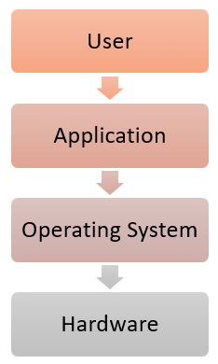

Image 3: OS

Reference: <https://www.guru99.com/introduction-linux.html>

## Advantage of Operating System

* Allows you to hide details of hardware by creating an abstraction
* Easy to use with a GUI
* Offers an environment in which a user may execute programs/applications
* The operating system must make sure that the computer system convenient to use
* Operating System acts as an intermediary among applications and the hardware components
* It provides the computer system resources with easy-to-use format
* Acts as an intermediator between all hardware’s and software’s of the system

## Disadvantages of Operating System

* If any issue occurs in OS, you may lose all the contents which have been stored in your system
* Operating system’s software is quite expensive for small size organization which adds burden on them. Example Windows
* It is never entirely secure as a threat can occur at any time

## What is Kernel in Operating System?

The kernel is the central component of a computer operating systems. The only job performed by the kernel is to the manage the communication between the software and the hardware. A Kernel is at the nucleus of a computer. It makes the communication between the hardware and software possible. While the Kernel is the innermost part of an operating system, a shell is the outermost one.

**Features of Kernel**

* Low-level scheduling of processes
* Inter-process communication
* Process synchronization
* Context switching

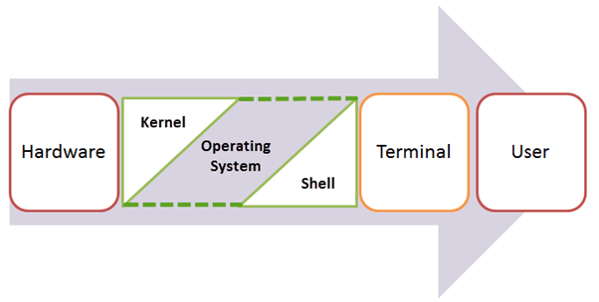

Image 4: Kernel

Reference: <https://www.guru99.com/introduction-linux.html>

**Objectives of Kernel :**

* To establish communication between user level application and hardware.
* To decide state of incoming processes.
* To control disk management.
* To control memory management.
* To control task management.

## Types of Kernel :

**1. Monolithic Kernel**

It is one of types of kernel where all operating system services operate in kernel space. It has dependencies between systems components. It has huge lines of code which is complex.

**Example:**

Unix, Linux, Open VMS, XTS-400 etc.

**Advantage:**

It has good performance.

**Disadvantage:**

It has dependencies between system component and lines of code in millions.

**2. Micro Kernel**

It is kernel types which has minimalist approach. It has virtual memory and thread scheduling. It is more stable with less services in kernel space. It puts rest in user space.

**Example :**

Mach, L4, AmigaOS, Minix, K42 etc.

**Advantage:**

It is more stable.

**Disadvantage:**

There are lots of system calls and context switches.

3. Hybrid Kernel

It is the combination of both monolithic kernel and mircrokernel. It has speed and design of monolithic kernel and modularity and stability of microkernel.

**Example :**

Windows NT, Netware, BeOS etc.

**Advantage:**

It combines both monolithic kernel and microkernel.

**Disadvantage:**

It is still similar to monolithic kernel.

**4. Exo Kernel**

It is the type of kernel which follows end-to-end principle. It has fewest hardware abstractions as possible. It allocates physical resources to applications.

**Example:**

Nemesis, ExOS etc.

**Advantage:**

It has fewest hardware abstractions.

**Disadvantage:**

There is more work for application developers.

**5. Nano Kernel**

It is the type of kernel that offers hardware abstraction but without system services. Micro Kernel also does not have system services therefore the Micro Kernel and Nano Kernel have become analogous.

**Example:**

EROS etc.

**Advantage:**

It offers hardware abstractions without system services.

**Disadvantage:**

It is quite same as Micro kernel hence it is less used.

# What is Linux Operating System?

LINUX is an operating system or a kernel distributed under an open-source license. Its functionality list is quite like UNIX. The kernel is a program at the heart of the Linux operating system that takes care of fundamental stuff, like letting hardware communicate with software.

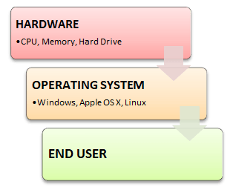

Image 5: Linux

Reference: <https://www.guru99.com/introduction-linux.html>

### Who created Linux?



Image 6: Founder of Linux

Reference: <https://www.guru99.com/introduction-linux.html>

Linux is an operating system or a kernel which germinated as an idea in the mind of young and bright **Linus Torvalds** when he was a computer science student. He used to work on the **UNIX OS (proprietary software)**and thought that it needed improvements.

However, when his suggestions were rejected by the designers of UNIX, he thought of launching an OS which will be **receptive to changes, modifications suggested by its users**.

## History of Linux

In 1991, the Linux history started with the starting of a particular project by the Finland student Linus Torvalds for creating a new free OS kernel. The final Linux Kernel was remarked by continuous development throughout the history since then.

* Linux was proposed by the Finland student Linus Torvalds in 1991.
* HP-UX (Hewlett Packard) 8.0 version was published.
* Hewlett Packard 9.0 version was published in 1992.
* FreeBSD 1.0 version and NetBSD8 version was released in 1993.
* Red Hat Linux was proposed in 1994. Caldera was detected by Ransom love and Bryan Sparks and NetBSD 1.0 version published.
* HP-UX 10.0 version and FreeBSD 2.0 version was released in 1995.
* K Desktop Environment was established by Matthias Ettrich in 1996.
* HP-UX 11.0 version was released in 1997.
* The IRIX 6.5 version, i.e., the fifth SGI UNIX generation, Free BSD 3.0 version, and Sun Solaris 7 OS was released in 1998.
* The Caldera System agreement with professional services division and SCO server software division was released in 2000.
* Linus Torvalds published the Linux version 2.4 source code in 2001.
* Microsoft filed the Trademark collection against Lindows.com in 2001.
* Lindows name was modified to Linspire in 2004.
* The first publication of Ubuntu was published in 2004.
* The openSUSE project started a free distribution from the community of Novell In 2005.
* Oracle published its Red Hat distribution in 2006.
* Dell begun laptop distribution with Ubuntu which was pre-installed on it in 2007.
* Linux kernel version 3.0 was released in 2011.
* Linux-based android of Google insisted 75% of the market share of the Smartphone, based on the number of phones exported in 2013.
* Ubuntu insisted on 20000000+ users in 2014.

## Components of Linux System

Linux Operating System has primarily three components:

**Kernel:**

Kernel is the core part of Linux. It is responsible for all major activities of this operating system. It is consisting of various modules and it interacts directly with the underlying hardware. Kernel provides the required abstraction to hide low level hardware details to system or application programs.

**System Library:**

System libraries are special functions or programs using which application programs or system utilities accesses Kernel's features. These libraries implement most of the functionalities of the operating system and do not require kernel module's code access rights.

**System Utility:**

System Utility programs are responsible for doing specialized, individual level tasks.

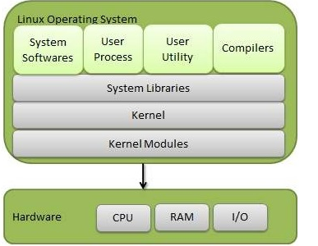

Image 7: Components of Linux

Reference: <https://www.tutorialspoint.com/operating_system/os_linux.htm>

## Basic features of Linux

**Portable** − Portability means software can works on different types of hardware in same way. Linux kernel and application programs supports their installation on any kind of hardware platform.

**Open Source** − Linux source code is freely available and it is community-based development project. Multiple teams work in collaboration to enhance the capability of Linux operating system and it is continuously evolving.

**Multi-User** − Linux is a multiuser system means multiple users can access system resources like memory/ ram/ application programs at same time.

**Multiprogramming** − Linux is a multiprogramming system means multiple applications can run at same time.

**Hierarchical File System** − Linux provides a standard file structure in which system files/ user files are arranged.

**Shell** − Linux provides a special interpreter program which can be used to execute commands of the operating system. It can be used to do various types of operations, call application programs. etc.

**Security** − Linux provides user security using authentication features like password protection/ controlled access to specific files/ encryption of data.

### Architectures of Linux Operating System

The Linux operating system's architecture mainly contains some of the components: the Kernel, System Library, Hardware layer, System, and Shell utility.

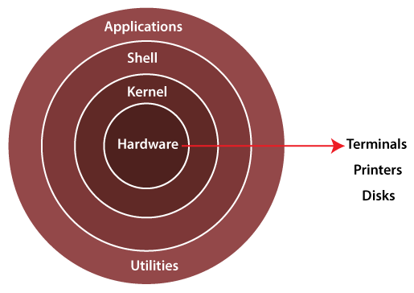

Image 8: Architecture of Linux

Reference: <https://www.javatpoint.com/architecture-of-linux>

**1. Kernel:** The kernel is one of the core sections of an operating system. It is responsible for each of the major actions of the Linux OS. This operating system contains distinct types of modules and cooperates with underlying hardware directly. The kernel facilitates required abstraction for hiding details of low-level hardware or application programs to the system. There are some of the important kernel types which are mentioned below:

* Monolithic Kernel
* Micro kernels
* Exo kernels
* Hybrid kernels

**2. System Libraries**: These libraries can be specified as some special functions. These are applied for implementing the operating system's functionality and don't need code access rights of the modules of kernel.

**3. System Utility Programs**: It is responsible for doing specialized level and individual activities.

**4. Hardware layer**: Linux operating system contains a hardware layer that consists of several peripheral devices like CPU, HDD, and RAM.

**5. Shell**: It is an interface among the kernel and user. It can afford the services of kernel. It can take commands through the user and runs the functions of the kernel. The shell is available in distinct types of OSes. These operating systems are categorized into two different types, which are the graphical shells and command-line shells.

The graphical line shells facilitate the graphical user interface, while the command line shells facilitate the command line interface. Thus, both of these shells implement operations. However, the graphical user interface shells work slower as compared to the command-line interface shells.

There are a few types of these shells which are categorized as follows:

* Korn shell
* Bourne shell
* C shell
* POSIX shell

## The Linux Kernel

The main purpose of a computer is to run a predefined sequence of instructions, known as a program. A program under execution is often referred to as a process. Now, most special purpose computers are meant to run a single process, but in a sophisticated system such a general-purpose computer, are intended to run many processes simultaneously. Any kind of process requires hardware resources such are Memory, Processor time, Storage space, etc.

In a General-Purpose Computer running many processes simultaneously, we need a middle layer to manage the distribution of the hardware resources of the computer efficiently and fairly among all the various processes running on the computer. This middle layer is referred to as the kernel. Basically, the kernel virtualizes the common hardware resources of the computer to provide each process with its own virtual resources. This makes the process seem as it is the sole process running on the machine. The kernel is also responsible for preventing and mitigating conflicts between different processes.

This schematically represented below:

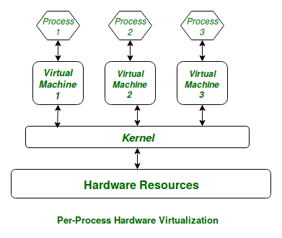

Image 9: Virtual Resources for each Process

Reference: <https://www.geeksforgeeks.org/the-linux-kernel/>

The Core Subsystems of the Linux Kernel are as follows:

* The Process Scheduler
* The Memory Management Unit (MMU)
* The Virtual File System (VFS)
* The Networking Unit
* Inter-Process Communication Unit

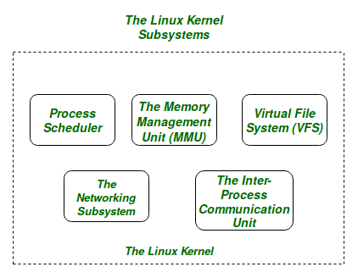

Image 10: Linux Kernel

Reference: <https://www.geeksforgeeks.org/the-linux-kernel/>

For the purpose of this article, we will only be focusing on the 1st three important subsystems of the Linux Kernel.

The basic functioning of each of the 1st three subsystems is elaborated below:

**The Process Scheduler:**

This kernel subsystem is responsible for fairly distributing the CPU time among all the processes running on the system simultaneously.

**The Memory Management Unit:**

This kernel sub-unit is responsible for proper distribution of the memory resources among the various processes running on the system. The MMU does more than just simply provide separate virtual address spaces for each of the processes.

**The Virtual File System:**

This subsystem is responsible for providing a unified interface to access stored data across different filesystems and physical storage media.

## User-interface of Linux

What is user interface in Linux?

Fundamentally, there are two different ways to work with the Linux operating system: through a graphical user interface (GUI), in which the user uses a mouse to manipulate windows. through the command line interface (CLI), in which the user types commands at a prompt.

An interface that allows users to interact with the system visually through icons, windows, or graphics is a GUI. You can use X through one of many window managers or desktop environments such as GNU Network Object Model Environment (GNOME) or Kool Desktop Environment (KDE).

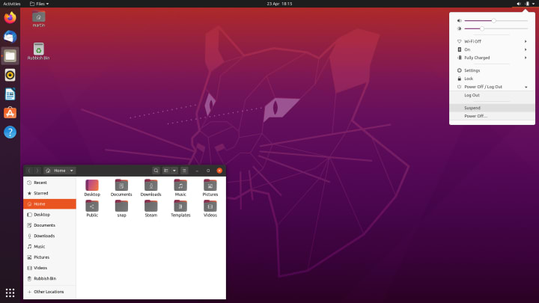

Image 11: Linux GUI

What is the user interface of an operating system?

**User interfaces**

A user interface (UI) refers to the part of an operating system, program, or device that allows a user to enter and receive information. A text-based user interface (see the image to the left) displays text, and its commands are usually typed on a command line using a keyboard.

What is difference between CLI and GUI?

CLI is that the word form used for Command Line Interface. CLI permits users to put in writing commands associate degree exceedingly in terminal or console window to interact with an operating system. … GUI stands for Graphical User Interface. GUI permits users to use the graphics to interact with an operating system.

What CLI stands for in Linux?

Command Line Interface

CLI is a command line program that accepts text input to execute operating system functions.

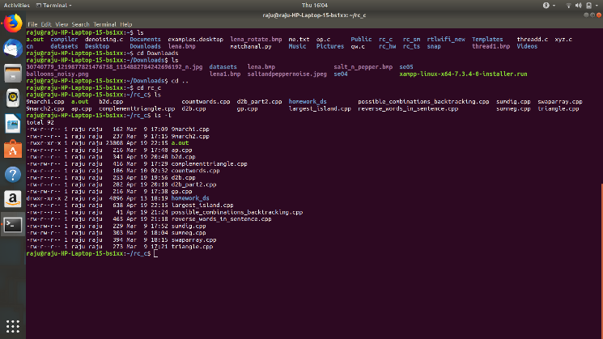

Image 12: CLI

Reference: <https://www.geeksforgeeks.org/linux-operating-system-cli-command-line-interface-and-gui-graphic-user-interface/>

## Distribution of Linux

A Linux distribution -- often shortened to "Linux distro" -- is a version of the open source Linux operating system that is packaged with other components, such as an installation programs, management tools and additional software such as the KVM hypervisor.

**Linux Distributions List**

There are on an average six hundred Linux distributors providing different features. Here, we'll discuss about some of the popular Linux distros today.

**Ubuntu**

It came into existence in 2004 by Canonical and quickly became popular. Canonical wants Ubuntu to be used as easy graphical Linux desktop without the use of command line. It is the most well-known Linux distribution. Ubuntu is a next version of Debian and easy to use for newbies. It comes with a lot of pre-installed apps and easy to use repositories libraries.

Earlier, Ubuntu uses GNOME2 desktop environment but now it has developed its own unity desktop environment. It releases every six months and currently working to expand to run on tablets and smartphones.

**Linux Mint**

Mint is based on Ubuntu and uses its repository software so some packages are common in both.

Earlier it was an alternative of Ubuntu because media codecs and proprietary software are included in mint but was absent in Ubuntu. But now it has its own popularity and it uses cinnamon and mate desktop instead of Ubuntu's unity desktop environment.

**Debian**

Debian has its existence since 1993 and releases its versions much slowly then Ubuntu and mint.

This makes it one of the most stable Linux distributors.

Ubuntu is based on Debian and was founded to improve the core bits of Debian more quickly and make it more user friendly. Every release name of Debian is based on the name of the movie Toy Story.

**Red Hat Enterprise / CentOS**

Red hat is a commercial Linux distributor. There products are red hat enterprise Linux (RHEL) and Fedora which are freely available. RHEL is well tested before release and supported till seven years after the release, whereas, fedora provides faster update and without any support.

Red hat uses trademark law to prevent their software from being redistributed. CentOS is a community project that uses red hat enterprise Linux code but removes all its trademark and make it freely available. In other words, it is a free version of RHEL and provide a stable platform for a long time.

**Fedora**

It is a project that mainly focuses on free software and provides latest version of software. It doesn't make its own desktop environment but used 'upstream' software. By default, it has GNOME3 desktop environment. It is less stable but provides the latest stuff.

### Best Command-Line Editors in Linux

Text editors are essential in any operating system and Linux is no exception. While desktop versions of various distributions are becoming more and more interactive and user-friendly, the real power of this operating system is the command line.

Linux text editors can be used for editing text files, writing codes, updating user instruction files, and more. A Linux system supports multiple text editors. There are two types of text editors in Linux, which are given below:

* Command-line text editors such as Vi, nano, pico, and more.
* GUI text editors such as gedit (for Gnome), Kwrite, and more.

**Vim**

Vim is the most common and famous text editor of the Linux world and comes installed by default (either vim or the more basic version vi) in most distributions. It has been available since 1991 and it is an improved version of the vi editor found on Unix machines.

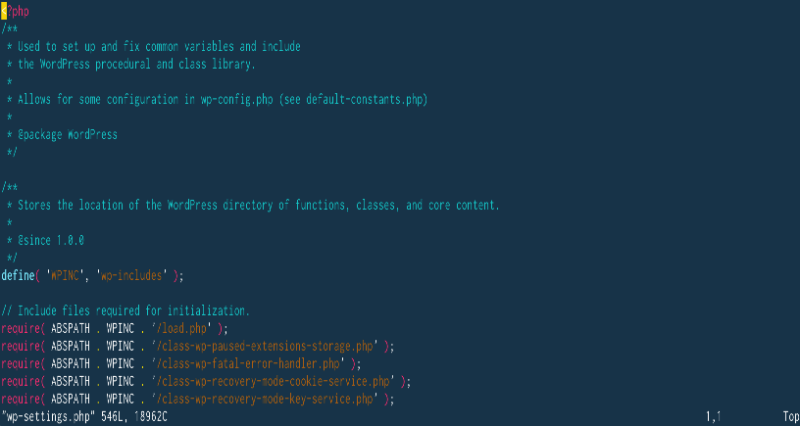

Image 13: Vim

Reference: <https://bigstep.com/blog/best-command-line-editors-in-linux>

Pros

* very powerful and fast, once you master it
* numerous advanced features
* solid and easy to find documentation for it
* it can be easily customized for various tasks, with a wide range of plugins

Cons

* famously unfriendly with new users, so most of them will have a hard time figuring out how to edit texts or even how to exit the program
* has a steep learning curve
* in order to use it effectively, you have to learn many shortcuts and commands

**Emacs**

Just like vim, emacs is a classic Unix/Linux text editor that has been around since the 1970s. The rivalry between vim and emacs users actually triggered one of the first flame wars between computer users, achieving cult status in the sysadmin and hacker culture.

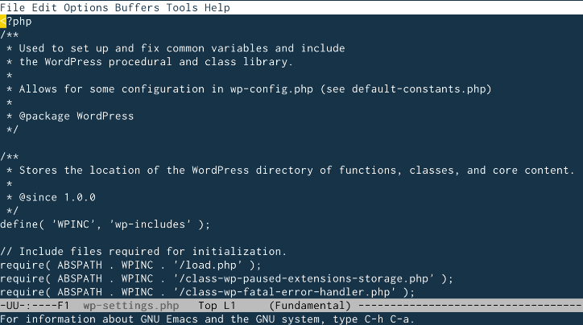

Image 14: Emacs

Reference: <https://bigstep.com/blog/best-command-line-editors-in-linux>

Pros

* very stable and fast
* many powerful features, including the Lisp programming language and even applications such as IRC clients or a package manager
* multiple users can share the same emacs instance
* online help is available directly from the editor
* has a huge collection of modules and plugins

Cons

* difficult to learn and very complex for new users
* some of the documentation is outdated

**Nano**

Nano is a development of the pico editor and was developed from the start to be user-friendly and intuitive for command-line beginners.

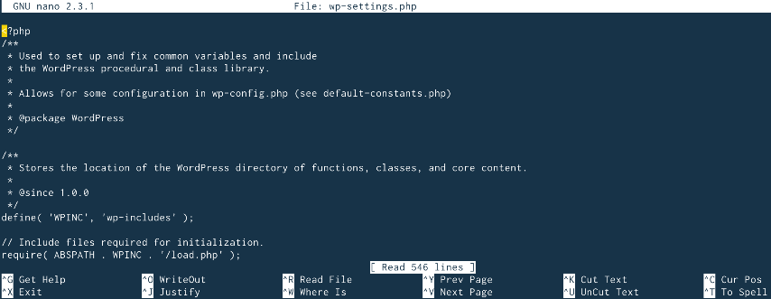

Image 15: Nano

Reference: <https://bigstep.com/blog/best-command-line-editors-in-linux>

Pros

* easy to use and learn
* quick navigation
* the most common shortcuts are displayed on the screen

Cons

* not as powerful as other editors
* intended for simple tasks

**Micro**

Micro is another user-friendly editor and actually aims to emulate the simplicity of nano, while adding more powerful features on top.

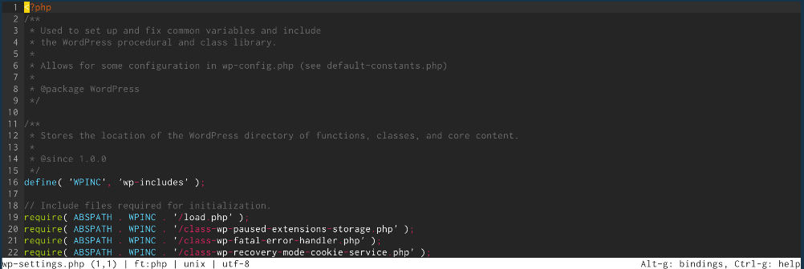

Image 16: Micro

Reference: <https://bigstep.com/blog/best-command-line-editors-in-linux>

Pros

* easy to use and install
* standard defaults and key bindings
* includes features such as a terminal emulator, syntax highlighting and many more
* advanced mouse support

Cons

* lacks some of the capabilities of vim or emacs
* needs additional packages in order to work

### Types of Users in Linux

What is a user account?

A user account is a systematic approach to track and monitor the usage of system resources. Each user account contains two unique identifiers; username and UID.

When a user account is created, its username is mapped to a unique UID.

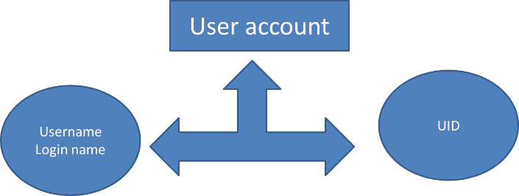

Image 17: User Account

Reference: <https://www.computernetworkingnotes.com/linux-tutorials/types-of-users-in-linux-explained-with-accounts.html>

Username is flexible. It can be changed as per requirement. Regardless it is selected first time or changed later; it must be unique in system. Two users can’t use the same username.

UID is fixed. It cannot be changed. Once assigned, it always remains the same for that user account.

Username is used to access the user account. Username is also known as login name. UID is used to authenticate, track and monitor the activity of user account. Username is used by the user while the UID is used by the system.

**Types of users**

There are three types of users in Linux: - **root, regular and service.**

**The root user account**

This is the main user account in Linux system. It is automatically created during the installation. It has the highest privilege in system. It can do any administrative work and can access any service. This account is intended for system administration and should be used only for this purpose. It should not be used for routine activities. It can’t be deleted. But if require, it can be disabled.

**The regular user account**

This is the normal user account. During the installation, one regular user account is created automatically. After the installation, we can create as many regular user accounts as we need. This account has moderate privilege. This account is intended for routine works. It can perform only the tasks for which it is allowed and can access only those files and services for which it is authorized. As per requirement, it can be disabled or deleted.

**The service account**

Service accounts are created by installation packages when they are installed. These accounts are used by services to run processes and execute functions. These accounts are neither intended nor should be used for routine work.

## Comparison of Linux with another Operating System

**Linux:**

Linux could be a free and open supply OS supported operating system standards. It provides programming interface still as programmed compatible with operating system primarily based systems and provides giant selection applications. A UNIX operating system additionally contains several severally developed parts, leading to UNIX operating system that is totally compatible and free from proprietary code.

**Windows:**

Windows may be a commissioned OS within which ASCII text file is inaccessible. it’s designed for the people with the angle of getting no programming information and for business and alternative industrial users. it’s terribly straightforward and simple to use.

The distinction between Linux and Windows package is that Linux is completely freed from price whereas windows is marketable package and is expensive. Associate operating system could be a program meant to regulate the pc or computer hardware Associate behave as an treater between user and hardware.

Linux is a open supply package wherever users will access the ASCII text file and might improve the code victimization the system. On the opposite hand, in windows, users can’t access ASCII text file, and it’s a authorized OS.

| **S.NO** | **Linux** | **Windows** |
| --- | --- | --- |
| 1. | Linux is a open source operating system. | While windows are the not the open source operating system. |
| 2. | Linux is free of cost. | While it is costly. |
| 3. | It’s file name case-sensitive. | While its file name is case-insensitive. |
| 4. | In Linux, monolithic kernel is used. | While in this, micro kernel is used. |
| 5. | Linux is more efficient in comparison of windows. | While windows are less efficient. |
| 6. | There is forward slash is used for Separating the directories. | While there is back slash is used for Separating the directories. |
| 7. | Linux provides more security than windows. | While it provides less security than Linux. |
| 8. | Linux is widely used in hacking purpose-based systems. | While windows does not provide much efficiency in hacking. |

## Advantages and disadvantages of Linux operating system

Advantages of Linux operating system

**Open source:**

Linux is an open-source OS that means anyone can see the source code and change it according to his needs. You can freely install Linux on many computers without getting paid license. If we compare this with windows or mac then they are paid operating systems. You have to get license of windows and mac to use on your machine.

**No anti-virus software needed:**

In Linux, you do not need anti-virus software to be installed on your PC. Linux has fewer chances to be affected with virus. The reason for strong virus protection is that Linux has large number of open-source developers which keeps an eye on virus-related stuff. If any source code needs to be updated then it is done in no time.

**Text editors:**

Linux has a vast range of text editors available. If you are a programmer then you can pick any of free software packages like visual studio code, Vim, Atom etc. Most of text editors are freely available and you can use it without any issue.

**Powerful command prompt:**

Command prompt in Linux is very advanced and if you are developer then you can perform most of your work using the command-line interface. You can install different repositories and packages through the command-line interface.

**No reboot needed:**

If you are windows user then you have seen system reboot while you install/uninstall any software or rebooting when the system becomes slow. But in case of Linux, you do not need to reboot your system in such cases.

**Low system specifications:**

If you have an old computer that has low specification then you can still run Linux. Linux has different distributions that are available for all types of computers e.g. large scale computers, servers, Pc etc.

**Good at multitasking:**

If you want to do some batch works like printing a large file or downloading large file then you can concurrently perform other tasks like typing or coding any program. Linux is good in doing such multitasking and your system will not slow down.

**Less disk space needed:**

If you have limited disk space then you can still run Linux. You do not need extra disk space for running Linux for a longer time.

**File formats:**

Linux supports a large number of file formats. So you have to not worry if any file format does not run on Linux. You can install different software packages for specific file format and it will work fine.

**Disadvantages of Linux operating system**

**Hardware drivers:**

One of the issues that most Linux users face is that some hardware drivers are not available for Linux. Hardware companies prefer to make drivers for windows or mac because they have more users as compared to Linux.

**Learning curve:**

Getting started with windows is easy for beginners but learning Linux is difficult. You have to learn about the command-line interface and searching for new software is also little bit difficult. If you face any problem in the operating system then finding solution is problematic. There are fewer experts for Linux as compared to windows and mac.

**Software alternative:**

Take an example of Photoshop which is a popular graphic editing tool. Photoshop is available for windows but is not present in Linux. There are other photo editing tools but Photoshop is a more powerful tool than others. MS office is another example which is not available for Linux users.

**Games:**

Most of the games are made for windows but not Linux. As windows platform is widely used so game developers have more interest in windows.

# Familiarization with GUI environment

## What is Graphical User Interface (GUI)?

GUI is an interface that allows users to interact with different electronic devices using icons and other visual indicators. The graphical user interfaces were created because command line interfaces were quite complicated and it was difficult to learn all the commands in it.

In today’s times, graphical user interfaces are used in many devices such as mobiles, MP3 players, gaming devices, smartphones etc.

The below diagram provides the position of the graphical user interface with respect to the computer system

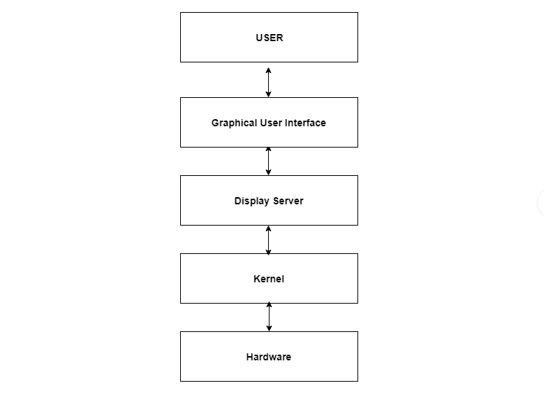

Image 18: GUI

Reference: <https://www.tutorialspoint.com/graphical-user-interface-gui>

**Elements in Graphical User Interface**

Graphical User Interface makes use of visual elements mostly. These elements define the appearance of the GUI. Some of these are described in detail as follows −

**Window**

This is the element that displays the information on the screen. It is very easy to manipulate a window. It can be opened or closed with the click of an icon. Moreover, it can be moved to any area by dragging it around. In a multitasking environment, multiple windows can be open at the same time, all of them performing different tasks.

There are multiple types of windows in a graphical user interface, such as container window, browser window, text terminal window, child window, message window etc.

The below diagram provides the position of the graphical user interface with respect to the computer system

**Menu**

A menu contains a list a choice and it allows users to select one from them. A menu bar is displayed horizontally across the screen such as pull-down menu. When any option is clicked in this menu, then the pull-down menu appears.

Another type of menu is the context menu that appears only when the user performs a specific action. An example of this is pressing the right mouse button. When this is done, a menu will appear under the cursor.

**Icons**

Files, programs, web pages etc. can be represented using a small picture in a graphical user interface. This picture is known as an icon. Using an icon is a fast way to open documents, run programs etc. because clicking on them yields instant access.

**Controls**

Information in an application can be directly read or influences using the graphical control elements. These are also known as widgets. Normally, widgets are used to display lists of similar items, navigate the system using links, tabs etc. and manipulating data using check boxes, radio boxes etc.

**Tabs**

A tab is associated with a view pane. It usually contains a text label or a graphical icon. Tabs are sometimes related to widgets and multiple tabs allow users to switch between different widgets. Tabs are used in various web browsers such as Internet Explorer, Firefox, Opera, Safari etc. Multiple web pages can be opened in a web browser and users can switch between them using tabs.

## Top 10 Linux Desktop Environments

**1. GNOME**

The most standard Linux desktop environment is GNOME. GNOME is the default environment of various platforms like Fedora etc. Whether it is the touch-based devices or traditional PCs, GNOME design suits both at the same time. A single board similar to the mobile device is fixed on top of the screen. Functioning over the Activities Overview rather than a dock or window list, these overviews display different apps, open the software, and numerous desktops.

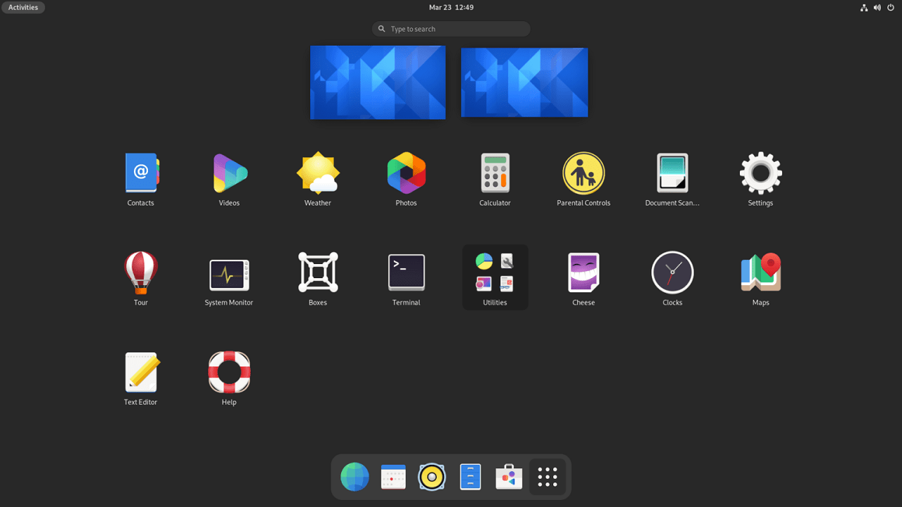

Image 19: GNOME - A Linux Desktop Environment

Reference: <https://www.tecmint.com/best-linux-desktop-environments/>

Main Features:

* User-friendly user interface
* Has the ability to modify their functionalities using shell extension of GNOME
* Extremely customizable

**2. KDE Plasma**

KDE is another foremost prevalent Linux desktop environment. The standard applications feature comes with every desktop interface. Under the KDE applications list, KDE maintains a set of applications, this can be accessed over “apps.kde.org”. The set comprises applications of all categories, from development tools and games to graphics and firewalls/security.

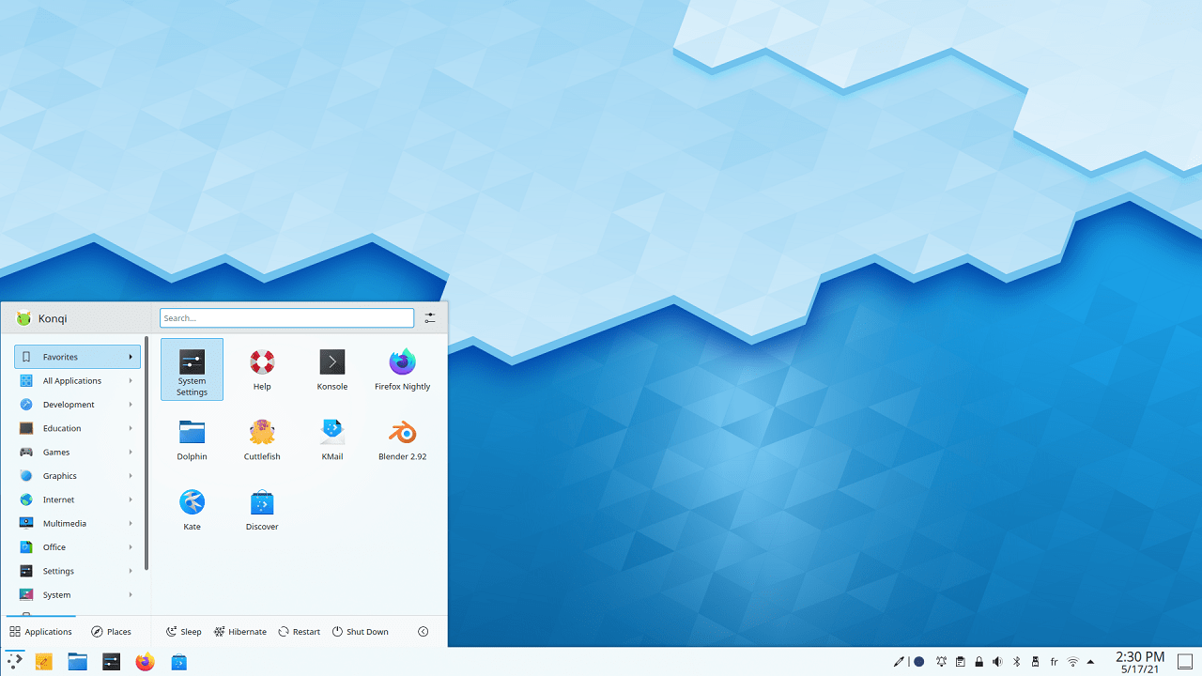

Image 20: KDE – A Linux Desktop Environment

Reference: <https://www.tecmint.com/best-linux-desktop-environments/>

**Main Features:**

* It is lightweight and extremely customizable.
* Easy to use
* Contains useful built-in tools

**3. Unity**

Unity is known as “Graphical User Interface” and is used for the GNOME environment. Project of Unity was begun by “Mark Shuttleworth and Canonical”, as these are the producers of the most popular Linux distribution i.e. Ubuntu. The aim of Unity is to offer desktop or netbook clients a steady, rich experience of computing.

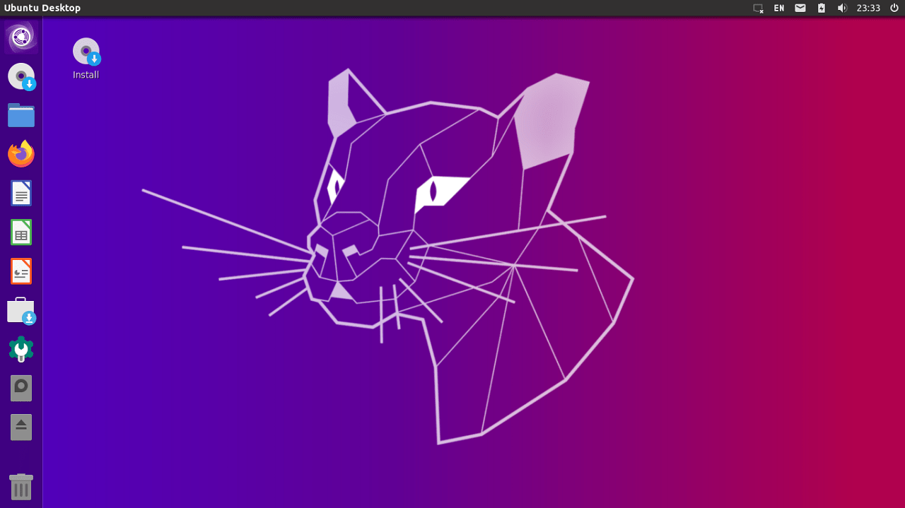

Image 21: UNITY - A Linux Desktop Environment

Reference: <https://www.tecmint.com/best-linux-desktop-environments/>

**Main Features:**

* It has a file manager as well as a window manager named Nautilus, Compiz respectively.
* It has a lens in order to send search queries to scope.
* It also gives information on various settings of the system i.e. power, sound, brightness, active session, etc.

**4. MATE**

The extension of GNOME 2 is MATE, which is quite an instinctive and likable desktop interface. MATE is not only operating on Linux but it also entertains many different Unix-like systems. Caja file manager, Mate terminal, and others are the default applications in MATE. Developers of MATE created applications from scratch for the environment of MATE. However, like Linux Mint, developers of MATE have additionally forked numerous main applications of GNOME in order to coordinate with MATE appropriately. X-Apps is also one of the applications used in MATE.

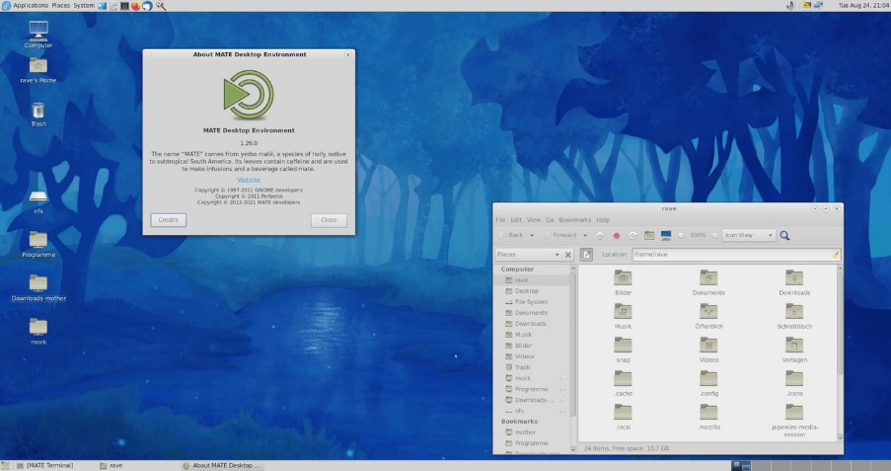

Image 22: MATE - A Linux Desktop Environment

Reference: <https://www.tecmint.com/best-linux-desktop-environments/>

**Main Features:**

* User-friendly
* It is a lightweight and fast environment

**5. Cinnamon**

The most commonly used variant of Linux and Linux Mint is Cinnamon. While the interface was suffering from drastic changes, Cinnamon began as a fork of GNOME. The appealing feature of Cinnamon is the traditional touch which helps long-time Windows users at ease. The attraction for users is the familiarity and friendly user interface. This makes Cinnamon a mixture of innovative ideas with a traditional touch in setups making it smooth for users yet carrying modern facilities.

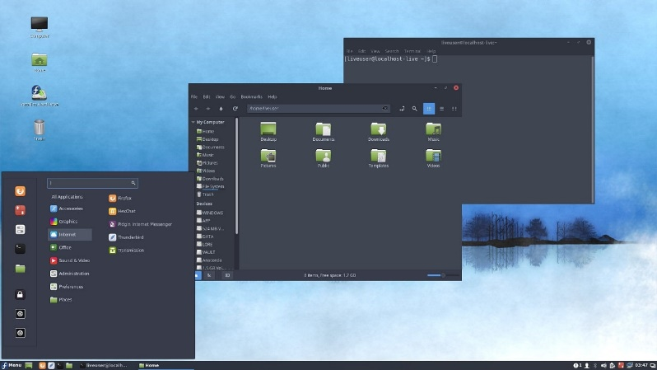

Image 23: Cinnamon – A Linux Desktop Environment

Reference: <https://www.tecmint.com/best-linux-desktop-environments/>

**Main Features:**

* Easy to use and customizable
* Polished UI
* Snappy and fast

**6. Budgie**

Next, we are talking about budgie which is another desktop environment created through the project of Solus. Solus utilizes package manager i.e “eopkg”. GNOME can also be used to execute a Budgie desktop environment on old as well as modern machines.

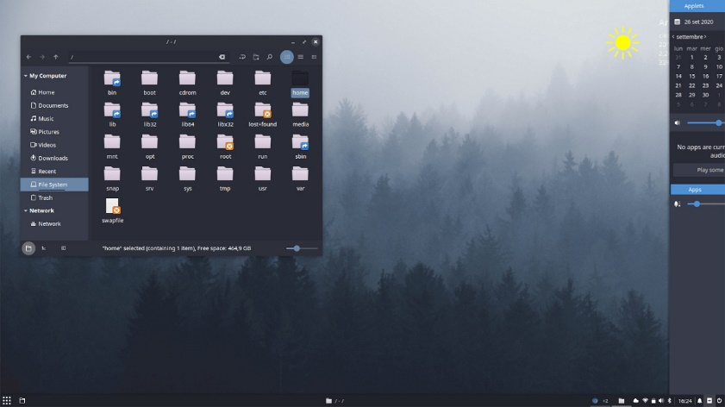

Image 24: BUDGIE - A Linux Desktop Environment

Reference: <https://www.tecmint.com/best-linux-desktop-environments/>

**Main Features:**

* It has a modern and elegant user interface
* Organizes windows easily
* Efficient performance in general tasks
* Use less memory

**7. LXQT**

LXQT is the new version of LXDE used for cloud servers and old hardware due to minimum consumption of RAM and CPU. It is the replacement of LXDE. LXQT is the default environment on various distros such as Lubuntu and a few more.

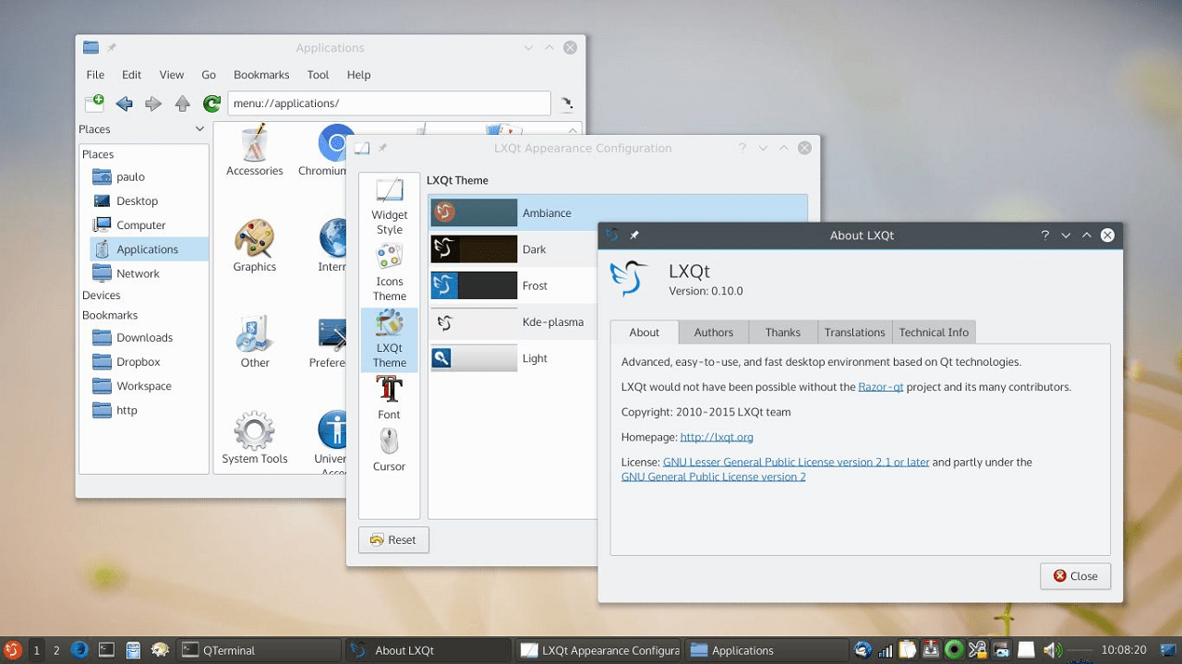

Image 25: LXQT - A Linux Desktop Environment

Reference: <https://www.tecmint.com/best-linux-desktop-environments/>

**Main Features:**

* It has the ability to support various languages
* It is an open-source, most simple desktop environment.
* Fast and lightweight.
* Supports components of saving integrated energy and also supports numerous shortcuts of the keyboard.

**8. XFCE**

Xfce supports considerable Linux distributions. It is a lightweight desktop environment but gives full-featured UX. Xfce does not support advanced customizations but it is the best desktop environment in terms of performance-centric.

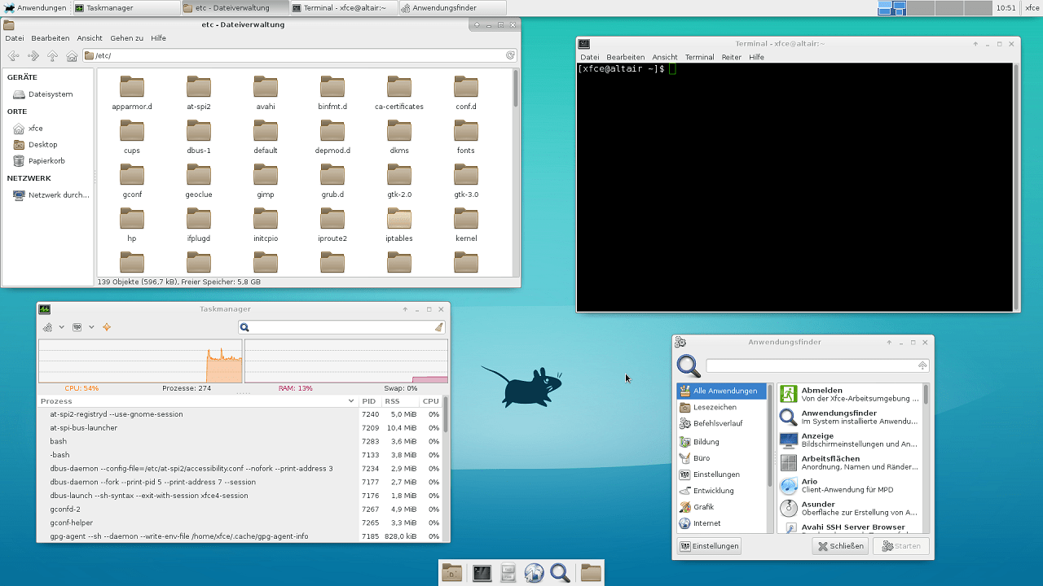

Image 26: XFCE – A Linux Desktop Environment

Reference: <https://www.tecmint.com/best-linux-desktop-environments/>

**Main Features:**

* Simpler open-source desktop environment
* Easily adaptable in old machines/hardware.
* It has a file manager as well as a window manager named Thunar, Xfwm respectively.
* It also has a desktop manager in order to put background images, icons, etc.
* Fast, lightweight, and efficient on resources.

**9. Deepin**

A modest, yet elegant desktop environment for Linux is Deepin. The good thing is, it works with other numerous Linux in line distributions like Arch Linux, Manjaro, and much more. Moreover, it is equipped with a carefully designed and easy-to-use interface making it most productive. Besides, the standard system makes it with fewer configurations the ultimate user-friendly system. Major configurations are created from a pop-up panel from the outside. However, like the Pantheon desktop environment, users can also execute their applications from the dock which is at the bottom of the screen.

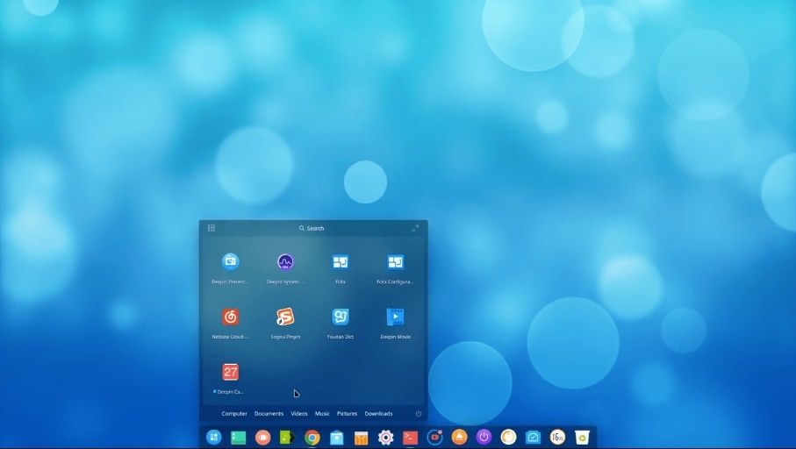

Image 27: Deepin Linux environment

Reference: <https://www.tecmint.com/best-linux-desktop-environments/>

**Main Features:**

* It contains polished animations and eye candy UI.
* User-friendly
* Reliable and safe

**10. LXDE**

LXDE is another most lightweight desktop environment. As it keeps low usage of resources, it utilizes minimal memory as compared to other desktop environments. However, LXDE is best suited for cloud computers that have old specifications like MIDs, netbooks, or old hardware. LXDE saves energy, also supports keyboard shortcuts and multi-language.

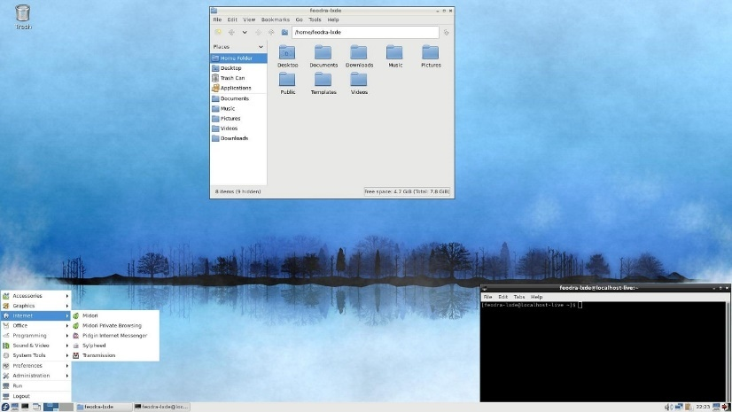

Image 28: LXDE

Reference: <https://www.tecmint.com/best-linux-desktop-environments/>

**Main Features:**

* Faster in performance and lightweight
* Energy-efficient environment
* Customizable for old hardware

## CLI vs GUI

**What is CLI?**

CLI, or Command Line Interface, is a text-based interface used to interact with software and operating system by typing commands into the interface and receive a response in the same way.

CLIs are provided by most operating systems by default and the two most popular ones are DOS (for Windows) and the bash shell (for Linux and OS X).

**What is GUI?**

GUI, or Graphical User Interface, is a visual-based interface which features the use of graphic images, including windows, icons, and menus. A mouse is the most common way to navigate through a GUI, although the keyboard is used sometimes.

**Advantages and disadvantages of CLI and GUI**

**1. Ease of use**

Because of the visual presentation, most people can learn and use GUI much faster and easier than CLI which requires a higher degree of memorization and familiarity.

For example, GUIs provide the user with immediate visual feedback in most cases, whereas there is often no obvious feedback in the case of CLIs.

**2. Functionality**

A GUI does not have the same level of functionality and granular control as a command line interface. So the CLI provides greater flexibility of use. It can be used to easily do things that are difficult or even impossible to do with a GUI.

**3. Speed**

A GUI needs to use additional system resources to load the graphical part thus it is going to be slower than using the command line.

**4. Multitasking**

Although many CLI offers multiple windows view, GUI generally has a higher ability to operate multiple tasks at the same time with ease.

**5. Scripting & Automation**

With a CLI, users have all the control over the file system and operating system, and the tasks become simple. You can create a script that contains a few lines of command and it will do the work for you.

Although GUI’s can create shortcuts, they do not readily support scripting or automation. For common tasks, a user must repeat each action within the GUI manually.

**When to use CLI:**

* Do things at scale. A simple CLI command can easily adjust configurations for a large group of systems at once.
* Something needs to be scripted and automated.
* You need greater control over system functions.
* Use NPM for Package Installs as Node Package Manager is easily the most popular tool for modern developers and it does not have a GUI.
* Utilize Git Version Control.
* For less memory usage.

**When to use GUI:**

* To reduce mental work. It can take care of a lot of work which may be obscure.
* Simplify the structure of tasks. Tasks can be done without many lines of code. Fewer typed lines of code lead to fewer typos, thus less time spending on the frustrating errors.
* Make results visible. You can see the system response clearly then recognize errors and debug easily while the system reaction in CLI is meaningless most of the times.
* Make the barrier of entry lower. Because of its simplicity and ease of use, GUI is being used by the majority of computer users, especially new and novice users.

# Syntax of shell commands

## Linux directory structure

Linux is based on UNIX and hence it borrows its filesystem hierarchy from UNIX. You’ll fine a similar directory structure in UNIX-like operating systems such as BSD and macOS. I’ll be using the term Linux hereafter instead of UNIX though.

**/ – The root directory**

Everything, all the files and directories, in Linux are located under ‘root’ represented by ‘/’. If you look at the directory structure, you’ll realize that it is similar to a plant’s root.

[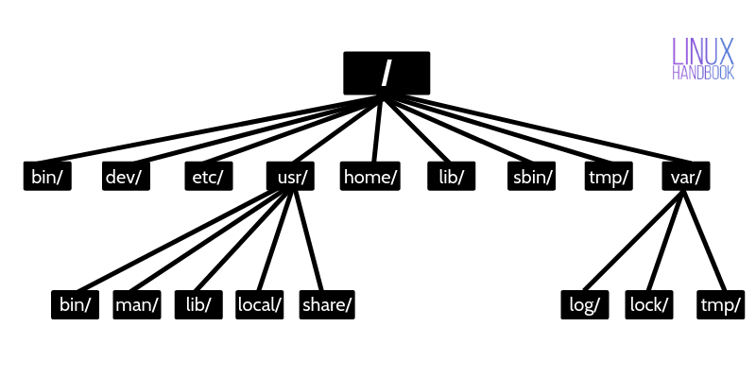](https://linuxhandbook.com/content/images/2020/06/linux-directory-structure.png)

Image 29: Linux Directory Structure

Since all other directories or files are descended from root, the absolute path of any file is traversed through root. For example, if you have a file in /home/user/documents, you can guess that the directory structure goes from root->home->user->documents.

* The /bin directory stores many utilities of Linux
* The /dev directory stores all the device-related files for the system
* The /etc directory stores the os related data which users and the os need to refer to, such as the passwd file
* The /lib directory contains libraries of data for the compilers installed in the Linux operating system, for examples, the C language routines
* The /home directory generally contains all the HOME directories of users
* the /usr directory stores the os files that are not involved in the boot process,
* The /var directory has information specific to different utilities of Linux.

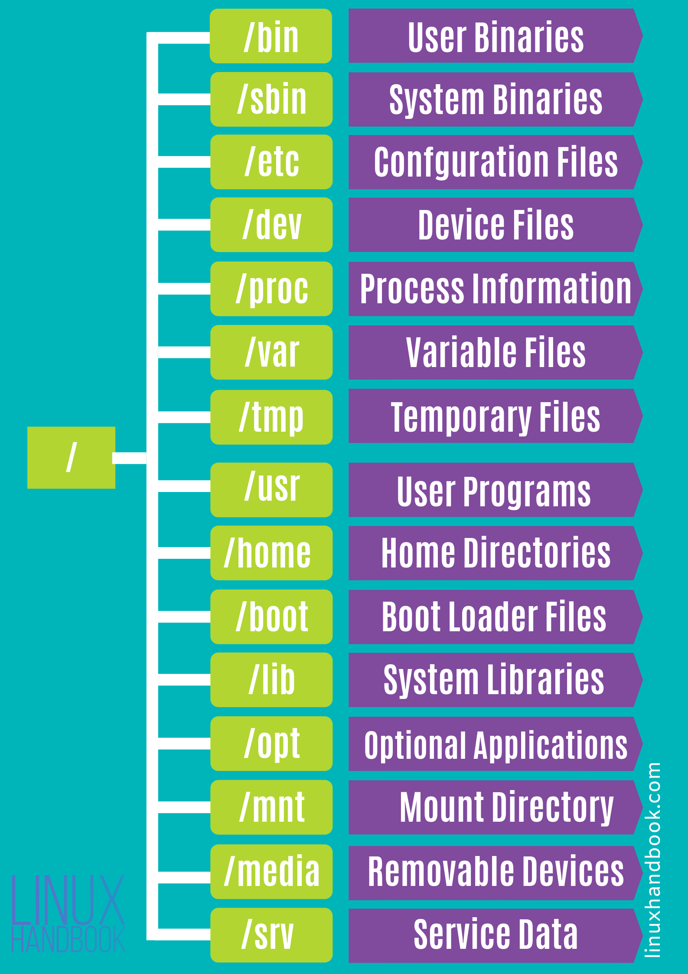

Image 30: Directory files

Reference: <https://www.geeksforgeeks.org/linux-directory-structure/>

## Types of Files in Linux

In Linux system, everything is a file and if it is not a file, it is a process. A file doesn't include only text files, images and compiled programs but also include partitions, hardware device drivers and directories. Linux consider everything as file.

Files are always case sensitive. Let's understand it through an example.

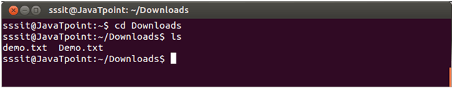

In above example, we have two files named as 'Demo.txt' and 'demo.txt'. Although, they both share the same name but still they are two different files.

**Types of Files:**

**Regular files (-):** It contain programs, executable files and text files.

**Directory files (d):** It is shown in blue color. It contains list of files.

**Special files**

* **Block file (b)**
* **Character device file (c)**
* **Named pipe file (p)**
* **Symbolic link file (l)**
* **Socket file (s)**

## What are Shell Commands?

The shell is the Linux command line interpreter. It provides an interface between the user and the kernel and executes programs called commands. For example, if a user enters ls then the shell executes the ls command. The shell can also execute other programs such as applications, scripts, and user programs (e.g., written in c or the shell programming language).

### What is Shell?

A shell is special user program which provide an interface to user to use operating system services. Shell accepts human readable commands from user and convert them into something which kernel can understand. It is a command language interpreter that execute commands read from input devices such as keyboards or from files. The shell gets started when the user logs in or start the terminal.

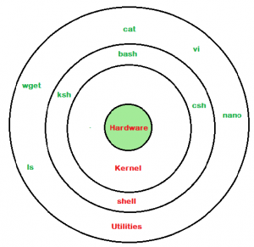

Image 31: Shell

Reference: <https://www.geeksforgeeks.org/basic-shell-commands-in-linux/>

## What are the types of shell commands?

SHELL is a program which provides the interface between the user and an operating system. When the user logs in OS starts a shell for user. Kernel controls all essential computer operations, and provides the restriction to hardware access, coordinates all executing utilities, and manages Resources between process. Using kernel only user can access utilities provided by operating system.

**Types of Shell:**

**The C Shell**

Denoted as csh

Bill Joy created it at the University of California at Berkeley. It incorporated features such as aliases and command history. It includes helpful programming features like built-in arithmetic and C-like expression syntax.

In C shell:

**Command full-path name is /bin/csh,**

**Non-root user default prompt is hostname %,**

**Root user default prompt is hostname #.**

**The Bourne Shell**

Denoted as sh

It was written by Steve Bourne at AT&T Bell Labs. It is the original UNIX shell. It is faster and more preferred. It lacks features for interactive use like the ability to recall previous commands. It also lacks built-in arithmetic and logical expression handling. It is default shell for Solaris OS.

For the Bourne shell the:

**Command full-path name is /bin/sh and /sbin/sh,**

**Non-root user default prompt is $,**

**Root user default prompt is #.**

**The Korn Shell**

It is denoted as ksh

It Was written by David Korn at AT&T Bell LabsIt is a superset of the Bourne shell.So it supports everything in the Bourne shell.It has interactive features. It includes features like built-in arithmetic and C-like arrays, functions, and string-manipulation facilities.It is faster than C shell. It is compatible with script written for C shell.

For the Korn shell the:

**Command full-path name is /bin/ksh,**

**Non-root user default prompt is $,**

**Root user default prompt is #.**

**GNU Bourne-Again Shell**

Denoted as bash

It is compatible to the Bourne shell. It includes features from Korn and Bourne shell.

For the GNU Bourne-Again shell the:

**Command full-path name is /bin/bash,**

**Default prompt for a non-root user is bash-g.gg$**

**(g.ggindicates the shell version number like bash-3.50$),**

**Root user default prompt is bash-g.gg#.**

## What is Command Line Interface (CLI)?

The Command Line Interface (CLI), is a non-graphical, text-based interface to the computer system, where the user types in a command and the computer then successfully executes it. The Terminal is the platform or the IDE that provides the command line interface (CLI) environment to the user.

CLI is still used by software developers and system administrators to configure computers, install software, and access features that are not available in the graphical interface.

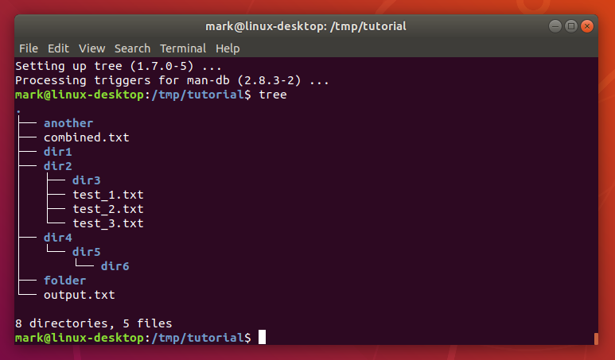

Image 32: CLI

Reference: <https://www.geeksforgeeks.org/basic-shell-commands-in-linux/>

## Basic Shell Commands in Linux

A shell is a special user program that provides an interface to the user to use operating system services. Shell accepts human-readable commands from the user and converts them into something which the kernel can understand. It is a command language interpreter that executes commands read from input devices such as keyboards or from files. The shell gets started when the user logs in or starts the terminal.

**Basic Linux Commands**

* ls – List directory contents. ...
* cd /var/log – Change the current directory. ...
* grep – Find text in a file. ...
* su / sudo command – There are some commands that need elevated rights to run on a Linux system. ...
* pwd – Print Working Directory. ...
* passwd – ...
* mv – Move a file. ...
* cp – Copy a file.

### Displaying the file contents on the terminal:

* **cat**: It is generally used to concatenate the files. It gives the output on the standard output.
* **more**: It is a filter for paging through text one screenful at a time.
* **less**: It is used to viewing the files instead of opening the file. Similar to *more* command but it allows backward as well as forward movement.
* **head** : Used to print the first N lines of a file. It accepts N as input and the default value of N is 10.
* **tail** : Used to print the last N-1 lines of a file. It accepts N as input and the default value of N is 10.

### File and Directory Manipulation Commands:

* **mkdir** : Used to create a directory if not already exist. It accepts the directory name as an input parameter.
* **cp** : This command will copy the files and directories from the source path to the destination path. It can copy a file/directory with the new name to the destination path. It accepts the source file/directory and destination file/directory.
* **mv** : Used to move the files or directories. This command’s working is almost similar to *cp* command but it deletes a copy of the file or directory from the source path.
* **rm** : Used to remove files or directories.
* **touch** : Used to create or update a file.

### Extract, sort, and filter data Commands:

* **grep** : This command is used to search for the specified text in a file.
* **grep with Regular Expressions**: Used to search for text using specific regular expressions in file.
* **sort** : This command is used to sort the contents of files.
* **wc** : Used to count the number of characters, words in a file.
* **cut** : Used to cut a specified part of a file.

### Basic Terminal Navigation Commands:

* [**ls**](https://www.geeksforgeeks.org/practical-applications-ls-command-linux/) : To get the list of all the files or folders.
* **ls -l:**Optional flags are added to **ls**to modify default behavior, listing contents in extended form **-l**is used for **“long” output**
* **ls -a:**Lists of all files including the hidden files, add **-a  flag**
* [**cd**](https://www.geeksforgeeks.org/cd-command-in-linux-with-examples/): Used to change the directory.
* [**du**](https://www.geeksforgeeks.org/du-command-linux-examples/): Show disk usage.
* [**pwd**](https://www.geeksforgeeks.org/pwd-command-in-linux-with-examples/): Show the present working directory.
* [**man**](https://www.geeksforgeeks.org/man-command-in-linux-with-examples/): Used to show the manual of any command present in Linux.
* [**rmdir**](https://www.geeksforgeeks.org/rmdir-command-in-linux-with-examples/): It is used to delete a directory if it is empty.
* [**ln**](https://www.geeksforgeeks.org/ln-command-in-linux-with-examples/)**file1 file2**: Creates a physical link.
* [**ln**](https://www.geeksforgeeks.org/ln-command-in-linux-with-examples/)**-s file1 file2**: Creates a symbolic link.
* [**locate:**](https://www.geeksforgeeks.org/locate-command-in-linux-with-examples/)It is used to locate a file in Linux System
* [**echo:**](https://www.geeksforgeeks.org/echo-command-in-linux-with-examples/)This command helps us move some data, usually text into a file.
* [**df:**](https://www.geeksforgeeks.org/df-command-linux-examples/)It is used to see the available disk space in each of the partitions in your system.
* [**tar:**](https://www.geeksforgeeks.org/tar-command-linux-examples/)Used to work with tarballs (or files compressed in a tarball archive)

### File Permissions Commands:

The *chmod*and *chown*commands are used to control access to files in UNIX and Linux systems.

* [**chown**](https://www.geeksforgeeks.org/chown-command-in-linux-with-examples/) : Used to change the owner of the file.
* [**chgrp**](https://www.geeksforgeeks.org/chgrp-command-in-linux-with-examples/) : Used to change the group owner of the file.
* [**chmod**](https://www.geeksforgeeks.org/chmod-command-linux/) : Used to modify the access/permission of a user.

### What is the use of shell command?

A shell is a computer program that presents a command line interface which allows you to control your computer using commands entered with a keyboard instead of controlling graphical user interfaces (GUIs) with a mouse/keyboard/touchscreen combination.

# Shell scripting

## What is shell scripting?

A system administrator should have a little knowledge about scripting to understand how their servers and applications are started, upgraded, maintained or removed and to understand how a user environment is built.

Shell provides users with an interface and accepts human-readable commands into the system and executes those commands which can run automatically and give the program’s output in a shell script.

Shell Scripting is an open-source computer program designed to be run by the Unix/Linux shell.

Shell Scripting is a program to write a series of commands for the shell to execute. It can combine lengthy and repetitive sequences of commands into a single and simple script that can be stored and executed anytime which, reduces programming efforts.

An Operating is made of many components, but its two prime components are –

* Kernel
* Shell

A Kernel is at the nucleus of a computer. It makes the communication between the hardware and software possible. While the Kernel is the innermost part of an operating system, a shell is the outermost one.

* A shell in a Linux operating system takes input from you in the form of commands, processes it, and then gives an output. It is the interface through which a user works on the programs, commands, and scripts. A shell is accessed by a terminal which runs it.
* When you run the terminal, the Shell issues a command prompt (usually $), where you can type your input, which is then executed when you hit the Enter key. The output or the result is thereafter displayed on the terminal.
* The Shell wraps around the delicate interior of an Operating system protecting it from accidental damage. Hence the name Shell.

## Types of Shell

There are two main shells in Linux:

**1. The Bourne Shell:** The prompt for this shell is $ and its derivatives are listed below:

* POSIX shell also is known as sh
* Korn Shell also knew as sh
* Bourne Again SHell also knew as bash (most popular)

**2. The C shell:** The prompt for this shell is %, and its subcategories are:

* C shell also is known as csh
* Tops C shell also is known as tcsh

A shell script comprises following elements –

* Shell Keywords – if, else, break etc.
* Shell commands – cd, ls, echo, pwd, touch etc.
* Functions
* Control flow – if..then..else, case and shell loops etc.

## Editors

### VI Editor

**What is the VI editor?**

The VI editor is the most popular and classic text editor in the Linux family. Below, are some reasons which make it a widely used editor –

* It is available in almost all Linux Distributions
* It works the same across different platforms and Distributions
* It is user-friendly. Hence, millions of Linux users love it and use it for their editing needs

**sudo apt install vim**

**VI Editor Insert mode:**

* This mode is for inserting text in the file.
* You can switch to the Insert mode from the command mode by pressing ‘i’ on the keyboard
* Once you are in Insert mode, any key would be taken as an input for the file on which you are currently working.
* To return to the command mode and save the changes you have made you need to press the Esc key

**How to use vi editor**

To launch the VI Editor -Open the Terminal (CLI) and type

**vi <filename_NEW> or <filename_EXISTING>**

And if you specify an existing file, then the editor would open it for you to edit. Else, you can create a new file.

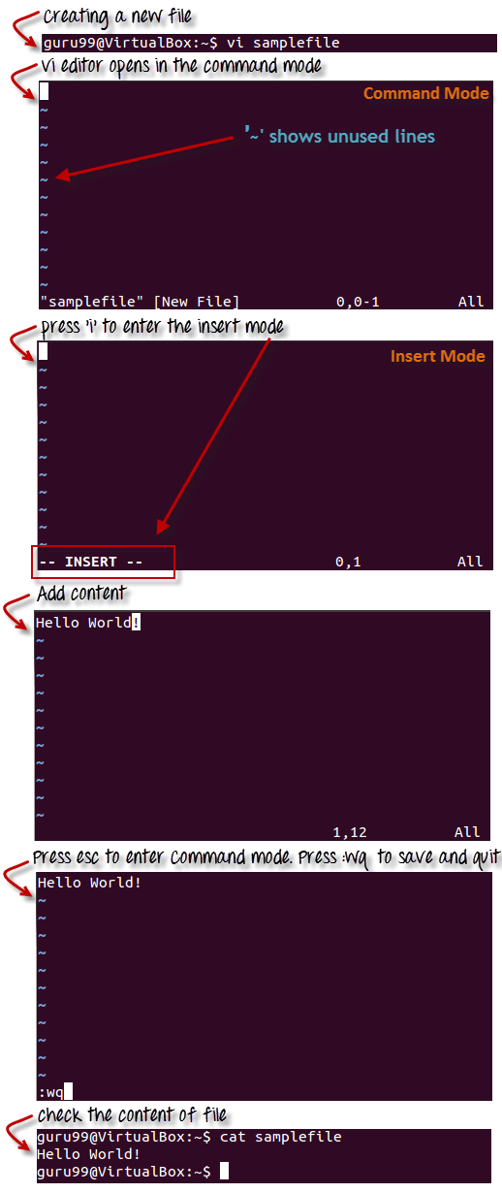

Image 33: Vi

Reference: <https://www.guru99.com/the-vi-editor.html>

**Steps to write and execute a script**

* Open the terminal. Go to the directory where you want to create your script.
* Create a file with .sh extension.
* Write the script in the file using an editor.
* Make the script executable with command chmod +x <fileName>.
* Run the script using ./<fileName>.

### Nano Editor

Nano is the most fundamental, command-line-based text editor for Linux. It has all common text editor features, including highlighting syntaxes, multiple buffers, scanning and replacement with regular expression support, type corrections, and UTF-8 encoding.

**How to Install Nano Text Editor**

In most Linux distributions, nano is normally supported by default but if it is not, use the next commands to install it.

In the Debian/Ubuntu system:

**$sudo apt install nanoIn the CentOS/Fedora system:**

**$yum install nano**

**How to Save and Exit Nano**

**Save Nano Command:** Ctrl+O will save the modifications you've made to the file. When you save the file, it will be generated if it does not already exist.

**Exit Nano Command:** Ctrl+X will close nano. If any patches haven't been saved yet into your system, you'll be prompted to do so.

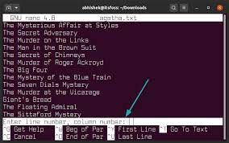

Image 34: Nano

Reference: <https://www.javatpoint.com/linux-nano-editor>

## Why do we need shell scripts?

There are many reasons to write shell scripts

* To avoid repetitive work and automation
* System admins use shell scripting for routine backups
* System monitoring
* Adding new functionality to the shell etc.

## What is Bash?

Bash or Shell is a command line tool that is used in open science to efficiently manipulate files and directories.

BASH is an acronym for Bourne Again Shell, a punning name, which is a tribute to Bourne Shell (i.e., invented by Steven Bourne).

Bash is a shell program written by Brian Fox as an upgraded version of Bourne Shell program 'sh'. It is an open-source GNU project. It was released in 1989 as one of the most popular shell distributions of GNU/Linux operating systems. It provides functional improvements over Bourne Shell for both programming and interactive uses. It includes command line editing, key bindings, command history with unlimited size, etc.

In basic terms, Bash is a command line interpreter that typically runs in a text window where user can interpret commands to carry out various actions. The combination of these commands as a series within a file is known as a Shell Script. Bash can read and execute the commands from a Shell Script.

## Features of Bash

* Bash is sh-compatible as it derived from the original UNIX Bourne Shell. It is incorporated with the best and useful features of the Korn and C shell like directory manipulation, job control, aliases, etc.
* Bash can be invoked by single-character command line options (-a, -b, -c, -i, -l, -r, etc. ) as well as by multi-character command line options also like --debugger, --help, --login, etc.
* Bash Start-up files are the scripts that Bash reads and executes when it starts. Each file has its specific use, and the collection of these files is used to help create an environment.
* Bash consists of Key bindings by which one can set up customized editing key sequences.
* Bash contains one-dimensional arrays using which you can easily reference and manipulate the lists of data.
* Bash comprised of Control Structures like the select construct that specially used for menu generation.
* Directory Stack in Bash specifies the history of recently-visited directories within a list. Example: pushd builtin is used to add the directory to the stack, popd is to remove directory from the stack and dirs builtin is to display content of the directory stack.
* Bash also comprised of restricted mode for the environment security. A shell gets restricted if bash starts with name rbash, or the bash --restricted, or bash -r option passed at invocation.

## Bash Scripting

Bash Scripting is a powerful part of system administration and development used at an extreme level. It is used by the System Administrators, Network Engineers, Developers, Scientists, and everyone who use Linux/Unix operating system. They use Bash for system administration, data crunching, web application deployment, automated backups, creating custom scripts for various pages, etc.

Script

In Computer programming, a script is a set of commands for an appropriate run time environment which is used to automate the execution of tasks.

Bash Script:

A Bash Shell Script is a plain text file containing a set of various commands that we usually type in the command line. It is used to automate repetitive tasks on Linux filesystem. It might include a set of commands, or a single command, or it might contain the hallmarks of imperative programming like loops, functions, conditional constructs, etc. Effectively, a Bash script is a computer program written in the Bash programming language.

**How to create and run a Bash Script?**

* To create an empty bash script, first, change the directory in which you want to save your script using cd command. Try to use text editor like gedit in which you want to type the shell commands.
* Use touch command to create the zero bytes sized script.

**touch file_name**

To open the script in the text editor (eg., gedit), type

**gedit file_name.sh**

* Here, .sh is suffixed as an extension that you have to provide for execution.
* Type the shell commands for your bash script in the newly opened text window or the text editor. Before typing bash shell commands, first, look at the base of any bash script.
* Each Bash based Linux script starts by the line-

**#! /bin/bash**

Where #! is referred to as the shebang and rest of the line is the path to the interpreter specifying the location of bash shell in our operating system.

* Bash use # to comment any line.
* Bash use echo command to print the output.
* At the end, execute the bash script prefixing with ./.

Have a look at the basic terms of a Bash Script, i.e., SheBang and echo command.

SheBang (#!)

The She Bang (#!) is a character sequence consisting of the characters number sign (#) and exclamation mark (!) at the beginning of a script.

Under the Unix-like operating systems, when a script with a shebang runs as a program, the program loader parses the rest of the lines with the first line as an interpreter directive. So, SheBang denotes an interpreter to execute the script lines, and it is known as the path directive for the execution of different kinds of Scripts like Bash, Python, etc.

Here is the correct SheBang format for the discussed Bash Script.

**#!/bin/bash**

The formatting for shebang is most important. Its incorrect format can cause improper working of commands. So, always remember these two points of SheBang formatting while creating a Script as follows:

* It should always be on the very first line of the Script.
* There should not be any space before the hash (#), between the hash exclamation marks (#!), and the path to the interpreter.

## Shell Variables

A shell variable is a variable that is available only to the current shell. In contrast, an environment variable is available system wide and can be used by other applications on the system.

A shell is the operating system's command interpreter. It processes the commands entered on the command line or read from a shell script file. 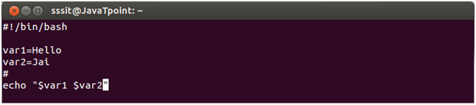

Look at the above snapshot, two variables are assigned to the script $var1 and $var2.

## Bash Operators

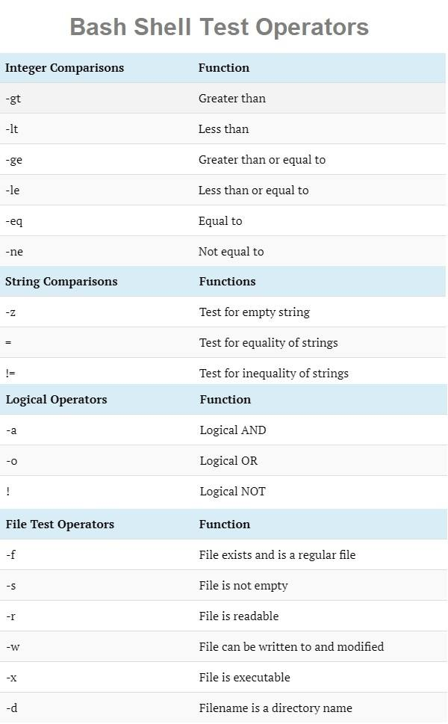

Image 33: Cloning a Computer

Reference: <https://www.slideshare.net/olgunsadik/cloning-a-computer>

## Read User Input

To read the Bash user input, we use the built-in Bash command called **read**. It takes input from the user and assigns it to the variable. It reads only a single line from the Bash shell. Below is the syntax for its implementation.

**read <variable_name>**

‘read’ command is used to take input from user in bash. Create a file named ‘user_input.sh’ and add the following script for taking input from the user. Here, one string value will be taken from the user and display the value by combining other string value.

#!/bin/bash

echo "Enter Your Name"

read name

echo "Welcome $name to LinuxHint"

Run the file with bash command.

$ **bash user_input.sh**

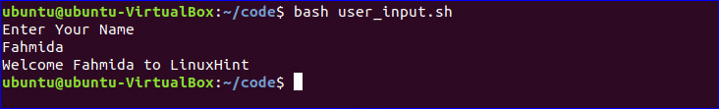

### Bash Conditional statements

Conditional Statements: There are total 5 conditional statements which can be used in bash programming

* if statement
* if-else statement
* if..elif..else..fi statement (Else If ladder)
* if..then..else..if..then..fi..fi..(Nested if)
* switch statement

**if statement**

This block will process if specified condition is true.

**Syntax:**

if [ expression ]

then

statement

fi

**if-else statement**

If specified condition is not true in if part then else part will be execute.

**Syntax**

if [ expression ]

then

statement1

else

statement2

fi

**if..elif..else..fi statement (Else If ladder)**

To use multiple conditions in one if-else block, then elif keyword is used in shell. If expression1 is true then it executes statement 1 and 2, and this process continues. If none of the condition is true then it processes else part.

**Syntax**

if [ expression1 ]

then

statement1

statement2

.

elif [ expression2 ]

then

statement3

statement4

else

statement5

fi

**if..then..else..if..then..fi..fi..(Nested if)**

Nested if-else block can be used when, one condition is satisfying then it again checks another condition. In the syntax, if expression1 is false then it processes else part, and again expression2 will be check.

**Syntax:**

if [ expression1 ]

then

statement1

statement2

.

else

if [ expression2 ]

then

statement3

.

fi

fi

**switch statement**

case statement works as a switch statement if specified value match with the pattern then it will execute a block of that particular pattern

When a match is found all of the associated statements until the double semicolon (;;) is executed.

A case will be terminated when the last command is executed.

If there is no match, the exit status of the case is zero.

**Syntax:**

case in

Pattern 1) Statement 1;;

Pattern n) Statement n;;

esac

**Example :**

Implementing if statement

#Initializing two variables

a=10

b=20

#Check whether they are equal

if [ $a == $b ]

then

echo "a is equal to b"

fi

## Bash Looping

There are total 3 looping statements which can be used in bash programming

* while statement
* for statement
* until statement

To alter the flow of loop statements, two commands are used they are,

* break
* continue

Their descriptions and syntax are as follows:

**while statement**

Here command is evaluated and based on the result loop will executed, if command raise to false then loop will be terminated

**Syntax**

while command

do

Statement to be executed

done

**for statement**

The for loop operate on lists of items. It repeats a set of commands for every item in a list.

Here var is the name of a variable and word1 to wordN are sequences of characters separated by spaces (words). Each time the for loop executes, the value of the variable var is set to the next word in the list of words, word1 to wordN.

**Syntax**

for var in word1 word2 ...wordn

do

Statement to be executed

done

**until statement**

The until loop is executed as many as times the condition/command evaluates to false. The loop terminates when the condition/command becomes true.

**Syntax**

until command

do

Statement to be executed until command is true

done

**Example:**

**Implementing for loop with break statement**

#Start of for loop

for a in 1 2 3 4 5 6 7 8 9 10

do

# if a is equal to 5 break the loop

if [ $a == 5 ]

then

break

fi

# Print the value

echo "Iteration no $a"

done

**Output**

$bash -f main.sh

Iteration no 1

Iteration no 2

Iteration no 3

Iteration no 4

## Bash Functions

Functions in bash scripting are a great option to reuse code. A Bash function can be defined as a set of commands which can be called several times within bash script. The purpose of function in bash is to help you make your scripts more readable and avoid writing the same code again and again. It also allows the developers to break a complicated and lengthy code to small parts which can be called whenever required. Functions can be called anytime and repeatedly, which will enable us to reuse, optimize, and minimize the code.

Following are some key points about bash functions:

* A function has to be declared in the shell script before we can use it.
* Arguments can be passed to the functions and accessed inside the function as $1, $2, etc.
* Local variables can be assigned within the function, and the scope of such variables will only be that particular function.
* Built-in commands of Bash shell can be overridden using functions.

**Syntax**

The syntax for declaring a bash function can be defined in two formats:

1. The first method starts with the function name, followed by parentheses. It is the most preferred and commonly used method:

function_name ()

{

commands

}

function_name () { commands; }

**Example:**

#!/bin/bash

function F1()

{

echo 'I like bash programming'

}

F1

Run the file with bash command.

$ bash function_example.sh



Learning Outcome

Familiarization with Open Office tools

# Familiarization of open office tools for creating documents

## What is open office?

OpenOffice is the leading open-source office software suite for word processing, spreadsheets, presentations, graphics, databases and more. It is available in many languages and works on all common computers. It stores all your data in an International open standard format and can also read and write files from other common office software packages. OpenOffice is easy to learn.

OpenOffice is a productive office suite with a collection of different software packages such as

* OpenOffice Writer - Word Processor to create text documents
* OpenOffice Calc - Spreadsheet to create worksheets
* OpenOffice Base - Database
* OpenOffice Impress - Presentation software
* OpenOffice Draw - Drawing Software
* OpenOffice Formula - Create formula and equations

Reference: <https://media.smallbiztrends.com/2016/12/open-office.png>

OpenOffice, sometimes abbreviated as OO, is a free and open-source office productivity software suite offered by The Apache Software Foundation (ASF) for word processing, spreadsheets, presentations, databases, graphics, and more.

## Advantages of open office

Here are some of the advantages of OpenOffice.org over other office suites:

**No licensing fees.**

OOo is free for anyone to use and distribute at no cost. Many features that are available as extra cost add-ins in other office suites (like PDF export) are free with OOo. There are no hidden charges now or in the future. Open source. You can distribute, copy, and modify the software as much as you wish, in accordance with either of OOo’s Open-Source licenses.

**Cross-platform.**

OOo3 runs on several hardware architectures and under multiple operating systems, such as Microsoft Windows, Mac OS X, Linux, and Sun Solaris.

**Extensive language support.**

OOo’s user interface is available in over 40 languages, and the OOo project provides spelling, hyphenation, and thesaurus dictionaries in over 70 languages and dialects. OOo also provides support for both Complex Text Layout (CTL) and Right to Left (RTL) layout languages (such as Hindi, Hebrew, and Arabic).

**Consistent user interface.**

All the components have a similar “look and feel,” making them easy to use and master.

**Integration.**

The components of OpenOffice.org are well integrated with one another. – All the components share a common spelling checker and other tools, which are used consistently across the suite. For example, the drawing tools available in Writer are also found in Calc, with similar but enhanced versions in Impress and Draw. – You do not need to know which application was used to create a particular file (for example, you can open a Draw file from Writer).

**Granularity.**

Usually, if you change an option, it affects all components. However, OOo options can be set at a component level or even document level.

**File compatibility.**

In addition to its native OpenDocument formats, OOo includes PDF and Flash export capabilities, as well as support for opening and saving files in many common formats including Microsoft Office, HTML, XML, WordPerfect, and Lotus 123 formats. New in OOo3 (using an extension): the ability to import and edit some PDF files.

## Features

The following tables list some important features of OpenOffice.org and compare them with two leading office suites, Microsoft Office 2003 (MSO) and WordPerfect X3 (WP).

**Styles and formatting**

|  |  |  |  |
| --- | --- | --- | --- |
| Features | OOo | MSO | WP |
| Navigator | Yes | Limited1 | no |
| Styles and formatting window | Yes | Yes | no |
| Keyboard support for paragraph styles | Yes | Yes | no |
| Support for page, frame and list styles | Yes | No Exactly | no |
| Word completion | Yes | Only | no |
| Spelling and language proofing modules | 70+ | 50+2 | 25 |
| Formula or equation tools | Yes | Yes | no |

**Interoperability**

|  |  |  |  |
| --- | --- | --- | --- |
| Feature | OOo | MSO | WP |
| PDF export capabilities | Yes | Yes1 | Yes |
| Flash export capabilities | Yes | No | Yes |
| XML export capabilities | Yes | Yes | Yes |
| OpenDocument XML format | Yes | No | No |
| Import/Export Microsoft office files | Yes | Yes | Yes |
| Import lotus 123 files | Yes | Yes | Yes |
| Connected to external databases (MySQL, Oracle, Access, etc.) | Yes | Yes | Yes |
| Languages available (localizations) | 40+ | 35+ | 30 |
| Supported Operating System | Windows, Mac OS X, Linux, Solaris | Windows only2 | Windows only |
| Unicode language support | Yes | Yes | No |

**Programmability**

Macros are programs which automate tasks and can be embedded in a document. The following table lists the languages available for macro development in each office suite.

|  |  |  |  |
| --- | --- | --- | --- |
| Language | OOo | MSO | WP |
| Basic-derived language | Open Basic | VBA | VBA |
| Bean shell | Yes | No | No |
| Java | Yes | No | No |
| JavaScript | Yes | No | No |
| Python | Yes | No | No |

Beyond simple macros, some office suites can be extended to include new features. This capability usually takes the form of plug-ins. In the case of OpenOffice.org, it can also be done through changes to the source code.

|  |  |  |  |
| --- | --- | --- | --- |
| Feature | OOo | MSO | WP |
| C and C++ | Yes | Yes | Yes |
| Java | Yes | No | No |
| Python | Yes | No | No |
| Source code available! | Yes | No | No |

**Security**

|  |  |  |  |
| --- | --- | --- | --- |
| Features | OOo | MSO | WP |
| Digital Signature | Yes | Yes | Yes |
| Strong encryption | Yes | Yes | Yes |
| Secure paths for macro execution | Yes | Yes | No |

## What are the minimum requirements?

OpenOffice.org 2.0 requires one of the following operating systems:

* Microsoft Windows 98, Windows ME, Windows 2000 (Service Pack 2 or higher), Windows XP or Windows 2003
* GNU/Linux Kernel version 2.2.13 and glibc 2.2.0 or newer
* Mac OS X 10.3.x (10.3.5 recommended), Mac OS X 10.4.x, plus X11
* Solaris version 8 or higher

More operating systems will be supported in the future.

Some OpenOffice.org features (wizards and the database component) require that the Java Runtime Environment (JRE) be installed on your computer. Although OOo will work fine without Java support, some features will not be available. You can download the latest version from <http://www.java.com/>

For a more detailed (and up-to-date) listing of requirements, see: <http://www.openoffice.org/dev_docs/source/sys_reqs.html>

## How do I install OpenOffice.org

Information on installing and setting up OpenOffice.org on the various supported operating systems is given here: <http://download.openoffice.org/2.0.2/instructions.html>

You can also download the more detailed Setup Guide (in several languages) from <http://documentation.openoffice.org/setup_guide2/index.html>

## Parts of the main window

The Figure shows the contents of OpenOffice Writer window such as Title bar, Menu bar, Standard Toolbar, Formatting Tool bar, Ruler, Work space and Status bar. The components of a open office writer window are explained below in Figure.

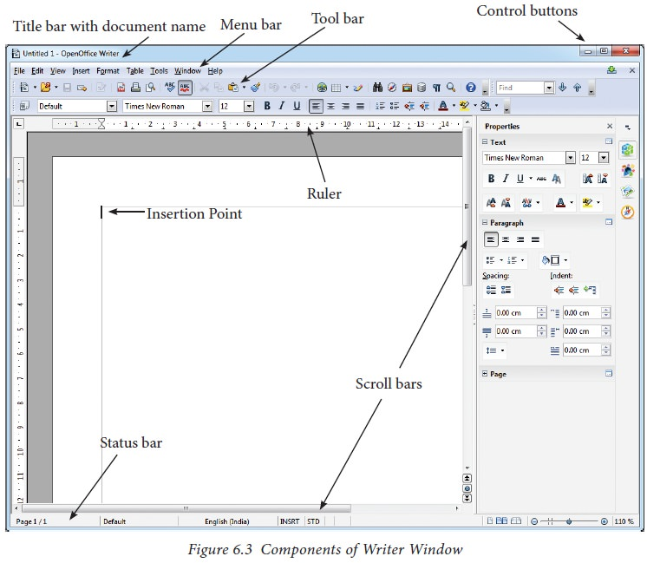

<https://img.brainkart.com/imagebk34/RuTbyaO.jpg>

### **Title Bar**

The title bar is displayed at the top most part of the window, which displays the name of the document and the name of the application. By default, the initial document is given the name as Untitled1.

### **Control Buttons**

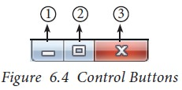In the right corner of title bar, (1) minimize, (2) maximize/restore and (3) close control buttons are available as shown in Figure.

<https://img.brainkart.com/imagebk34/PPypAbe.jpg>

1. **Minimize button:**

When you click minimize button, it shrinks your document window maller in size and shows it as a small button on the task bar. To restore it in its original size, place your mouse pointer on the OpenOffice button which is available in the Taskbar, you can view your document as miniature and when you click on the button, your document is restored to its original size.

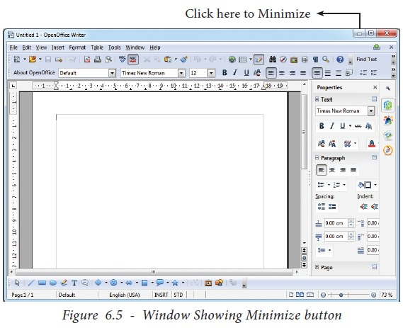

https://img.brainkart.com/imagebk34/s1ovOz1.jpg

https://img.brainkart.com/imagebk34/Ind9RXh.jpg

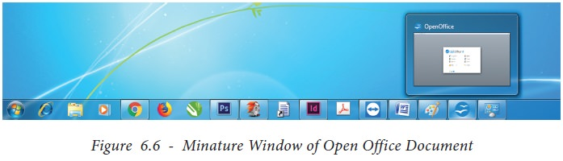

https://img.brainkart.com/imagebk34/s1ovOz1.jpg

1. **Maximize button**

When you click maximize button, your document window is displayed in full screen. When it is in full screen, the maximize button is changed as “Restore”.

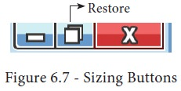

https://img.brainkart.com/imagebk34/qD2Wf4P.jpg

When you click restore button, the document window regains its original size.

1. **Close button**

This button is called as “Close” button, when you click this button, the application is closed and OpenOffice returns back to the desktop. So, the red colored close button may be called as “Exit” or “Quit”.

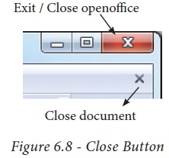

https://img.brainkart.com/imagebk34/6keNap1.jpg

There is another X mark on the right most corner of the menu bar. This is actually used to close your document. When you click this X mark, your document will be closed, OpenOffice will be still opened.

### Menu Bar

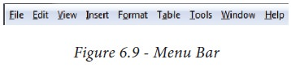The menu bar is just below the title bar which comprises of various menus consisting of various options.

https://img.brainkart.com/imagebk34/O5uOC27.jpg

* **File –** The File menu contains various option for file management tasks: New, Open, Close, Save, Save As, Print, Export etc.
* **Edit –**The Edit menu contains the editing options like, cut, copy, paste, Undo, Redo etc.
* **View –**The View menu contains the options which are used to modify the environment of writer like display of toolbars, web layout, print layout, navigator etc.
* **Insert –** The Insert menu contains commands for inserting various elements such as pictures, tables, charts, comments, headers, footers, special characters etc.
* **Format –** The Format menu contains the options of various text and page formatting features like page size, layout, font characteristics, bullets and numbering etc.
* **Tables–** The Table menu contains various tools to manage and manipulate tables such as create table, insert rows, insert columns, split cells, merge cells etc.
* **Tools –** The Tools menu contains various tools and functions such as spell check, macros, mail merge, end notes/ footnotes etc.
* **Window –** The window menu shows display options such as New Window, Close Windows, Split and Freeze.
* **Help –** The Help menu lists out the inbuilt help features available with OpenOffice.

### Tool Bar

Under the menu bar, there are two toolbars available by default. They are:

1. Standard Toolbar
2. Formatting Toolbar

**Standard Tool Bar–** This tool bar is just below the menu bar which consists of shortcut icons for frequently performed tasks. There are many shortcut icons like cut, copy, paste, undo etc…

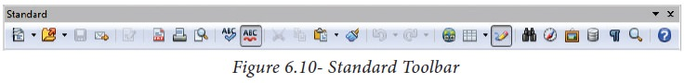

https://img.brainkart.com/imagebk34/z1DLVq1.jpg

**Formatting Tool Bar–** The formatting tool bar is below the standard tool bar which consists of icons used for formatting the text like bold, underline, italics, font type, font color etc.

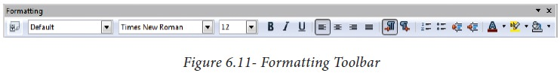

https://img.brainkart.com/imagebk34/RR6C4Ld.jpg

### Ruler

The ruler is a scale below the formatting tool bar which shows the margins. There are two set of rulers.

1. Horizontal ruler.
2. Vertical ruler.

Horizontal ruler is used to set left and right margins of a page and vertical ruler for top and bottom setting.

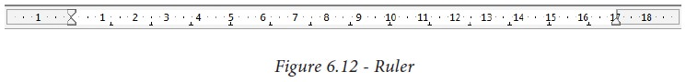

https://img.brainkart.com/imagebk34/zpbpbsM.jpg

### **Work Space**

The work space is the blank area which is used to type the content of the file. A flashing vertical bar appears at the beginning of the screen which is called as “Insertion pointer”.

### **Status Bar**

The status bar is at the bottom of the window which shows the current status of the document such as number of pages, current page number, default language etc.

## Working with documents

### **Starting a new document**

You can create a new, blank document in OOo in several ways.

When OOo is open but no document is open (for example if you close all the open documents but leave the program running), a Welcome screen is shown. Click one of the icons to open a new document of that type, or click the Templates icon to start a new document using a template.

You can also start a new document in one of the following ways. If a document is already open in OOo, the new document opens in a new window.

* Use File > New and choose the type of document.
* Use the arrow next to the New button on the main toolbar. From the drop-down menu, select the type of document to be created.
* Press Control+N on the keyboard.
* Use File > Wizards for some types of documents.

### **Entering the Text**

Once a new document is open, the text can be typed in blank area of the screen. To create a document the user can start typing straight away. As the text is typed they appear on the screen and the flashing vertical bar called the insertion pointer moves to the right. When the text reaches the end of the line, the word is automatically wrapped to the next line. This feature in any word processor is known as “Word Wrap”.

The Enter key must not be pressed at the end of each line. The Enter key should be pressed only at the end of a paragraph or when a blank line is to be inserted. When a page is filled up, OpenOffice Writer automatically creates a new page.

### **Saving the Document**

The first time the document is saved, OpenOffice Writer prompts for a name. Naming the file enables the user to find and open that file again. One can select the drive and folder where the file will be stored. To save a document for a first time, the following steps are used:

Click File -> Save ‚ (or) File -> Save As (or) Ctrl + S

The “Save As” dialog box appears as on Figure below.

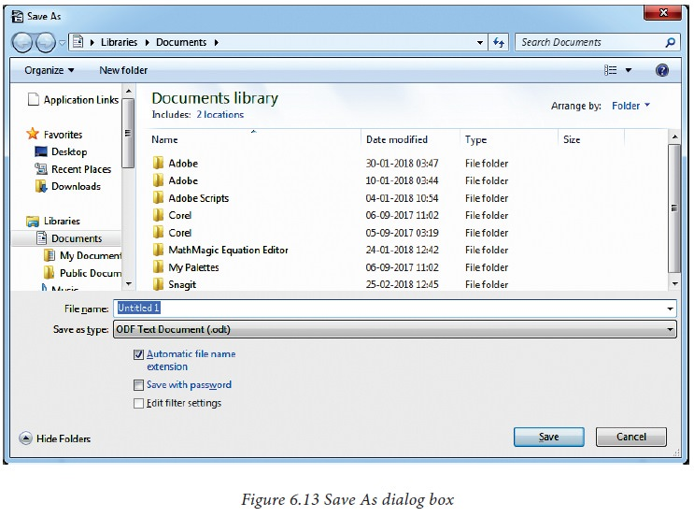

https://img.brainkart.com/imagebk34/ecA1qn9.jpg

* Select location to store your document. The default location to store all documents is “Documents” folder in Windows.
* Type your document name in the File Name box.
* All documents in OpenOffice writer will be stored with .odt extension. You can store your OpenOffice document as Microsoft Word document or pdf. To do so, select file type from Save as type list box. This list box shows variety of formats to be saved.
* Finally, click “Save” button.
* Once the file is saved, your document name will be displayed on the title bar.

### **Saving with password**

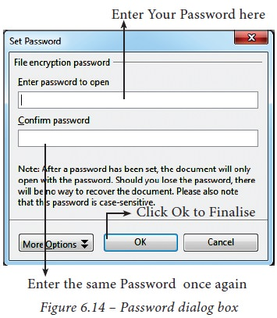In OpenOffice writer, a document can be protected with a password. You can set a password to protect your document while saving a file. To save a file with password, click on **“Save with Password”** check box and then click **“Save”** button. Immediately it shows **“Set Password”** dialog box as given the Figure below.

https://img.brainkart.com/imagebk34/Ra2dcPS.jpg

In this dialog box, Enter a password in **“Enter Password to open”** text box and retype the same password in **“Confirm Password”** box for confirmation. Finally click “OK” button.

**“More Options”** button provides some more features to your protected document such as **“Read only”** and change password.

### **Closing a Document**

After your document is saved, it is still open. So, you can continue typing your document. When the work is finished, you should save the document and then close document using File -> Close command (or) Press Ctrl + W.

### **Closing Unsaved Document:**

When you close an unsaved file using the close control button, Writer shows a warning message as shown in Figure below.

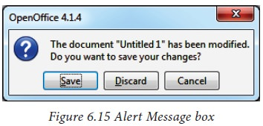

https://img.brainkart.com/imagebk34/CjylYx2.jpg

If you accept the warning message, click the “Save” button. When you click the “Save” button, it proceeds to save the file. If you are not willing to save the file, then click “Discard”, or if you want to cancel this warning and continue working in the same document, click “Cancel”.

### **Opening an existing document**

Once a document is saved, it can be opened at any time. To open an existing document, Click on the File -> Open or Ctrl + O, the Open dialog box appears, enter the name of the file in the File Name text box and click on OPEN button as in Figure 6.16.

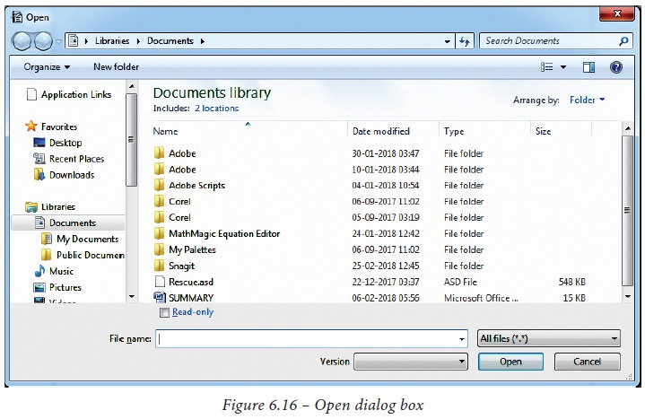

https://img.brainkart.com/imagebk34/zQiKbVD.jpg

### **Editing a document**

Once a document is typed, it can be edited in many ways. If there is some insertions or deletions, it can be done while typing or after typing also. Corrections can be made in two different ways :

**Backspace Key:** Deletes the character left of the insertion pointer.

**Delete Key :** Deletes the character right of the insertion pointer

To insert a text in between if something is left out, the insertion can be made by taking the insertion pointer to the current location and Press the Insert Key the newly typed text is inserted, so that the existing text moves to the right. This is Insert mode. Press the Insert Key again, the text is over written on the existing text. This is called Type over mode. You can toggle between the insert mode and type over mode by pressing the Insert key.

### **Deleting and renaming files**

You can rename or delete files within the OpenOffice.org dialogs. It is not possible to copy and paste files within the dialogs.

**Rename a file**

To rename a file while using OpenOffice.org:

1. Choose File > Open and browse to the required file.
2. Right-click on the file name and choose Rename. The file name will be selected.
3. Typing replaces the selected name, or use a left or right arrow key to move the insertion point to modify the existing name.

**Deleting a file**

To delete a file while using this dialog:

1. Right-click on the file name to display a context menu.
2. Click Delete and you will get a confirmation dialog. Note: Instead of Right-click > Delete, you can simply press the Delete key.

### **Moving within a document**

There are different ways of moving within a document. There are many shortcut keys given in Table below which are used to move easily within a document.

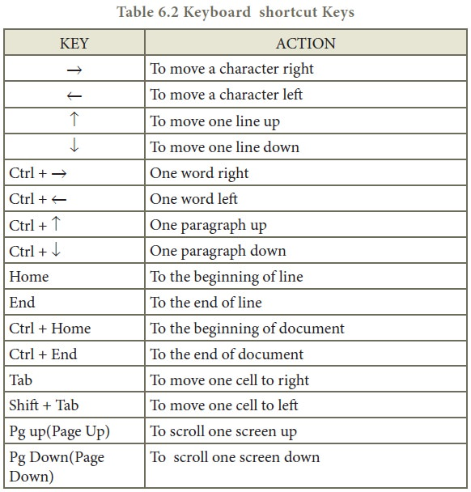

### **Page Preview, Setting the printer and Printing a document**

1. **Preview the document to be printed**

It is a good practice to preview the document before taking the print out. The steps to be followed to preview the document :

* Click File -> Page Preview, or click the Page Preview button. The Writer displays the Page Preview toolbar.
* In the page preview tool bar click Multiple Pages icon to display multiple pages.
* To close the preview click the Close Preview button.

1. **Setting the Printer and Printing**

The following are the steps to change the printer setting :

* Click File -> Print or Ctrl + P or Print File Icon which opens the Print dialog box as shown in Figure below.
* Click General Tab.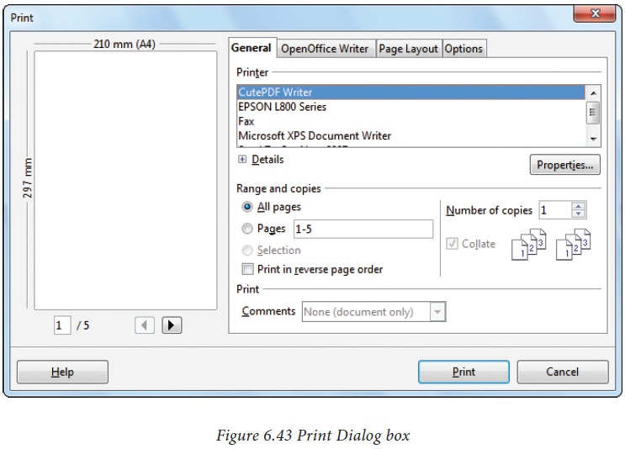

·

https://img.brainkart.com/imagebk34/4MkXDN8.jpg

* Select the required printer from the list of printers.
* Under Range and copies section: select All Pages option to print all pages, select Pages option to specify the particular page or page range.
* Specify Number of Copies using spin arrows.
* Click Print button.

# Open Office tools for creating spreadsheet

Spreadsheet is a very useful office automation tool to organize, analysis and store data in a tabular form. Spreadsheet was developed as computerized equivalent to paper-based accounting worksheets.

Spreadsheet users can adjust any of the stored values and can observe the effects on the calculated values. This is called "What if " analysis. Modern spreadsheet can have multiple interacting sheets and can display data either as text or numerals or in a graphical form.

## Working with OpenOffice Calc

Calc is the spreadsheet component of OpenOffice. You can enter any kind of data in a spreadsheet and then manipulate this data to produce certain results. Alternatively, you can enter data and then use Calc in a ‘What If...’ manner by changing some of the data and observing the results without having to retype the entire spreadsheet.

## Features of OpenOffice Calc

* Connecting with Excel - Ability to open, edit, and save Microsoft Excel spreadsheets
* AutoSum - helps you to add the contents of a cluster of adjacent cells.
* List AutoFill - automatically extends cell formatting when a new item is added to the end of a list.
* AutoFill - allows you to quickly fill cells with repetitive or sequential data such as chronological dates or numbers, and repeated text. AutoFill can also be used to copy functions. You can also alter text and numbers with this feature.
* Charts - helps you in presenting a graphical representation of your data in the form of Pie, Bar, Line charts and more.
* Functions: which can be used to create formula to perform complex calculations on data.
* Database functions: to arrange, store, and filter data.

## Structure of a Spreadsheet

### **Creating a new worksheet**

A new spreadsheet can be created through various methods.

From windows, select

**Start -> All Programs ->OpenOffice -> OpenOffice Calc (or)**

From Star Center (Welcome Screen):

**Double-click on “OpenOffice” icon the desktop**

Now, a welcome screen appears as shown in Figure below.

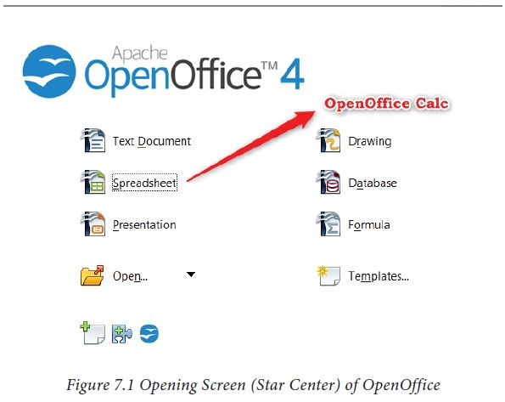

https://img.brainkart.com/imagebk34/gqWsgKo.jpg

This open screen is called as **“Star Center”.** Calc is one of the components of OpenOffice. So, it may be invoked from the **“Star Center”** by simply clicking on the “Spreadsheet” icon. (or)

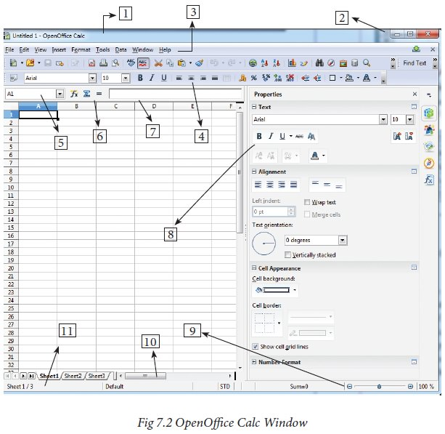A new spreadsheet can also be created by selecting **File -> New -> Spreadsheet** from any OpenOffice Application. After using any one of the above said methods, OpenOffice Calc window appears as shown in Figure above. The outline of the window is very similar to other application windows of OpenOffice. The main area of the Calc window is called as **“Work area”** or **“Worksheet”.**

https://img.brainkart.com/imagebk34/T8QXgiz.jpg

A worksheet is a grid of cells with a programmable calculator attached to each cell. When you open a new spreadsheet, there are three worksheets available by default. You can include more sheets and organize them.

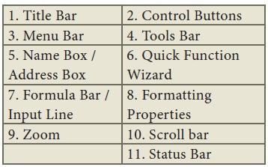

## Parts of the OpenOffice Calc Window

Appearance of the Calc window is very similar to that of the Writer window. The workspace of writer is a big blank area. But, in calc, the grid of cells is the workspace.

### Title Bar

Top of the window is called the **“Title Bar”**. It is used to show the name of the file and name of the application. In OpenOffice calc, the default name for the first unsaved worksheet is **“Untitled1”**. When you save the file, Untitled will change to the name in which you saved.

### Control Buttons:

In the right corner of title bar, (1) minimize, (2) maximize / restore and (3) close control buttons are available.

### Menu Bar

Below the title bar is menu bar. Most of the menus are very similar to what you learnt in OpenOffice Writer.

* **File -** menu contains the commands of all file management tasks like, Create a new file, Open an existing file, Close the current file, Save a file, Save a file in another name, print file, Export file etc.
* **Edit -** menu contains the editing commands like, cut, copy, paste, Undo, Redo, Fill etc., Most of the menu items are similar to Writer Edit menu. But, for Calc, some special **editing options are available under this menu.**
* **View -** menu contains the commends which are used to modify the environment of calc.
* **Insert –** menu contains commands for inserting various calc elements such as cells, columns, rows, functions, charts etc.,
* **Format –** menu contains the commands of various text and cell formatting features.
* **Tools –** menu contains various tools and functions such as spell check, protect document, insert pictures, macros, etc.,
* **Data –** menu contains the commands to manipulate data in a spreadsheet such as sort, filter, subtotal, validity etc.,
* **Window –** menu shows display options such as New Window, Close Windows, Split and Freeze.
* **Help –** menu lists in-built help features available with OpenOffice.

### Tools Bar

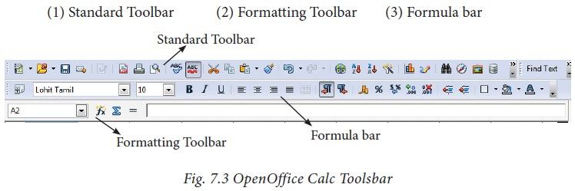Under the menu bar, there are three toolbars available by default. They are:

https://img.brainkart.com/imagebk34/pyDy6FE.jpg

* **Standard Toolbar –** contains frequently used File, Edit and Data menu commands as icons such as New Open Save, Send, print, print preview, Cut, Copy, Paste, Sorting, inserting chart etc.
* **Formatting Toolbar –** contains frequently used text and cell formatting commands as such as changing font style, font size, font color, alignments, cell formatting etc.,
* **Formula bar –** This is a very important element in a spreadsheet. It contains Name box, Function Wizard, Sum button, Function button and Input line.

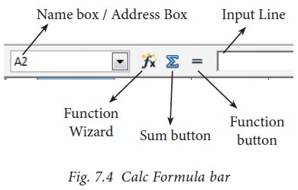

https://img.brainkart.com/imagebk34/mRGXKtH.jpg

* **Name box:** It display the current cell address
* **Function Wizard:** It is used to insert function
* **Sum button:** It is used to quickly insert sum function.
* **Input Line:** This is used to show the contents of the current cell. It always shows actually what you typed in a cell. It is also used to edit the contents.

### Scroll bar

Spreadsheet window also has two sets of scrolling bars

1. Vertical Scrollbar

* 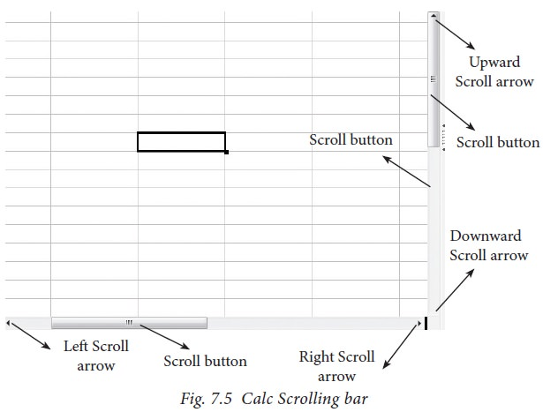Horizontal Scrollbar Vertical Scroll bar: It is used to move the screen up and down.

https://img.brainkart.com/imagebk34/ZFS9oMM.jpg

* Horizontal Scroll bar: It is used move the screen left and right.
* Scroll buttons: used to move the screen to the relative distance.

### **Row, Column, Cell and Cell Pointer**

Below the formula bar contains the worksheet of work area which consist of grid cells The worksheet has number of rows and columns, where each column is labelled as A, B, C, D ….. AA, AB, AC ….. and the rows are numbered from 1, 2, 3 …. .

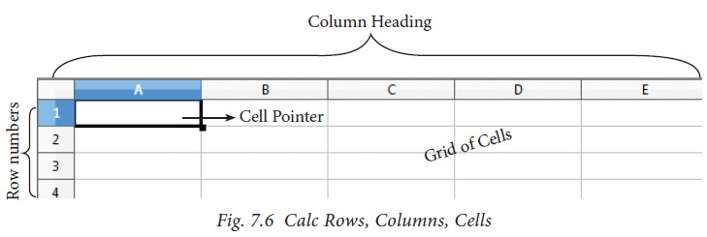

<https://img.brainkart.com/imagebk34/qbZdacA.jpg>

OpenOffice Calc version 4.1.5 contains 1024 columns and 10,48,576 rows. Column heading starts from A and end with AMJ. In the case of Microsoft Excel 2016, there are 16,384 columns (A to XFD) and 10,48,576 rows available.

**Cell**

Intersection of each row and column makes a box which is called as “Cell”. Each cell has its unique address.

Cell address is the combination of column heading and row number. For example, the intersection of column B and row 4 makes a cell B4. (Figure below). Every cell is thus identified by its unique cell address.

Cell pointer is a rectangle box which can be moved around the worksheet. The cell in which the cell pointer is currently located is known as “Active cell”. When you type any content, it will appear in the active cell. The address of the active cell is displayed in the Name box / Address box. Active cell’s column name and row number will be highlighted. Using this visual clue, one can easily identify an active cell. Moreover, the contents of an active cell will be displayed in the formula bar.

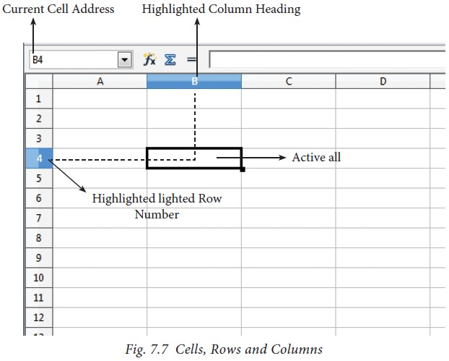

<https://img.brainkart.com/imagebk34/a4HdwOy.jpg>

### **Worksheet tabs**

At the bottom of the grid of cells are the sheet tabs. By default there are 3 sheets “Sheet1”, “Sheet2” and “Sheet3”, (Figure below). When you open a new worksheet, sheet1 is the default active sheet. Active sheet tab will appear in white color. If you click on another sheet, it will become active and its color will turn white. Multiple sheets can also be selected by clicking the sheet and press the Ctrl button (Ctrl + Click). Selected sheets will turn to white color.

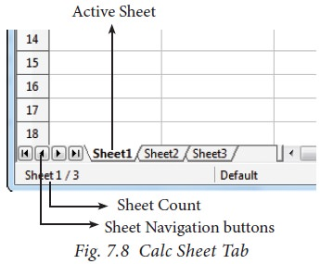

<https://img.brainkart.com/imagebk34/raYfVHv.jpg>

On the left of the sheet tab, four navigation buttons are used to move between worksheets.

1. Move to the First sheet
2. Move to the previous sheet
3. Move to Next sheet
4. Move to the Last sheet

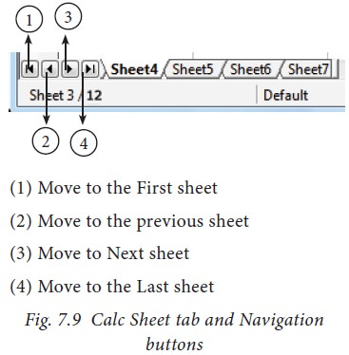

<https://img.brainkart.com/imagebk34/IPuulWG.jpg>

Image: Calc Sheet tab and Navigation buttons

Left corner of status bar shows the total count of sheets and the present active sheet number. For example, if the status bar shows sheet 3/12; 3 refers to the serial number of the current sheet and 12 refers to the total number of sheets available.

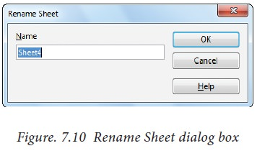Every sheet name can be renamed. To rename a sheet, just double-click on the sheet, which will show a small box as shown in Figure below.

<https://img.brainkart.com/imagebk34/AfAlwt4.jp> g

It shows the current name; delete or overwrite the existing name and type a new name; click OK button. New name will be displayed on the sheet.

### **Status bar**

Below the sheet tabs and horizontal scrolling bar is the “Status Bar”. It shows the current status of the worksheet.

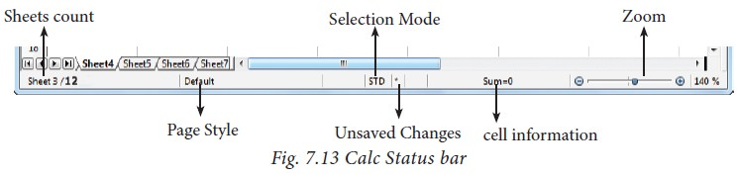

https://img.brainkart.com/imagebk34/N8Hwpg1.jpg

* **Sheets count:** Displays current serial number of the sheet / total number of sheets available.
* **Page Style:** Displays the page style of the current sheet. To make changes, just double-click on “Default” and it will show you the “Page Style” dialog box, which is used to change the margin, orientation, paper size, inserting header, footer, border style etc.,
* **Selection Mode:** Displays the selection mode of the current sheet. There are three modes available to select the cells of a worksheet. They are, Standard (STD), Extend (EXT) and Add (ADD).
* **Unsaved Changes:** An asterisk (*) symbol indicates the changes made in the worksheet but not yet saved. If you have saved your changes, it will disappear.

## Working with Spreadsheet

### **Working with Data**

When you open a new spreadsheet, the cell pointer is located in cell A1. So, the Cell A1 is known as **“Home Cell”.** Cell pointer can be moved anywhere in the spreadsheet using the direction keys.

**“Tab key”** is used to move the cell pointer towards the right side or forward direction. **“Shift+Tab”** is used to move backward i.e. from right to left in a row. **“Enter”** key is also used to move the cell pointer. Enter moves the cell pointer to a cell below the current cell i.e., downwards. Four “direction keys” are used to move the cell pointer anywhere in the worksheet.

1. **Entering Data:**

Any data can be typed directly in any cell of the worksheet. But, the cell in which you type data should be an active cell. So, move the cell pointer to a particular cell to make it active cell; or click any cell to make it active cell. Then, start typing any data. When you type data, spreadsheet recognizes the type of data entered in cells.

**Data types:**

Data are in different types. Data are made up of alphabets, numbers, Date and time is another data type even though it has numbers and symbols. In general, data types are classified as:

**Alphabetic data type –** consists of alphabets only Numeric data type – consists only of numbers (whole number or fractional numbers) Alphanumeric data types – consists of a combination of alphabets and numerals Date data type – consists only of date Time data type – consists only time

* 1. **Entering Numbers:**

Any numeric data can be entered in a spreadsheet. Entered numbers are aligned to the right side within the cell by default. Negative numbers may be entered with a minus sign or within brackets (Refer Figure 7.12). If you enter any number within the bracket, it will be changed as negative number i.e., number prefixed with minus. If any number starts with 0 (zero); Calc will drop the leading zero.

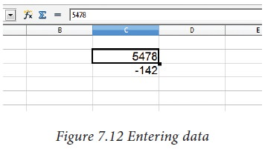

https://img.brainkart.com/imagebk34/aekC3Z0.jpg

* 1. **Entering Text:**

Unlike numbers, any character can be entered as data in Calc. Entered text will be aligned to the left side within the cell by default. When you enter any numeric value, if it has aligned left, it is understood that the entered content is not a number. If there is any number that starts with a single quote, calc converts that number to text.

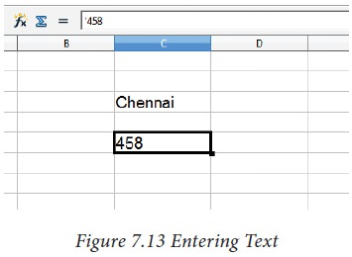

https://img.brainkart.com/imagebk34/pgU0bPJ.jpg

* 1. **Entering Date and Time:**

Before entering date, ensure the format of your system date. Calc accepts date as per the system date format. If your system has American date format i.e. month-date-year; you should enter dates in Calc spreadsheet as mm/dd/yy. If your system follows the Indian date format, date should be entered as dd/mm/yy form in Calc. Only the correct form of date is accepted by Calc as a date.v

For example: If your system has American Date format, 18th December 2017 should be entered as 12/18/17. As soon as the date is typed in the correct form, the entered date will be aligned on the right side within the cell, and if you place the cell pointer in that cell, the formula bar shows your date as **“12/18/2017”**. This is a visual clue to know whether the date is accepted or not.

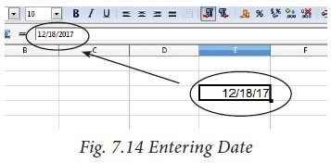

https://img.brainkart.com/imagebk34/4PQPiyo.jpg

A Date format can be changed to any other valid form using “Cell Formatting” dialog box, and it will be discussed later.

Like dates, for entering time, calc follows the general format HH:MM:SS. where HH, MM and SS represent hours, minutes and seconds respectively.

### **Copy, Cut and Paste – Spreadsheet**

1. **Copy and paste Data**

* Select the cell or cells you want to copy
* Select Edit -> Copy or Click “Copy” icon from the standard toolbar or Press Ctrl + C
* Move the cell pointer to the cell in which you want to paste.
* Select Edit -> Paste or Click “Paste” icon or Press Ctrl + V

1. **Cut and Paste Data**

* Select the cell or cells you want to cut
* Select Edit -> Cut or Click “Cut” icon from the standard toolbar or Press Ctrl + X
* Move the cell pointer to the cell in which you want to paste.
* Select Edit -> Paste or Click “Paste” icon or Press Ctrl + V

1. **Copy and Paste Formula**

* The process of Copy and Paste data is used for copying formula.
* When you copy a formula from one cell to another cell, the address of the pasted formula will change according to its row. This is called “Relative Cell Reference”.

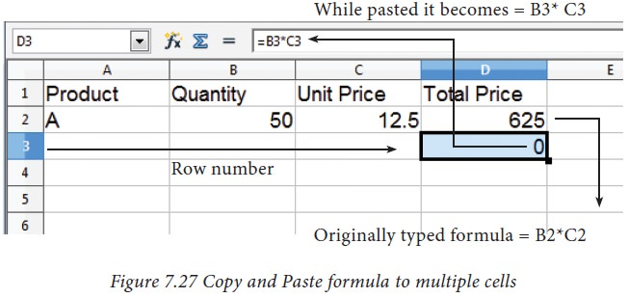**Example:**

<https://img.brainkart.com/imagebk34/foGvzjM.jpg>

1. **Copy a formula from one cell and paste it in multiple cells:**

Step 1: Copy the formula from H2 using Ctrl + C or Edit -> Copy (or) click “Copy” icon.

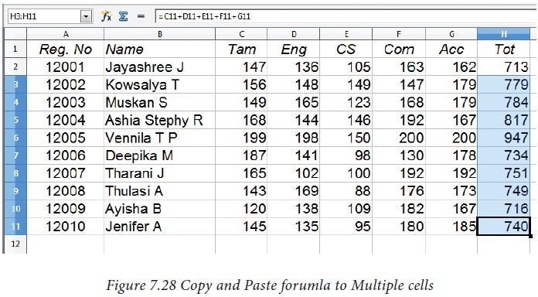

<https://img.brainkart.com/imagebk34/ceZsIOh.jpg>

Step 2: Select all cells (i.e., H3 to H11) in which you want to paste this addition formula.

Step 3: Paste the copied formula using Ctrl + V or Edit -> Paste (or) Click “Paste” icon.

## Inserting Columns, Rows and Cells

**Inserting Columns, Rows and Cells**

In Calc, Columns, rows and cells can be inserted individually or in groups.

1. **Inserting a Column:**

When you insert a new column, it is inserted to the left of the current column. The location of the cell pointer present, is the Current column. In Calc, you can insert a new column anywhere in the worksheet.

**Step 1:** Select the column where a new column should be inserted.

**Step 2:** Right-click on the selected column name that you selected. A pop-up menu appears.

**Step 3:** click the “Insert Columns” option from the menu.

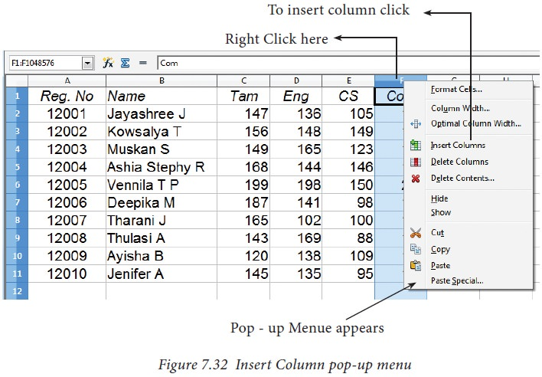Now, a new column will be inserted to the left of the current column.

<https://img.brainkart.com/imagebk34/NDHDYwR.jpg>

https://img.brainkart.com/imagebk34/02V7NXi.jpg

A new column can also be inserted using Insert -> Column’s command.

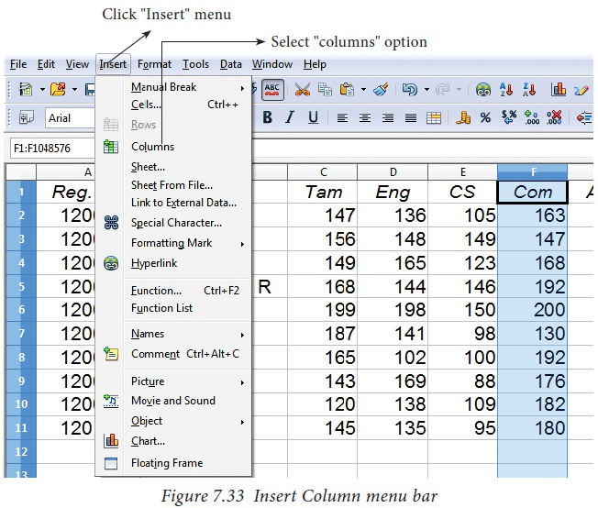

<https://img.brainkart.com/imagebk34/NDHDYwR.jpg>

1. **Inserting Rows**

When you insert a new row, it is inserted above the current row. The location of the cell pointer present is the current row. In Calc, you can insert a new row anywhere in the worksheet.

**Step 1:** Select the row where a new row to be inserted.

**Step 2:** Right-click on the row number, a pop-up menu appears

**Step 3:** click “Insert Rows” option from the menu.

Now, a new row will be inserted to above the current row.

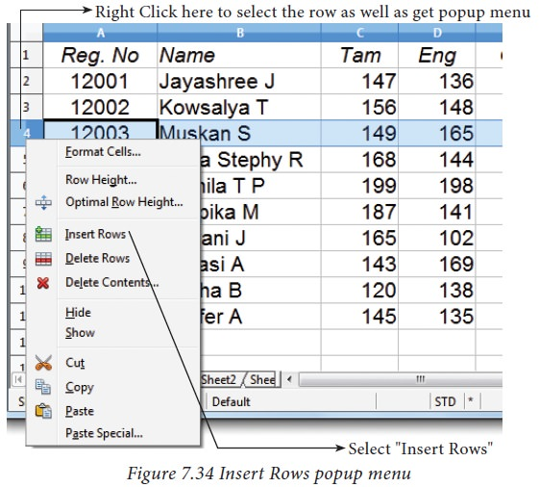

<https://img.brainkart.com/imagebk34/26kerh2.jpg>

**Insert -> Rows** command is used to insert a new row.

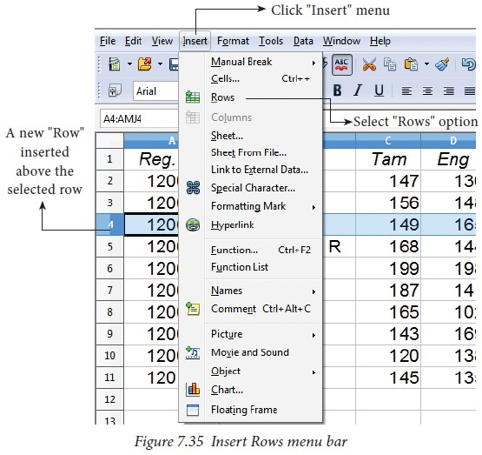

<https://img.brainkart.com/imagebk34/g0pJCCq.jpg>

1. **Inserting Cells**

* To insert a new cell between two existing cells, just right-click on any existing cell
* From the pop-up menu, select “Insert” option Figure given below Insert cells
* The “Insert Cells” dialog box appear with four options
  + 1. Shift cells down
    2. Shift cells right
    3. Entire row
    4. Entire Column

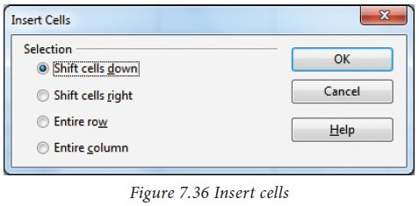

<https://img.brainkart.com/imagebk34/d0pFgWE.jpg>

* Any one of the four options is selected.
* Selecting “Shift cells down”, inserts a new cell in the present location and the existing cells are shifted downwards.
* Selecting “Shift cells right”, inserts a new cell in the present location and the existing cells are shifted towards right.
* Selecting the “Entire Row” or “Entire Column” option, inserts a new row or a new column.v

1. **Inserting multiple columns or rows**

Multiple columns or rows can be inserted at once rather than inserting one at a time.

* Select multiple rows or columns for insertion.
* Follow steps as in 1 and 2

1. **Inserting Columns, Rows and Cells using “Insert Cells” Toolbar**

* Insert Cells floating toolbar is also used to insert cells, rows and columns
* Click View -> Toolbars -> Insert Cell
* A tiny floating toolbar appears on the screen with four icons. Using these icons, you can insert cells, rows and columns. Refer Figure given below.

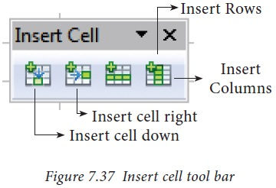

<https://img.brainkart.com/imagebk34/kLsTJ3z.jpg>

## Deleting columns and rows

**Deleting columns and rows**

A single or multiple columns or rows can be deleted.

1. **Delete single column or row**

A single column or row can be deleted by using the mouse:

* Select the column or row to be deleted.
* Choose Edit →Delete Cells from the menu bar.

(or)

* Right-click on the column or row header.
* Choose Delete Columns or Delete Rows from the pop-up menu.

1. **Delete multiple columns or rows**

Multiple columns or rows can be deleted at a time. Refer Figure given below.

* Select the required columns or rows for deletion.
* Right-click on the selected columns or row.
* Choose Delete Columns or Delete Rows from the pop-up menu or Edit -> Delete Cells.

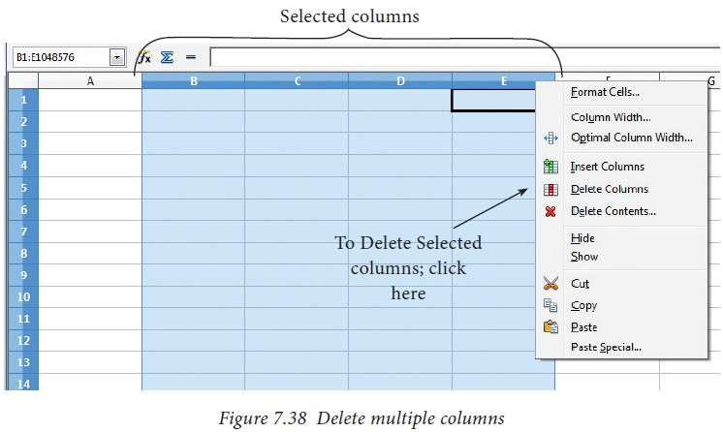

<https://img.brainkart.com/imagebk34/Hab10Nr.jpg>

## Save, Close and Open the Worksheet

**Saving Worksheet**

The process of saving a worksheet is very similar to saving a document. Steps to save a worksheet are as follows:

**Step 1:** File -> Save (or) Ctrl + S (or) Click “Save” icon on the standard tool bar.

**Step 2:** If the spreadsheet has not been saved previously, the Save As dialog box will appear.

**Step 3:** Type the name in “File Name” list box. OpenOffice Calc Spreadsheets are stored with extension .ods by default.

**Step 4:** Click “Save” button.

After clicking the save button, the given file name is displayed in the title bar as shown in Figure given below.

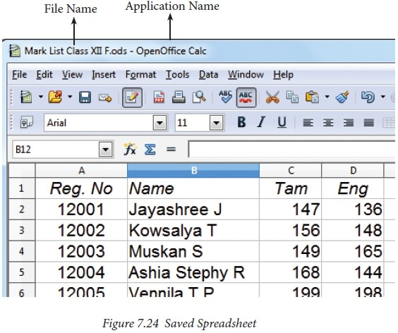

<https://img.brainkart.com/imagebk34/kJIIW7N.jpg>

**File Extension:**

A file extension or file name extension helps to identify the type of file.

Following table gives the file extension of commonly used files.

**Note:** The saved file is stored in the "Document folder" by default.

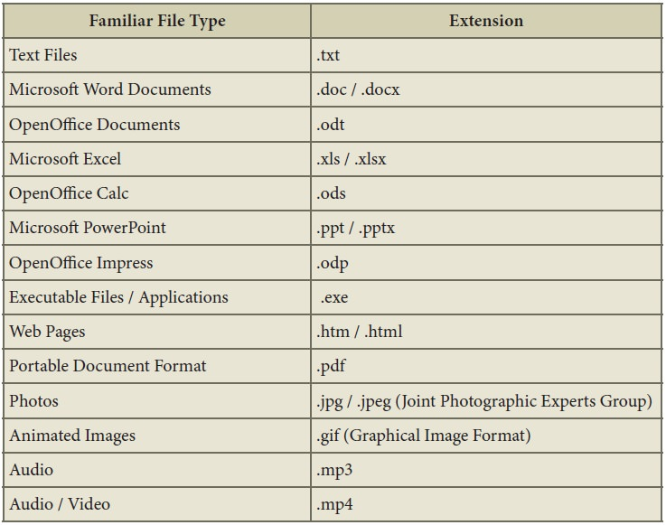

**Auto Save:**

The OpenOffice saves a file at regular intervals. This is called as “Auto Save” feature. The default time interval is 15 minutes. It can be reduced even to one minute. If any unexpected shutdown occurs, this feature will recover your file.

**Closing a Worksheet:**

After saving the worksheet; it remains open. So, you can continue to work with the spreadsheet. When the work is finished, you should save using File -> Save (or) Click “Save” icon (or) Ctrl + S and then to close the worksheet using File -> Close command (or) Press Ctrl + W.

**Opening an existing worksheet**

1. **Using Open dialog box**

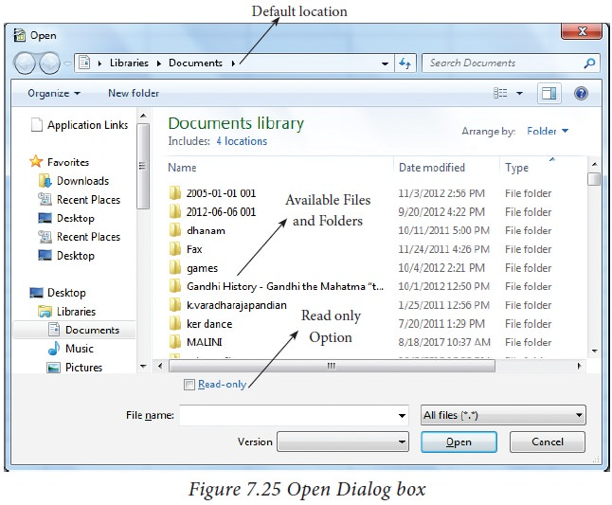To reopen an existing worksheet, the File → Open command (or) “Open” icon (or) Ctrl + O can be used. An Open dialog box appears as shown in Figure 7.25 that is similar to “Save As” dialog box.

https://img.brainkart.com/imagebk34/weTQMdS.jpg

The name of the file to be opened can be chosen from the list or folder in which worksheet has been saved.

1. **Using Recent documents**

OpenOffice keeps a list of recently opened files. File -> Recent Documents option can be used to open an existing worksheet from the list as shown in Figure given below.

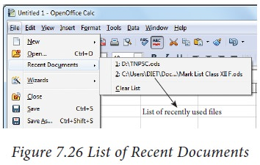

https://img.brainkart.com/imagebk34/OoMgxoZ.jpg

## Creating Formulae – Spreadsheet

### **Creating Formulae**

After entering the data in worksheet, you can perform calculations on the data in the worksheet. In order to create formulae, you first need to know the syntax that describes the format for specifying a formula.

In Calc, you can enter formulas in two methods, either directly into the cell or at the input line. Formula in Calc may start with equal (=) or plus(+) or minus(–) sign followed by a combination of values, operators and cell references. But, as a general practice, all formulas should start with an equal sign. If any formula starts with a + or –, the values will be considered as positive or negative respectively.

1. **Operators**

Operators are symbols for doing some mathematical,

Statistical and logical calculations. Combination of values, operators and cell references is called as “Expression”. Calc supports a variety of operators which are categorized as:

1. Arithmetic Operators
2. Relational Operators
3. Reference Operators
4. Text Operator

**1.1 Arithmetic Operators**

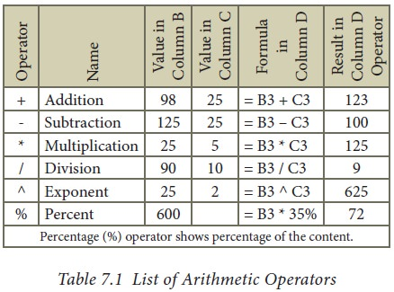Arithmetic operators are symbols for performing simple arithmetic operations such as addition, subtraction, multiplication, division etc., These operators return a numerical result.

https://img.brainkart.com/imagebk34/9csFCzE.jpg

Formula bar shows the formula what the user had entered. But, the cell shows the resulted value given below.

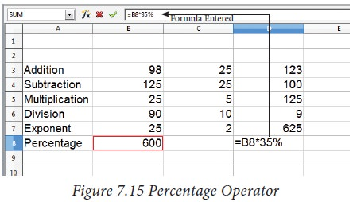

**1.2 Relational Operators**

Relational operators are symbols used for comparing two values such as greater than, less than, equal to etc. The relational operators are also called as "Comparative operators". These operators return either a True or a False.

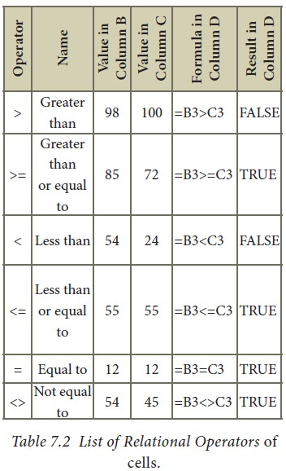

https://img.brainkart.com/imagebk34/e7frlNi.jpg

https://img.brainkart.com/imagebk34/e7frlNi.jpg

**1.3 Reference Operator**

Reference operators are used to refer cell ranges. A continuous group of cells is called as “Range”. There are three types of reference operators that are used to refer cells in calc; they are (1) Range Reference Operator, (2) Range Concatenation (3) Intersection Operator.

**Range Reference Operator**

Colon (:) is the range reference operator. It is used to group a range of cells. An expression using a range operator has the following syntax:

**reference left: reference right**

where reference left is the starting cell address of a linear group of cells or upper left corner address of a rectangular group

Reference right is the last cell address of a linear group or lower right corner address of a rectangular group of cell.

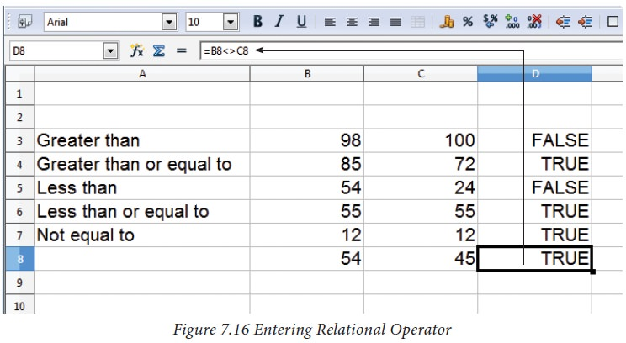

https://img.brainkart.com/imagebk34/ZrOVphS.jpg

Example:

(i) Linear group of cells A1, A2,A3,A4,A5 is referred as A1:A5

(ii) Rectangular group of cells A2, A3, A4, ….. B2, B3, B4,….D5, D6 is referred as A2:D6 (Refer fig below).

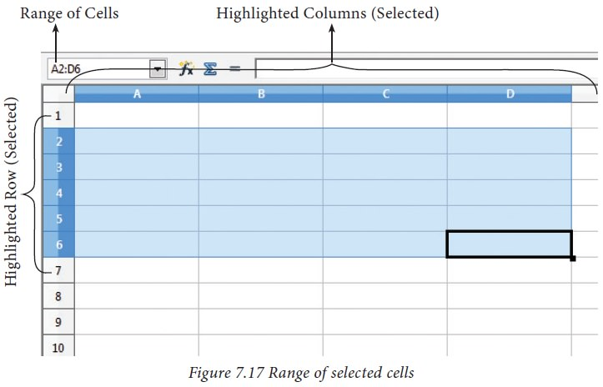

Name box shows the reference A2:D6 corresponding to the cells included in the drag operation with the mouse to highlight the range.

**Reference concatenation operator:**

Concatenation means joining together. Tilde (~) symbol is used as a concatenation operator in calc. An expression using a concatenation operator has the following syntax:

**reference left ~ reference right**

**Example:**

If you want to find the sum of the values from A1 to A6 and C3 to F3. The formula is =SUM (A1:A6 ~ C3:F3)

SUM is a function to find the sum of a group of values.

**Intersection Operator:**

Intersection operator is used to join two set of groups. It is very similar to Range concatenation operator. The intersection operator is represented by an exclamation

**reference left ! reference right**

Example: (A2:D3! B2:E4)

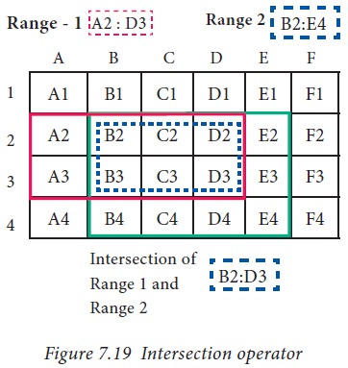

https://img.brainkart.com/imagebk34/hYhj5ul.jpg

The result of (A2:D3! B2:E4) is referred by the range B2:D3, because these cells are both inside A2:D3 and B2:E4.

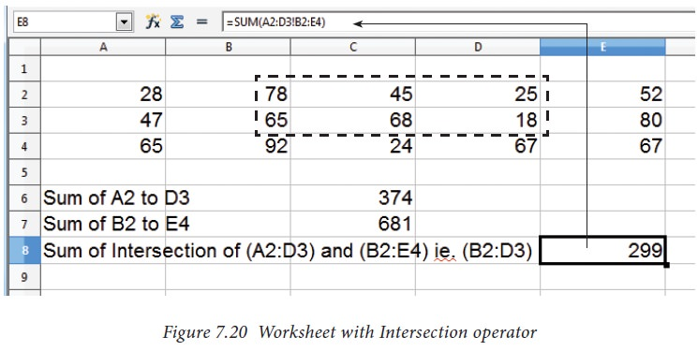

https://img.brainkart.com/imagebk34/47MLxPT.jpg

**1.4 Text Operator:**

In Calc, “&” is a text operator which is used to combine two or more text. Joining two different texts is also known as “Text Concatenation” (Refer Figure 7.23). An expression using the text operator has the following syntax:

text reference1 & text reference2

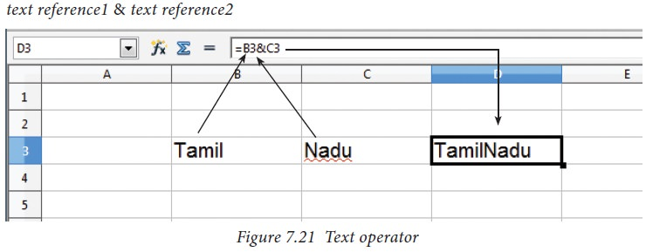

https://img.brainkart.com/imagebk34/4z7Lh1I.jpg

When arithmetic operators are used in a formula, Calc calculates the results using the rule of precedence followed in Mathematics. The order is:

1. Exponentiation (^ )
2. Negation (-)
3. Multiplication and Division (*, /)
4. Addition and Subtraction (+, -)

Here is an example to illustrate how to create a formula:

**Illustration 1:**

Create a Marks worksheet with the following data:

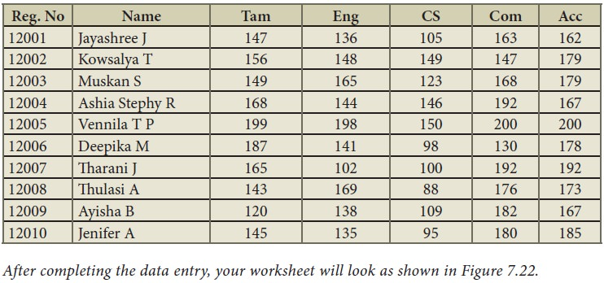

After completing the data entry, your worksheet will look as shown in Figure below.

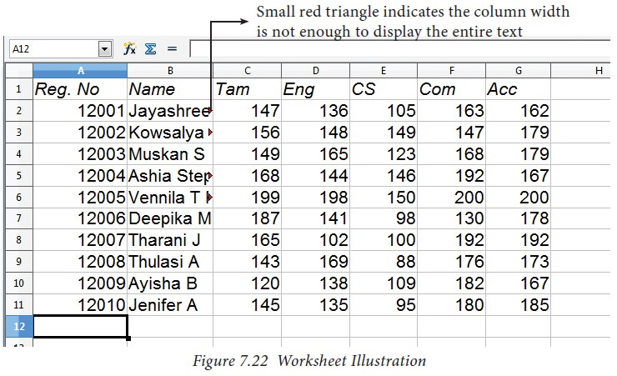

https://img.brainkart.com/imagebk34/AxWi5Oj.jpg

1. **Construction of formula**

To construct a formula, follow the steps below:

* Cell pointer should be in the cell in which you want to display the result.
* Formula should begin with an = sign.
* In a formula, use only cell reference (cell addresses) instead of the actual values within the cells.
* While constructing a formula, BODMAS rule should be kept in mind.
* General Syntax of constructing a formula is: = cell reference1 <operator> cell reference2 <operator> ……………….
* Cell references are of two types (i) Relative cell reference (ii) Absolute Cell reference.
* If you refer cell addresses directly while constructing formulae, it is called as “Relative Cell reference”.

Examples of Relative Cell references:

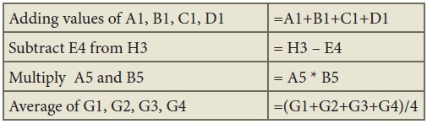

* In the above table, all cell references are “Relative cell references”.
* While writing a formula, if you use the $ symbol in front of a column name and row number, it will become an “Absolute Cell reference”.
* Examples of Absolute cell references:

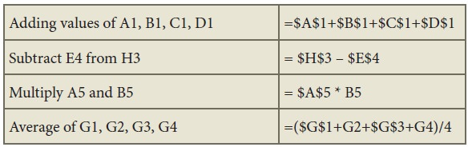

Adding values of A1, B1, C1, D1 =$A$1+$B$1+$C$1+$D$1

Subtract E4 from H3 = $H$3 – $E$4

Multiply A5 and B5 = $A$5 * B5

Average of G1, G2, G3, G4 =($G$1+G2+$G$3+G4)/4

In an expression, all cells need not necessarily be relative or absolute. You can mix both type of references.

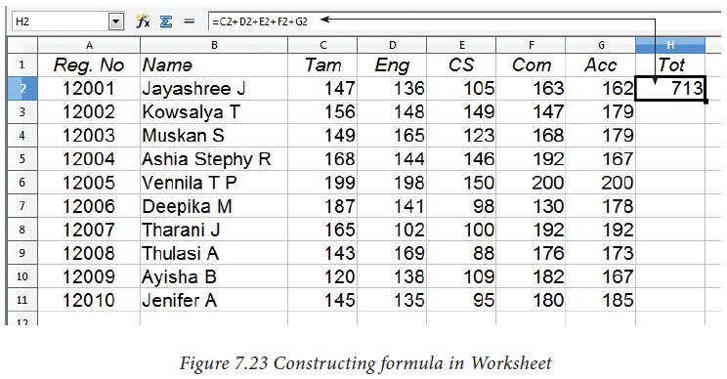

https://img.brainkart.com/imagebk34/dlB1grO.jpg

The following section explains the use of relative cell reference. About “Absolute cell reference”, you will be learn later in this chapter.

**Finding Total to the above Illustration:**

* Move the cell pointer to H2 (Total column)
* Type the following formula; after entering the formula, press “Enter” key = C2+D2+E2+F2+G2 (Refere Figure)
* Now, you will get the sum of all the values of C2, D2, E2, F2 and G2
* The above-mentioned formula clearly stated that, how worksheets are working with cells.
* While referring to the cell addresses in a formula, the spreadsheet reads the value inside the cell that you refer. This is a good practice of constructing a formula. Because, if you change any value, the spreadsheet recalculates with that new value.

After entering a formula the result is display as in Figure below.



https://img.brainkart.com/imagebk34/dlB1grO.jpg

## Functions - Spreadsheet

OpenOffice Calc has more than 350 functions under 11 categories. Functions are predefined formulae already available with Calc. They are used to perform several frequently done calculations. Every function has a unique name and a prototype. Functions are categorized according to their functionality. For example, the functions such as Sum, Average, Sin, Cos etc., are categorized as “Mathematical Functions”.

1. **Inserting Functions into**

**Worksheet:**

A function can be inserted by

* Direct Insert Method or Using Function Wizard method.
  1. **Direct Insert method:**

If you know the function name and its syntax, it can be directly typed in any cell of the worksheet.

For example, SUM is the most frequently used function to add a set of values. The syntax of the SUM ( ) is:

**=SUM (range 1; range 2; range 3…… range n)**

If you want to know the sum of the values in A1, A2, A3, A4 and in A5, Place your cell pointer in A5 and directly type the formulae as follows.

= SUM (A1:A4)

While inserting a function the following points should be kept in mind.

1. A function should begin with an equal sign.
2. Use proper name for the function to be used.
3. Arguments should be given within the brackets as per the syntax. Each function has a unique argument list.
4. Press “Enter” key after typing the function.

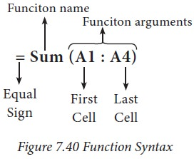

https://img.brainkart.com/imagebk34/ramRQqZ.jpg

* 1. **Using Function Wizard method**

A function can inserted using Function Wizard in Calc. Function Wizard is a dialog box provides the step-by-step procedure to insert a function. Function wizard can be invoked by clicking the Function Wizard icon on the Formula bar (or) Insert -> Function (or) Ctrl + F2. Refer Figure below.

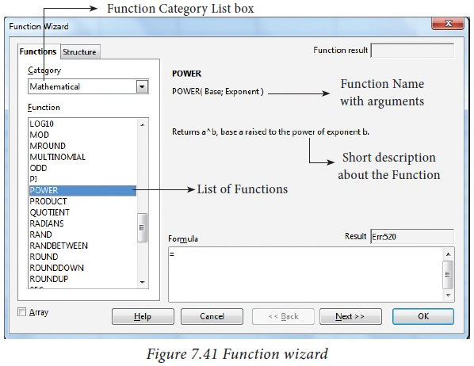

https://img.brainkart.com/imagebk34/ajcHnGW.jpg

**Function category drop down list box:**

Function Wizard has two tabs viz. Functions and Shortcuts. In Functions Tab, the list of categories is available in Category drop down list box. In Calc, the functions are categorized into 11 types. They are,

1. Database
2. Date and Time
3. Financial
4. Information
5. Logical
6. Mathematical
7. Array
8. Statistical
9. Spreadsheet
10. Text
11. Add-in

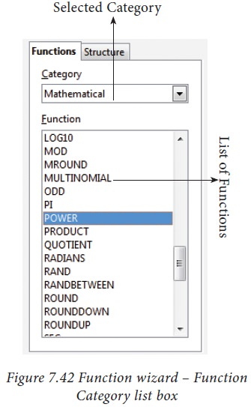If you select any particular category, the Functions list box shows the functions which belongs to the selected category. If “All” is selected under category all functions in calc is displayed in alphabetical order. Refer Figure below.

https://img.brainkart.com/imagebk34/SFZIgYd.jpg

**Function Description**

When you select a function, the function wizard shows the function name, syntax and a small description about the function on the right side of the dialog box. Refer Figure below.

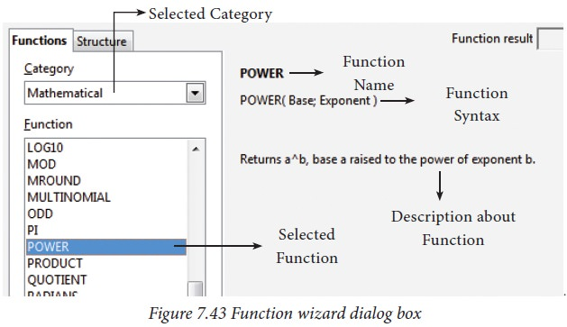

https://img.brainkart.com/imagebk34/yjf2Bo2.jpg

**Inserting a function using Function Wizard: (with Cell Reference)**

The following steps explains to insert POWER( ) function in a cell.

**About POWER ( ) function:**

POWER ( ) is a function which is used to calculate power of an exponent value of a number. This function is categorized as a Mathematical function. There are two inputs needed to find the power value of a number. They are, Base value and exponent value. For example, to find the value of 25 to the power of 2 (252) where 25 is the base value, 2 is the exponent value.

The syntax of POWER( ) is = POWER (Base ; Exponent)

Both Base and Exponent are arguments. In Calc, arguments are separated by a semicolon.

**Inserting POWER( ) in a worksheet:**

**Step 1:** In cell A2 type the base value 25

**Step 2:** In cell B2 type the exponent value 2

**Step 3:** Move the cell pointer to C2; in which you want display result.

**Step 4:** Click fx icon from Formula bar (or) choose Insert -> Functions (or) Press Ctrl + F2.

**Step 5:** Pull down category list box, Choose “Mathematical”

All function under Mathematical category is displayed in the “Functions” list box

**Step 6:** Scroll the “Functions” list box and select “POWER( )”. The function wizard shows the description about the selected function on the right corner of the dialog box

**Step 7:** Click “Next” command button. Now, Function wizard appears as shown in the Figure below.

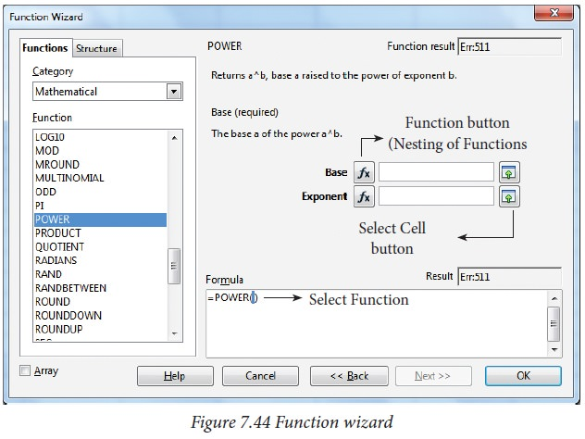

https://img.brainkart.com/imagebk34/1QosVDQ.jpg

**Step 8:** Click on the cell which is contains the base value (A2).

Now, the minimized wizard shows the cell address you have selected (A2). Refer Figure below

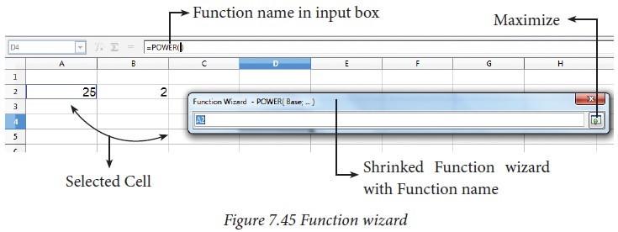

https://img.brainkart.com/imagebk34/fAJNw1x.jpg

**Step 9:** Click “Maximize” button to display full wizard. Now, Function wizard appears as shown in Figure below.

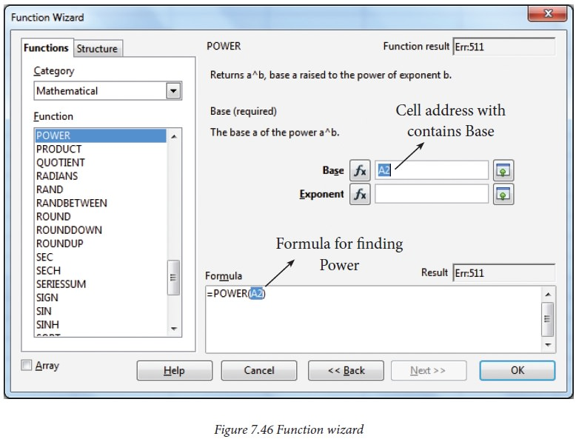

https://img.brainkart.com/imagebk34/hqynuue.jpg

Base box shows the cell address which contain base value.

**Step 10:** Directly type the cell address which contains exponent, in Exponent box; or repeat steps 7, 8 and 9.

After entering Base and Exponent cell references, the function wizard appears as shown in Figure below.

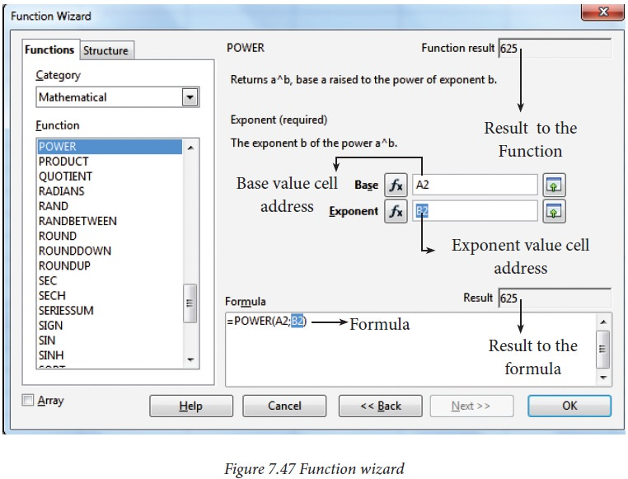

https://img.brainkart.com/imagebk34/erkF7KD.jpg

The formula box displays the syntax of the function with input values and Result box displays the result value.

**Step 11:** If the result is correct, click “OK” button else click “Back” button to display the previous page of this wizard.

**Inserting a function using Function Wizard: (with direct values)**

In the previous example, Cell addresses are used for Base and Exponent values. In Calc, direct values can be used instead of using cell reference (i.e. cell address) to find the same result.

In this case, type base and exponent value instead of cell address. Function wizard displays the result in the current cell. Refer Figure shown below.

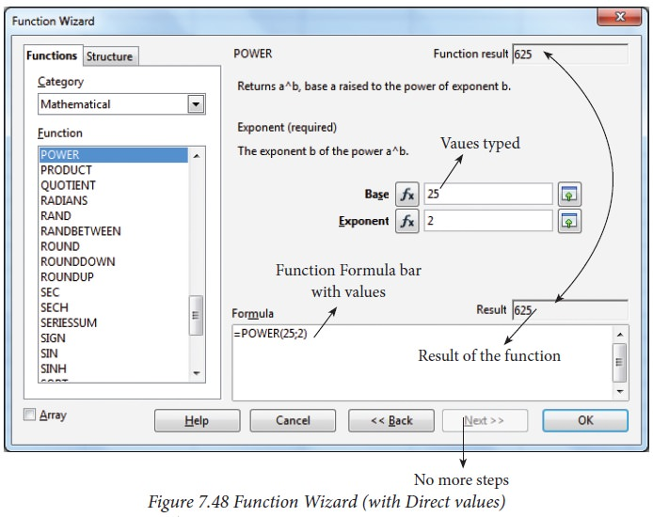

https://img.brainkart.com/imagebk34/9Os3t4t.jpg

## Formatting Worksheet

**Formatting Worksheet**

Formatting Data in a cell gives additional effect to the text. Additional effect includes changing the font style, font size, automatic wrapping, bold, underline, italic etc. The data in Calc can be formatted in several ways. Using formatting icons can be used.

1. **Text Formatting**

Making the cell contents as bold, italics, underlined, changing font style, size, colour etc., comes under text formatting. All text formatting options are available as icons in Formatting toolbar learnt in OpenOffice Writer. Figure shown below *Text Formatting Toolbar.*

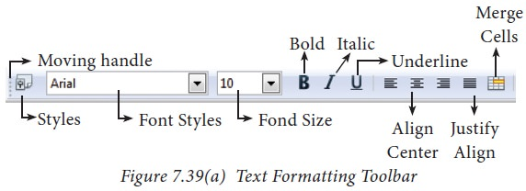

https://img.brainkart.com/imagebk34/hDWGpop.jpg

1. **Number formatting**

Number formatting options are used to visually change the format of a numeric content. These formatting changes are only for visual as, it does not change its original value. For example, to display a number as currency form use Number format: Currency.

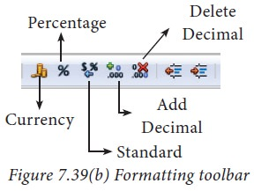Number format: Currency will be used as shown Figure given below.

https://img.brainkart.com/imagebk34/rNkLlHz.jpg

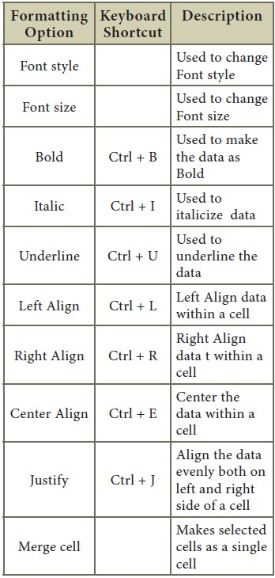

## Working with Chart

One of the most important features of spreadsheet is the ability to create charts based on numeric data. The charts are used to present data in an easy manner. Creating charts is the key factor for the of success of spreadsheet. OpenOffice Calc provides a “chart wizard” to create and manipulate charts.

#### **Chart Wizard**

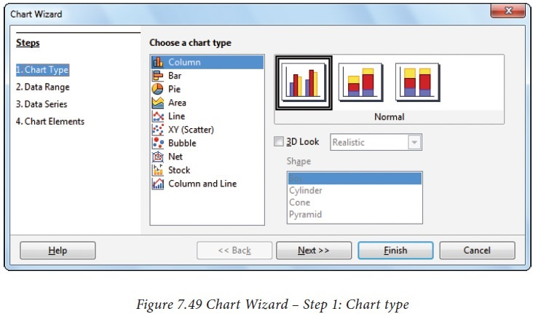Chart wizard is used to insert charts in Calc. Chart wizard can be invoked by clicking “chart” icon from standard toolbar or choosing Insert → Chart command. A "Chart wizard" appear as shown in Figure shown below.

https://img.brainkart.com/imagebk34/9RUqLW8.jpg

Chart wizard dialog box has 4 steps viz. (1) Chart type (2) Data Range (3) Data Series and (4) Chart Elements. The “Next” button is used to move from one step to another step.

**Step 1: Chart type**

The first step of “Chart wizard” is used to select Chart type. All available chart types are listed under the “Choose a chart type” list box. On the right side of the list box shows style of the selected chart; each chart type has different styles.

For example, Column chart has three styles viz. Normal, Stacked and Percent Stacked.

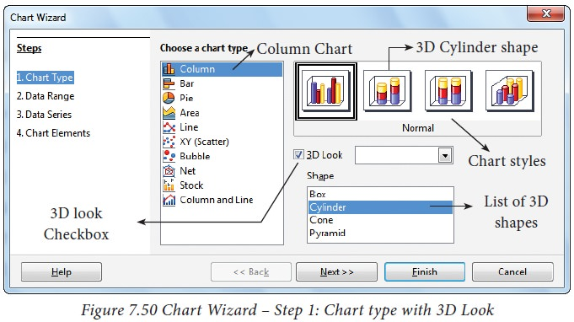"3D Look" check box helps to display the selected chart type in an attractive form. 3D Look is applied only for Column, Bar, Pie and Area chart type. Refer Figure shown below.

https://img.brainkart.com/imagebk34/pjrCQ35.jpg

Click, “Next” button to move to the second step.

**Step 2: Data Range**

In this step, specify the range of data for which the chart should be created in “Data range” text box or click “Select data range” button which is at the end of the textbox to minimize the wizard.

If the user had selected the data before invoking "chart wizard", the selected range will appear automatically in the textbox as shown in Figure shown below.

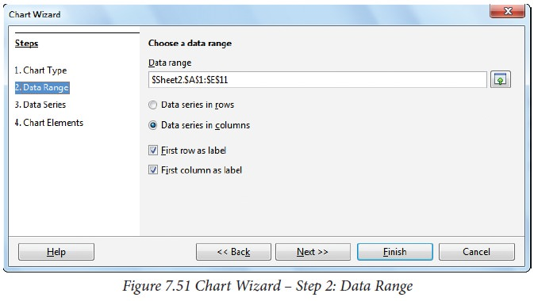

https://img.brainkart.com/imagebk34/j21BZTL.jpg

There are two checkboxes used to set the first row or first column or both, as X and Y axis labels to the chart.

Click "Next" button to move to the third step.

**Step 3: Data Series**

In this step, the user can fine tune the data to be included in the chart. If you don’t want to include any column, click the column names listed in “Data Series” box and click on “Remove” button or if you want to add some more columns click “Add” button. Refer Figure shown below. This is useful only if you have very specific requirements for data in your chart. Otherwise simply click “Next” button to move the last step.

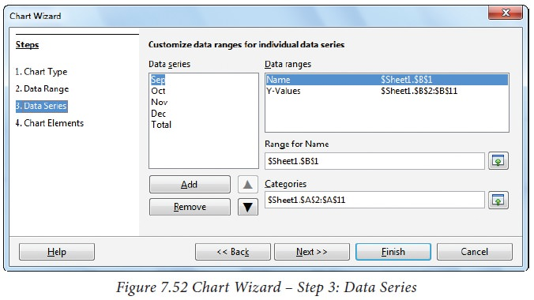

https://img.brainkart.com/imagebk34/DMIDX2P.jpg

**Step 4: Chart Element**

This step is used to insert or change titles and legend. In “Title” box, type the title for the chart, to add a subtitle type it in the “Subtitle” box. Refer Figure 7.53. For example, A chart for showing the highest mark holder in you class, you may enter as “Highest Mark holder” as title and “Class XII F” as subtitle.

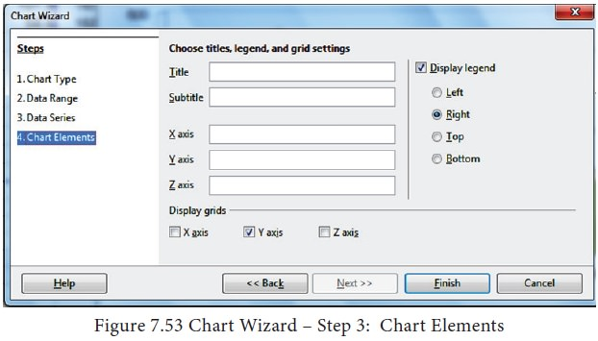

https://img.brainkart.com/imagebk34/yBKZY8u.jpg

User can add or modify the labels of X and Y axis. To create a chart, click “Finish” button.

#### **Demo for creating a chart**

Type the following data in a new worksheet as in Figure shown below. The following steps is followed to create a chart for the given data.

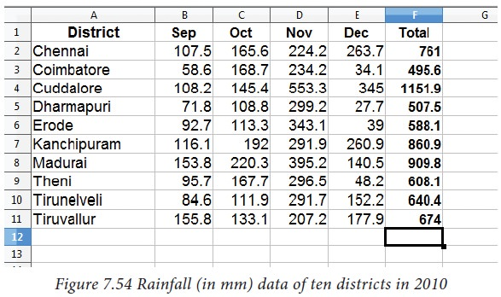

https://img.brainkart.com/imagebk34/zsOkz0h.jpg

**Step 1 – Select Data:**

Select the data from A1 to F11.

**Step 2 – To open the chart wizard:**

Click “Chart” icon from Standard toolbar (or) choose Insert → Chart.

**Step 3 – Selecting Chart type and shape: (Refer Figure shown below).**

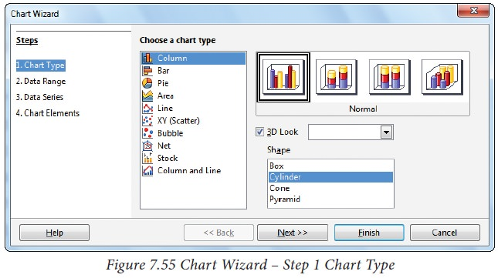

https://img.brainkart.com/imagebk34/wiGuOBR.jpg

* Select “Chart type” as Column and style as Normal
* Check “3D Look” and click “Cylinder shape”
* Click “Next” button.
* If the user wants change any other type or shape, click on the style image. Preview of the chart displayed on the background of the chart wizard. So, you can view the chart at every stage of design.

**Step 4 – Defining Data range: (Refer Figure given below)**

* In this case, the data has been selected earlier. So, the selected data range is displayed in the “Data range” box.
* Other settings are by default. Click “Next” to move to step 5.

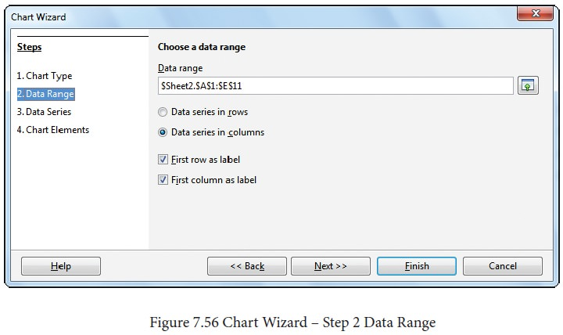

https://img.brainkart.com/imagebk34/Br4KgFx.jpg

**Step 5 – Adding or Removing Data series: (Refer Figure shown below)**

* “Data Series” list box shows all the columns to be included in the chart.
* Click on the “Total” in the data series box and click “Remove” button to remove the column.
* If you don’t want to add or remove any other column, click “Next” button to move to the last step.

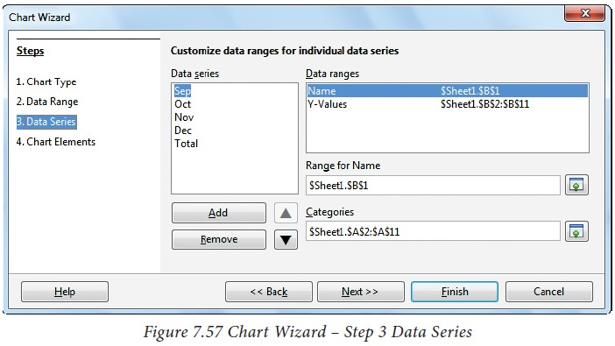

https://img.brainkart.com/imagebk34/ajJpIV8.jpg

**Step 6 – Adding Title, Subtitle, Name of X and Y axis: (Refer Figure shown below)**

* Type the title and subtitle of the chart in “Title” and “Subtitle” box
* Type the name of the X and Y-axis in the respective boxes.
* The Display legent text box is selected to the right which is the default.
* Click “Finish” button.

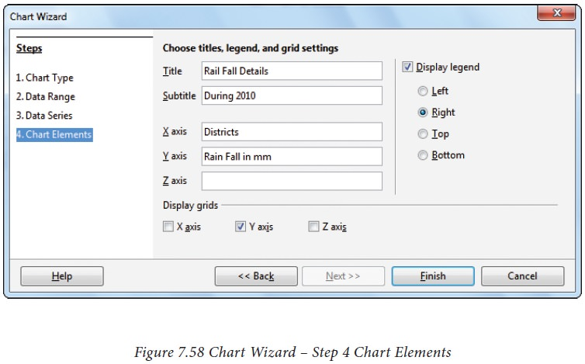

https://img.brainkart.com/imagebk34/h8PP4oW.jpg

Now the chart will be displayed as in Figure shown below.

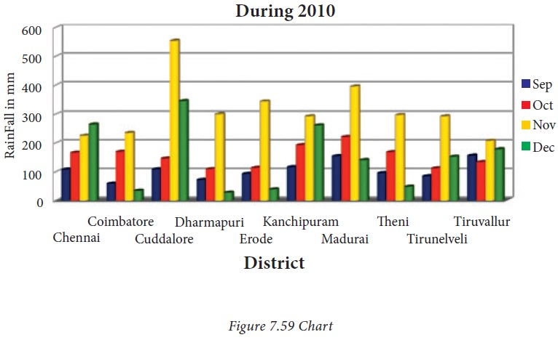

https://img.brainkart.com/imagebk34/rtSf1eU.jpg

#### **Editing Chart elements:**

After inserting a chart any element of the chart can be modified. To modify the element

1. Double click on the element
2. Right click on the selected element
3. Select Format from the popup menu.

For example, To change the display pattern of the X-axis, double-click on the X-axis and then right-click on it. A pop-up menu appears as shown in the Figure given below.

In this popup menu, click “Format Axis…” option.

Now the chart will be displayed as given below

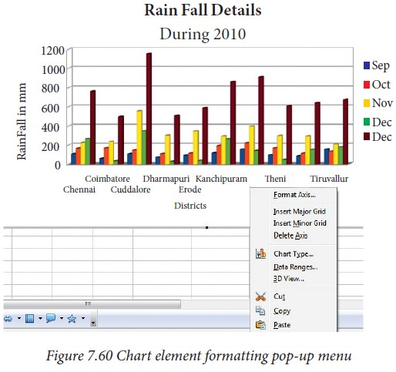

https://img.brainkart.com/imagebk34/O3mltu2.jpg

Now, a Format Axis dialog box appears as shown in Figure shown below

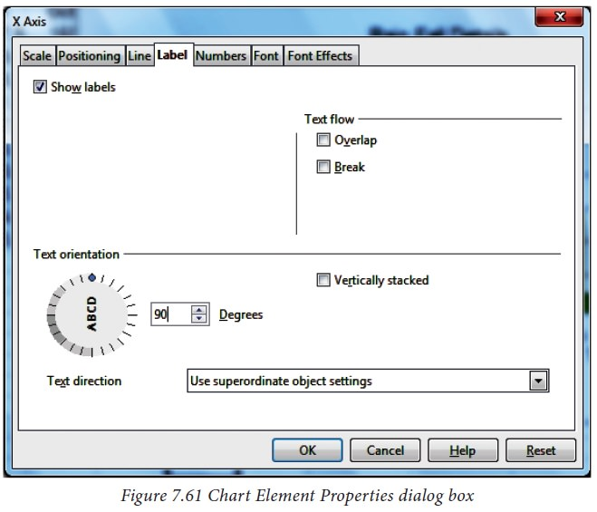

https://img.brainkart.com/imagebk34/6a5TBoV.jpg

Select “Label” tab.

* In Text Orientation spin box, type as 90 degree or click and drag the Text direction animated handle.
* Clicl “OK” button.

Now, the chart will be as in Figure given below.

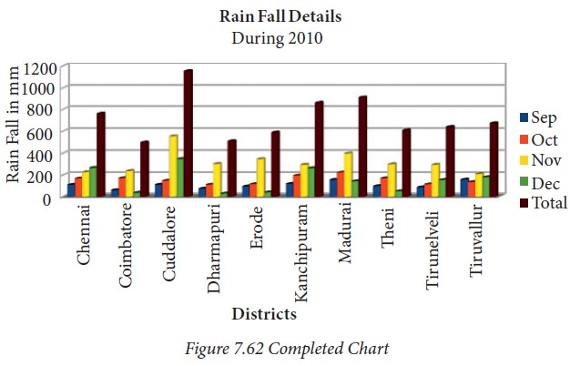

# Open Office tools for creating presentation

## Structure of Presentation

### **Opening a new presentation**

You can start Impress in several ways.

* In order to open Impress using Start button, click Start button and select All Programs -> Open Office -> OpenOffice Impress.

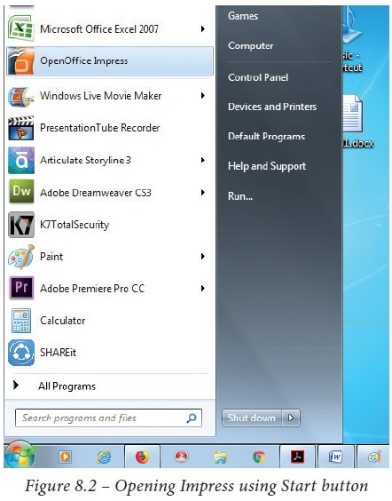

https://img.brainkart.com/imagebk34/hmXOjMx.jpg

* 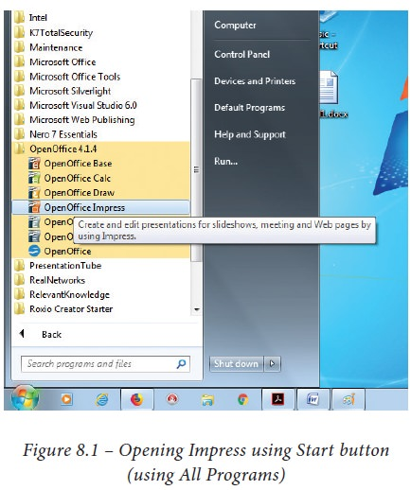If it is already pinned in the Start menu, just click and open it.

https://img.brainkart.com/imagebk34/X353OrQ.jpg

### **Creating a new presentation**

You can create a presentation by any one of the following methods.

1. By selecting an Empty presentation
2. By selecting from template
3. By selecting from Open existing presentation
4. Using Empty presentation
   * 1. Select Empty presentation under Type. It creates a presentation from scratch.

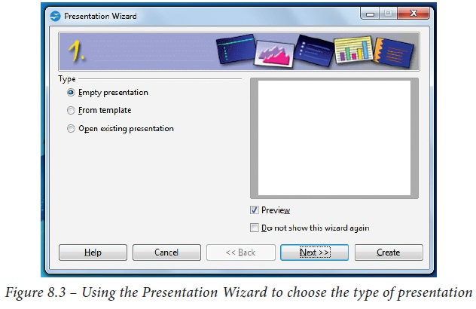

https://img.brainkart.com/imagebk34/7U1S8sf.jpg

* + 1. Click Next. The Presentation Wizard step 2 appears. Figure 8.4 shows the Wizard.

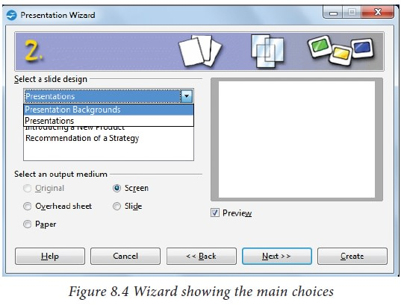

https://img.brainkart.com/imagebk34/HTE8EPC.jpg

* + 1. Choose a design under Select a slide design. The slide design section gives you two main choices: Presentation Backgrounds and Presentations.

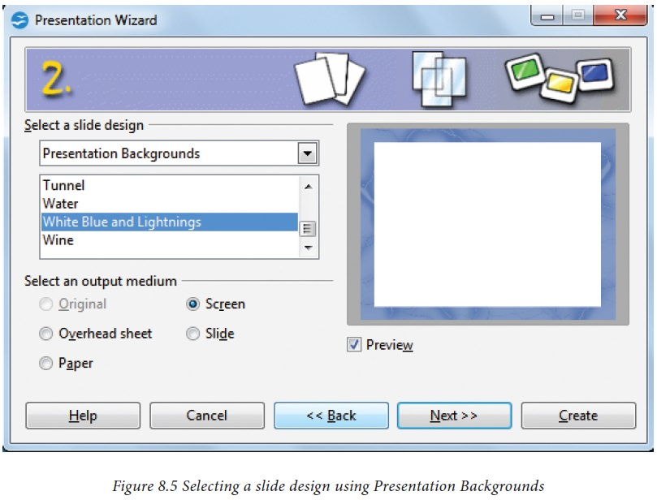

https://img.brainkart.com/imagebk34/0D3Ap17.jpg

* + 1. Each one has a list of choices for slide designs. If you want to use one of these other than the <Original>, click it to select it. The preview of the same will be shown in the preview pane.
    2. <Original> is an empty background.

You can also select among three 8. Click Next. The Presentation Wizard step 3 appears . In this predefined Presentations: <Original>, Introducing a New Product, and step, you can choose the desired slide Recommendation of a Strategy. transition from the Effect drop-down (Figure given below).

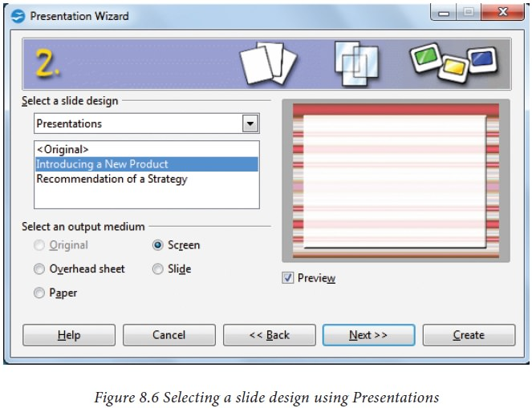

https://img.brainkart.com/imagebk34/YgM7F1k.jpg

* + 1. Click an item to see a preview of the transition between the different slide design in the Preview window.

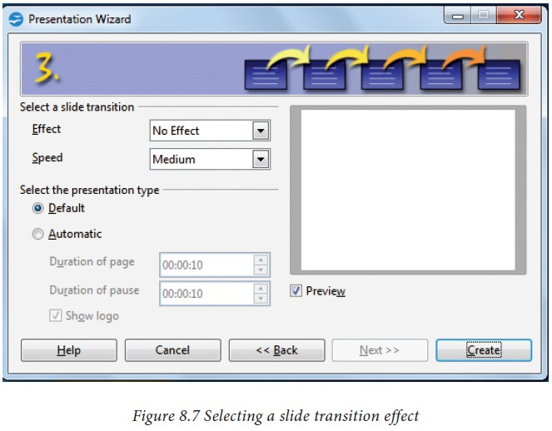

https://img.brainkart.com/imagebk34/QHtXpxW.jpg

* + 1. Select how the presentation will be Speed drop-down menu. Medium is a good choice. Click Create. A new used under Select an output medium.

Generally, presentations are created for computer screen display, so select Screen option.

* + 1. Click Next. The Presentation Wizard step 3 appears. In this step, you can choose the desired slide transition from the Effect drop-down menu. Select the desired speed for the transition between the different slides in the presentation from the Speed drop-down menu. Medium is a good choice. Click Create. A new presentation is created. (Figure shown below).

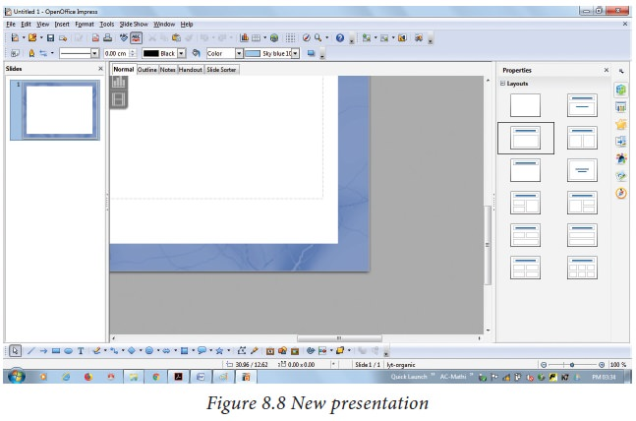

https://img.brainkart.com/imagebk34/RCxsLNt.jpg

1. **Using Template**

* If you choose the option from template, it uses a template design already created as the basis for a new presentation. The wizard changes to show a list of available templates. Choose the template that you want. (Figure shown below).

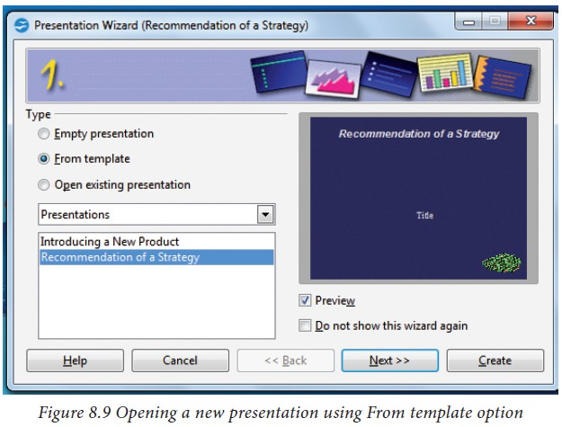

https://img.brainkart.com/imagebk34/ynIHqs9.jpg

* Introducing a New Product and Recommendation of a Strategy are pre-packaged presentation templates.



https://img.brainkart.com/imagebk34/ynIHqs9.jpg

1. **Using Open existing presentation**

* If you choose the option Open existing presentation, it helps in continuing the work on a previously created presentation.
* You have to open a presentation already prepared by clicking Open button. The wizard changes to show a list of existing presentations, from which you can choose the one that you want. (Figure given below).

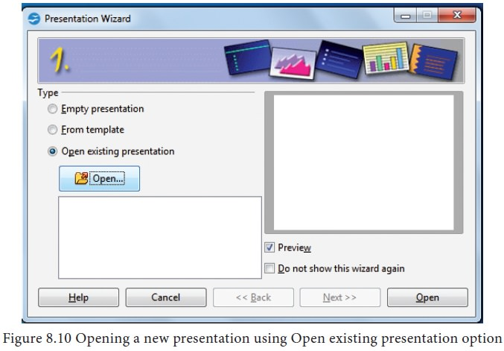

https://img.brainkart.com/imagebk34/Uu8FTVW.jpg

## Various ways of Starting Impress

You can start Impress in various ways.

1. You can select the presentation from the system menu or the OpenOffice. org Quick starter.
2. Or you can click the triangle to the right of the new icon on the main toolbar and select Presentation from the drop-down menu (Figure shown below).

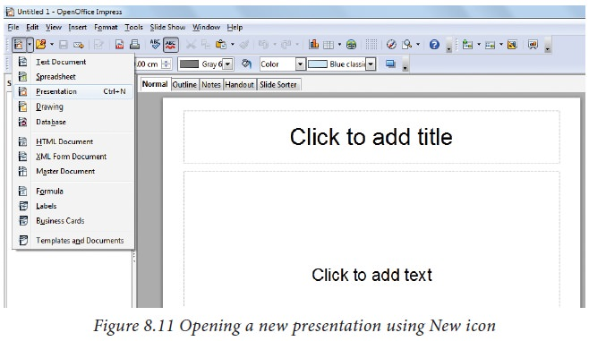

https://img.brainkart.com/imagebk34/pUWoWS8.jpg

1. Or else, choose File -> New -> Presentation. (Figure given below).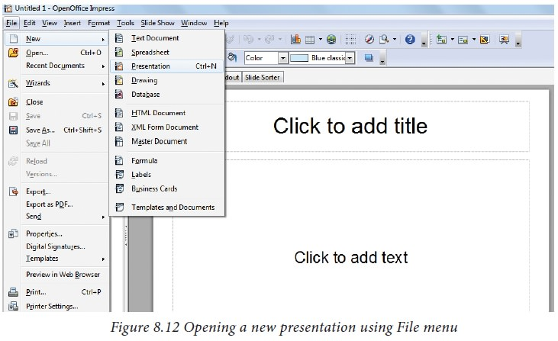

## Parts of the main Impress window

The main Impress window (Figure shown below) has three parts: the Slides pane, the Workspace and the Task pane. Additionally, several toolbars can be displayed or hidden during the creation of a presentation.

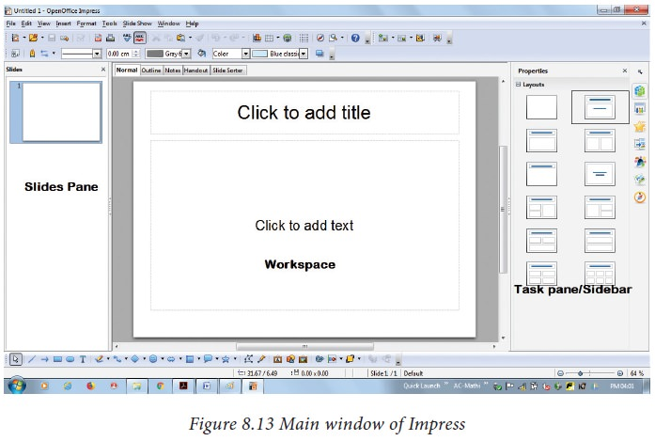

https://img.brainkart.com/imagebk34/OsL0cuW.jpg

1. **Slides pane**

* The Slides pane contains thumbnail pictures of the slides in your presentation, in the order of our insertion of slides.
* Clicking a slide in this pane selects it and places it in the Workspace. While it is there, you can apply any changes that are desired to that particular slide.

Several additional operations can be performed on one or more slides in the Slides pane:

* Add new slides at any place within the presentation after the first slide.
* Mark a slide as hidden so that it will not be shown as part of the slide show.
* Delete a slide from the presentation if it is no longer needed.
* Rename a slide.
* Copy or move the contents of one slide to another (copy and paste, or cut and paste, respectively).

It is also possible to perform the following operations, other than using the Slides pane.

* Change the slide transition following the selected slide or after each slide in a group of slides.
* Change the sequence of slides in the presentation.
* Change the slide design. (A window opens allowing you to load your own design.)
* Change slide layout for a group of slides simultaneously. (This requires using the Layouts section of the Tasks pane.)

1. **Tasks pane**

The Tasks pane has five sections:

* 1. **Master Pages**

You define the page style for your presentation using Master Pages. Impress contains pre-packaged Master Pages (slide masters). One of them by default is blank, and the rest have a specific background. (Figure shown below).

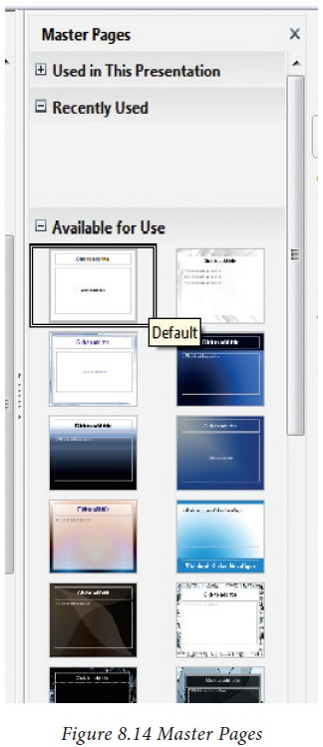

https://img.brainkart.com/imagebk34/6QRbrA8.jpg

* 1. **Layout**

Pre-packaged layouts are shown. You can choose the one that you want, use it as it is or modify it to suit your own requirements. At present, it is not possible to create custom layouts. (Figure shown below).

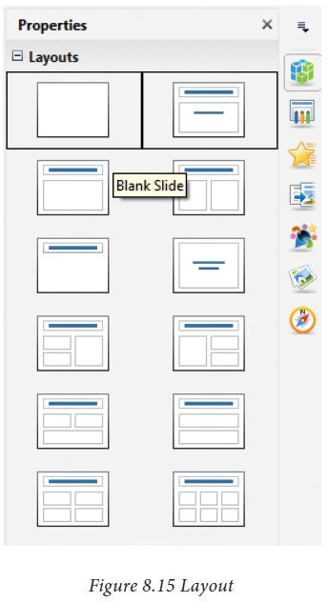

https://img.brainkart.com/imagebk34/0zOFMsV.jpg

* 1. **Table Design**

Standard table styles are provided in this pane. You can further modify the appearance of a table with the selections to show or hide specific rows and columns, or to apply a banded appearance to the rows and columns. (Figure shown below).

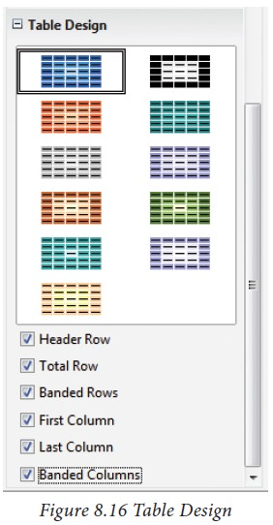

https://img.brainkart.com/imagebk34/doObjYj.jpg

* 1. **Custom Animation**

A variety of animations for selected elements of a slide are listed here. Animation can be added to selected elements of a slide and it can also be changed or removed later. (Figure shown below).

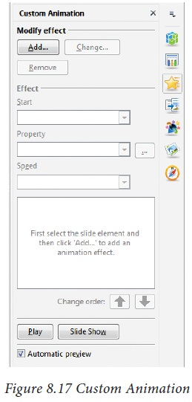

https://img.brainkart.com/imagebk34/omQceH4.jpg

* 1. **Slide Transition**

Transitions are available, including No Transition. You can select the transition speed (slow, medium, fast). You can also choose between an automatic or manual transition, and how long you want the selected slide to be shown (automatic transition only). (Figure shown below).

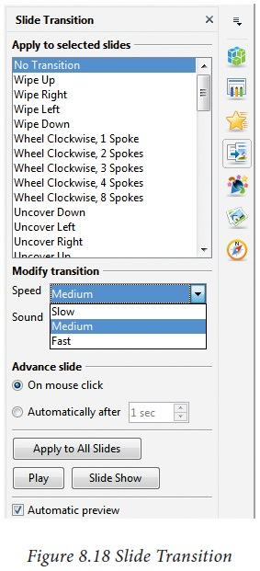

https://img.brainkart.com/imagebk34/omQceH4.jpg

## Window elements of Impress

Figure given below shows the elements of the Impress Window Open source application .

The window elements of Impress include Title Bar, Menu Bar, Tool Bar, Ruler Bar and the Scroll Bar which are similar to the elements in Open Office writer.

1. **View Buttons:**

The Workspace has five tabs: Normal, Outline, Notes, Handout, and Slide Sorter, as seen in Figure above. These five tabs are called View Buttons.

1. **Status Bar**

Status Bar is present at the bottom of your window, which gives statistics about the file that you are viewing.

It is a good practice to check the information shown there. In case you do not need the information in the Status Bar, you can hide it by selecting View -> Status Bar from the main menu.

1. **Navigator**

The Navigator (Figure given below) displays all objects contained in a document. It provides another convenient way to move around a document and find items in it. The Navigator button is located on the Standard toolbar. You can also display the Navigator by choosing Edit -> Navigator on the menu bar or pressing Ctrl+Shift+F5.

The Navigator is more useful if you give your objects (pictures, spreadsheets, and so on) meaningful names, instead of leaving them as the default “Object 1” and “Picture 1” as shown in Figure given below.

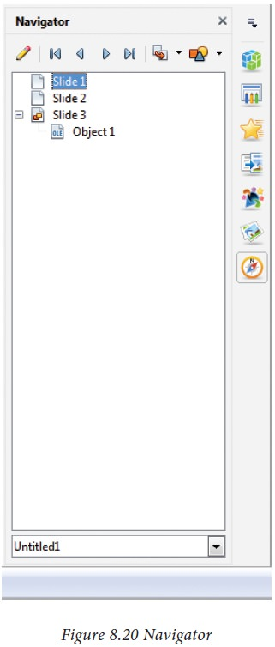

## Working with Presentation

### **Workspace**

The Workspace has five tabs: Normal, Outline, Notes, Handout and Slide Sorter, as seen in Figure given below. These five tabs are called View Buttons. There are many toolbars that can be used during the slide creation; they are revealed by selecting them with View -> Toolbars.

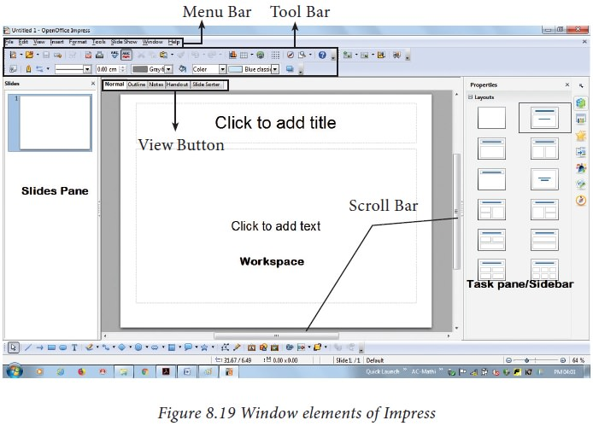

https://img.brainkart.com/imagebk34/Nw6cNac.jpg

The actual Workspace section is below the View Buttons. This is where you assemble the various parts of your selected slide. Each view is designed to ease the completion of certain tasks.

**Normal view** is the main view for creating individual slides. Use this view to format and design slides and to add text, graphics and animation effects.

**Outline view** shows topic titles, bulleted lists and numbered lists for each slide in outline format. Use this view to rearrange the order of slides, edit titles and headings, rearrange the order of items in a list and add new slides.

**Note’s view** lets you add notes to each slide that are not seen when the presentation is shown.

**Slide Sorter** view shows a thumbnail of each slide in order. Use this view to rearrange the order of slides, produce a timed slide show, or add transitions between selected slides.

**Handout view** lets you print your slides for a handout. You can choose one, two, three, four, or six slides per page from Tasks pane -> Layouts. Thumbnails can be re-arranged in this view by dragging and dropping them.



https://img.brainkart.com/imagebk34/pGKzWO7.jpg

* + - 1. **Normal view**

There are two ways to place a slide in the Slide Design area of the Normal view: clicking the slide thumbnail in the Slides pane or using the Navigator.

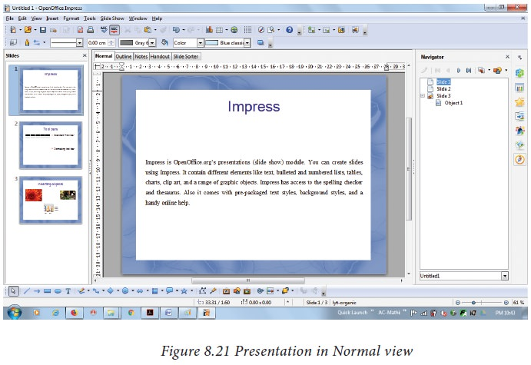To open the Navigator, click the Navigator button in the Standard Toolbar or press Ctrl+Shift+F5 and select a slide by scrolling down the Navigator list until you find the one that you want and then double-click it. (Figure given below)

https://img.brainkart.com/imagebk34/qltAcfy.jpg

* + - 1. **Outline view**

Outline view contains all the slides of the presentation in their numbered sequence. Only the text in each slide is shown. Slide names are not included.

Outline view serves for two purposes.

1. Making changes in the text of a slide:

* Add or delete text in a slide just as in the Normal view.
* Move the paragraphs of text in the selected slide up or down by using the up and down arrow buttons (Move Up or Move Down) on the Text Formatting toolbar
* Change the outline level for any of the paragraphs in a slide using the left and right arrow buttons (Promote or Demote).Both move a paragraph and change its outline level using a combination of these four arrow buttons.

1. Comparing the slides with your outline (if you have prepared one in advance). If you notice from your outline that another slide is needed, you can create it directly in the Outline view or you can return to the Normal view to create it, then return to review all the slides against your outline in the Outline view.

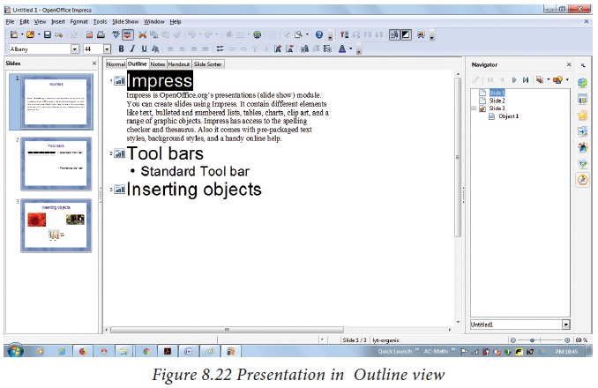

https://img.brainkart.com/imagebk34/cM5IiNf.jpg

If a slide is not in the correct sequence, you can move it to its proper place :

1. Click the slide icon of the slide that you wish to move, as indicated in Figure given above.
2. Drag and drop it where you want.
3. **Notes view**

Use the Notes view to add notes to a slide:

* Click the Notes tab in the Workspace (Figure given below).
* Select the slide to which you will add notes.
* Double-click the slide in the Slide pane, or
* Double-click the slide’s name in the Navigator.
* In the text box below the slide, click on the words Click to add notes and begin typing.

You can resize the notes text box using the green resizing handles and move it by placing the pointer on the border, then click and drag. To make changes in the text style, press the F11 key to open the Styles and Formatting window.

1. **Slide Sorter view**

The Slide Sorter view contains all of the slide thumbnails (Figure given below).

Use this view to work with a group of slides or with only one slide.

Change the number of slides per row, if desired:

1. Check View • Toolbars • Slide View to show the Slide view toolbar (Figure given below).
2. Adjust the number of slides (up to a maximum of 15).
3. After you have adjusted the number of slides per row, View • Toolbars • Slide View will remove this toolbar from view.

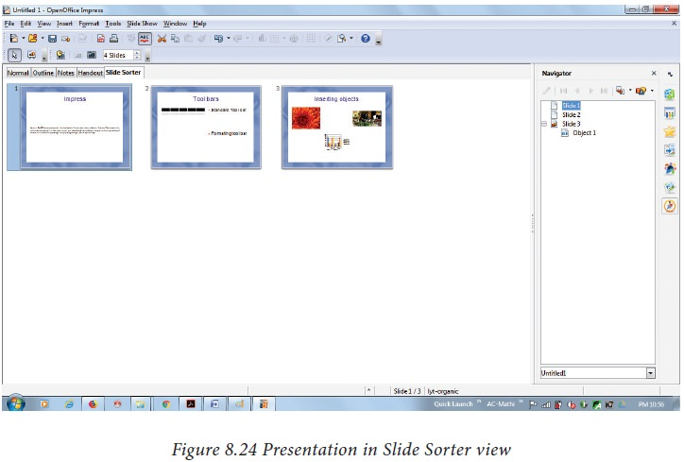

https://img.brainkart.com/imagebk34/0vQi8tf.jpg

**To select a group of slides, use one of these methods:**

* **Use the Control (Ctrl) key:** Click on the first slide and, while pressing Control, select the other desired slides.
* **Use the Shift key:** Click on the first slide, and while pressing the Shift key, select the final slide in the group. This selects all of the other slides in between the first and the last.
* **Use the cursor:** Click on the first slide to be selected. Hold down the left mouse button.
* Drag the cursor to the last slide thumbnail.

A dashed outline of a rectangle forms as you drag the cursor through the slide thumbnails and a thick black border is drawn around the selected slides. Make sure that this rectangle includes all the slides you want to select. (Figure given below).

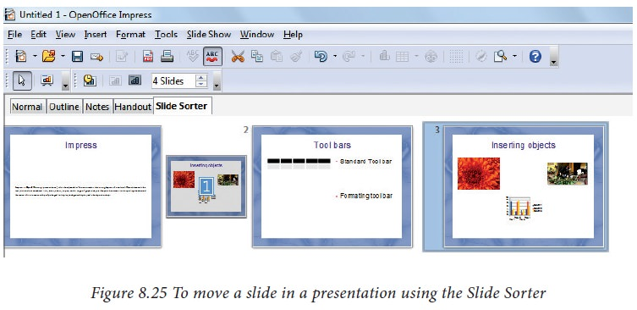

https://img.brainkart.com/imagebk34/helycZi.jpg

**To move a group of slides:**

1. Select the group of slides.
2. Drag and drop the group to their new location. The same vertical black line appears to show you where the group of slides will go. You can work with slides in the Slide Sorter view as in the Slide pane.

To make changes, right-click a slide and do the following, using the pop-up menu:

* Add a new slide after the selected slide.
* Delete or rename the selected slide.
* Change the Slide Layout.
* Change the Slide Transition.

For one slide, click the slide to select it. Then add the desired transition.

For more than one slide, select the group of slides and add the desired transition.

* Mark a slide as hidden. Hidden slides will not be shown in the slide show.
* Copy or cut and paste a slide.

1. **Handout view**

Handout view is for setting up the layout of your slides for a printed handout. Click the Handout tab in the workspace, then choose Layout in the tasks pane (Figure given below). You can then choose to print one, two, three, four, or six slides per page.

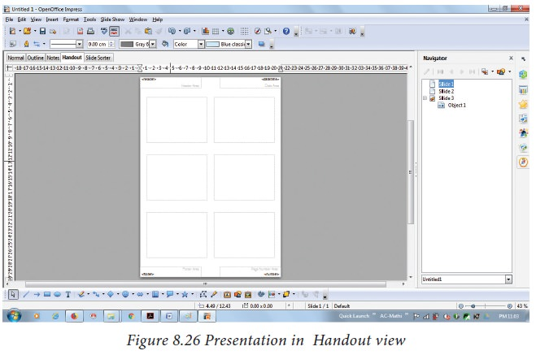

https://img.brainkart.com/imagebk34/8nCOzSD.jpg

To print a handout:

* Select the slides using the Slide Sorter. (Use the steps listed in selecting a group of slides.)
* Select File Print or press Ctrl+P to open the Print dialog box.
* Select Options in the bottom left corner of the Print dialog box.
* Check Handouts in the Contents section, and then click OK.
* Click OK to close the Print dialog box.

### **Formatting a presentation**

* + - 1. **Inserting, deleting and rearranging slides**

Tip Note: Remember to save frequently while working on the presentation, to prevent any loss of information. You might also want to activate the Auto Recovery function (Tools -> Options -> Load/Save -> General). Make sure that Save Auto Recovery information every is selected and that you have entered a suitable recovery frequency.

* + - 1. **Creating the first slide**

The first slide is normally a title slide. Decide the layout as per its purpose of presentation. You can use the pre-packaged layouts available in the Layout section of the Tasks pane. Suitable layouts are Title Slide (which also contains a section for a subtitle) or Title Only, Title and Content, Title and two content and so on.

Select a layout in the Layout section of the Tasks pane by clicking on it: it appears in the Workspace. To create the title, click on Click to add title (assuming the Blank Slide layout was not used) and then type the title text.

Adjustments to the formatting of the title can be done by pressing the F11 key, right-clicking the Title presentation style entry, and selecting Modify from the pop-up menu.

If you are using the Title Slide layout, click on “Click to add text” to add a subtitle. Proceed as above to make adjustments to the formatting if required. (Figure given below)

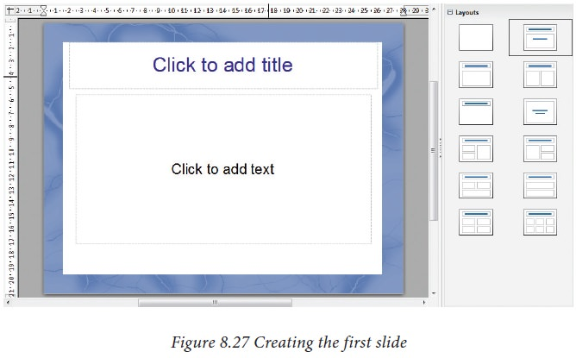

https://img.brainkart.com/imagebk34/n7wbHaV.jpg

* + - 1. **Inserting additional slides**

The steps for inserting additional slides are basically the same as for selecting the title page. It is a process that has to be repeated for each slide.

Unless you are using more than one slide master, your only concern is the Layouts section of the Tasks pane (Figure given below).

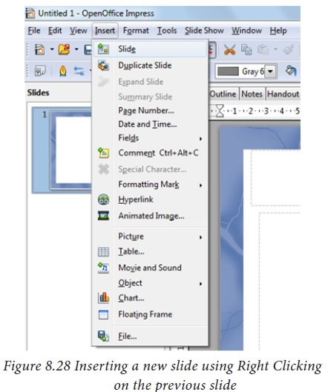

https://img.brainkart.com/imagebk34/pkBR8GI.jpg

First insert all the slides that are needed as per your outline. Only after this, you should begin adding special effects such as custom animation and slide transitions.

Step 1: Insert a new slide. This can be done in a variety of ways.

* Insert -> Slide.
* Right-click on the present slide, and select Slide -> New Slide from the pop-up menu. (Figure given above).
* Click the empty space after the last slide also to create a new slide by right clicking New Slide. (Figure given below)
* Click the Slide icon in the Presentation toolbar.

Step 2: Select the layout slide that best fits your needs. (Figure given above).

Step 3: Modify the elements of the slide like removing unneeded elements, adding needed elements (such as pictures), and inserting text.

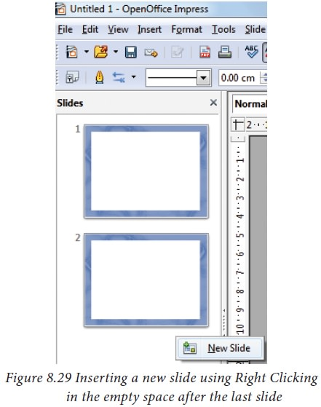

https://img.brainkart.com/imagebk34/TIExzv0.jpg

* + - 1. **Deleting a Slide**

You can delete a slide at any time using the following pro c e du re .

* Select the slide you want to delete
* Click Edit • Delete slide (Refer Figure 8.30)

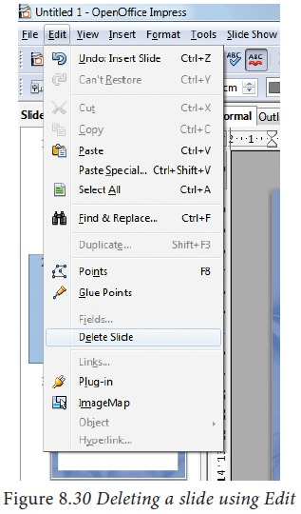

https://img.brainkart.com/imagebk34/SEhh9AL.jpg

* Or else, right click the slide and choose Delete slide from the pop-up menu. (Figure given below)
  + - 1. **Rearranging slides**

If you want to rearrange the slides, you need to follow the procedure below.

* Select the slide that you want to rearrange.
* Drag that slide to the desired position by holding the mouse using left click.
* Release the mouse once you drag the slide to the desired place. (Figure given below)

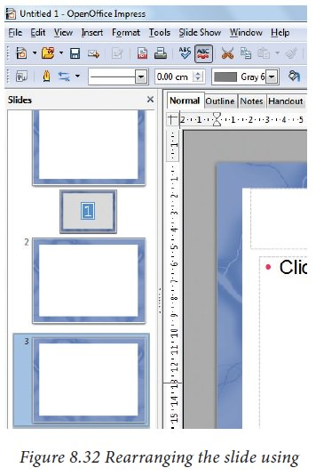

https://img.brainkart.com/imagebk34/sq6L4Tj.jpg

### **Running the slide show**

To run the slide show, do one of the following:

* Click Slide Show -> Slide Show on the main menu bar. (Figure given below).

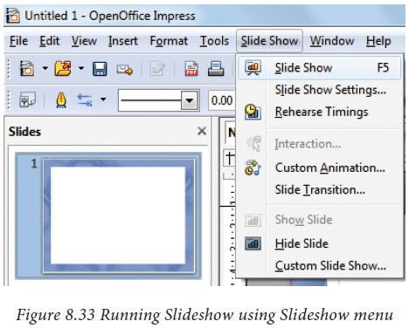

https://img.brainkart.com/imagebk34/LLqz6RR.jpg

* Click the Slide Show button on the Presentation toolbar or the Slide Sorter toolbar (Figure given below).

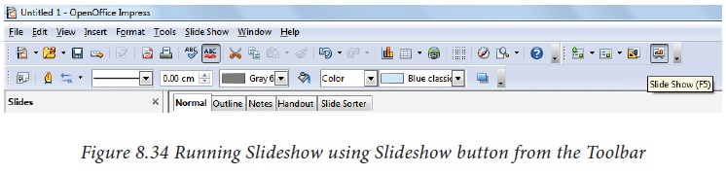

https://img.brainkart.com/imagebk34/CxGBgah.jpg

* Press F5 or F9.
* If the slide transition is Automatically after x seconds, let the slide show run by itself.
* If the slide transition is On mouse click, do one of the following to move from one slide to the next.
* Use the arrow keys on the keyboard to go to the next slide or to go back to the previous one.
* Click the mouse button to advance to the next slide.
* Press the Spacebar on the keyboard to advance to the next slide.
* When you advance past the last slide, the message “Click to exit presentation...” appears. Click the mouse or press any key to exit the presentation.
* To exit the slide show at any time, including at the end, press the Esc key.

### **Saving a Presentation**

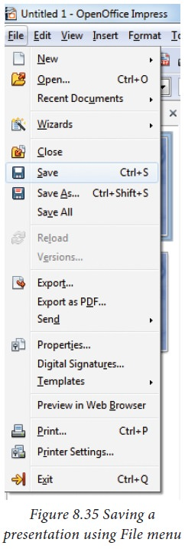In order to save a presentation Click File -> Save (Figure given below)

·

https://img.brainkart.com/imagebk34/WCWQSaR.jpg

* After giving save option, Impress will open a dialog box asking the name in which this file should be saved (Figure given below)

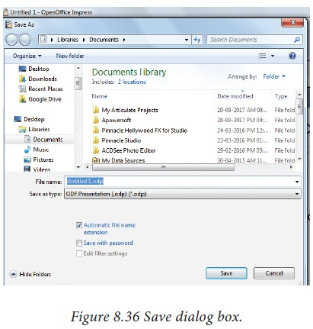

https://img.brainkart.com/imagebk34/kVNFqGl.jpg

* The default file extension for Impress is .odp.
* Type the name of the file you want to give in the text box space after File Name in the dialog box. (Figure given above).
* You can save the presentation as a PPT presentation also. (Figure given below)

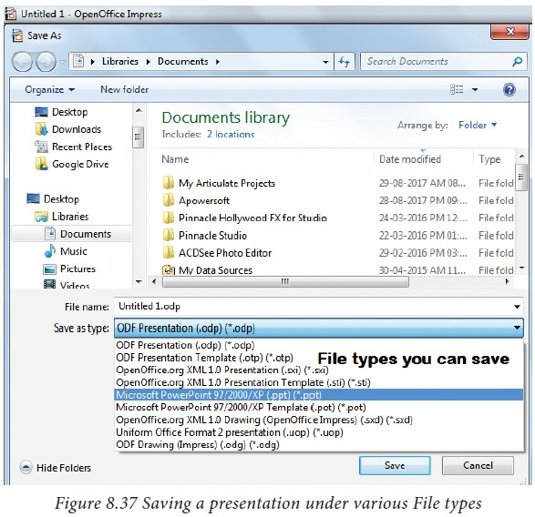

https://img.brainkart.com/imagebk34/4umrzAe.jpg

## Creating Graphic Objects

You can create your own graphics using the drawing tools available in Impress. Impress contains a number of advanced drawing functions. To create more advanced graphic objects, you can use OpenOffice.org to draw and import the graphic object created into an Impress slide.

#### **The Drawing toolbar**

The Drawing toolbar contains tools that are used to create graphic objects. If this toolbar is not showing, select View ->Toolbars Drawing from the main menu bar.

* **Select:** selects objects. You can select multiple objects by dragging the mouse .
* **Line:** draws a straight line.
* **Arrow:** draws a straight line ending with an arrowhead. The arrowhead will be placed where you release the mouse button.
* **Rectangle:** draws a rectangle. Press the Shift button to draw a square.
* **Ellipse:** draws an ellipse. Press the Shift button to draw a circle.
* **Text:** creates a text box with the text aligned horizontally.
* **Vertical text:** creates a text box with the text aligned vertically.
* **Curve:** draws a curve.
* **Connectors:** draws a connector line between two figures. Click the black triangle for additional connectors.

### **Inserting images - presentation**

**Inserting images**

In order to insert an image in OpenOffice Impress, place the cursor in the place where you want the image to be inserted. Then, Click Insert -> select Picture -> From File option from the Insert menu.

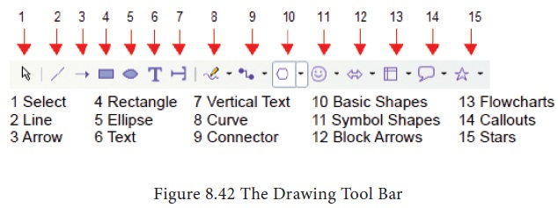

https://img.brainkart.com/imagebk34/cq6mzBW.jpg

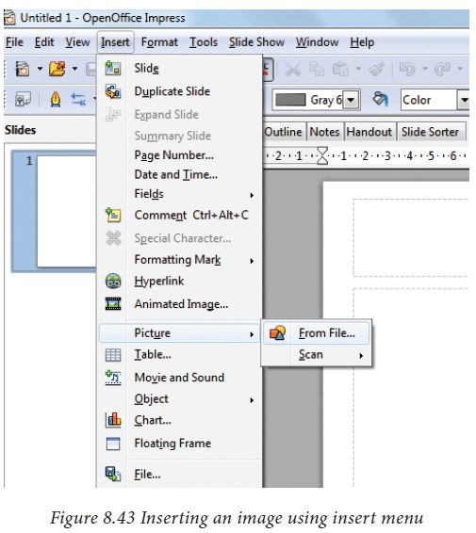OpenOffice Impress will display the dialog box, where you can select the image from the specific location and select open. The image will be inserted in the specified location.

https://img.brainkart.com/imagebk34/f3V5bLy.jpg

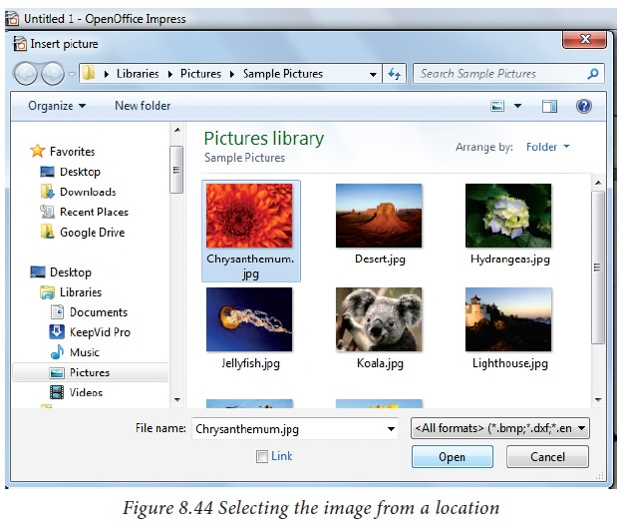

https://img.brainkart.com/imagebk34/IrQYXcG.jpg

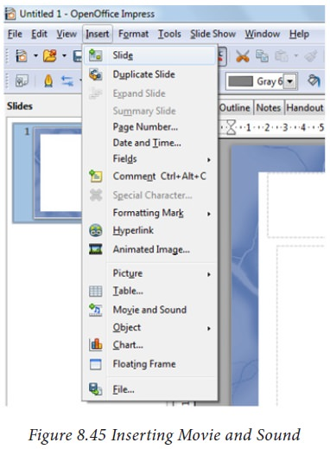

https://img.brainkart.com/imagebk34/5C5ra5E.jpg

### **Inserting audio and video**

Open Office Impress will let you insert audio files or movie files. The audio and move files can be inserted by clicking Insert Movie and Sounds Option from the Insert menu. Figure given below.



https://img.brainkart.com/imagebk34/5C5ra5E.jpg

Same as inserting images here also, a dialog box will be opened. Select the audio or movie file form the specified location and open. It will be opened in the slide. Figure given below. The movie or audio file inserted will be played during the slide show by clicking the mouse over it.

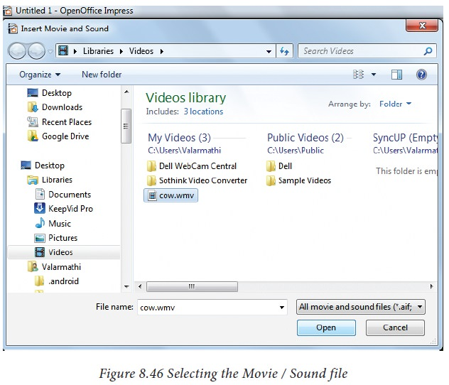

https://img.brainkart.com/imagebk34/i0NKdDn.jpg

Learning Outcome

Familiarization with PC Management

## 

## 

# Familiarization with Disk management

## Introduction

**What is Disk Management?**

Disk Management is a Microsoft Windows utility first introduced in Windows XP as a replacement for the fdisk command. It enables users to view and manage the disk drives installed in their computer and the partitions associated with those drives. As the image below shows, each drive is displayed followed by the layout, type, file system, status, capacity, free space, % free, and fault tolerance.

It's used to manage the drives installed in a computer—like hard disk drives (internal and external), optical disk drives, and flash drives. It can be used to partition and format drives, assign drive letters, and much more.

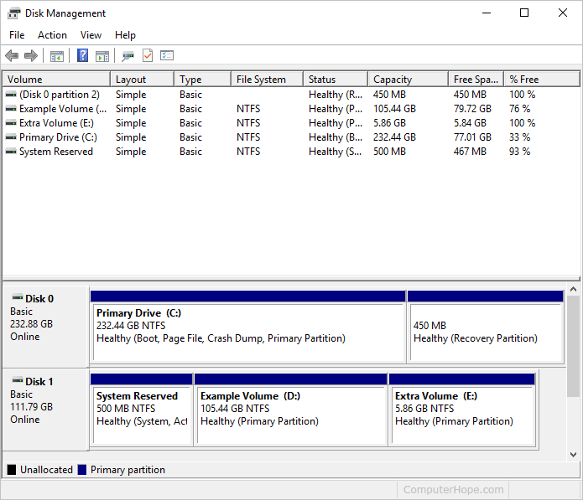

Image: Disk Management

Reference: <https://www.computerhope.com/issues/pictures/win10-disk-management.jpg>

**Disk Management Availability**

Disk Management is available in most versions of Microsoft Windows including Windows 11, Windows 10, Windows 8, Windows 7, Windows Vista, Windows XP, and Windows 2000.

## How to Open Disk Management

The most common way to access Disk Management is via the Computer Management utility, which you can get to from Administrative Tools in the Control Panel.

As the most frequently used Windows built-in disk partition management tool with basic features, it can help realize some simple disk managements. However, first of all, we should figure our how to get to this tool. Generally, there are 3 ways available.

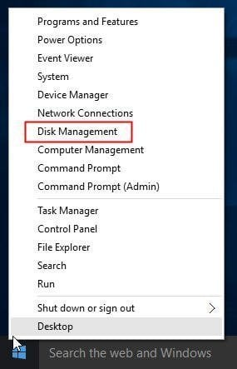**Way 1:** The easiest way to open Disk Management in Windows 10 is from computer Desktop. Right click on Start Menu (or press Windows+X hotkey) and then select "Disk Management".

Image: open-disk-management-windows

Reference: <https://www.diskpart.com/windows-10/images/windows-10-disk-management/open-disk-management-windows-10.jpg>

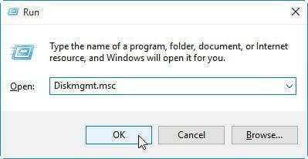**Way 2:** Use Windows+R hotkey to open Run window. Then type "Diskmgmt.msc" and click "OK" or hit "Enter" key.

Image: open-disk-management-from-run

Reference: <https://www.diskpart.com/windows-10/images/windows-10-disk-management/open-disk-management-from-run.jpg>

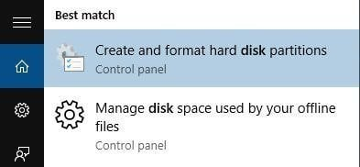**Way 3:** Directly type "disk management" in the Search box and choose "Create and format hard disk partitions" from the results.

Image: search-disk-management

Reference: <https://www.diskpart.com/windows-10/images/windows-10-disk-management/search-disk-management.jpg>

## How to Use Disk Management

Disk Management has two main sections—a top and a bottom:

* The top section contains a list of all the partitions, formatted or not, that Windows recognizes.
* The bottom section contains a graphical representation of the physical drives installed in the computer.

Performing certain actions on the drives or partitions make them available or unavailable to Windows and configure them to be used by Windows in certain ways.

## How to Partition a Hard Drive

Hard drives must be partitioned before being formatted in Windows.

**What to Know**

* The first thing to do after installing a hard drive is to partition it.
* To partition a drive, open Disk Management, select the drive, create a volume at the size you want, and select a drive letter.
* You'll want to format the drive next unless you have advanced plans for the partition but that's not very common.

**What Is Partitioning?**

To partition a hard drive in Windows means to section off a part of it and make that part available to the operating system.

In other words, a hard drive isn't useful to your operating system until it's partitioned. Additionally, it's not available to you to store files on until you format it (which is another, just as simple process).

Most of the time, this "part" of the hard drive is the entire usable space, but creating multiple partitions on a hard drive is also possible so that you can store backup files in one partition, movies in another, etc.

**How to Partition a Hard Drive in Windows**

Don't worry if this process sounds a bit more complicated than you thought because it's not. Partitioning a hard drive in Windows isn't at all hard and usually only takes a few minutes to do.

Here's how to do it:

1. Open Disk Management, the tool included in all versions of Windows that lets you partition drives, among a number of other things.

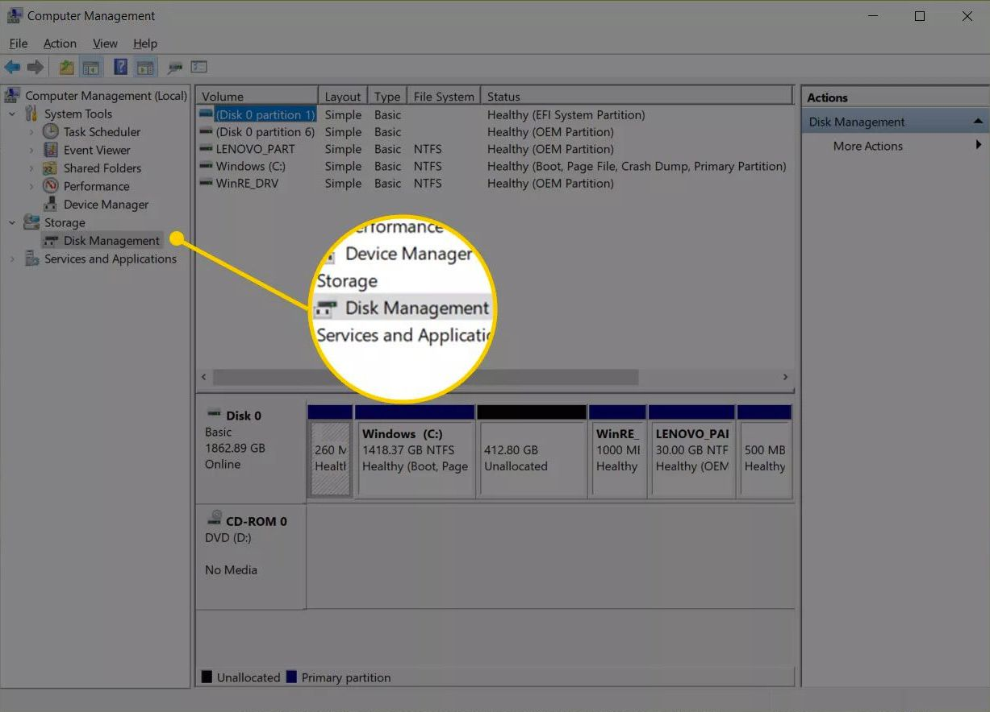

Image: how-to-partition-a-hard-drive

Reference:<https://www.lifewire.com/thmb/0UXXUZDix55KTmmwa4fGJYgxmtE=/1227x884/filters:no_upscale():max_bytes(150000):strip_icc()/009_how-to-partition-a-hard-drive-2626081-5c82c5dc46e0fb0001cbf4cc.jpg>

In Windows 10 and Windows 8/8.1, the Power User Menu is the easiest way to start Disk Management. You can also open Disk Management via command prompt in any version of Windows, but the Computer Management method is probably best for most people. Check which version of Windows is installed on your computer if you're not sure.

1. When Disk Management opens, you should see an Initialize Disk window with the message "You must initialize a disk before Logical Disk Manager can access it."

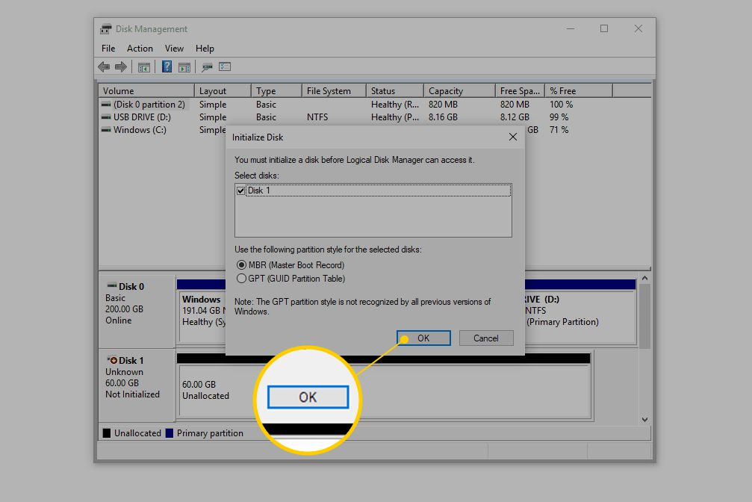

Image: how-to-partition-a-hard-drive

Reference:<https://www.lifewire.com/thmb/CDl9e9ow0Ra_ULfQ83rnJpWb9sQ=/1007x672/filters:no_upscale():max_bytes(150000):strip_icc()/001_how-to-partition-a-hard-drive-2626081-5c82ad7c4cedfd000190b160.jpg>

In Windows XP, you'll see an Initialize and Convert Disk Wizard screen instead. Follow that wizard, making sure to not select the option to "convert" the disk, unless you're sure you need to. Skip to Step 4 when done.﻿

**Note:** Don't worry if this window doesn't appear. There are legitimate reasons you may not see it—we'll know soon if there's a problem or not. Skip down to Step 4 if you don't see this.

1. On this screen, you're asked to choose a partition style for the new hard drive. Choose GPT if the new hard drive you installed is 2 TB or larger. Choose MBR if it's smaller than 2 TB.

Choose OK after making your selection.

1. Locate the hard drive you want to partition from the drive map at the bottom of the Disk Management window.

You might need to maximize the Disk Management or Computer Management window to see all the drives on the bottom. An unpartitioned drive will not show up in the drive list at the top of the window.

**Note:** If the hard drive is new, it will probably be on a dedicated row labeled Disk 1 (or 2, etc.) and will say Unallocated. If the space you want to partition is part of an existing drive, you'll see Unallocated next to existing partitions on that drive.

**Important:** If you don't see the drive you want to partition, you may have installed it incorrectly. Turn off your computer and double-check that the hard drive is properly installed.

1. Once you've found the space you want to partition, tap-and-hold or right-click anywhere on it, and choose New Simple Volume.



Image: how-to-partition-a-hard-drive

Reference:<https://www.lifewire.com/thmb/ATQst9QBPgZEWXtUMWrYBmTB2gI=/1126x697/filters:no_upscale():max_bytes(150000):strip_icc()/002_how-to-partition-a-hard-drive-2626081-5c82c62d46e0fb00010f10b6.jpg>

In Windows XP, the option is called New Partition.

1. Choose Next > on the New Simple Volume Wizard window that appeared.



Image: how-to-partition-a-hard-drive

Reference: <https://www.lifewire.com/thmb/9zHKG3FGCmO-8EWWoPh1VUagwdg=/650x0/filters:no_upscale():max_bytes(150000):strip_icc():format(webp)/003_how-to-partition-a-hard-drive-2626081-5c82adb846e0fb0001a0be31.jpg>

In Windows XP, a Select Partition Type screen appears next, where you should choose Primary partition. The Extended partition option is useful only if you're creating five or more partitions on a single physical hard drive. Select Next > after making the selection.

1. Choose Next > on the Specify Volume Size step to confirm the size of the drive you're creating.



Image: how-to-partition-a-hard-drive

Reference:<https://www.lifewire.com/thmb/4xtocdwN00p2tsp4W0rKb7JyyQs=/650x0/filters:no_upscale():max_bytes(150000):strip_icc():format(webp)/004_how-to-partition-a-hard-drive-2626081-5c82add546e0fb0001a0be33.jpg>

The default size that you see in the Simple volume size in MB: field should equal the amount shown in the Maximum disk space in MB: field. This means that you're creating a partition that equals the total available space on the physical hard drive.

1. Select Next > on the Assign Drive Letter or Path step, assuming the default drive letter you see is OK with you.



Image: how-to-partition-a-hard-drive

Reference:<https://www.lifewire.com/thmb/m5ghUv2ipi2RYEJ4mSQoAifE2Us=/650x0/filters:no_upscale():max_bytes(150000):strip_icc():format(webp)/005_how-to-partition-a-hard-drive-2626081-5c82adf64cedfd000190b164.jpg>

Windows automatically assigns the first available drive letter, skipping A & B, which on most computers will be D or E. You're welcome to set the Assign the following drive letter option to anything that's available.

1. Choose Do not format this volume on the Format Partition step, and then select Next >.



how-to-partition-a-hard-drive

Reference:<https://www.lifewire.com/thmb/2C8NQOgm8E61SFgnXYQ0kYFadlU=/650x0/filters:no_upscale():max_bytes(150000):strip_icc():format(webp)/006_how-to-partition-a-hard-drive-2626081-5c82ae1c46e0fb000113662e.jpg>

1. Verify your choices on the Completing the New Simple Volume Wizard screen, which should look something like this:



Image: how-to-partition-a-hard-drive

Reference:<https://www.lifewire.com/thmb/E7Jh6NzEHjBl23UqxyZjhe0UHJQ=/650x0/filters:no_upscale():max_bytes(150000):strip_icc():format(webp)/007_how-to-partition-a-hard-drive-2626081-5c82ae48c9e77c0001a3e4f4.jpg>

* Volume Type: **Simple Volume**
* Disk selected: **Disk 1**
* Volume size: **61437 MB**
* Drive letter or path: **F:**
* File system: **None**
* Allocation unit size: **Default**

Because your computer and hard drive are unlikely exactly like mine, expect your Disk selected, Volume size, and Drive letter or path values to be different than what you see here. File system: None just means that you've decided not to also format the drive right now.

1. Choose Finish and Windows will partition the drive, a process that will only take a few seconds on most computers.
2. Next, Windows will try to open the new drive automatically. However, since it's not yet formatted and can't be used, you'll see this message instead: "You need to format the disk in drive F: before you can use it. Do you want to format it?"

This only happens in Windows 10, Windows 8, and Windows 7. You won't see this in Windows Vista or Windows XP and that's perfectly fine. Just skip to the last step below if you're using one of those versions of Windows.

1. Select Cancel. Or, if you know how to format a hard drive in Windows, feel free to choose Format disk instead. If you don't, consult a tutorial first before attempting it.



Image: how-to-partition-a-hard-drive

Reference<https://www.lifewire.com/thmb/kyLqh1cebh2m014peEIavGBvS40=/650x0/filters:no_upscale():max_bytes(150000):strip_icc():format(webp)/008_how-to-partition-a-hard-drive-2626081-5c82ae75c9e77c0001a6761a.jpg>

## How to Format a Hard Drive in Windows

Follow these easy steps to format a hard drive in Windows 10, Windows 8, Windows 7, Windows Vista, or Windows XP:

1. Open Disk Management, the hard drive manager included with all versions of Windows.



Image: how-to-format-a-hard-drive

Reference:<https://www.lifewire.com/thmb/BAfcDsXhVa_FevvK8x6qelrTVFU=/650x0/filters:no_upscale():max_bytes(150000):strip_icc():format(webp)/001_how-to-format-a-hard-drive-2626077-5c3e8296c9e77c0001323453.jpg>

Opening Disk Management can be done a number of ways depending on your version of Windows, but the easiest method is to type **diskmgmt.msc** in the Run dialog box or the Start menu.

Another way to open Disk Management is through Control Panel.

1. After Disk Management opens, which might take several seconds, look for the drive you want to format from the list at the top. There's a lot of information in Disk Management, so if you can't see everything, maximize the window.



how-to-format-a-hard-drive

Reference:<https://www.lifewire.com/thmb/ZbPAraYUOebfV10OtPmq_TdKvno=/650x0/filters:no_upscale():max_bytes(150000):strip_icc():format(webp)/002_how-to-format-a-hard-drive-2626077-5c3e82adc9e77c00012a04ab.jpg>

Look for the amount of storage on the drive as well as the drive name. For example, if it says Music for the drive name and it has 2 GB of hard drive space, then you've likely selected a small flash drive full of music.

Feel free to open the drive to make sure that it's what you want to format if it makes you confident that you're going to format the right device.

1. If you don't see the drive listed on the top or an Initialize Disk window appears, it probably means that the hard drive is new and has not yet been partitioned. Partitioning is something that must be done before a hard drive is formatted.



how-to-format-a-hard-drive

Reference:<https://www.lifewire.com/thmb/CnaftQSECOW9KiWCp7RXrnc16Ew=/650x0/filters:no_upscale():max_bytes(150000):strip_icc():format(webp)/003_how-to-format-a-hard-drive-2626077-5c3e82c6c9e77c00019f8939.jpg>

**Existing Drive:** If you're formatting a drive that you've been using and that has data on it, double-check in Explorer that the drive letter you're choosing here in Disk Management is the same as the one you see in Explorer that has the information on it that you want to erase. Once formatted, the existing data on the disk are probably unrecoverable for most people.

**New Drive:** If you're formatting a new drive, a great way to tell that it's the right one is to look at the File System column in the top part of Disk Management. Your existing drives will show file systems of NTFS or FAT32 but a new, unformatted drive will show RAW instead.

1. The first of several formatting details which we'll cover over the next several steps is the volume label, which is essentially a name given to the hard drive.

In the Volume label textbox, enter whatever name you'd like to give to the drive.



Image:how-to-format-a-hard-drive

Reference: <https://www.lifewire.com/thmb/ULWAd0M1yuZoE5D760-eSQNA5ls=/650x0/filters:no_upscale():max_bytes(150000):strip_icc():format(webp)/004_how-to-format-a-hard-drive-2626077-5c3e82e2c9e77c00016ee2c0.jpg>

If the drive had a previous name and that makes sense for you, by all means, keep it.

1. Next up is the file system choice. In the File system textbox, choose NTFS.



Image: how-to-format-a-hard-drive

Reference: <https://www.lifewire.com/thmb/FXk--js9sw3JIIMXp-3BwFAdor4=/650x0/filters:no_upscale():max_bytes(150000):strip_icc():format(webp)/005_how-to-format-a-hard-drive-2626077-5c3e8301c9e77c00012a16e7.jpg>

NTFS is the most recent file system available and is almost always the best choice. Only choose FAT32 (FAT—which is actually FAT16—isn't available unless the drive is 2 GB or smaller) if you are specifically told to do so by a program's instructions that you're planning on using on the drive. This is not common.

1. In the Allocation unit size textbox, choose Default. The best allocation size based on the size of the hard drive will be chosen.



Image: how-to-format-a-hard-drive

Reference:<https://www.lifewire.com/thmb/LLEq6hLThS5AjOLYd_bZW7qNtKY=/650x0/filters:no_upscale():max_bytes(150000):strip_icc():format(webp)/006_how-to-format-a-hard-drive-2626077-5c3e831cc9e77c0001a9258c.jpg>

It's not at all common to set a custom allocation unit size when formatting a hard drive in Windows.

1. Next is the Perform a quick format checkbox. Windows will check this box by default, suggesting that you do a "quick format" but we recommend that you uncheck this box so that a "standard format" is performed.



Image: how-to-format-a-hard-drive

Reference:<https://www.lifewire.com/thmb/Y_A6WN76uQO48YbmuinItp5fOFc=/650x0/filters:no_upscale():max_bytes(150000):strip_icc():format(webp)/007_how-to-format-a-hard-drive-2626077-5c3e833a46e0fb0001aa2acc.jpg>

In a standard format, each individual "part" of the hard drive, called a sector, is checked for errors and overwritten with a zero—a sometimes painfully slow process. This procedure ensures that the hard drive is physically working as expected, that each sector is a reliable place to store data, and that existing data is unrecoverable.

In a quick format, this bad sector search and basic data sanitization is skipped entirely and Windows assumes that the hard drive is free of errors. A quick format is very fast.

You, of course, can do whatever you like—either method will get the drive formatted. However, especially for older and brand-new drives, we'd prefer to take our time and do the error checking right now instead of letting our important data do the testing for us later on. The data sanitization aspect of a full format is nice, too, if you're planning on selling or disposing of this drive.

1. The final format option is the Enable file and folder compression setting that is unchecked by default, which we recommend sticking with.



Image: how-to-format-a-hard-drive

Reference:<https://www.lifewire.com/thmb/9jJpxH6DWXVuIkfUpJ92Or9hyhk=/650x0/filters:no_upscale():max_bytes(150000):strip_icc():format(webp)/008_how-to-format-a-hard-drive-2626077-5c3e835dc9e77c0001325f39.jpg>

The file and folder compression feature allows you to choose files or folders to be compressed and decompressed on the fly, potentially offering considerable savings on hard drive space. The downside here is that performance can be equally affected, making your day-to-day Windows use much slower than it would be without compression enabled.

File and folder compression has little use in today's world of very large and very inexpensive hard drives. In all but the rarest occasions, a modern computer with a large hard drive is better off protecting all the processing power it can and skipping on the hard drive space savings.

1. Review the settings you've made in the last several steps and then click OK.



Image: how-to-format-a-hard-drive

Reference: <https://www.lifewire.com/thmb/fep7oK8UbRWvGaz-d3DAL63_xWQ=/650x0/filters:no_upscale():max_bytes(150000):strip_icc():format(webp)/009_how-to-format-a-hard-drive-2626077-5c3e8452c9e77c0001329405.jpg>

As a reminder, here's what you should see:

**Volume label:** [label of your choosing]

**File system:** NTFS

**Allocation unit size:** Default

**Perform a quick format:** unchecked

**Enable file and folder compression:** unchecked

Look back at whatever previous steps you need to if you're wondering why these are the best options.

1. Windows is usually pretty good about warning you before you might do something damaging, and a hard drive format is no exception.



Image: how-to-format-a-hard-drive

Reference: <https://www.lifewire.com/thmb/JVNJP4Vd-JCpYjgdOHCkCIfHtSs=/650x0/filters:no_upscale():max_bytes(150000):strip_icc():format(webp)/010_how-to-format-a-hard-drive-2626077-5c3e846dc9e77c0001329a59.jpg>

1. The hard drive format has begun! You can check the progress by watching the Formatting: xx% indicator under the Status column in the top part of Disk Management or in the graphical representation of your hard drive in the bottom section.



Image: how-to-format-a-hard-drive

Reference:<https://www.lifewire.com/thmb/BptGPHyWzUy_bgo4qjV0kEnN84Y=/650x0/filters:no_upscale():max_bytes(150000):strip_icc():format(webp)/011_how-to-format-a-hard-drive-2626077-5c3e848b46e0fb0001526cb5.jpg>

If you chose a quick format, your hard drive should only take several seconds to format. If you chose the standard format, which we suggested, the time it takes the drive to format will depend almost completely on the size of the drive. A small drive will take a small amount of time to format and a very large drive will take a very long time to format.

Your hard drive's speed, as well as your overall computer's speed, play some part but the size is the biggest variable.

1. Disk Management in Windows won't flash a big "Your Format is Complete!" message, so after the format percentage indicator reaches 100%, wait a few seconds and then check again under Status and make sure it's listed as Healthy like your other drives.



Image: how-to-format-a-hard-drive

Reference:<https://www.lifewire.com/thmb/cpjUiGUwuRBMMQDy1EjsdwTrz7A=/650x0/filters:no_upscale():max_bytes(150000):strip_icc():format(webp)/012_how-to-format-a-hard-drive-2626077-5c3e84aec9e77c000132ab28.jpg>

1. That's it! Your hard drive has been formatted and it's ready for use in Windows. You can use the new drive however you want—back up files, store music, and videos, etc.



Image: how-to-format-a-hard-drive

Reference: <https://www.lifewire.com/thmb/hQxcswELoqi-45n_usnJnbjniv4=/650x0/filters:no_upscale():max_bytes(150000):strip_icc():format(webp)/013_how-to-format-a-hard-drive-2626077-5c3e84c4c9e77c00019ff4b4.jpg>

## Task Scheduler

### **How to create an automated task using Task Scheduler on Windows**

Windows Scheduler helps you automate your work

**How Windows 10 Task Scheduler Works**

Task Scheduler has been a utility included through several versions of the Windows operating system. The ability to create an automated task with Windows 10 task scheduler opens up many possibilities. You can trigger windows to run tasks based on a schedule or system events. Task scheduler can launch an application or a script that performs tasks for you.

This can be helpful to do things like:

* Launch a Chrome browser and Outlook app you use every time you use your computer.
* Launch a time logging application at the end of the day to clock your work hours.
* Trigger a batch job or PowerShell script with command prompt commands to clean your computer daily.
* Automatically shut down your computer at the same time every day.

### **How to create a basic task using Task Scheduler**

Use the steps below to launch an application on your computer at the same time every morning.

* + - 1. Select the Start menu and type "Task Scheduler" and select the Task Scheduler app to launch it.



Image: CreateanAutomatedTaskwithWindows

Reference:<https://www.lifewire.com/thmb/RNr_fUghjXvgPXXBHN09JdEOcCA=/650x0/filters:no_upscale():max_bytes(150000):strip_icc():format(webp)/A1-CreateanAutomatedTaskwithWindows10TaskScheduler-annotated-78bd399f1e1143e6a7ed82e03e00b340.jpg>

* + - 1. You can organize your automated tasks into your own folder. Just right click on Task Scheduler Library in the left navigation tree, and select New Folder.

Image: CreateanAutomatedTaskwithWindows

Reference:<https://www.lifewire.com/thmb/RNr_fUghjXvgPXXBHN09JdEOcCA=/650x0/filters:no_upscale():max_bytes(150000):strip_icc():format(webp)/A1-CreateanAutomatedTaskwithWindows10TaskScheduler-annotated-78bd399f1e1143e6a7ed82e03e00b340.jpg>

* + - 1. Give the folder a name like "My Tasks" and select OK.



Image: CreateanAutomatedTaskwithWindows

Reference:<https://www.lifewire.com/thmb/kNhis6PP_2niv800XyA9en31jTQ=/650x0/filters:no_upscale():max_bytes(150000):strip_icc():format(webp)/A3-CreateanAutomatedTaskwithWindows10TaskScheduler-annotated-e35ab416d0c64fdda282e0692d84b1a2.jpg>

* + - 1. Select the new folder you've created. In the Actions navigation bar on the right, select Create Basic Task. This will open the Create Basic Task Wizard. Type a name for the task in the Name field. Select Next to continue.



Image: CreateanAutomatedTaskwithWindows

Reference: <https://www.lifewire.com/thmb/HBVzZxV5INUP4WZNTtvLjEX0-iY=/650x0/filters:no_upscale():max_bytes(150000):strip_icc():format(webp)/A4-CreateanAutomatedTaskwithWindows10TaskScheduler-annotated-b678b1b51be44a77afdcfb4d0f445c8d.jpg>

1. The next step of the wizard is to choose a trigger for your task. You can choose one of the time intervals, or one of the system events. In this example, we'll select Daily. Select Next to continue.



Image: CreateanAutomatedTaskwithWindows

Reference:<https://www.lifewire.com/thmb/n1qc96cze8AqNsZTWqx6NEBeAls=/650x0/filters:no_upscale():max_bytes(150000):strip_icc():format(webp)/A5-CreateanAutomatedTaskwithWindows10TaskScheduler-annotated-d9bde967c811431196dc03dd9b9119cc.jpg>

1. The next step is to fine tune the interval trigger. In this case we'll set the trigger to happen at 8 AM every day, starting today. Set the recurrence to every 1 day. Select Next to continue.

Image: CreateanAutomatedTaskwithWindows

Reference: <https://www.lifewire.com/thmb/l3vbtXCxQnvw7CF_fo2iSKmKsMY=/650x0/filters:no_upscale():max_bytes(150000):strip_icc():format(webp)/A6-CreateanAutomatedTaskwithWindows10TaskScheduler-annotated-57456959f53c4477a0bdeb1e3392d041.jpg>

1. The next step is to set up the Action for the task. In this case, select Start a Program and then select Next.



Image: CreateanAutomatedTaskwithWindows

Reference:<https://www.lifewire.com/thmb/hIrcS0kZd2o8mCJfMPKQNsJ2O9s=/650x0/filters:no_upscale():max_bytes(150000):strip_icc():format(webp)/A7-CreateanAutomatedTaskwithWindows10TaskScheduler-annotated-a0c474c86aa341b484abb8e3bd24c2e2.jpg>

1. Select the Browse button and browse to Chrome which should be located at "C:\Program Files (x86) \Google\Chrome\Application\". The file name is chrome.exe. Once you browse to the file, select it and select Open. Select Next to continue.

Image: CreateanAutomatedTaskwithWindows

Reference: <https://www.lifewire.com/thmb/FYhWIuRaosRiGaad8ra-IBVw7CI=/650x0/filters:no_upscale():max_bytes(150000):strip_icc():format(webp)/A8-CreateanAutomatedTaskwithWindows10TaskScheduler-annotated-315d4492766344d78d151a7c16628b6d.jpg>

1. On the Finish tab of the Wizard, you'll see the Trigger status and Action you've created. Select Finish to close the Basic Task wizard.



Image: CreateanAutomatedTaskwithWindows

Reference: <https://www.lifewire.com/thmb/PSVOXzQ1-CLIpEFu3T9s09jGxBg=/650x0/filters:no_upscale():max_bytes(150000):strip_icc():format(webp)/A9-CreateanAutomatedTaskwithWindows10TaskScheduler-annotated-af9aa5e1784c4c2aa018ea76bbaf4193.jpg>

1. You'll see your new task in the main pane in the Task Scheduler window. You can right click the task and select Run to test it actually launches the way you want it to. Now the task will run every day at the interval you've set up.

## How to create an advanced task using Task Scheduler

Instead of using the Basic Task Wizard, you can step through the task configuration window using the regular task setup window. In this example, we'll show how to launch Microsoft Word on the last day of the month.

* + - 1. To launch the Advanced Task configuration window, back on the main Task Scheduler window, select Create Task in the right navigation pane.



Image: Create an Advance Task with Windows

Reference: <https://www.lifewire.com/thmb/nNslVT-nH3p98ys-RAm-suUTaDc=/650x0/filters:no_upscale():max_bytes(150000):strip_icc():format(webp)/B1-CreateanAutomatedTaskwithWindows10TaskScheduler-annotated-51dfdc7894ee4447a1eb36c575311758.jpg>

* + - 1. This will launch the Create Task window. On the General tab, type a name for your task in the Name field.



Image: Create an Advance Task with Windows

Reference:<https://www.lifewire.com/thmb/A_ZDINnTTWbeihXmDUlJF7shS2A=/650x0/filters:no_upscale():max_bytes(150000):strip_icc():format(webp)/A2-CreateanAutomatedTaskwithWindows10TaskScheduler-annotated-2f7bbc9f89144fa5a2c69ebbba2ab006.jpg>

* + - 1. On the Triggers tab, select New. This is where you can adjust the schedule. In this case, select Monthly, select all months in the Months dropdown and set the Days dropdown to 30 for the end of the month. Make sure Enabled is selected. Select OK.



Image: Create an Advance Task with Windows

Reference: <https://www.lifewire.com/thmb/FnMJ5Ebj5rcHcw-_dTgR_ylfOWg=/650x0/filters:no_upscale():max_bytes(150000):strip_icc():format(webp)/A3-CreateanAutomatedTaskwithWindows10TaskScheduler-annotated-7b1371ad86014c54bb89c4e41ae7adba.jpg>

* + - 1. On the Actions tab, select New. Select Start a program in the Action dropdown. Select the Browse button and browse to the Word executable at "C:\Program Files\Microsoft Office\root\Office16\". The file name is winword.exe. Once you browse to the file, select it and select Open. Select OK.



Image: Create an Advance Task with Windows

Reference:<https://www.lifewire.com/thmb/pBtrLJyv4M17FdT3or9hYBYcHHI=/650x0/filters:no_upscale():max_bytes(150000):strip_icc():format(webp)/B4-CreateanAutomatedTaskwithWindows10TaskScheduler-annotated-ac753d42c0104558b56221eb19fa503f.jpg>

* + - 1. On the Conditions tab, you can further configure your task to run:
* Only if the computer is idle
* Only if the computer's plugged in
* Wake up the computer to run it
* Only if you're connected to your network
* The Conditions tab in Task Scheduler in Windows 10.
  + - 1. On the Settings tab, you can further configure your task:
* To be run manually
* Run again if it fails
* Automatically restart
* Stop if it runs too long
* Force to stop if it doesn't end properly
* Delete the task if it's not scheduled to run again
* The setting tab in Task Scheduler in Windows 10.

Image: Create an Advance Task with Windows 

Reference:<https://www.lifewire.com/thmb/1Hd1QceJxjuMNA_BqO8SdbspUQE=/650x0/filters:no_upscale():max_bytes(150000):strip_icc():format(webp)/B6-CreateanAutomatedTaskwithWindows10TaskScheduler-annotated-4dcf01a5683043a4a801234548c83806.jpg>

* + - 1. Once you're done setting up all of the task tabs, select OK to finish. You'll see the task appear in the main Task Scheduler window.

## How to run, edit, and delete a task using Task Scheduler

Once you've created the task, you can use these steps to view, exit, or run it on demand:

Open Start.

Search for Task Scheduler, click the top result to open the experience.

Expand the Task Scheduler Library branch.

Select the folder with your tasks.

To run a task on demand, right-click it and select the Run option.

To edit a task, right-click it and select the Properties options.

To delete a task, right-click it and select the Delete option.

In the page, you'll also be able to see all your tasks with information, such as the triggers, when the task run last and when it'll run the next time.

Alternatively, you can always select the task, and use the Actions pane on the right to quickly perform actions, such as run, end, disable, and edit the job.

While we're focusing this guide on Windows 10, Task Scheduler has been around for a long time, which means that you can use the same instructions on Windows 8.1, Windows 7, and older versions.

# Even Viewer

### Definition

The Windows Event Viewer is an administrative tool found in all versions of Windows. It allows you to view events, errors, and additional important information about what's happening under the hood in your operating system.

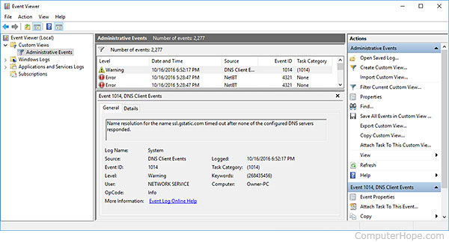Image: Event viewer

Reference: <https://www.computerhope.com/jargon/e/eventviewer-win10.jpg>

**About Windows Events**

When you are using Windows, the operating system keeps a record of important and useful information about what is happening on the computer. This information is stored in a series of logs known collectively as the Windows Event Log.

There are five types of events that are logged:

1. **Information:** Lets you know that an application, service, or driver completed an operation.
2. **Warning:** Informs you of a situation that is probably significant, but not yet a serious problem. For example, low disk space will trigger a warning event.
3. **Error:** Indicates a serious problem that may cause a loss of functionality or loss of data.
4. **Success Audit:** Records a successful event that is audited for security purposes. For example, when a user successfully logs on to the system, a Success Audit event is recorded.
5. **Failure Audit:** Records an unsuccessful event that is audited for security purposes. For example, when a user unsuccessfully tries to log on to the system, a Failure Audit event is recorded.

The Event Viewer allows you to view this information by category.

### Opening the Event Viewer

There are multiple ways to open Event Viewer:

**Open it by search.**

Type event in the search box on taskbar and choose View event logs in the result.

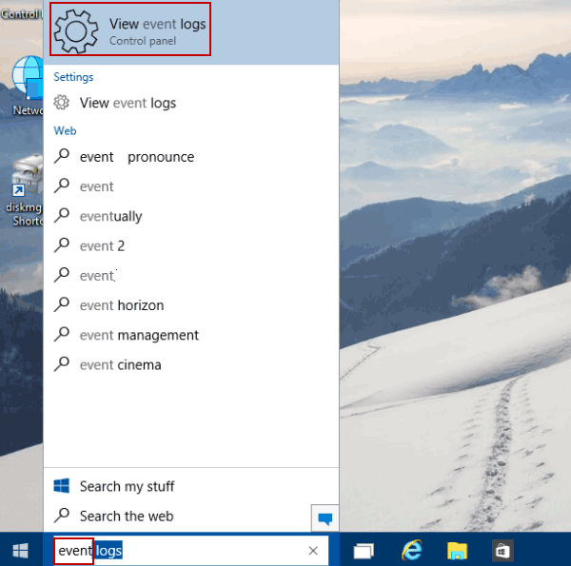

Image: ways-to-open-event-viewer-in-windows

Reference: <https://www.isunshare.com/images/article/windows-10/6-ways-to-open-event-viewer-in-windows-10/type-event-and-tap-view-event-logs.png>

**Turn on Event Viewer via Run.**

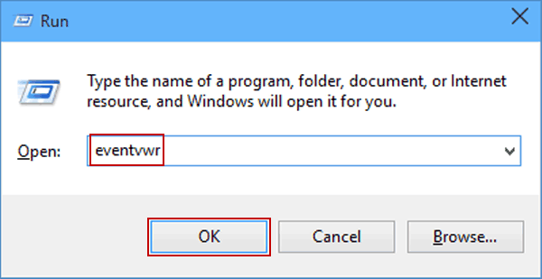Press Windows+R to open the Run dialog, enter eventvwr (or eventvwr.msc) and hit OK.

**Image: Event Viewer via Run**

Reference: <https://www.isunshare.com/images/article/windows-10/6-ways-to-open-event-viewer-in-windows-10/enter-eventvwr-and-hit-ok.png>

**Open Event Viewer via Command Prompt.**

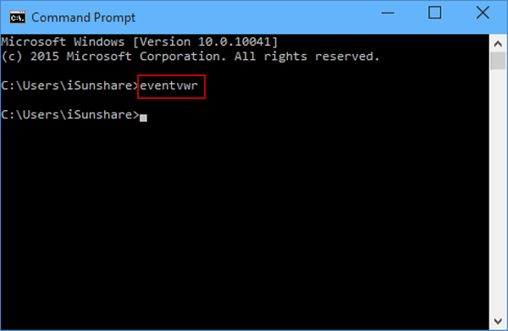Open Command Prompt, type eventvwr and press Enter.

**Image: Event Viewer via Command Prompt**

Reference: <https://www.isunshare.com/images/article/windows-10/6-ways-to-open-event-viewer-in-windows-10/type-eventvwr-and-press-enter.png>

**Open Event Viewer in Control Panel.**

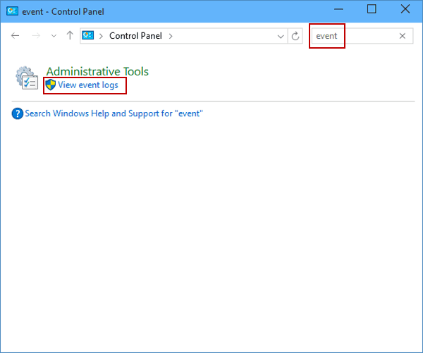Access Control Panel, enter event in the top-right search box and click View event logs in the result.

**Image: Event Viewer in Control Panel**

Reference: <https://www.isunshare.com/images/article/windows-10/6-ways-to-open-event-viewer-in-windows-10/open-event-viewer-in-control-panel.png>

**Open it in This PC.**

Open This PC, type event viewer in the search box on the top-right corner, and then double-click Event Viewer in the list.

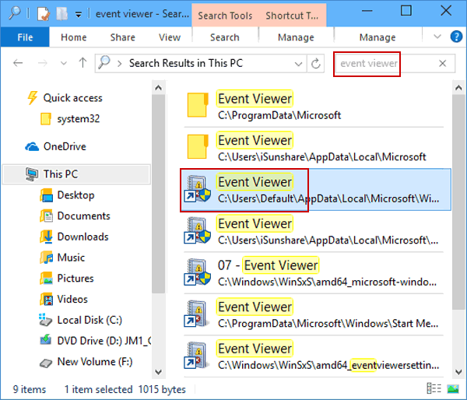

**Event Viewer in PC**

Reference: <https://www.isunshare.com/images/article/windows-10/6-ways-to-open-event-viewer-in-windows-10/open-event-viewer-in-this-pc.png>

# Device manager

## What Is Device Manager?

Device Manager is an extension of the Microsoft Management Console that provides a central and organized view of all the Microsoft Windows recognized hardware installed in a computer.

Device Manager is used to manage the hardware devices installed in a computer like hard disk drives, keyboards, sound cards, USB devices, and more.

You can use Device Manager to change hardware configuration options, manage drivers, disable and enable hardware, identify conflicts between hardware devices, and much more.

Think of Device Manager as the primary list of hardware that Windows understands. All the hardware on your computer can be configured from this centralized utility.



Image: Device manager

Reference:<https://www.lifewire.com/thmb/_uKM1QCadzk06CvvYR2AK03d7FY=/650x0/filters:no_upscale():max_bytes(150000):strip_icc():format(webp)/device-manager-101f5f25854b46b9811278cc4608632f.png>

## Device Manager Availability

Device Manager is available in nearly every Microsoft Windows version including Windows 11, Windows 10, Windows 8, Windows 7, Windows Vista, Windows XP, Windows 2000, Windows ME, Windows 98, Windows 95, and more.

## How to Access Device Manager

Device Manager can be accessed in several different ways in all versions of Windows, most commonly from the Control Panel, the Command Prompt, or Computer Management. However, a few of the newer operating systems support some unique ways for opening Device Manager.

How to Open Device Manager in Windows 11, 10, 8, 7, Vista, or XP.



Image: How to Access Device Manager

Reference: <https://www.lifewire.com/thmb/c4VGe_uuVYKcTF-nRFXX1x_MMm8=/650x0/filters:no_upscale():max_bytes(150000):strip_icc():format(webp)/device-manager-windows-10-start-menu-d6c9d5b991144df488027d2e439f3858.png>

Device Manager can also be opened through the command-line or Run dialog box with a special command.

## How to Use Device Manager

Like what's shown in the example image above, Device Manager lists devices in separate categories so that it's easier to find what you're looking for. You can expand each section to see which devices are listed inside. Once you find the right hardware device, double-click it to see more information like its current status, driver details, or in some cases its power management options.

Some of these categories include Audio inputs and outputs, Disk drives, Display adapters, DVD/CD-ROM drives, Network adapters, Printers, and Sound, video and game controllers.

If you were having troubles with your network card, let's say, you might open the Network adapters area and see if there are any unusual icons or colors associated with the device in question. You can double-click it if you want more information about it or to perform one of the tasks listed below.



Image: How to Use Device Manager

Reference:<https://www.lifewire.com/thmb/GXa_TZB89Phc5hH7OafO2Uhoo28=/650x0/filters:no_upscale():max_bytes(150000):strip_icc():format(webp)/device-manager-code-22-7a1e74f0662240f18ee19c5efa22b01a.png>

Each device listing in Device Manager contains a detailed driver, system resource, and other configuration information and settings. When you change a setting for a piece of hardware, it changes the way Windows works with that hardware.

# Shared folders

## Share files or folders over a network

To share a file or folder in File Explorer, do one of the following:

1. Right-click or press a file, select Give access to > Specific people.

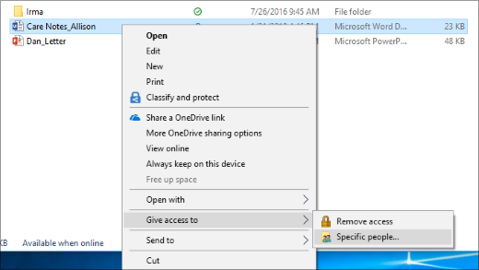

Image: Share files or folders over a network

Reference: <https://support.content.office.net/en-us/media/4436f313-6596-0ace-52dc-d04d96fa0257.png>

1. Select a file, select the Share tab at the top of File Explorer, and then in the Share with section select Specific people.

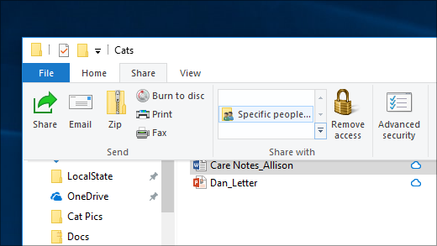

Image: Share files or folders over a network

Reference: <https://support.content.office.net/en-us/media/6c48e535-dfeb-3792-17f0-8f52933db316.png>

If you select multiple files at once, you can share them all in the same way. It works for folders, too—share a folder, and all files in it will be shared.

## Stop sharing files or folders

To stop sharing in File Explorer, do one of the following:

1. Right-click or press a file or folder, then select Give access to > Remove access.

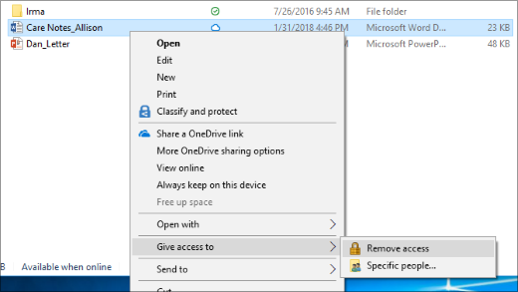

Image: stop sharing file or folder

Reference: <https://support.content.office.net/en-us/media/75a38268-1dcd-7258-5dbf-45c0776a7a08.png>

1. Select a file or folder, select the Share tab at the top of File Explorer, and then in the Share with section select Remove access.

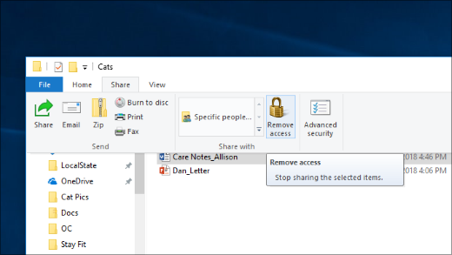

Image: stop sharing file or folder

Reference: <https://support.content.office.net/en-us/media/141268ae-a9f9-47c8-5817-ce88025783b4.png>

# Services and Applications

## Definition of services

A Windows service is an application that usually serves a core operating system function running in the background and has no user interface. The Windows operating system makes use of these applications or services to do what an OS does, such as manage network connections, play sound, provide file system functionality, provide security and authentication, display colors and interact with the user through the GUI.

The following are some characteristics of Windows services:

* Always running
* No UI
* Run in a separate Windows session, so are available to all users
* Offer recovery actions

## Definition of application

A program that is written to run under the Microsoft Windows operating system, also called a "Windows app." All 32-bit Windows applications run in the 32-bit and 64-bit versions of Windows. All 64-bit applications require 64-bit Windows, which is the standard on new Windows computers and tablets.

Older 16-bit Windows applications can run in the 32-bit versions of Windows, including Windows 95, 98, XP, Vista, 7, 8 and 10. However, 16-bit applications do not run natively in the 64-bit versions of Windows

# Virus and its type and Antivirus

## Definition of VIRUS

A computer virus is a program which can harm our device and files and infect them for no further use. When a virus program is executed, it replicates itself by modifying other computer programs and instead enters its own coding. This code infects a file or program and if it spreads massively, it may ultimately result in crashing of the device.

Since the computer virus only hits the programming of the device, it is not visible. But there are certain indications which can help you analyses that a device is virus-hit. Given below are such signs which may help you identify computer viruses:

* **Speed of the System –** In case a virus is completely executed into your device, the time taken to open applications may become longer and the entire system processing may start working slowly
* **Pop-up Windows –** One may start getting too many pop up windows on their screen which may be virus affected and harm the device even more
* **Self-Execution of Programs –** Files or applications may start opening in the background of the system by themselves and you may not even know about them
* **Log out from Accounts –** In case of a virus attack, the probability of accounts getting hacked increase and password protected sites may also get hacked and you might get logged out from all of them
* **Crashing of the Device –** In most cases, if the virus spreads in maximum files and programs, there are chances that the entire device may crash and stop working

The first thing which you might notice in case of virus attack is the speed with which your system shall process. And then gradually other changes can also be observed.

## Types of Computer Virus

Discussed below are the different types of computer viruses:

* **Boot Sector Virus –** It is a type of virus that infects the boot sector of floppy disks or the Master Boot Record (MBR) of hard disks. The Boot sector comprises all the files which are required to start the Operating system of the computer. The virus either overwrites the existing program or copies itself to another part of the disk.
* **Direct Action Virus –** When a virus attaches itself directly to a .exe or .com file and enters the device while its execution is called a Direct Action Virus. If it gets installed in the memory, it keeps itself hidden. It is also known as Non-Resident Virus.
* **Resident Virus –** A virus which saves itself in the memory of the computer and then infects other files and programs when its originating program is no longer working. This virus can easily infect other files because it is hidden in the memory and is hard to be removed from the system.
* **Multipartite Virus –** A virus which can attack both, the boot sector and the executable files of an already infected computer is called a multipartite virus. If a multipartite virus attacks your system, you are at risk of cyber threat.
* **Overwrite Virus –** One of the most harmful viruses, the overwrite virus can completely remove the existing program and replace it with the malicious code by overwriting it. Gradually it can completely replace the host’s programming code with the harmful code.
* **Polymorphic Virus –** Spread through spam and infected websites, the polymorphic virus are file infectors which are complex and are tough to detect. They create a modified or morphed version of the existing program and infect the system and retain the original code.
* **File Infector Virus –** As the name suggests, it first infects a single file and then later spreads itself to other executable files and programs. The main source of this virus are games and word processors.
* **Space filler Virus –** It is a rare type of virus which fills in the empty spaces of a file with viruses. It is known as cavity virus. It will neither affect the size of the file nor can be detected easily.
* **Macro Virus –** A virus written in the same macro language as used in the software program and infects the computer if a word processor file is opened. Mainly the source of such viruses is via emails.

## What Causes Computer Viruses?

Computer viruses are standard programs; only instead of offering useful resources, these programs can damage your device. For a threat actor to execute a virus on your machine, you must initiate execution. In some cases, an attacker can execute malicious code through your browser or remotely from another network computer. Modern browsers have defenses against local machine code execution, but third-party software installed on the browser could have vulnerabilities that allow viruses to run locally.

The delivery of a computer virus can happen in several ways.

* One common method is via a phishing email.
* Another technique is hosting malware on a server that promises to provide a legitimate program.
* It can be delivered using macros or by injecting malicious code into legitimate software files.

## What Is a Computer Worm?

A computer worm is malware, just like a virus, but a worm takes a copy of itself and propagates it to other users. Worms can also deliver a payload and exhaust resources.

For example, an email worm sends a copy of itself to everyone on an infected user’s email contact list. When it reaches recipient inboxes, anyone who runs the worm sends it to their contact list. Email worms exhaust storage space and spread very quickly across the internet, so they create issues differently than a virus.

## What Does a Computer Virus Do?

The way a computer virus acts depends on how it’s coded. It could be something as simple as a prank that doesn’t cause any damage, or it could be sophisticated, leading to criminal activity and fraud. Many viruses only affect a local device, but others spread across a network environment to find other vulnerable hosts.

A virus that infects a host device will continue delivering a payload until it’s removed. Most antivirus vendors have small removal programs that eliminate the virus. Polymorphic viruses make it difficult for removal because they change their footprint consistently. The payload could be stealing data, destroying data, or interrupting services on the network or the local device.

## Symptoms of Computer Virus

Malware authors write code that is undetectable until the payload is delivered. However, like any software program, bugs could present issues while the virus runs. Signs that you have a computer virus include:

* Popup windows, including ads (adware) or links to malicious websites.
* Your web browser home page changes, and you did not change it.
* Outbound emails to your contact list or people on your contact list alert you to strange messages sent by your account.
* The computer crashes often, runs out of memory with few active programs, or a blue screen of death in Windows.
* Slow computer performance even when running few programs or the computer was recently booted.
* Unknown programs start when the computer boots or when you open specific programs.
* Passwords change without your knowledge or your interaction on the account.

## Examples of Computer Virus

The web contains millions of computer viruses, but only a few have gained popularity and infect record numbers of machines. Some examples of widespread computer viruses include:

* Morris Worm
* Nimda
* ILOVEYOU
* SQL Slammer
* Stuxnet
* CryptoLocker
* Conficker
* Tinba
* Welchia
* Shlayer

## How to Prevent Computer Viruses

Computer viruses can damage your PC, send sensitive data to attackers, and cause downtime until the system is repaired. You can avoid becoming the next computer virus victim by following a few best practices:

1. **Install antivirus software:** Antivirus should run on any device connected to the network. It’s your first defense against viruses. Antivirus software stops malware executables from running on your local device.
2. **Don’t open executable email attachments:** Many malware attacks including ransomware start with a malicious email attachment. Executable attachments should never be opened, and users should avoid running macros programmed into files such as Microsoft Word or Excel.
3. **Keep your operating system updated:** Developers for all major operating systems release patches to remediate common bugs and security vulnerabilities. Always keep your operating system updated and stop using end-of-life versions (e.g., Windows 7 or Windows XP).
4. **Avoid questionable websites:** older browsers are vulnerable to exploits used when just browsing a website. You should always keep your browser updated with the latest patches, but avoiding these sites will stop drive-by downloads or redirecting you to sites that host malware.
5. **Don’t use pirated software:** Free pirated software might be tempting, but it’s often packaged with malware. Download vendor software only from the official source and avoid using software that’s pirated and shared.

## What is an Anti-Virus?

Antivirus is a program that helps to secure various systems by scanning, detecting and removing viruses, malware, computer worms, and so on. There are several free and paid antivirus software programs, all of which ultimately have the same goal, which is to protect systems and the information in them against the possibility of being infected by different types of viruses and destroy them immediately.

In the past, users were reluctant to use this because antivirus caused their systems to slow down, but these days, antivirus is very advanced. They do not slow down computer systems, and they also provide lots of abilities for users, these modern antivirus software programs **protect systems against malware**, etc., and have no effect on speed.

## Different types of software:

1. **Cloud-Based Software:**

This type of antivirus is very powerful and analyses data in the cloud and finally sends the necessary command to the computer. This antivirus software has two parts: the client installed on the computer and the other is the web service, each of which has its tasks.

1. **Standalone Software:**

This type of antivirus is designed to fight specific viruses because it is specialized. One of the features of this type of antivirus is that you can use it even in emergencies because it can also be installed on a USB and used to scan for viruses. This feature has caused many users to use this type of antivirus, some antivirus software programs in this type do not need to be installed, and you just need to simply download the complete file and do the scanning, but some of them need to be installed.

1. **Security Software Suites:**

This type can go far beyond anti-virus programs, and in addition to being able to scan all viruses, they have more capabilities that can greatly secure your system. One of the features of this type is that it has parental control programs, which causes many parents who are worried about their children to get help from this type.

## What Does Anti-Virus Software Do?

Several different companies build antivirus software and what each offer can vary but all perform some essential functions:

* Scan specific files or directories for any malware or known malicious patterns
* Allow you to schedule scans to automatically run for you
* Allow you to initiate a scan of a particular file or your entire computer, or of a CD or flash drive at any time.
* Remove any malicious code detected –sometimes you will be notified of an infection and asked if you want to clean the file, other programs will automatically do this behind the scenes.
* Show you the ‘health’ of your computer

Always be sure you have the best, up-to-date security software installed to protect your computers, laptops, tablets, and smartphones.

## What Are the Benefits of Antivirus Software?

Antivirus solutions protect more than just laptops, office computers, smartphones and tablets. They protect precious memories, music and photo libraries, and important documents from destruction by malware. Make sure your protection is up to the challenge of defending against the latest threats.

Modern antivirus solutions are capable of:

* Detecting, blocking, and removing viruses, malware, and ransomware
* Preventing identity theft and block phishing and fraud
* Warning about dangerous websites and links before you click
* Scanning the Dark Web to find if an email address has been compromised
* Keeping online accounts protected with secure password encryption
* Providing simple training to teach you and your family how to be even safer online
* Tuning up your computer to keep it running smoothly, just like new

## How Does Antivirus Software Work?

Many antivirus software programs still download malware definitions straight to your device and scan your files in search of matches. But since, as we mentioned, most malware regularly morphs in appearance to avoid detection, Webroot works differently. Instead of storing examples of recognized malware on your device, it stores malware definitions in the cloud. This allows us to take up less space, scan faster, and maintain a more robust threat library.

# Using different types of firewalls

## What Is Firewall

A firewall is a network security device that monitors incoming and outgoing network traffic and decides whether to allow or block specific traffic based on a defined set of security rules.

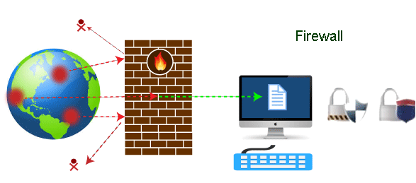

Image: what-is-firewall

Reference: <https://static.javatpoint.com/tutorial/firewall/images/what-is-firewall-1.png>

Firewalls have been a first line of defense in network security for over 25 years. They establish a barrier between secured and controlled internal networks that can be trusted and untrusted outside networks, such as the Internet.

A firewall can be hardware, software, or both.

## Types of Firewalls

A firewall can either be software or hardware. Software firewalls are programs installed on each computer, and they regulate network traffic through applications and port numbers. Meanwhile, hardware firewalls are the equipment established between the gateway and your network. Additionally, you call a firewall delivered by a cloud solution as a cloud firewall.

There are multiple types of firewalls based on their traffic filtering methods, structure, and functionality. A few of the types of firewalls are:

1. **Packet Filtering**

A packet filtering firewall controls data flow to and from a network. It allows or blocks the data transfer based on the packet's source address, the destination address of the packet, the application protocols to transfer the data, and so on.

1. **Proxy Service Firewall**

This type of firewall protects the network by filtering messages at the application layer. For a specific application, a proxy firewall serves as the gateway from one network to another.

1. **Stateful Inspection**

Such a firewall permits or blocks network traffic based on state, port, and protocol. Here, it decides filtering based on administrator-defined rules and context.

1. **Next-Generation Firewall**

According to Gartner, Inc.’s definition, the next-generation firewall is a deep-packet inspection firewall that adds application-level inspection, intrusion prevention, and information from outside the firewall to go beyond port/protocol inspection and blocking.

1. **Unified Threat Management (UTM) Firewall**

A UTM device generally integrates the capabilities of a stateful inspection firewall, intrusion prevention, and antivirus in a loosely linked manner. It may include additional services and, in many cases, cloud management. UTMs are designed to be simple and easy to use.

1. **Threat-Focused NGFW**

These firewalls provide advanced threat detection and mitigation. With network and endpoint event correlation, they may detect evasive or suspicious behavior.

1. **Application Layer Firewalls**

These firewalls can examine application layer (of OSI model) information like an HTTP request. If finds some suspicious application that can be responsible for harming our network or that is not safe for our network then it gets blocked right away.

## How Does a Firewall Work?

As mentioned previously, firewalls filter the network traffic within a private network. It analyses which traffic should be allowed or restricted based on a set of rules. Think of the firewall like a gatekeeper at your computer’s entry point which only allows trusted sources, or IP addresses, to enter your network.

A firewall welcomes only those incoming traffic that has been configured to accept. It distinguishes between good and malicious traffic and either allows or blocks specific data packets on pre-established security rules.

These rules are based on several aspects indicated by the packet data, like their source, destination, content, and so on. They block traffic coming from suspicious sources to prevent cyberattacks.

For example, the image depicted below shows how a firewall allows good traffic to pass to the user’s private network.

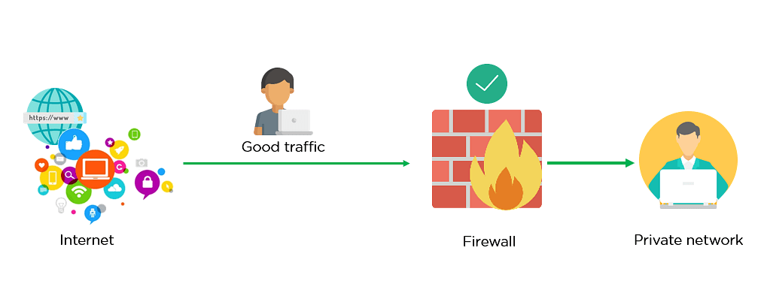

Image: Firewall allowing Good Traffic

Reference: <https://www.simplilearn.com/ice9/free_resources_article_thumb/Firewall_1.png>

However, in the example below, the firewall blocks malicious traffic from entering the private network, thereby protecting the user’s network from being susceptible to a cyberattack.

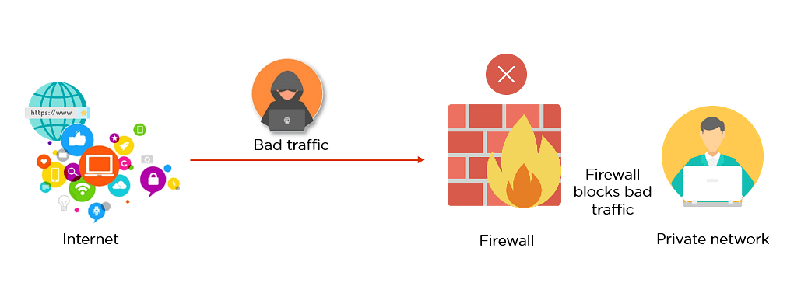

Image: Firewall blocking Bad Traffic

Reference: <https://www.simplilearn.com/ice9/free_resources_article_thumb/Firewall_2.png>

This way, a firewall carries out quick assessments to detect malware and other suspicious activities.

There are different types of firewalls to read data packets at different network levels. Now, you will move on to the next section of this tutorial and understand the different types of firewalls.

## Advantages of Using Firewalls

Now that you have understood the types of firewalls, let us look at the advantages of using firewalls.

* Firewalls play an important role in the companies for security management. Below are some of the important advantages of using firewalls.
* It provides enhanced security and privacy from vulnerable services. It prevents unauthorized users from accessing a private network that is connected to the internet.
* Firewalls provide faster response time and can handle more traffic loads.
* A firewall allows you to easily handle and update the security protocols from a single authorized device.
* It safeguards your network from phishing attacks.

**How to Use Firewall Protection?**

To keep your network and devices safe, make sure your firewall is set up and maintained correctly. Here are some tips to help you improve your firewall security:

* Constantly update your firewalls as soon as possible: Firmware patches keep your firewall updated against any newly discovered vulnerabilities.
* Use antivirus protection: In addition to firewalls, you need to use antivirus software to protect your system from viruses and other infections.
* Limit accessible ports and host: Limit inbound and outbound connections to a strict whitelist of trusted IP addresses.
* Have active network: To avoid downtime, have active network redundancies. Data backups for network hosts and other critical systems can help you avoid data loss and lost productivity in the case of a disaster.

Learning Outcome

Hardware Maintenance

# Hardware Maintenance

## Common Preventive Methods

Computer hardware maintenance involves taking care of the computer's physical components, such as its keyboard, hard drive and internal CD or DVD drives. Cleaning the computer, keeping its fans free from dust, and defragmenting its hard drives regularly are all parts of a computer hardware maintenance program.

Maintaining hardware helps to extend the computer's lifespan. It helps to prevent wear and tear, and keeps the system functioning smoothly. Several components and their special maintenance requirements described as below:

1. **Mouse**

* The most common mouse problem occurs when the on-screen cursor doesn’t move according to the movement of the mouse. Because the rollers inside the mouse casing that are responsible for moving the cursor collect dust and dirt from the surface that the mouse moves on. To rectify this problem, you need to clean the rollers occasionally. To do so, open the mouse ball cover from the bottom of the mouse and remove the ball. You can usually remove the mouse ball cover with a press-and-turn action. Use a cotton swab dipped in a very small amount of some liquid cleaning compound, such as isopropyl alcohol, to clean the rollers.
* In case cleaning doesn’t help, check the mouse drivers to see if the right drivers are present and if they are set up correctly. You should also check the port to which the mouse is connected.
* Another common problem that you might face while working with the mouse is a missing or inoperative mouse cursor. This problem can be attributed to either the software or the hardware. To resolve this problem, ensure that the mouse is plugged in properly and that the mouse cable is not physically damaged.

1. **Keyboard**

* You need to clean keyboards periodically. A lot of dust and other particles can accumulate between the keys. Because the portable PCs are small, the damage caused is more than on desktop PCs. Always ensure that the computer is switched off while you are performing the following maintenance activities:

1. Turn the keyboard upside down and gently shake out loose dirt.
2. Clean the key tops with a soft cloth dipped in an all-purpose cleaner.
3. Clean between the keys with a lint-free swab.

* For handling keyboard problems, replacing a keyboard is far more efficient than repairing it. Use the following steps to troubleshoot any keyboard-related problems:

1. Check that the keyboard is seated correctly. You may have opened your computer and neglected to replace the keyboard correctly.
2. Switch off the computer and switch it on again. Rebooting the computer reloads the device drivers, which control the corresponding device.
3. Check the voltages of the connector pins (on the system unit) using a digital multimeter.
4. If nothing works, the keyboard needs to be replaced.
5. **Floppy drive**

* The mechanical nature of a floppy drive makes it prone to a number of problems. Some common error messages generated by floppy drive problems and how to interpret and resolve them:

1. Non-system disk or disk error. Replace and press any key when ready.

This message appears when you try to boot from a non-bootable disk. To solve the problem, all you need to do is remove the disk and press any key. The system then bypasses the floppy drive and loads the operating system from the hard drive.

1. Invalid or missing COMMAND.COM

This message appears if you try to load DOS from a disk that has the two hidden system files, but COMMAND.COM is either missing or is corrupted. In such a case, you should first boot from a bootable floppy and then copy the COMMAND.COM file to the disk from which you were trying to boot.

1. Not ready reading drive A:, Abort, Retry, Fail?

This message will appear if the system cannot read the disk in drive A — perhaps because the disk is not inserted properly or is missing. If you insert the disk properly and the problem persists, you may have bad sectors in the disk, a bad boot record, or errors in the FAT.

1. General failure reading drive A:, Abort, Retry, Fail?

This message may appear if you try to read a disk that is not formatted or is corrupted. The message could also mean that the floppy drive itself is bad. To determine the problem area, try accessing other disks. If the disk is the problem but the disk is formatted, then the disk is probably unusable — perhaps due to a bad master boot record.

1. Track 0 bad, disk not usable

This message is most likely to occur if you try to format a disk using the wrong disk type. Check the FORMAT command. Don’t try to format a disk using the wrong density.

1. Write-protect error writing drive A:

This message indicates that you are trying to write to a disk that is write protected. Check the write-protect tab on the disk. If you are using a 31⁄2-inch floppy, the write-protect hole must be closed, with the switch (also called a tab) towards the center of the disk. For a 51⁄2-inch floppy, ensure that the write protect notch is uncovered.

1. **CD-ROM drives**

* Compact discs are currently the most popular medium for mass storage. Storing up to 650MB of data, they can transfer large applications, multimedia software, and large data files (such as sound files or graphics) from one computer to another. Early CD-ROM drives (called 1X drives) had data-transfer rates of 150 kilobytes per second (Kbps). Later CD-ROM drives brought higher speeds — 2X, 4X, 32X, 40X, to 52X.
* Generally, the CD-ROM drives are reliable, but as the technology changes, you have to replace your CD-ROM drive according to your requirements. You can consider a CD-ROM replacement if:

1. Your CD-ROM generates constant read errors, even after troubleshooting.
2. Your CD-ROM constantly makes a loud noise, even after troubleshooting.
3. Your current disk drive has difficulty reading CD-R (recordable) discs.

* Before you add a new CD-ROM drive, make sure that you modify the jumpers on the IDE controller if you are using the IDE CD-ROM. However, if you are using a SCSI CD-ROM, set a proper SCSI ID and termination setting. To do so, set the jumpers on your CD-ROM drive to a unique SCSI ID. Then, if the disk drive is at the end of a SCSI chain of devices, set the termination jumpers. To add a new CD-ROM drive:

1. Ground yourself to a static mat.
2. Shut down the system, remove the power cable, and open the outer case.
3. Remove the front placeholder panel.
4. Make sure that you set all the jumpers and terminators.
5. Attach the slide rails if your drive bay requires them.
6. Connect the controller cable and the power cable.
7. Connect the audio cable from the CD-ROM drive to the sound card. The audio port is adjacent to the power cable port on the CD-ROM drive. To find where the connector goes on the sound card, refer to the sound card’s documentation.
8. Slide the CD-ROM drive into the drive bay.
9. Close the computer case and reconnect the power cable
10. **Hard disk drive**

Hard disk drives are another type of device that requires very little intervention to keep running. Mechanical failure of hard drives is rare, and when it does occur the solution is generally replacement. The most common problem with hard drives is corrupted sectors. Often, they can be repaired with tools such as ScanDisk (part of the Windows 95 and 98 system tools) or one of the many after-market utility software packages available. Here are a few suggestions for preventing problems with hard drives:

* Avoid rough handling.
* Never move a hard disk when it is still spinning.
* Never expose the internal housing to open air.
* Perform regular data backups.
* Use software utilities to maintain the condition of the device (CHKDSK and ScanDisk; hard drive defragmentation programs and antivirus programs).

1. **Monitor**

Common symptoms of a monitor problem include distorted images, incorrect colors, or no display on the screen. As always, you should do some basic troubleshooting first. Very often, problems are due to faulty connection or improper power supply. However, display problems might also be caused by display adapter problems, insufficient VRAM, and IRQ conflicts. The following pints examine some common display problems and ways to resolve them.

* Blank screen/Power light (LED) does not glow

First, ensure that the wall outlet, to which the monitor is connected, is functional. Try plugging in a lamp or some other device to see if the power supply works. If the power cord of the monitor is directly connected to an external power strip,check if the power strip and the monitor are switched on. If the monitor power cord is connected to the back of the computer, ensure that the connection is tight and secure. Check if the computer is switched on and is receiving power. Check if the power socket voltage is rated between 104–130 volts. If you use a monitor with a switch at the back that lets you choose from the range of 110–220 volts, ensure that the switch is in the right position. If your monitor has a fuse at the back, remove it and check for broken wires that indicate a bad fuse.

* Power light glows, but no display on screen

The first thing you should do in this situation is check the brightness and contrast adjustment. If brightness and contrast are set to the minimum value, you will not be able to see anything on-screen, even if the monitor is working properly. If you don’t observe any change, check if the display signal cable connection with the computer is secure. If the monitor-to-computer cable can be detached, try using one that you know is working fine. If this works, reconnect the old cable and recheck the connection.

* Monitor displays wrong characters

If wrong characters are displayed, your monitor is probably fine. The problem is most likely with the video card. Try using a good one. Sometimes, wrong characters can also be displayed as a result of a bad chip, ROM or RAM on the motherboard. Use a good motherboard to see if the problem is resolved.

* Monitor flickers/has wavy lines

The most common cause of this problem is a cable connection error. Check the connections. This problem can also be caused due to electrical/magnetic signal interference.

* Monitor cannot display graphics

If you find that your monitor is unable to display graphics or becomes blank when trying to open certain applications, there is a problem with either the VRAM or the graphics card. Check if your computer has a graphics, or video accelerator, card.

* Picture out of focus

Use the buttons on the outside of the monitor to readjust the screen dimensions, screen positions, color, brightness, and contrast. If that does not solve your problem, you might have to take you monitor to a service center, where some adjustments will be made inside the monitor.

* Screen goes blank after a certain period of inactivity

You might observe that your computer screen becomes blank if the computer is left unused for a while. This is generally not a problem. Some computers follow the energy-saving standards. The monitors in these computers are sent into a standby mode or a sleep mode after a specified period of inactivity. You can usually identify if your monitor is in the power-saving mode if the LED light changes to orange from the usual green.

1. **Power supply**

A problem with your computer’s power supply may manifest itself in a number of different situations:

* 1. Your computer boots successfully at times and at other times it halts during booting.
  2. Your computer hangs for apparently no reason at all and sometimes even reboots itself.
  3. You keep getting error codes or beep codes during startup, but inconsistently.
  4. You encounter memory problems sporadically.
  5. Data is not correctly written on the hard disk.
  6. The keyboard suddenly stops working and then starts again.
  7. The motherboard fails.
  8. The power supply is too hot to touch.
* Each of these cases indicates a power supply problem. The PSU, or power supply unit, is an important component because it supplies power to all other components in the system. So, if you face any problems regarding the power supply, you should try to resolve them by performing some fundamental checks.
* First, check the power from the wall socket. If the external power supply is fine, you need to get inside the system unit.
* Clean the PSU and the system. Dust acts as an insulator and could retain the heat generated by the PSU inside the computer itself.
* Use a voltmeter to check the output voltage in the PSU. Apply the voltmeter leads to an unused PSU power connector. Ensure that the PSU output voltages are –5VDC, +5VDC, –12VDC, and +12VDC. At least one of the power connectors from the PSU should be connected to a device. In the absence of any load, the output voltage will not be depicted correctly.
* Check the power outlet. Set a VOM meter or a multimeter to read AC voltage. The acceptable power outlet range is 104–130 volts of AC.
* If the voltages are not within the acceptable limits, the PSU needs to be replaced. You might find that the fan on the power supply makes a lot of grinding noise. This might be caused by a bad fan or by a short that occurred elsewhere in the system.
* Replace the entire PSU (it is a more cost-effective solution than trying to repair the fan). If the problem persists, you can eliminate the fan as the problem area. Then you should remove all connections from the PSU and turn the power on. If the fan works, the problem lies with one of the components. Try connecting one component at a time to find out the root cause of the problem — most likely the drives, motherboard, power cords or interface cards. Replace the faulty component with one that works.

1. **Printer**

Printers are more mechanical than other peripherals and therefore require more attention. Because they use paper, ink, or carbon, printers generate pollutants that can build up and cause problems. Always check the manufacturer's recommendations for cleaning. Here are a few steps for cleaning the most popular types of printers:

1. Dot-Matrix Printers

* Adjust the print-head spacing.
* Check the tension on the print-head positioning belt. Use a non-fibrous swab dipped in alcohol to clean the print head.
* Clean the printer's roller surfaces.
* Clean the surface of the platen.
* Clean the gear train of the paper-handling motor.
* Apply light oil to the gears using a foam swab.
* Turn the platen to distribute the oil.
* Apply a light coating of oil to the rails.
* Move the carriage assembly to distribute the oil.

1. Ink-Jet Printers

* Adjust the print-head spacing.
* Check the tension on the print-head-positioning belt.
* Clean the printer and its mechanism.
* Clean the printer's roller surfaces.
* Clean the surface of the platen.
* Clean the surface of the ink-jet print head.
* Clean the gear train of the paper-handling motor.
* Apply light oil to the gears using a foam swab.
* Turn the platen to distribute the oil.
* Apply a light coating of oil to the rails.
* Move the carriage assembly to distribute the oil.

1. Laser Printers

* Vacuum to remove dust buildup and excess toner from the interior. Remove the toner cartridge before vacuuming.
* Clean the laser printer's rollers using a damp cloth or denatured alcohol.
* Clean the gear train of the paper-handling motor using a foam swab.
* Apply light oil to the gears using a foam swab.
* Distribute the oil throughout the gear train.
* Clean the writing mechanism thoroughly using compressed air. If possible, wipe the laser lens with lint-free wipes to remove fingerprints and stains.
* Clean the corona wires using a swab dipped in alcohol. Be careful not to break any of the strands because if you do, your printer will be rendered useless until they are repaired!

## Safety precautions in handling PC

Use the following safety guidelines to help ensure your own personal safety and to help protect your equipment and working environment from potential damage.

1. **Finding a Place to Work**

The first thing you need to think about when planning your new homebuilt computer has nothing to do with parts, performance, or configuration. You need to find a place to work.

1. **Staking Out your Work Area**

Professionals and die-hard home computer builders usually have work benches that are dedicated to nothing but computer work. But most home computer builders are not so lucky. Still, most people can find someplace to build their new PC. Here are some things to think about when deciding where you will work:

* You need a sturdy table or workbench. Ideally, you'll want a table that's big enough to hold a computer laying on its side, your tools, the parts you are installing, and any technical documents or instructions you will be using.
* The table should be clean and non-metallic. If not, then you'll need to cover it with a non-conductive surface such as a plastic table cloth or a piece of plywood or Masonite.
* Your work area should be well-lit and have a grounded AC power outlet that you can plug a surge suppressor into so you can test your new PC once it's assembled.
* Avoid places that are damp, subject to temperature extremes, dirty, or dusty.
* If possible, try to avoid carpeted rooms. Carpeting tends to generate a lot of static when you walk across it. (If your work area is carpeted and your parents, spouse, or landlord object to your ripping it up, then just then pay special attention to anti-static precautions.)

1. **Backups**

The most important precaution against any risk of data loss is a full, up-to-date backup. Tape backup drives are the wisest form of insurance for your computer, and good tape drives are very inexpensive ($150.00 or less). This will protect you against lightning, fire, theft, accidental data loss, virus damage, hardware “crashes”, etc. The two most important things to remember about backups are 1) Backup regularly - full backups weekly and partial backups daily is best and 2) Keep a full back up in another location, such as at home or in a safety deposit box. This way you will not lose your data in a fire or if the computer is stolen.

1. **Telephone line danger**

One potential threat to your computer which most often goes unnoticed is your modem connection. Surges and power fluctuations can hit your system through your phone line and cause serious damage. Make sure your power strip or battery backup has telephone line protection. During a heavy electrical storm, your safest phone line protection is to disconnect the phone jack from your modem.

1. **Battery backups**

A single power outage is not as damaging to your computer as the extreme surges and drops in power that occur during a blackout, brownout, or just your ordinary lightning storm. Your computer is very sensitive to power fluctuations - protect yourself against this. Uninterrupted Power Supplies (UPS) are available at most any computer store or Office supply store. The “Blackout Buster” is a very good battery backup which also provides superior protection through your modem/fax/telephone line. The Blackout Buster retails for $129.00 and is available at Comp USA.

1. **Turn off your computer**

Many of our clients are on networks and have made it a habit to keep the computers on all the time. Monsoon season is the exception to the rule. Whenever a storm or brownout is expected, your safest strategy is to turn off all computers and monitors. These precautions can save you a great deal of frustration and loss.

## Service Flow Sequence (SFS) and Trouble Shooting Chart (TSC) of PC

Any problem that has anything to do with your HD can be diagnosed.

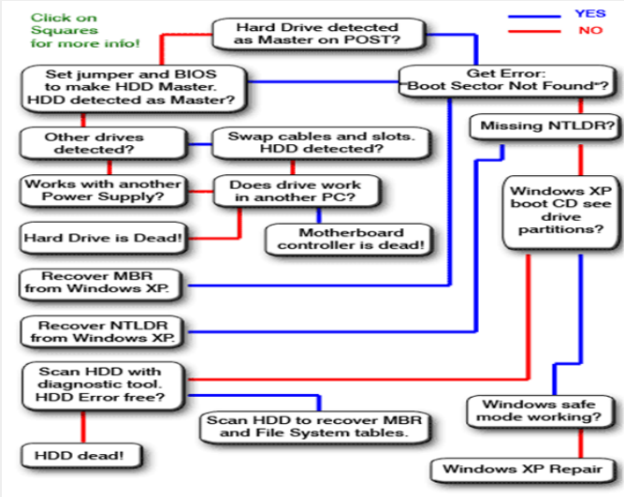

Image1: **Service Flow Sequence (SFS)**

Reference: https://www.medicalexpo.com/prod/pac-technology/product-106764-793349.html

## Ten Occupational Health and Safety Procedure (OHS) this is about Safety and Anti-Static Rules

1. When possible, try to avoid working in carpeted areas. Carpeting greatly increases static buildup within your body.
2. Personal protective equipment is correctly used.
3. Hazard/risks in the workplace and their corresponding indicators are identified to minimize or eliminate risk to co-workers, workplace and environment.
4. Always handle electronic components by a non-conducting (non-metallic) edge. Don't touch the pins or other connectors.
5. Read and follow instructions on the manual carefully.
6. Do not eat, drink or smoke while assembling the computer
7. When working on a computer avoid places that are damp, subject to temperature extremes, dirty, or dusty.
8. The table should be clean and non-metallic to avoid short circuits
9. Always disconnect a computer from the AC power and from any powered peripherals while you are working on it.
10. Never plug an ATX power supply into AC power while adding and connecting cards of motherboard.

## Sub-Assemblies and Components

Subassemblies are electronic parts of the computer that are a portion or part of a functional area. A subassembly can contain pcb’s or just electronic parts. Two or more components combined into a unit will form a subassembly. Each subassembly can contain components, such as motherboard to make one individual subassembly.

**Motherboard**

* The motherboard is the main printed circuit board and contains the buses, or electrical pathways, found in a computer.
* The motherboard accommodates the central processing unit (CPU), random access memory (RAM), expansion slots, heat sink and fan assembly, basic input/output system (BIOS) chip, chipset, and the circuitry that interconnects the motherboard components. Sockets, internal and external connectors, and various ports are also placed on the motherboard.

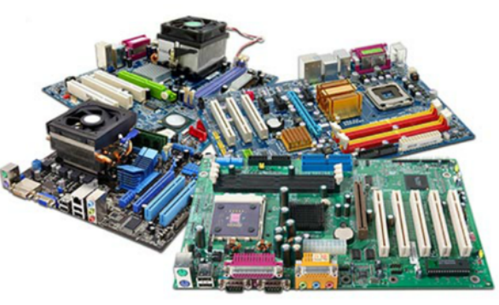

Image2: Motherboard

Reference: <https://p6cdn4static.sharpschool.com/UserFiles/Servers/Server_20856499/File/Teacher%20Pages/Lindsay%20Dolezal/IT%20Essentials/1.1.2.pdf>

The different system board components are: -

1. **Processor**

One of the easiest items to recognize on the motherboard is the processor. The processor is usually the largest chip on the system board and can be identified generally because it often has a heat sink or fan located on top of it.

Classic Pentium motherboards typically have a socket 7 slot that the processor is inserted into. This socket is implemented as a ZIF (zero insertion force) socket, which means that the processor chip can be removed or added to the socket with very little effort. ZIF sockets typically have a lever that you pull to pop the processor out of the socket.

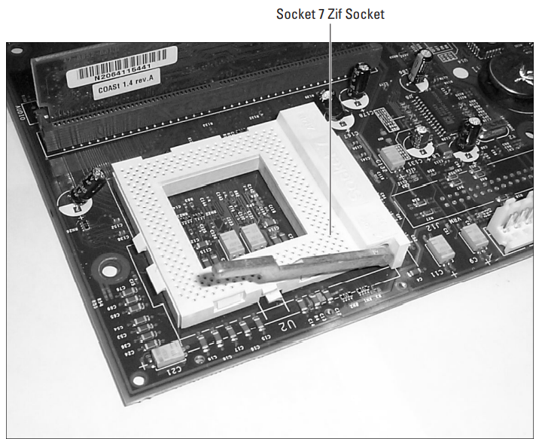

Image3: ZIF Socket

Reference: <https://1library.net/document/ozl74lly-a-bible-pdf.html>

1. **Memory**

One of the first items that should stand out is the processor or its socket; the next thing are the memory slots that are used to install RAM.

There are typically two types of sockets to install memory: SIMM (Single InLine Memory Module) sockets and DIMM (Dual Inline Memory Module) sockets. Original Pentium systems typically have either four 72-pin SIMM sockets, or two 168-pin DIMM sockets to install memory. Figure 3-2 shows a motherboard with four 72-pin SIMM sockets and two DIMM sockets.

**Cache memory**

Cache memory is faster than RAM, the system can store information accessed from RAM in cache memory when the data is accessed the first time. The processor can then retrieve the information from the faster cache memory for subsequent calls. All the processors today have integrated cache memory, which is known as level-1 cache. The types of cache are as follows:

1. L1 (level-1) cache: Cache that is integrated within the processor.
2. L2 (level-2) cache: Cache that is located outside the processor, like on the motherboard.

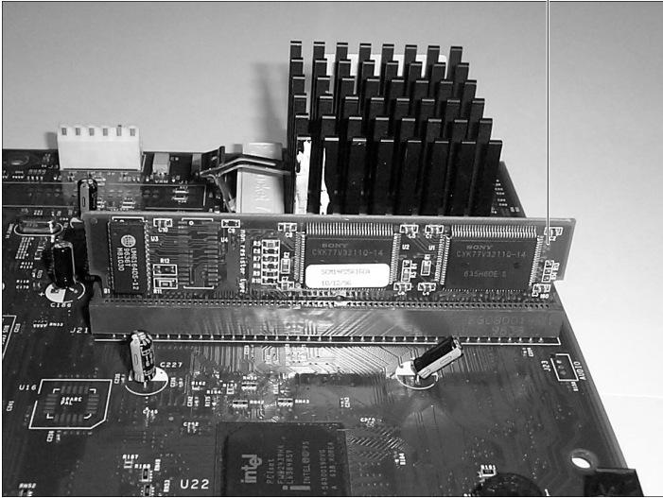

Image4: L2 cache

Reference: <https://1library.net/document/ozl74lly-a-bible-pdf.html>

1. **Expansion slot**

Most motherboards have one or more expansion slots, which serve the purpose of adding functionality to the computer. Even if, for example, your computer doesn’t have sound capability right now, you can install a sound card into the expansion slot to add that capability.

Expansion slots come in different varieties on systems today, and it is extremely important to understand the benefits of each type. There are probably some white narrow slots on the board, which are the PCI slots.

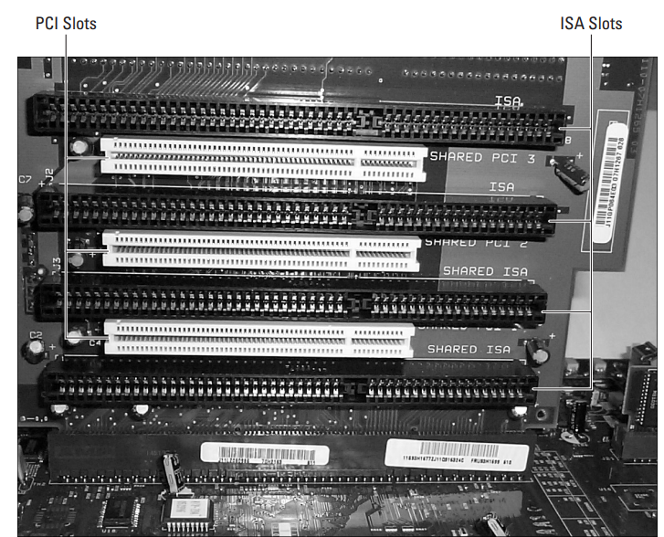

Image5: Expansion slots

Reference: <https://1library.net/document/ozl74lly-a-bible-pdf.html>

1. **Communication ports**

Newer system boards have communication ports integrated directly into the board. The communication ports are also known as the COM ports. Typically, there are two COM ports on each system, COM1 and COM2.

COM ports are also known as serial ports. The reason that they are called serial ports is because they send data in a series — a single bit at a time. If eight bits of data are being delivered to a device connected to the COM ports, then the system is sending the eight bits of data, one at a time.

Serial ports on the back of the system board are one of two types:

* DB9-male is a male serial port with 9 pins.
* DB25-male is a male serial port with 25 pins

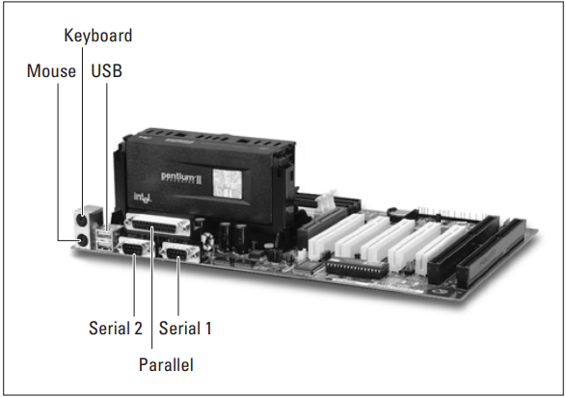

Image6: Communication Ports

Reference: <https://1library.net/document/ozl74lly-a-bible-pdf.html>

**Parallel port**

Another type of connector on the back of the motherboard is the parallel port. The parallel port is also known as the printer port, or LPT1. The parallel port gets its name by being able to send information eight bits at a time. Whereas serial ports only send one bit at a time in single file, parallel ports send can send eight bits in one operation — side-by-side rather than single file.

The parallel port is a female port located on the back of the system board with 25 pins, which is known as DB25-female.

1. **Keyboard/mouse connector**

Keyboard/mouse connector Most motherboards today have mouse and keyboard connectors that are most likely PS2 style connectors.

Older motherboards may have an older DIN keyboard connector, which you can see on baby AT motherboards. These systems may or may not have a mouse port on the system board. If not, the mouse connector was located on the case that the system board was inserted into; the mouse connector would connect by wires to the system board.

1. **Power connector**

Located on the system board, you should see a type of connector that you can use to connect the power supply to the motherboard. All of these devices connected to the motherboard need to get power from somewhere, so the power supply is connected to the motherboard, which supplies power to the board and its components.

There are power cables coming from the power supply to connect to the motherboard with very unique connectors on the end, these may be labeled as P1 and P2, or on some systems, P8 and P9.

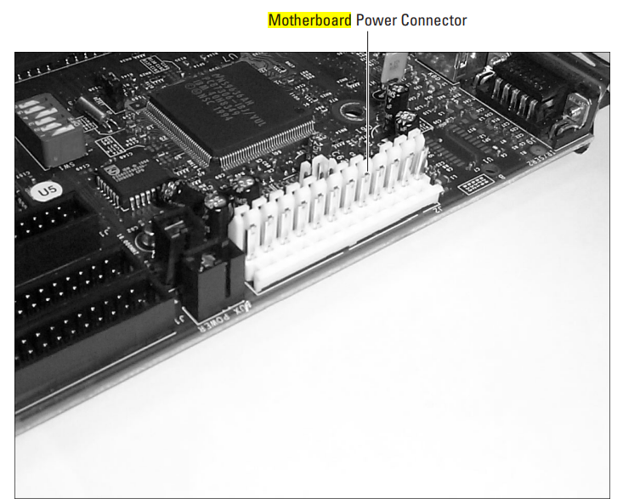

Image7: Power connector

Reference: <https://1library.net/document/ozl74lly-a-bible-pdf.html>

1. **Video adapter**

Many motherboards today come with a built-in video adapter, sometimes called a video card or video controller.

The following steps are:

1. The video adapter is responsible for receiving digital data from the processor, which instructs the video adapter on how the images are to be drawn on the screen.
2. The video adapter stores the information about drawing the images in its memory and starts converting the information into analog data that the monitor can understand.
3. The data is sent in analog format from the video adapter to the monitor

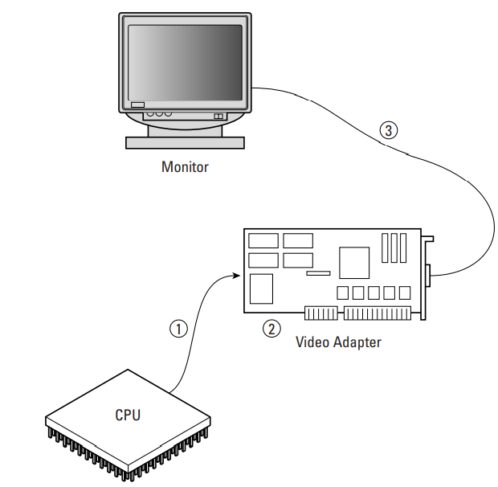

Image8: video adapter

Reference: <https://1library.net/document/ozl74lly-a-bible-pdf.html>

1. **Hard disk controller**

A controller is a device that is responsible for controlling data flow, so a hard drive controller is responsible for both of the following:

1. Receiving information from the processor and converting or interpreting the information into signals that the hard disk can understand
2. Sending information back to the processor and converting the information into signals that the processor can understand

Older drives implemented the controller as an expansion card installed into the system that connected to the hard disk via a cable connection. Today, however, hard disk controllers are integrated into the hard disks. You can also find either one or two hard disk controllers on newer motherboards (for more information, see the section titled “EIDE/ATA-2”). The controller on the motherboard has 40 pins and connects to the drive using a 40-wire ribbon cable.

## Points to be considered while purchasing and replacing components

1. **Quality**

Quality can be determined by asking yourself the following questions:

1. How well does this product meet my specific needs?
2. Does it have the features and functions I require?
3. How well is it made?
4. How long will it last?
5. **Price**
6. Everyone has a budget, but that doesn’t mean buying cheap is necessarily the way to go.
7. If you purchase a product that breaks easily or doesn’t fully meet your needs.
8. You’ll end up needing to replace it, thereby busting your budget.
9. **Service after the sale**

The following are the few aspects that you’d be wise to look into before purchasing:

1. Return policy
2. Warranty
3. Service agreement

# Preventive Maintenance

Preventive maintenance involves taking the necessary precautions and actions to prevent accidents or equipment failures from occurring before they happen. For example: performing regular business and equipment inspections, cleaning and lubricating essential equipment, and tidying your business’s grounds are all examples of preventive maintenance.

Preventive maintenance can be defined as an equipment maintenance strategy based on replacing, or restoring, an asset at a fixed interval regardless of its condition. Scheduled restoration tasks and replacement tasks are examples of preventive maintenance tasks.

The goal of preventive maintenance is to prevent equipment failure before it occurs, and to reduce the risk of accidents. Ultimately, taking certain precautions to ensure minimal risk to your business means that you and your staff can focus on improving what already works, instead of having to repair what is broken.

1. **Time Based Maintenance (TBM)**

Time-Based Maintenance refers to replacing or renewing an item to restore its reliability at a fixed time, interval or usage regardless of its condition. It can be helpful to create a monthly or annual maintenance schedule that complies with manufacturer recommendations for inspecting and cleaning equipment to keep you on track.

Time Based Maintenance is basically a type of maintenance that is done at a regular interval while the equipment is still functioning with the objective of preventing failure or reducing the likelihood of failure. Preventive maintenance can be time based i.e., every week, every month or every three months. But preventive maintenance can also be based on usage e.g., every 150 cycles, every 10,000hrs or like your car: service every 10,000km.

1. **Failure Finding Maintenance (FFM)**

Failure Finding Maintenance tasks are aimed at detecting hidden failures typically associated with protective functions. Think pressure safety valves, trips transmitter and the like. This type of equipment won’t be required to function until something else has failed. That means that under normal operating conditions you will not know whether this equipment is still functional i.e. the failure modes are hidden. And since these failures are hidden, you’ll need to find them before you are relying on that equipment to protect you.

1. **Risk Based Maintenance (RBM)**

Risk Based Maintenance (RBM) is when you use a risk assessment methodology to assign your scarce maintenance resources to those assets that carry the most risk in case of a failure (remembering that risk = likelihood x consequence).

As a result, equipment that has a higher risk and a very high consequences of failure would be subject to more frequent maintenance and inspection. Low risk equipment may be maintained at a much lower frequency and possibly with a much smaller scope of work. When you implement a Risk Based Maintenance process effectively you should have reduced the total risk of failure across your plant in the most economical way.

Risk-Based Maintenance is essentially preventive maintenance where the frequency and scope of the maintenance activities is continuously optimised based on the findings from testing or inspection and a thorough risk assessment. Examples of Risk-Based Maintenance would be Risk-Based Inspection as applied to static equipment like vessels and piping or even pressure relief valves.

1. **Condition Based Maintenance (CBM)**

It may be possible to take action to prevent it from failing completely and/or to avoid the consequences of failure. Condition Based Maintenance as a strategy therefore looks for physical evidence that a failure is occurring or is about to occur. An important concept within Condition Based Maintenance is the P-F curve shown in the figure below:

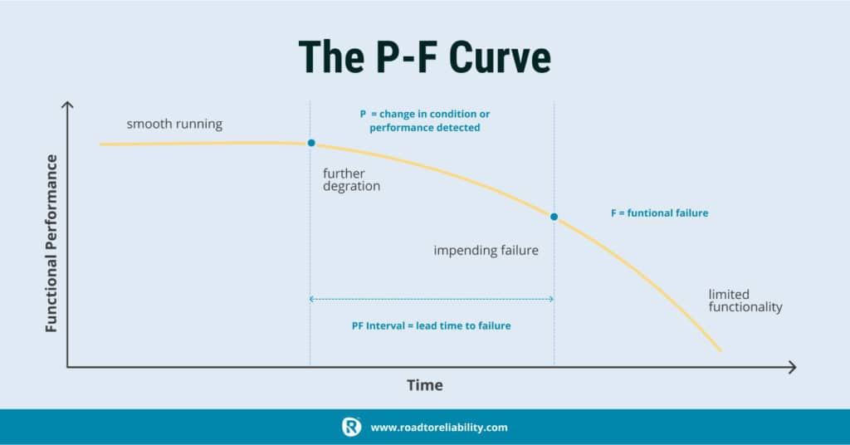

Image 9: The P-F Curve

Reference: <https://roadtoreliability.com/wp-content/uploads/2021/11/3.jpg>

The curve shows that as a failure starts manifesting, the equipment deteriorates to the point at which it can possibly be detected (point “P”). If the failure is not detected and mitigated, it continues until a functional failure occurs (point “F”). The time range between P and F, commonly called the P-F interval, is the window of opportunity during which an inspection can possibly detect the imminent failure and give you time to address it.

It is important to realize that CBM as a maintenance strategy does not reduce the likelihood of a failure occurring through life-renewal, but instead is aimed at intervening before the failure occurs, on the premise that this is more economical and should have less of an impact on availability.

In other words: condition monitoring does not fix machines and condition monitoring does not stop failures. Condition monitoring only lets you find problems before they become a failure. A common rule of thumb is that the interval between CBM tasks should be one-half or one-third of the P-F interval. How much more effective CBM is above breakdown maintenance depends on how long the P-F interval is. With plenty of warning the rectification can be planned, materials and resources can be mobilized and breakdown prevented (though production is still stopped for the maintenance duration). When the P-F interval is only a few days the resulting organizational and workplace actions are much like a breakdown and the value of CBM is largely lost. For CBM to be effective as a strategy, early intervention is essential. This requires an efficient and effective process for data gathering, data analysis, decision making and finally intervention. For failure modes where the P-F interval shows a large variability, condition monitoring is not an effective strategy.

## Predictive Maintenance (PM)

Predictive Maintenance (PDM) this was essentially as a synonym for Condition Based Maintenance. Predictive Maintenance is an extension, a more advanced approach to CBM where we use potentially many process parameters gained from online sensors to determine if our equipment is moving away from stable operating conditions and is heading towards failure. The central idea here is to predict when the failure is going to occur and then determine the appropriate time for maintenance intervention.

## Corrective Maintenance

A Run to Failure or Corrective Maintenance strategy only restores the function of an item after it has been allowed to fail. It is based on the assumption that the failure is acceptable (i.e., no significant impact on safety or the environment) and preventing failure is either not economical or not possible. Apart from being the outcome of a deliberate Run to Failure strategy Corrective Maintenance is also the result of unplanned failures which were not avoided through preventive maintenance. A run to failure strategy can effectively be used for general area lighting, smart process instrumentation (without trip functionality) etc. where the consequence of failure is limited and would not necessitate a need for an urgent repair. When opting for corrective maintenance as a strategy it is essential to ensure that the failure modes under consideration do not have the potential to become Emergency Maintenance.

1. **Deferred Corrective Maintenance (DCM)**

When a corrective maintenance work request is raised it is essential that you prioritize it properly to make sure that where possible you defer the work request and give your team the time to properly plan and schedule the work.

1. **Emergency Maintenance (EM)**

Emergency Maintenance is corrective maintenance that is so urgent that it breaks into your Frozen Weekly Schedule. Emergency Maintenance is the one and only maintenance type that we really want to avoid as much as possible.

## Preventive Maintenance Tools

The tools used to maintain computer components in two categories: materials and equipment, and software utilities.

1. **Materials and equipment**

A common cause of computer problems can be attributed to dust, dirt, and erratic power supply. To keep components dirt-free, you can use various liquid cleaning compounds. You can take care of dust using a vacuum cleaner. To control erratic power supply, you can either use a UPS or a suppressor.

**Liquid cleaning compounds**

The most commonly used liquid cleaning compounds include various forms of alcohol — isopropyl and denatured alcohol — and soapy water. Before you use any liquid cleaning compound, it is important that you read the manufacturer’s instructions and documentation to ensure that the compound does not have a detrimental effect on the component. You can also buy specialized cleaning compounds direct from the manufacturer.

Use a sponge dampened with mild detergent or soapy water to clean the monitor, outer case of the system unit, keyboard, and other peripherals.

**Vacuum cleaners**

Dirt and dust particles get inside your system unit through its air ducts and lodge themselves almost anywhere. If the air ducts become clogged, air circulation is affected, causing the system to heat up. Other common problems caused by these particles include wear and tear of components and conduction of charge that leads to a risk of damage to the components. Thus, it is important to vacuum clean the interior of the system unit regularly. You can use small, portable vacuum cleaners, since they are economical and easy to manage.

**UPS and suppressors**

Erratic power supply or voltage fluctuation might damage the components of the computer. Overvoltage or undervoltage in power supply can cause voltage fluctuations. Overvoltage generates spikes and surges.

1. Spike: A short burst of electricity exceeding 100 percent of the normal voltage for an extremely short duration (microseconds), usually at 400–5,600 volts. A spike is also known as an impulse.
2. Surge: Occurs when power exceeds 110 percent of the normal voltage for more than a few seconds. Surges are the most common cause of computer damage.

Undervoltage is also unfavorable to the computer. The most common undervoltage problems are brownouts and blackouts:

1. Brownout (or Sag): A partial loss of voltage or power. Brownouts occur when the voltage drops below 110 volts for a few seconds. This might happen when the usage of the voltage in your area increases suddenly. Brownouts can cause frozen keyboards and unexpected system crashes, resulting in corrupt disks and lost data. Brownouts also reduce the life and efficiency of your computer.
2. Blackout: A complete loss of power. Possible causes of blackouts are blown fuses, transformers, and downed power lines. Though a blackout might not lead to hardware damage, it can result in data and memory loss.

To protect the computer against damages that might be caused from overvoltage and undervoltage, you use power protection devices, such as Uninterruptible Power Supply (UPS) and suppressors.

A UPS monitors the power received from the AC source before sending it to the computer. It also acts as a backup power supply in the event of a power failure. A UPS has three components: an inverter, a battery, and a charger.

There are two types of UPS: Standby UPS (SPS) and Online UPS.

* 1. Standby UPS: Only provides backup power during a blackout. It does not take part in supplying normal power to the computer and therefore is not a good protection against the other types of power problems.
  2. Online UPS: Passes the power to the computer after conditioning it, thereby providing protection against surges, spikes, and brownouts.

A suppressor just takes care of the surges and spikes and provides voltage within the prescribed range. It does not act as a backup power supply.

1. **Software utilities**

A considerable decrease in the performance of your computer could result from scattered data or fragmentation on the disk. Fragmentation occurs when you frequently create, modify, or delete the files on the hard disk. Large files are usually scattered among various clusters. When you try to access a file that is scattered across various clusters, the access time increases. This is because a search needs to be carried on all clusters to put a file together. Also, some clusters of the disks might have gone bad. These clusters need to be identified and marked to prevent applications from using them.

You can use software utilities, such as Disk Defragmenter and ScanDisk, for assessing and fixing disk problems. The Disk Defragmenter utility unites the separated blocks by moving the data to contiguous blocks. Since the data is no longer scattered, the performance of the system increases. It is advisable that you run the Disk Defragmenter utility regularly. The Scandisk utility is available with Windows 95, 98, and NT. However, the Disk Defragmenter utility is available only with Windows 95 and 98. To run the Disk Defragmenter, select Programs ➪ Accessories ➪ System Tools ➪ Disk Defragmenter from the Start menu.

The ScanDisk utility scans disks to mark out physical and logical errors on them. You can try to recover any valuable data that is present in the bad sectors. It is advisable to run the ScanDisk utility regularly to check for lost or bad clusters on the disks. To run the ScanDisk utility, select Programs ➪ Accessories ➪ System Tools ➪ ScanDisk from the Start menu.

There are various third-party utilities, such as SpeedDisk and Disk Doctor, which can be used to assess and fix disk problems. However, you need to keep in mind the operating system your computer is using before deciding which utility to use.

## Preventative Maintenance

Preventive maintenance is the key to obtaining years of trouble-free service from your computer system. A properly administered preventive maintenance program pays for itself by reducing problem behavior, data loss, and component failure and by ensuring a long life for your system. In several cases, I have “repaired” an ailing system with nothing more than a preventive maintenance session. Preventive maintenance also can increase your system’s resale value because it will look and run better. There are two types of preventive maintenance procedures: active and passive.

* + 1. Passive maintenance

Passive preventive maintenance includes precautionary steps you can take to protect a system from the environment, such as using power-protection devices; ensuring a clean, temperature-controlled environment; and preventing excessive vibration. In other words, passive preventive maintenance means treating your system well and with care.

* + 1. Active maintenance

An active preventive maintenance program includes procedures that promote a longer, trouble-free life for your PC. This type of preventive maintenance primarily involves the periodic cleaning of the system and its components, as well as performing backups, antivirus and antispyware scans, and other software-related procedures.

**Passive Preventive Maintenance Procedures**

Passive preventive maintenance involves taking care of the system by providing the best possible environment—both physical and electrical—for the system. Physical concerns include conditions such as ambient temperature, thermal stress from power cycling, dust and smoke contamination, and disturbances such as shock and vibration. Electrical concerns include items such as static electricity, power-line noise (when the system is plugged into a wall outlet or other external power source), and radio-frequency interference.

**Active Preventive Maintenance Procedures**

How often you should perform active preventive maintenance procedures depends on the environment in which you operate your system as well as the quality of the system's components. If your system is in a dirty environment, such as a machine shop floor or a gas station service area, you might need to clean your system every three months or less. For normal office environments, cleaning a system every few months to a year is usually fine. If you frequently use your system outdoors, it may require more frequent cleanings, depending on the amount of dirt and dust in the environment.

Other preventive maintenance procedures include making periodic backups of your data and critical areas, such as boot sectors, file allocation tables (FATs), and directory structures on the disk. Also, you should defragment your hard disks at least once a month to maintain disk efficiency and speed, as well as to increase your ability to recover data should there be a more serious problem.

# Maintenance Scheduling

There are no universal maintenance schedules that work on every computer. Each schedule must be individualized to meet the needs of the work environment.

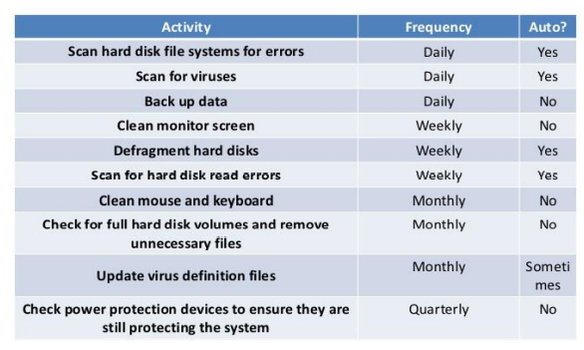

Image 10: Maintenance Checklist

Reference: <https://www.slideshare.net/RheighHenleyCalderon/5-pc-maintenance>

Do This Daily

* Back up data.
* Check computer ventilation to ensure that it is clear.
* Remove any paper, books, or boxes that might impede the flow of air into or out of the computer

Do This Weekly

* Clean the outside of the case
* Clean the screen
* Run CHKDSK or ScanDisk on all hard disk drives
* Run a current antivirus program and check all drives
* Inspect all peripheral devices.

Do This Monthly

* Clean the inside of the system.
* Clean the inside of any printers
* Vacuum the keyboard
* Clean the mouse ball and x and y wheels
* Defragment all hard disk drives
* Delete any unnecessary temporary files

Do This Every Six Months

* Perform an extensive preventive maintenance check
* Apply an antistatic solution to the entire computer
* Check and reseat all cables
* Run the printer's self-test programs

Do This Annually

* Reformat the hard disk drive and reinstall all software. Don't forget to back up data first.
* Check all floppy disk drives
* Consider an upgrade to your computer. Check to see that your components can handle your workload.

**Need of diagnostics program**

Diagnosing Windows is not only something IT analysts need to worry about. Anyone who owns a computer should be comfortable using Windows diagnostics tools to do basic troubleshooting.

The following most effective Windows diagnostics tools you can use to identify what may be ailing your Windows PC are: -

1. **Process Explorer**

Most computer experts will direct you to use the Processes tab in Task Manager to see what applications may be consuming all your CPU time. The problem with Task Manager is it only shows top level processes. On the other hand, Process Explorer uses a tree structure to show you not only top-level processes, but also child processes connected to that application.

Process Explorer also includes all the following diagnostics features:

* Real-Time CPU, Memory, I/O, and GPU charts.
* Color coding to see most active processes.
* Get detailed properties about processes like memory, priority, handles, and more.
* Customize multiprocessor CPU load and process priority.

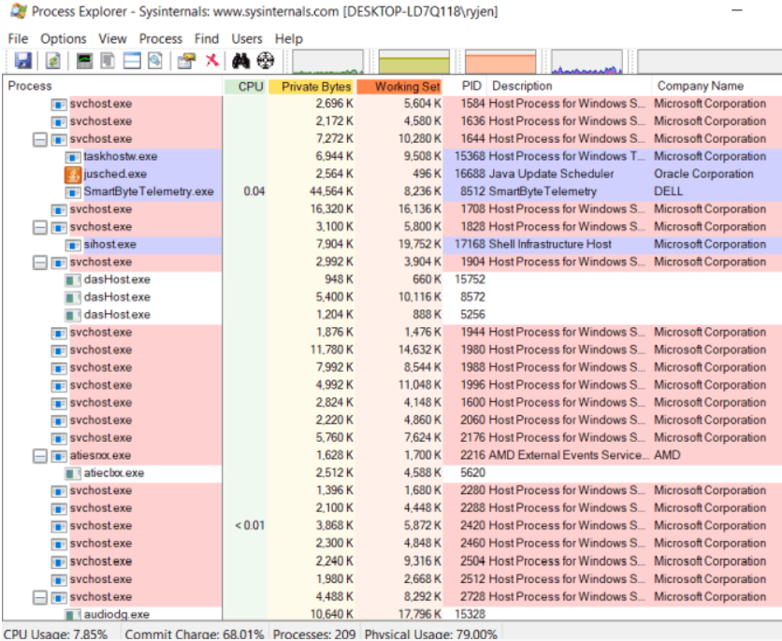

Image11: Process Explorer

Reference: <https://helpdeskgeek.com/free-tools-review/15-windows-diagnostics-tools-to-improve-your-pcs-health/>

1. **CPUID**

When you’re working with a remote help desk and need CPU information, CPUID is a powerful tool to view everything you need to know about your CPU. It can also help gather GPU or memory card information if you’re looking to upgrade your system and want to find a perfect match.

It’s free to download and use and works on both 32-bit and 64-bit systems. The amount of information it shows you about your CPU and other system information is impressive.

* Processor brand and all specifications
* Cache sizes
* Motherboard brand and version.
* Current memory size and timings
* Specs for memory cards in each slot
* GPU brand, clock speed and memory
* CPU benchmarking and stress testing tools

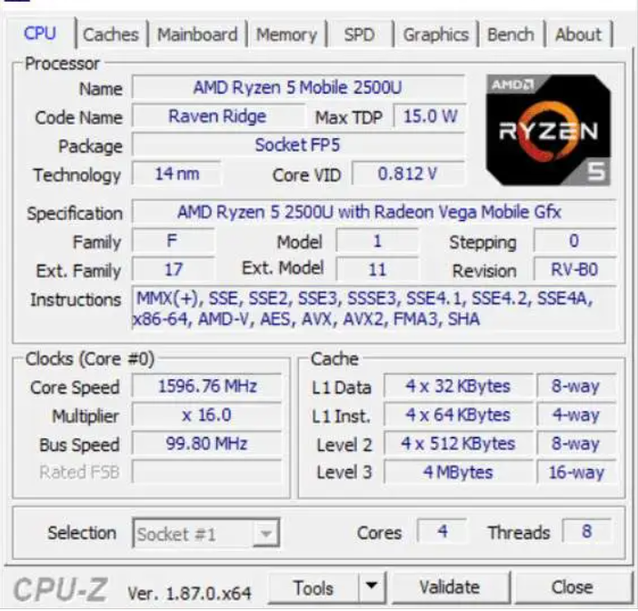

Image12: CPU-Z

Reference: <https://helpdeskgeek.com/free-tools-review/15-windows-diagnostics-tools-to-improve-your-pcs-health/>

1. **System Explorer**

System Explorer is an impressive tool that gives you more insight into your overall system performance than most other available tools.

In addition to running processes, it includes real-time charting, all active internet connections, and a history of process activity.

Features in System Explorer include:

* Tree structure breakdown of all active processes
* Built-in tool to perform a file security check on active processes
* Double click a process to see what company create it and all associated modules
* Excellent system usage real-time charting of CPU, RM, and I/O
* All running processes using your computer’s internet connection
* Historical list of processor activities

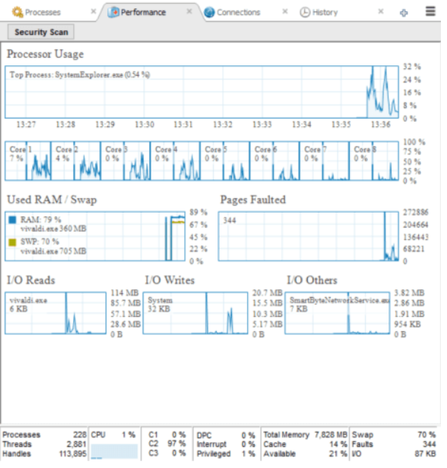

Image13: System Explorer

Reference: <https://helpdeskgeek.com/free-tools-review/15-windows-diagnostics-tools-to-improve-your-pcs-health/>

1. **Reliability Monitor**

There is one useful diagnostics tool built right into Windows 10 that you can use without the need for an install. This is called the Reliability Monitor.

To open it, click Start and type reliability. Select View reliability history.

The reliability history graph shows you where any errors have occurred in your Windows system. These are the same errors you might see in the Windows Event Logs but laid out in a graphical way where errors are easy to spot.

How to use the Reliability Monitor:

* Click on any red X to see more information in the bottom pane about those errors.
* Click any yellow! to see more information about those warnings.
* Use View technical details to see more detailed information about warnings or errors.

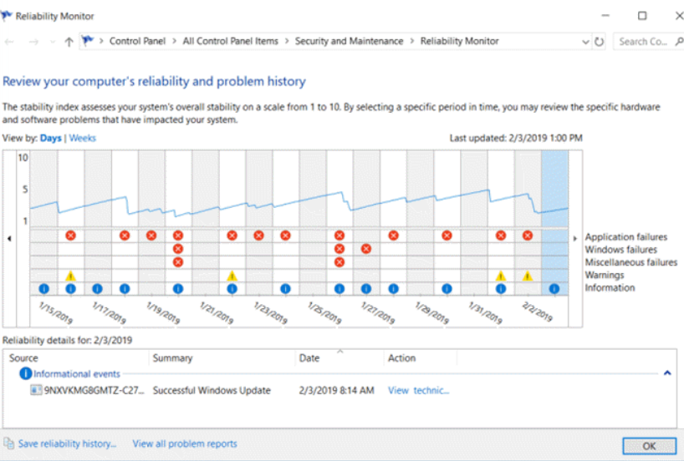

Image14: Reliability Monitor

Reference: <https://helpdeskgeek.com/free-tools-review/15-windows-diagnostics-tools-to-improve-your-pcs-health/>

1. **Wifi Analyzer**

This is a free application you can install from the Microsoft Store. It’s a powerful tool for quickly analyzing all wireless networks where you are.

It provides the current strength of available Wi-Fi signals. It also shows you a breakdown of details for the network you’re currently connected to. These include the channel, frequency, bandwidth, and more.

Other features of the free version include:

* Realtime graph of all local Wi-Fi signals and their strength
* Filter Wi-Fi graphs based on wireless frequency
* Bar chart of the strength of all available wireless networks
* Link speed of your currently connected network

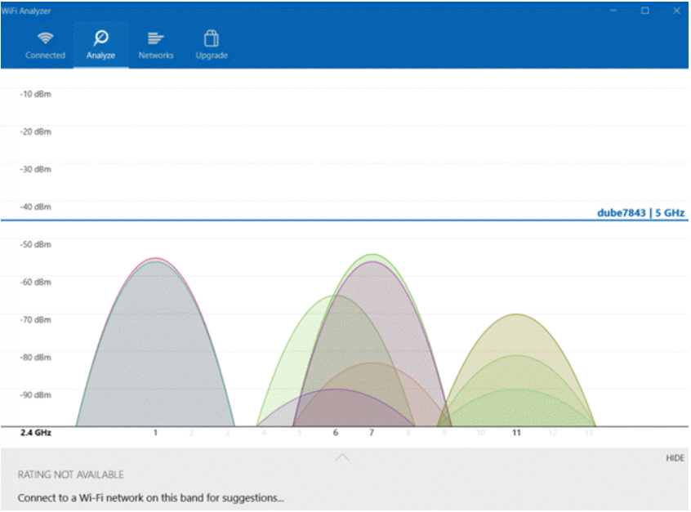

Image15: WiFi Analyzer

Reference: <https://helpdeskgeek.com/free-tools-review/15-windows-diagnostics-tools-to-improve-your-pcs-health/>

1. **Windows Sysinternal Suite**

Process Explorer is a SysInternals app available for download from the Microsoft website. SysInternals offers an entire suite of utilities and tools. You can download them all at once by downloading the entire suite.

This suite includes utilities like:

* AdExplorer
* Autologon
* ClockRes
* Coreinfo
* Desktops
* DiskView
* PageDefrag
* RAMMap (image shown above)
* Sysmon
* TCPView

If you want software that can monitor processes, hardware, services, and everything else about your system, this utility suite is probably the best single diagnostics suite you can download.

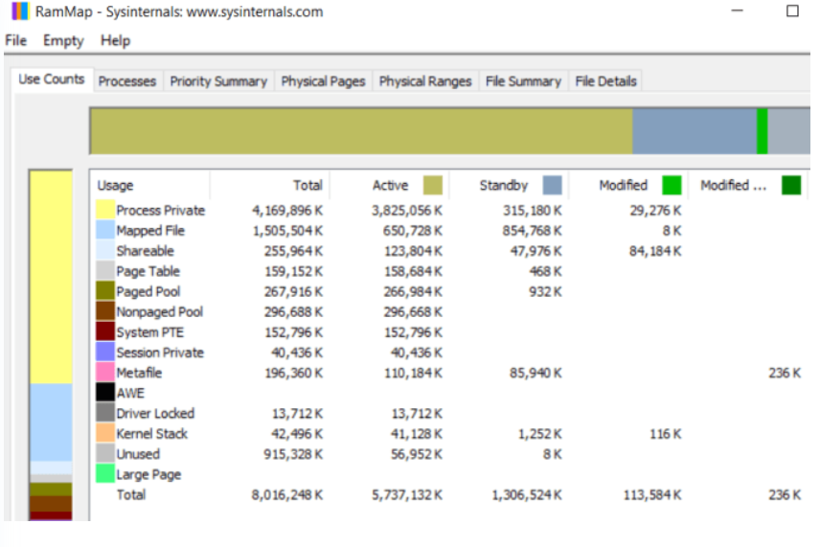

Image16: Windows Sysinternal Suite

Reference: <https://helpdeskgeek.com/free-tools-review/15-windows-diagnostics-tools-to-improve-your-pcs-health/>

1. **ESET SysInpector**

It’s a free application that’s normally integrated into the ESET Antivirus software. It’s at least an excellent first tool to try if you’re not sure where to start. The software scans and detects issues with all the following:

* Processes and services
* Suspicious files
* Problem software
* Incompatible hardware
* Outdated or problem drivers
* OS files that require updates
* Registry problems
* Suspicious apps accessing the network or internet

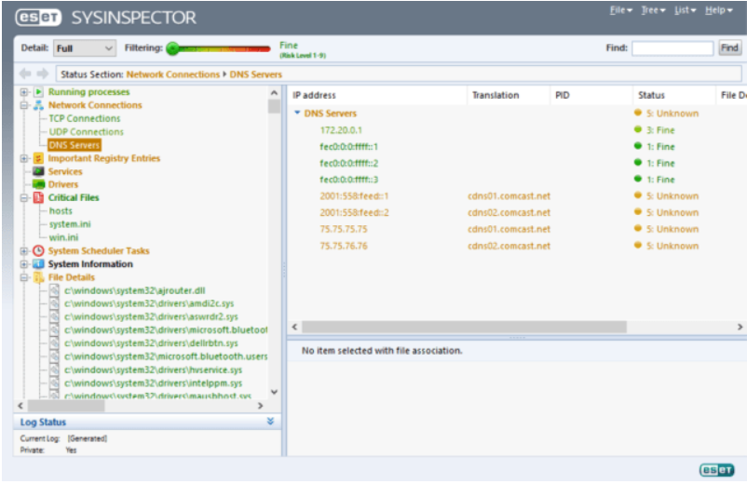

Image17: ESET SysInpector

Reference: <https://helpdeskgeek.com/free-tools-review/15-windows-diagnostics-tools-to-improve-your-pcs-health/>

## Monitors

A monitor is an electronic output device that is also known as a video display terminal (VDT) or a video display unit (VDU). It is used to display images, text, video, and graphics information generated by a connected computer via a computer's video card. Although it is almost like a TV, its resolution is much higher than a TV. The first computer monitor was introduced on 1 March 1973, which was part of the Xerox Alto computer system.

Older monitors were built by using a fluorescent screen and Cathode Ray Tube (CRT), which made them heavy and large in size and thus causing them to cover more space on the desk. Nowadays, all monitors are made up by using flat-panel display technology, commonly backlit with LEDs. These modern monitors take less space on the desk as compared to older CRT displays.

## Types of Monitors

1. **Cathode Ray Tube (CRT) Monitors**

It is a technology used in early monitors. It uses a beam of electrons to create an image on the screen. It comprises the guns that fire a beam of electrons inside the screen. The electron beams repeatedly hit the surface of the screen. These guns are responsible for generating RGB (Red, Green, Blue) colors, and more other colors can be generated with the help of combining these three colors. Today's Flat Panel Monitors replace the CRT monitors.

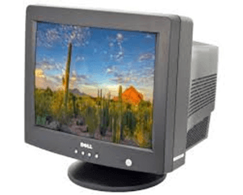

Image18: CRT

Reference: <https://static.javatpoint.com/computer/images/types-of-monitors1.png>

1. **Flat Panel Monitors**

These types of monitors are lightweight and take less space. They consume less power as compared to CRT monitors. These monitors are more effective as they do not provide harmful radiation. These monitors are more expensive than CRTs. The flat-panel monitors are used in PDA, notebook computers, and cellular phones. These monitors are available in various sizes like 15", 17", 18" & 19" and more. The display of a flat-panel monitor is made with the help of two plates of glass. These plates contain a substance, which is activated in many ways.

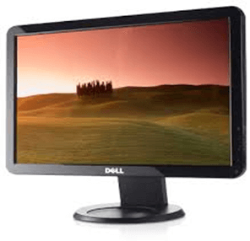

Image19: Flat panel monitor

Reference: <https://static.javatpoint.com/computer/images/types-of-monitors2.png>

Flat-panel monitor screens use two types of technologies, which are given below:

* Liquid Crystal Display: LCD (Liquid crystal display) screen contains a substance known as liquid crystal. The particles of this substance are aligned in a way that the light located backside on the screens, which allow generating an image or blocking. Liquid crystal display offers a clear picture as compared to CRT display and emits less radiation. Furthermore, it consumes less power and takes less space than a CRT display.
* Gas Plasma Display: This display uses gas plasma technology, which uses a layer of gas between 2 plates of glass. When voltage is applied, the gas releases ultraviolet light. By this ultraviolet light, the pixels on the screen glow and form an image. These displays are available in different sizes of up to 150 inches. Although it offers effective colors as compared to the LCD monitor, it is more expensive. That's why it is less used.

1. **Touch Screen Monitors**

These monitors are also known as an input device. It enables users to interact with the computer by using a finger or stylus instead of using a mouse or keyboard. When users touch the screen by their finger, it occurs an event and forwards it to the controller for processing. These types of screens include pictures or words that help users to interact with the computer. It takes input from the users by touching menus or icons presented on the screen.

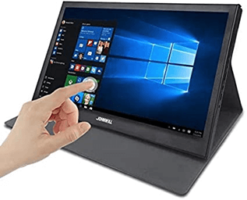

Image20: Touch screen monitor

Reference: <https://static.javatpoint.com/computer/images/types-of-monitors2.png>

There are different types of touch screen monitors; three common types are given below:

* Resistive Touch Screen: Generally, this screen includes a thin electrically conductive and resistive layer of metal. When the touch is pressed, a change in the electrical current occurs that is sent to the controller. Nowadays, these screens are widely in use. These monitors are more reliable as they cannot be affected by liquids or dust.
* Surface Wave Touch Screens: These monitors process the input through ultrasonic waves. When a user touches the screen, the wave is processed and absorbed by the computer. It is less reliable as they can be damaged by water or dust.
* Capacitive Touch Screen: This screen includes a cover with an electrically-charged material. This material continuously flows the current over the screen. It is mainly used by the finger rather than a stylus. These monitors contain better clarity and do not damage by dust. Nowadays, capacitive touch screen is mostly used in smart phones.

1. **LED Monitors**

It is a flat screen computer monitor, which stands for light-emitting diode display. It is lightweight in terms of weight and has a short depth. As the source of light, it uses a panel of LEDs. Nowadays, a wide number of electronic devices, both large and small devices such as laptop screens, mobile phones, TVs, computer monitors, tablets, and more, use LED displays. It is believed that James P. Mitchell invented the first LED display. On 18 March 1978, the first prototype of an LED display was published to the market at the SEF (Science and Engineering Fair) in Iowa. On 8 May 1978, it was shown again in Anaheim California, at the SEF. This prototype received awards from NASA and General Motors.

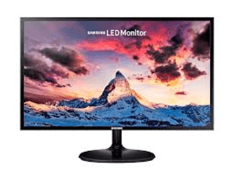

Image21: LED monitor

Reference: <https://static.javatpoint.com/computer/images/types-of-monitors2.png>

1. **OLED Monitors**

It is a new flat light-emitting display technology, which is more efficient, brighter, thinner, and better refresh rates feature and contrast as compared to the LCD display. It is made up of locating a series of organic thin films between two conductors. These displays do not need a backlight as they are emissive displays. Furthermore, it provides better image quality ever and used in tablets and high-end smart phones. Nowadays, it is widely used in laptops, TVs, mobile phones, digital cameras, tablets, VR headsets. The demand for mobile phone vendors, more than 500 million AMOLED screens were produced in 2018. The Samsung display is the main producer of the AMOLED screen. For example, Apple is using AMOLED OLED panel made by SDC in its 2018 iPhone XS - a 5.8" 1125x2436. Additionally, iPhone X is also using the same AMOLED display.

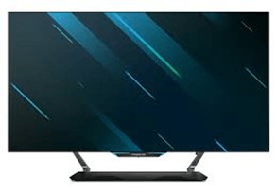

Image22: OLED monitor

Reference: <https://static.javatpoint.com/computer/images/types-of-monitors2.png>

1. **DLP Monitors**

DLP stands for Digital Light Processing, developed by Texas Instruments. It is a technology, which is used for presentations by projecting images from a monitor onto a big screen. Before developing the DLP, most of the computer projection systems produced faded and blurry images as they were based on LCD technology. DLP technology utilizes a digital micro mirror device, which is a tiny mirror housed on a special kind of microchip. Furthermore, it offers better quality pictures that can also be visible in a lit room normally.

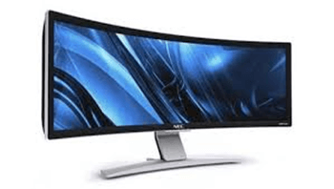

Image23: DLP monitor

Reference: <https://static.javatpoint.com/computer/images/types-of-monitors2.png>

1. **TFT Monitors**

It is a type of LCD flat panel display, which stands for a thin-film transistor. In TFT monitors, all pixels are controlled with the help of one to four transistors. The high-quality flat-panel LCDs use these transistors. Although the TFT-based monitors provide better resolution of all the flat-panel techniques, these are highly expensive. The LCDs, which use thin-film transistor (TFT) technology, are known as active-matrix displays. The active-matrix displays offer higher quality as compared to older passive-matrix displays.

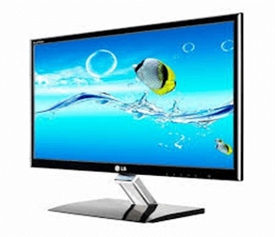

Image24: TFT monitor

Reference: <https://static.javatpoint.com/computer/images/types-of-monitors2.png>

1. **Plasma Screen Monitors**

A plasma screen is a thin, flat-panel, and capable of hanging on a wall like LCD and LED televisions. It is a brighter screen as compared to LCD displays and thinner than CRT displays. It can be used to either display modes of digital computer input or analog video signals, and sometimes, it is marketed as 'thin-panel' displays. Plasma displays have wide viewing angles, high contrast ratios, and high refresh rates, which is used to reduce a blur video. Additionally, it provides better quality pictures as it supports high resolutions of up to 1920 x 1080.The plasma screen also includes some disadvantages such as the chance of screen burn-in, consumes more power, loss of brightness with time, can be heavier in weight.

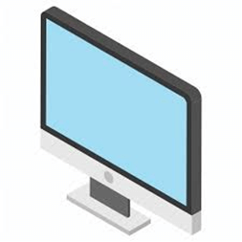

Image25: Plasma screen monitor

Reference: <https://static.javatpoint.com/computer/images/types-of-monitors2.png>

**Types of monitors on the basis of color display**

1. **Monochrome monitor**

It is a single-colored monitor. It can display only text and images of a single color against a contrasting background. The first monitor displayed text and images of light green color against black background.

1. **Gray scale monitor**

It is a single-colored monitor. It can display only text and images of a single color against a contrasting background. The first monitor displayed text and images of light green color against black background.

1. **Color monitor**

It can display 16-42 million colors. It uses 3 basic colors Red, Blue and Green. All the other colors are the combination of these colors. Color monitors are also known as RGB monitors.

**Color Video**

* Most models of monitors available today are at least VGA. VGA (which stands for video graphics adapter) allows the monitor to send an analog signal to X that controls the flow and depth of colors more superbly than pre-VGA models allowed.
* Super VGA-capable monitors allow monitors to display higher resolutions and richer colors. The amount of RAM on the video card determines the number of colors the monitor can display. Some monitors and video cards promise True Color, which allows for up to 16 million colors.
* IBM introduced its first color monitors (1981) with the Color Graphics Adapter (CGA), which had the ability to use four colors at a pathetic resolution of only 320 × 200. The card could be switched to two colors, which would result in a slightly higher resolution.
* In 1985, IBM introduced the Enhanced Graphics Adapter (EGA) that could display 16 colors at a resolution of 320 × 200 or 640 × 350.
* IBM later introduced (1987) an adapter capable of even higher resolution with its Video Graphics Adapter (VGA). The original VGA card had 256K of memory and the ability to display 16 colors at 640 × 480 or 256 colors at 320 @ts 200. As you can see, the higher the number of colors used results in a lower resolution. This card is the bare minimum for today’s monitors and video cards. VGA uses analog and allows users to select from over 260,000 shades of colors.

**Video Electronics Standard Association**

IBM was, for the most part, in control of the standards for color video adapters and monitors. The Video Electronics Standard Association (VESA) is a collection of manufacturers that later set out to improve on IBM’s video technologies. The result was the Super VGA video card. While it’s not the most creatively named card, it is, well, super (at least in comparison to its predecessor VGA).

Super Video Graphics Array (SVGA) can support:

* 256 colors at a resolution of 800 × 600
* 16 colors at 1,024 × 768
* 65,536 colors at 640 × 480

## Graphics Card

Graphics Card may not be the essential component for an average or normal user but it is the most important component for high end gamers and people who run resource intensive graphics applications or software’s. Graphics Cards are very advanced devices and are made up of complex components.

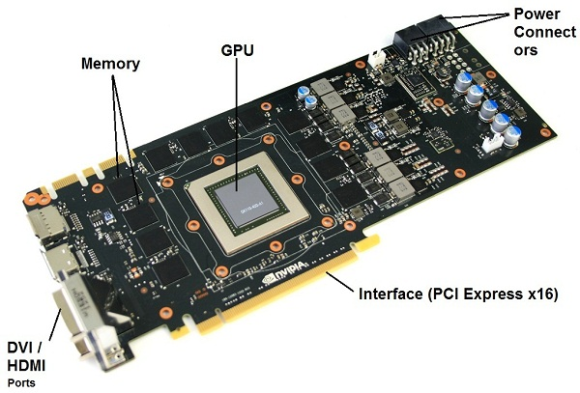

Image26: Graphic Card

Reference: <https://www.akshatblog.com/graphics-card-components-explained-in-detail/>

Components of Graphics Card

1. **GPU (Graphics Processing Unit)**

Graphics Processing Unit or commonly known as GPU is the heart of the Graphics Card. It is the main component of the graphics card where all the graphics processing takes place. Unlike CPU that has only 2 – 16 cores, a GPU processor is made up of hundreds or thousands of small cores or units that runs in parallel to perform complex graphics operations. Nvidia called these cores or processors as Cuda Cores or Shaders and AMD / ATI called them as Stream Processors.

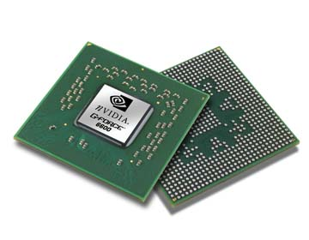

Image27: GPU

Reference: <https://www.akshatblog.com/graphics-card-components-explained-in-detail/>

1. **Memory**

Memory is the place where all the complex textures and other graphics information are stored. GPU fetches the textures from the memory, processes them, send it back to RAM and then it sends it to the RAMDAC and then to your LCD Screen or monitor. RAMDAC is Random Access Memory Digital to Analog Converter which converts the image to the analog signal and sends them to your Monitor or LCD screen through display cable.

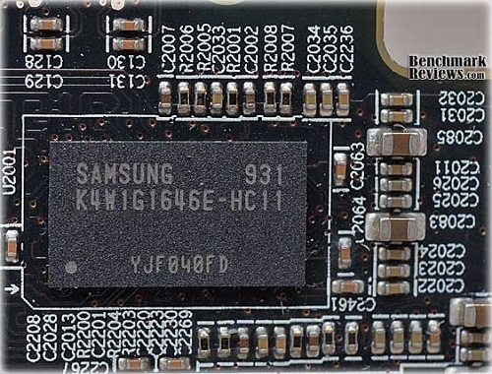

Image28: Memory

Reference: <https://www.akshatblog.com/graphics-card-components-explained-in-detail/>

Graphics Cards have different types of memory depending upon the GPU used in the graphics card. The most common type of memories used in graphics cards are GDDR3 and GDDR5 RAM, where G stands for Graphics and DDR stands for Double Data Rate. Graphics Card RAM or Memory is much faster than the Memory used in your Desktop or Laptop.

1. **Internal Interface**

The internal interface is the one through which your Graphics Card connects to your motherboard. Older graphics cards use AGP (Accelerated Graphics Port) interface to connect to the motherboard but now it has been replaced by much faster and efficient PCI Express 2.0 x16 interface. The motherboard should also have the PCI Express x16 slot otherwise you will not be able to use the card. Some motherboards have two PCI Express x16 slots side by side, so that you can use graphics cards connected in SLI or Crossfire mode for increased performance.

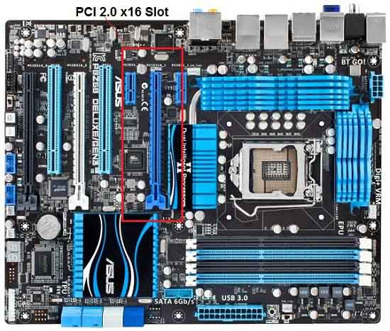

Image29: PCI Express x16 slot

Reference: <https://www.akshatblog.com/graphics-card-components-explained-in-detail/>

1. **Heat Sink and Fan**

Heatsink and Fan forms the cooling part of the graphics card, which are used to lower down the temperature of GPU and RAM (in some cards). Heatsink is a passive cooling device that is made up of copper or aluminum and its main purpose is to take the heat away from the GPU and dissipates it in the surroundings. Fan is an active cooling device that blows air onto the heatsink to make heatsink cool down faster so that it can draw away the heat quickly from the components. Some low-end graphics cards are equipped with only heatsink but the all the mid and high range ones have both heatsink and fan combination for proper and efficient cooling.

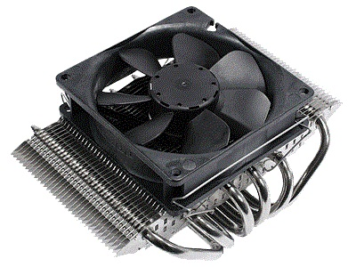

Image30: Heat Sink and Fan

Reference: <https://www.akshatblog.com/graphics-card-components-explained-in-detail/>

1. **Power Connectors (6-pin)**

The power connectors are only present in mid to high range graphics cards because these cards need additional power for their operation. These are 6-pin power connectors and in high range cards there can be two of these connectors present. Low or budget range graphics card do not have these 6-pin power connectors as they do not require that much power for their working and they draw power from the motherboard PCI Express x16 slot only.

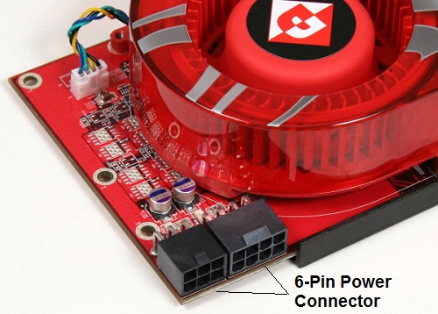

Image31: Heat Sink and Fan

Reference: <https://www.akshatblog.com/graphics-card-components-explained-in-detail/>

## LCD and CRT Monitors

Difference Between CRT and LCD is that CRT is a desktop/pc monitor that contains a cathode-ray tube. A cathode-ray tube (CRT) is a large, sealed glass tube. While LCD is a desktop/pc monitor that uses a liquid crystal display to produce images. These monitors produce sharp, flicker-free images.

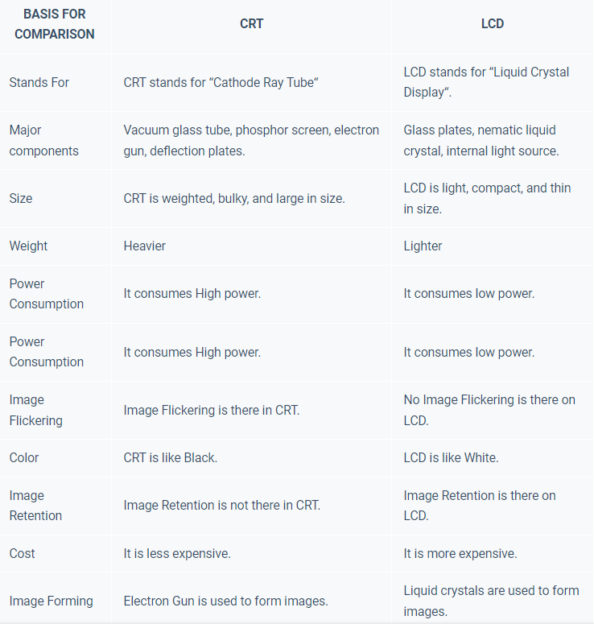

**Displays memory quality and performance**

1. **VRAM**

VRAM (video RAM) refers to any type of random-access memory (RAM) specifically used to store image data for a computer display. VRAM's purpose is to ensure the even and smooth execution of graphics display. It is most important in applications that display complex image textures or render polygon-based three-dimensional (3D) structures. All types of VRAM are special arrangements of dynamic RAM ([DRAM](https://www.techtarget.com/searchstorage/definition/DRAM)). VRAM is a buffer between the computer processor and the display and is often called the frame buffer. When images are to be sent to the display, they are first read by the processor as data from some form of main (non-video) RAM and then written to VRAM.

From VRAM, the data is sent as a digital signal via a digital video interface or high-definition multimedia interface, or [HDMI](https://whatis.techtarget.com/definition/HDMI), video port to a modern, flat-screen LED (light-emitting diode) display. If the display is an older cathode ray tube model, or if the modern display is connected by an older VGA (video graphics array) connector to the video card, the video signal is first converted by a [RAM digital-to-analog converter](https://whatis.techtarget.com/definition/RAMDAC-random-access-memory-digital-to-analog-converter) into analog signals that are sent to the display.

**Types of VRAM**

1. Multibank Dynamic RAM (MDRAM)

It is a high-performance RAM developed by MoSys. It divides memory into multiple 32 kilobyte (KB) parts, or banks that can be accessed individually. Traditional VRAM is [monolithic](https://whatis.techtarget.com/definition/monolithic), where the entire frame buffer is accessed at one time. Having individual memory banks enables access to be performed concurrently, increasing overall performance. MDRAM is also cheaper since, unlike other forms of VRAM, cards can be manufactured with just the right amount of RAM for a given resolution capability, instead of requiring it to be in multiples of megabytes.

1. Rambus Dynamic RAM (RDRAM)

It is a VRAM designed by Rambus that includes a proprietary [bus](https://www.techtarget.com/searchstorage/definition/bus) that speeds up the data flow between VRAM and the frame buffer.

1. Synchronous Graphics RAM (SGRAM)

It is a clock-synchronized DRAM that is a relatively low-cost video memory. SGRAM is single-ported memory, but it can act like dual-ported memory by opening two [memory pages](https://searchservervirtualization.techtarget.com/definition/memory-paging) at the same time, instead of just one.

1. Window RAM (WRAM)

It is a very high-performance VRAM that is dual-ported and has approximately 25% more [bandwidth](https://www.techtarget.com/searchnetworking/definition/bandwidth) than VRAM, but it costs less. Its features make it more efficient to read data for use in block fills and text drawing. WRAM can be used for very high resolution such as 1,600 x 1,200 pixels -- using true color. Window RAM is unrelated to Microsoft Windows.

Learning Outcome

Basic Troubleshooting of PC

# Basic Troubleshooting of PC

## Some of the most common PC hardware problems that need troubleshooting

* Your computer won’t turn on.
* Your computer turns on, but still doesn’t work.
* Your computer screen freezes.
* Your computer has insufficient memory.
* You get a CMOS error.
* Your operating system is missing or your hard drive isn’t detected.
* You get the blue screen of death.

When it comes to hardware, some techs may have trouble assessing what steps to take to figure out what’s wrong and how to repair it. Which component is having the issue? Should you just replace the component? Should you try to troubleshoot the software first?

In this article we’ll go over how to troubleshoot common PC hardware issues (seven of them, to be exact) and the best way to go about fixing them. Remember this, though. The most basic tip is to always try the most obvious solutions first. It could save you a lot of time and frustration.

### **Problem #1:** Your Computer Won’t Turn On

This is a common problem that often offers a simple solution.

Is everything plugged in? I can’t tell you how many times I have come across a “broken” computer that simply had an unplugged component.

Try plugging into different power outlets. It isn’t uncommon to blow a fuse, especially with more power-hungry systems.

Is either the monitor, mouse, or keyboard the only thing not working? If so, try plugging in a different one to see if that does the job. Most of the time, replacing one of these is cheaper than attempting a repair.

Once you’ve completed the above steps, it’s time to look at the tower.

Are the lights on in the front or back of the tower? If not, the power supply unit (PSU) may be turned off.

Next, you can open up your tower and look at the motherboard. Most have a small LED light built in to show if power is running to the motherboard. If it’s turned off, you can either try using a PSU tester, or replace the PSU. Never try to open a PSU and try to repair it yourself as this is extremely dangerous.

**Problem #2:** Your Computer Turns On, But Still Doesn’t Work

If power is obviously flowing to the computer system and its peripherals, there may be a component issue. When you first turn on the computer, do you hear or see anything out of the ordinary? Many times the computer’s Power-On Self-Test (POST) will let you know what’s going on with the machine.

## Beep Codes

If you hear any beeps when your computer turns on, they can help you troubleshoot common PC hardware problems. Here’s a list of beep codes (hint: remember these if you’re taking the COMPTIA A+ exam).

No beep but the system turns on and runs fine - Under normal circumstances, most computer systems will beep one short beep when turned on. If yours doesn’t, your “beeper” may have died out.

No beep - The power supply is not plugged in or turned on. Or, the power supply is completely dead.

Steady, short beeps - The power supply may be bad or the voltages might be wrong. A replacement would usually be necessary.

Steady, long beeps - The power supply has gone bad.

Long, continuous beep - Your Random Access Memory (RAM) sticks may have gone bad. If there is more than one stick installed, try taking one out to see if the computer boots. If it does not, try the same thing with the other stick. This will tell you which stick has gone bad and you can replace or upgrade accordingly. If there is only one stick installed, you will need to replace or upgrade it to fix the problem.

One long, two short beeps - There has been a video card failure. Your first action is to try reseating the video card. This often solves the problem when the computer system is connected to projectors because the VGA/DVI/Video cable gets moved so often that the card can be slowly unplugged. If reseating doesn’t work, replace the video card.

**Problem #3:** Your Computer Screen Freezes

When your computer freezes and isn’t responsive to your mouse or keyboard, the first thing to do is just wait. Sometimes it will just take a few minutes for your computer to process. Then, end-task the non-responding program. If that doesn’t work, turn off the computer by holding down the power button and then rebooting into Safe Mode (don’t forget about saving your work first, if you can).

If you’ve tried all of this and your computer still won’t unlock, you may be dealing with either defective hardware or a defective device driver. If this is your case, replace the defective piece immediately so it doesn’t cause further damage.

Another thing you could be dealing with is a virus that is overwhelming your system. Run a virus scan, remove the virus, recover or reinstall damaged files or software, and implement the latest security software.

**Problem #4:** Your Computer Has Insufficient Memory

Receiving an “insufficient memory or disk space” error message can usually be solved (at least temporarily) by closing extra windows to free up some RAM. If you’ve done that and the error still comes up, you can try rebooting your computer and installing the latest operating system update.

If you really don’t have enough available memory and space (which can be checked in Windows 10 by pressing the Windows-R button and typing perfmon in the Open field to run the Performance Monitor), you can uninstall or delete any unused or unnecessary files, especially those of the video/music type. Your final solution is to add more RAM.

**Problem #5:** You Get a CMOS Error

The CMOS (complementary metal-oxide semiconductor) is an onboard chip that stores information ranging from the time and date to system hardware settings. If you get a CMOS alert message showing up on your screen, it’s likely you need to replace the CMOS battery located on the motherboard. Remove it carefully, insert a new battery that is exactly the same as the old one, and enter the CMOS values to the defaults.

**Problem #6:** Your Operating System Is Missing or Your Hard Drive Isn’t Detected

If the message “Missing Operating System” shows up on your screen, there are four possibilities the problem could be (and four ways to solve it):

1. The basic input/output system (BIOS) doesn’t detect Windows’ hard disk, or the disk failed. If you know how, take out the hard drive and reconnect it. If that doesn’t work, the hard drive’s interface is forbidden or the hard drive is seriously damaged.

Restart the computer and watch for the message telling you which key to strike to go into the BIOS. The key can vary from system to system so you may need to use a search engine to find the instructions for your system. Be sure to strike the specified key as soon as you see the message.

In the BIOS highlight the hard drive and set it to “Auto”. If it’s still invisible, you need a hard drive repair or replacement.

2. The BIOS settings are incorrect. Set the BIOS back to Default State.

3. The Master Boot Record (MBR) is damaged or corrupted. Rebuild the MBR using either the Windows installation disk, the Windows repair disk, or a bootable partitioning tool.

4. The Windows boot file partition isn’t active. Start the computer using a bootable partitioning tool. If that doesn’t work, set the wrong partition to ‘inactive’ and activate the correct partition.

**Problem #7:** The Blue Screen of Death

The blue screen of death (BSOD) appears when Microsoft Windows has an unrecoverable, critical error that causes a crash and subsequent data loss. This can be caused by the low-level software in Windows crashing.

When the BSOD occurs, the computer automatically creates a minidump file and restarts the computer. If the blue screen appears again, follow the prompts, identify and search for the error code online, and learn how to fix the problem.

Some of the common solutions are to:

Make sure your computer isn’t overheating. If it is, close unused applications, check the fan is working properly, and conduct a good dusting after the computer is turned off before trying other solutions for an overheating PC.

Boot into Safe Mode before trying to fix a problem.

Test your hardware components and check the computer’s memory for errors.

Check for incorrectly installed or buggy drivers. Install updated drivers.

Scan for Malware that is causing the crash.

Reset or reinstall Windows.

Use System Restore to get your computer back to its previous state. If it works, you probably have a software problem on your hands.

Signs You Need to Call a Professional

If you don’t feel confident doing any of these troubleshooting steps, the answer is simple–call an IT professional. There are no reasons to risk the life of your computer (or your own safety) just to tinker around and avoid putting in a ticket.

Basic of software troubleshooting:

1. Free up RAM by closing other open programs.

Every piece of software uses Random Access Memory (RAM). The more software that's running on your computer, the more RAM it uses. This can be especially problematic if you're using older machines that don't have a lot of RAM. So if a software program refuses to load or is running slowly, the first thing to do is to close all other open applications.

If you want to find out which open applications might be hogging your RAM, both Windows and Macintosh operating systems (OS) have tools that display this information:

In Windows, hit Ctrl+Alt+Delete, then choose the Start Task Manager option. From the window that appears, click the Processes tab, then click the Memory menu item. This sorts all open processes based on the amount of RAM they're using. You can shut down a runaway process by clicking the End Process button. Before you do that, you may want to do a bit of research on the process to ensure that you don't accidentally stop a critical process or program.

In Mac OS X, use the Activity Monitor (called the Process Viewer in older versions of OS X). Access the Activity Monitor by going to Applications > Utilities. Once you've called up the Activity Monitor, sort programs based on RAM usage by clicking the column labeled "Real Memory."

2. Restart the software.

Software problems can stem from a conflict with other programs or simply from difficulties the software encountered when starting up. Shutting the program down and restarting it can sometimes resolve these issues.

3. Shut down and restart your computer.

If restarting the problematic program doesn't resolve the issue, try rebooting your computer. Once the computer has fully restarted, re-launch the application in question and see if the problem has been resolved.

4. Use the Internet to find help.

No matter what software problems you encounter, chances are it's happened to someone else. So there's a good chance you can find help on the Internet. Here are a few places to get started:

Search for answers: In your search engine query, include the software program name and version, the problem you encountered, and the circumstances under which the problem occurred. If you received a specific error message, enter the exact error message text, along with the name of the application.

Check the vendor's website: Most software vendors provide some form of product help, such as answers to frequently asked questions, product documentation, or user discussion forums.

Check other websites: TechSoup's article Learning About Technology Online lists a number of other websites that offer technology tutorials, articles, and discussion forums.

5. Undo any recent hardware or software changes.

Changes to software and hardware can sometimes cause software problems, such as:

Conflicts with other software: Newly installed software may conflict with other software. For example, Symantec Norton Antivirus can conflict with competing antivirus products. So, if you recently installed another antivirus program and Norton Antivirus no longer works correctly, uninstalling the other antivirus product could solve your problem.

Changes to computer settings: Undo any recent changes to your computer's settings, and try launching the software again. For example, the Windows Control Panel includes an option to "Set Program Access and Defaults," which allows you to disable access to certain applications. If you accidentally disable access to a program here, the program may not run.

Conflicts with new or improperly configured hardware, such as scanners and printers. If you've recently connected new hardware to one of your computers, try disconnecting the hardware and see if that corrects the software issue.

6. Uninstall the software, then reinstall it.

Sometimes, software problems occur because critical application files have been removed, updated, or deleted. For example, many Windows applications use Dynamic Link Library (DLL) files to perform basic tasks. Often, several applications will use the same DLL file. If you've recently removed one program from your computer, it's possible you removed DLL files that another program relied on. Similarly, adding a program could add or update DLL files. Applications that were dependent on those DLL files may become unstable or stop working entirely.

To ensure that all the necessary files are intact, you can completely uninstall the problematic software, then reinstall it. Even if you remove a program using its built-in uninstall wizard (if it includes one), it's still a good idea to check your hard drive's Program Files folder — usually located on the C drive — for any remnants of the program, and delete any files or folders you find.

Before reinstalling, check to see if there's a new version of the program available. The vendor or developer might have introduced bug fixes that address the issue you're having.

7. Look for software patches.

Software vendors may also fix bugs by issuing patches — small software updates that address known problems. Even if you're using the most current version of the software, there may be a more recent patch available for that version.

8. Scan for viruses and malware.

Viruses, spyware, and other forms of malicious software (or "malware") can cause software to freeze, crash, or quit working entirely.

If tips 1 through 8 haven't helped solve your software problem, you may also want to scan the computer using both antivirus and anti-malware tools to find and remove viruses and malware. Use the most thorough scan mode available, and remember to restart your machine if the antivirus or anti-malware programs found any threats.

9. Check for a firewall conflict.

Some organizations may choose to install personal firewall software on each computer, rather than a centralized hardware or software-based firewall. Personal firewalls can be an important line of defense against hackers and other security threats, but they can also cause software conflicts.

Firewalls frequently display messages asking whether it should allow a program to run or block it. Therefore, it's possible to accidentally tell the personal firewall to block a program from running. Check the firewall's settings to see if the problematic software was added to the firewall's list of programs to block. If so, change the firewall's settings to allow the software to run, then check to see if you're still having issues with your software.

10. Boot up in Safe Mode.

Some software malfunctions can be caused by OS settings or other system problems. Windows and Mac operating systems both offer a troubleshooting environment known as Safe Mode. Safe Mode disables non-critical applications and processes, which theoretically makes it easier to isolate problems.

Most Windows computers allow you to enter Safe Mode by pressing the F8 key as your computer is booting up. On a Mac, enter Safe Mode by pressing the Shift key while your computer boots up (or immediately after it boots up).

Once your computer is in Safe Mode, launch the problematic software and try to replicate the problem you had while your computer was in normal mode. If you don't have the same problem in safe mode, there's a good chance that the issue was caused by your OS or another program, not by the application you are troubleshooting.

11. Defragment your hard drive.

As a final troubleshooting step, you might defragment your computer's hard drive. Defragmenting rearranges your hard drive's file structure so that the system runs more efficiently. Defragmenting will probably be most useful if you're experiencing overall sluggishness on your computer, because defragmenting is meant to make your entire system run faster. Note that defragmenting a hard drive applies primarily to Windows-based computers.

Most recent Windows editions — including XP, Vista, and Windows 7 — include a built-in disk-defragmentation tool. To launch it, go to Start > All Programs > Accessories > System Tools > Disk Defragmenter. Be aware that defragmenting a hard drive can be time-consuming, so make sure to perform this task when you will be away from your computer for a few hours.

## What Is An I/O Device Error?

An I/O device error (short for Input/Output device error) happens when Windows is not able to perform an input/output action (such as reading or copying data) when it is trying to access a drive or disk.

It can occur to many different types of hardware devices or media.

Reasons for I/O Device Error.

* This plugged storage device is incorrectly connected. PC cannot detect your connected device normally.
* The computer USB port or USB card reader is damaged or broken.
* The computer storage device driver is outdated, damaged or incompatible with your attached device.
* The external hard drive, memory card or USB drive is recognized with a wrong drive letter.
* The external hard drive, memory card or USB drive that you are trying to access is dirty or damaged.
* Windows is trying to use a transfer mode that the hardware device cannot use.

**Common Symptoms of "I/O Device Error"**

In general, you will get the following messages if your storage device unexpectedly gets the I/O device error issue:

* "The request could not be performed because of an I/O device error".
* "I/O error 32", "I/O error 21" or the similar "I/O error + codes".
* "Only part of a read process memory request was completed" or "Only part of a write process memory request was completed".

**The Easiest Solutions to Fix Hard Disk I/O Device Error**

Solution 1: Check all cables connections

In the case of External Hard drives, most of the I/O device errors occur due to cords and cables that connect the external hard drive to the computer. Therefore, the first thing you should do is to check the cord connections with your computer system. Make sure; all the cords are connected tightly at both hub and computer Ports. You can also try to plug the external hard drive into another port of your computer or replace the connection cable to check whether the error is due to the cable. If this solution fixed the problems, then you are done. If this did not resolve the issue, try another solution.

Solution 2: Update or Re-Install the Drivers

At times, an outdated driver may also cause an I/O device error. This error can be fixed by updating or re-installing a new driver. You need to check whether the drivers are updated and compatible with the disk transfer.

Solution 3: Check all the Cords

The next easiest way to resolve I/O errors on an external drive is cord crosstalk. At times, when the electricity in one set of wires tends to leak into another set of cables, then it might interfere when you perform input-output operations. To fix this problem disconnect all the additional devices except your external hard drive on your computer and connect only those cords of necessary tools. You can also avoid this issue permanently by replacing the current wires with better cables. You can also join your external drive to another system to check whether the cord is faulty or there is a problem with your external drive.

Solution 4: Change the drive transfer mode in IDE Channel Properties

OS cannot transfer data from drive to computer if the transfer mode is incorrect, you can change transfer mode by following steps.

Press (Windows + X) both Keys together and select device manager from the menu list

Expand IDE ATA/ATAPI controllers. A subset will open, that lists the different IDE ATA/ATAPI channels.

Right-click on the channel where the appropriate drive is connected, and then click properties. Typically, this channel is the Secondary IDE channel.

Go to the advanced settings tab and select PIO Only in the transfer mode box for the device that represents the appropriate drive. Typically, this is device 0. Then, click ok and exit all windows.

Test the drive and check if the error message has been removed.

Warning: Do not change the Primary IDE Channel, Device 0. Changing this transfer mode setting may cause the computer to operate incorrectly or not at all.

Solution 5: Check and Repair Device in Command Prompt

Press (Windows + X) both Keys together and select Command Prompt (Admin) from the menu list

Click Yes to allow OS to launch the Command Prompt as Administrator.

In Command Prompt window, type chkdsk G: /f /r /x. Here G is the drive letter; you can replace it with your drive letter.

This option will check and repair disk errors on the external & internal hard drive/USB drive/SD card to fix I/O device errors. And then you will no longer see the “The request could not be performed because of an I/O device error” message.

# Introduction to networks

## What is a Computer Network?

A computer network is a group of computers that use a set of common communication protocols over digital interconnections for the purpose of sharing resources located on or provided by the network nodes.

Computer networking refers to connected computing devices (such as laptops, desktops, servers, smartphones, and tablets) and an ever-expanding array of IoT devices (such as cameras, door locks, doorbells, refrigerators, audio/visual systems, thermostats, and various sensors) that communicate with one another.

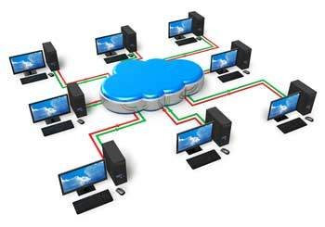A collection of distributed, intelligent machines that shares data and information through interconnected lines of communication is called networking. When two or more computers are brought together in connection with cable or without cable, which may extend within a limited room or to the entire world, the computers are said to be network connections.

Image 1: Computer Network

Reference: <https://www.tutorialspoint.com/computer_fundamentals/computer_networking.htm>

## Characteristics of a Computer Network

*/*

* Share resources from one computer to another.
* Create files and store them in one computer, access those files from the other computer(s) connected over the network.
* Connect a printer, scanner, or a fax machine to one computer within the network and let other computers of the network use the machines available over the network.

Following is the list of hardware's required to set up a computer network.

* Network Cables
* Distributors
* Routers
* Internal Network Cards
* 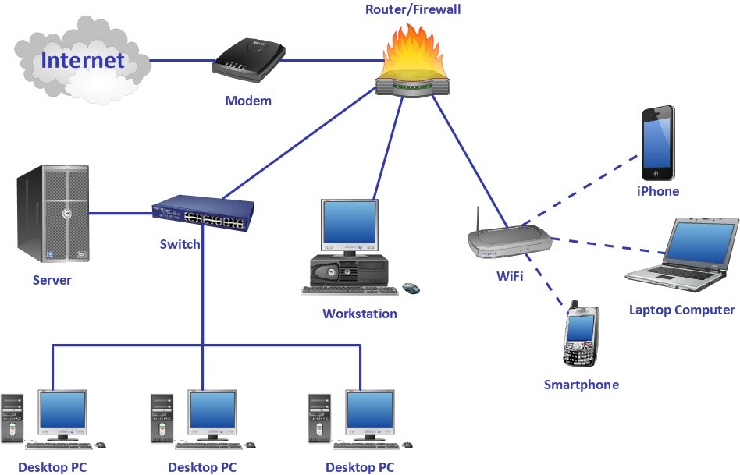External Network Cards

Image 2: Characteristics of a Computer Network Reference: <https://tyrocity.com/topic/computer-networks/>

## Network Cables

Network cables are used to connect computers. The most commonly used cable is Category 5 cable RJ-45.

*/*

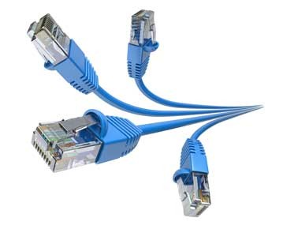

Image 3: RJ-45

Reference: <https://www.tutorialspoint.com/computer_fundamentals/computer_networking.htm>

## Distributors

A computer can be connected to another one via a serial port but if we need to connect many computers to produce a network, this serial connection will not work.

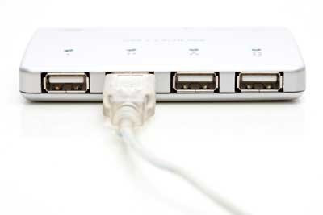

Image 4: Distributors

Reference: <https://www.tutorialspoint.com/computer_fundamentals/computer_networking.htm>

The solution is to use a central body to which other computers, printers, scanners, etc. can be connected and then this body will manage or distribute network traffic.

## Router

A router is a type of device which acts as the central point among computers and other devices that are a part of the network. It is equipped with holes called ports. Computers and other devices are connected to a router using network cables. Now-a-days routers come in wireless modes using which computers can be connected without any physical cable.

*/*

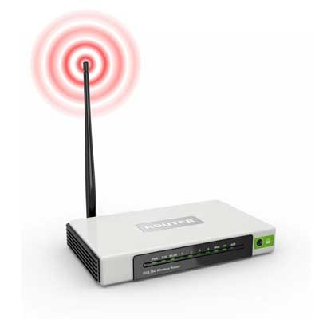

Image 5: Router

Reference: <https://www.tutorialspoint.com/computer_fundamentals/computer_networking.htm>

## Network Card

Network card is a necessary component of a computer without which a computer cannot be connected over a network. It is also known as the network adapter or Network Interface Card (NIC).

Network cards are of two types:

* Internal Network Cards
* External Network Cards

**Internal Network Cards**

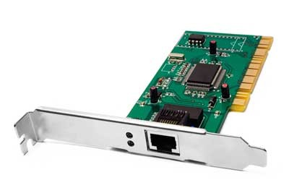Motherboard has a slot for an internal network card where it is to be inserted. Internal network cards are of two types in which the first type uses Peripheral Component Interconnect (PCI) connection, while the second type uses Industry Standard Architecture (ISA). Network cables are required to provide network access.

Image 6:Internal Network Cards

Reference: <https://www.tutorialspoint.com/computer_fundamentals/computer_networking.htm>

**External Network Cards**

External network cards are of two types: Wireless and USB based. Wireless network cards need to be inserted into the motherboard, however no network cable is required to connect to the network.

*/*

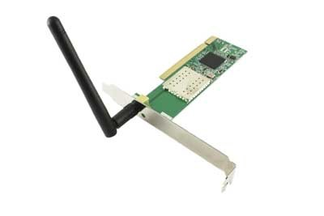

Image 7:External Network Cards

Reference: <https://www.tutorialspoint.com/computer_fundamentals/computer_networking.htm>

## Basics Components of Computer Network

A computer network is built up from several components. These components together make it possible to transfer data from one device to another and makes smooth communication between two different devices. In this guide, we will discuss the main components of a computer network.

* Servers
* Clients
* Transmission Media
* Network Interface card
* Modem
* Hub
* Switch
* Cables and connectors
* Router
* 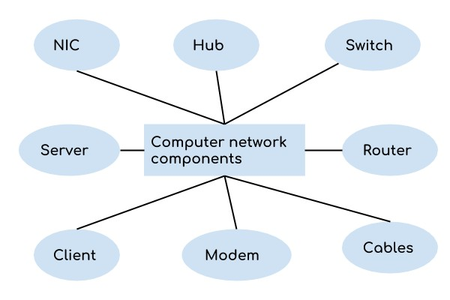LAN cable

*/*

Image 8: Network Components Reference:<https://beginnersbook.com/2019/03/computer-network-components/>

**Server**

Servers are computers that run operating systems and hold data that can be shared over a computer network.

**Client**

A client is a computer that is connected to other computers in the network and can receive data sent by other computers.

**Transmission Media**

All computers in a computer network are connected with each other through a transmission media such as wires, optical fibre cables, coaxial cables etc.

**Network Interface card**

Each system or computer in a computer network must have a card called network interface card (NIC). The main purpose of NIC is to format the data, send the data and receive the data at the receiving node.

**Modem**

Modem Short for modulator-demodulator In a communication modem converts the digital data into analog so that it transmits over the phone line because the phone line transmits analog data. In the same way on the other hand when data is received modem again converts this analog data into a digital single so that computer stores and processes this information.

Modulator means that it converts digital signals into analog signals and sends it over telephone lines. This process is known as modulation.

Demodulator means that receiving modem converts analog signals into digital signals and this process is known as demodulation.

It helps us to transmit data from one computer to another computer using standard telephone lines.

*/*

**Cables and Connectors**

Networking cables are networking hardware used to connect one network device to other network devices or to connect two or more computers to share printers, scanners etc.

**Hub**

Hub acts as a device that connects all the computers in a network to each other. Any request that comes from a client computer first received by Hub and then hub transmits this request over a network so that the correct server receives and responds to it.

**Switch**

Switch is similar to hub however instead of broadcasting a incoming data request it uses the physical device address in the incoming request to transfer the request to the correct server computer.

**Router**

Router joins multiple computer networks to each other. For example let's say a company runs 100 computers over a local area network(LAN) and another company runs another LAN of 150 computers. These both LANs can be connected with each other through an internet connection which is provided by the router.

**LAN cable**

A wire that is used to connect more than one computers or other devices such as printers and scanners to each other.

## Features of a Computer Network

*/*

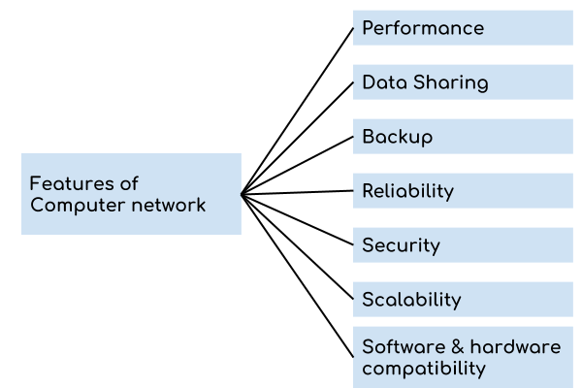

Image 9: Features of a Computer Network Reference:<https://beginnersbook.com/2019/03/computer-network-features/>

A computer network has following features:

**Performance:**

Performance of a computer network is measured in terms of response time. The response time of sending and receiving data from one node (computer in a computer network are often referred as node) to another should be minimal.

**Data Sharing:**

One of the reasons why we use a computer network is to share the data between different systems connected with each other through a transmission media.

**Backup:**

A computer network must have a central server that keeps the backup of all the data that is to be shared over a network so that in case of a failure it should be able to recover the data faster.

**Software and hardware compatibility:**

A computer network must not limit all the computers in a computer network to use same software and hardware, instead it should allow the better compatibility between the different software and hardware configuration.

*/*

**Reliability:**

There should not be any failure in the network or if it occurs the recovery from a failure should be fast.

**Security:**

A computer network should be secure so that the data transmitting over a network should be safe from unauthorised access. Also, the sent data should be received as it is at the receiving node, which means there should not be any loss of data during transmission.

**Scalability:**

A computer network should be scalable which means it should always allow to add new computers (or nodes) to the already existing computer network.

## Advantages Computer Networks

* Workgroups-a group of users can work together on a single project
* Shared databases-many users can access the data,such as bank accounts
* Distributed Systems-a problem can be divided into parts and each part worked on independently
* Communications-Data can be shared,such as emails,video conferencing,VoIP
* Device Sharing-Many users share one pointer
* Software sharing-Software is installed on a server and can be updated centrally
* Security-All work is under a central and breaches can be tracked

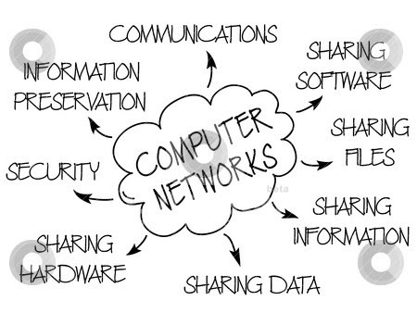

Image 11: Advantages of Computer Network

Reference: <http://wifinotes.com/computer-networks/advantages-of-computer-networking.html>

## Disadvantages Computer Networks

*/*

* Buying the computer cable and servers can be very expensive.
* Viruses can spread to other computers throughout a computer network.
* People can hack your computer.
* It encourages people to become dependent on computers.
* It comes with the risk of security issues.

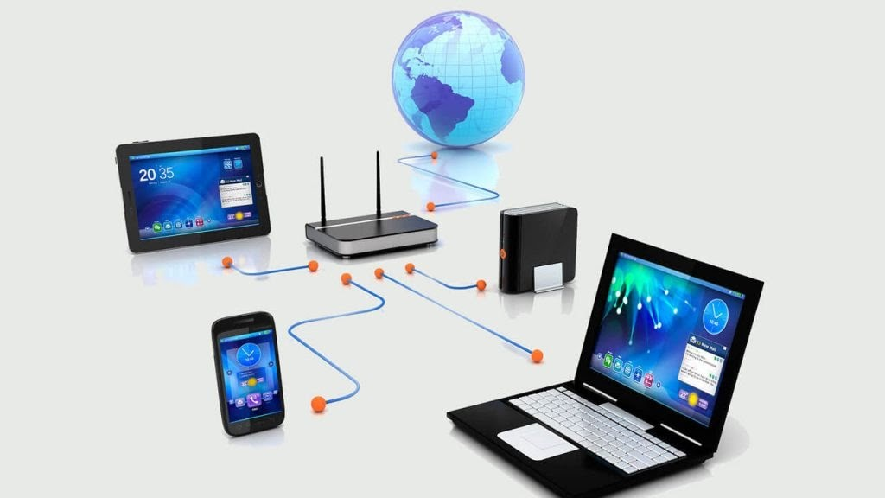

Image 12:Disadvantages of Computer Network

Reference: <https://www.tutorialspoint.com/computer_fundamentals/computer_networking.htm>

*/*

## Type of Networks

**Type of Area Networks**

A computer network is a group of computers linked to each other that enables the computer to communicate with another computer and share their resources, data, and applications.

* LAN
* MAN
* WAN
* VLAN
* WLAN
* VPN
* CAN
* SAN
* SHAN
* PAN

**LAN(Local Area Network)**

* Group of interconnected computers within a small area. (room, building,campus)
* Two or more pc's can from a LAN to share files, folders, printers, applications and other devices
* Coaxial or CAT 5 cables are normally used for connections
* Due to short distances, errors and noise are minimal.
* Local Area Network provides higher security.
* Data transfer rate is 10 to 100 mbps. Example: A computer lab in a school

**Advantages of LAN**

**Resource Sharing:**

LAN provides resource sharing such as computer resources like printers, scanners, modems, DVD-ROM drives, and hard disks can be shared within the connected devices. This reduces cost and hardware purchases.

*/*

**Software Applications Sharing:**

In a Local Area Network, it is easy to use the same software in a number of computers connected to a network instead of purchasing the separately licensed software for each client a network.

**Easy and Cheap Communication:**

Data and messages can easily be shared with the other computer connected to the network.

**Centralized Data:**

The data of all network users can be stored on a hard disk of the central/server computer. This helps users to use any computer in a network to access the required data.

**Data Security:**

Since data is stored on the server computer, it will be easy to manage data at only one place and the data will be more secure too.

**Internet Sharing:**

Local Area Network provides the facility to share a single internet connection among all the LAN users. In school labs and internet Cafes, single internet connection is used to provide internet to all connected computers.

**Disadvantages of LAN**

**High Setup Cost:**

*/*

The initial setup costs of installing Local Area Networks is high because there is special software required to make a server. Also, communication devices like an ethernet cable, switches, hubs, routers, cables are costly.

**Privacy Violations:**

The LAN administrator can see and check personal data files of each and every LAN user. Moreover, he can view the computer and internet history of the LAN user.

**Data Security Threat:**

Unauthorized users can access important data of an office or campus if a server hard disk is not properly secured by the LAN administrator.

**LAN Maintenance Job:**

Local Area Network requires a LAN Administrator because there are problems such as software installations, program faults or hardware failures or cable disturbances in Local Area Network. A LAN Administrator is required to maintain these issues.

**Covers Limited Area:**

LANs are restricted in size; they cover a small area like a single office, single building or a group of nearby buildings.

**MAN(Metropolitan Area Network)**

* Design to extend over a large area.
* Connecting number of LAN's to form larger network, so that resources can be shared.
* Government agencies use MAN to connect to the citizens and private industries
* In MAN, various LANs are connected to each other through a telephone exchange line.
* Networks can be up to 5 to 50 km.
* Data transfer rate is low compared to LAN.

Example: Organization with different branches located in the city.

*/*

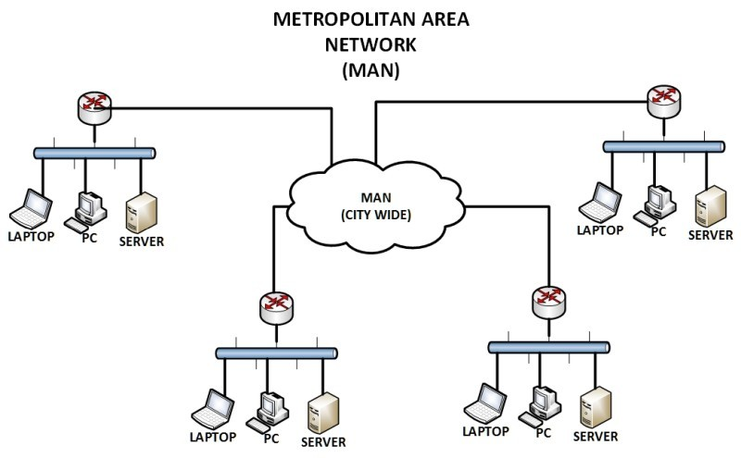

Image 14:MAN Reference:<https://www.networkstraining.com/different-types-of-networks/>

**Advantages of a MAN Network**

There are many advantages of the MAN network, some of them given below.

**Less Expensive:**

It is less expensive to attach MAN with WAN Network. MAN gives you good efficiency of data. All data on MAN is easily manageable in a centralized way.

**Sending Local Emails:**

You can send local emails fast and free on MAN.

**High Speed than WAN:**

The speed of data can easily reach 1000 Mbps, as MAN uses fiber optics. Files and database transfer rates are fast.

**Sharing of the Internet:**

With the installation of MANs, users can share their internet connection. In this way, multiple users can get the same high-speed internet.

**Conversion of LAN to MAN is Easy:**

MAN is a combination of two or more LAN networks. So it is a faster way to connect two LAN networks together. It is possible by the fast configuration of links.

**High Security:**

MAN’s has a higher-security level than WAN.

**Disadvantages of MAN Network Difficult To Manage:**

It is very difficult to manage if the size and number of LANs network increase. This is due to security and extra configuration problems.

**Internet Speed Difference:**

As it cannot work on phone copper wires. Copper wires affect the speed of MAN.So high cost is needed for fiber optics.

**Hackers Attack:**

In this network, there is a high risk of attacking hackers as compared to LAN. So data may be a leak. Highly security staff is the need in MAN.

**Technical Staff Requires to Set up:**

Highly technical people are required to set up MAN. The technical people are network administrators and troubleshooters.

**Need More wires:**

In MAN more than LAN networks, cables require. As you know, it is a combination of two LANs.

**WAN(Wide Area Network)**

* A Wide Area Network is a network that extends over a large geographical area such as states or countries.
* Contains multiple LAN's and MAN's.
* A Wide Area Network is quite a bigger network than the LAN.
* Distinguished in terms of geographical range.
* Data transfer rate depends upon the ISP provider and varies over the location. Example:Internet

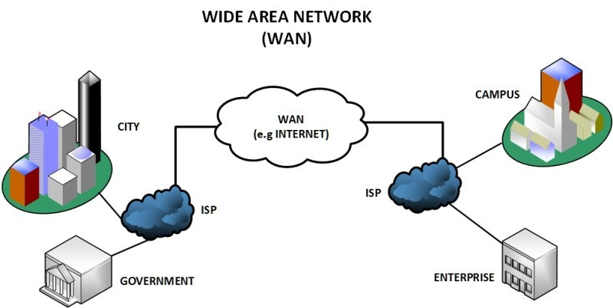

**Advantages of WAN :**Image 15: WAN

Reference: <https://www.networkstraining.com/different-types-of-networks/>

WAN covers a larger geographical area. Hence business offices situated at longer distances can easily communicate.

*/*

*/*

Like LAN, it allows sharing of resources and application softwares among distributed workstations or users.

The software files are shared among all the users. Hence all will have access to the latest files. This avoids use of previous versions by them.

Organizations can form their global integrated network through WAN. Moreover it supports global markets and global businesses.

The emergence of IoT (Internet of Things) and advanced wireless technologies such as LAN or LAN-Advanced have made it easy for the growth of WAN based devices. Messages can be sent very quickly across the globe with the help of applications such as whatsApp, facebook messenger etc.

**Disadvantage of WAN :**

* Initial investment costs are higher.
* It is difficult to maintain the network. It requires skilled technicians and network administrators.
* There are more errors and issues due to wide coverage and use of different technologies. Often it requires more time to resolve issues due to involvement of multiple wired and wireless technologies.
* It has lower security compared to LAN and MAN due to wider coverage and use of more technologies.
* Security is a big concern and requires use of firewall and security softwares/protocols at multiple points across the entire system. This will avoid chances of hacking by intruders.

**WLAN(Wireless Local Area Network)**

* A WLAN makes use of a WirelessAccess Point (WAP) device, which serves as the point of connectivity for wireless clients on the network.
* A LAN that uses high frequency radio waves for communication.
* Provides short range connectivity with high speed data transmission

*/*

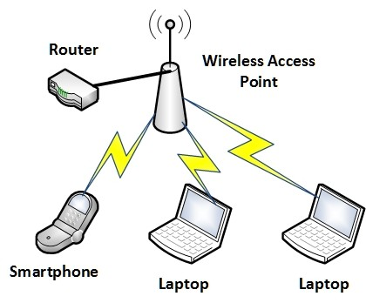

Image 16:WLAN Reference:<https://www.networkstraining.com/different-types-of-networks/>

**Advantages of WLAN:**

* It is a reliable type of communication
* As WLAN reduces physical wires so it is a flexible way of communication
* WLAN also reduces the cost of ownership
* It is easier to add or remove workstation
* It provides high data rate due to small area coverage
* You can also move workstation while maintaining the connectivity
* For propagation, the light of sight is not required
* The direction of connectivity can be anywhere i.e. you can connect devices in any direction unless it is in the range of access point
* Easy installation and you need don’t need extra cables for installation
* WLAN can be useful in disaster situations e.g. earthquake and fire. People can still communicate through the wireless network during a disaster
* It is economical because of the small area access
* If there are any building or trees then still wireless connection works

**Disadvantages of WLAN:**

* WLAN requires license
* It has a limited area to cover
* Government agencies can limit the signals of WLAN if required. This can affect data transfer from connected devices to the internet
* If the number of connected devices increases then data transfer rate decreases
* WLAN uses radio frequency which can interfere with other devices which use radio frequency
* If there is rain or thunder then communication may interfere.
* Attackers can get access to the transmitted data because wireless LAN has low data security
* Signals may be affected by the environment as compared to using fiber optics
* The radiation of WLAN can be harmful to the environment
* As WLAN uses access points and access points are expensive than wires and hubs
* Access points can get signals of nearest access points
* It is required to change the network card and access point when standard changes
* LAN cable is still required which acts as the backbone of the WLAN
* Low data transfer rate than wired connection because WLAN uses radio frequency
* Chances of errors are high
* Communication is not secure and can be accessed by unauthorized users

**VLAN(Virtual Local Area Network)**

* Virtual Local Area Networks (VLANs) divide a single existing physical network into multiple logical networks.
* Thereby, each VLAN forms its own broadcast domain.
* Communication between two different VLANs is only possible through a router that has been connected to both VLANs.
* VLANs behave as if they had been constructed using switches that are independent of each other.

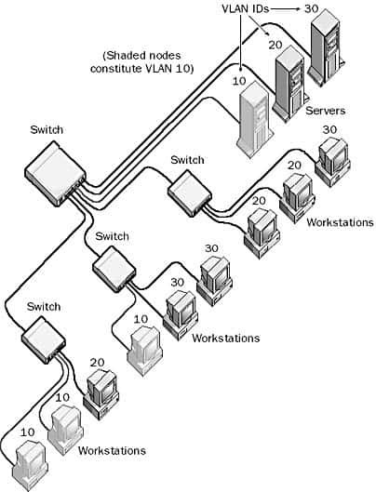

**Advantages of VLANs:**

Image 17: VLAN Reference:<https://networkencyclopedia.com/virtual-lan-vlan/>

* VLANs provide enhanced network security. In a VLAN network environment, with multiple broadcast domains, network administrators have control over each port and user.

*/*

* Allowing network administrators to apply additional security to network communication.

*/*

* Making expansion and relocation of a network or a network device easier.
* Providing flexibility because administrators are able to configure in a centralized environment while the devices might be located in different geographical locations.
* Decreasing the latency and traffic load on the network and the network devices, offering increased performance.
* VLANs enable logical grouping of end-stations that are physically dispersed on a network.
* It allows higher performance and reduced latency.
* It allows users to work on sensitive information which should not be seen by other users.
* VLAN Removes the physical boundary.

**Disadvantages of VLANs:**

* High risk of virus issues because one infected system may spread a virus through the whole logical network.
* Equipment limitations in very large networks because additional routers might be needed to control the workload.
* More effective at controlling latency than a WAN, but less efficient than a LAN.
* For Inter-VLAN communication we need a router.
* Management is complex.
* Possible problems in interoperability.

## VPN(Virtual Private Network)

* A Virtual Private Network is a type of network that makes use of existing private or public network infrastructure (e.g. the Internet) to provide a secure network connection.
* This is often achieved by creating an encrypted tunnel for secured end-to-end connectivity.
* A Virtual Private Network uses data encryption techniques to provide security for files that are sent or received over the network.
* This is often used by organizations that have highly sensitive data to transfer.

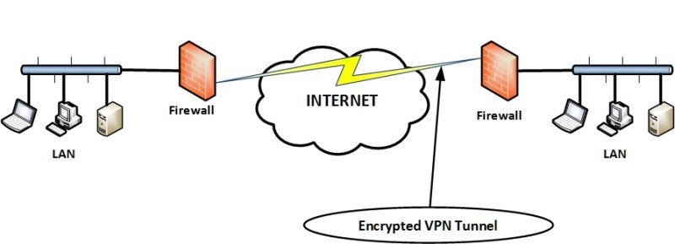

**VPN Advantages**

Image 18: VPN

Reference: <https://www.networkstraining.com/different-types-of-networks/>

* A VPN service hides your real IP address, effectively masking your online identity and allowing you to bypass geo-blocks.

*/*

* Since a VPN masks your IP address, it also helps you bypass firewalls.
* A VPN encrypts your online connections, protecting your data from hackers and ISP/government surveillance.
* By encrypting your online traffic, a VPN ensures your ISP can’t throttle your bandwidth.
* A VPN offers you a better online gaming experience by keeping you safe from IP bans, DDoS attacks, and by giving you access to geo-blocked/banned video games.
* With a VPN, you are much safer when downloading torrents since your ISP can’t see what you’re doing, and other people who are downloading/uploading the same torrent can’t see your real IP address.
* A VPN can potentially help you avoid online price discrimination (like when airline companies charge more for the same ticket if you’re from a different geographical area) since it hides your IP address.

**VPN Disadvantages**

* VPN services will usually cost money, as free VPNs aren’t an option since they don’t work right and endanger your data.
* Not all devices and operating systems natively support VPN applications, so you might have to manually set up a connection sometimes.
* Using a VPN will usually lower your online speeds to a certain extent because of various factors (distance from the server, type of encryption that’s used, what VPN protocol you use, etc.).
* Some VPN providers log user data, which can put your privacy in danger.

## CAN(Campus Area Network)

* A campus area network (CAN) is a network of multiple interconnected local area networks (LAN) in a limited geographical area.
* CAN is smaller than WAN (Wide Area Network)
* CAN is also known as a controller area network. Example:Network in university

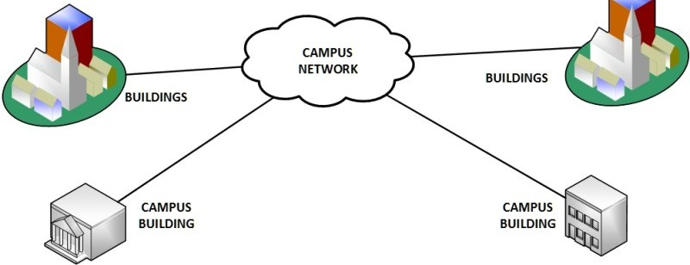

**Advantages of CAN: Economical:**Image 19: CAN

Reference: <https://www.networkstraining.com/different-types-of-networks/>

CAN is economical in the sense that it uses fewer cables, switches, hubs and routers. Sharing of data is easy:

*/*

In CAN, the message is sent one time and is transferred to all the linked departments easily.

**Use a wireless connection:**

CAN use a wireless connection for connecting different departments and buildings across one organization.

**Transferring files is fast:**

In CAN, files are transferred with high speed over the network (internet).

**One ISP across all departments:**

In CAN, the internet is used from the same ISP (Internet Service Provider).

**Disadvantages of CAN:**

* Limitation for connecting nodes:
* The connection between nodes (computers) is limited in size i.e. you cannot connect a large number of nodes together in CAN. And also CAN have a maximum length of 40 meters.

*/*

* Maintenance is expensive:
* Troubleshooting and maintenance of CAN are expensive as compared to other networks.

**SAN(Storage Area Network)**

* A Storage Area Network (SAN) is a specialized, high-speed network that provides block-level network access to storage.
* Connects servers to data storage devices via fiber-optic cables.
* SANs are typically composed of hosts,switches, storage elements, and storage devices that are interconnected using a variety of technologies, topologies, and protocols.

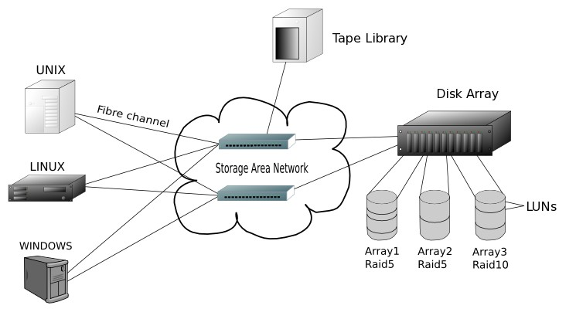Example: Used for daily backup of organization or a mirror copy

Image 20: SAN

Reference: <https://www.networkstraining.com/different-types-of-networks/>

**Advantages of Storage Area Networks**

The different advantages of storage area networks are:

* The storage devices are independent of the system and their data is accessed using the storage area network. So the storage devices can be increased and decreased as required.
* The storage is removed from the purview of the system and moved and moved onto a separate network. This leads to a better performance overall as the data is not affected by local traffic or bottlenecks.
* The storage data is very secure on the storage area network and cannot be copied or stolen by anyone else.
* There can be a remote copy of the storage data kept separately using the storage area network. This can be useful if there is a primary data failure or natural disaster.

**Disadvantages of Storage Area Networks**

*/*

The different disadvantages of storage area networks are:

* If there is a lot of traffic in the storage area network, then operations will be extremely slow. So it is better not to use storage area networks for data extensive applications.
* The storage area network operates in a shared environment. So there is a change that data may be leaked for sensitive operations.

**SHAN(Smart Home Area Network)**

A home area network (HAN) is a network contained within a user's home that connects a person's digital devices,from multiple computers and their peripheral devices to telephones, VCRs,televisions, video games, home security,systems, smart appliances, fax machines and other digital devices that are wired into the network.

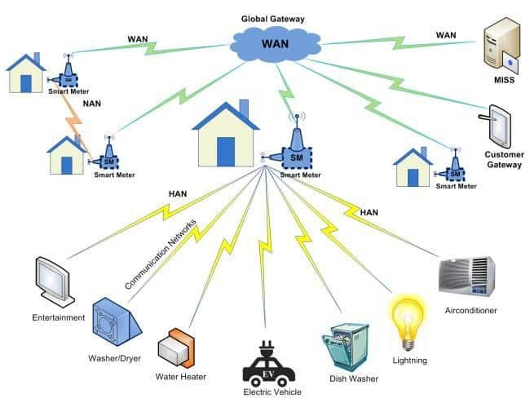The SHAN network is generally used in homes and office space.

Image 21: SHAN Reference:<https://networkencyclopedia.com/home-area-network-han/>

**Advantages of SHAN Accessibility:**

This is a better way which gives the better accessibility for all the devices in the network for accessing Internet connection.

**Management:**

The resources on this network can be managed and controlled by this easy manner and data usage also can be managed.

*/*

**Security:**

It enhances the home network security and reliability.Internet network also password protected.It can support MAC Address filtering.So Internet can be accessed by authorised peoples only.

**Resources sharing:**

Resources on the network can be shared over the network. such as files,folders,printers,faxes etc..

**Multi User:**

Multiple users can access the network resources such as the Internet,shared devices,files etc simultaneously.

**Life Style:**

It makes the quality of life and home with digital communication by its style.

**Disadvantages of SHAN Lack of Wifi Password:**

If the wifi password is easily guessed by others then anybody within the range can steal Internet access and resources on the network.

**Wifi-Microwaves:**

Wireless devices use the microwave as a medium for communication.This microwave signals will specially affect brains.It is not good for health.

**Expensive:**

The devices which are used for communication should be capable of accessing the Internet which is expensive.etc...smart TV,laptops,smart phones...

**Internet slow:**

When multiple people access the Internet with the same share point then Internet speed will be shared to all users with equivalent speed.If one person is downloading a large file from the Internet then it will slow down the speed for all other uses.

## PAN(Personal Area Network)

* Personal Area Network is a network arranged within an individual person,typically within a range of 10 meters.
* Personal Area Network is used for connecting the computer devices of personal use is known as Personal AreaNetwork.
* Personal computer devices that are used to develop the personal area network are the laptop, mobile phones,media player and play stations.
* Personal Area Network covers an area of 30 feet.

*/*

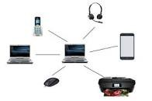

Image 22: PAN

Reference: <https://www.javatpoint.com/types-of-computer-network>

There are two types of Personal Area Network: Computer Network Types

* Wired Personal Area Network
* Wireless Personal Area Network

**Wireless Personal Area Network:**

Wireless Personal Area Network is developed by simply using wireless technologies such as WiFi, Bluetooth. It is a low range network.

**Wired Personal Area Network:**

Wired Personal Area Network is created by using the USB.

**Advantages of personal area network:**

* As PANs are for personal use, so benefits are more easily understandable than LAN,WAN,MAN.
* In PAN no extra space is required.
* No need for extra cable and wire.
* Easy to connect to many devices at a time.
* Affordable Cost.
* PAN is easy to use.
* It is very reliable.
* This Network is fully Secure.
* We can use it in office meetings.
* It is used in TV remotes, AC remotes etc.
* Data can Synchronize between different devices.
* Portable

*/*

**Disadvantages of personal area network:**

* Its range is less.
* Its interference is with radio signals.
* Transfer of data is slow.
* It creates Health problems.
* Cost is high in terms of communication devices.
* Infrared signals travel only in a straight line

# Internet and Intranet etc.

## Internet

The Internet is a global network of millions of private, public, academic, business, and government networks worldwide connected with each other over the network to share massive amounts of information, resources and services.

* It is a public network therefore anyone can access the internet.
* The Internet consists of a network of computers that anyone can access.
* Many intranets together make up the internet.
* There is no limit to the number of users who can use the internet at any given time
* The information available on the internet is gathered from different sources. Anyone can easily access any data on the internet.

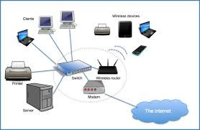

Image 23:Internet Reference:<https://www.shutterstock.com/search/intranet>

**Advantages:**

* huge amounts of information can be accessed almost anywhere
* can help with disabilities to be more independent
* improved communication

**Disadvantages:**

* increased problems due to hacking and viruses
* pedophiles look at the children on the internet
* addiction to gambling.

## Intranet

The term "Intranet" basically stands for the network of a specific organization or the private network of an organization. It may be used for organizations or networks that do not want their information to be able to be accessed by outside sources, and is especially important for organizations that require a high amount of secrecy - such as a server that holds military secrets or a database for the CIA. It has a firewall surrounding the system to avoid the unauthorized user from accessing the network. Only authorized users have permission to access the network.

* It is a private network therefore anyone can’t access intranet.
* An intranet is a smaller network of computers that allows access to a particular group of users.
* One can access the intranet from the internet. However, there are restrictions on the number of users.
* Only a specific few users can access the intranet.
* There are limitations on the volume of traffic at any given time.
* Intranet contains a specific kind of information only.

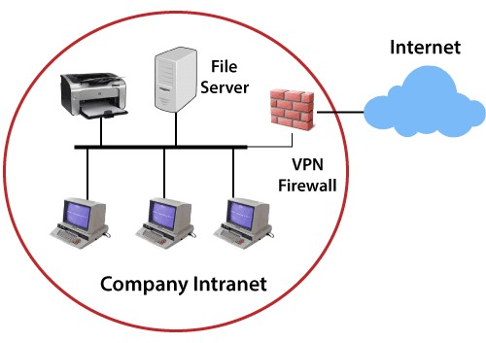

Image 24: Intranet Reference: <https://www.javatpoint.com/intranet>

**Advantages:**

* ideal for school because they can be used to prevent students from accessing unsafe websites the email system is more secure
* only information relevant to the organisation can be accessed- saves time

**Disadvantages:**

* less information
* can't go on websites needed

## Difference between Internet and Intranet

**Internet**

* The Internet is a wide network of computers and is open for all.
* The Internet itself contains a large number of intranets.
* The number of users who use the internet is Unlimited.
* The Visitors traffic is unlimited.
* The Internet contains different sources of information and is available for all.

**Intranet**

* Intranet is also a network of computers designed for a specific group of users.
* Intranet can be accessed from the Internet but with restrictions.
* The number of users is limited.
* The traffic allowed is also limited.
* Intranet contains only specific group information.

Therefore the Internet is an open, public space, while an intranet is designed to be a private space. An intranet may be accessible from the Internet, but it is protected by a password and accessible only to authorized users.

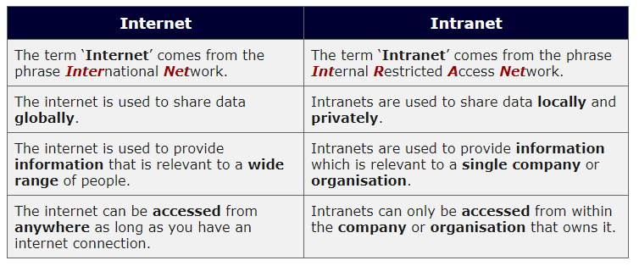

Image 25:Difference between Internet and Intranet Reference:<https://techdifferences.com/difference-between-internet-and-intranet.html>

## Extranet

An extranet is a private network that only authorized users can access. These authorized users may include business partners, suppliers, and even some customers. They can use the extranet to exchange information with each other without having to enter the host company’s main network. An extranet is like a secure file room located somewhere off the company premises. Only those issued a key can enter and browse through the filing cabinets.

* An extranet is a communication network based on the internet protocol such as Transmission Control protocol and internet protocol.
* It is used for information sharing.
* The access to the extranet is restricted to only those users who have login credentials.

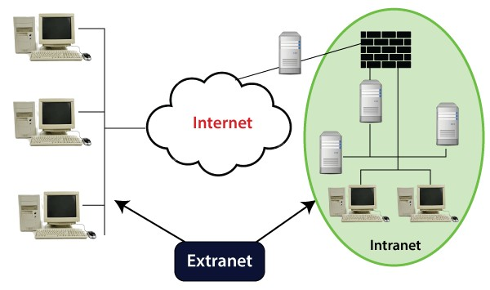

Image 26:Extranet

Reference: <https://invidgroup.com/what-is-an-extranet/>

**Advantages:**

* Communicate and collaborate more effectively with their stakeholders and clients via a secure network.

*/*

* Integrate supply chains like consolidated processes.
* Reduce costs by making relevant documentation like manuals available online to all the relevant parties.
* Improve their business relationships through the collaboration within the extranet.
* Simplify their internal processes by using a single interface.
* Secure company communication in a controlled environment.

*/*

* Work flexibly as the extranet allows people to work remotely and be more mobile. More so, people are given 24/7 access to the core business information irrespective of their location.

**Disadvantages of an Extranet**

* If hosted internally instead of via an active server page, the implementation of an extranet within an organization tends to be quite expensive.
* Extranets can reduce personal contact (face-to-face meetings) with customers and business partners. This could cause a lack of connections made between people and a company, which hurts the business when it comes to the loyalty of its business partners and customers.
* The security of extranets can be a big concern because it deals with valuable information. Systems, therefore, need to be carefully controlled in order to avoid hacks or misuse of data.

## Uses and benefits of Network

**Networking benefits**

The benefits of networking on computers and other devices include low costs and higher productivity. Thanks to networks, resources can be shared, which reduces data duplication and corruption.

**Fewer peripherals are needed**.

Every computer on the network does not need its printer, scanner, or backup device. It is possible to configure several printers in a central location and share them among network users. All network users send print jobs to a central print server that manages print requests. The print server can distribute print jobs among the various printers, or it can queue jobs that require a particular printer.

**Greater communication capabilities**

Networks offer various collaboration tools that can be used to establish communications between network users. Online collaboration tools include email, forums and chat, voice and video, and instant messaging. With these tools, users can communicate with friends,family, and colleagues.

**Duplication and file corruption are avoided**

A server manages network resources. The servers store the data and share it with the users of a network. Confidential or essential data can be protected and shared with users who have permission to access such data. Document tracking software can be used to prevent users from overwriting or modifying files that other users are accessing at the same time.

**Lower cost in license acquisition**

Acquiring application licenses can be expensive for individual computers. Many software providers offer site licenses for networks, which can significantly reduce the cost of the software. The site license allows a group of people or an entire organization to usethe application for a single fee.

**Centralized administration**

Centralized administration reduces the number of people needed to manage devices and data on the network, allowing the company to save time and money.

*/*

Individual users of the network do not need to manage their data and devices. An administrator can control the data, devices, and permissions of network users. Creating backup copies of the data is more comfortable because of the data stored in a central location.

**Resources are conserved**

It is possible to distribute data processing among many computers to prevent a computer from being overloaded with processing tasks.

**Uses of Networking**

**Information and Resource Sharing** − Computer networks allow organizations having units which are placed apart from each other, to share information in a very effective manner. Programs and software in any computer can be accessed by other computers linked to the network. It also allows sharing of hardware equipment, like printers and scanners among varied users.

**Retrieving Remote Information** − Through computer networks, users can retrieve remote information on a variety of topics. The information is stored in remote databases to which the user gains access through information systems like the World Wide Web.

**Speedy Interpersonal Communication** − Computer networks have increased the speed and volume of communication like never before. Electronic Mail (email) is extensively used for sending texts, documents, images, and videos across the globe. Online communications have increased by manifold times through social networking services.

**eCommerce** − Computer networks have paved the way for a variety of business and commercial transactions online, popularly called e-commerce. Users and organizations can pool funds, buy or sell items, pay bills, manage bank accounts, pay taxes, transfer funds and handle investments electronically.

**Highly Reliable Systems** − Computer networks allow systems to be distributed in nature, by the virtue of which data is stored in multiple sources. This makes the system highly reliable. If a failure occurs in one source, then the system will still continue to function and data will still be available from the other sources.

**Cost–Effective Systems** − Computer networks have reduced the cost of establishment of computer systems in organizations. Previously, it was imperative for organizations to set up expensive mainframes for computation and storage. With the advent of networks, it is sufficient to set up interconnected personal computers (PCs) for the same purpose.

*/*

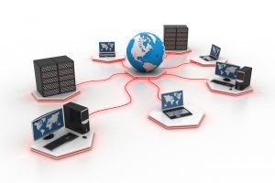VoIP − VoIP or Voice over Internet protocol has revolutionized telecommunication systems. Through this, telephone calls are made digitally using Internet Protocols instead of the regular analog phone lines.

Image 27:Uses of Computer Network

Reference: <https://www.ccsipro.com/blog/uses-of-computer-network/>

Server-client based network

*/*

* + - A Computer networking model where one or more powerful computers (servers) provide the different computer network services and all other users of the computer network (clients) access those services to perform the user's tasks is known as client/server computer networking model.
    - In such networks, there exists a central controller called server. A server is a specialized computer that controls the network resources and provides services to other computers in the network.
    - All other computers in the network are called clients. A client computer receives the requested services from a server.
    - A server performs all the major operations like security and network management.
    - All the clients communicate with each other via centralized server
    - If client 1 wants to send data to client 2, it first sends a request to the server to seek permission for it. The server then sends a signal to client 1 allowing it to initiate the communication.
    - A server is also responsible for managing all the network resources such as files, directories, applications & shared devices like printers etc.
    - If any of the clients wants to access these services, it first seeks permission from the server by sending a request.
    - 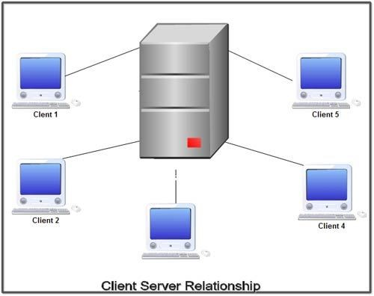Most Local Area Networks are based on client server relationships.

Image 28: Client-server Relationship

Reference: <http://ecomputernotes.com/computernetworkingnotes/computer-network/explain-clientserver-networking-model>

*/*

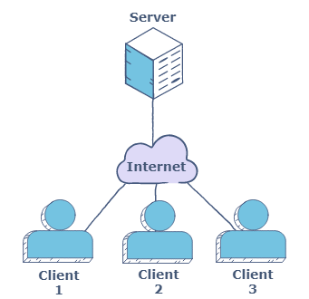The design of applications for a distributed computing environment required that they effectively be divided into two parts: client (front end) and server (back end). The network model on which they were implemented mirrored this client-server model with a user's PC (the client) typically acting as the requesting machine and a more powerful server machine to which it was connected via either a LAN or a WAN acting as the supplying machine. It requires a special networking operating system. It provides user level security and it is more expensive.

Image 29: Client-server Network Model

Reference: <https://www.educative.io/edpresso/what-are-p2p-and-clientserver-networks>

## Advantages of Client-Server Architecture

Organizations often seek opportunities to maintain services and quality competition to sustain its market position with the help of technologies. Deployment of client-server computing in an organization will effectively increase its productivity through the usage of cost-effective user interface, enhanced data storage, vast connectivity and reliable application services

**Improved Data Sharing:**

Data is retained by usual business processes and manipulated on a server is available for designated users (clients) over an authorized access.

**Integration of Services:**

Every client is given the opportunity to access corporate information via desktop interface eliminating the necessity to log into a terminal mode or processor.

**Shared Resources Amongst Different Platforms:**

Application used for client-server model is built regardless of the hardware platform or technical background of the entitled software (operating system software) providing an open computing environment, enforcing users to obtain the services of clients and servers (database, application and communication services)

**Data Processing Capability Despite the Location:**

*/*

Client-server users can directly log into a system despite the location or technology of the processors.

**Easy Maintenance:**

Client-server architecture is a distributed model representing dispersed responsibilities among independent computers integrated across a network. Therefore, it's easy to replace, repair, upgrade and relocate a server while the client remains unaffected. This unaware change is called Encapsulation.

**Security:**

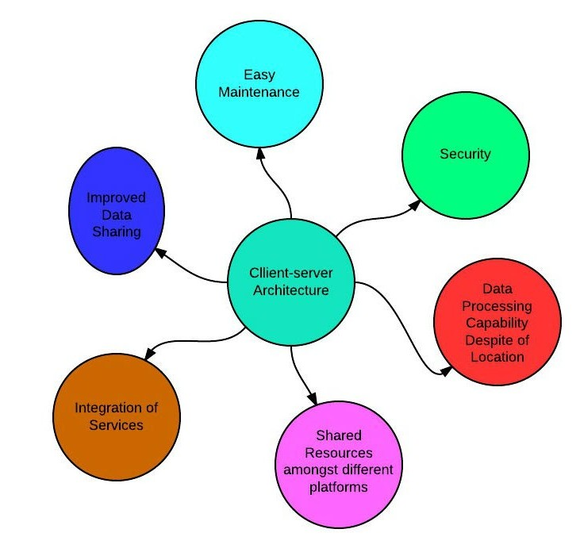Servers have better control access and resources to ensure that only authorized clients can access or manipulate data and server updates are administered effectively.

Image 30: Advantages of Client-Server Reference:<https://sites.google.com/site/clientserverarchitecture/advantages-of-client-server-architecture>

## Disadvantages of Client-Server Architecture

**Overloaded Servers:**

When there are frequent simultaneous client requests, servers severely get overloaded, forming traffic congestion.

**Impact of Centralized Architecture:**

Since it is centralized, if a critical server fails, client requests are not accomplished. Therefore, client-servers lacks the robustness of a good network.

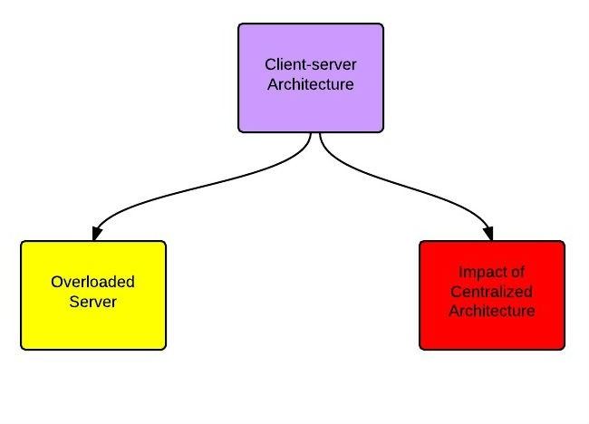

Image 31: Disadvantages of Client-Server Reference:<https://sites.google.com/site/clientserverarchitecture/advantages-of-client-server-architecture>

*/*

## Peer to peer networks

* + - In the peer to peer computer network model we simply use the same Workgroup for all the computers and a unique name for each computer in a computer network.
    - There is no master or controller or central server in this computer network and computers join hands to share files, printers and Internet access.
    - It is practical for workgroups of a dozen or less computers making it common environments, where each PC acts as an independent workstation and maintains its own security that stores data on its own disk but which can share it with all other PCs on the network.
    - Software for peer-to-peer network is included with most modern desktop operating systems such as Windows and Mac OS.
    - Peer to peer relationship is suitable for small networks having less than 10 computers on a single LAN.
    - 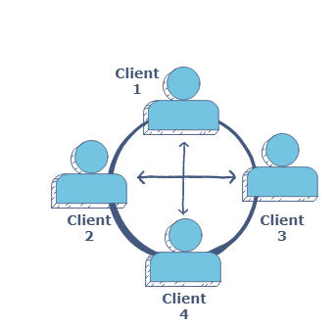In a peer to peer network each computer can not act as both a server and a client.

Image 32:Peer-to-Peer Reference:<https://sites.google.com/site/clientserverarchitecture/advantages-of-client-server-architecture>

*/*

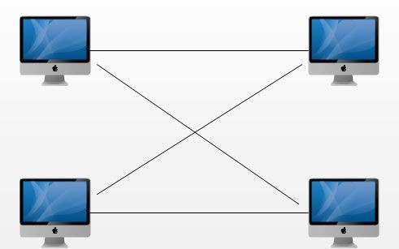

Image 33: Workgroup Reference:<http://ecomputernotes.com/computernetworkingnotes/computer-network/explain-peer-to-peer-networking-model>

## Advantages of Peer to Peer Networks

1. Such networks are easy to set up and maintain as each computer manages itself.
2. It eliminates extra cost required in setting up the server.
3. Since each device is master of its own, they an: not dependent on other computers for their operations.

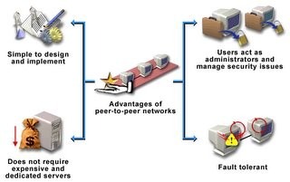

Image 34: Advantages of Peer to peer Network

Reference: <http://mdalikhoja.blogspot.com/2006/04/advantages-of-peer-to-peer-networks.html>

**Disadvantages of Peer-to-Peer Networks**

1. In a peer-to-peer network, the absence of a centralized server makes it difficult to backup data as data is located on different workstations.
2. Security is weak as each system manages itself only.
3. 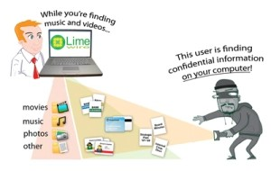There is no central point of data storage for file archiving.

Image 35: Disadvantages of Peer to peer Network Reference:<https://eternalsunshineoftheismind.wordpress.com/2013/02/18/advantages-and-disadvantages-of-p2p/>

## Difference between Client-server and Peer to Peer Networks

Both peer-to-peer and client-server networks connect computers so that they can share resources from one computer to others such as files, videos, and pictures.

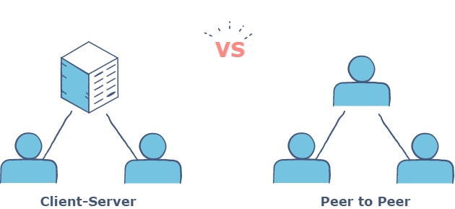

Image 36:Client-server and Peer to Peer Networks Reference:<https://www.educative.io/edpresso/what-are-p2p-and-clientserver-networks>

*/*

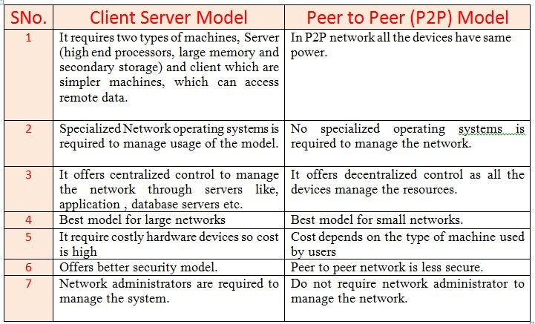

Image 37: Difference between Client-server and Peer to Peer Networks Reference: <http://mynetgyan.com/chapter/8/38>

# Network Interface Card

## What is a Network Interface Card?

Network Interface Card is a hardware device that is installed on the computer so that it can be connected to the internet. It is also called Ethernet Card or Network Adapter. Every NIC has a 48-bit unique serial number called a MAC address which is stored in ROM carried on the card. Every computer must have at least one NIC if it wants to connect to the internet.

**Purpose**

* + - NIC allows both wired and wireless communications.
    - NIC allows communications between computers connected via local area network (LAN) as well as communications over large-scale network through Internet Protocol (IP).
    - NIC is both a physical layer and a data link layer device, i.e. it provides the necessary hardware circuitry so that the physical layer processes and some data link layer processes can run on it.

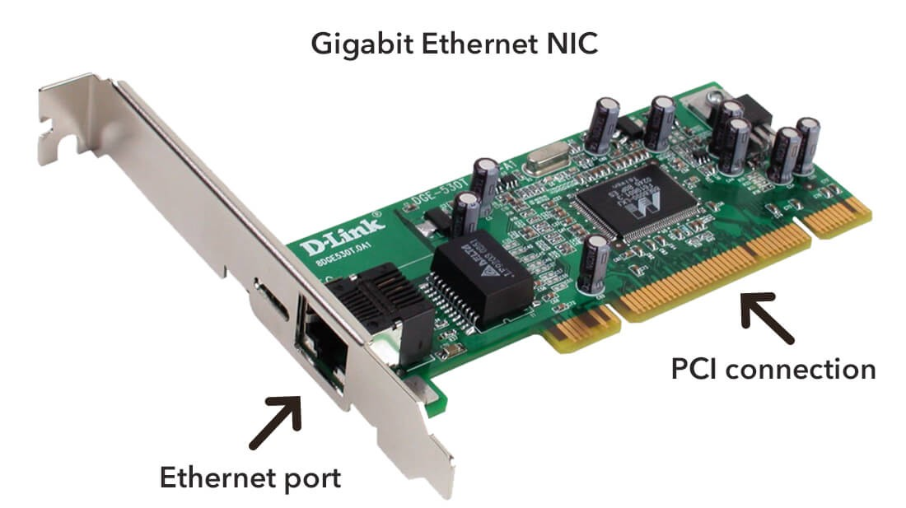

Image 38: NIC

Reference: [h](https://www.tutorialspoint.com/computer_fundamentals/computer_networking.htm)[ttps://techterms.com/definition/nic](https://techterms.com/definition/nic)

## Components of NIC

The main components of the Network Interface Card are as follows

* + - An external Memory is used to store the data temporarily and uses the stored data whenever required while processing the communication.

*/*

* + - Connectors are used to make the physical link between cables and plugin with the board, this type of connection is especially seen in Ethernet type of NIC cables.
    - A Processor converts the data message into a signal format for communication to take place easily.
    - Different types of standard Buses are plugged into Buses Connector slots, based on the compatibility of the operation process buses are chosen.
    - Jumpers or Dual in package switches are used to control the communication operation, which is either by turning on or turning off the switch.
    - MAC address which is a unique identity address is given to network interface cards where ethernet packets are communicated with the computer. MAC address is also known as a physical network address.
    - 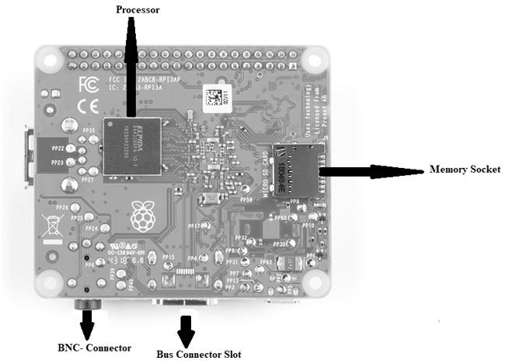A router is an NIC device that is used to connect wirelessly to the internet.

Image391:Components of NIC

Reference: <https://www.elprocus.com/network-interface-card-nic/>

## Types of NIC Cards

* + - Wired
    - Wireless
    - USB

*/*

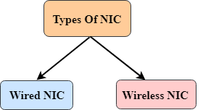

Image 40: Types of NIC Reference:<https://www.javatpoint.com/computer-network-components>

### Wired:

These NIC have input jacks made of cables(Ethernet Cable). The motherboard has a slot for the network cards where they are inserted. The most widely used LAN technology is Ethernet. Ethernet-based NIC is available in hardware shops. The speed of Ethernet-based NIC can be 10/100/1000 Mbps.

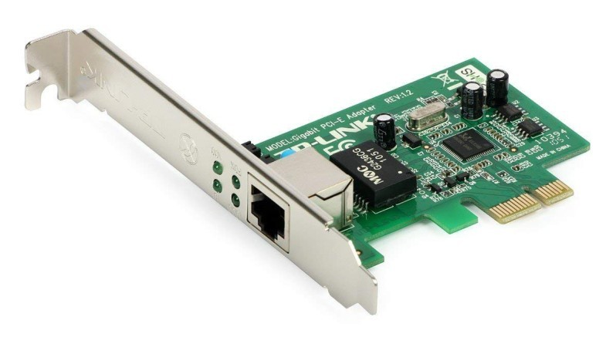Example: TP-LINK TG-3468 Gigabit PCI Express Network Adapter

Image 41: Wired

Reference: <https://afteracademy.com/blog/what-is-a-network-interface-card>

### Wireless:

Wireless network cards are inserted into the motherboard but no network cables are required to connect the computer to the internet. These NICs are designed for Wi-Fi connections.

Example: Intel 3160 Dual-Band Wireless Adapter

*/*

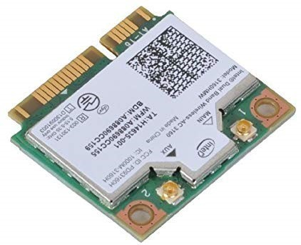

Image 42: Wireless

Reference: <https://afteracademy.com/blog/what-is-a-network-interface-card>

### USB:

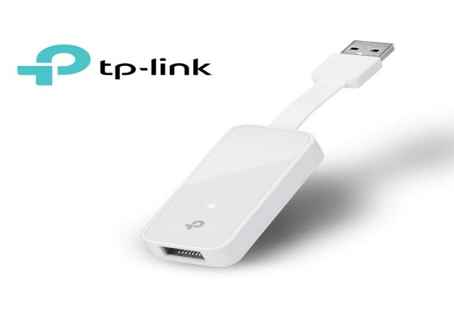These are NICs that provide network connection over the device plugged in the USB port. For Example, if you are a gamer and you are tired of watching helplessly that your gaming character dies due to Wi-Fi-induced lags. So the USB-ethernet adapter can be a solution to your problem. Example: TP-Link TL-UE300 USB 3.0 to RJ45 Gigabit Ethernet Network Adapter

Image 43: USB

Reference: <https://afteracademy.com/blog/what-is-a-network-interface-card>

## Advantages of NIC

* + - The communication speed using the Internet is high usually in Gigabytes
    - Highly reliable connection
    - Many peripheral devices can be connected using many ports of NIC cards.
    - Bulk data can be shared among many users.

## Disadvantages of NIC

* + - Inconvenient in case of wired cable NIC, as it is not portable like a wireless router
* The configuration should be proper for better communication.
* Data is unsecured.

*/*

# Transmission Media and Topologies Media Type

## What is Transmission Media?

A communication channel that is used to carry the data from the transmitter to the receiver through the electromagnetic signals.

The main function of this is to carry the data in the bits form through the Local Area Network (LAN). In data communication, it works like a physical path between the sender & the receiver.

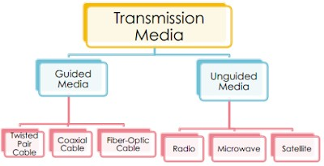

Image 44: Transmission Media Reference:<https://mangoguys.wordpress.com/2013/12/03/wireless-transmission-media/>

## Types of transmission media

1. Physical transmission media/Guided media/Wired
   * Twisted-Pair Cable,Coaxial Cable,Fiber-Optic Cable
2. Wireless transmission media/Unguided media/Wireless
   * Infrared,Broadcast Radio,Cellular Radio,Microwave, communications satellite

**Bounded or Guided Media Coaxial Cables:**

These are made up of copper. A plastic layer provides insulation between the copper wire and metal shield. Metal shield helps to block any outside interference.

*/*

* Transmission rate is 10 Megabits per second (Mbps).
* It is less expensive than Fiber Optic.
* Mostly used for long distance transmission.
* Provide high quality data transmission without distortion or loss of signal.
* It can be classified in two categories

**UTP (Unshielded Twisted Pair Cable)**

* It has a maximum range of 100 meters (328 feet).
* It consists of 2 or 4 twisted wire pairs.
* Widely used in LANs.

**STP(Shielded Twisted Pair Cable)**

* Same as UTP but it is covered with a shield for resistance.
* It is more reliable and faster than UTP.
* It covers a long distance.
* Normally used as a back bone cable.

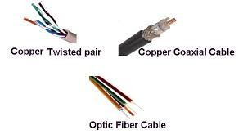

Image 45: Guided media

Reference: <http://computernetworkingsimplified.in/physical-layer/overview-guided-unguided-media/>

**Unbounded or Unguided Media Infrared:**

* Infrared signals can be used for short range communication in a closed area
* using line-of-sight propagation.

**Microwaves:**

* Microwaves are used for unicast communication such as cellular
* telephones, satellite networks, and wireless LANs.

*/*

* Higher frequency ranges cannot penetrate walls.
* Use directional antennas - point to point line of sight communications.

●

**Radio Waves:**

* Radio waves are used for multicast communications, such as radio and
* television, and paging systems. They can penetrate through walls.
* Highly regulated. Use omni directional antennas

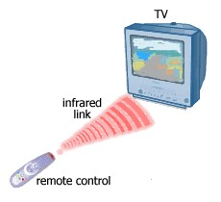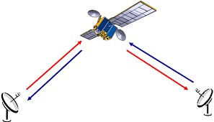

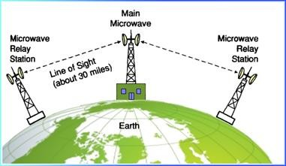

Image 46:Unguided media

Reference: <http://www.datacom2u.com/ENWirelessMedia.php>

# Crimping tools and Color standards for Straight crimping and Cross crimping

*/*

## Crimping Tools

A crimping tool is a device used to conjoin two pieces of metal by deforming one or both of them in a way that causes them to hold each other. The result of the tool's work is called a crimp.

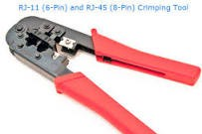

Image 47: Crimping Tool Reference:<https://www.computerhope.com/jargon/c/crimp.htm>

**Ethernet Cable Color**

* A straight-thru is used as a patch cord in Ethernet connections.
* A crossover is used to connect two Ethernet devices without a hub or for connecting two hubs.
* A crossover has one end with the Orange set of wires switched with the Green set.

*/*

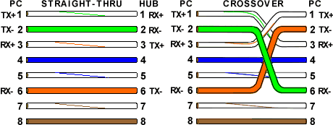

Image 48: Cable Color

Reference: <https://incentre.net/ethernet-cable-color-coding-diagram/>

**Ethernet Cable Color Coding Diagram for:**

Category-5 cables Category-5E cables Category-6 cables Category-6E cables

The information listed here is to assist network administrators in the color coding of Ethernet cables. Please be aware that modifying Ethernet cables improperly may cause loss of network connectivity. Use this information at your own risk, and ensure all connectors and cables are modified in accordance with standards. The Internet Centre and its affiliates cannot be held liable for the use of this information in whole or in part.

**T-568A Straight-Through Ethernet Cable**

STRAIGHT THROUGH Ethernet cables are the standard cable used for almost all purposes, and are often called "patch cables". It is highly recommended you duplicate the color order as shown on the left. Note how the green pair is not side-by-side as are all the other pairs. This configuration allows for longer wire runs.

*/*

**T-568A Straight-Through Ethernet Cable**

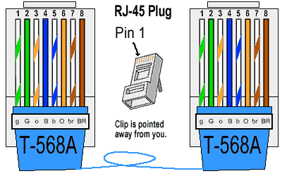

Image 49: T-568A Straight-through Cable

Reference: <https://incentre.net/ethernet-cable-color-coding-diagram/>

The TIA/EIA 568-A standard which was ratified in 1995, was replaced by the TIA/EIA 568-B standard in 2002 and has been updated since. Both standards define the T-568A and T-568B pin-outs for using Unshielded Twisted Pair cable and RJ-45 connectors for Ethernet connectivity. The standards and pin-out specification appear to be related and interchangeable, but are not the same and should not be used interchangeably.

1. **8B Straight-Through Ethernet Cable**

**T-568B Straight-Through Ethernet Cable**

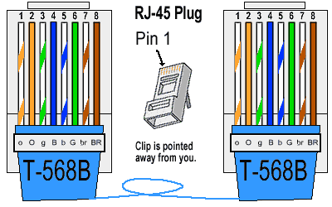

Image 50: T-568B Straight-through Cable

Reference: <https://incentre.net/ethernet-cable-color-coding-diagram/>

Both the T-568A and the T-568B standard Straight-Through cables are used most often as patch cords for your Ethernet connections. If you require a cable to connect two Ethernet devices

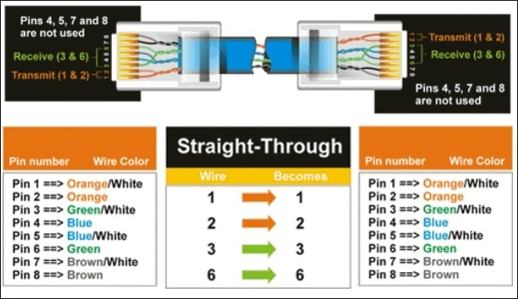directly together without a hub or when you connect two hubs together, you will need to use a Crossover cable instead.

*/*

Image 51: Straight Through cable Color

Reference: <https://www.networkkings.org/color-coding-of-straight-and-crossover-cable/>

**RJ-45 Crossover Ethernet Cable**

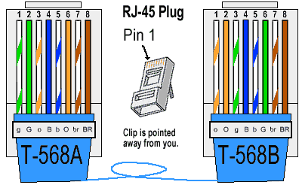CROSSOVER CABLES - The purpose of a Crossover Ethernet cable is to directly connect one computer to another computer (or device) without going through a router, switch or hub.

Image 52: RJ-45 crossover cable Reference:<https://www.networkkings.org/color-coding-of-straight-and-crossover-cable/>

*/*

A good way of remembering how to wire a Crossover Ethernet cable is to wire one end using the T-568A standard and the other end using the T-568B standard. Another way of remembering the color coding is to simply switch the Green set of wires in place with the Orange set of wires. Specifically, switch the solid Green (G) with the solid Orange, and switch the green/white with the orange/white.

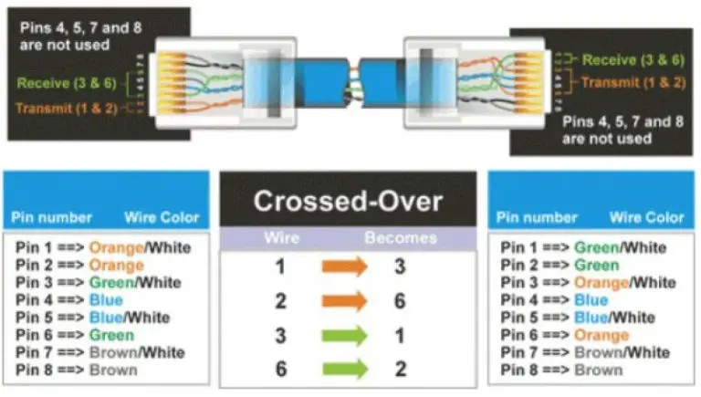

Image 53: RJ-45 crossover cable Color Reference:<https://www.networkkings.org/color-coding-of-straight-and-crossover-cable/>

## Ethernet Cable Instructions

* + Pull the cable off the reel to the desired length and cut. If you are pulling cables through holes, it's easier to attach the RJ-45 plugs after the cable is pulled. The total length of wire segments between a PC and a hub or between two PC’s cannot exceed 100 Meters (328 feet) for 100BASE-TX and 300 Meters for 10BASE-T.
  + Start on one end and strip the cable jacket off (about 1″) using a stripper or a knife. Be extra careful not to nick the wires, otherwise you will need to start over.
  + Spread, untwist the pairs, and arrange the wires in the order of the desired cable end. Flatten the end between your thumb and forefinger. Trim the ends of the wires so they are even with one another, leaving only 1/2″ in wire length. If it is longer than 1/2″ it will be out-of-spec and susceptible to crosstalk. Flatten and insure there are no spaces between wires.
  + Hold the RJ-45 plug with the clip facing down or away from you. Push the wires firmly into the plug. Inspect each wire is flat even at the front of the plug. Check the order of the wires. Double check again. Check that the jacket is fitted right against the stop of the plug. Carefully hold the wire and firmly crimp the RJ-45 with the crimper.

*/*

* Check the color orientation, check that the crimped connection is not about to come apart, and check to see if the wires are flat against the front of the plug. If even one of these are incorrect, you will have to start over. Test the Ethernet cable.

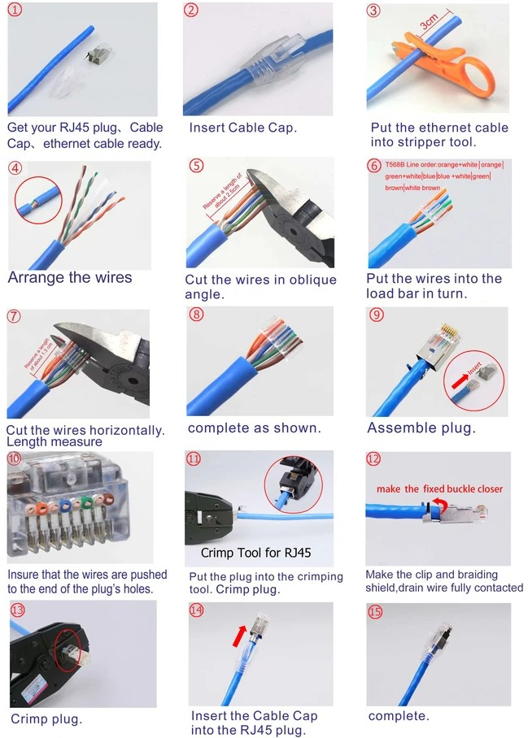

Learning Outcome

Transmission Media and Topologies Media types

# Concept of Server, client.

## Client-Server Definition

Client-server denotes a relationship between cooperating programs in an application, composed of clients initiating requests for services and servers providing that function or service.

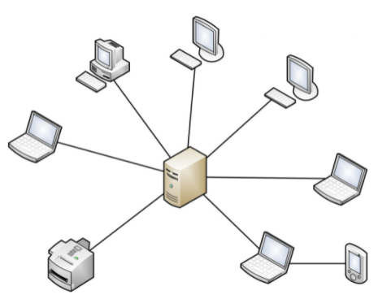

Image 1: Client-Server network

Reference: <https://www.omnisci.com/technical-glossary/client-server>

## What is the Client-Server Model?

The client-server model, or client-server architecture, is a distributed application framework dividing tasks between servers and clients, which either reside in the same system or communicate through a computer network or the Internet. The client relies on sending a request to another program in order to access a service made available by a server. The server runs one or more programs that share resources with and distribute work among clients.

The client server relationship communicates in a request–response messaging pattern and must adhere to a common communications protocol, which formally defines the rules, language, and dialog patterns to be used. Client-server communication typically adheres to the TCP/IP protocol suite.

## Categories of Client-Server Computing

There are four main categories of client-server computing:

* *One-Tier architecture:* consists of a simple program running on a single computer without requiring access to the network. User requests don’t manage any network protocols, therefore the code is simple and the network is relieved of the extra traffic.
* *Two-Tier architecture:* consists of the client, the server, and the protocol that links the two tiers. The Graphical User Interface code resides on the client host and the domain logic resides on the server host. The client-server GUI is written in high-level languages such as C++ and Java.
* *Three-Tier architecture:* consists of a presentation tier, which is the User Interface layer, the application tier, which is the service layer that performs detailed processing, and the data tier, which consists of a database server that stores information.
* *N-Tier architecture:* divides an application into logical layers, which separate responsibilities and manage dependencies, and physical tiers, which run on separate machines, improve scalability, and add latency from the additional network communication. N-Tier architecture can be closed-layer, in which a layer can only communicate with the next layer down, or open-layer, in which a layer can communicate with any layers below it.

## Difference Between Client and Server

Clients, also known as service requesters, are pieces of computer hardware or server software that request resources and services made available by a server. Client computing is classified as Thick, Thin, or Hybrid.

* *Thick Client:* a client that provides rich functionality, performs the majority of data processing itself, and relies very lightly upon the server.
* *Thin Client:* a thin-client server is a lightweight computer that relies heavily on the resources of the host computer -- an application server performs the majority of any required data processing.
* *Hybrid Client:* possessing a combination of thin client and thick client characteristics, a hybrid client relies on the server to store persistent data, but is capable of local processing.

A server is a device or computer program that provides functionality for other devices or programs. Any computerized process that can be used or called upon by a client to share resources and distribute work is a server. Some common examples of servers include:

* *Application Server:* hosts web applications that users in the network can use without needing their own copy.
* *Computing Server:* shares an enormous amount of computer resources with networked computers that require more CPU power and RAM than is typically available for a personal computer.
* *Database Server:* maintains and shares databases for any computer program that ingests well-organized data, such as accounting software and spreadsheets.‍
* *Web Server:* hosts web pages and facilitates the existence of the World Wide Web.‍

## Difference Between Server-Side Programming and Client-Side Programming

Server-side programming refers to a program that runs on the server and focuses on the generation of dynamic content. Server-side programming is used for querying and interacting with the database, accessing files on a server, interacting with other servers, processing user input, and structuring web applications. Popular programming languages for server-side programming include C++, Java and JSP, PHP, Python, and Ruby on Rails.

Client-side programming refers to a program that runs on the client machine and focuses on the user interface and other processes such as reading and/or writing cookies. Client-side programming is used for sending requests to the server, interacting with local storage, interacting with temporary storage, creating interactive web pages, and functions as an interface between client and server. Popular programming languages for client-server programming include AJAX, CSS, HTML, Javascript, and VBScript.

## Client-Server vs Peer-to-Peer

Peer-to-peer (P2P) is a decentralized communications model in which all nodes in the network have equivalent capability and can function as both a client and server. Nodes in peer-to-peer computing collectively use their resources and communicate with each other directly on-demand.

An algorithm in the peer-to-peer communications protocol balances load, making other peers available to compensate for any resource downtime, and rerouting requests as the load capacity and availability of peers changes. A major advantage of peer-to-peer networking is the ability to expand the network to manage a large number of clients.

In client-server computing, a centralized communications model, the server is the central node that communicates with other client nodes. A major advantage that the client-server relationship has over the peer-to-peer relationship is the ability to manage data and applications in one, centralized server.

**Node**

## What is a computer network and where do network nodes fit in?

A computer network is a system of computers and computing devices that are connected via communication links. These links allow the computers and other devices to send information over the network.

A network node is a connection point in a communications network. Each node is an endpoint for data transmissions or redistribution. Nodes have either a programmed or engineered capability to recognize, process and forward transmissions to other network nodes.

The concept of network nodes came into being with the use of distributed networks and packet switching. Depending on the application, network nodes perform a variety of functions.

## What does a network node do?

A network node sits at a point in the network where it sends, receives, stores or creates information. It transmits data to communicate with other nodes in the network.

In a computer network, nodes can be physical networked devices, such as modems, PCs and printers. These devices recognize transmissions from other nodes and forward them to other nodes. A node checks for identification, such as an IP address, to grant access to the node.

Nodes connect over a link or communication channel. In a computer network these may be cable, fiber optic or wireless connections.

## What are the types of network nodes?

There are several ways to categorize nodes. One way is by network type; another is by network topology.

### Network type

**Data communications.** In data communications, physical network nodes include data communications equipment or devices that sit between data terminal equipment (DTE) and data transmission circuits. These include switches, bridges, modems or hubs that perform signal conversion, coding and line clocking. These nodes also include DTE, such as digital telephone handsets, printers, routers, servers and workstations.

**Internet network.** On the internet and with intranets, most physical network nodes are host computers identified by an IP address. However, some data link devices, such as wireless local area network (LAN) access points, do not have IP host addresses. They are considered physical network or LAN nodes rather than internet nodes or hosts.

**LANs and wide area networks.** These nodes are devices that perform a specific function. Each one must have a Media Access Control address for each network interface card. Examples include modems with Ethernet interfaces, wireless LAN access points and computers.

**Telecommunications network.** In fixed telephone networks, nodes may be public or private telephone exchanges or a computer providing an intelligent network service. In cellular communications, nodes include base station controllers that control one or more base stations. Cellular network base stations are not considered nodes.

**Cable system.** In cable systems, nodes use fiber optic cable to connect to businesses and homes served by a common fiber optic receiver within a geographic location. A fiber optic node describes the number of homes or businesses that a specific fiber node can serve.

### Network topologies

Another way to categorize nodes is by how they are arranged in a physical computer network. This is known as the network topology approach. Some common network topologies include these four:

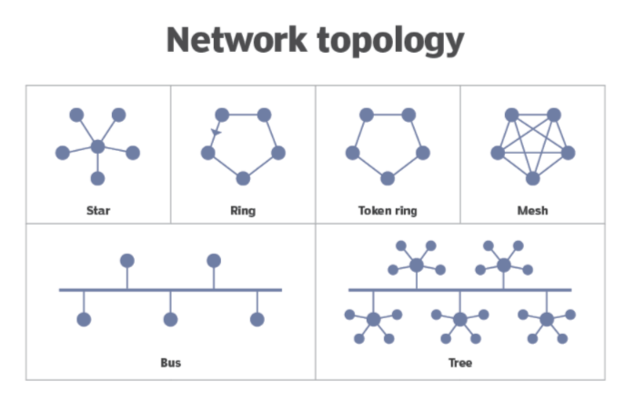

Image 2: Network Topology

Reference: <https://www.techtarget.com/searchnetworking/definition/node#:~:text=A%20network%20node%20sits%20at,as%20modems%2C%20PCs%20and%20printers>.

**Bus topology** connects individual nodes directly to a main cable.

**Ring topology** has nodes connected in a loop or ring; each node has a neighbor on each side.

**Star topology** connects all nodes to a central hub.

**Mesh topology** has every node connected to every other node.

## Segment

A network segment is a portion of a computer network. The nature and extent of a segment depends on the nature of the network and the device or devices used to interconnect end stations.

## Backbone

Backbone is most important part of a system which provides the central support to the rest system, for example backbone of a human body that balance and hold all the body parts. Similarly in Computer Networks a Backbone Network is as a Network containing a high capacity connectivity infrastructure that backbone to the different part of the network.

Actually a backbone network allows multiple LANs to get connected in a backbone network, not a single station is directly connected to the backbone but the stations are part of LAN, and backbone connect those LANs.

## What is web hosting?

Web hosting is an online service that allows you to publish your website files onto the internet. So, anyone who has access to the internet has access to your website. In practice, it usually refers to the service you get from a web hosting provider.

## How does web hosting work?

Once you’ve chosen your domain name and signed up to a hosting plan, then your website is accessible on the internet.

When you use web hosting services, your web host is responsible for making sure your server is up and running. Not only that, but it is also a hosts job to prevent any security breaches and store all your files, assets and databases onto the server.

## What types of web hosting are there?

### Shared Hosting

Shared hosting is when a web hosting provider hosts a number of different websites on the same server. It is the most affordable form of hosting because you share the same server, so you split costs. If you are looking to start a blog or have a business that's just starting up, then shared hosting is a good option.

### WordPress Hosting

WordPress Hosting simply means hosting that has been optimised for WordPress on a server level to ensure smooth sailing.

### VPS Hosting

VPS stands for Virtual Private Server. Like shared hosting, websites that run on VPS share a physical server with other websites. However, each VPS tenant has its own partition with guaranteed dedicated resources. There’s often more memory, storage and processing power available – with a price tag to match.

### Dedicated Hosting

Dedicated hosting means you have the entire server to yourself. It gives you access like a VPS, but you don’t have to share the server with other sites or apps. Effectively, you are leasing a physical web server housed at your service provider’s facility.

### Cloud Hosting

These days, cloud hosting has become a bit of a nebulous term. So, we would strongly recommend looking closely at what you are getting if you are signing up for “Cloud Hosting”.

## How much does website hosting cost?

Your website hosting cost will vary by provider. Technically you can use a free web hosting service.

### Free vs Paid web hosting

By opting for free hosting, you may encounter problems such as unwanted advertising on your page and their domain name in your URL. When you pay for web hosting, you are in full control of what content is on your website.

## Where do domains come into the picture with website hosting?

Let’s think of your website as a house built from individual files. The web hosting is the land the house (website) is on, and the domain is its address. When someone types in the domain name into their web browser or clicks a web link, the domain is the means through which the browser locates the right server and downloads the website files.

# Analog Transmission

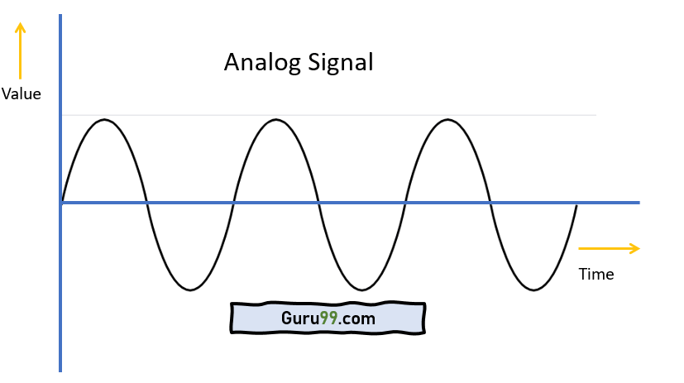

Image 3: Analog Signal

Reference: <https://www.guru99.com/analog-vs-digital.html>

An analog wave form (or signal) is characterized by being continuously variable along amplitude and frequency. In the case of telephony, for instance, when you speak into a handset, there are changes in the air pressure around your mouth. Those changes in air pressure fall onto the handset, where they are amplified and then converted into current, or voltage fluctuations. Those fluctuations in current are an analog of the actual voice pattern—hence the use of the term analog to describe these signals.

# Digital Transmission

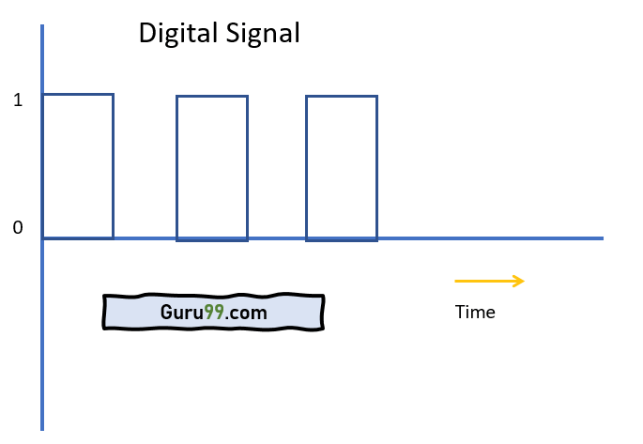

Image 4: Digital Signal

Reference: <https://www.guru99.com/analog-vs-digital.html>

Digital transmission is quite different from analog transmission. For one thing, the signal is much simpler. Rather than being a continuously variable wave form, it is a series of discrete pulses, representing one bits and zero bits.

## Advantages of Analog Signals

* Here, are pros/benefits of Analog Signals
* Easier in processing
* Best suited for audio and video transmission.
* It has a low cost and is portable.
* It has a much higher density so that it can present more refined information.
* Not necessary to buy a new graphics board.
* Uses less bandwidth than digital sounds
* Provide more accurate representation of a sound
* It is the natural form of a sound.

## Disadvantages of Analog Signals

Here are cons/drawback of Analog Signals:

* Analog tends to have a lower quality signal than digital.
* The cables are sensitive to external influences.
* The cost of the Analog wire is high and not easily portable.
* Low availability of models with digital interfaces.
* Recording analog sound on tape is quite expensive if the tape is damaged
* It offers limitations in editing
* Tape is becoming hard to find
* It is quite difficult to synchronize analog sound
* Quality is easily lost
* Data can become corrupted
* Plenty of recording devices and formats which can become confusing to store a digital signal
* Digital sounds can cut an analog sound wave which means that you can’t get a perfect reproduction of a sound
* Offers poor multi-user interfaces

## Advantages of Digital Signals

Here, are pros/advantages of Digital Signals:

* Digital data can be easily compressed.
* Any information in the digital form can be encrypted.
* Equipment that uses digital signals is more common and less expensive.
* Digital signal makes running instruments free from observation errors like parallax and approximation errors.
* A lot of editing tools are available
* You can edit the sound without altering the original copy
* Easy to transmit the data over networks

## Disadvantages of Digital Signals

* Sampling may cause loss of information.
* A/D and D/A demands mixed-signal hardware
* Processor speed is limited
* Develop quantization and round-off errors
* It requires greater bandwidth
* Systems and processing is more complex.

## Analog and Digital Signals: Systems and Applications

Traditional audio and communication systems used analog signals. However, with advances in silicon process technologies, digital signal processing capabilities, encoding algorithms, and encryption requirements — in addition to increases in bandwidth efficiencies — many of these systems have become digital. They are still some applications where analog signals have legacy use or benefits. Most systems that interface to real-world signals (such as sound, light, temperature, and pressure) use an analog interface to capture or transmit the information. A few analog signal applications are listed below:

* Audio recording and reproduction
* Temperature sensors
* Image sensors
* Radio signals
* Telephones
* Control systems

Although many original communication systems used analog signaling (telephones), recent technologies use digital signals because of their advantages with noise immunity, encryption, bandwidth efficiency, and the ability to use repeaters for long-distance transmission. A few digital signal applications are listed below:

* Communication systems (broadband, cellular)
* Networking and data communications
* Digital interfaces for programmability

# Base band and Broadband transmission

**Broadband system** use modulation techniques to reduce the effect of noise in the environment. Broadband transmission employs multiple channel unidirectional transmission using combination of phase and amplitude modulation.

**Baseband** is a digital signal is transmitted on the medium using one of the signal codes like NRZ, RZ Manchester biphase-M code etc. is called baseband transmission.

These are following differences between Broadband and Baseband transmission.

**Baseband transmission –**

* Digital signalling.
* Frequency division multiplexing is not possible.
* Baseband is bi-directional transmission.
* Short distance signal travelling.
* Entire bandwidth is for single signal transmission.

Example: Ethernet is using Basebands for LAN.

**Broadband transmission –**

* Analog signalling.
* Transmission of data is unidirectional.
* Signal travelling distance is long.
* Frequency division multiplexing possible.
* Simultaneous transmission of multiple signals over different frequencies.

Example : Used to transmit cable TV to premises.

# STP cable, UTP cable, Coaxial cable, Fiber cable and Connectors

Cables are commonly used to carry communication signals within Local Area Networks (LAN). There are three common types of cable media that can be used to connect devices to a network and they are coaxial cable, twisted-pair cable, and fiber-optic cable.

## Coaxial Cables

Coaxial cable looks similar to the cable used to carry TV signal. A solid-core copper wire conductor runs down the middle of the cable. Around that solid-core copper wire is a layer of insulation, and covering that insulation is braided wire and metal foil shield, which shields against electromagnetic interference. A final layer of plastic insulation jacket covers the braided wire.

Following image shows the general structure of coaxial cable.

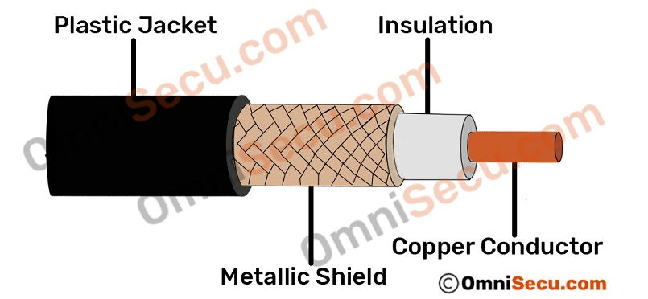

Image 5: Coaxial Cable

Reference: <https://www.omnisecu.com/basic-networking/common-network-cable-types.php>

There are two types of coaxial cabling: ThinNet and ThickNet. ThinNet is a flexible coaxial cable about ¼ inch thick. ThinNet is used for short-distance. ThinNet connects directly to a workstation’s network adapter card using a British Naval Connector (BNC). The maximum length of thinnet is 185 to 200 meters. ThickNet coaxial cable is thicker cable than ThinNet. ThickNet cable is about ½ inch thick and can support data transfer over longer distances than ThinNet. ThickNet has a maximum supported cable length of 500 meters and usually is used as a backbone to connect several smaller ThinNet-based networks.

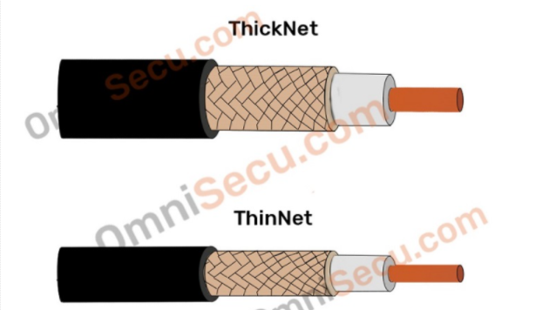

Image 6: Types of Coaxial Cable

Reference: <https://www.omnisecu.com/basic-networking/common-network-cable-types.php>

There are two Ethernet media standards defined for coaxial cable-based Ethernet. Those standards are 10Base2 and 10Base5.

10Base2 has a bandwidth speed of 10 Mbps, to a maximum distance of 200 meters. 10 denotes bandwidth speed and 2 denotes 200 meters. Base denotes baseband type of signal. Coaxial cable used for 10Base2 Ethernet media standard is ThinNet.

10Base5 has a bandwidth speed of 10 Mbps, to a maximum distance of 500 meters. 10 denotes bandwidth speed and 5 denotes 500 meters. Base denotes baseband type of signal. Coaxial cable used for 10Base5 Ethernet media standard is ThickNet.

The bandwidth available for both 10Base2 (Thinnet Ethernet) and 10Base5 (Thicknet Ethernet) were 10 Mbps (Megabits per second).

Type of Cable used to wire Local Area Networks (LAN) these days is Twisted Pair cable. It is extremely difficult to find a live business network using coaxial cable.

## Twisted Pair Cables

Twisted-pair cable is the most common type of cabling you can see in today's Local Area Networks (LAN) networks. A pair of wires forms a circuit that can transmit data. The pairs are twisted to provide protection against crosstalk. Crosstalk is the undesired signal noise generated by the electromagnetic fields of the adjacent wires.

When a wire is carrying a current, the current creates a magnetic field around the wire. This field can interfere with signals on nearby wires. To eliminate this, pairs of wires carry signals in opposite directions, so that the two magnetic fields also occur in opposite directions and cancel each other out. This process is known as cancellation.

Color codes used for Twisted Pair wire’s plastic insulation are Orange, Orange-White, Blue, Blue-White, Green, Green-White, Brown and Brown-White.

Two types of twisted pair cables are Unshielded Twisted Pair (UTP) and Shielded Twisted Pair (STP).

## Unshielded Twisted Pair (UTP) cables

Unshielded Twisted Pair (UTP) cable is the most common networking media. Unshielded Twisted Pair (UTP) consists of four pairs of thin, copper wires covered in color-coded plastic insulation that are twisted together. The wire pairs are then covered with a plastic outer jacket. UTP cables are of small diameter and it doesn’t need grounding. Since there is no shielding for UTP cabling, it relies only on "cancellation" to avoid noise.

Following image shows Unshielded Twisted Pair (UTP) cable.

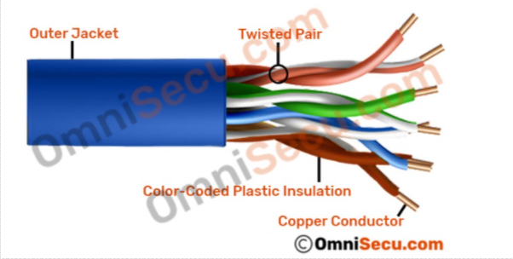

Image 7: Unshielded Twisted Pair (UTP) cable

Reference: <https://www.omnisecu.com/basic-networking/common-network-cable-types.php>

## Shielded Twisted Pair (STP) cables

Shielded Twisted Pair (STP) cables additionally have an overall conducting metallic shields covering four twisted pair wires. There may be another conducting metallic shields covering individual twisted pairs also. These metallic shields blocks out electromagnetic interference to prevent unwanted noise from the communication circuit.

Drain wires are also used in Shielded Twisted Pair (STP) cables together with metallic shields for grounding purpose. The drain wire provides a low-resistance connection to shield for better grounding. The main purpose of drain wire is to carry away unwanted interference noise to ground.

Following images show two different types of Shielded Twisted Pair cables (STP).

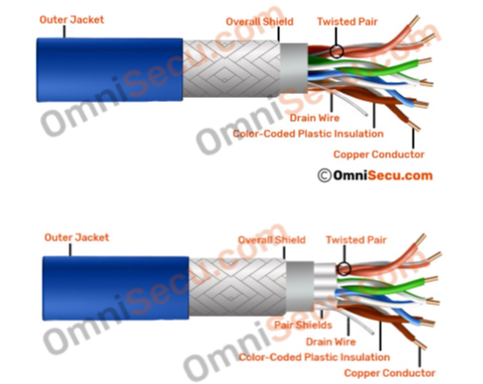

Image 8: Shielded Twisted Pair (STP) cables

Reference: <https://www.omnisecu.com/basic-networking/common-network-cable-types.php>

## Types of Connectors

## Ethernet Cable Connectors

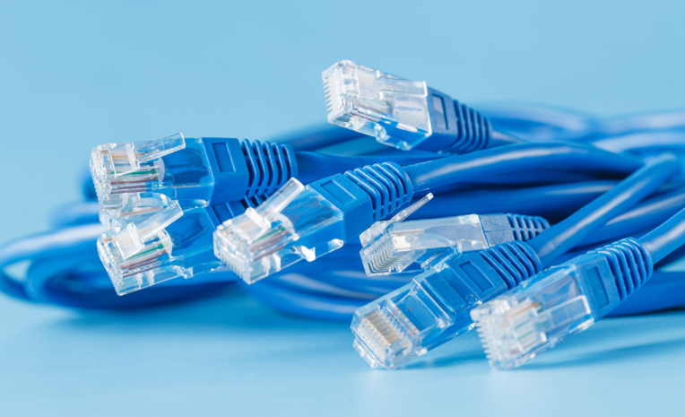

Image 9: RJ-45 connector

Reference: <https://www.homedepot.com/c/ab/types-of-cables-and-connectors-in-networking/9ba683603be9fa5395fab90e9250f90>

RJ45 connectors are used for CAT6 cables and CAT5e cables. These connectors for twisted-pair Ethernet cables are similar in appearance to a standard telephone cord connector. They are wider, however, because they have eight conductors compared to only four conductors on a telephone jack.

## Coaxial Cable Connectors

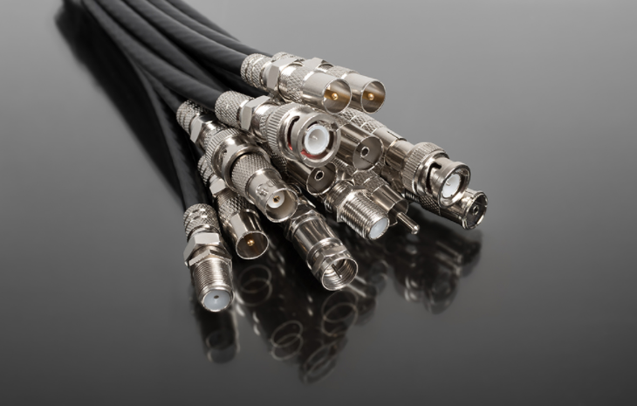

Image 10: BNC connector

Reference: <https://www.homedepot.com/c/ab/types-of-cables-and-connectors-in-networking/9ba683603be9fa5395fab90e9250f90>

BNC connectors are a type of F-series connectors commonly found in households. This type of connector for RG59 or RG6 coaxial cable is used for cable television equipment, broadcast TV antenna applications and CCTV security camera installations. They are easy to connect and disconnect from equipment and provide inexpensive, stable connections to these communications devices and other cables.

## USB Connectors

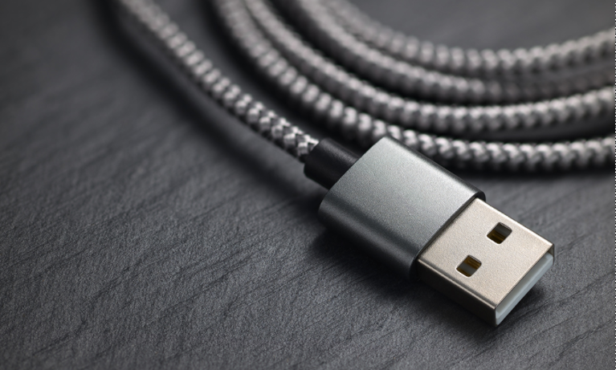

Image 11: USB connector

Reference: <https://www.homedepot.com/c/ab/types-of-cables-and-connectors-in-networking/9ba683603be9fa5395fab90e9250f90>

USB connectors are perhaps most familiar to the majority of people. USB (Universal Serial Bus) connectors typically join external devices to a personal computer or are used for mobile phone charging. There are adapters that will allow an Ethernet cable to connect directly to a USB port, though this type of setup would be a temporary solution for networking.

## Fiber Optic Cable Connectors

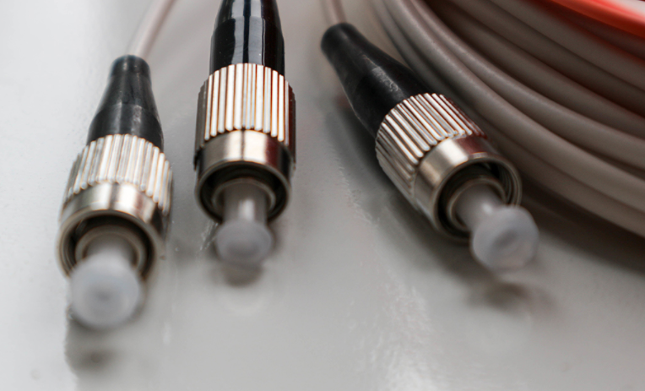

Image 12: Fiber optic connector

Reference: <https://www.homedepot.com/c/ab/types-of-cables-and-connectors-in-networking/9ba683603be9fa5395fab90e9250f90>

Fiber optic connectors require different types of connectors from those used with coax or twisted-pair cables, such as CAT5e. These types of connectors in networking must align glass fibers with precision to allow for communication. If you choose to use optical cable over twisted pair Ethernet, you may need to install a special adapter in your computer to utilize various fiber optic cable connector types.

# Physical and logical topologies

## Physical Topology

Physical topology indicates arrangement of different elements of a network. It reflects physical layout of devices and cables to a form a connected network. It is concerned with essentials of network ignoring minute details like transfer of data and device type. The pattern of arrangement of nodes (computers) and network cables depends on ease of installation and setup of the network. It affects cost and bandwidth capacity based on solution of devices. It takes into account placement of nodes and distance between them. Devices can be arranged to form a ring (Ring Topology) or linearly connected in a line called Bus Topology.

## Logical Topology

Logical Topology reflects arrangement of devices and their communication. It is the transmission of data over physical topology. It is independent of physical topology, irrespective of arrangements of nodes. It is concerned with intricate details of network like type of devices (switches, routers) chosen and their quality, which affect rate and speed of data packets delivery. The logical topology ensures optimal flow control that can be regulated within network.

## Types of Network Topology

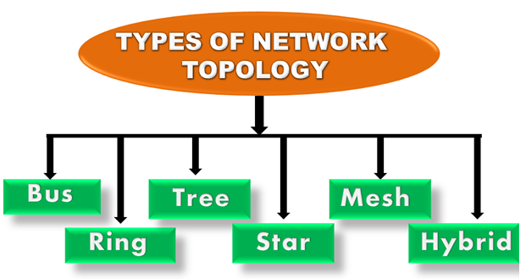

Image 13: Types of Network topology

Reference: <https://www.javatpoint.com/computer-network-topologies>

Topology defines the structure of the network of how all the components are interconnected to each other. There are two types of topology: physical and logical topology.

Physical topology is the geometric representation of all the nodes in a network.

### Bus Topology

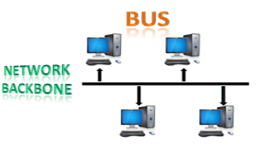

Image 14: Bus topology

Reference: <https://www.javatpoint.com/computer-network-topologies>

* The bus topology is designed in such a way that all the stations are connected through a single cable known as a backbone cable.
* Each node is either connected to the backbone cable by drop cable or directly connected to the backbone cable.
* When a node wants to send a message over the network, it puts a message over the network. All the stations available in the network will receive the message whether it has been addressed or not.
* The bus topology is mainly used in 802.3 (ethernet) and 802.4 standard networks.
* The configuration of a bus topology is quite simpler as compared to other topologies.
* The backbone cable is considered as a "single lane" through which the message is broadcast to all the stations.
* The most common access method of the bus topologies is CSMA (Carrier Sense Multiple Access).

### Ring Topology

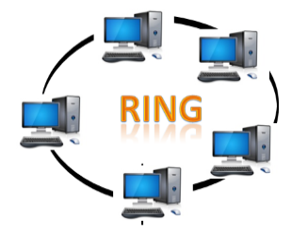

Image 15: Ring topology

Reference: <https://www.javatpoint.com/computer-network-topologies>

* Ring topology is like a bus topology, but with connected ends.
* The node that receives the message from the previous computer will retransmit to the next node.
* The data flows in one direction, i.e., it is unidirectional.
* The data flows in a single loop continuously known as an endless loop.
* It has no terminated ends, i.e., each node is connected to other node and having no termination point.
* The data in a ring topology flow in a clockwise direction.
* The most common access method of the ring topology is token passing.
* Token passing: It is a network access method in which token is passed from one node to another node.
* Token: It is a frame that circulates around the network.

### Star Topology

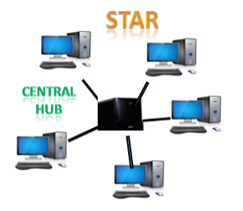

Image 16: Star topology

Reference: <https://www.javatpoint.com/computer-network-topologies>

* Star topology is an arrangement of the network in which every node is connected to the central hub, switch or a central computer.
* The central computer is known as a server, and the peripheral devices attached to the server are known as clients.
* Coaxial cable or RJ-45 cables are used to connect the computers.
* Hubs or Switches are mainly used as connection devices in a physical star topology.
* Star topology is the most popular topology in network implementation.

### Tree topology

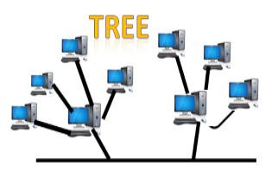

Image 17: Tree topology

Reference: <https://www.javatpoint.com/computer-network-topologies>

* Tree topology combines the characteristics of bus topology and star topology.
* A tree topology is a type of structure in which all the computers are connected with each other in hierarchical fashion.
* The top-most node in tree topology is known as a root node, and all other nodes are the descendants of the root node.
* There is only one path exists between two nodes for the data transmission. Thus, it forms a parent-child hierarchy.

### Mesh topology

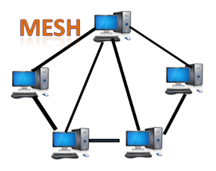

Image 18: Mesh topology

Reference: <https://www.javatpoint.com/computer-network-topologies>

* Mesh technology is an arrangement of the network in which computers are interconnected with each other through various redundant connections.
* There are multiple paths from one computer to another computer.
* It does not contain the switch, hub or any central computer which acts as a central point of communication.
* The Internet is an example of the mesh topology.
* Mesh topology is mainly used for WAN implementations where communication failures are a critical concern.
* Mesh topology is mainly used for wireless networks.
* Mesh topology can be formed by using the formula:
* Number of cables = (n*(n-1))/2;

Where n is the number of nodes that represents the network.

### Hybrid Topology

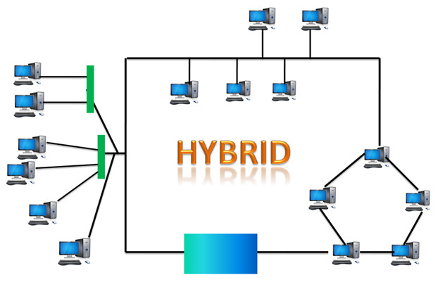

Image 19: Hybrid topology

Reference: <https://www.javatpoint.com/computer-network-topologies>

* The combination of various different topologies is known as Hybrid topology.
* A Hybrid topology is a connection between different links and nodes to transfer the data.
* When two or more different topologies are combined together is termed as Hybrid topology and if similar topologies are connected with each other will not result in Hybrid topology. For example, if there exist a ring topology in one branch of ICICI bank and bus topology in another branch of ICICI bank, connecting these two topologies will result in Hybrid topology.

# Asynchronous & Synchronous Transmission

## Synchronous Transmission:

In Synchronous Transmission, data is sent in form of blocks or frames. This transmission is the full duplex type. Between sender and receiver the synchronization is compulsory. In Synchronous transmission, There is no gap present between data. It is more efficient and more reliable than asynchronous transmission to transfer the large amount of data.

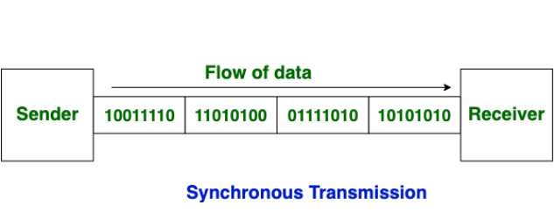

Image 20: Synchronous transmission

Reference: <https://www.guru99.com/difference-between-synchronous-and-asynchronous-transmission.html>

## Asynchronous Transmission:

In Asynchronous Transmission, data is sent in form of byte or character. This transmission is the half duplex type transmission. In this transmission start bits and stop bits are added with data. It does not require synchronization.

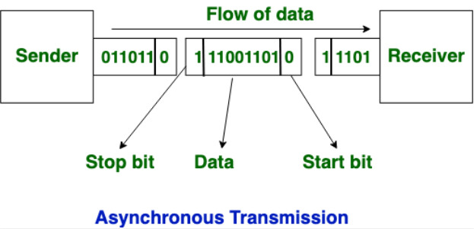

Image 21: Asynchronous transmission

Reference: <https://www.guru99.com/difference-between-synchronous-and-asynchronous-transmission.html>

## Differences between Synchronous and Asynchronous Transmission

* Synchronous is a data transfer method in which a continuous stream of data signals is accompanied by timing signals whereas Asynchronous data transmission is a data transfer method in which the sender and the receiver use the flow control method.
* In, synchronous transmission method users need to wait until it sending finishes before getting a response from the server. On the contrary, Asynchronous transmission method users do not have to wait until sending completes before receiving a response from the server.
* Synchronous Transmission sends data in the form of blocks or frames while Asynchronous Transmission send data in the form of character or byte.
* Synchronous Transmission is fast. On the other hand, Asynchronous transmission method is slow.
* Synchronous Transmission is costly whereas Asynchronous Transmission is economical.

Learning Outcome

**Different Types of Protocols**

# **Web Protocols**

## **Introduction**

**Definition 1:** A protocol is a standard set of rules that allow electronic devices to communicate with each other.

**Definition 2:** A protocol is a set of guidelines to govern the data transfer between the devices.

A Network Protocol is a group of rules accompanied by the network. Network protocols will be formalized requirements and plans composed of rules, procedures, and types that describe communication among a couple of devices over the network. The protocol can be described as an approach to rules that enable a couple of entities of a communication program to transfer information through any type of variety of a physical medium. The protocol identifies the rules, syntax, semantics as well as, synchronization of communication as well as, feasible error managing methods. In this article, we will discuss the different types of networking protocols. Let's discuss each of them briefly:

1. **Transmission Control Protocol (TCP):** TCP is a popular communication protocol which is used for communicating over a network. It divides any message into series of packets that are sent from source to destination and there it gets reassembled at the destination.
2. **Internet Protocol (IP):** IP is designed explicitly as addressing protocol. It is mostly used with TCP. The IP addresses in packets help in routing them through different nodes in a network until it reaches the destination system. TCP/IP is the most popular protocol connecting the networks.
3. **User Datagram Protocol (UDP):** UDP is a substitute communication protocol to Transmission Control Protocol implemented primarily for creating loss-tolerating and low-latency linking between different applications.
4. **Post office Protocol (POP):** POP3 is designed for receiving incoming E-mails.
5. **Simple mail transport Protocol (SMTP):** SMTP is designed to send and distribute outgoing E-Mail.
6. **File Transfer Protocol (FTP):** FTP allows users to transfer files from one machine to another. Types of files may include program files, multimedia files, text files, and documents, etc.
7. **Hyper Text Transfer Protocol (HTTP):** HTTP is designed for transferring a hypertext among two or more systems. HTML tags are used for creating links. These links may be in any form like text or images. HTTP is designed on Client-server principles which allow a client system for establishing a connection with the server machine for making a request. The server acknowledges the request initiated by the client and responds accordingly.
8. **Hyper Text Transfer Protocol Secure (HTTPS):** HTTPS is abbreviated as Hyper Text Transfer Protocol Secure is a standard protocol to secure the communication among two computers one using the browser and other fetching data from web server. HTTP is used for transferring data between the client browser (request) and the web server (response) in the hypertext format, same in case of HTTPS except that the transferring of data is done in an encrypted format. So it can be said that https thwart hackers from interpretation or modification of data throughout the transfer of packets.
9. **Telnet:** Telnet is a set of rules designed for connecting one system with another. The connecting process here is termed as remote login. The system which requests for connection is the local computer, and the system which accepts the connection is the remote computer.
10. **Gopher:** Gopher is a collection of rules implemented for searching, retrieving as well as displaying documents from isolated sites. Gopher also works on the client/server principle.

# **Transmission Control Protocol**

## Introduction

It provides a full transport layer services to applications.

TCP is a connection oriented protocol and offers end-to-end packet delivery. It acts as back bone for connection TCP is a reliable protocol as it detects the error and retransmits the damaged frames.

● TCP is among the most widely used protocol using the internet.

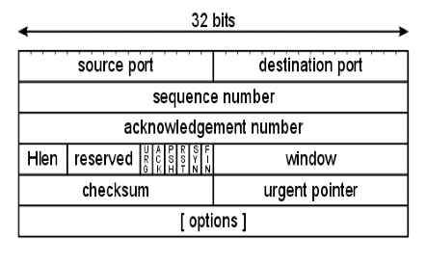

**Transmission Control Protocal**

**Ref : 3-ttps://lh3.googleusercontent.com/proxy/MmQAe8LlPH97fO51WtYBRv6hMEL4GNj-QprSgwN8WXL_zGga4jsXDWUsZ1JCCJwoXF rY15EKcwhxis3JHKWrlbDRHjGWUCd4Yt7LPpur0Uky-gvRE4j0J28RhRC6_g**

* TCP is a two-way conversation.
* TCP is focused on stability.
* Packets will be instructed and numbered.
* Packets will be error-checked.

TCP is a connection oriented protocol and offers end-to-end packet delivery. It acts as back bone for connection. It exhibits the following key features:

Transmission Control Protocol (TCP) corresponds to the Transport Layer of OSI Model. TCP is a reliable and connection oriented protocol.

### TCP offers:

* Stream Data Transfer.
* Reliability.
* Efficient Flow Control
* Full-duplex operation.
* Multiplexing.

TCP offers connection oriented end-to-end packet delivery.

TCP ensures reliability by sequencing bytes with a forwarding acknowledgement number that indicates to the destination the next byte the source expect to receive.

It retransmits the bytes not acknowledged with in specified time period.

### TCP Services

**Stream Deliver Service**

TCP protocol is stream oriented because it allows the sending process to send data as stream of bytes and the receiving process to obtain data as stream of bytes.

**Sending and Receiving Buffers**

It may not be possible for sending and receiving process to produce and obtain data at same speed, therefore, TCP needs buffers for storage at sending and receiving ends.

**Bytes and Segments**

The Transmission Control Protocol (TCP), at transport layer groups the bytes into a packet. This packet is called segment. Before transmission of these packets, these segments are encapsulated into an IP datagram.

**Full Duplex Service**

Transmitting the data in duplex mode means flow of data in both the directions at the same time.

**Connection Oriented Service**

TCP offers connection oriented service in the following manner:

TCP of process-1 informs TCP of process – 2 and gets its approval.

TCP of process – 1 and TCP of process – 2 and exchange data in both the two directions.

After completing the data exchange, when buffers on both sides are empty, the two TCP’s destroy their buffers.

**Reliable Service**

For sake of reliability, TCP uses acknowledgement mechanism.

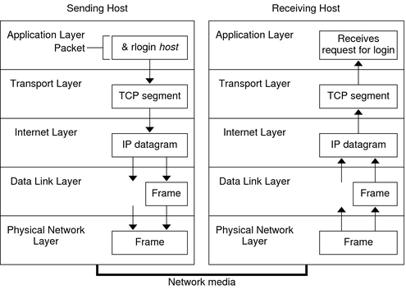

**Reliable Service**

Ref- https://docs.oracle.com/cd/E18752_01/html/816-4554/figures/ipov.fig88.png

## TCP Benefits

1. It is an Open standard and is independent of hardware and software manufacturer.
2. It can send data between different computer systems running completely through Operating system.
3. It is separated from the underlying hardware and it will run over Ethernet, tokens ring and even over dial-up telephones lines.
4. It is a routable protocol.
5. It has a reliable and efficient data-delivery mechanism.
6. It uses a common addressing scheme, so any system can address any other system.

# Internet Protocol

## Introduction

Internet Protocol is connectionless and unreliable protocol. It ensures no guarantee of successfully transmission of data.

In order to make it reliable, it must be paired with reliable protocol such as TCP at the transport layer.

The Internet protocol suite provides end-to-end data communication specifying how data should be packetized, addressed, transmitted, routed, and received. This functionality is organized into four abstraction layers, which classify all related protocols according to the scope of networking involved.[1][2] From lowest to highest, the layers are the link layer, containing communication methods for data that remains within a single network segment (link); the internet layer, providing internetworking between independent networks; the transport layer, handling host-to-host communication; and the application layer, providing process-to-process data exchange for applications.

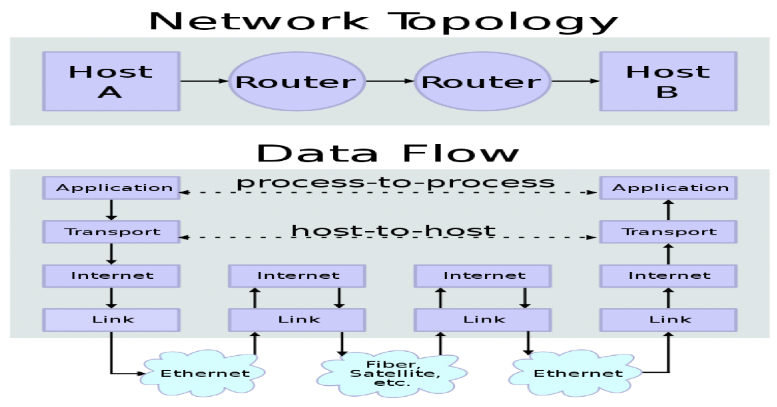

**Simple Network Topology**

Ref-https://upload.wikimedia.org/wikipedia/commons/thumb/c/c4/IP_stack_connections.svg/350px-IP_stack_connections.svg.png

Conceptual data flow in a simple network topology of two hosts (A and B) connected by a link between their respective routers. The application on each host executes read and write operations as if the processes were directly connected to each other by some kind of data pipe. After establishment of this pipe, most details of the communication are hidden from each process, as the underlying principles of communication are implemented in the lower protocol layers. In analogy, at the transport layer the communication appears as host-to-host, without knowledge of the application data structures and the connecting routers, while at the internetworking layer, individual network boundaries are traversed at each router.

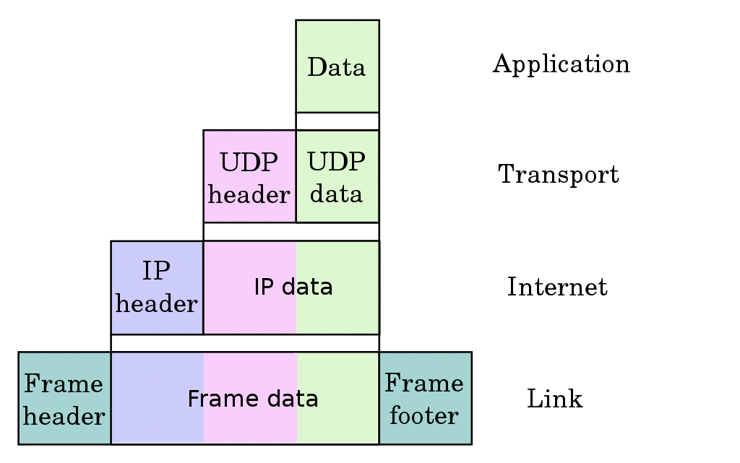

Ref-htthttps://upload.wikimedia.org/wikipedia/commons/thumb/3/3b/UDP_encapsulation.svg/1024px-UDP_encapsulation.svg.png

* The application layer is the scope within which applications, or processes, create user data and communicate this data to other applications on another or the same host.
* The transport layer performs host-to-host communications on either the local network or remote networks separated by routers.[33] It provides a channel for the communication needs of applications. UDP is the basic transport layer protocol, providing an unreliable connectionless datagram service. The Transmission Control Protocol provides flow-control, connection establishment, and reliable transmission of data.
* The internet layer exchanges datagrams across network boundaries. It provides a uniform networking interface that hides the actual topology (layout) of the underlying network connections. It is therefore also the layer that establishes internetworking. Indeed, it defines and establishes the Internet. This layer defines the addressing and routing structures used for the TCP/IP protocol suite. The primary protocol in this scope is the Internet Protocol, which defines IP addresses. Its function in routing is to transport datagrams to the next host, functioning as an IP router, that has the connectivity to a network closer to the final data destination.
* The link layer defines the networking methods within the scope of the local network link on which hosts communicate without intervening routers. This layer includes the protocols used to describe the local network topology and the interfaces needed to affect the transmission of Internet layer datagrams to next-neighbor hosts.

**Short Information**

* The application layer sends the data (to be transferred to remote destination ) to the transport layer.
* The transport layer puts its header in the beginning and sends this complete packet (TCP-header + app-data) to the IP layer.
* On the same lines, The IP layer puts its header in front of the data received from TCP (Note that data received from TCP = TCP-header + app-data).
* So now the structure of IP datagram becomes IP-header + TCP-header + app-data.
* This IP datagram is passed to the Ethernet layer which on the same lines adds its own header to IP datagram and then the whole packet is transmitted over network.

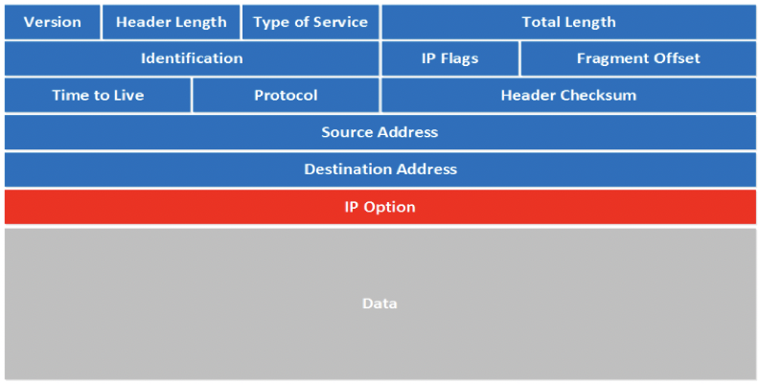

Ref-https://networklessons.com/cisco/ccna-routing-switching-icnd1-100-105/ipv4-packet-header

**Version**: the first field tells us which IP version we are using, only IPv4 uses this header so you will always find decimal value 4 here.

**Header Length**: this 4 bit field tells us the length of the IP header in 32 bit increments. The minimum length of an IP header is 20 bytes so with 32 bit increments, you would see value of 5 here. The maximum value we can create with 4 bits is 15 so with 32 bit increments, that would be a header length of 60 bytes. This field is also called the **Internet Header Length (IHL)**.

* **Type of Service**: this is used for QoS (Quality of Service). There are 8 bits that we can use to mark the packet which we can use to give the packet a certain treatment. You can read more about this field in my IP precedence and DSCP tutorial.
* **Total Length**: this 16-bit field indicates the entire size of the IP packet (header and data) in bytes. The minimum size is 20 bytes (if you have no data) and the maximum size is 65.535 bytes, that’s the highest value you can create with 16 bits.
* **Identification**: If the IP packet is fragmented then each fragmented packet will use the same 16 bit identification number to identify to which IP packet they belong to.
* **IP Flags**: These 3 bits are used for fragmentation:
  + The first bit is always set to 0.
  + The second bit is called the **DF (Don’t Fragment) bit** and indicates that this packet should not be fragmented.
  + The third bit is called the **MF (More Fragments)** bit and is set on all fragmented packets except the last one.
* **Fragment Offset**: this 13 bit field specifies the position of the fragment in the original fragmented IP packet.
* **Time to Live**: Every time an IP packet passes through a router, the time to live field is decremented by 1. Once it hits 0 the router will drop the packet and sends an ICMP time exceeded message to the sender. The time to live field has 8 bits and is used to prevent packets from looping around forever (if you have a routing loop).
* **Protocol**: this 8 bit field tells us which protocol is encapsulated in the IP packet, for example TCP has value 6 and UDP has value 17.
* **Header Checksum**: this 16 bit field is used to store a checksum of the header. The receiver can use the checksum to check if there are any errors in the header.
* **Source Address**: here you will find the 32 bit source IP address.
* **Destination Address**: and here’s the 32 bit destination IP address.
* **IP Option**: this field is not used often, is optional and has a variable length based on the options that were used. When you use this field, the value in the header length field will increase. An example of a possible option is “source route” where the sender requests for a certain routing path.

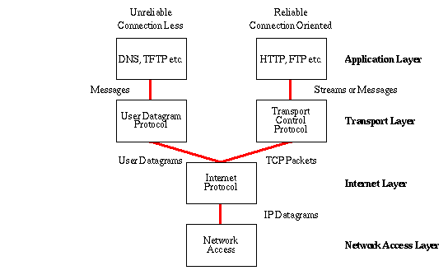

**Ref-https://www.w3.org/People/Frystyk/thesis/tcp.gif**

* The application layer sends the data (to be transferred to remote destination ) to the transport layer.
* The transport layer puts its header in the beginning and sends this complete packet (TCP-header + app-data) to the IP layer.
* On the same lines, The IP layer puts its header in front of the data received from TCP (Note that data received from TCP = TCP-header + app-data).
* So now the structure of IP datagram becomes IP-header + TCP-header + app-data.
* This IP datagram is passed to the ethernet layer which on the same lines adds its own header to IP datagram and then the whole packet is transmitted over network.

# User Datagram Protocol (UDP)

## Introduction

**User Datagram Protocol (UDP)** is a Transport Layer protocol. UDP is a part of the Internet Protocol suite, referred to as UDP/IP suite. Unlike TCP, it is an **unreliable and connectionless protocol.** So, there is no need to establish a connection prior to data transfer.

Though Transmission Control Protocol (TCP) is the dominant transport layer protocol used with most of the Internet services; provides assured delivery, reliability, and much more but all these services cost us additional overhead and latency. Here, UDP comes into the picture. For real-time services like computer gaming, voice or video communication, live conferences; we need UDP. Since high performance is needed, UDP permits packets to be dropped instead of processing delayed packets. There is no error checking in UDP, so it also saves bandwidth.   
User Datagram Protocol (UDP) is more efficient in terms of both latency and bandwidth.

## UDP Header

UDP header is an **8-bytes** fixed and simple header, while for TCP it may vary from 20 bytes to 60 bytes. The first 8 Bytes contains all necessary header information and the remaining part consist of data. UDP port number fields are each 16 bits long, therefore the range for port numbers is defined from 0 to 65535; port number 0 is reserved. Port numbers help to distinguish different user requests or processes.

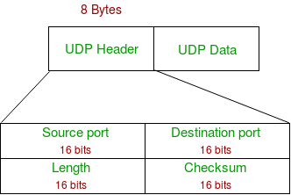

Ref: https://media.geeksforgeeks.org/wp-content/uploads/UDP-header.png

1. **Source Port:** Source Port is a 2 Byte long field used to identify the port number of the source.
2. **Destination Port:** It is a 2 Byte long field, used to identify the port of the destined packet.
3. **Length:** Length is the length of UDP including the header and the data. It is a 16-bits field.
4. **Checksum:** Checksum is 2 Bytes long field. It is the 16-bit one’s complement of the one’s complement sum of the UDP header, the pseudo-header of information from the IP header, and the data, padded with zero octets at the end (if necessary) to make a multiple of two octets.

**Notes –** Unlike TCP, the Checksum calculation is not mandatory in UDP. No Error control or flow control is provided by UDP. Hence UDP depends on IP and ICMP for error reporting.

## Applications of UDP

* Used for simple request-response communication when the size of data is less and hence there is lesser concern about flow and error control.
* It is a suitable protocol for multicasting as UDP supports packet switching.
* UDP is used for some routing update protocols like RIP(Routing Information Protocol).
* Normally used for real-time applications which cannot tolerate uneven delays between sections of a received message.
* Following implementations uses UDP as a transport layer protocol:
  + NTP (Network Time Protocol)
  + DNS (Domain Name Service)
  + BOOTP, DHCP.
  + NNP (Network News Protocol)
  + Quote of the day protocol
  + TFTP, RTSP, RIP.
* The application layer can do some of the tasks through UDP-
  + Trace Route
  + Record Route
  + Timestamp
* UDP takes a datagram from Network Layer, attaches its header, and sends it to the user. So, it works fast.
* Actually, UDP is a null protocol if you remove the checksum field.
  + Reduce the requirement of computer resources.
  + When using the Multicast or Broadcast to transfer.
  + The transmission of Real-time packets, mainly in multimedia applications.

# POP Protocol

The POP protocol stands for Post Office Protocol. As we know that SMTP is used as a message transfer agent. When the message is sent, then SMPT is used to deliver the message from the client to the server and then to the recipient server. But the message is sent from the recipient server to the actual server with the help of the Message Access Agent. The Message Access Agent contains two types of protocols, i.e., POP3 and IMAP.

## How is mail transmitted?

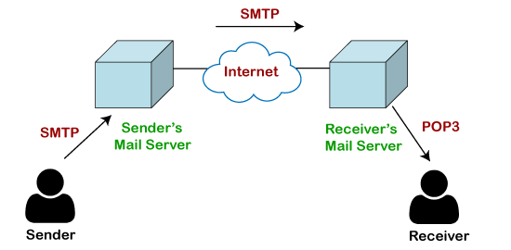

Ref: https://static.javatpoint.com/tutorial/computer-network/images/pop-protocol.png

Suppose sender wants to send the mail to receiver. First mail is transmitted to the sender's mail server. Then, the mail is transmitted from the sender's mail server to the receiver's mail server over the internet. On receiving the mail at the receiver's mail server, the mail is then sent to the user. The whole process is done with the help of Email protocols. The transmission of mail from the sender to the sender's mail server and then to the receiver's mail server is done with the help of the [SMTP protocol](https://www.javatpoint.com/simple-mail-transfer-protocol). At the receiver's mail server, the POP or [IMAP protocol](https://www.javatpoint.com/imap-protocol) takes the data and transmits to the actual user.

Since SMTP is a push protocol so it pushes the message from the client to the server. As we can observe in the above figure that SMTP pushes the message from the client to the recipient's mail server. The third stage of email communication requires a pull protocol, and POP is a pull protocol. When the mail is transmitted from the recipient mail server to the client which means that the client is pulling the mail from the server.

## What is POP3?

The POP3 is a simple protocol and having very limited functionalities. In the case of the POP3 protocol, the POP3 client is installed on the recipient system while the POP3 server is installed on the recipient's mail server.

## History of POP3 protocol

The first version of post office protocol was first introduced in 1984 as RFC 918 by the [internet](https://www.javatpoint.com/internet) engineering task force. The developers developed a simple and effective email protocol known as the POP3 protocol, which is used for retrieving the emails from the server. This provides the facility for accessing the mails offline rather than accessing the mailbox offline.

In 1985, the post office protocol version 2 was introduced in RFC 937, but it was replaced with the post office protocol version 3 in 1988 with the publication of RFC 1081. Then, POP3 was revised for the next 10 years before it was published. Once it was refined completely, it got published on 1996.

Although the POP3 protocol has undergone various enhancements, the developers maintained a basic principle that it follows a three-stage process at the time of mail retrieval between the client and the server. They tried to make this protocol very simple, and this simplicity makes this protocol very popular today.

**Let's understand the working of the POP3 protocol.**

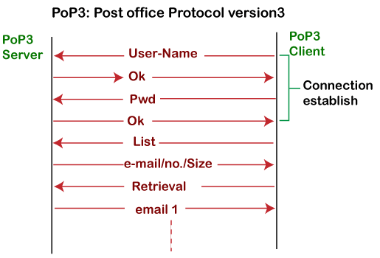

Ref: https://static.javatpoint.com/tutorial/computer-network/images/pop-protocol2.png

To establish the connection between the POP3 server and the POP3 client, the POP3 server asks for the user name to the POP3 client. If the username is found in the POP3 server, then it sends the ok message. It then asks for the password from the POP3 client; then the POP3 client sends the password to the POP3 server. If the password is matched, then the POP3 server sends the OK message, and the connection gets established. After the establishment of a connection, the client can see the list of mails on the POP3 mail server. In the list of mails, the user will get the email numbers and sizes from the server. Out of this list, the user can start the retrieval of mail.

Once the client retrieves all the emails from the server, all the emails from the server are deleted. Therefore, we can say that the emails are restricted to a particular machine, so it would not be possible to access the same mails on another machine. This situation can be overcome by configuring the email settings to leave a copy of mail on the mail server.

## Advantages of POP3 protocol

**The following are the advantages of a POP3 protocol:**

* It allows the users to read the email offline. It requires an internet connection only at the time of downloading emails from the server. Once the mails are downloaded from the server, then all the downloaded mails reside on our PC or hard disk of our computer, which can be accessed without the internet. Therefore, we can say that the POP3 protocol does not require permanent internet connectivity.
* It provides easy and fast access to the emails as they are already stored on our PC.
* There is no limit on the size of the email which we receive or send.
* It requires less server storage space as all the mails are stored on the local machine.
* There is maximum size on the mailbox, but it is limited by the size of the hard disk.
* It is a simple protocol so it is one of the most popular protocols used today.
* It is easy to configure and use.

## Disadvantages of POP3 protocol

**The following are the disadvantages of a POP3 protocol:**

* If the emails are downloaded from the server, then all the mails are deleted from the server by default. So, mails cannot be accessed from other machines unless they are configured to leave a copy of the mail on the server.
* Transferring the mail folder from the local machine to another machine can be difficult.
* Since all the attachments are stored on your local machine, there is a high risk of a virus attack if the virus scanner does not scan them. The virus attack can harm the computer.
* The email folder which is downloaded from the mail server can also become corrupted.
* The mails are stored on the local machine, so anyone who sits on your machine can access the email folder.

# Hyper Text Transfer Protocol

## Introduction

HTTP is a communication protocol. It defines mechanism for communication between browser and the web server. It is also called request and response protocol because the communication between browser and server takes place in request and response pairs.

## HTTP Request

HTTP request comprises of lines which contains: Request line  
Header Fields  
Message body

**Key Points**

The first line i.e. the Request line specifies the request method i.e. Get or Post.

The second line specifies the header which indicates the domain name of the server from where index.htm is retrieved.

## HTTP Response

Like HTTP request, HTTP response also has certain structure. HTTP response contains: Status line  
Headers  
Message body

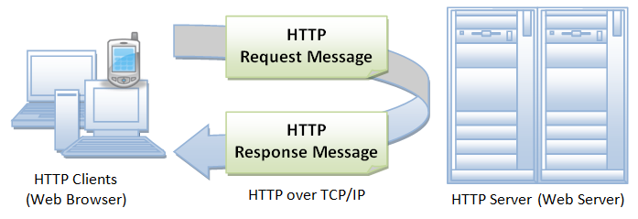

**Ref-https://www.ntu.edu.sg/home/ehchua/programming/webprogramming/images/HTTP.png**

# Hyper Text Transfer Protocol Secure

## Introduction

* Hypertext Transfer Protocol Secure (HTTPS) is an extension of the Hypertext Transfer Protocol (HTTP). It is used for secure communication over a computer network, and is widely used on the Internet.
* In HTTPS, the communication protocol is encrypted using Transport Layer Security (TLS) or, formerly, Secure Sockets Layer (SSL).
* The protocol is therefore also referred to as HTTP over TLS,[3] or HTTP over SSL.

## Advantages

* User Data is Encrypted
* You’ll Enjoy Better SEO
* Protects your website from Phishing
* Authentication of the accessed website, and protection of the privacy and integrity of the exchanged data while in transit.

It protects against man-in-the-middle attacks, and the bidirectional encryption of communications between a client and server protects the communications against eavesdropping and tampering

## Limitations

* SSL/TLS does not prevent the indexing of the site by a web crawler
* SSL (Secure Sockets Layer) and TLS (Transport Layer Security) encryption can be configured in two modes: simple and mutual.

### From an architectural point of view

An SSL/TLS connection is managed by the first front machine that initiates the TLS connection. If, for any reasons (routing, traffic optimization, etc.), this front machine is not the application server and it has to decipher data, solutions have to be found to propagate user authentication information or certificate to the application server, which needs to know who is going to be connected.

For SSL/TLS with mutual authentication, the SSL/TLS session is managed by the first server that initiates the connection. In situations where encryption has to be propagated along chained servers, session time Out management becomes extremely tricky to implement.

Security is maximal with mutual SSL/TLS, but on the client-side there is no way to properly end the SSL/TLS connection and disconnect the user except by waiting for the server session to expire or by closing all related client applications.

SSL/TLS does not prevent the indexing of the site by a web crawler, and in some cases  
the URI of the encrypted resource can be inferred by knowing only the intercepted request/response size.[33] This allows an attacker to have access to the plaintext (the publicly available static content), and the encrypted text (the encrypted version of the static content), permitting a cryptographic attack.

* SSL 1.0 – never publicly released due to security issues.
* SSL 2.0 – released in 1995. Deprecated in 2011. Has known security issues.
* SSL 3.0 – released in 1996. Deprecated in 2015. Has known security issues.
* TLS 1.0 – released in 1999 as an upgrade to SSL 3.0. Planned deprecation in 2020.
* TLS 1.1 – released in 2006. Planned deprecation in 2020.
* TLS 1.2 – released in 2008.
* TLS 1.3 – released in 2018.

# File Transfer Protocol

## Introduction

* FTP is used to copy files from one host to another browser and the web server.
* FTP creates two processes such as Control Process and Data Transfer Process at both ends i.e. at client as well as at server.
* FTP establishes two different connections: one is for data transfer and other is for control information.
* Control connection is made between control processes while Data Connection is made between
* FTP uses port 21 for the control connection and Port 20 for the data connection.

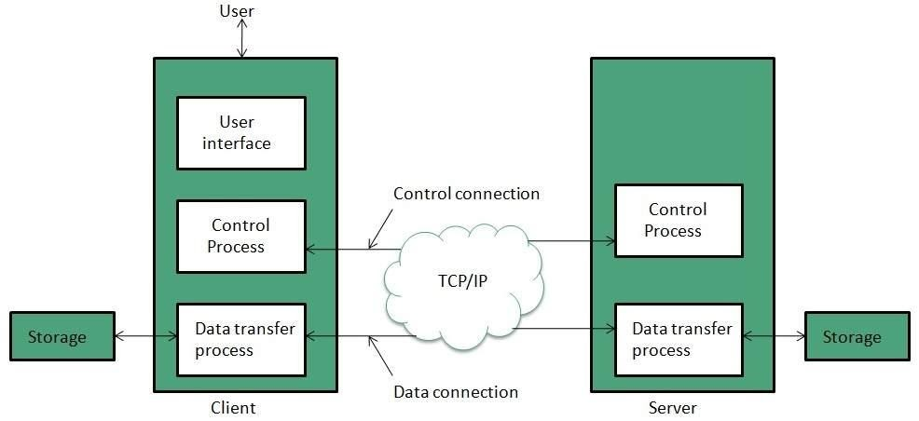

**Ref-https://www.tutorialspoint.com/internet_technologies/images/internet-ftp_model.jpg**

# Simple Mail Transfer Protocol

SMTP is a set of communication guidelines that allow software to transmit an electronic mail over the internet is called Simple Mail Transfer Protocol.

* It is a program used for sending messages to other computer users based on e-mail addresses.
* It provides a mail exchange between users on the same or different computers, and it also supports:

1. It can send a single message to one or more recipients.
2. Sending message can include text, voice, video or graphics.
3. It can also send the messages on networks outside the internet.

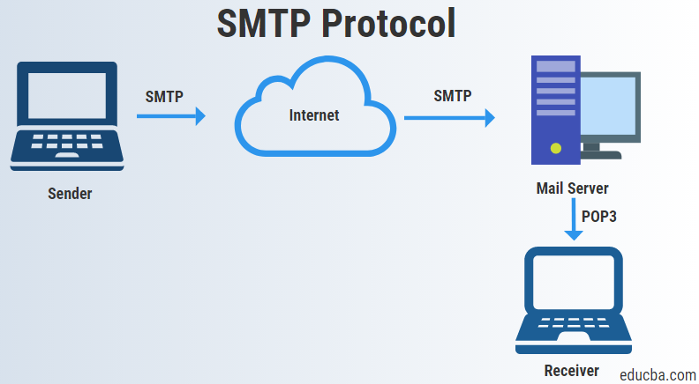

**Ref-https://cdn.educba.com/academy/wp-content/uploads/2019/07/smtp-protocol.png**

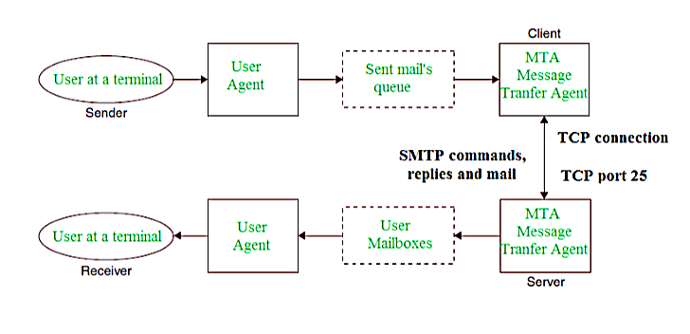

**Ref- https://media.geeksforgeeks.org/wp-content/cdn-uploads/gq/2017/02/SMTP_1.png**

## Some SMTP Commands

* HELO – Identifies the client to the server, fully qualified domain name, only sent once per session
* MAIL – Initiate a message transfer, fully qualified domain of originator
* RCPT – Follows MAIL, identifies an addressee, typically the fully qualified name of the addressee and for multiple addressees use one RCPT for each addressee
* DATA – send data line by line

# Open System Interconnection Model (OSI) Introduction

## Introduction

* OSI stands for Open Systems Interconnection. It has been developed by ISO – ‘International Organization of Standardization‘, in the year 1984.
* Designed to show the flow of moving data from one software application of one computer to another software application of another computer.
* Open Systems Interconnection (OSI) model is the virtual model which describes the Concept of a computer system with the concern of internal structure and technology.

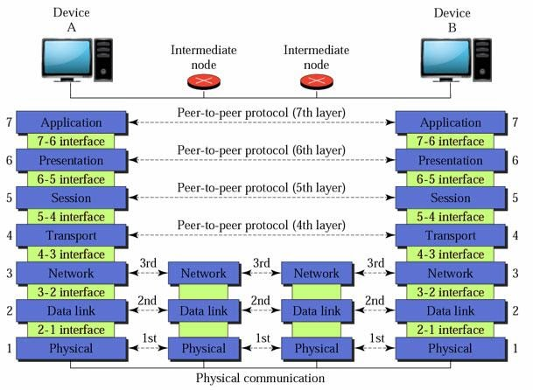

**Ref-https://cdn.educba.com/academy/wp-content/uploads/2019/05/OSI-Model1_Done.jpg**

## Physical Layer Functions

* The functions of the physical layer are :
* **Bit synchronization:** The physical layer provides the synchronization of the bits by providing a clock. This clock controls both sender and receiver thus providing synchronization at bit level.
* **Bit rate control:** The Physical layer also defines the transmission rate i.e. the number of bits sent per second.
* **Physical topologies:** Physical layer specifies the way in which the different, devices/nodes are arranged in a network i.e. bus, star or mesh topolgy.
* **Transmission mode:** Physical layer also defines the way in which the data flows between the two connected devices. The various transmission modes possible are: Simplex, half-duplex and full-duplex.

## Data Link Layer Functions

* The data link layer is responsible for the node to node delivery of the message. The main function of this layer is to make sure data transfer is error-free from one node to another, over the physical layer.
* Packet in Data Link layer is referred as Frame.
* Data Link layer is handled by the NIC (Network Interface Card) and device drivers of host machines.
* Switch & Bridge are Data Link Layer devices.

**1. Logical Link Control (LLC) 2. Media Access Control (MAC)**

1. **Framing:** Framing is a function of the data link layer. It provides a way for a sender to transmit a set of bits that are meaningful to the receiver. This can be accomplished by attaching special bit patterns to the beginning and end of the frame.
2. **Physical addressing:** After creating frames, Data link layer adds physical addresses (MAC address) of sender and/or receiver in the header of each frame.
3. **Error control:** Data link layer provides the mechanism of error control in which it detects and retransmits damaged or lost frames.
4. **Flow Control:** The data rate must be constant on both sides else the data may get corrupted thus , flow control coordinates that amount of data that can be sent before receiving acknowledgement.
5. **Access control:** When a single communication channel is shared by multiple devices, MAC sub-layer of data link layer helps to determine which device has control over the channel at a given time.

## Network Layer Functions

* **Routing:** The network layer protocols determine which route is suitable from source to destination. This function of network layer is known as routing.
* **Logical Addressing:** In order to identify each device on internetwork uniquely, network layer defines an addressing scheme. The sender & receiver’s IP address are placed in the header by network layer. Such an address distinguishes each device uniquely and universally.
* Segment in Network layer is referred as Packet.
* Network layer is implemented by networking devices such as routers.

## Transport Layer Functions

* **Segmentation and Reassembly:** This layer accepts the message from the (session) layer , breaks the message into smaller units . Each of the segment produced has a header associated with it. The transport layer at the destination station reassembles the message.
* **Service Point Addressing:** In order to deliver the message to correct process, transport layer header includes a type of address called service point address or port address. Thus by specifying this address, transport layer makes sure that the message is delivered to the correct process.
* The services provided by the transport layer :
* **Connection Oriented Service:** It is a three-phase process which include – Connection Establishment  
  – Data Transfer  
  – Termination / disconnection

In this type of transmission, the receiving device sends an acknowledgement, back to the source after a packet or group of packet is received. This type of transmission is reliable and secure.

* **Connection less service:** It is a one-phase process and includes Data Transfer. In this type of transmission, the receiver does not acknowledge receipt of a packet. This approach allows for much faster communication between devices. Connection-oriented service is more reliable than connectionless Service.

## Session Layer Functions

* **Session establishment, maintenance and termination:** The layer allows the two processes to establish, use and terminate a connection.
* **Synchronization :** This layer allows a process to add checkpoints which are considered as synchronization points into the data. These synchronization point help to identify the error so that the data is re-synchronized properly, and ends of the messages are not cut prematurely and data loss is avoided.

**Dialog Controller :** The session layer allows two systems to start communication with each other in half-duplex or full-duplex.

## Presentation Layer Functions

* **Translation :** For example, ASCII to EBCDIC.
* **Encryption/ Decryption :** Data encryption translates the data into another form or code. The encrypted data is known as the cipher text and the decrypted data is known as plain text. A key value is used for encrypting as well as decrypting data.
* **Compression:** Reduces the number of bits that need to be transmitted on the network.

## Application layer Functions

At the very top of the OSI Reference Model stack of layers, we find Application layer which is implemented by the network applications. These applications produce the data, which has to be transferred over the network. This layer also serves as a window for the application services to access the network and for displaying the received information to the user.

* Network Virtual Terminal
* FTAM-File transfer access and management
* Mail Services
* Directory Services

# Media Access Methods

## Introduction

A media access method refers to the manner in which a computer terminal on a network gains and controls access to the network's physical medium such as a cable.

The prime objective of media access is to prevent data packets from colliding when two or more computer terminals on a network try to transmit data simultaneously over a network.

## Carrier Sense Multiple Access with Collision Detection (CSMA/CD)

* This is a media access method which defines how the network places data on the cable and how it takes it off.
* CSMA/CD specifies how bus topologies such as Ethernet handle transmission collisions.
* It usually operates in two modes of Carrier Sense, Multiple Access and Collision Detection.
* **Carrier Sense** means that each station on the LAN continually listens to (tests) the cable for the presence of a signal prior to transmitting.
* **Multiple Access** means that there are many computers attempting to transmit and compete for the opportunity to send data (i.e., they are in contention).
* **Collision Detection** means that when a collision is detected, the stations will stop transmitting and wait a random length of time before retransmitting the data.

CSMA/CD works best in an environment where relatively fewer, longer data frames are transmitted. This is in contrast to token passing which works best with a relatively large amount of short data frames. Because CSMA/CD works to control or manage collisions rather than prevent them, network performance can be degraded with heavy data traffic. More traffic will lead to a greater number of collisions and retransmissions in a network. CSMA/CD is used on Ethernet networks.

## Carrier Sense Multiple Access with Collision Avoidance (CSMA/CA)

* CSMA/CA stands for Carrier-Sense Multiple Access with Collision Avoidance and is a media access method very similar to CSMA/CD.
* The difference is that the CD (collision detection) is changed to CA (collision avoidance).
* Instead of detecting and reacting to collisions, CSMA/CA tries to avoid them by having each computer signal its intention to transmit before actually transmitting.
* In effect, the transmitting computer gives a “Request” prior to transmitting.
* Although CSMA/CA can prevent collisions, it comes with a cost in the form of the additional overhead incurred by having each workstation broadcast its intention prior to transmitting. Thus, CSMA/CA is slower than CSMA/CD. CSMA/CA is used on Apple networks

## Token Passing

* Token passing is a media access method by which collisions are prevented.
* Collisions are eliminated under token passing because only a computer that possesses a free token (a small data frame) is allowed to transmit.
* The token passing method also allows different priorities to be assigned to different stations on the ring.
* Transmissions from stations with higher priority take precedence over stations with lower priority.
* Token passing works best in an environment where a relatively large number of shorter data frames are being transmitted
* There are two common error conditions that can occur on a token passing LAN: Constant Frame Error
* A token cannot be acknowledged and continues to be passed around the ring. Lost Token Error
* A token is accidentally “hung up” or removed from the ring.

## Demand Priority

* Demand priority utilizes a “hub-centric approach” to media access. A “smart hub” controls access to the network. When a workstation needs to transmit, it sends a request to the hub. The hub grants permission to transmit based on network conditions and requester priority. As they are under the control of the hub, workstations or terminals do not compete for access to the network.
* Unlike regular Ethernet in which a transmission is transmitted to all stations, demand priority utilizes a directed transmission. The hub directs the transmission from sender to intended recipient rather than sending it to all stations.
* With demand priority, workstations can transmit and receive at the same time. This is because demand priority uses “quartet signaling” (Transmission of data on four pairs of wires).

|  |  |
| --- | --- |
| CSMA/CD | Token Passing |
| Used primarily by Ethernet LANs. | Used primarily by Token Ring LANs. |
| Works best in larger networks with relatively fewer, longer data frames. | Works best in small to medium size networks with many short data frames |
| Does not allow different priorities to be assigned to stations. | Allows different priorities to be assigned to stations. |
| Normally less expensive than token passing. | Normally more expensive than CSMA/CD. |

# Domain Name Services

## Introduction

* Domain Name System (DNS) is an Internet service that translates the domain names into IP addresses, which computer can understand.
* Every device connected to the internet has a unique IP address which other machines use to find the device.

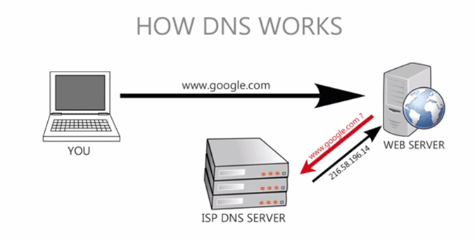

**Ref-https://www.eternalsoftsolutions.com/blog/wp-content/uploads/2019/02/how_dns_works.png**

## DNS Records

|  |  |  |
| --- | --- | --- |
| Records | Description | Function |
| A | Address Record | It returns a 32bit IP addresses. This is where the actual Website is redirected towards most commonly. |
| CNAME | Canonical Name Record | This is an Alias. The DNS Server will continue to lookup with this new name. |
| DNAME | Delegation Name | This again is an alias for a name and also its subname, unlike CNAME, which is only an alias for itself. But similar to CNAME, the DNS Server tries to lookup with this new name as well. |
| DNSKEY | DNS KEY Record | There is another record known as KEY record which I haven’t mentioned here. The format of DNSKEY is same as the KEY, and is used in DNSSEC (more in description). |
| LOC | Location Record | This provides the geographical location depending upon the domain name. |
| MX | Mail Exchange Record | This is related to the email routing which I mentioned previously. This maps the domain name with the email ID. |
| NS | Name Server Record | Provides a DNS ZONE to authorized name servers. |
| TKEY | Secret Key Record | This is the Key used with TSIG which is encrypted under Public Key. |
| TSIG | Transaction Signature | This is used to authenticate updates coming from an approved source or name server. It is used along with TKEY. |
| TXT | Text Record | This file provides machine data related to frameworks and encryption. |

**There are 4 DNS servers involved in loading a webpage:**

The recursor can be thought of as a librarian who is asked to go find a particular book somewhere in a library. The DNS recursor is a server designed to receive queries from client machines through applications such as web browsers. Typically the recursor is then responsible for making additional requests in order to satisfy the client’s DNS query.

**Root nameserver** - The root server is the first step in translating (resolving) human readable host names into IP addresses. It can be thought of like an index in a library that points to different racks of books - typically it serves as a reference to other more specific locations.

* **TLD nameserver** - The top level domain server (TLD) can be thought of as a specific rack of books in a library. This nameserver is the next step in the search for a specific IP address, and it hosts the last portion of a hostname (In example.com, the TLD server is “com”).
* **Authoritative nameserver** - This final nameserver can be thought of as a dictionary on a rack of books, in which a specific name can be translated into its definition. The authoritative nameserver is the last stop in the nameserver query. If the authoritative name server has access to the requested record, it will return the IP address for the requested hostname back to the DNS Recursor (the librarian) that made the initial request.

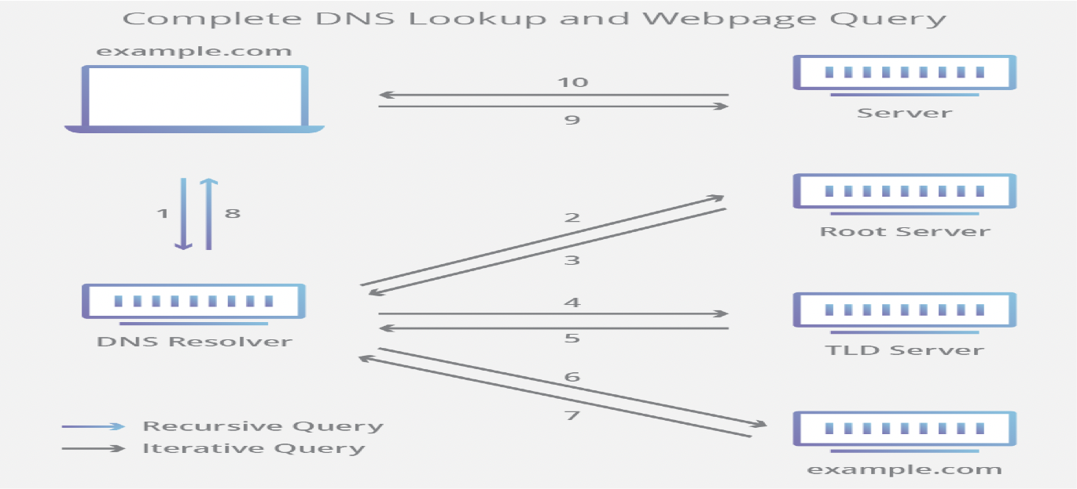

**Ref-https://www.cloudflare.com/img/learning/dns/what-is-dns/dns-lookup-diagram.png**

# Dynamic Host Configuration Protocol

## Introduction

* Dynamic Host Configuration Protocol (DHCP) is a network management protocol used to dynamically assign an Internet Protocol (IP) address to any device, or node, on a network so they can communicate using IP.
* The DHCP client will demand an IP address by broadcasting a DHCP Discover message to the local subnet.

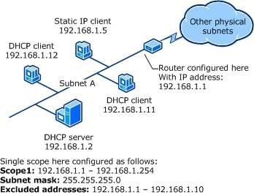

**Ref-https://networkencyclopedia.com/wp-content/uploads/2019/08/configuring-dhcp-scope.jpg**

## DHCP Process

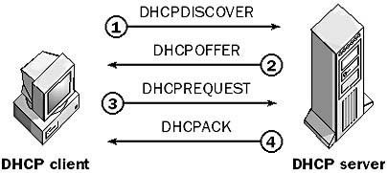

**Ref-https://networkencyclopedia.com/wp-content/uploads/2019/08/dhcp.jpg**

1. **DHCPDISCOVER:** The client broadcasts a request for a DHCP server.
2. **DHCPOFFER:** DHCP servers on the network offer an address to the client.
3. **DHCPREQUEST**: The client broadcasts a request to lease an address from one of the offering DHCP servers.
4. **DHCPACK:** The DHCP server that the client responds to acknowledges the client, assigns it any configured DHCP options, and updates its DHCP database. The client then initializes and binds its TCP/IP protocol stack and can begin network communication.

# Windows Internet Name Service

## Introduction

Windows Internet Name Service, or WINS, is a Microsoft Windows service that dynamically registers NetBIOS names of computers on the network.

The Windows Internet Naming Service (WINS) converts the NetBIOS host names into IP addresses.

It allows the Windows machines on a given LAN segment to recognize Windows machines on other LAN segments.

It was designed specifically to support NetBIOS over TCP/IP (NetBT)

## Advantages

* In order for NetBIOS hosts (servers and clients running pre-Windows 2000 versions of Microsoft Windows) to communicate on a network, their NetBIOS names must first be resolved into IP addresses. WINS servers perform this task.
* Directed traffic to WINS servers generates less network traffic than broadcasts.
* WINS provides a mechanism for browsing network resources across multiple domains and subnets.
* The WINS database of NetBIOS name to IP address mappings is dynamically maintained, eliminating the need for ln hosts files on clients.

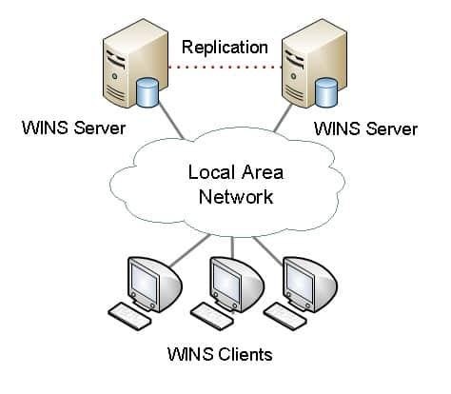

**Ref-https://networkencyclopedia.com/wp-content/uploads/2019/09/wins-windows-internet-name-service.jpg**

## Example

In this example, the following occurs:

1. A WINS client, HOST-A, registers any of its local NetBIOS names with WINS-A, its configured WINS server.
2. Another WINS client, HOST-B, queries WINS-A to locate the IP address for HOST-A on the network.
3. WINS-A replies with the IP address for HOST-A, 192.168.1.20.

## Remote Access Service

A remote access service (RAS) is any combination of hardware and software to enable the remote access tools or information that typically reside on a network of IT devices.

A remote access service connects a client to a host computer, known as a remote access server.

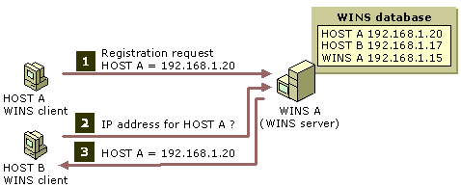

**Ref-https://networkencyclopedia.com/wp-content/uploads/2019/09/windows-internet-name-service-wins.gif**

RAS is arranged within an organization and directly connected with the organization's internal network and systems.

* A remote access server (RAS) is a type of server that provides a suite of services to remotely connected users over a network or the Internet.
* It operates as a remote gateway or central server that connects remote users with an organization's internal local area network (LAN).
* RAS is a service that allows remote clients to connect to the server over a modem using a RAS-based protocol such as the Serial Line Internet Protocol (SLIP) or the newer Point-to-Point Protocol (PPP).
* PPP can run with network protocols such as TCP/IP, IPX/SPX, and NetBEUI; SLIP only supports TCP/IP.
* Examples : Team Viewwer, Ammyy software

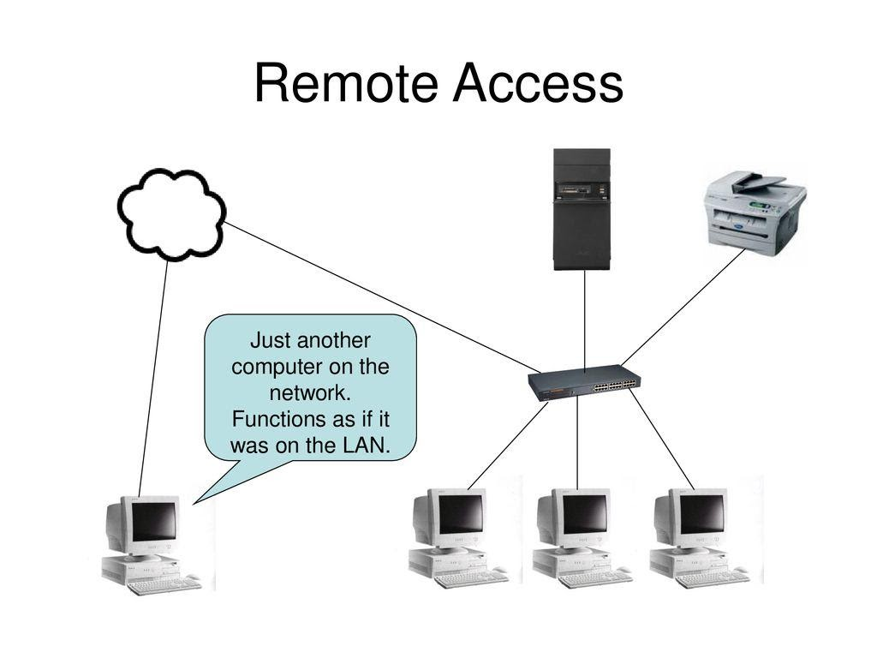

**Ref: https://slideplayer.com/slide/14892336/91/images/2/Remote+Access+Just+another+computer+on+the+network.+Functions+as+if+it+w as+on+the+LAN..jpg**

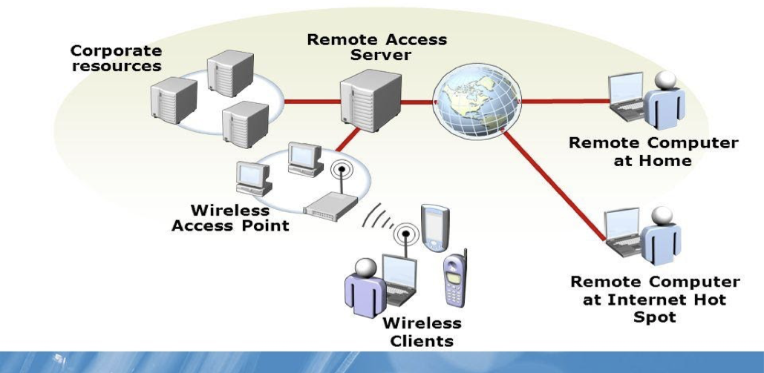

**Ref-https://slideplayer.com/slide/7602148/25/images/4/Remote+Computer+at+Home+Remote+Computer+at+Internet+Hot+Spot.jpg**

# Web Services

## Introduction

Web service is a standardized medium to circulate communication between the client and server applications on the World Wide Web.

A web service is a software module that is designed to perform a certain set of tasks.

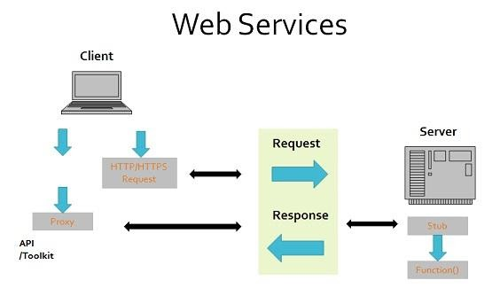

**Ref-https://documentation.alphasoftware.com/pages/Guides/Services/Web%20Service%20Clients/images/WebServicesSimple.jpg**

A web service is a client server application or application component for communication A web service communicate over network between two devices  
It is a software system for interoperable machine to machine communication

A web service is a collection of open protocols and standards used for exchanging data between applications or systems

## Web Services Architecture

1. **Provider**-Theprovidercreatesthewebserviceandmakesitavailabletoclient application who want to use it.

2. **Requestor**-Are questor is nothing but the client application that needs to recontact a web service. The client application can be a .Net, Java, or any other language based application which looks for some sort of functionality via a web service.

3. **Broker**-Thebrokerisnothingbuttheapplicationwhichprovidesaccesstothe UDDI. The UDDI, as discussed in the earlier topic enables the client application to locate the web service.

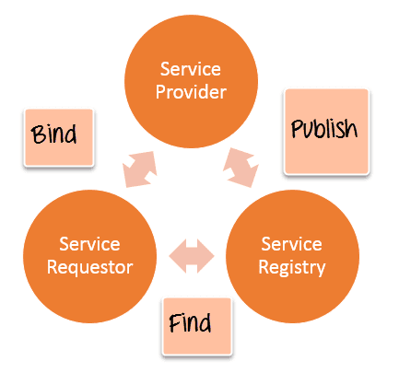

**Ref-https://www.guru99.com/images/3-2016/032316_0646_Webservicea3.png**

1. **Publish**-Aproviderinformsthebroker(serviceregistry)abouttheexistence of the web service by using the broker's publish interface to make the service accessible to clients
2. **Find**-There questor consults the broker to locate a published webservice
3. **Bind**-Withtheinformationitgainedfromthebroker(serviceregistry)about

the web service, the requestor is able to bind, or invoke, the web service.

## Types of Web Services

There are mainly two types of web services.

1. SOAP web services.
2. RESTful web services.

## SOAP (Simple Object Access Protocol)

SOAP is known as a transport-independent messaging protocol. SOAP is based on transferring XML data as SOAP Messages. Each message has something which is known as an XML document. Only the structure of the XML document follows a specific pattern, but not the content. The best part of Web services and SOAP is that its all sent via HTTP, which is the standard web protocol.

Here is what a SOAP message consists of

Each SOAP document needs to have a root element known as the <Envelope> element. The root element is the first element in an XML document.

The "envelope" is in turn divided into 2 parts. The first is the header, and the next is the body.

The header contains the routing data which is basically the information which tells the XML document to which client it needs to be sent to.

The body will contain the actual message.  
The diagram below shows a simple example of the communication via SOAP.

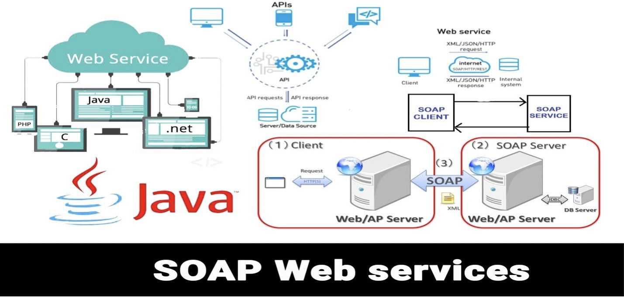

**Ref-https://miro.medium.com/max/7016/1*ecBXg7uI6pr1TQU9dVBNew.jpeg**

## Web Services Advantages

1. **Exposing Business Functionality on the network**-A webservice is a unit of managed code that provides some sort of functionality to client applications or end users. This functionality can be invoked over the HTTP protocol which means that it can also be invoked over the internet. Nowadays all applications are on the internet which makes the purpose of Web services more useful. That means the web service can be anywhere on the internet and provide the necessary functionality as required.

2. **Interoperability amongst applications**-Web services allow various applications to talk to each other and share data and services among themselves. All types of applications can talk to each other. So instead of writing specific code which can only be understood by specific applications, you can now write generic code that can be understood by all applications

3. **A Standardized Protocol which everybody understands**-Web services use standardized industry protocol for the communication. All the four layers (Service Transport, XML Messaging, Service

Description, and Service Discovery layers) uses well-defined protocols in the web services protocol stack.

4. **Reduction in cost of communication**-Web services use SOAP over HTTP protocol, so you can use your existing low-cost internet for implementing web services.

## REST - Representational State Transfer

REST is an architectural style not a protocol.

Restful Web Service is a lightweight, maintainable, and scalable service that is built on the REST architecture.

Restful Web Service, expose API from your application in a secure, uniform, stateless manner to the calling client.

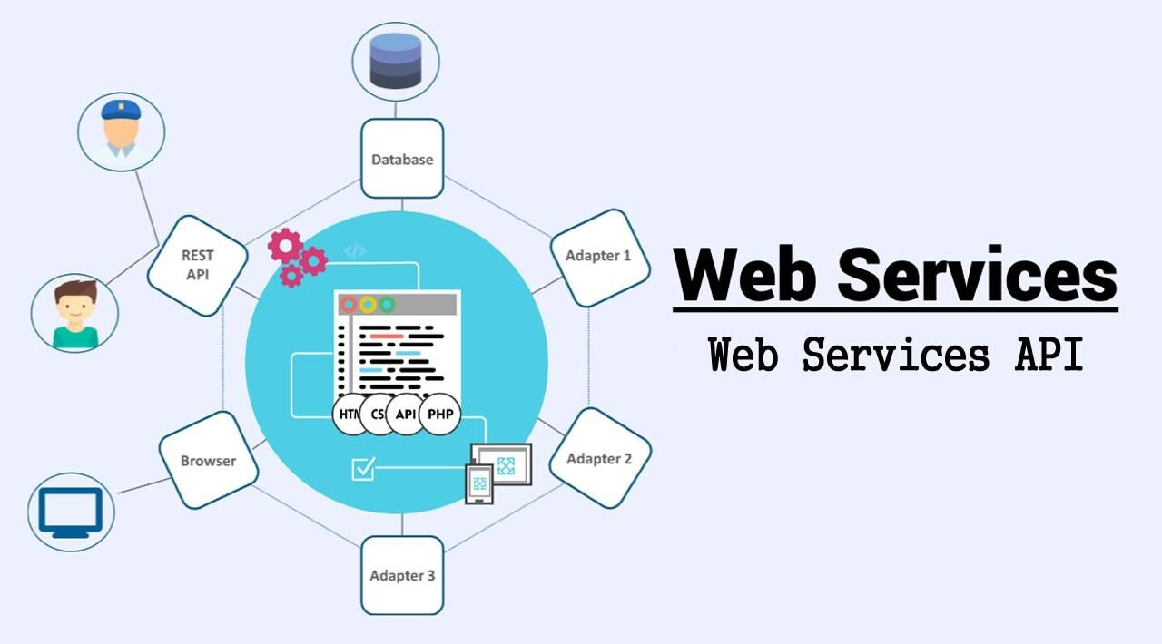

**Ref-https://miro.medium.com/max/7016/1*ecBXg7uI6pr1TQU9dVBNew.jpeg**

## Advantages

|  |  |  |
| --- | --- | --- |
| Type | Advantages | Description |
| SOAP | Security | SOAP defines its own security known as WS Security |
|  | Language and Platform independent | SOAP web services can be written in any programming language and executed in any platform |
| RESTful | Fast | RESTful Web Services are fast |
| Language and Platform independent | It is also language and platform independent |
| Can use SOAP | RESTful web services can use SOAP web services as the implementation |
| Permits different data format | RESTful web service permits different data format such as Plain Text, HTML, XML and JSON |

**Disadvantages**

|  |  |
| --- | --- |
| Disadvantages | Description |
| Slow | SOAP uses XML format that must be parsed to be read. It defines many standards that must be followed while developing the SOAP applications. So it is slow and consumes more bandwidth and resource. |
| WSDL Dependent | SOAP uses WSDL and doesn't have any other mechanism to discover the service |

# Proxy Services

## Introduction

A proxy server is a server (a computer system or an application) that acts as an intermediate for requests from clients looking for resources from other servers. A client connects to the proxy

server, inviting some service, such as a file, connection, web page, or another resource available from a different server and the proxy server estimates the request as a way to simplify and control its difficulty. Proxies were generated to add structure and encapsulation to circulated systems.

The main purpose of proxy service is to filter requests to ensure that no dangerous traffic creeps in by relating strict routing rules and to boost the performance of the system.

A proxy server is a server (a computer system or an application) that acts as an intermediate for requests from clients looking for resources from other servers.

## Functions:

Monitoring and Filtering Improving performance Translation  
Accessing services anonymously Security

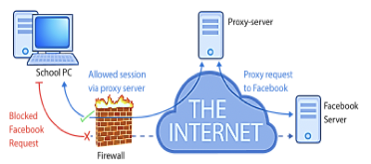

**Ref-https://www.google.com/url?sa=i&url=https%3A%2F%2Fen.wikipedia.org%2Fwiki%2FProxy_server&psig=AOvVaw04nu3-U1qG**

**Anonymity:** The web server you use can only see the IP address of the proxy and not your system.

**Control**: If you are the owner of a website, you can see who visits your website. You can choose who visits your website. If you have blocked someone from your website they would get a message saying something like “site unavailable”

**Caching:** You can save bandwidth if I cache a web site.

**Malware:** You can intercept unwanted things and stop junks at the proxy.

**Load Balancing:** Efficiently distributing incoming network traffic among servers.

**Types of Proxy services**

Proxy services are of two types

**Forward proxy.**

A forward proxy is an Internet-facing proxy that is used to retrieve a range of sources.

**Reverse proxy**

A reverse proxy is particularly used for the protection and security of the server. It includes tasks like caching, authentication and decryption.

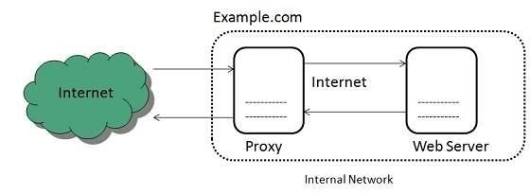

**Ref-:https://www.tutorialspoint.com/internet_technologies/images/internet-forward_proxy.jpg**

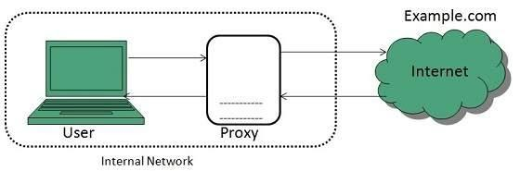

**Ref-https://www.tutorialspoint.com/internet_technologies/images/internet-reverse_proxy.jpg**

# Network Devices

Network devices are the devices used for consolidating a network, connecting to a network,

routing the packets, strengthening the signals, interactive with others, surfing the web,

sharing files on the network.

## Functions of Network Interface Card (NIC)

A Network interface card (also known as a NIC, network card, or network interface

controller) is an electronic device that joins a computer to a computer network, usually a

LAN. It is considered a piece of computer hardware. The NIC contains the electronic circuitry

required to connect using a wired connection (e.g., Ethernet) or a wireless connection (e.g., WiFi).



Image 1 – Gigabit Ethernet NIC

Reference - <https://techterms.com/definition/nic>

## Repeaters

Repeaters receive network signals on one port, amplify them, and repeat them out the other

port. Since they operate only at the Physical layer of the OSI model, repeaters can intersect

different media types but cannot convert protocols.

The repeater can do more harm than good because it propagates everything, including noise

and error packets. The purpose of a repeater is to extend the maximum distance of a single

network segment.



Image 2 – Repeater Mode

Reference - <https://www.tp-link.com/ae/support/faq/151/>

## Hub

A hub (also called a concentrator) serves as a central joining point for several network

devices. At a basic level, a hub is nothing more than a multiport repeater. A hub repeats what

it obtains on one port to all other ports.

## Types of hubs - There are three types of Hubs

### Active Hub

An active hub is usually powered and amplifies and cleans up the signal it receives, thus

doubling the effective segment distance limitation for the specific topology.

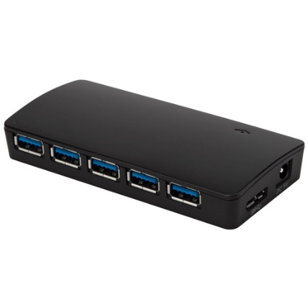

Image3 – Active Hub

Active Hub features

* Need a power source
* Power added to the signal when passed through port
* Prevents weakening of signal by multiple devices being attached
* Repeats signal to all hosts connected to hub

### Passive Hub

A passive hub typically is unpowered and makes only physical, electrical connections.

Usually, the maximum segment distance of a topology is shortened because the hub takes some

power away from the signal strength in order to do its job.

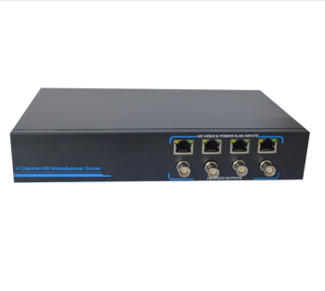

Image4 – Passive Hub

Passive Hub Features

* Act as connection point, not as repeater
* Do not require electricity to run
* Inexpensive and easy to configure

### Intelligent Hub

When compared with active and passive hubs, intelligent hubs have more benefits. People who desire to extend businesses in networking might allocate users to use the same pool in an effective way through these hubs.

Implementing an intelligent hub enhances the performance of a LAN connection. When there arises any defect in the physical equipment, it can be found easily and resolved through management data that is corrected by the hub.

Intelligent hubs also have the feature called flexibility that means it has increased transmission rates for multiple devices. It has a transmission rated of nearly 10, 16 with a speed of nearly 100Mbps for desktop connection.

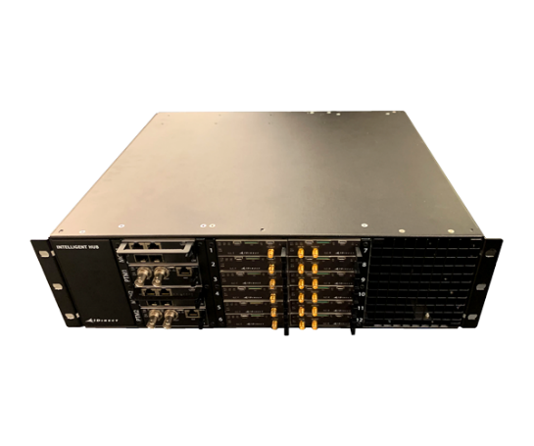

Image5 – Intelligent Hub

Intelligent Hub Functions

* Setting alerts on problem conditions such as excessive collisions
* Isolating and disconnecting problem computers
* Providing network statistics to remote management consoles

# Switches

## What is a switch?

Switches are key building blocks for any network. They connect multiple devices, such as

computers, wireless access points, printers, and servers; on the same network within a building

or campus. A switch enables connected devices to share information and talk to each other.

A switch is a data link layer networking device which connects devices in a network and uses

packet switching to send and receive data over the network.

When a user accesses the internet or another computer network outside their immediate location,

messages are sent through the network of transmission media. This technique of transferring the

information from one computer network to another network is known as switching. Switching in

a computer network is achieved by using switches. A switch is a small hardware device which is

used to join multiple computers together with one local area network (LAN).



Image 1 -Switch

Reference - <https://www.indiamart.com/proddetail/networking-switches-dlink-and-digisol-11032831233.html>

## Role of switches in networking

● Network switches operate at layer 2 (Data link layer) in the OSI model.

● Switching is transparent to the user and does not require any configuration in the home

network.

● Switches are used to forward the packets based on MAC addresses.

● A Switch is used to transfer the data only to the device that has been addressed. It verifies

the destination address to route the packet appropriately.

● It is operated in full duplex mode.

● Packet collision is minimum as it directly communicates between source and destination.

● It does not broadcast the message as it works with limited bandwidth.

Why is switching concept required?

Switching concept is developed because of the following reasons:

● Bandwidth: It is defined as the maximum transfer rate of a cable. It is a very critical and expensive resource. Therefore, switching techniques are used for the effective utilization of the bandwidth of a network.

● Collision: Collision is the effect that occurs when more than one device transmits the

message over the same physical media, and they collide with each other. To overcome

this problem, switching technology is implemented so that packets do not collide with

each other.

## Types of Switches

Switches are the connectivity points of an Ethernet network. These are small devices that can

receive data from multiple input ports and send it to the specific output port that takes data to its

intended destination in the network. There are different types of switches in a network. These

are:

**1. Unmanaged switches –**

These are the switches that are mostly used in home networks and small businesses as

they plug-in and instantly start doing their job and such switches do not need to be

watched or configured. These require only small cable connections. It allows devices on a

network to connect with each other such as a computer to a computer or a computer to a

printer in one location. They are the least expensive switches among all categories.



Image2 -Unmanaged Switch

Reference - <https://www.netgear.com/business/products/switches/unmanaged/>

**2. Managed switches –**

These types of switches have many features like the highest levels of security, precision

control and full management of the network. These are used in organizations containing a

large network and can be customized to enhance the functionality of a certain network.

These are the costliest option but their scalability makes them an ideal option for a

network that is growing. They are achieved by setting a simple network management

protocol (SNMP).

They are of two types:

**a. Smart switches:**

These switches offer basic management features with the ability to create some

levels of security but have a simpler management interface than the other

managed switches. Thus, they are often called partially managed switches. These

are mostly used in fast and constant LANs which support gigabit data transfer and

allocations. It can accept configuration of VLANs (Virtual LAN).

**b. Enterprise managed switches:**

They have features like ability to fix, copy, transform and display different

network configurations along with a web interface SNMP agent and command

line interface. These are also known as fully managed switches and are more

expensive than the smart switches as they have more features that can be

enhanced. These are used in organizations that contain a large number of ports,

switches and nodes.



Image 3 -Managed Switch

Reference - <https://www.netgear.com/business/products/switches/unmanaged/>

**3. LAN switches –**

These are also known as Ethernet switches or data switches and are used to reduce

network congestion or bottleneck by distributing a package of data only to its intended

recipient. These are used to connect points on a LAN.



Image4 -LAN Switch

Reference - <https://www.netgear.com/business/products/switches/unmanaged/>

**4. PoE switches –**

PoE switches are used in PoE technology which stands for power over Ethernet that is a

technology that integrates data and power on the same cable allowing power devices to

receive data in parallel to power. Thus, these switches provide greater flexibility by

simplifying the cabling process.



Image5 -PoE Switch

Reference - <https://www.wifi-stock.com/details/zq-poes-8-7.html/products/switches/unmanaged/>

## Advantages of Switches

● Switches increase available network bandwidth

● Switches reduce the workload on individual computers

● Switches increase network performance

● Networks that include switches experience fewer frame collisions because switches

create collision domains for each connection (a process called micro segmentation)

● Switches connect directly to workstations.

## Disadvantages of Switches

● A Switch is more expensive than network bridges.

● A Switch cannot determine the network connectivity issues easily.

● Proper designing and configuration of the switch are required to handle multicast packets.

● Broadcast traffic may be troublesome.

● While limiting broadcasts, they are not as good as routers.

# Routers

## What is a Router?

The router is a physical or virtual internetworking device that is designed to receive, analyze, and

forward data packets between computer networks. A router examines a destination IP address of

a given data packet, and it uses the headers and forwarding tables to decide the best way to

transfer the packets. There are some popular companies that develop routers; such are Cisco,

3Com, HP, Juniper, D-Link, Nortel, etc.

Some important points of routers are given below:

● A router is used in LAN (Local Area Network) and WAN (Wide Area Network)

environments. For example, it is used in offices for connectivity, and you can also

establish the connection between distant networks such as from Bhopal to

● It shares information with other routers in networking.

● It uses the routing protocol to transfer the data across a network.

● Furthermore, it is more expensive than other networking devices like switches and hubs.



Image6 -Router

Reference - <https://www.lifewire.com/what-is-a-router-2618162>

A router works on the third layer of the OSI model, and it is based on the IP address of a

computer. It uses protocols such as ICMP to communicate between two or more networks. It is

also known as an intelligent device as it can calculate the best route to pass the network packets

from source to the destination automatically.

A virtual router is a software function or software-based framework that performs the same

functions as a physical router. It may be used to increase the reliability of the network by virtual

router redundancy protocol, which is done by configuring a virtual router as a default gateway. A

virtual router runs on commodity servers, and it is packaged with alone or another network

functions, like load balancing, firewall packet filtering, and wide area network optimization

capabilities.

## How does Router work?

A router analyzes a destination IP address of a given packet header and compares it with the

routing table to decide the packet's next path. The list of routing tables provides directions to

transfer the data to a particular network destination. They have a set of rules that compute the

best path to forward the data to the given IP address.

Routers use a modem such as a cable, fiber, or DSL modem to allow communication between

other devices and the internet. Most of the routers have several ports to connect different devices

to the internet at the same time. It uses the routing tables to determine where to send data and

from where the traffic is coming.

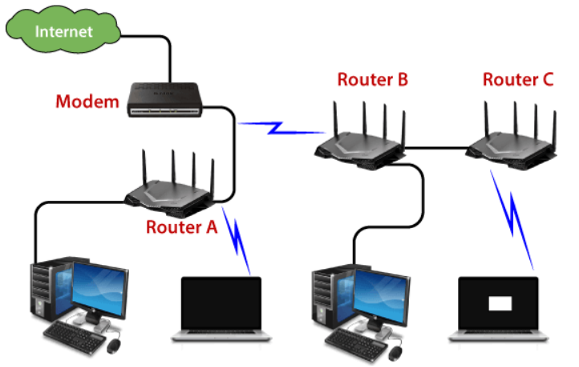

Image7 -Router working

Reference - <https://www.javatpoint.com/router>

A routing table mainly defines the default path used by the router. So, it may fail to find the best

way to forward the data for a given packet. For example, the office router along a single default

path instructs all networks to its internet services provider.

There are two types of tables in the router that are static and dynamic. The static routing tables

are configured manually, and the dynamic routing tables are updated automatically by dynamic

routers based on network activity.

## Routing Table

A routing table determines the path for a given packet with the help of an IP address of a device

and necessary information from the table and sends the packet to the destination network. The

routers have the internal memory that is known as Random Access Memory (RAM). All the

information of the routing table is stored in RAM of routers.

A routing table contains the following entities:

● It contains an IP address of all routers which are required to decide the way to reach the

destination network.

● It includes extrovert interface information.

● Furthermore, it also contained IP addresses and subnet masks of the destination host.

## Network Element in Router

There are two types of a network element in the router which are as follows:

● Control plane: A router supports a routing table that determines which path and physical

interface connection should be used to send the packet. It is done by using internal

pre-configured directives, which are called static routes, or by learning routes with the

help of routing protocol. A routing table stores the static and dynamic routes. Then the

control-plane logic eliminates the unnecessary directives from the table and constructs a

forwarding information base that is used by the forwarding plane.

● Forwarding plane: A router sends data packets between incoming and outgoing interface

connections. It uses information stored in the packet header and matches it to entries in

the FIB, which is supplied by the control plane; accordingly, it forwards the data packet

to the correct network type. It is also called the user plane or data plane.

## Routing Protocols

Routing protocols specify a way for the router to identify other routers on the network and make

dynamic decisions to send all network messages. There are several protocols, which are given

below:

● Open Shortest Path First (OSPF): It is used to calculate the best route for the given

packets to reach the destination, as they move via a set of connected networks. It is

identified by the Internet Engineering Task Force (IETF) as Interior Gateway Protocol.

● Border Gateway Protocol (BGP): It helps manage how packets are routed on the internet

via exchange of information between edge routers. It provides network stability for

routers if one internet connection goes down while forwarding the packets, it can adapt

another network connection quickly to send the packets.

● Interior Gateway Routing Protocol (IGRP): It specifies how routing information will be

exchanged between gateways within an independent network. Then, the other network

protocols can use the routing information to determine how transmissions should be

routed.

● Enhanced Interior Gateway Routing Protocol (EIGRP): In this protocol, if a router is

unable to find a path to a destination from the tables, it asks the route to its neighbors, and

they pass the query to their neighbors until a router has found the path. When the entry of

the routing table changes in one of the routers, it informs its neighbors only about the

changes, but does not send the entire table.

● Exterior Gateway Protocol (EGP): It decides how routing information can be exchanged

between two neighbor gateway hosts, each of which has its own router. Additionally, it is

commonly used to exchange routing table information between hosts on the internet.

● Routing Information Protocol (RIP): It determines how routers can share information

while transferring traffic among connected groups of local area networks. The maximum

number of hops that can be allowed for RIP is 15, which restricts the size of networks

that RIP can support.

## Features of Router

● A router works on the 3rd layer (Network Layer) of the OSI model, and it is able to

communicate with its adjacent devices with the help of IP addresses and subnet.

● A router provides high-speed internet connectivity with the different types of ports like

gigabit, fast-Ethernet, and STM link port.

● It allows the users to configure the port as per their requirements in the network.

● Routers' main components are central processing unit (CPU), flash memory, RAM,

Non-Volatile RAM, console, network, and interface card.

● Routers are capable of routing the traffic in a large networking system by considering the

sub-network as an intact network.

● Routers filter out the unwanted interference, as well as carry out the data encapsulation

and decapsulation process.

● Routers provide the redundancy as it always works in master and slave mode.

● It allows the users to connect several LAN and WAN.

● Furthermore, a router creates various paths to forward the data.

## Types of Routers

There are various types of routers in networking; such are given below:

**1. Wireless Router:** Wireless routers are used to offer Wi-Fi connectivity to laptops, smartphones, and other devices with Wi-Fi network capabilities, and it can also provide standard ethernet routing for a small number of wired network systems.

Wireless routers are capable of generating a wireless signal in your home or office, and it allows

the computers to connect with routers within a range, and use the internet. If the connection is

indoors, the range of the wireless router is about 150 feet, and when the connection is outdoors,

then its range is up to 300 feet.

Furthermore, you can make more secure wireless routers with a password or get your IP address.

Thereafter, you can log in to your router by using a user ID and password that will come with

your router.



Image8 -Wireless Router

Reference - <https://www.lifewire.com/what-is-a-router-2618162>

**2. Brouter:** A brouter is a combination of the bridge and a router. It allows transferring the data

between networks like a bridge. And like a router, it can also route the data within a network to

the individual systems. Thus, it combines these two functions of bridge and router by routing

some incoming data to the correct systems while transferring the other data to another network.



Image9 -Brouter

Reference - <https://www.lifewire.com/what-is-a-router-2618162>

**3. Core router:** A core router is a type of router that can route the data within a network, but it is

not able to route the data between the networks. It is a computer communication system device

and the backbone of networks, as it helps to link all network devices. It is used by internet

service providers (ISPs), and it also provides various types of fast and powerful data

communication interfaces.



Image10 -Core Router

Reference - <https://www.indiamart.com/proddetail/cisco-service-provider-core-router-17912957255.html>

**4. Edge router:** An edge router is a lower-capacity device that is placed at the boundary of a

network. It allows an internal network to connect with the external networks. It is also called an

access router. It uses an External BGP (Border Gateway Protocol) to provide connectivity with

remote networks over the internet.

There are two types of edge routers in networking:

● Subscriber edge router

● Label edge router

The subscriber edge router belongs to an end-user organization, and it works in a situation were

it acts on a border device.

The label edge router is used in the boundary of Multiprotocol Label Switching (MPLS)

networks. It acts as a gateway between the LAN, WAN, or the internet.



Image11 -Edge Router

Reference - <https://www.technodabbler.com/edge-router-x/>

**5. Broadband routers:** Broadband routers are mainly used to provide high-speed internet access

to computers. It is needed when you connect to the internet through phone and use voice over IP

technology (VOIP).

All broadband routers have the option of three or four Ethernet ports for connecting the laptop

and desktop systems. A broadband router is configured and provided by the internet service

provider (ISP). It is also known as a broadband modem, asymmetric digital subscriber line

(ADSL), or digital subscriber line (DSL) modem.



Image12 - Broadband Router

Reference - <https://www.technodabbler.com/edge-router-x/>

## Advantages of Router

There are so many benefits of a router, which are given below:

● Security: Router provides the security, as LANs work in broadcast mode. The

information is transmitted over the network and traverses the entire cable system.

Although the data is available to each station, but the station which is specifically

addressed reads the data.

● Performance enhancement: It enhances the performance within the individual network.

For example, if a network has 14 workstations, and all generate approximately the same

volume of traffic. The traffic of 14 workstations runs through the same cable in a single

network. But if the network is divided into two sub-networks each with 7 workstations,

then a load of traffic is reduced to half. As each of the networks has its own servers and

hard disk, so fewer PCs will need the network cabling system.

● Reliability: Routers provide reliability. If one network gets down when the server has

stopped, or there is a defect in the cable, then the router services, and other networks will

not be affected. The routers separate the affected network, whereas the unaffected

networks remain connected, without interrupting the work and any data loss.

● Networking Range: In networking, a cable is used to connect the devices, but its length

cannot exceed 1000 meters. A router can overcome this limitation by performing the

function of a repeater (Regenerating the signals). The physical range can be as per the

requirement of a particular installation, as long as a router is installed before the

maximum cable range exceeds.

## Disadvantages of Router

● They operate based on routable network protocols.

● They are expensive compared to other network devices.

● Dynamic router communications can cause additional network overhead. This results into

less bandwidth for user data.

● They are slower as they need to analyze data from layer-1 through layer-3.

● They require a considerable number of initial configurations.

● They are protocol dependent devices which must understand the protocol they are

forwarding.

# Bridges

## What is a bridge?

A network bridge is a device that divides a network into segments. Each segment represents a

separate collision domain, so the number of collisions on the network is reduced. Each collision

domain has its own separate bandwidth, so a bridge also improves the network performance.

A bridge works at the Data link layer (Layer 2) of the OSI model. It inspects incoming traffic

and decides whether to forward it or filter it. Each incoming Ethernet frame is inspected for the

destination MAC address. If the bridge determines that the destination host is on another

segment of the network, it forwards the frame to that segment.

Consider the following example network:



Image13 -Bridge

Reference - <https://geek-university.com/ccna/what-is-a-network-bridge/>

In the picture above we have a network of four computers. The network is divided into segments

by a bridge. Each segment is a separate collision domain with its own bandwidth. Let’s say that

Host A wants to communicate with Host C. Host A will send the frame with the Host C’s

destination MAC address to the bridge. The bridge will inspect the frame and forward it to the

segment of the network Host C is on.

Network bridges offer substantial improvements over network hubs, but they are not widely used

any more in modern LANs. Switches are commonly used instead.

## Types of Bridges

● Transparent Bridge: As the name suggests, it is an invisible bridge in the computer

network. The main function of this bridge is to block or forward the data depending on

the MAC address. The other devices within the network are unaware of the existence of

bridges. These types of bridges are most popular and operate in a transparent way to the

entire networks which are connected to hosts. This bridge saves the addresses of MAC

within a table that is similar to a routing table. This estimates the information when a

packet is routed to its position. So it can also merge several bridges to check incoming

traffic in a better way. These bridges are implemented mainly in Ethernet networks.

● Translational Bridge: A translational bridge plays a key role in changing a networking

system from one type to another. These bridges are used to connect two different

networks like token ring & Ethernet. This bridge can add or remove the data based on the

traveling direction, and forward the frames of the data link layer in between LANs which

uses various types of network protocols. The different network connections are Ethernet

to FDDI/token ring otherwise Ethernet on UTP (unshielded twisted pair) to coax & in

between FOC and copper wiring.

● Source-route Bridge: Source-route Bridge is one type of technique used for Token Ring

networks and it is designed by IBM. In this bridge, the total frame route is embedded in

one frame. So that it allows the bridge to make precise decisions of how the frame is

forwarding using the network. By using this method, two similar network segments are

connected to the data link layer. It can be done in a distributed way wherever end-stations

join within the bridging algorithm.

## Functions of Bridges

The main functions of bridges in a computer network include the following.

● This networking device is used for dividing local area networks into several segments.

● In the OSI model, it works under the data link layer.

● It is used to store the address of MAC in PCs used in a network and also used for

diminishing the network traffic.

## Advantages of Bridge

The advantages are

● It acts as a repeater to extend a network

● Network traffic on a segment can be reduced by subdividing it into network

communications

● Collisions can be reduced.

● Some types of bridges connect the networks with the help of architectures & types of

media.

● Bridges increase the available bandwidth to individual nodes because fewer network

nodes share a collision domain

● It avoids waste BW (bandwidth)

● The length of the network can be increased.

● Connects different segments of network transmission.

## Disadvantages of Bridge

The disadvantages are

● It is unable to read specific IP addresses because they are more troubled with the MAC

addresses.

● They cannot help while building the network between the different architectures of

networks.

● It transfers all kinds of broadcast messages, so they are incapable to stop the scope of

messages.

● These are expensive as we compare with repeaters

● It doesn’t handle more variable & complex data load which occurs from WAN.

## Difference between Bridge and Router

|  |  |
| --- | --- |
| **Bridge** | **Router** |
| A bridge is a networking device that is used to  connect two local area networks (LANs) by  using media access control addresses and  transmit the data between them. | A router is also a networking device that  sends the data from one network to another  network with the help of their IP addresses. |
| A bridge is able to connect only two different  LAN segments. | A router is capable of connecting the LAN  and WAN. |
| A bridge transfers the data in the form of  frames. | A router transfers the data in the form of  packets. |
| It sends data based on the MAC address of a  device. | It sends data based on the IP address of a  device. |
| The bridge has only one port to connect the  device. | The router has several ports to connect the  devices. |
| The bridge does not use any table to forward  the data. | The router uses a routing table to send the  data. |

# Internet Service Provider

## What is an Internet Service Provider?

ISP stands for Internet Service Provider. It is a company that provides access to the internet and

similar services such as Website designing and virtual hosting. For example, when you connect

to the Internet, the connection between your Internet-enabled device and the internet is executed

through a specific transmission technology that involves the transfer of information packets

through an Internet Protocol route.

Data is transmitted through different technologies, including cable modem, dial-up, DSL, high

speed interconnects. An Internet service provider is also known as an Internet access provider

(IAP).



Image14 -ISP

Reference - <https://www.javatpoint.com/isp-full-form>

## Why use an ISP?

Unless you have a specialized line (other than a telephone line), you cannot connect directly to

the internet using your telephone line. Indeed, the telephone line was not designed for this:

● it was originally designed to transport "voice", i.e., a frequency modulation in the range

of the voice tone

● telephone servers only know how to start a conversation from a telephone number

● unless you resort to a special service, generally it is not possible to have communication between more than two points...

So, the internet service provider is an intermediary (connected to the internet by specialized

lines) which gives you access to the Internet, using a number which you enter using your

modem, and which enables a connection to be established.

How does the ISP connect you to the Internet?

When you are connected to the Internet through your service provider, communication between

you and the ISP is established using a simple protocol: PPP (Point to Point Protocol), a protocol

making it possible for two remote computers to communicate without having an IP address. In

fact your computer does not have an IP address. However, an IP address is necessary to be able to go onto the Internet because the protocol used on the Internet is the TCP/IP protocol which

makes it possible for a very large number of computers which are located by these addresses to

communicate. So, communication between you and the service provider is established according

to the PPP protocol which is characterized by:

● a telephone calls

● initialization of communication

● verification of the user’s name (login or userid)

● verification of the password

Once you are "connected", the internet service provider lends you an IP address which you keep

for the whole duration that you are connected to the internet. However, this address is not fixed

because at the time of the next connection the service provider gives you one of its free addresses

(Therefore, different because depending on its capacity, it may have several hundreds of thousand addresses.). Your connection is therefore a proxy connection because it is your service provider who sends all the requests you make and the service provider who receives all the pages that you request and who returns them to you. It is for these reasons for example that when you have Internet access via an ISP, you must pick up your email on each connection because generally it is the service provider that receives your email (it is stored on one of its servers).

## Types of Internet Service Providers

The connection between your Internet enabled device and the global network is executed through a specific digital data transmission technology. It represents the transfer of information packets through an Internet Protocol route.

Accordingly, based on the method of data transmission, the Internet access provided by ISPs can

be divided into many types, some of which are as follows:

● Dial-up Internet access - This is the oldest method of providing access to the Internet. It

uses a telephone line to perform a modem-to-modem connection. For that purpose, the

user's computer is attached to a telephone line enabled modem device, which dials into

the node of the ISP and starts transferring data between the servers that store websites the

user wants to see and their Internet connected device. The dial-up Internet is today

considered outdated in most Internet societies due to the slow connection speed it ensures

(about 40-50 kbit/s.). However, the wide availability of telephone access makes this type

of Internet access the only alternative for remote areas that remain off the broadband

network. It is also the least expensive Internet access service and is preferred by users on

a tight budget.



Image15 -Dial-up internet access

Reference - <https://www.highspeed-internet-providers.com/how-dialup-works.html>

● DSL - DSL, which stands for 'digital subscriber line' is an advanced version of the dial-up

Internet access method. It uses high frequency to execute a connection over the telephone

network and allows the internet and the phone connection to run on the same telephone

line. This method offers an Asymmetric Digital Subscriber (ADSL), where the upload

speed is less than the download speed, and a Symmetric Digital Subscriber Line (SDSL),

which offers equal upload and download speeds. Out of these two, ADSL is more popular

among users and is popularly known as DSL.



Image16 -DSL

Reference - <https://www.javatpoint.com/dsl-full-form>

● Cable Internet - The cable Internet is among the most preferred methods for providing

residential Internet access. Technically speaking, it represents a broadband Internet access

method, using the high-bandwidth cable television network to transmit data between the

global network and the households. To use cable Internet, you will need a cable modem at

home that will be connected with the CMTS (Cable Modem Termination System) of your

cable ISP. The cable Internet access can be offered together with a cable television

subscription and separately, for customers' convenience. The second case incurs higher

subscription fees due to the extra equipment installation costs.

● Wireless Broadband (WiBB): It is a modern broadband technology for Internet access. It

allows high-speed wireless internet within a large area. To use this technology, you are

required to place a dish on the top of your house and point it to the transmitter of your

Wireless Internet Service Provider (WISP).



Image17 -Wireless Broadband

Reference - <https://www.wifi4india.com/broadband/wireless-broadband-service.html>

● Wi-Fi Internet - Wi-Fi (from Wireless Fidelity) has become one of the most widely

distributed Internet access methods, with the growing usage of portable computers and

Internet enabled mobile devices, such as smartphones, PDAs, game consoles, etc. In this

sense, it is the most mobile Internet access method, since you are able to use it

everywhere as long as you are located within the scope of coverage, i.e. within the range

of an Internet connected wireless network. Due to its ability to serve mobile devices,

Wi-Fi is used in public places such as airports, hotels and restaurants to provide Internet

access to customers. There are also specialized Wi-Fi hotspots where the service is either

free or paid. Some of the largest cities in the world are in the process of building Wi-Fi

networks that cover all the public places in the central areas.



Image18 - WIFI

Reference - <https://www.princehotels.com/kawana/notice/information-on-internet-wifi-connection-service-in-kawana-hotel/>

● ISDN: It is a short form of Integrated Services Digital Network. It is a telephone system

network which integrates a high-quality digital transmission of voice and data over the

same standard phone line. It offers a fast upstream and downstream Internet connection

speed and allows both voice calls and data transfer.



Image19 -ISDN

Reference - <http://jonapchan.blogspot.com/2012/01/isdn.html>

● Ethernet: It is a wired LAN (Local Area Network) where computers are connected within

a primary physical space. It enables devices to communicate with each other via a

protocol (a set of rules or common network language). It may provide different speeds

such as 10 Mbps, 100 Mbps and 10 Gbps.



Image20 -Ethernet

Reference - <https://www.conceptdraw.com/examples/ethernet-network>

Learning Outcome

## Network Security

# Introduction to Network Security

***Network security is the process of taking preventative measures to protect the underlying networking infrastructure from unauthorized access, misuse, malfunction, modification, destruction or improper disclosure.***

The Internet has undoubtedly become a huge part of our lives. Many people in today’s generation rely on the Internet for many of their professional, social and personal activities. But are you sure your network is secure?

## ****How can we ensure network security?****

We must ensure that the passwords are Strong and Complex everywhere- within the network too, not just on individual computers within an org. These passwords cannot be simple , default and easily guessable ones. This simple step can go a long way toward securing your networks.

## ****Why is security so important?****

Information security performs key roles such as:

* The organisation’s ability to function without any hindrance
* Enabling the safe operation of applications implemented on the organisation’s IT systems
* Protecting the data the organisation collects and its uses

### **What are the different types of Network Security?**

* Access Control
* Application Security
* Firewalls
* Virtual Private Networks(VPN)
* Behavioral Analytics
* Wireless Security
* Intrusion Prevention System
  1. **Basic router security**

**How to Secure a Cisco Router Basically?**

Security is an important concern for a network engineer. How can a network engineer provide security of a router? In this**Basic Cisco Router Security Configuration** lesson, we will talk about, how to **Secure a Router**. We still see the **Router Security Steps** one by one. Let’s start.

## Disabling Unused Ports

For a router basic security configuration, the first step is **shutdowning**all the **unused ports**. If you are using a port, it needs to be up. But if you don’t use any ports, then always disable (administratively down) these unused ports.

Shutdowning, in other words, disabling a port is very easy. You can do it with “**shutdown**” command under that interface.

Router(config)# **interface fastethernet 0/0**

Router(config-if)# **shutdown**

## Enable and Enable Secret Passwords

The second important router security step is **passwords**. You should use passwords on your router.  
Here, there are two passwords: **Enable**and **enable secret password**.

**Enable password** stores the password in clear text format. So, it is easy to see it. But ,enable secret password stores password in encrypted mode. So, it is more secure.

To **encrypt**all passwords in a router/switch, you can use “**service pasword-encryption**” command.  
Let’s see how to configure this paswords on a router.

Router(config)# **enable password 12345**

Router(config)# **enable secret 12345**

Router(config)# **service password-encryption**

## Configuring Console Access Password

Like telnet, you also need to configure **Console Access** password for a secure router. To do this, firstly you need to enter line **console mode** and then set the **password string**. Again, with the login keyword, you can activate it.

* 1. **Different types of encryption**

**What is Data Encryption in Network Security?**

Data encryption is the process of converting data from a readable format to a scrambled piece of information. This is done to prevent prying eyes from reading confidential data in transit. Encryption can be applied to documents, files, messages, or any other form of communication over a network.

**How Does Data Encryption Work?**

The data that needs to be encrypted is termed plaintext or cleartext. The plaintext needs to be passed via some encryption algorithms, which are basically mathematical calculations to be done on raw information. There are multiple encryption algorithms, each of which differs by application and security index.

Apart from the algorithms, one also needs an encryption key. Using said key and a suitable encryption algorithm, the plaintext is converted into the encrypted piece of data, also known as ciphertext. Instead of sending the plaintext to the receiver, the ciphertext is sent through insecure channels of communication.

Once the ciphertext reaches the intended receiver, he/she can use a decryption key to convert the ciphertext back to its original readable format i.e. plaintext. This decryption key must be kept secret at all times, and may or not be similar to the key used for encrypting the message. Let’s understand the same with an example.

Let us understand the work process with the help of an example.

**Example**

A woman wants to send her boyfriend a personal text, so she encrypts it using specialized software that scrambles the data into what appears to be unreadable gibberish. She then sends the message out, and her boyfriend, in turn, uses the correct decryption to translate it.

Thus, what starts out looking like this:

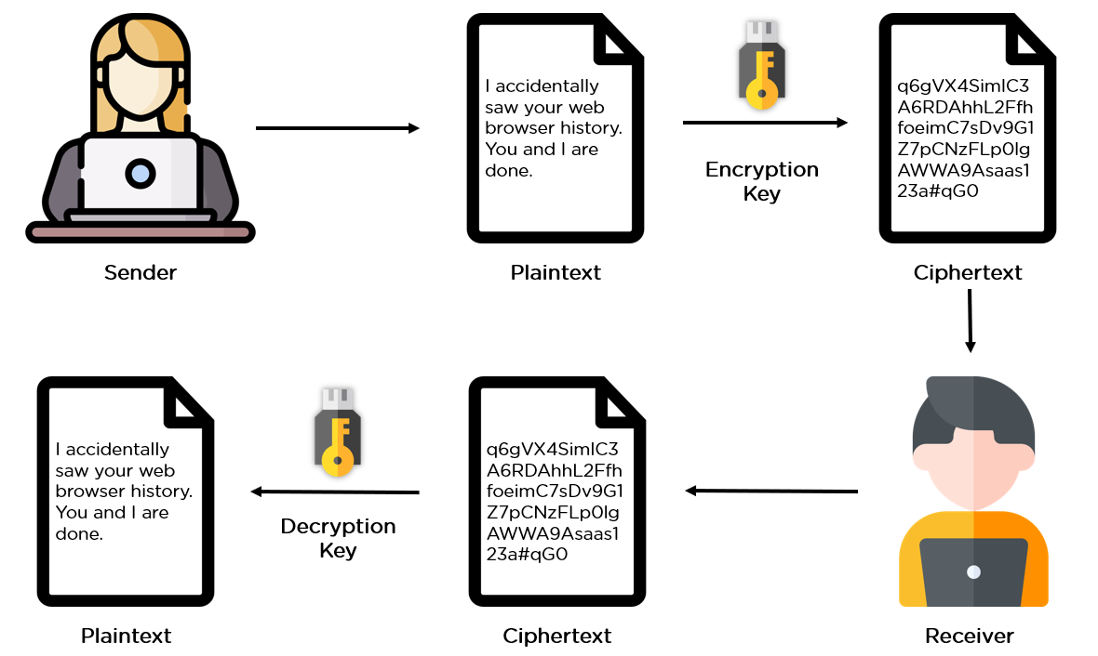

**Image 1:**[**https://www.simplilearn.com/data-encryption-methods-article**](https://www.simplilearn.com/data-encryption-methods-article)

Fortunately, the keys do all the actual encryption/decryption work, leaving both people more time to contemplate the smoldering ruins of their relationship in total privacy.

Next, in our learning about effective encryption methods, let us find out why we need encryption.

**Why Do We Need Data Encryption?**

If anyone wonders why organizations need to practice encryption, keep these four reasons in mind:

* **Authentication:**Public key encryption proves that a website's origin server owns the private key and thus was legitimately assigned an SSL certificate. In a world where so many fraudulent websites exist, this is an important feature.
* **Privacy:** Encryption guarantees that no one can read messages or access data except the legitimate recipient or data owner. This measure prevents cybercriminals, hackers, internet service providers, spammers, and even government institutions from accessing and reading personal data.
* **Regulatory Compliance:** Many industries and government departments have rules in place that require organizations that work with users’ personal information to keep that data encrypted. A sampling of regulatory and compliance standards that enforce encryption include [HIPAA](https://www.simplilearn.com/bridging-gap-between-hipaa-and-cloud-computing-guide-pdf), PCI-DSS, and the [GDPR](https://www.simplilearn.com/what-is-gdpr-compliance-and-how-to-follow-it-article).
* **Security:** Encryption helps protect information from data breaches, whether the data is at rest or in transit. For example, even if a corporate-owned device is misplaced or stolen, the data stored on it will most likely be secure if the hard drive is properly encrypted. Encryption also helps protect data against malicious activities like man-in-the-middle attacks, and lets parties communicate without the fear of data leaks

**What are the 2 Types of Data Encryption Techniques?**

There are several data encryption approaches available to choose from. Most internet security (IS) professionals break down encryption into three distinct methods: symmetric, asymmetric, and hashing. These, in turn, are broken down into different types. We’ll explore each one separately.

### **What is the Symmetric Encryption Method?**

Also called private-key cryptography or a secret key algorithm, this method requires the sender and the receiver to have access to the same key. So, the recipient needs to have the key before the message is decrypted. This method works best for closed systems, which have less risk of a third-party intrusion.

On the positive side, symmetric encryption is faster than asymmetric encryption. However, on the negative side, both parties need to make sure the key is stored securely and available only to the software that needs to use it.

### **What is the Asymmetric Encryption Method?**

Also called public-key [cryptography](https://www.simplilearn.com/understanding-cryptography-article), this method uses two keys for the encryption process, a public and a private key, which are mathematically linked. The user employs one key for encryption and the other for decryption, though it doesn’t matter which you choose first.

As the name implies, the public key is freely available to anyone, whereas the private key remains with the intended recipients only, who need it to decipher the messages. Both keys are simply large numbers that aren’t identical but are paired with each other, which is where the “asymmetric” part comes in.

## ****Best Encryption Algorithms****

There’s a host of different encryption algorithms available today. Here are five of the more common ones.

* **AES.**The Advanced Encryption Standard (AES) is the trusted standard algorithm used by the United States government, as well as other organizations. Although extremely efficient in the 128-bit form, AES also uses 192- and 256-bit keys for very demanding encryption purposes. AES is widely considered invulnerable to all attacks except for brute force. Regardless, many internet security experts believe AES will eventually be regarded as the go-to standard for encrypting data in the private sector.
* **Triple DES.**Triple DES is the successor to the original [Data Encryption Standard (DES) algorithm](https://www.simplilearn.com/what-is-des-article), created in response to hackers who figured out how to breach DES. It’s symmetric encryption that was once the most widely used symmetric algorithm in the industry, though it’s being gradually phased out. TripleDES applies the [DES](https://www.simplilearn.com/what-is-des-article) algorithm three times to every data block and is commonly used to encrypt UNIX passwords and ATM PINs.
* **RSA.**RSA is a public-key encryption asymmetric algorithm and the standard for encrypting information transmitted via the internet. RSA encryption is robust and reliable because it creates a massive bunch of gibberish that frustrates would-be hackers, causing them to expend a lot of time and energy to crack into systems.
* **Blowfish.**Blowfish is another algorithm that was designed to replace DES. This symmetric tool breaks messages into 64-bit blocks and encrypts them individually. Blowfish has established a reputation for speed, flexibility, and is unbreakable. It’s in the public domain, so that makes it free, adding even more to its appeal. Blowfish is commonly found on e-commerce platforms, securing payments, and in password management tools.
* **Twofish.**Twofish is Blowfish’s successor. It’s license-free, symmetric encryption that deciphers 128-bit data blocks. Additionally, Twofish always encrypts data in 16 rounds, no matter what the key size. Twofish is perfect for both software and hardware environments and is considered one of the fastest of its type. Many of today’s file and folder encryption software solutions use this method.
* **Rivest-Shamir-Adleman (RSA).**Rivest-Shamir-Adleman is an asymmetric encryption algorithm that works off the factorization of the product of two large prime numbers. Only a user with knowledge of these two numbers can decode the message successfully. Digital signatures commonly use RSA, but the algorithm slows down when it encrypts large volumes of data.

## Threats and the basics of securing a network.

**Most Common Network Security Risks**

Here are the most common security threats examples:

**1. Computer virus**

We’ve all heard about them, and we all have our fears. For everyday Internet users, computer viruses are one of the most common network threats in cybersecurity. Statistics show that approximately 33% of household computers are affected with some type of malware, more than half of which are viruses.

Computer viruses are pieces of software that are designed to be spread from one computer to another. They’re often sent as email attachments or downloaded from specific websites with the intent to infect your computer — and other computers on your contact list — by using systems on your network. Viruses are known to send spam, disable your security settings, corrupt and steal data from your computer including personal information such as passwords, even going as far as to delete everything on your hard drive.

**2. Rogue security software**

Leveraging the fear of computer viruses, scammers have a found a new way to commit Internet fraud.

Rogue security software is malicious software that mislead users to believe that they have network security issues, most commonly a computer virus installed on their computer or that their security measures are not up to date. Then they offer to install or update users’ security settings. They’ll either ask you to download their program to remove the alleged viruses, or to pay for a tool. Both cases lead to actual malware being installed on your computer.

**3. Trojan horse**

Metaphorically, a “Trojan horse” refers to tricking someone into inviting an attacker into a securely protected area. In computing, it holds a very similar meaning — a Trojan horse, or “Trojan,” is a malicious bit of attacking code or software that tricks users into running it willingly, by hiding behind a legitimate program.

They spread often by email; it may appear as an email from someone you know, and when you click on the email and its included attachment, you’ve immediately downloaded malware to your computer. [Trojans](https://securitytrails.com/blog/trojan-attacks) also spread when you click on a false advertisement.

Once inside your computer, a Trojan horse can record your passwords by logging keystrokes, hijacking your webcam, and stealing any sensitive data you may have on your computer.



**4. Adware and spyware**

By “adware” we consider any software that is designed to track data of your browsing habits and, based on that, show you advertisements and pop-ups. Adware collects data with your consent — and is even a legitimate source of income for companies that allow users to try their software for free, but with advertisements showing while using the software. The adware clause is often hidden in related User Agreement docs, but it can be checked by carefully reading anything you accept while installing software. The presence of adware on your computer is noticeable only in those pop-ups, and sometimes it can slow down your computer’s processor and internet connection speed.

When adware is downloaded without consent, it is considered malicious.

Spyware works similarly to adware, but is installed on your computer without your knowledge. It can contain keyloggers that record personal information including email addresses, passwords, even credit card numbers, making it dangerous because of the high risk of identity theft.

**5. Computer worm**

Computer worms are pieces of malware programs that replicate quickly and spread from one computer to another. A worm spreads from an infected computer by sending itself to all of the computer’s contacts, then immediately to the contacts of the other computers. Interestingly, they are not always designed to cause harm; there are worms that are made just to spread. Transmission of worms is also often done by exploiting software vulnerabilities. While we don’t hear about them much today, computer worm are one of the most common computer network threats.

**6. DOS and DDOS attack**

Have you ever found yourself waiting impatiently for the online release of a product, one that you’re eagerly waiting to purchase? You keep refreshing the page, waiting for that moment when the product will go live. Then, as you press F5 for the last time, the page shows an error: “Service Unavailable.” The server must be overloaded!

There are indeed cases like these where a website’s server gets overloaded with traffic and simply crashes, sometimes when a news story breaks. But more commonly, this is what happens to a website during a DoS attack, or denial-of-service, a malicious traffic overload that occurs when attackers overflood a website with traffic. When a website has too much traffic, it’s unable to serve its content to visitors.

A DoS attack is performed by one machine and its internet connection, by flooding a website with packets and making it impossible for legitimate users to access the content of flooded website. Fortunately, you can’t really overload a server with a single other server or a PC anymore. In the past years it hasn’t been that common if anything, then by flaws in the protocol.

A DDoS attack, or distributed denial-of-service attack, is similar to DoS, but is more forceful. It’s harder to overcome a DDoS attack. It’s launched from several computers, and the number of computers involved can range from just a couple of them to thousands or even more.

Since it’s likely that not all of those machines belong to the attacker, they are compromised and added to the attacker’s network by malware. These computers can be distributed around the entire globe, and that network of compromised computers is called botnet.

Since the attack comes from so many different IP addresses simultaneously, a DDoS attack is much more difficult for the victim to locate and defend against.

**7. Phishing**

Phishing is a method of a [social engineering](https://securitytrails.com/blog/social-engineering-attacks) with the goal of obtaining sensitive data such as passwords, usernames, credit card numbers.

The attacks often come in the form of instant messages or phishing emails designed to appear legitimate. The recipient of the email is then tricked into opening a malicious link, which leads to the installation of malware on the recipient’s computer. It can also obtain personal information by sending an email that appears to be sent from a bank, asking to verify your identity by giving away your private information.

**8. Rootkit**

Rootkit is a collection of software tools that enables remote control and administration-level access over a computer or computer networks. Once remote access is obtained, the rootkit can perform a number of malicious actions; they come equipped with keyloggers, password stealers and antivirus disablers.

Rootkits are installed by hiding in legitimate software: when you give permission to that software to make changes to your OS, the rootkit installs itself in your computer and waits for the hacker to activate it. Other ways of rootkit distribution include phishing emails, malicious links, files, and downloading software from suspicious websites.



**9. SQL Injection attack**

We know today that many servers storing data for websites use SQL. As technology has progressed, network security threats have advanced, leading us to the threat of SQL injection attacks.

SQL injection attacks are designed to target data-driven applications by exploiting security vulnerabilities in the application’s software. They use malicious code to obtain private data, change and even destroy that data, and can go as far as to void transactions on websites. It has quickly become one of the most dangerous privacy issues for data confidentiality. You can read more on the history of [SQL injection attacks](https://en.wikipedia.org/wiki/SQL_injection) to better understand the threat it poses to cybersecurity.

**10. MIM attacks**

[Man-in-the-middle attacks](https://securitytrails.com/blog/man-in-the-middle-attacks) are cybersecurity attacks that allow the attacker to eavesdrop on communication between two targets. It can listen to a communication which should, in normal settings, be private.

As an example, a man-in-the-middle attack happens when the attacker wants to intercept a communication between person A and person B. Person A sends their public key to person B, but the attacker intercepts it and sends a forged message to person B, representing themselves as A, but instead it has the attackers public key. B believes that the message comes from person A and encrypts the message with the attackers public key, sends it back to A, but attacker again intercepts this message, opens the message with private key, possibly alters it, and re-encrypts it using the public key that was firstly provided by person A. Again, when the message is transferred back to person A, they believe it comes from person B, and this way, we have an attacker in the middle that eavesdrops the communication between two targets.

Here are just some of the types of MITM attacks:

* DNS spoofing
* HTTPS spoofing
* IP spoofing
* ARP spoofing
* SSL hijacking
* Wi-Fi hacking

## Secure Administrative Access

Configuring administrative access on the Cisco router is an important step toward network security. You can access all Cisco routers in various ways:

* Console
* VTY
* Aux
* SNMP
* HTTP

### Connection Through the Console Port

To protect administrative access to the routers, you must protect the console port via a password policy. You can store passwords locally on the router or use some kind of remote administration using a CiscoSecure Access Control Server authentication, authorization, and accounting (AAA) server. You can store passwords locally on the router or use Remote Authentication Dial-In User Service (RADIUS) or Terminal Access Controller Access Control System + (TACACS+) for remote AAA using CSACS.

### Password Policy

You should keep the following rules in mind when formulating a password policy:

* Acceptable password length must be between 1 and 25 characters. Blank passwords are not a part of a good security policy. The passwords should contain alphanumeric, uppercase, and lowercase characters.
* On Cisco equipment, the first character in the password cannot be a number.
* Leading spaces in the password are ignored; however. spaces after the first character are not ignored.
* Passwords must be changed often, and using the same passwords over again should be avoided. Be creative and generate unique passwords every time. Do not use obvious passwords such as your dog's name or your date of birth.

### Securing Privilege EXEC Mode Using the enable secret Command

When you first power on the router, assuming that there is no prior configuration stored in the nonvolatile RAM (NVRAM), the router enters the Initial Configuration dialog box. The Initial Configuration dialog box is a menu system that assists you in applying basic configuration on the router. You can use Ctrl+Z to break out of the Initial Configuration dialog box.

To make changes to the router configuration, you have to first enter privilege EXEC mode. By default, you do not need a password to access privilege EXEC mode. You can use the enable command to access the privilege EXEC mode of a router:

Router> enable

Router#

Once you are in privilege EXEC mode, you can then secure privilege EXEC mode on the routers using the enable secret command in global configuration mode. The enable secret command encrypts the password to the privilege EXEC mode using the Message Digest 5 (MD5) hashing algorithm. It is a one-way hash. In other words, once you have a password using MD5, you cannot unhash it:

Router> enable

Router# configure terminal

Router(config)# enable secret Passwordciscorocks

Router(config)#

# LAN security considerations

Office network security is the local area network (LAN) in the workspace or office. Security of this network is a top priority. It doesn’t matter how big your company is or [if you’re a startup](https://www.securicy.com/blog/4-ways-startups-can-protect-network-security-a-risk-based-approach/), you don’t want a malicious actor taking down your network or breaking into your proprietary software.

he first thing that I recommend people do when they’re thinking about network security is starting with an inventory.

## Your Network Security Starts with Taking Inventory

Start by asking: are there servers on the network? How many workstations in the office? How many laptops or cell phones connected to the network? Are the [IoT devices](https://www.securicy.com/blog/what-is-the-internet-of-things-iot/) mandatory? What type of data are these IoT devices transmitting around?

Taking this inventory will give you a good idea of the level of complexity of your office network. Your network security depends on securing or removing all of these devices.

The average, modern, early-stage SaaS company that has around 20 employees can operate with a moderately lighter level of security than a company that employs 500 employees that has multiple servers and IoT devices all over the office space. Those companies that operate on a larger scale likely have a person in charge of security (i.e. Security Officer) within the organization who has a strong understanding of network security.

## Securing Your Office Network

For the average SaaS company you can operate on the following minimum network security recommendations:

#### **1. Get a support router with an activated firewall**

Change the default admin login credentials so that if your network is compromised the hacker can’t make changes to the network. Every time a vulnerability is discovered, there will be a firmware update issued. It’s critical that you install these updates. An easy way to make sure an update isn’t missed would be to turn on the auto-update feature.

#### **2. Use WPA2 encryption**

This is a type of encryption that secures the vast majority of Wi-Fi networks. The WPA2 should have a strong password.

#### **3. Create a “Guest Network”**

You want this for individuals who visit the office but are not a part of your company. Most modern routers have a feature to enable a guest network. This is an easy way to boost your network security.

#### **4. Physically secure your network hardware**

Physical security is a very important consideration. The hardware shouldn’t be out in the open where anybody can access it. You want hardware stored in a controlled room or locked office where a member of the organization can keep an eye on it. An extra precaution would be to monitor the hardware with a security camera.

#### **5. Acquire higher-quality routers**

You likely have basic routers like the kind that the service provider sets up or the cheap ones from the electronics store come with a low-level firewall. However, a business-grade router comes with stronger firewalls. Some even have intrusion detection or intrusion protection systems built into them that make them worth the extra cost. The stronger routers are likely to have better performance on the network because these models have the ability to handle more devices.

#### **6. Deactivate the “use ports” on the router**

There are often USB or Ethernet ports on a router that are not in use. Deactivating these ports will limit the chances that somebody could plug a rouge device into the network. Since these ports are one more entry point to worry about when it comes to LAN security, turn them off if you can.

#### **7. Add MAC address filtering**

MAC address filtering is a security measure that only allows devices that the organization is aware of to connect to the network. The filtering can be done collecting the [MAC address](https://en.wikipedia.org/wiki/MAC_filtering) of every device and then uploading those credentials into a database in the router. It may seem like an extra precaution but it just ensures that if a hacker was able to get the password to the network, they wouldn’t be able to gain access without having one of the identified MAC addresses.

In the end, your data isn’t fully secure unless your network is secure too.

**5. Network Security Devices.**

# Types of Network Security Devices

## Active Devices

These security devices block the surplus traffic. Firewalls, antivirus scanning devices, and content filtering devices are the examples of such devices.

## Passive Devices

These devices identify and report on unwanted traffic, for example, intrusion detection appliances.

## Preventative Devices

These devices scan the networks and identify potential security problems. For example, penetration testing devices and vulnerability assessment appliances.

## Unified Threat Management (UTM)

These devices serve as all-in-one security devices. Examples include firewalls, content filtering, web caching, etc.

# Firewalls

A firewall is a network security system that manages and regulates the network traffic based on some protocols. A firewall establishes a barrier between a trusted internal network and the internet. Firewalls exist both as software that run on a hardware and as hardware appliances. Firewalls that are hardware-based also provide other functions like acting as a DHCP server for that network.

Most personal computers use software-based firewalls to secure data from threats from the internet. Many routers that pass data between networks contain firewall components and conversely, many firewalls can perform basic routing functions. Firewalls are commonly used in private networks or *intranets* to prevent unauthorized access from the internet. Every message entering or leaving the intranet goes through the firewall to be examined for security measures.

An ideal firewall configuration consists of both hardware and software based devices. A firewall also helps in providing remote access to a private network through secure authentication certificates and logins.

## Hardware and Software Firewalls

Hardware firewalls are standalone products. These are also found in broadband routers. Most hardware firewalls provide a minimum of four network ports to connect other computers. For larger networks − e.g., for business purpose − business networking firewall solutions are available.

Software firewalls are installed on your computers. A software firewall protects your computer from internet threats.

# Antivirus

An antivirus is a tool that is used to detect and remove malicious software. It was originally designed to detect and remove viruses from computers.

Modern antivirus software provide protection not only from virus, but also from worms, Trojan-horses, adwares, spywares, keyloggers, etc. Some products also provide protection from malicious URLs, spam, phishing attacks, botnets, DDoS attacks, etc.

# Content Filtering

Content filtering devices screen unpleasant and offensive emails or webpages. These are used as a part of firewalls in corporations as well as in personal computers. These devices generate the message "Access Denied" when someone tries to access any unauthorized web page or email.

Content is usually screened for pornographic content and also for violence- or hate-oriented content. Organizations also exclude shopping and job related contents.

Content filtering can be divided into the following categories −

* Web filtering
* Screening of Web sites or pages
* E-mail filtering
* Screening of e-mail for spam
* Other objectionable content

# Intrusion Detection Systems

Intrusion Detection Systems, also known as Intrusion Detection and Prevention Systems, are the appliances that monitor malicious activities in a network, log information about such activities, take steps to stop them, and finally report them.

Intrusion detection systems help in sending an alarm against any malicious activity in the network, drop the packets, and reset the connection to save the IP address from any blockage. Intrusion detection systems can also perform the following actions −

* Correct Cyclic Redundancy Check (CRC) errors
* Prevent TCP sequencing issues
* Clean up unwanted transport and network layer options

Learning Outcome

Able to Configure and Perform Remote Accessing & Routing.

# Overview of Remote Access

## Introduction to Remote Access

Remote access is a method to establish a connection over the server, and it extends the ability to access the network. It allows the user to manage and view the system to fix any faults or requirements when it is not able to connect physically. In other terms, the user can access the system with an internet connection or telecommunication method. IT employees and company chiefs who are traveling to a different location should need to access the computer networks by using remote access control.

A remote access strategy also gives organizations the flexibility to hire the best talent regardless of location, remove silos and promote collaboration between teams, offices and locations.

Technical support professionals also use remote access to connect to users' computers from remote locations to help them resolve issues with their systems or software. One common method of providing remote access is via a remote access VPN connection. A VPN creates a safe and encrypted connection over a less secure network, such as the internet. VPN technology was developed as a way to enable remote users and branch offices to securely log into corporate applications and other resources.

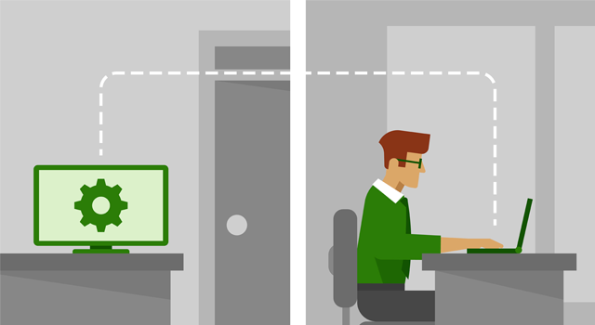

Image : Introduction to Remote access.

Reference: <https://1e1851c3a3519282423c-9ba0ce2ac411d9ff878c3235c5043bea.ssl.cf1.rackcdn.com/post/remote-desktop-security-040119-h.png>

## How Remote Access Works

* Remote access is generally obtained with the combined working of hardware and software with robust network connectivity. For example, standard remote access is available before the widespread internet connection. It is attained by terminal simulation which is managed using a hardware modem linked to a telephonic network. The secured remote access is provided by secure software called VPN. It is used to communicate all the hosts by a wired interface network or via internet connection or means of Wi-Fi network interface. The VPN is used to link every individual network to the allotted private networks.
* By using remote access, the VPN has the capability of connecting every private network to the VPN server. When the user is associated with a network through VPN, then the particular software encrypts the traffic before it reaches the destination over the internet. The gateway or VPN server is situated at every target network and then decrypted the information and then transmit to the concerned host located in the private network. A computer should possess the software which should enable it to associate the system which is hosted in remote access service of the organization. If the user wants to interact with another system in the host location, he can log in to the IP of the system in the host location and can check all the status which is displayed in the window of the desktop of the targeted computer.
* The organization can use remote desktop to allow the user to link the network and applications remotely. The application software that is used in remote desktop is integrated into the operating system of the remote host. It allows the applications to execute in a remote method on a network server which is viewed temporarily at the remote establishment of the remote connection. The user can access safely on the cloud applications from any location on any device by using different authentication techniques that include remote sign on for one time that enables the user secure and easy control to the application without any need of VPN configuration or modification of firewall strategies.

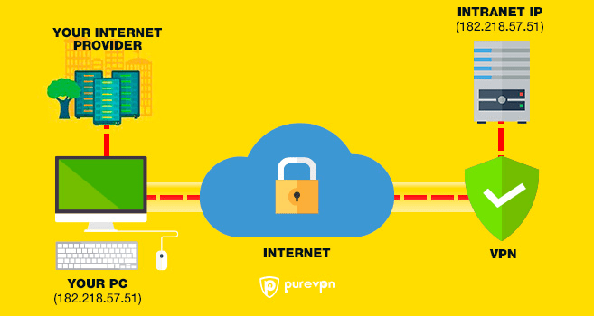

Image : How Remote Access Works

Reference: <https://d107a8nc3g2c4h.cloudfront.net/blog/wp-content/uploads/2015/06/remote-access-vpn1.png>

## Types of Remote Access

Traditionally, enterprises use modems and dial-up technologies to allow employees to connect to office networks via telephone networks connected to remote access servers. Devices connected to dial-up networks use analog modems to call assigned telephone numbers to make connections and send or receive messages.

### Broadband

Broadband provides remote users with high-speed connection options to business networks and to the internet. There are several types of broadband, including the following:

### Cable Broadband

Cable broadband shares bandwidth across many users and, as a result, upstream data rates can be slow during high-usage hours in areas with many subscribers.

### DSL (Digital Subscriber Line)

DSL broadband provides high-speed networking over a telephone network using broadband modem tech. However, DSL only works over a limited physical distance and may not be available in some areas if the local telephone infrastructure doesn't support DSL technology.

### Cellular Internet

Cellular internet services can be accessed by mobile devices via a wireless connection from any location where a cellular network is available.

### Satellite Internet

Satellite internet services use telecommunications satellites to provide users with internet access in areas where land-based internet access isn't available, as well as for temporary mobile installations.

### Fiber Optics

Fiber optics broadband technology enables users to transfer large amounts of data quickly and seamlessly.

## Remote Access Protocol

A remote access protocol is a communications standard that allows your computer to talk to the remote network. Common remote access and VPN protocols include the following:

### Point-to-Point Protocol (PPP)

Point-to-Point Protocol (PPP) enables hosts to set up a direct connection between two endpoints.

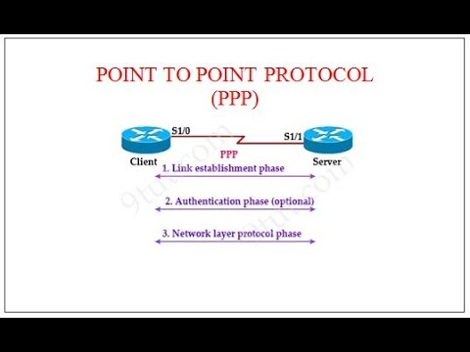

Image : Point-to-Point Protocol(PPP)

Reference: <https://i.ytimg.com/vi/iG5mkMgkPo0/hqdefault.jpg>

## IPSec

Internet Protocol Security is a set of security protocols used to enable authentication and encryption services to secure the transfer of IP packets over the internet.

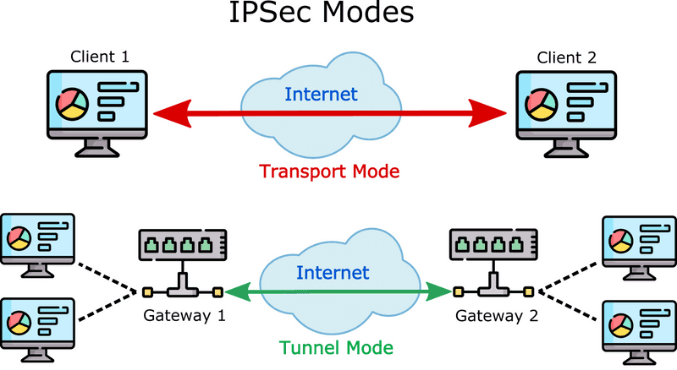

Image : Point-to-Point Protocol(PPP)

Reference: <https://www.twingate.com/static/8690c1d6814e87231a0902b9e5e46a76/5a190/ipsec-mode-diagram.png>

## Point-to-Point Tunneling (PPTP)

Point-to-Point Tunneling (PPTP) is one of the oldest protocols for implementing virtual private networks. However, over the years, it has proven to be vulnerable to many types of attack. Although PPTP is not very secure, it persists in some cases.

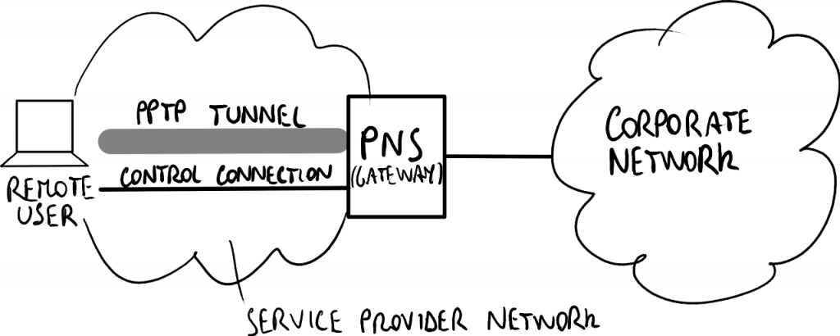

Image : Point-to-Point Tunneling(PPTP)

Reference: <https://techgenix.com/tgwordpress/wp-content/uploads/2017/07/PPTPgraphic-1024x410.png>

## Layer Two Tunneling Protocol (L2TP)

Layer Two Tunneling Protocol (L2TP) is a VPN protocol that does not offer encryption or cryptographic authentication for the traffic that passes through the connection. As a result, it is usually paired with IPsec, which provides those services.

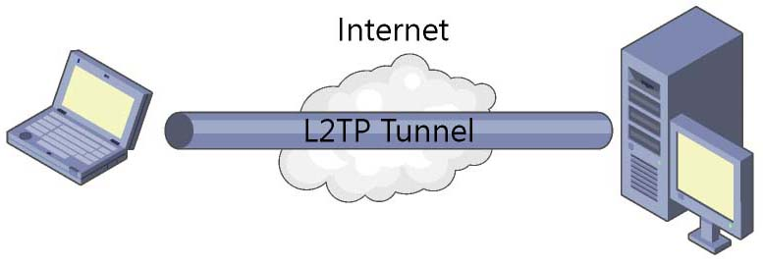

Image : Layer Two Tunneling Protocol(L2TP)

Reference: <https://linuxscriptshub.com/wp-content/uploads/2017/08/l2tp-vpn.jpg>

## Remote Authentication Dial-In User Service (RADIUS)

Remote Authentication Dial-In User Service (RADIUS) is a protocol developed in 1991 and published as an Internet Standard track specification in 2000 to enable remote access servers to communicate with a central server to authenticate dial-in users and authorize their access to the requested system or service.

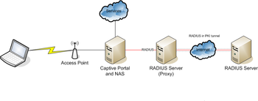

Image : Remote Authentication Dial-In User Service (RADIUS)

Reference: <https://upload.wikimedia.org/wikipedia/commons/thumb/e/e7/Drawing_Roaming_RADIUS.png/350px-Drawing_Roaming_RADIUS.png>

## Terminal Access Controller Access Control System (TACACS)

Terminal Access Controller Access Control System (TACACS) is a remote authentication protocol that was originally common to UNIX networks that enables a remote access server to forward a user's password to an authentication server to determine whether access to a given system should be allowed. TACACS+ is a separate protocol designed to handle authentication and authorization, and to account for administrator access to network devices, such as routers and switches.

## VPN Concept

A VPN is a private network that uses a public network (usually the internet) to connect remote sites or users together. The VPN uses "virtual" connections routed through the internet from the business's private network or a third-party VPN service to the remote site or person. VPNs help ensure security — anyone intercepting the encrypted data can't read it.

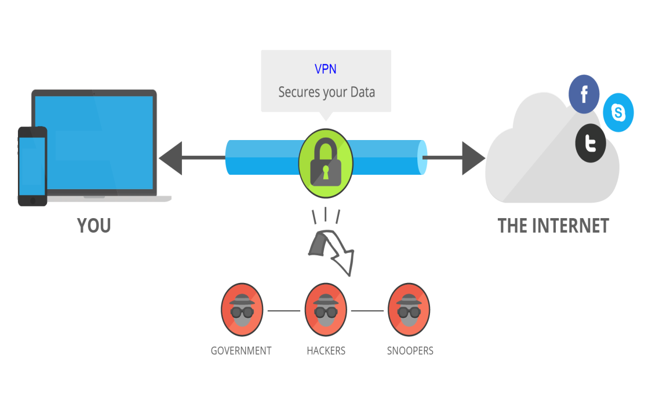

Image : VPN Conept

Reference: <https://media.fs.com/images/community/wp-content/uploads/2018/07/what-is-vpn-router.png>

A VPN's purpose is providing a secure and reliable private connection between computer networks over an existing public network, typically the internet. Before looking at the technology that makes a VPN possible, let's consider all the benefits and features someone should expect in a VPN.

## VPN Benefits

A well-designed VPN provides the following benefits:

* Extended connections across multiple geographic locations without using a leased line
* Improved security for exchanging data
* Flexibility for remote offices and employees to use the business intranet over an existing internet connection as if they're directly connected to the network
* Savings in time and expense for employees to commute if they work from virtual workplaces
* Improved productivity for remote employees

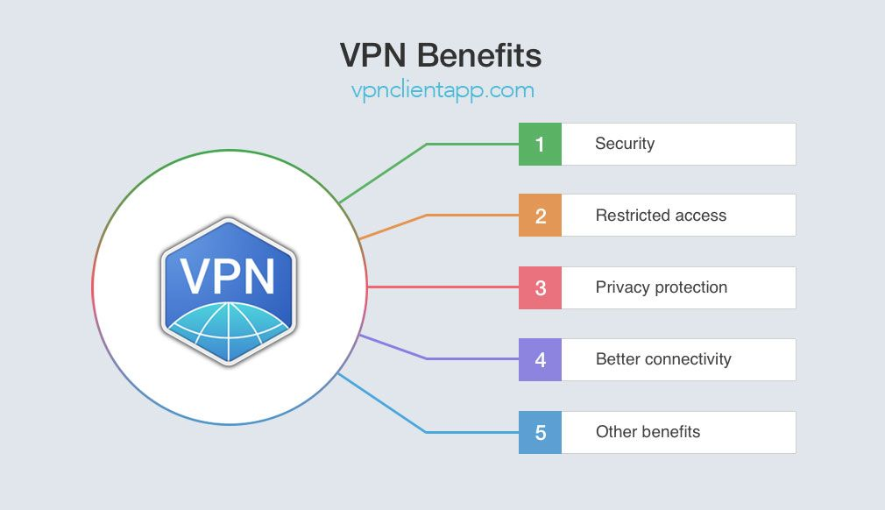

Image : VPN Benefits

Reference: <https://i.pinimg.com/originals/8a/3e/16/8a3e16757aa24e512564e10665b4702f.jpg>

## Features of VPN

A company might not require all these benefits from its business VPN, but it should demand the following essential VPN features:

### Security

The VPN should protect data while it's traveling on the public network. If intruders attempt to capture the data, they should be unable to read or use it.



Image : Features of VPN

Reference: <https://www.safetydetectives.com/wp-content/uploads/2021/08/Best-VPN-Services-300x158.png>

### Reliability

Employees and remote offices should be able to connect to the VPN with no trouble at any time (unless hours are restricted), and the VPN should provide the same quality of connection for each user even when it is handling its maximum number of simultaneous connections.

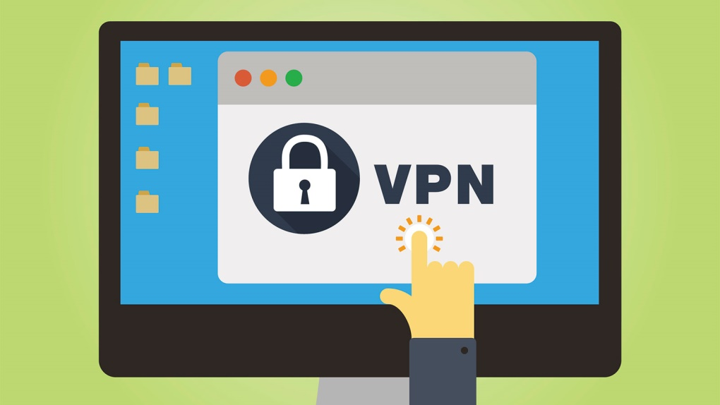

Image : Features of VPN: Reliablity

Reference: <https://cdn.hswstatic.com/gif/VPN.jpg>

### Scalability

As a business grows, it should be able to extend its VPN services to handle that growth without replacing the VPN technology altogether.

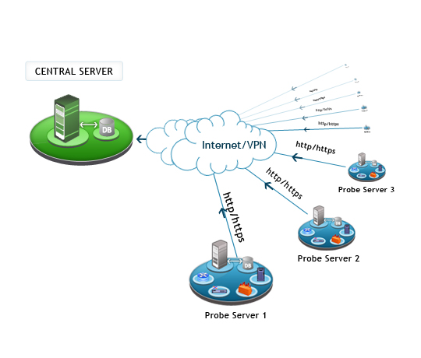

Image : Features of VPN: Scalability

Reference: <https://www.manageengine.com/network-monitoring/images/server-multi-probes.jpg>

# VPN Types

## Public VPN

Public VPN providers are often evaluated on whether they capture information about their users and the number of countries in which they have remote servers. Because a VPN privatizes information about the user, he or she can use a VPN connection to mask the location they're connecting from, which may permit access to geographically restricted information, such as a TV service limited to access from a certain country.

One interesting thing to note about VPNs is that there are no standards about how to set them up. This article covers network, authentication and security protocols that provide the features and benefits listed above. It also describes how a VPN's components work together. If you're establishing your own VPN, though, it's up to you to decide which protocols and components to use and to understand how they work together.

## Remote-Access VPN

A remote-access VPN allows individual users to establish secure connections with a remote computer network. Those users can access the secure resources on that network as if they were directly plugged in to the network's servers. An example of a company that needs a remote-access VPN is a large firm with hundreds of salespeople in the field. Another name for this type of VPN is virtual private dial-up network (VPDN), acknowledging that in its earliest form, a remote-access VPN required dialing in to a server using an analog telephone system.

There are two components required in a remote-access VPN. The first is a network access server (NAS, usually pronounced "nazz" conversationally), also called a media gateway or a remote-access server (RAS). (Note: IT professionals also use NAS to mean network-attached storage.) A NAS might be a dedicated server, or it might be one of multiple software applications running on a shared server. It's a NAS that a user connects to from the internet in order to use a VPN. The NAS requires that user to provide valid credentials to sign in to the VPN. To authenticate the user's credentials, the NAS uses either its own authentication process or a separate authentication server running on the network.

The other required component of remote-access VPNs is client software. In other words, employees who want to use the VPN from their computers require software on those computers that can establish and maintain a connection to the VPN. Most operating systems today have built-in software that can connect to remote-access VPNs, though some VPNs might require users to install a specific application instead. The client software sets up the tunneled connection to a NAS, which the user indicates by its internet address. The software also manages the encryption required to keep the connection secure. You can read more about tunneling and encryption later in this article.

Large corporations or businesses with knowledgeable IT staff typically purchase, deploy and maintain their own remote-access VPNs. Businesses can also choose to outsource their remote-access VPN services through an enterprise service provider (ESP). The ESP sets up a NAS for the business and keeps that NAS running smoothly.

A remote-access VPN is great for individual employees, but what about entire branch offices with dozens or even hundreds of employees? Next, we'll look at another type of VPN used to keep businesses connected LAN-to-LAN

## Site-to-Site VPN

A site-to-site VPN allows offices in multiple fixed locations to establish secure connections with each other over a public network such as the internet. Site-to-site VPN extends the company's network, making computer resources from one location available to employees at other locations.

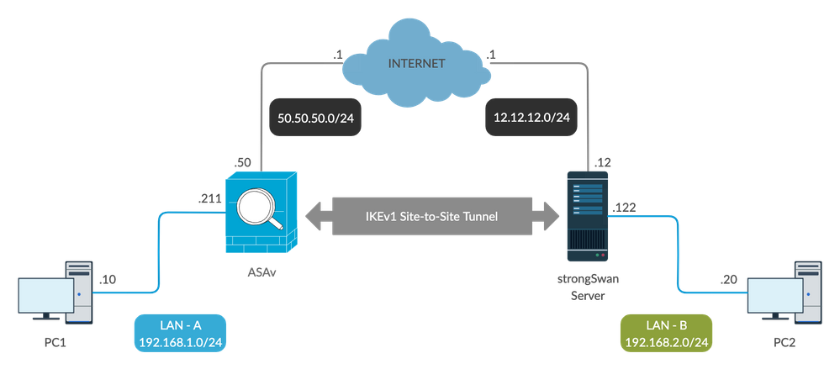

Image : Features of VPN:Site-Site VPN

Reference: <https://www.cisco.com/c/dam/en/us/support/docs/security/asa-5500-x-series-firewalls/215884-configure-a-site-to-site-vpn-tunnel-with-00.png>

An example of a company that needs a site-to-site VPN is a growing corporation with dozens of branch offices around the world.

There are two types of site-to-site VPNs:

1. Intranet-based: If a company has one or more remote locations that they wish to join in a single private network, they can create an intranet VPN to connect each separate LAN to a single WAN.
2. Extranet-based: When a company has a close relationship with another company (such as a partner, supplier or customer), it can build an extranet VPN that connects those companies' LANs. This extranet VPN allows the companies to work together in a secure, shared network environment while preventing access to their separate intranets.

Even though the purpose of a site-to-site VPN is different from that of a remote-access VPN, it could use some of the same software and equipment. Ideally, though, a site-to-site VPN should eliminate the need for each computer to run VPN client software as if it were on a remote-access VPN. Dedicated VPN client equipment, described later in this article, can accomplish this goal in a site-to-site VPN.

# VPN Tunneling

Most VPNs rely on tunneling to create a private network that reaches across the internet. In our article "How does the internet work?" we describe how each data file is broken into a series of packets to be sent and received by computers connected to the internet. Tunneling is the process of placing an entire packet within another packet before it's transported over the internet. That outer packet protects the contents from public view and ensures that the packet moves within a virtual tunnel.

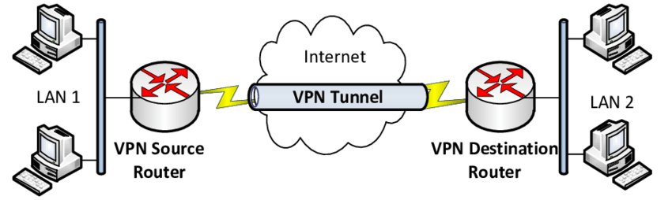

Image : VPN Tunneling

Reference: <https://www.researchgate.net/publication/320536838/figure/fig1/AS:732633726214157@1551684900881/VPN-Tunneling-structure.png>

This layering of packets is called encapsulation. Computers or other network devices at both ends of the tunnel, called tunnel interfaces, can encapsulate outgoing packets and reopen incoming packets. Users (at one end of the tunnel) and IT personnel (at one or both ends of the tunnel) configure the tunnel interfaces they're responsible for to use a tunneling protocol. Also called an encapsulation protocol, a tunneling protocol is a standardized way to encapsulate packets [source: Microsoft]. Later in this article, you can read about the different tunneling protocols used by VPNs.

The purpose of the tunneling protocol is to add a layer of security that protects each packet on its journey over the internet. The packet is traveling with the same transport protocol it would have used without the tunnel; this protocol defines how each computer sends and receives data over its ISP. Each inner packet still maintains the passenger protocol, such as internet protocol (IP), which defines how it travels on the LANs at each end of the tunnel. (See the sidebar for more about how computers use common network protocols to communicate.) The tunneling protocol used for encapsulation adds a layer of security to protect the packet on its journey over the internet.

To better understand the relationships between protocols, think of tunneling as having a computer delivered to you by a shipping company. The vendor who is sending you the computer packs the computer (passenger protocol) in a box (tunneling protocol). Shippers then place that box on a shipping truck (transport protocol) at the vendor's warehouse (one tunnel interface). The truck (transport protocol) travels over the highways (internet) to your home (the other tunnel interface) and delivers the computer. You open the box (tunneling protocol) and remove the computer (passenger protocol).

Some VPNs, such as ExpressVPN have a split tunneling feature. This means you can choose which apps send data through the VPN and which use your regular, local connection.

## Equipment Used For VPN

When planning or extending a VPN, though, you should consider the following equipment:

### Network access server

As previously described, a NAS is responsible for setting up and maintaining each tunnel in a remote-access VPN.

### Firewall

A firewall provides a strong barrier between your private network and the internet. IT staff can set firewalls to restrict what type of traffic can pass through from the internet onto a LAN, and on what TCP and UDP ports. Even without a VPN, a LAN should include a firewall to help protect against malicious internet traffic.

## AAA Server

The acronym stands for the server's three responsibilities: authentication, authorization and accounting. For each VPN connection, the AAA server confirms who you are (authentication), identifies what you're allowed to access over the connection (authorization) and tracks what you do while you're logged in (accounting).

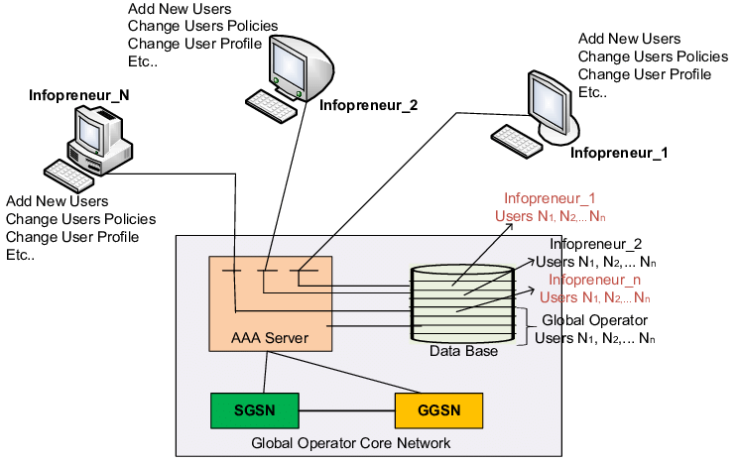

Image : AAA Server

Reference: <https://www.researchgate.net/profile/Sherif-Abdel-Wahed/publication/265537319/figure/fig1/AS:613956192317453@1523389971598/AAA-Server-with-dedicated-API-to-Infopreneurs.png>

## VPN Concentrator

This device replaces an AAA server installed on a generic server. The hardware and software work together to establish VPN tunnels and handle large numbers of simultaneous connections.

## VPN-enabled/VPN-optimized Router

This is a typical router that delegates traffic on a network, but with the added feature of routing traffic using protocols specific to VPNs.

## VPN-enabled Firewall

This is a conventional firewall protecting traffic between networks, but with the added feature of managing traffic using protocols specific to VPNs.

## VPN Client

This is software running on a dedicated device that acts as the tunnel interface for multiple connections. This setup spares each computer from having to run its own VPN client software.

# VPN Security

Encryption is the process of encoding data so that only a computer with the right decoder will be able to read and use it. You could use encryption to protect files on your computer or e-mails you send to friends or colleagues. An encryption key tells the computer what computations to perform on data in order to encrypt or decrypt it. The most common forms of encryption are symmetric-key encryption or public-key encryption:

In symmetric-key encryption, all computers (or users) share the same key used to both encrypt and decrypt a message. In public-key encryption, each computer (or user) has a public-private key pair. One computer uses its private key to encrypt a message, and another computer uses the corresponding public key to decrypt that message.

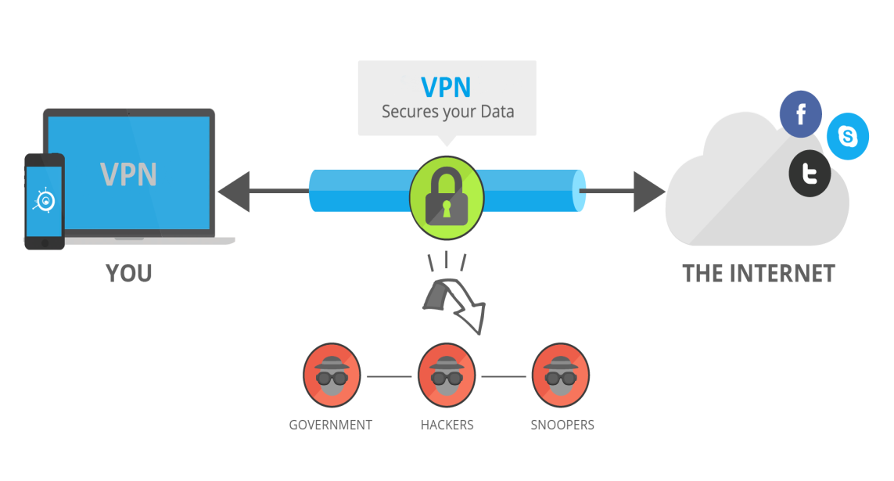

Image: VPN Security

Reference: <https://sites.google.com/site/virtualprivatenetworks/_/rsrc/1472764625920/website-builder/what-is-vpn.png>

In a VPN, the computers at each end of the tunnel encrypt the data entering the tunnel and decrypt it at the other end. However, a VPN needs more than just a pair of keys to apply encryption. That's where protocols come in. A site-to-site VPN could use either internet protocol security protocol (IPSec) or generic routing encapsulation (GRE). GRE provides the framework for how to package the passenger protocol for transport over the internet protocol (IP). This framework includes information on what type of packet you're encapsulating and the connection between sender and receiver.

IPSec is a widely used protocol for securing traffic on IP networks, including the internet. IPSec can encrypt data between various devices, including router to router, firewall to router, desktop to router, and desktop to server. IPSec consists of two sub-protocols which provide the instructions a VPN needs to secure its packets:

Encapsulated Security Payload (ESP) encrypts the packet's payload (the data it's transporting) with a symmetric key.

Authentication Header (AH) uses a hashing operation on the packet header to help hide certain packet information (like the sender's identity) until it gets to its destination.

Networked devices can use IPSec in one of two encryption modes. In transport mode, devices encrypt the data traveling between them. In tunnel mode, the devices build a virtual tunnel between two networks. As you might guess, VPNs use IPSec in tunnel mode with IPSec ESP and IPSec AH working together.

In a remote- access VPN, tunneling typically relies on Point-to-point Protocol (PPP) which is part of the native protocols used by the internet. More accurately, though, remote-access VPNs use one of three protocols based on PPP:

### L2F (Layer 2 Forwarding)

L2F (Layer 2 Forwarding) developed by Cisco; uses any authentication scheme supported by PPP.

### PPTP (Point-to-point Tunneling Protocol)

PPTP (Point-to-point Tunneling Protocol) supports 40-bit and 128-bit encryption and any authentication scheme supported by PPP.

### L2TP (Layer 2 Tunneling Protocol)

L2TP (Layer 2 Tunneling Protocol) combines features of PPTP and L2F and fully supports IPSec; also applicable in site-to-site VPNs

Over time, people have developed new and better technologies to use in networks, which improves the features of existing VPNs. VPN-specific technologies, though, such as tunneling protocols, haven't changed much in that time, perhaps because current VPNs do such a good job at to keep businesses connected around the world.

# Remote Access Authentication Protocol

There are simply two methods to authenticate PPP links namely Password Authentication Protocol (PAP) and Challenge Handshake Authentication Protocol (CHAP). From these two authentication protocols, PAP is less secured as the password is sent in clear text and is performed only at the initial link establishment.

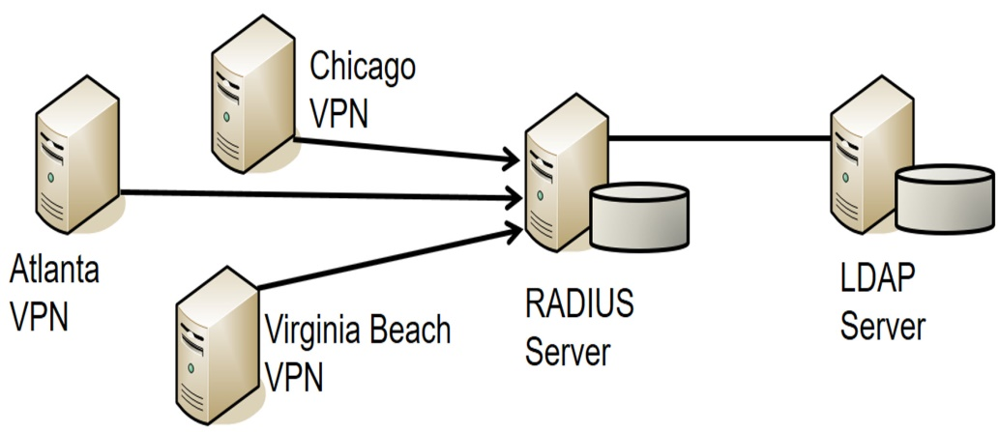

Image : Remote Access Authentication Protocol

Reference: <https://blogs.getcertifiedgetahead.com/wp-content/uploads/2019/03/Remote-Access-Authentication-Methods.jpg>

## PAP

PAP is a password Authentication Protocol used by PPP links to validate users. PAP authentication requires the calling device to enter the username and password. If the credentials match with the local database of the called device or in the remote AAA database then it is allowed to access otherwise denied.

### Features of PAP

Some of the features of PAP are:

* The password is sent in clear text.
* All network operating system support PAP.
* It uses two-way Handshake Protocol.
* It is non-interactive.
* PAP supports both one-way authentication (unidirectional) and two-way authentication (bidirectional).

### When to use PAP

PAP is usually used in following scenarios:

* When the application doesn’t support CHAP.
* Circumstances where it is necessary to sent a plain text password to stimulate a login at the called device (remote host).
* When there is occurrence of incompatibilities between different vendors of CHAP.

### Advantage of CHAP over PAP

Some of the advantages are:

* CHAP is more secured than PAP.
* CHAP can provide authentication periodically to recognise that the user accessing the PPP link is same or not.
* In CHAP, the real passwords are never shared on the link instead a hash value of it is calculated and transferred.

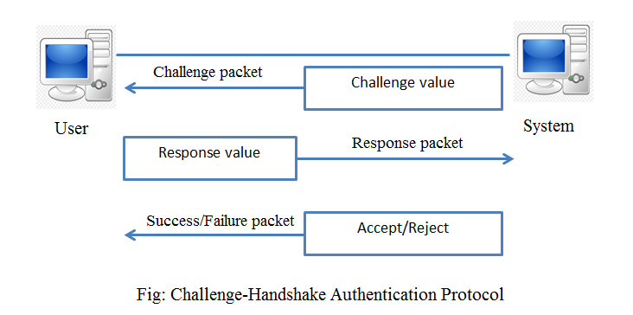

Image: Challenge-Handshake Authentication Protocol

Reference: <https://webeduclick.com/wp-content/uploads/2020/02/Challenge-Handshake-Authentication-Protocol-CHAP.png>

### Advantage of PAP over CHAP

The only advantage PAP holds over CHAP is that it is supported by the all the network operating system vendors therefore it can be said that PAP is used where CHAP is not supported. But if CHAP is supported then it is recommended to use CHAP as it is more secured.

## CHAP

Challenge Handshake Authentication Protocol (CHAP) is a Point-to-point protocol (PPP) authentication protocol developed by IETF (Internet Engineering Task Force). It is used at the initial startup of the link. Also, it performs periodic checkups to check if the router is still communicating with the same host.

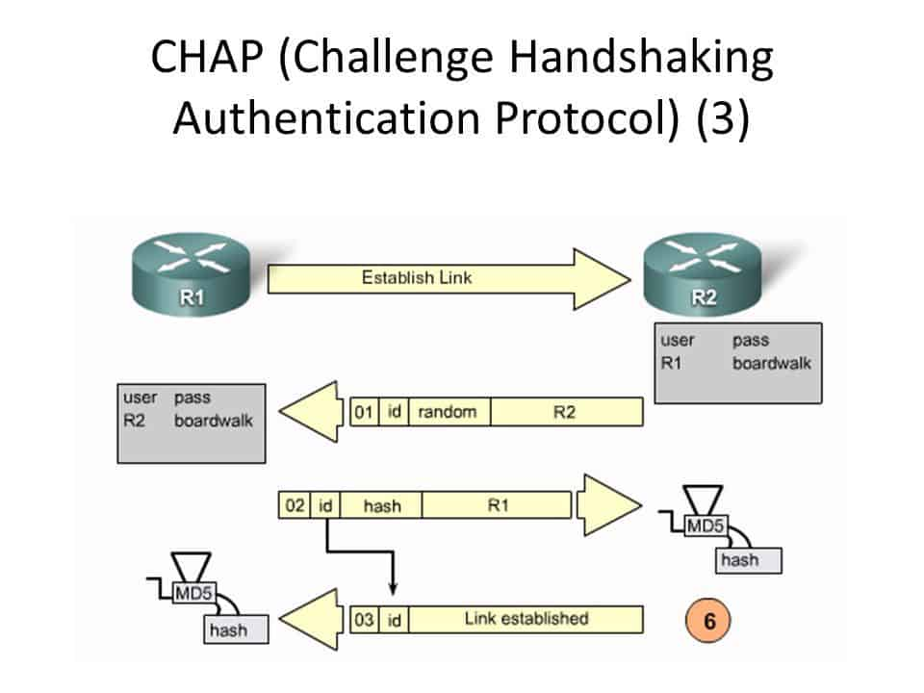

Image: Challenge Handshaking Authentication Protocol

Reference: <https://networkencyclopedia.com/wp-content/uploads/2019/08/CHAP-Challenge-Handshaking-Authentication-Protocol.jpg>

### Features of CHAP

* It uses 3-way handshaking protocol (not like TCP). First, the authenticator sends a challenge packet to the peer then, the peer responds with a value using its one way hash function. The authenticator then matches the received value with its own calculated hash value. If the values match then the authentication is acknowledged otherwise, the connection will be terminated.
* It uses one-way hash function called MD5.
* It also authenticates periodically to check if the communication is taking place with the same device or not.
* Also, it provides more security than PAP (Password Authentication Procedure) as the value used (find out by hash function) is changed variably.
* CHAP requires to know the plaintext of the secret as it is never sent over the network.

### CHAP Packets

There are 4 types of CHAP packets

#### Challenge Packet

It is a packet sent, by the authenticator to peer, at the starting of the CHAP 3-way Handshake. Challenge packet is also sent periodically to check if the connection is not altered. It contains Identifier value, value field which contains random value and also contains name field which contains name of the authenticator. The name field is used for password look up. The name field is also fed to MD5 hash generator and a one-way hash value is generated.

#### Response Packet

It is used to response to the challenge packet. It contains the Value field which contains one-way hash value generated, identifier value and the name field. The Name field of the Response packet is set to the hostname of the peer router. Now, the Name field of Challenge packet is looked up for the password. The router looks up for an entry that matches the username in the Name field of the Challenge packet and gets the password. Then, this password is hashed by feeding it to MD5 hash generator and one way hash value is generated. This value is inserted into the value field of response packet and sent to the authenticator.

#### Success Packet

Now, the authenticator also performs the same thing by looking up in name field (if it has an entry for that username) of the response packet and by using that it generates a hash value. If the value generated is same as that of peer then the success packet is send.

#### Failure Packet

If the generated value is different then the failure packet is send to the peer.

### The Extensible Authentication Protocol (EAP)

This protocol enables extensible authentication for network access. The Extensible Authentication Protocol (EAP) enables extensible authentication for network access. EAP methods operate within the EAP framework to support a variety of authentication techniques. For example, an administrator who requires digital certificate-based authentication might deploy the EAP-TLS method. For more information, see [RFC2716].

Strong credentials such as digital certificates offer many security benefits. However, in many environments these credentials can be prohibitively expensive to send to clients. In such environments, an administrator might use a simple password-based EAP method where the client and server have shared authentication.

The Extensible Authentication Protocol Method for Microsoft Challenge Handshake Authentication Protocol (CHAP) is an EAP method that is designed to meet this need. It does so by having the client and server use MSCHAPv2 to mutually authenticate each other.

To understand the Extensible Authentication Protocol Method for Microsoft CHAP, it is necessary to understand both EAP and MSCHAPv2, as specified in [RFC3748] sections 3 and 4, and [RFC2759] section 1, respectively.

The flow for successful authentication with Extensible Authentication Protocol Method for Microsoft CHAP is as follows:

* An EAP session is established between a client (EAP peer) and an EAP server.
* The EAP server and EAP peer negotiate the EAP method to use. The Extensible Authentication Protocol Method for Microsoft CHAP is selected.
* The EAP peer and EAP server continue to exchange EAP messages with MSCHAPv2 packets encapsulated in the payload.
* After the MSCHAPv2 packets successfully authenticate the client and the server to each other, the EAP authentication finishes.

The Extensible Authentication Protocol Method for Microsoft CHAP is exposed to the same security threats as MSCHAPv2 and needs to be protected inside a secure tunnel, such as the one specified in [MS-PEAP].

The Extensible Authentication Protocol Method for Microsoft CHAP is typically deployed in an environment such as the one that is shown in the following diagram. The EAP peer mutually authenticates with an EAP server through a network access server, for example, a Point-to-Point Protocol (PPP) dial-up server, wireless access point, or VPN gateway.

The Extensible Authentication Protocol Method for Microsoft CHAP messages are carried from the EAP peer to the network access server (NAS) over lower-layer protocols, such as PPP or 802.1X (Port-Based Network Access Control, which is an IEEE standard for local and metropolitan area networks) [IEEE802.1X].

The Extensible Authentication Protocol Method for Microsoft CHAP messages are then carried from the network access server to the EAP server over a higher-level protocol, such as Remote Authentication Dial-In User Service (RADIUS). For more information about RADIUS, see [RFC2865] and [RFC2869].

## MS-CHAP

MS-CHAP is the Microsoft version of the Challenge-Handshake Authentication Protocol, CHAP. The protocol exists in two versions, MS-CHAPv1 (defined in RFC 2433) and MS-CHAPv2 (defined in RFC 2759). MS-CHAPv2 was introduced with pptp3-fix that was included in Windows NT 4.0 SP4 and was added to Windows 98 in the "Windows 98 Dial-Up Networking Security Upgrade Release"[1] and Windows 95 in the "Dial Up Networking 1.3 Performance & Security Update for MS Windows 95" upgrade. Windows Vista dropped support for MS-CHAPv1.

MS-CHAP is used as one authentication option in Microsoft's implementation of the PPTP protocol for virtual private networks. It is also used as an authentication option with RADIUS[2] servers which are used with IEEE 802.1X (e.g., WiFi security using the WPA-Enterprise protocol). It is further used as the main authentication option of the Protected Extensible Authentication Protocol (PEAP).

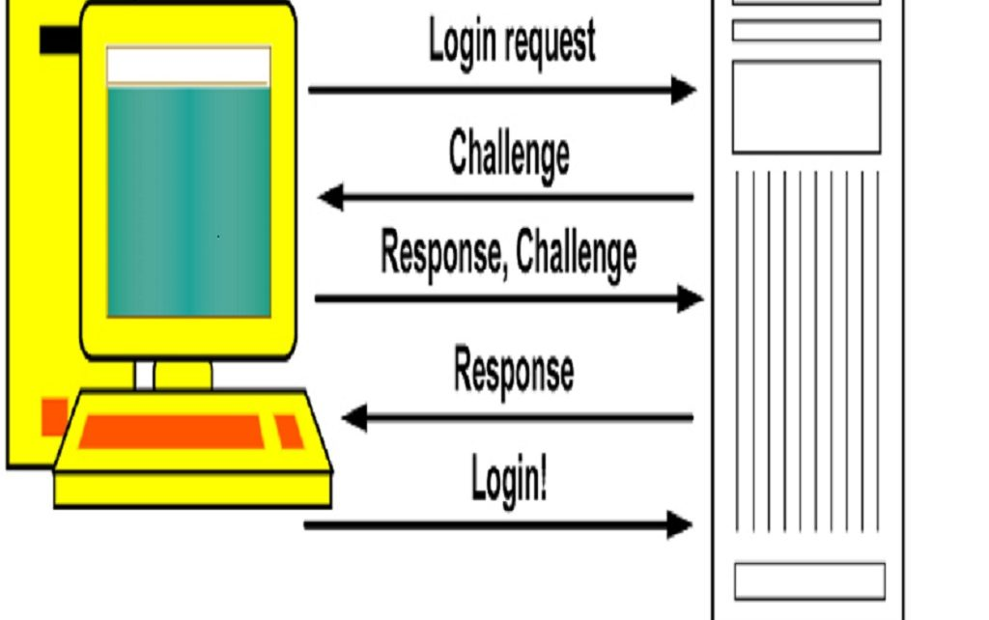

Image : MS-CHAP

Reference: <https://www.techniqworld.com/wp-content/uploads/2018/06/MS-Challenge-1024x642.jpg>

As compared with CHAP, MS-CHAP:

* Is enabled by negotiating CHAP Algorithm 0x80 (0x81 for MS-chapv2) in LCP option 3, Authentication Protocol
* Provides an authenticator-controlled password change mechanism
* Provides an authenticator-controlled authentication retry mechanism
* Defines failure codes returned in the Failure packet message field

MS-CHAPv2 provides mutual authentication between peers by piggybacking a peer challenge on the Response packet and an authenticator response on the Success packet.

## MS-CHAP v2

MS-CHAP v2 (Microsoft Challenge Handshake Authentication Protocol version 2) is a Microsoft authentication protocol that, like CHAP, avoids sending passwords in clear-text. MS-CHAP v1 is not supported.

Steel-Belted Radius Carrier must be able to perform a digest operation similar to CHAP to support MS-CHAP v2. Therefore, it must have access to its own copy of the user’s password. Native User passwords are stored in the Steel-Belted Radius Carrier database. SQL or LDAP BindName authentication retrieves the password by means of a query to the database; the retrieved password can be used to create a digest if it is in clear-text form.

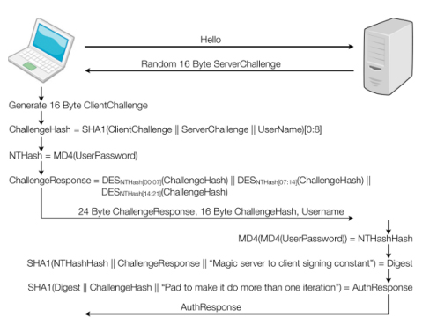

Image: MS-CHAP V2

Reference: <https://i.stack.imgur.com/Iu8Bi.jpg>

MS-CHAP v2 communicates users’ requests to change their passwords to a RADIUS server. Steel-Belted Radius Carrier supports this feature, although it must also be supported by whatever application the user is using to log in. For more information about MS-CHAP v2, see RFC 2433, Microsoft PPP CHAP Extensions; RFC 2548, Microsoft Vendor-specific RADIUS Attributes; and RFC 2759, Microsoft PPP CHAP Extensions, Version 2.

# Remote Authentication Dial-In User Service (RADIUS)

## What is RADIUS?

The Remote Authentication Dial-In User Service (RADIUS) was developed in 1991 as an access server authentication and accounting protocol. It was later brought into the Internet Engineering Task Force (IETF) standards. Just about everyone uses RADIUS, since RADIUS is the underlying authentication and access protocol used by the majority of network and computing systems. RADIUS is commonly used to facilitate roaming between ISPs.

## How it Works?

The user or machine sends a request to a Network Access Server (NAS) to gain access to a network resource. This request includes access credentials (such as a username and password) which are passed to the NAS device via the link-layer protocol. The request may contain other information about the user, such as network address, phone number, or physical attachment to the NAS.

The RADIUS server checks that the information is correct using an authentication protocol (ex: PAP, CHAP, EAP). The RADIUS server returns with one of three responses: Access Reject, Access Challenge, or Access Accept. Each of these responses can be passed to the user in a return webpage.

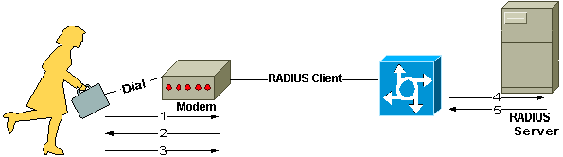

Image: How Radius Works

Reference: <https://www.cisco.com/c/dam/en/us/support/docs/security-vpn/remote-authentication-dial-user-service-radius/12433-32a.gif>

Once the user is authenticated, the RADIUS server will check that the user is authorized for the specific network service.

## Background Information

Communication between a network access server (NAS) and a RADIUS server is based on the User Datagram Protocol (UDP). Generally, the RADIUS protocol is considered a connectionless service. Issues related to server availability, retransmission, and timeouts are handled by the RADIUS-enabled devices rather than the transmission protocol.

## RADIUS is a Client/Server Protocol

The RADIUS client is typically a NAS and the RADIUS server is usually a daemon process running on a UNIX or Windows NT machine. The client passes user information to designated RADIUS servers and acts on the response that is returned. RADIUS servers receive user connection requests, authenticate the user, and then return the configuration information necessary for the client to deliver service to the user. A RADIUS server can act as a proxy client to other RADIUS servers or other kinds of authentication servers.

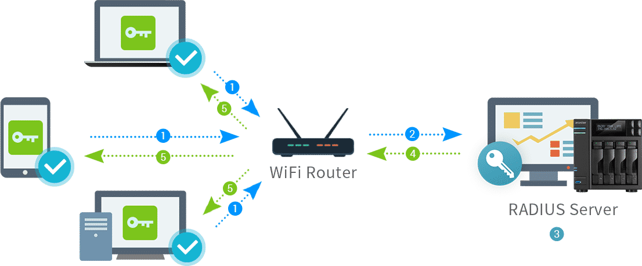

Image : RADIUS is a Client/Server Protocol

Reference: <https://www.freelancinggig.com/blog/wp-content/uploads/2019/05/What-is-RADIUS-Server.png>

## Connection Steps

1. User initiates PPP authentication to the NAS.
2. NAS prompts for username and password (if Password Authentication Protocol [PAP]) or challenge (if Challenge Handshake Authentication Protocol [CHAP]).
3. User replies.
4. RADIUS client sends username and encrypted password to the RADIUS server.
5. RADIUS server responds with Accept, Reject, or Challenge.
6. The RADIUS client acts upon services and services parameters bundled with Accept or Reject.

### Authentication and Authorization

The RADIUS server can support a variety of methods to authenticate a user. When it is provided with the username and original password given by the user, it can support PPP, PAP or CHAP, UNIX login, and other authentication mechanisms.

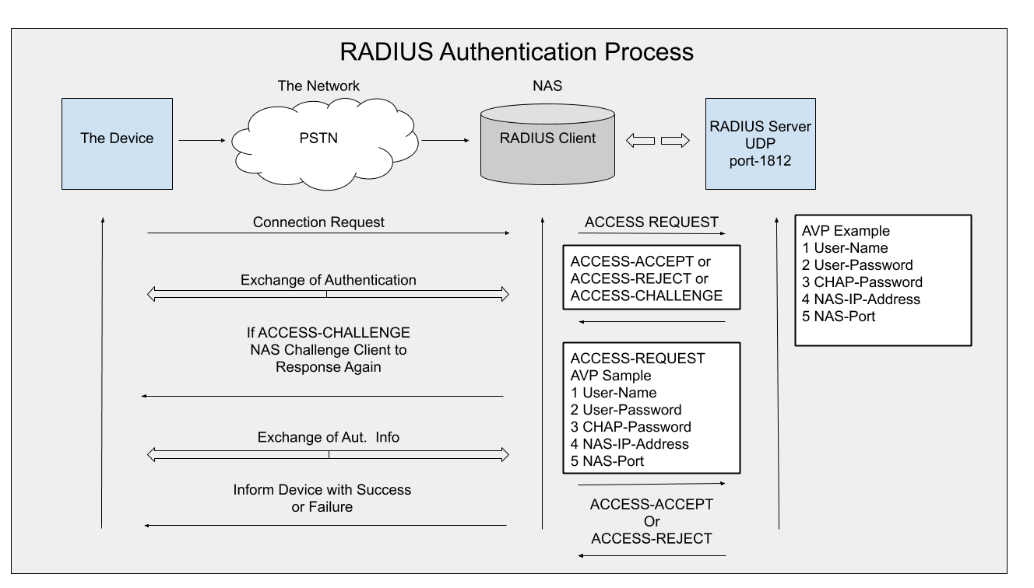

Image : Authentication and Authorization

Reference: <https://jumpcloud.com/wp-content/themes/jumpcloud/assets/images/pillar-radius/RADIUS-Authentication-Process.png>

Typically, a user login consists of a query (Access-Request) from the NAS to the RADIUS server and a corresponding response (Access-Accept or Access-Reject) from the server. The Access-Request packet contains the username, encrypted password, NAS IP address, and port. The early deployment of RADIUS was done using UDP port number 1645, which conflicts with the "datametrics" service. Because of this conflict, RFC 2865 officially assigned port number 1812 for RADIUS. Most Cisco devices and applications offer support for either set of port numbers. The format of the request also provides information about the type of session that the user wants to initiate. For example, if the query is presented in character mode, the inference is "Service-Type = Exec-User," but if the request is presented in PPP packet mode, the inference is "Service Type = Framed User" and "Framed Type = PPP."

When the RADIUS server receives the Access-Request from the NAS, it searches a database for the username listed. If the username does not exist in the database, either a default profile is loaded or the RADIUS server immediately sends an Access-Reject message. This Access-Reject message can be accompanied by a text message indicating the reason for the refusal.

In RADIUS, authentication and authorization are coupled together. If the username is found and the password is correct, the RADIUS server returns an Access-Accept response, including a list of attribute-value pairs that describe the parameters to be used for this session. Typical parameters include service type (shell or framed), protocol type, IP address to assign the user (static or dynamic), access list to apply, or a static route to install in the NAS routing table. The configuration information in the RADIUS server defines what will be installed on the NAS. The figure below illustrates the RADIUS authentication and authorization sequence.

### Accounting

The accounting features of the RADIUS protocol can be used independently of RADIUS authentication or authorization. The RADIUS accounting functions allow data to be sent at the start and end of sessions, indicating the amount of resources (such as time, packets, bytes, and so on) used during the session. An Internet service provider (ISP) might use RADIUS access control and accounting software to meet special security and billing needs. The accounting port for RADIUS for most Cisco devices is 1646, but it can also be 1813 (because of the change in ports as specified in RFC 2139 leavingcisco.com).

Transactions between the client and RADIUS server are authenticated through the use of a shared secret, which is never sent over the network. In addition, user passwords are sent encrypted between the client and RADIUS server to eliminate the possibility that someone snooping on an insecure network could determine a user's password.

# TCP/IP Routing

## Introduction to TCP/IP Routing

Since TCP/IP is the protocol used for the Internet, it is a necessity that the protocol supports the immense size. TCP/IP must support routing capabilities, if not, information sent out to the Internet may never be delivered to its proper destination.

Routers use routing tables which designate where specific IP Address ranges exist. The benefit is to determine which direction the frames must be sent in order to reach their destination. It is also possible to determine which path is best if there are multiple paths to reach the same destination. Multiple destinations allow for redundancy of delivery if a path should fail. For example, look at Figure 1. Let's assume a company is made up of four buildings. Each building site is connected to two other sites through routers. Router A hosts Network 1, Router B hosts Network 2 and so on as shown in the diagram. If the connection between Router A and Router B is somehow broken, Network 1 can still communicate with Network 2 by going through Router D and Router C. Communication goes the other way as well and all four networks are still able to carry on full communications. When one connection fails, the routers can detect the failure and react appropriately to maintain communications.

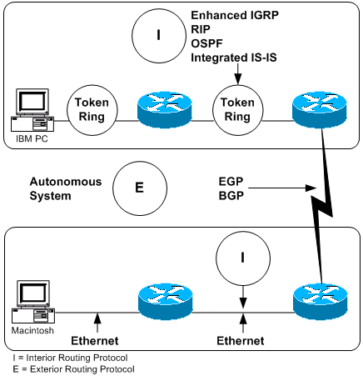

Image : Introduction to TCP/IP Routing

Reference: <https://www.cisco.com/c/dam/en/us/support/docs/ip/routing-information-protocol-rip/13769-fig-5-new.gif>

There are five basic routing protocols to manage the routers to maintain communications for all the networks. These five routing protocols are:

1. Border Gateway Protocol (BGP)
2. Routing Information Protocol (RIP)
3. Open Shortest Path First (OSPF)
4. Interior Gateway Routing Protocol (IGRP)
5. Enhanced Interior Gateway Routing Protocol (EIGRP)

Setting up router tables can be done in two ways, either static or dynamic. To statically manage a number of routers can be a chore. Each routing table must be manually entered for each router. If a route is added or removed, then each routing table must be edited on all routers. For larger companies, this prospect can become a very lengthy task.

Routing tables can be dynamically modified by using one of the routing protocols. The table is updated from other routing tables which are created by the router. A router can detect other routers to communicate with to exchange information.

So, before we look at each routing protocol, let us look in more detail about the functions of the routing protocols.

We discussed static and dynamic table creation, so let’s look at Single and Multipath. A Routing Protocol which handles single path can only manage a single path in the routing table. Looking back at Figure 1, this means Router B will send data to Network 1 through Router A only. Router B has no path for Network 1 through Router C. On the other hand, with a Multipath Protocol, Router B can get to Network 1 through Router A or through Router C.

The next item is dependant on whether the routers are Flat or Hierarchical. In a Flat system, all routers are equal in importance. In Figure 1, Routers A, B, C and D are all considered equal. When one router needs to send data to a specific network, it sends the data to any other router to reach the destination. This is only true in a Multipath system. With a Hierarchical setup, Routers can be designated as the Backbone as shown in Figure 2. Here, Routers A and D are the Backbone. All communication from Routers B, C, E and F go through Routers A and D. The layout is of course set up differently. In Figure 1, if Router A were connected to the Internet, it could be designated as a Backbone since it should definitely be a more used path.

Another function is the Interior or Exterior routing. If a company has routers within the company, these are usually running an Interior type protocol. The Interior type protocol allows the routers within the company to update one another. Exterior type protocols is used on the Internet to allow sharing between routers which may not be owned by the same company. Within a company, ‘Domains’ may be set up to keep routers separated from each other. A ‘Domain’ may be a department, floor, building or any separation needed. Each ‘Domain’ is then set as Interior to allow the routers within that single ‘Domain’ to share routing tables with one another. Any router problems of one ‘Domain’ should not impact another unless the routers are using an Exterior type protocol.

The last item to cover in Router Protocol functions is Distance Vector and Link State. With a Distance Vector Protocol, every router sends out all or a large part of its routing table to other routers directly connected to it. With a Link State Protocol, the routing table is sent to all routers on the local network. The problem with a Distance Vector Protocol is that the routers update their tables slowly. When all routers are updated and routes are agreed on by all routers, this event is called convergence. Link State Protocols converge quickly but ultimately use more of the router’s resources.

* BGP – Dynamic, Multipath, Flat, Exterior, Distance Vector
* RIP – Dynamic, Single-path, Flat, Interior, Distance Vector
* OSPF – Dynamic, Multipath, Hierarchical, Interior, Link State
* IGRP – Dynamic, Multipath, Flat, Interior, Distance Vector
* EIRGP – Dynamic, Multipath, Flat, Interior, Distance Vector

Each router or device can be set to use a specific routing protocol that will serve the needs of the network. All routers which must communicate with one another are required to have the same protocol. Any routers with different protocols cannot communicate with one another to share information.

NOTE: Having different protocols cannot allow two devices to communicate. It is as similar as having a system running TCP/IP and another with AppleTalk. The two cannot communicate in any way without some type of intervening ‘translator’. Keep in mind that protocols are basically a set of rules which determine how information is sent over a network. A similar analogy is when two people are speaking two very different languages (we are not talking American English and British English, but English and Chinese or Russian).

## Protocols Types

Although there are many types of routing protocols, three major classes are in widespread use on IP networks:

* Interior gateway protocols type 1, link-state routing protocols, such as OSPF and IS-IS
* Interior gateway protocols type 2, distance-vector routing protocols, such as Routing Information Protocol, RIPv2, IGRP.
* Exterior gateway protocols are routing protocols used on the Internet for exchanging routing information between Autonomous Systems, such as Border Gateway Protocol (BGP), Path Vector Routing Protocol. Exterior gateway protocols should not be confused with Exterior Gateway Protocol (EGP), an obsolete routing protocol.

There are three types of routes:

### Host Route

Defines a gateway that can forward packets to a specific host or gateway on another network.

### Network Route

Defines a gateway that can forward packets to any of the hosts on a specific network.

### Default Route

Defines a gateway to use when a host or network route to a destination is not otherwise defined.

Routes are defined in the kernel routing table, which can hold up to 32 route definitions. These route definitions include information on networks reachable from the local host, gateways that can be used to reach remote networks, and the hop count (or distance metric) to those networks. When a gateway receives a datagram, it checks the routing tables to find out where next to send the datagram along the path to its destination.

## Static & Dynamic Routing

In TCP/IP, routing can be one of two types: static or dynamic. With static routing, you maintain the routing table manually using the route command. Static routing is practical for a single network communicating with one or two other networks. However, as your network begins to communicate with more networks, the number of gateways increases, and so does the amount of time and effort required to maintain the routing table manually.

With dynamic routing, daemons update the routing table automatically. Routing daemons continuously receive information broadcast by other routing daemons, and so continuously update the routing table.

TCP/IP provides two daemons for use in dynamic routing, the routed and gated daemons. The gated daemon supports Routing Information Protocol (RIP), Routing Information Protocol Next Generation (RIPng), Exterior Gateway Protocol (EGP), Border Gateway Protocol (BGP) and BGP4+, Defense Communications Network Local-Network Protocol (HELLO), Open Shortest Path First (OSPF), Intermediate System to Intermediate System (IS-IS), and Internet Control Message Protocol (ICMP and ICMPv6)/Router Discovery routing protocols simultaneously. In addition, the gated daemon supports the Simple Network Management Protocol (SNMP). The routed daemon only supports Routing Information Protocol.

Routing daemons can operate in one of two modes, passive or active, depending upon the options you use when starting the daemons. In active mode, routing daemons both broadcast routing information periodically about their local network to gateways and hosts, and receive routing information from hosts and gateways. In passive mode, routing daemons receive routing information from hosts and gateways, but do not attempt to keep remote gateways updated (they do not advertise their own routing information).

These two types of routing can be used not only for gateways, but for other hosts on a network as well. Static routing works the same for gateways as for other hosts. Dynamic routing daemons, however, must be run in the passive (quiet) mode when run on a host that is not a gateway.

## Gateways

Gateways are a type of router. Routers connect two or more networks and provide the routing function. Some routers, for example, route at the network interface level or at the physical level.

Gateways, however, route at the network level. Gateways receive IP datagrams from other gateways for delivery to hosts on the local network, and route IP datagrams from one network to another. For example, a gateway connecting two Token-Ring networks has two Token-Ring adapter cards, each with its own Token-Ring network interface. To pass on information, the gateway receives datagrams through one network interface and sends them out through the other network interface. Gateways periodically verify their network connections through interface status messages.

Gateways route packets according to the destination network, not according to the destination host. That is, a gateway machine is not required to keep track of every possible host destination for a packet. Instead, a gateway routes packets according to the network of the destination host. The destination network then takes care of sending the packet to the destination host. Thus, a typical gateway machine requires only limited disk storage capacity (if any) and limited main memory capacity.

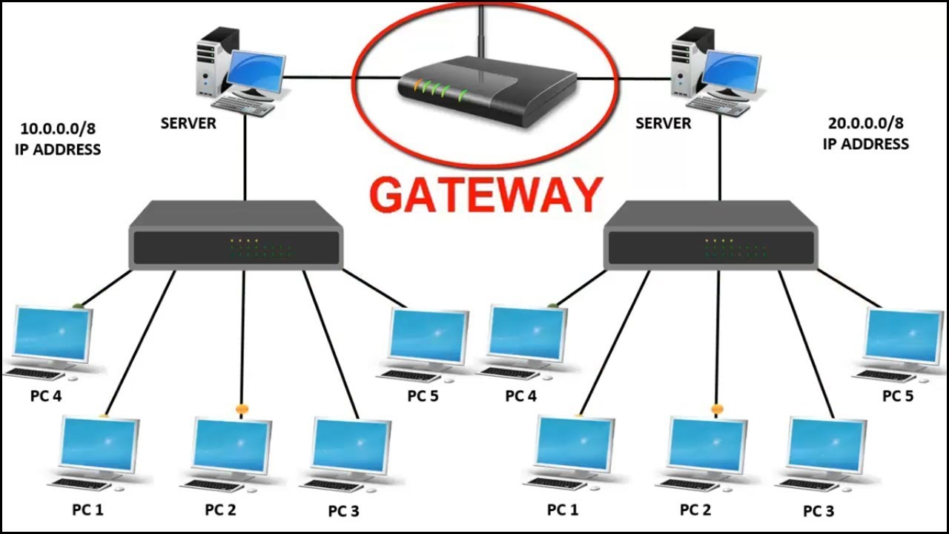

Image: Gateways

Reference: <https://i.ytimg.com/vi/ai5bFPVToMU/maxresdefault.jpg>

. The distance a message must travel from originating host to destination host depends upon the number of gateway hops it must make. A gateway is zero hops from a network to which it is directly attached, one hop from a network that is reachable through one gateway, and so on. Message distance is usually expressed in the number of gateway hops required, or hop counts (also called the metric).

## Interior and Exterior Gateways

Interior gateways are gateways that belong to the same autonomous system. They communicate with each other using the Routing Information Protocol (RIP), Routing Information Protocol Next Generation (RIPng), Intermediate System to Intermediate System protocol, Open Shortest Path First protocol (OSPF), or the HELLO Protocol (HELLO). Exterior gateways belong to different autonomous systems. They use the Exterior Gateway Protocol (EGP), the Border Gateway Protocol (BGP), or BGP4+.

For example, consider two autonomous systems. The first is all the networks administered by the Widget Company. The second is all the networks administered by the Gadget Company. The Widget Company has one machine, called apple, which is Widget's gateway to the Internet. The Gadget Company has one machine, called orange, which is Gadget's gateway to the Internet. Both companies have several different networks internal to the companies. The gateways connecting the internal networks are interior gateways. But apple and orange are exterior gateways.

Each exterior gateway does not communicate with every other exterior gateway. Instead, the exterior gateway acquires a set of neighbors (other exterior gateways) with which it communicates. These neighbors are not defined by geographic proximity, but rather by their established communications with each other. The neighboring gateways, in turn, have other exterior gateway neighbors. In this way, the exterior gateways' routing tables are updated and routing information is propagated among the exterior gateways.

The routing information is sent in a pair, (N,D), where N is a network and D is a distance reflecting the cost of reaching the specified network. Each gateway advertises the networks it can reach and the costs of reaching them. The receiving gateway calculates the shortest paths to other networks and passes this information along to its neighbors. Thus, each exterior gateway is continually receiving routing information, updating its routing table and then passing that information to its exterior neighbors.

## Gateway Protocols

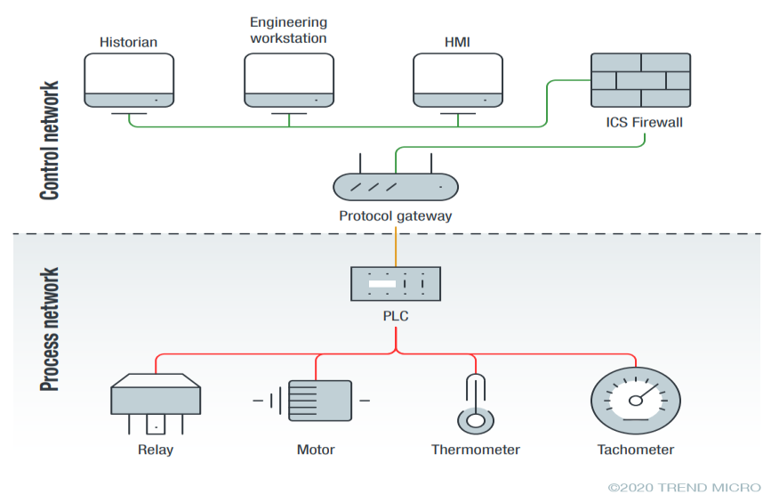

Image : Gateway Protocol

Reference: <https://documents.trendmicro.com/images/TEx/articles/protocol-gateways-fig-1.png>

### HELLO Protocol (HELLO)

HELLO is one protocol that the interior gateways use to communicate among themselves. HELLO calculates the shortest path to other networks by determining the path that has the least delay time.

### Routing Information Protocol (RIP)

Routing Information Protocol is a protocol that the interior gateways use to communicate among themselves. Like the HELLO Protocol, RIP calculates the shortest path to other networks. Unlike HELLO, RIP estimates distance not by delay time, but by hop counts. Because the gated daemon stores all metrics internally as time delays, it converts RIP hop counts into time delays.

### Routing Information Protocol Next Generation

RIPng is the RIP protocol that is enhanced to support IPv6.

### Open Shortest Path First (OSPF)

OPSF is a protocol that the interior gateways use to communicate among themselves. It is a link-state protocol that is better suited than RIP for complex networks with many routers. It provides equal cost multipath routing.



Image: Open Shortest Path First

Reference: <https://media.geeksforgeeks.org/wp-content/uploads/rrf.png>

### Exterior Gateway Protocol (EGP)

The exterior gateways can use the Exterior Gateway Protocol to communicate among themselves. The EGP does not calculate the shortest path to other networks. Instead, it merely indicates whether a particular network is reachable or not.

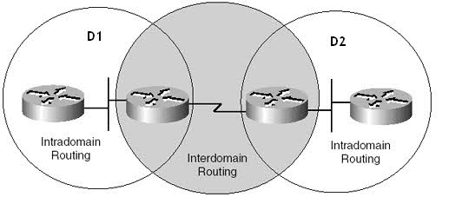

Image: Exterior Gateway Protocol

Reference: <https://networkencyclopedia.com/wp-content/uploads/2019/08/exterior-gateway-protocol.jpg>

### Border Gateway Protocol (BGP)

The exterior gateways can use this protocol to communicate among themselves. It exchanges reachability information between autonomous systems, but provides more capabilities than EGP. BGP uses path attributes to provide more information about each route as an aid in selecting the best route.

### Border Gateway Protocol 4+

BGP4+ is the BGP protocol version 4, which supports IPv6 and has other enhancements over past versions of the protocol.

### Intermediate System to Intermediate System (IS-IS)

Interior gateways use IS-IS protocol to communicate among themselves. It is a link-state protocol that can route IP and ISO/CLNP packets and, like OSPF, uses a "shorter path first" algorithm to determine routes.

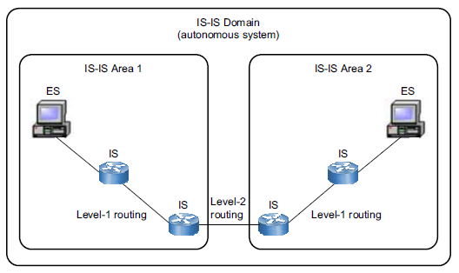

Image2: Intermediate System to Intermediate System

Reference: <https://docs.vmware.com/en/VMware-Smart-Assurance/10.1.0/npm-isis-user-guide-101/images/GUID-24FBF02A-1713-41C1-8356-E18A43C624F7-low.png>

References

1. <https://www.geeksforgeeks.org/software-and-its-types/\>
2. <https://ncert.nic.in/vocational/pdf/keit104.pdf>
3. <https://sites.google.com/view/master-training>
4. <https://www.geeksforgeeks.org/introduction-of-operating-system-set-1/>
5. <https://www.computerhope.com/msdos.htm#commands>
6. <https://www.computerhope.com/jargon/d/director.htm>
7. <https://www.geeksforgeeks.org/disk-defragmentation-in-operating-system/>
8. <https://www.studyadda.com/notes/2nd-class/computers-science/mouse-and-keyboard-usage/keyboard-and-mouse-usage/13209>
9. <https://parablu.com/demystifying-data-backups-types-of-backups/>
10. <https://blogs.helsinki.fi/students-digital-skills/1-introduction-to-the-use-of-computers/1-2-files-and-directories/compression-and-extraction/>
11. <https://digitalworld839.com/types-of-keyboards-computer/>
12. <https://www.guru99.com/introduction-linux.html>
13. <https://www.c-sharpcorner.com/article/introduction-to-linux-operating-system/>
14. <https://www.geeksforgeeks.org/basic-shell-commands-in-linux/>
15. <https://tecadmin.net/best-linux-desktop-environments/>
16. <https://www.brainkart.com/article/An-Introduction-to-OpenOffice-Writer_33692/>
17. <http://www.openoffice.org/documentation/manuals/userguide3/0101GS3-IntroducingOOo.pdf>
18. <https://smallbiztrends.com/2016/12/what-is-openoffice.html>
19. <https://wiki.openoffice.org/w/images/e/e3/0601MG-Introduction.pdf>
20. <https://www.brainkart.com/article/Editing-a-document_33694/>
21. <https://www.brainkart.com/article/Page-Preview,-Setting-the-printer-and-Printing-a-document_33706/>
22. <https://www.brainkart.com/article/Creating-a-new-worksheet---Spreadsheet_33709/>
23. <https://www.brainkart.com/article/Working-with-Data---Spreadsheet_33710/>
24. <https://www.brainkart.com/article/Creating-Formulae---Spreadsheet_33711/>
25. <https://www.brainkart.com/article/Save,-Close-and-Open-the-Worksheet_33712/>
26. <https://www.brainkart.com/article/Copy,-Cut-and-Paste---Spreadsheet_33713/>
27. <https://www.brainkart.com/article/Inserting-Columns,-Rows-and-Cells---Spreadsheet_33715/>
28. <https://www.brainkart.com/article/Deleting-columns-and-rows---Spreadsheet_33716/>
29. <https://www.brainkart.com/article/Functions---Spreadsheet_33718/>
30. <https://www.brainkart.com/article/Formatting-Worksheet---Spreadsheet_33717/>
31. <https://www.brainkart.com/article/Working-with-Chart---Spreadsheet_33719/>
32. <https://www.brainkart.com/article/Presentation-Software---Meaning_33722/>
33. <https://www.computerhope.com/jargon/d/diskmana.htm#:~:text=Disk%20Management%20is%20a%20Microsoft,partitions%20associated%20with%20those%20drives>.
34. <https://www.diskpart.com/windows-10/windows-10-disk-management-0528.html>
35. <https://www.lifewire.com/create-automated-task-with-task-scheduler-on-windows-10-5112606>
36. <https://www.windowscentral.com/how-create-automated-task-using-task-scheduler-windows-10>
37. <https://www.isunshare.com/windows-10/6-ways-to-open-event-viewer-in-windows-10.html>
38. <https://www.computerhope.com/jargon/e/evenview.html>
39. <https://www.lifewire.com/device-manager-2625860>
40. <https://support.microsoft.com/en-us/windows/file-sharing-over-a-network-in-windows-10-b58704b2-f53a-4b82-7bc1-80f9994725bf>
41. <https://www.techopedia.com/definition/13530/windows-service>
42. <https://www.pcmag.com/encyclopedia/term/windows-application>
43. <https://www.proofpoint.com/us/threat-reference/computer-virus>
44. <https://www.dotnek.com/Blog/Security/what-is-antivirus-and-its-types>
45. <https://byjus.com/govt-exams/computer-virus/#What-is-a-Computer-Virus>?
46. <https://www.webroot.com/in/en/resources/tips-articles/what-is-anti-virus-software>
47. <https://www.cisco.com/c/en_in/products/security/firewalls/what-is-a-firewall.html>
48. <https://www.javatpoint.com/firewall>
49. <https://www.simplilearn.com/tutorials/cyber-security-tutorial/what-is-firewall>
50. <https://coastapp.com/blog/preventive-maintenance/>
51. <https://roadtoreliability.com/types-of-maintenance/>
52. <https://www.slideshare.net/RheighHenleyCalderon/5-pc-maintenance>
53. <https://www.javatpoint.com/monitor>
54. <https://www.techtarget.com/searchstorage/definition/video-RAM>
55. <https://1library.net/document/ozl74lly-a-bible-pdf.html>
56. <https://www.cisco.com/c/en_in/products/switches/what-is-a-lan-local-area-network.html>
57. <https://www.geeksforgeeks.org/difference-between-lan-man-and-wan/>
58. <https://www.geeksforgeeks.org/difference-between-internet-and-intranet/>
59. <https://www.stellarinfo.co.in/blog/how-to-fix-the-io-errors-for-the-external-hard-disk-drives/>
60. <https://www.tutorialspoint.com/computer_fundamentals/computer_networking.htm>
61. <https://beginnersbook.com/2019/03/computer-network-components/>
62. <https://www.networkstraining.com/different-types-of-networks/>
63. <https://www.javatpoint.com/intranet>
64. <https://www.educative.io/edpresso/what-are-p2p-and-clientserver-networks>
65. <https://afteracademy.com/blog/what-is-a-network-interface-card>
66. <https://incentre.net/ethernet-cable-color-coding-diagram/>
67. <https://www.omnisci.com/technical-glossary/client-server>
68. <https://www.techtarget.com/searchnetworking/definition/node#:~:text=A%20network%20node%20sits%20at,as%20modems%2C%20PCs%20and%20printers>.
69. <https://en.wikipedia.org/wiki/Network_segment#:~:text=A%20network%20segment%20is%20a,used%20to%20interconnect%20end%20stations>.
70. <https://www.geeksforgeeks.org/types-and-uses-of-backbone-networks/#:~:text=The%20backbone%20itself%20is%20a,%3A%20Bus%20backbone%2C%20Star%20backbone>.
71. <https://www.one.com/en/hosting/what-is-web-hosting>
72. <https://www.informit.com/articles/article.aspx?p=24687&seqNum=5>
73. <https://www.guru99.com/analog-vs-digital.html>
74. <https://www.monolithicpower.com/en/analog-vs-digital-signal>
75. <https://www.geeksforgeeks.org/difference-between-broadband-and-baseband-transmission/>
76. <https://www.omnisecu.com/basic-networking/common-network-cable-types.php>
77. <https://www.homedepot.com/c/ab/types-of-cables-and-connectors-in-networking/9ba683603be9fa5395fab90e9250f90>
78. <https://www.geeksforgeeks.org/difference-between-physical-and-logical-topology/>
79. <https://www.javatpoint.com/computer-network-topologies>
80. <https://www.geeksforgeeks.org/difference-between-synchronous-and-asynchronous-transmission/>
81. <https://www.guru99.com/difference-between-synchronous-and-asynchronous-transmission.html>
82. <https://ipcisco.com/lesson/basic-cisco-router-security-configuration/>
83. <https://www.simplilearn.com/data-encryption-methods-article>
84. <https://securitytrails.com/blog/top-10-common-network-security-threats-explained>
85. <https://www.tutorialspoint.com/information_security_cyber_law/network_security.htm>
86. <https://www.techopedia.com/definition/5553/remote-access>
87. <https://www.catonetworks.com/blog/types-of-remote-access-technologies-for-enterprises/>
88. <https://www.seomining.com/web-technologies/module4/remote-access-protocols.php>
89. <https://networklessons.com/cisco/ccna-routing-switching-icnd2-200-105/introduction-to-vpns>
90. <https://www.cactusvpn.com/beginners-guide-to-vpn/vpn-features/>
91. <https://www.geeksforgeeks.org/types-of-virtual-private-network-vpn-and-its-protocols/>
92. <https://cybernews.com/what-is-vpn/what-is-a-vpn-tunnel/>
93. <https://www.cloudflare.com/en-in/learning/access-management/vpn-security/>
94. <https://www.geeksforgeeks.org/password-authentication-protocol-pap/>
95. <https://networkencyclopedia.com/challenge-handshake-authentication-protocol-chap/>
96. <https://www.certiology.com/tech-terms/network/microsoft-challenge-handshake-authentication-protocol-ms-chap-v1-and-v2.html>
97. <https://www.cisco.com/c/en/us/support/docs/security/firepower-management-center/217437-configure-ftd-remote-access-vpn-with-msc.html>
98. <https://www.foxpass.com/blog/radius-server-and-how-it-works>
99. <https://www.techtarget.com/searchnetworking/definition/TCP-IP>
100. <https://www.techtarget.com/searchnetworking/definition/TCP-IP>
101. <https://www.trendmicro.com/vinfo/us/security/definition/protocol-gateway>